OS LAB
Practical 4
- Write a C program where a parent process creates multiple child processes and synchronizes their completion using wait() and waitpid(). Compare the behavior of both functions.

Create a scenario where a child process becomes a zombie process. Investigate the process table and then modify the program to eliminate zombie processes using proper synchronization techniques.
#include <stdio.h>
#include <stdlib.h>
#include <unistd.h>
#include <sys/wait.h>

int main()
{
pid_t child1, child2, child3;
int status;

printf("Parent process started\n");
printf("Parent PID: %d\n\n", getpid());

// Create first child
child1 = fork();

if (child1 == 0)
{
printf("Child 1: PID = %d, PPID = %d\n", getpid(), getppid());
sleep(2);
printf("Child 1 completed\n");
exit(10);
}

// Create second child
child2 = fork();

if (child2 == 0)
{
printf("Child 2: PID = %d, PPID = %d\n", getpid(), getppid());
sleep(4);
printf("Child 2 completed\n");
exit(20);
}

// Create third child
child3 = fork();

if (child3 == 0)
{
printf("Child 3: PID = %d, PPID = %d\n", getpid(), getppid());
sleep(1);
printf("Child 3 completed\n");
exit(30);
}

// Parent waits for any child using wait()
printf("\nParent using wait()...\n");

pid_t finished = wait(&status);

printf("wait(): Child PID %d finished\n", finished);

if (WIFEXITED(status))
printf("Exit status = %d\n", WEXITSTATUS(status));

// Parent waits specifically for child1 using waitpid()
printf("\nParent using waitpid() for Child 1...\n");

waitpid(child1, &status, 0);

printf("waitpid(): Child 1 PID %d finished\n", child1);

if (WIFEXITED(status))
printf("Exit status = %d\n", WEXITSTATUS(status));

// Wait for remaining children
waitpid(child2, &status, 0);
waitpid(child3, &status, 0);

printf("\nAll child processes completed.\n");
printf("Parent process exiting.\n");

return 0;
}
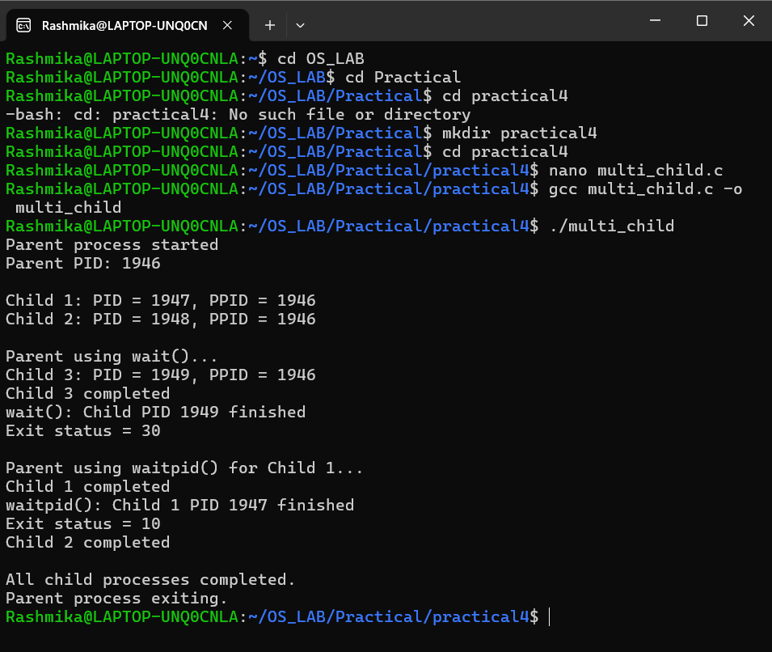
#include <stdio.h>
#include <stdlib.h>
#include <unistd.h>

int main()
{
pid_t pid = fork();

if (pid < 0)
{
perror("fork");
return 1;
}

if (pid == 0)
{
printf("Child process\n");
printf("Child PID: %d\n", getpid());
printf("Child exiting...\n");

exit(0);
}
else
{
printf("Parent process\n");
printf("Parent PID: %d\n", getpid());
printf("Child PID: %d\n", pid);

printf("Parent sleeping for 30 seconds...\n");

sleep(30);

printf("Parent exiting\n");
}

return 0;
}
