OS LAB
PRACTICAL
FILE PERMISSION
Task of the Day
- Give Read and Write only to the owner
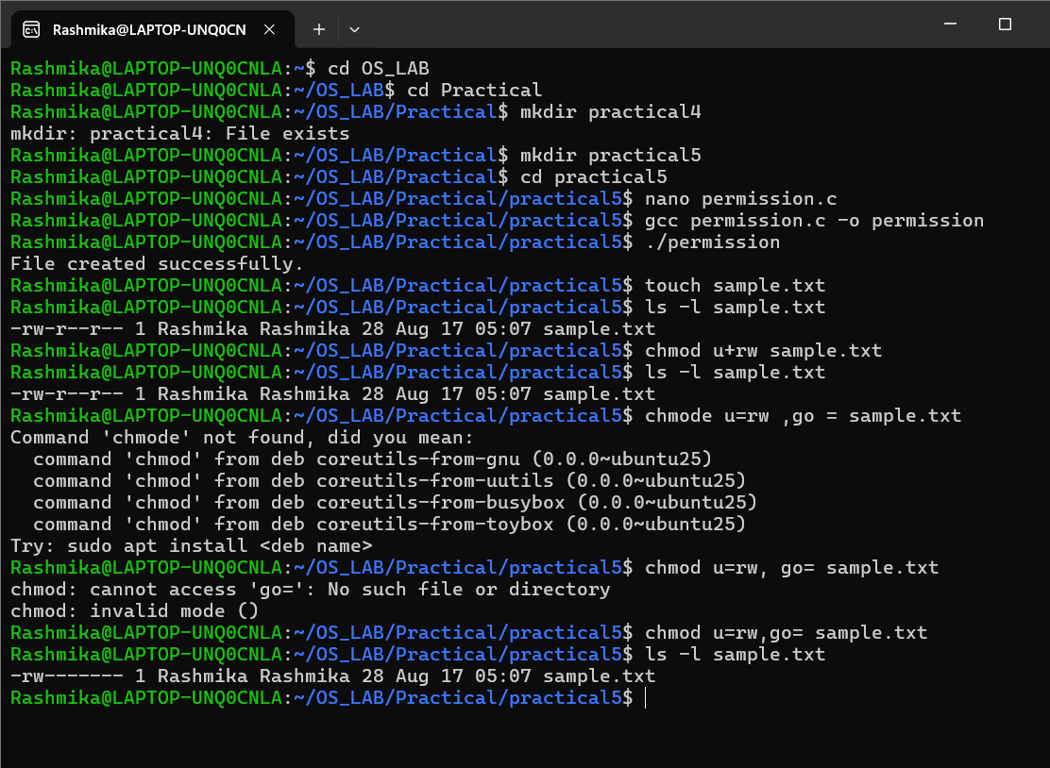
2)Give Read and Write to the owner and group
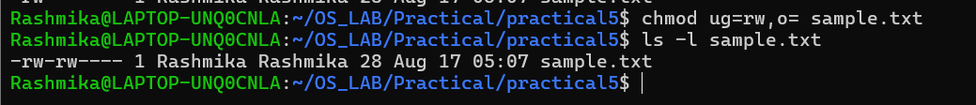3)Only owner can read and write
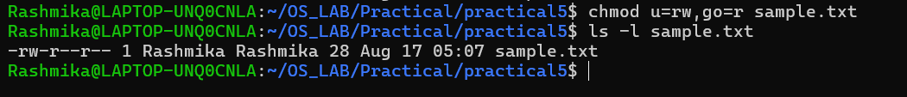
4) Owner read/write, everyone else read-only
5) Owner can do everything, others can only read and execute
6) Owner and group can read/write
7) Only owner can execute
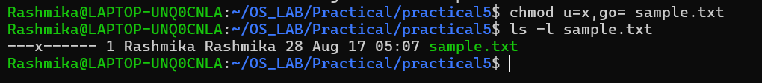

Fill in the permission numbers for the following:

8) Owner: read + write; Group: nothing; Others: nothing → 600
9) Owner: read + write; Group: read; Others: read →644
10) Owner: read + write + execute; Group: read + execute; Others: read + execute → 755
11) Owner: read + write; Group: read + write; Others: nothing → 660
12) Everyone: read only → 444

