“Linux File Descriptor and File I/O Management System.”
A Project Report Submitted in the partial fulfillment of the requirements for the award of the degree of

BACHELOR OF TECHNOLOGY
In

DEPARTMENT OF COMPUTER SCIENCE ENGINEERING & INFORMATION TECHNOLOGY

By

ALLAMSETTI LAHARI 2520090004

KOMALI VARNIKA 2520090010

DEVAJI RASHMIKA 2520090152

Under the Esteemed Guidance of

Dr. Alekya
Assistant Professor
Department of Computer Science and Engineering & Information Technology




K L (Deemed to be) University

DEPARTMENT OF COMPUTER SCIENCE AND INFORMATION TECHNOLOGY

Declaration

The Project Report entitled “Linux File Descriptor and File I/O Management System.” is a record of Bonafide work of ALLAMSETTI LAHARI - 2520090004 , KOMALI VARNIKA - 2520090010, DEVAJI RASHMIKA - 2520090152 submitted in partial fulfillment for the award of B. Tech in Computer Science and Information Technology to the K L University. The results embodied in this report have not been copied from any other departments/University/Institute.

ALLAMSETTI LAHARI 2520090004

KOMALI VARNIKA 2520090010

DEVAJI RASHMIKA 2520090152

K L (Deemed to be) University

DEPARTMENT OF COMPUTER SCIENCE ENGINEERING

& INFORMATION TECHNOLOGY

CERTIFICATE

This is certify that the mini project based report entitled“Linux File Descriptor and File I/O Management System” is a bonafide work done and submitted by ALLAMSETTI LAHARI – 2520090004 , KOMALI VARNIKA – 2520090010 , DEVAJI RASHMIKA - 2520090152 in partial fulfillment of the requirements for the award of the degree of BACHELOR OF TECHNOLOGY in Department of Computer Science Engineering & Information Technology, K L (Deemed to be University), during the academic year 2026-2027.

Signature of the Guide

Signature of the Course Coordinator Signature of the HOD

ACKNOWLEDGEMENT
The success in this project would not have been possible but for the timely help and guidance rendered by many people. Our wish to express my sincere thanks to all those who has assisted us in one way or the other for the completion of my project.

Our greatest appreciation to my Course Coordinator Dr. K. Anusha, and my guide Dr. Alekya, Department of Computer Science which cannot be expressed in words for his/her tremendous support, encouragement and guidance for this project.

We express our gratitude to Dr. Khaja Shareef (CSIT), Head of the Department for Computer Science Engineering & Information Technology for providing us with adequate facilities, ways and means by which we are able to complete this project-based Lab.

We thank all the members of teaching and non-teaching staff members, and also who have assisted me directly or indirectly for successful completion of this project. Finally, I sincerely thank my parents, friends and classmates for their kind help and cooperation during my work.

ALLAMSETTI LAHARI 2520090004

KOMALI VARNIKA 2520090010

DEVAJI RASHMIKA 2520090152
Abstract

The Linux operating system provides powerful services for managing files, processes, memory, and communication between programs, but understanding how these services work internally can be challenging for beginners. To address this, our project focuses on the Design and Development of a Linux File Descriptor and File I/O Management System. The core aim of this project is to provide an interactive, terminal-based platform that demonstrates how user programs communicate with the Linux kernel through system calls and how the operating system manages files and other resources efficiently.

The system is structured around several interconnected modules covering File I/O, File Descriptor Management, Process Management, Inter-Process Communication, Memory Management, and Thread Synchronization. The File I/O module provides operations such as creating, opening, reading, writing, appending, seeking, copying, renaming, and deleting files using system calls including open(), read(), write(), close(), and lseek(). The project also demonstrates file descriptor duplication using dup() and dup2(), file metadata using stat() and fstat(), inode information, /proc/self/fd/, memory-mapped file I/O using mmap(), and the role of the Linux Virtual File System (VFS). Process and IPC modules further demonstrate fork(), exec(), waitpid(), pipes, FIFOs, and signal handling.

The project also incorporates important memory management and concurrency concepts to provide practical coverage of the complete Operating Systems syllabus. It demonstrates dynamic memory allocation, process address-space layout, /proc memory mappings, Copy-on-Write, and POSIX threads with race conditions, mutexes, condition variables, and semaphores. The system is developed in C using standard POSIX/Linux APIs, with proper error handling through errno and perror(), and is designed to run directly on Ubuntu/Linux without requiring external libraries or root privileges. Overall, this project provides a unified and practical environment for understanding how the Linux kernel, system calls, file systems, processes, memory, IPC, and synchronization mechanisms work together to provide operating-system services to user applications.
.

Index
S. No. | Chapter | Topics / Subtopics | Page No.
 | Acknowledgement |  | i
 | Abstract |  | ii
1 | Introduction |  | 1–2
 |  | 1.1 Background of the Project
 |  | 1.2 Problem Statement
 |  | 1.3 Scope of the Project
 |  | 1.4 Objectives of the Project
 |  | 1.5 Importance of the Application
 |  | 1.6 Target Users / Audience
2 | OS Concepts and Background Study |  | 3–4
 |  | 2.1 Operating System Concepts Related to the Project
 |  | 2.2 Existing Methods / Algorithms
 |  | 2.3 Proposed Approach
 |  | 2.4 Advantages of the Proposed Approach
3 | System Requirements |  | 5–6
 |  | 3.1 Hardware Requirements
 |  | 3.2 Software Requirements
 |  | 3.3 Operating System Environment – Ubuntu / WSL
 |  | 3.4 Development Tools and Compilers
4 | Technology and Tools Used |  | 7–8
 |  | 4.1 C / C++ Programming
 |  | 4.2 GCC Compiler
 |  | 4.3 Linux System Calls
 |  | 4.4 POSIX Threads / Synchronization
 |  | 4.5 Linux Commands and Utilities
 |  | 4.6 Other Tools / Libraries Used
5 | System Architecture and Design |  | 9–11
 |  | 5.1 Overall System Architecture
 |  | 5.2 System Workflow
 |  | 5.3 Flowchart / Data Flow
 |  | 5.4 Module Description
 |  | 5.5 Input and Output Design
6 | Implementation |  | 12–16
 |  | 6.1 Module-wise Implementation
 |  | 6.2 Algorithm / Pseudocode
 |  | 6.3 Core C / C++ Implementation
 |  | 6.4 Linux System Calls / APIs Used
 |  | 6.5 Process / Thread Implementation
 |  | 6.6 IPC / Synchronization Implementation
 |  | 6.7 Memory Management Implementation
 |  | 6.8 Optional User Interface Implementation
7 | Execution and Demonstration |  | 17–24
 |  | 7.1 Compilation in Ubuntu
 |  | 7.2 Execution Commands
 |  | 7.3 Sample Inputs and Outputs
 |  | 7.4 Screenshots of Execution
 |  | 7.5 Demonstration of OS Concepts
8 | Conclusion |  | 25
 |  | 8.1 Summary of the Project
 |  | 8.2 Objectives Achieved
 |  | 8.3 Results Achieved
 |  | 8.4 Skills and Learning Outcomes
9 | References |  | 26
 |  | 9.1 Books
 |  | 9.2 Research Papers
 |  | 9.3 Linux / GNU Documentation
 |  | 9.4 Online Resources

CHAPTER -1 INTRODUCTION

1.1 Background of the Project

File management is one of the fundamental responsibilities of an operating system. In Linux, files are accessed through file descriptors, which provide processes with references to open files and other I/O resources. System calls such as open(), read(), write(), lseek(), and close() enable applications to perform file-related operations through the kernel. Although these mechanisms are extensively used by software applications, their internal operation can be difficult to understand without practical implementation.

The proposed project provides a practical environment for studying these mechanisms through an interactive terminal-based application. It demonstrates how file descriptors are created and managed, how data is transferred between applications and files, and how file metadata and inode information are maintained by the Linux filesystem. The project also provides demonstrations of related operating-system mechanisms, thereby connecting theoretical concepts with practical system-level implementation.

1.2 Problem Statement

Understanding Linux file descriptors, system calls, and low-level file I/O operations can be challenging when these concepts are studied only through theoretical explanations. Conventional file-management applications generally hide the underlying operating-system mechanisms and do not provide sufficient visibility into file descriptors, system calls, file metadata, and kernel-level resource management.

Therefore, there is a need for a practical system that demonstrates fundamental Linux file-management operations while providing a clear understanding of how applications interact with operating-system resources. The proposed Linux File Descriptor and File I/O Management System addresses this requirement by integrating essential file operations and related system-level mechanisms into a single interactive application.

1.3 Scope of the Project

The scope of the project includes the implementation and demonstration of fundamental Linux file-management and system-programming operations using the C programming language and POSIX APIs. The application covers file creation, opening, reading, writing, appending, seeking, copying, renaming, deletion, file-descriptor handling, file metadata, inode information, and inspection of open file descriptors through the /proc filesystem.

The project also extends its scope to selected operating-system mechanisms such as process creation and synchronization, inter-process communication, memory management, and multithreading. The system is intended for execution in a Linux environment such as Ubuntu and focuses on educational and practical understanding rather than large-scale production file management.

1.4 Objectives of the Project

The primary objectives of the project are:

To develop a Linux-based application for demonstrating fundamental file and file-descriptor operations.

To provide practical implementation of POSIX system calls such as open(), read(), write(), lseek(), and close().

To demonstrate the relationship between file descriptors, processes, and operating-system resources.

To examine file metadata, inode information, and open file descriptors using Linux system interfaces.

To demonstrate fundamental concepts of process management and inter-process communication.

To provide practical demonstrations of memory management and multithreading mechanisms.

To implement appropriate error handling and resource-management techniques.

To strengthen practical understanding of Linux system programming through an integrated application.

1.5 Importance of the Application

The application is important because it provides a practical approach to understanding low-level Linux file-management and system-programming concepts. Instead of treating file operations as simple high-level programming tasks, the application demonstrates how processes use file descriptors and system calls to communicate with the Linux kernel. This helps bridge the gap between theoretical operating-system concepts and their actual implementation.

The system is also useful for understanding resource management, process interaction, memory operations, and synchronization mechanisms in a controlled environment. Its modular and interactive design makes it suitable for academic laboratory work, demonstrations, experimentation, and examination preparation involving Linux system programming.

1.6 Target Users / Audience

The primary target users of the application are students, educators, and beginners in Linux system programming and operating systems. Students can use the system to understand file descriptors, POSIX system calls, file I/O, processes, inter-process communication, memory management, and multithreading through practical demonstrations.

The application may also be useful for academic instructors and laboratory environments as a demonstration and experimentation tool. By providing direct interaction with Linux system-level operations, the project can support laboratory exercises, technical demonstrations, project evaluations, and the development of foundational system-programming skills.

CHAPTER -2 OS CONCEPTS AND BACKGROUND STUDY

2.1 Operating System Concepts Related to the Project

The main concept used in the project is Linux file management and file I/O. When a process opens a file, Linux assigns a file descriptor that the process uses to access the file. System calls such as open(), read(), write(), lseek(), and close() are used to perform file operations. The project also demonstrates file metadata, inode information, file permissions, and open file descriptors through the /proc filesystem.

The project also covers related concepts such as process management, inter-process communication, memory management, and multithreading. Process creation and synchronization are demonstrated using fork(), exec(), and waitpid(), while pipes and named pipes are used for communication between processes. Memory and thread operations

demonstrate how Linux manages memory and concurrent execution. Together, these concepts provide a practical understanding of how applications use operating-system services.

2.2 Existing Methods / Algorithms

File operations can be performed using high-level file-handling functions or low-level Linux/POSIX system calls. High-level methods are convenient for application development, while system calls such as open(), read(), write(), and close() provide direct interaction with the operating system. However, these low-level operations are often studied separately through individual laboratory programs.

Similarly, concepts such as processes, IPC, memory management, and threads are commonly demonstrated using separate programs. Although this helps explain individual concepts, it does not provide a unified view of how these mechanisms work together. The proposed project addresses this limitation by integrating the relevant demonstrations into a single structured application.

2.3 Proposed Approach

The proposed system is implemented as an interactive, terminal-based application using C and standard POSIX/Linux APIs. Its primary functionality is to perform and demonstrate file-related operations such as creating, opening, reading, writing, appending, seeking, copying, renaming, and deleting files. The application also provides information about file descriptors, file metadata, inode details, and open file descriptors, allowing users to observe the underlying file-management mechanisms.

The system is organized into separate modules for file management, process management, inter-process communication, memory management, and multithreading. Each module focuses on a specific operating-system concept while maintaining proper error handling and resource management. This modular approach makes the application easier to understand, test, and maintain while providing a practical connection between user programs, Linux system calls, and the operating-system kernel.

2.4 Advantages of the Proposed Approach

The proposed approach provides the following advantages:

Practical understanding: Converts theoretical operating-system concepts into executable demonstrations.

Low-level visibility: Provides better understanding of file descriptors, system calls, inodes, and kernel-level resource management.

Integrated learning: Combines file I/O with process management, IPC, memory management, and multithreading.

Modular design: Separates major functionalities into independent modules, improving organization and maintainability.

Error handling: Demonstrates appropriate handling of system-call failures using mechanisms such as errno and perror().

Interactive operation: Provides a terminal-based interface through which users can directly execute and observe system-level operations.

Educational value: Supports laboratory experimentation, technical demonstrations, and practical learning of Linux system programming.

CHAPTER- 3 SYSTEM REQUIREMENTS

3.1 Hardware Requirements

The project can be developed and executed on a standard laptop or desktop computer. The following configuration is sufficient for compiling and running all the modules of the application:
Component | Requirement
Processor | Intel Core i3 or equivalent and above
RAM | Minimum 4GB
Storage | Minimum 500MB of available space
Display | Standard monitor
Input | Standard keyboard

No additional hardware devices or external peripherals are required because the project operates through the Linux terminal and interacts with the operating system using software-based system calls.

3.2 Software Requirements

The project requires a Linux-based programming environment with support for C, POSIX system calls, and POSIX threads. The following software components are used:
Software / Component | Requirement
Operating system | Ubuntu Linux
Programming Language | C
Compiler | GCC
Build Tool | GNU Make
System APIs | POSIX / Linux APIs
Thread Support | POSIX Threads (pthread)
File System Interface | Linux /proc filesystem
Development Environment | VS code or compatible text editor
Terminal | Ubuntu / Linux Terminal

The application does not require a database, web server, or external application framework. Its functionality is implemented using Linux system interfaces and libraries available within the operating-system environment.

3.3 Operating System Environment – Ubuntu / WSL

The project is designed for Ubuntu/Linux, as the application uses Linux-specific system calls, the /proc filesystem, POSIX process mechanisms, pipes, memory-management interfaces, and POSIX threads. Ubuntu provides the required kernel interfaces and command-line environment for compiling and executing the project.

For development on Windows, Windows Subsystem for Linux (WSL) can be used with Ubuntu. WSL provides a Linux environment in which GCC, GNU Make, POSIX APIs, and Linux commands can be used. In the project environment, Ubuntu through WSL is suitable for creating the source files, compiling the modules, and executing the final linux_file_io_manager application.

3.4 Development Tools and Compilers

GCC (GNU Compiler Collection) is used to compile the C source files and generate the executable application. The project is compiled with warning options such as -Wall and -Wextra, while the -pthread option is required for the thread and synchronization components.

GNU Make is used to simplify and automate the compilation of the multiple source files and their corresponding object files. A Makefile defines the compilation and linking process as well as cleaning operations. Visual Studio Code or a Linux terminal editor can be used for source-code development, while optional tools such as GDB, Valgrind, and strace may be used during testing and debugging to inspect program behavior, memory usage, and system calls.

CHAPTER- 4 TECHNOLOGY AND TOOLS USED

4.1 C / C++ Programming

The project is written in C. The final version is in one source file, main.c, of about 1,760 lines. C was the natural choice because the Linux system call interface is defined for C and because the course focuses on it. The features used are structures (for the shared statistics, the descriptor slots and the log events), enumerations (worker status), static functions, variable-argument functions for the trace printing, and volatile sig_atomic_t flags for the signal handlers. No C++ features were required.

4.2 GCC Compiler

The program is compiled with the following command:
gcc -Wall -Wextra -pthread -o fd_manager main.c

The compilation finishes without any warning. The output file fd_manager is the executable which is run with ./fd_manager.

4.3 Linux System Calls

Table 4.1 System calls and library calls used
System call | Purpose in the project
open() | Open or create a file and obtain a descriptor
read() | Read bytes from a descriptor into a buffer
write() | Write bytes from a buffer to a descriptor
lseek() | Move or query the file offset
close() | Release a descriptor
dup(), dup2() | Duplicate a descriptor, redirect standard output
fcntl() | Read access mode (F_GETFL), move audit descriptor to a high number (F_DUPFD)
stat(), fstat(), access() | Inode number, size, permissions, file existence
pipe(), fork(), waitpid(), _exit() | Child process and communication for the copy option
sigaction() | Handle SIGINT and SIGCHLD, ignore SIGPIPE
mmap(), munmap() | Shared statistics memory
sem_init(), sem_wait(), sem_post() | Semaphore used to wake the logger thread
pthread_create(), pthread_mutex_lock(), pthread_cond_wait() | Logger thread and its synchronization

4.4 POSIX Threads / Synchronization

The audit log is written by a second thread created with pthread_create(). The main thread does not write to the log itself. It adds a LogEvent to a circular queue of 64 entries while holding a mutex and then calls sem_post(). The logger thread sleeps in sem_wait() until it is woken, takes the mutex, removes one event, writes it to audit.log with write() and releases the mutex. A condition variable is used so that the main thread can wait until all queued events have been written before a fork() or before exit.

SIGINT and SIGCHLD are blocked while the logger thread is created, so these signals are always delivered to the main thread.

4.5 Linux Commands and Utilities

Table 4.2 Commands used
Command | Use
gcc | Compile the program
ls -l, ls -li | Check file size, permissions and inode numbers after operations
cat | Display file contents to compare with what the program read
cd, mkdir | Move to the project folder
./fd_manager | Run the program

4.6 Other Tools / Libraries Used

Only standard headers were included: stdio.h, stdlib.h, string.h, unistd.h, fcntl.h, errno.h, signal.h, sys/stat.h, sys/types.h, sys/wait.h, sys/mman.h, pthread.h, semaphore.h, time.h, dirent.h, limits.h and stdarg.h. No third-party library was used.

CHAPTER- 5 SYSTEM ARCHITECTURE AND DESIGN

5.1 Overall System Architecture

The system is arranged in layers. The user talks to the menu, the menu calls one function per option, those functions make system calls, and the kernel serves them through the VFS and the file system. The trace layer and the logger thread sit beside the operation functions.
User | Terminal: menu choice and text input
Menu and input handling | print_menu(), read_line(), read_number(), main() switch
Operation modules | open, write, read, lseek, offset, descriptor table, dup, dup2, copy, statistics, audit log, close
Support modules | Trace printer (Learning Mode) | Signal handlers | Logger thread (mutex + semaphore) | Shared statistics (mmap)
System call interface | open, read, write, lseek, close, dup, dup2, fcntl, stat, pipe, fork, waitpid, mmap
Linux kernel | Descriptor table, open file description, VFS, file system, inode, page cache
Storage | Files created by the user and audit.log

Fig 5.1 Layered architecture of the system

5.2 System Workflow

When the program starts it creates the shared statistics region with mmap(), starts the logger thread and asks the user to select Basic Mode or Learning Mode. After that it shows the menu in a loop. The steps for one operation are:

The user types a menu number.

The matching function asks for any extra input (file name, text, number of bytes).

The function makes the system call and checks the return value.

On success the result is printed. In Learning Mode the trace is printed as well.

The event is queued for the logger thread, which appends a line to audit.log.

The loop shows the menu again until the user chooses option 15 or presses Ctrl+C.

On exit the program closes every descriptor it opened, stops the logger thread, releases the shared memory and prints Goodbye.

5.3 Flowchart / Data Flow

Start: mmap() statistics, start logger thread, select mode

↓

Show menu and read choice

↓

Choice 1–14: run the selected operation (system call, check result)

↓

Print result; print Internal Execution Trace if Learning Mode

↓

log_event(): queue entry, sem_post(); logger thread writes audit.log

↓

Choice 15 or Ctrl+C: close descriptors, stop logger, munmap(), exit

Fig 5.2 Control flow of the program (the menu loop repeats from step 2 until exit)

The data flow of the copy option is slightly different because two processes are involved. The parent writes the command COPY source destination into the first pipe and closes it. The child reads it, opens the source with O_RDONLY and the destination with O_WRONLY | O_CREAT | O_TRUNC, copies the data in blocks of 4096 bytes, updates the shared statistics and sends a result message through the second pipe. The parent reads that message, calls waitpid() to collect the child, and prints the result.

5.4 Module Description

Table 5.1 Modules of the system
Module | Main functions | Description
Menu and input | print_menu, read_line, read_number | Shows the 15 options, reads a line safely, accepts only whole numbers
Mode and trace | select_mode, toggle_trace, trace_begin, trace_real, trace_concept | Chooses Basic or Learning Mode and prints the tagged trace
File operations | action_open, action_write, action_read, action_lseek, action_show_offset, action_close | Core file I/O with system calls
Descriptor table | action_fd_table, print_fd_table, fd_target | Lists open descriptors and what each one points to
Duplication | action_dup, action_dup2 | Shared offset demo and stdout redirection
Process and IPC | action_copy, child_worker | fork(), two pipes, waitpid() and exit status
Signals | install_signal_handlers | SIGINT, SIGCHLD and SIGPIPE
Memory | g_stats (mmap), malloc buffers, action_stats | Shared counters and heap buffers
Logger thread | logger_start, logger_main, log_event, logger_stop, action_audit_log | Writes audit.log using mutex and semaphore

5.5 Input and Output Design

Input is taken from the keyboard only. The program asks for one thing at a time: a menu number, a file name, an access mode (1 read only, 2 write only, 3 read and write), the text to write, the number of bytes to read (1 to 1000) or the lseek reference point (SEEK_SET, SEEK_CUR, SEEK_END). File names must not be empty, and the copy option does not accept names with spaces. Wrong input is rejected with a message such as Please type a whole number.

Output has three parts. First the normal result of the operation. Second, in Learning Mode, the Internal Execution Trace, divided into headings such as CO-1 User Space to Kernel Space, CO-5 File Descriptor and File System View and CO-6 Concurrency View. Third, a line in audit.log in the format [date time] event text, for example:
[2026-10-07 05:46:06] open("NOTES.txt", O_RDWR | O_CREAT) -> FD 3, mode Read and Write

CHAPTER- 6 IMPLEMENTATION

6.1 Module-wise Implementation

The work was divided among the three team members as given in the project problem statement, and the modules were joined together in main.c.

Table 6.1 Individual contribution
Roll Number | Student Name | Modules implemented
2520090004 | Lahari Allamsetti | Menu-driven interface, file creation/opening, basic input handling
2520090152 | Devaji Rashmika | read(), write(), lseek() and close() operations, main file I/O workflow
2520090010 | Komali Varnika | Error handling, testing of file operations, documentation of outputs and results

File creation and opening (option 2). The user enters a file name and chooses read only, write only or read and write. The flags passed to open() are O_RDONLY, O_WRONLY | O_CREAT or O_RDWR | O_CREAT with permission 0644. The program checks with access() whether the file already existed, and after the call it reads the access mode with fcntl(F_GETFL), the offset with lseek(fd, 0, SEEK_CUR) and the inode and size with fstat(). The descriptor is stored in a slot table of 16 entries so that it can be shown and closed later.

Writing and reading (options 3 and 4). The text typed by the user is written with write() and the number of bytes actually written is compared with the number requested. For reading, a buffer is allocated with malloc(), read() is called and the data is printed, followed by the offset before and after. A read at the end of the file returns 0 bytes, which the program reports as end of file.

Seek and offset (options 5 and 6). lseek() is called with SEEK_SET, SEEK_CUR or SEEK_END and a signed number of bytes. Only the offset changes. No data is read or written.

Descriptor table (option 7) and close (option 14). The table lists descriptors 0, 1 and 2 and every descriptor opened by the user, with the target file name read from /proc/self/fd. Closing a descriptor removes it from the slot table, and if it was made with dup() the program tells the user that the other descriptor still works.

dup() and dup2() (options 8 and 9). dup() creates a second descriptor for the same open file description. The demo reads some bytes through each descriptor to show that the offset moves for both. For dup2() the program saves the terminal descriptor with dup(1), redirects descriptor 1 to the chosen file, prints the text with printf(), and then restores the terminal. This is how a shell implements command > file.

Copy with a child process (option 10), statistics (option 11) and audit log (option 12). These are described in sections 6.5 to 6.7.

6.2 Algorithm / Pseudocode

Algorithm for opening a file (option 2)
1. Read file name; reject empty name
2. Ask access mode -> flags (O_RDONLY / O_WRONLY|O_CREAT / O_RDWR|O_CREAT)
3. existed = access(name, F_OK)
4. fd = open(name, flags, 0644)
5. if fd == -1: print errno message, count error, stop
6. offset = lseek(fd, 0, SEEK_CUR)
7. mode = fcntl(fd, F_GETFL) & O_ACCMODE
8. fstat(fd) -> inode, size, permissions
9. store fd and name in the slot table
10. print result (and trace in Learning Mode); log_event()

Algorithm for the copy option (option 10)
1. Read source and destination; stat(source) must be a regular file
2. Reject if both names refer to the same inode
3. pipe(cmd), pipe(res)
4. wait until logger thread is idle; pid = fork()
5. CHILD: close unused pipe ends, read "COPY src dst" from cmd pipe
open(src, O_RDONLY); open(dst, O_WRONLY|O_CREAT|O_TRUNC)
loop: n = read(in, buf, 4096); write_all(out, buf, n)
update shared statistics; write result to res pipe; _exit(0)
6. PARENT: close unused ends, write command to cmd pipe, close it
read result from res pipe; waitpid(pid)
print result; log_event(); show trace in Learning Mode

6.3 Core C / C++ Implementation

A few important pieces of main.c are given below. The first is the helper that keeps calling write() until the whole buffer is written, because write() may write fewer bytes than asked and may be interrupted by a signal.
static int write_all(int fd, const char *buf, size_t count)
{
while (count > 0) {
ssize_t n = write(fd, buf, count);
if (n == -1) {
if (errno == EINTR) continue;
return -1;
}
buf += n;
count -= (size_t)n;
}
return 0;
}

The shared statistics are updated with an atomic add so that the parent and the child can both change them safely:
static void stat_add(long *field, long amount)
{
__sync_fetch_and_add(field, amount);
}

The signal handlers do the minimum. They only set a flag, and the main loop checks it:
static void on_sigint(int sig) { (void)sig; g_sigint = 1; }
static void on_sigchld(int sig) { (void)sig; g_sigchld_count++; }

Errors from system calls are reported in one place and also counted in the shared statistics:
static void report_error(const char *call, int err)
{
printf("ERROR: %s failed: %s (errno = %d)\n", call, strerror(err), err);
fflush(stdout);
if (g_stats) stat_add(&g_stats->errors, 1);
}

6.4 Linux System Calls / APIs Used

Table 6.2 System calls used by each option
Menu option | System calls made
2 Open/Create file | access(), open(), lseek(), fcntl(), fstat()
3 Write text | write(), lseek()
4 Read file | malloc(), read(), lseek(), free()
5 lseek | lseek()
6 Show offset | lseek(fd, 0, SEEK_CUR)
7 Descriptor table | fcntl(), readlink on /proc/self/fd
8 dup() | dup(), read(), lseek()
9 dup2() | dup(), dup2(), fflush(), close()
10 Copy | stat(), pipe(), fork(), open(), read(), write(), close(), waitpid(), _exit()
11 Statistics | reads from the mmap shared block
12 Audit log | open(), read() on audit.log
14 Close | close()
At start / exit | mmap(), sigaction(), pthread_create(), sem_init(), munmap(), pthread_join()

6.5 Process / Thread Implementation

Process. The copy option creates a child with fork(). Before the fork the program waits until the logger thread is idle, because forking while another thread holds a lock could leave the child with a lock that nobody will release. The child never returns to the menu. It does its work and ends with _exit(), so that the buffered output of the parent is not flushed twice.
wait_logger_idle();
fflush(stdout);
pid_t pid = fork();
if (pid == 0) child_worker(); /* the child never comes back */
/* parent continues here */
...
do { w = waitpid(pid, &status, 0); } while (w == -1 && errno == EINTR);

The parent then checks WIFEXITED(status) and WEXITSTATUS(status) to know whether the copy succeeded. Because the child exits, it becomes a zombie until waitpid() collects it, and the Learning Mode trace says so.

Thread. The logger thread starts in logger_start() and runs logger_main(). It is stopped in logger_stop(), which sets a quit flag, posts the semaphore, joins the thread and destroys the mutex and semaphore. The audit file descriptor is moved to number 10 or higher with fcntl(F_DUPFD, 10) so that the low numbers 3, 4, 5 stay free for the files the user opens.

6.6 IPC / Synchronization Implementation

Pipes. Two pipes are created before fork(). In the command pipe the parent writes and the child reads, and in the result pipe the child writes and the parent reads. Each side closes the ends it does not use. Closing the write end of the command pipe tells the child that the message is complete. SIGPIPE is ignored so that writing to a closed pipe gives the error EPIPE instead of killing the program.

Signals. Ctrl+C sets g_sigint, the input function returns, and the program cleans up and exits normally. SIGCHLD increments a counter that is shown in the trace after a copy. SIGINT is installed without SA_RESTART so that a blocked fgets() is interrupted.

Mutex and semaphore. The queue of log events is the shared resource. Its head, tail and count are changed only while g_log_mutex is held, and the semaphore g_log_sem counts how many events are waiting. Without the mutex two writers could mix their text inside audit.log. The trace for this part shows whether the mutex was free or busy when the logger thread tried to lock it.
/* main thread */
pthread_mutex_lock(&g_log_mutex);
g_queue[g_q_tail] = ev;
g_q_tail = (g_q_tail + 1) % LOG_QUEUE;
g_q_count++;
pthread_mutex_unlock(&g_log_mutex);
sem_post(&g_log_sem); /* wake the logger thread */

6.7 Memory Management Implementation

Heap memory is used for the read and write buffers. The program allocates count + 1 bytes with malloc(), so there is room for the terminating character, checks that malloc() did not return NULL, and frees the buffer after printing.

Shared memory is created once in main():
g_stats = mmap(NULL, sizeof(IOStats), PROT_READ | PROT_WRITE,
MAP_SHARED | MAP_ANONYMOUS, -1, 0);

The IOStats structure holds the number of files opened, reads, writes, bytes read, bytes written, errors, copies done and the worker status. Option 11 displays it. Because the region is shared, a copy done by the child process is added to the same counters that the parent shows.

To show the difference between shared and private memory, the program also keeps an ordinary variable g_private_counter. The child sets its copy to 42 but the parent still shows 0 after the copy, which proves that memory is copied at fork() and is not shared. The region is released with munmap() at exit.

6.8 Optional User Interface Implementation

The interface is a text menu in the terminal. Every screen shows the current mode and the number of open files, followed by the 15 options:
1. Select Basic Mode or Learning Mode
2. Open/Create file
3. Write text to file
4. Read file content
5. Move file offset with lseek()
6. Display current file offset
7. Show active file descriptors
8. Duplicate descriptor with dup()
9. Redirect stdout using dup2()
10. Copy file using child process and pipes
11. Display shared I/O statistics
12. Show audit log
13. Enable/Disable Internal Execution Trace
14. Close descriptor
15. Exit

When more than one file is open, the program lists them and asks which descriptor to use, so the user does not have to remember the numbers. A graphical interface was not built because the aim was to study system calls, not interface design.

CHAPTER- 7 EXECUTION AND DEMONSTRATION

7.1 Compilation in Ubuntu
cd ~/OS_LAB/linux_file_io_manager
gcc -Wall -Wextra -pthread -o fd_manager main.c

The program compiles without errors or warnings and produces the executable fd_manager.

7.2 Execution Commands
./fd_manager

The program asks for the mode first (1 for Basic, 2 for Learning) and then shows the menu. Pressing Ctrl+C at any prompt exits safely. The files created during testing (NOTES.txt, hello.txt, notes.txt, me.txt) and audit.log are created in the folder from which the program is run.

7.3 Sample Inputs and Outputs

Sample run 1: open a file, write text, move the offset to the start and read part of it, in Learning Mode. Inputs given: mode 2, option 2 with file name sample.txt and access mode 3, option 3 with the text "Hello from our OS project", option 5 with SEEK_SET and 0, option 4 reading 7 bytes. A shortened form of the output is shown (process IDs, thread IDs, inode numbers and addresses change on every run).
Learning Mode selected. Every operation will now explain what happens internally.

========== INTERNAL EXECUTION TRACE: open() ==========
System call requested:
open("sample.txt", O_RDWR | O_CREAT, 0644)

Real runtime result:
[REAL] File existed before open(): no, it was created (checked with access())
[REAL] File descriptor allocated : 3
[REAL] Initial file offset : 0 (from lseek(fd, 0, SEEK_CUR))
[REAL] Access mode (kernel says) : Read and Write (from fcntl(fd, F_GETFL))
[REAL] File size : 0 bytes permissions: 644

========== INTERNAL EXECUTION TRACE: write() ==========
System call requested:
write(3, buffer, 26)
Real runtime result:
[REAL] Bytes requested : 26
[REAL] Bytes written : 26
[REAL] Offset before : 0
[REAL] Offset after : 26

========== INTERNAL EXECUTION TRACE: lseek() ==========
System call requested:
lseek(3, 0, SEEK_SET)
Real runtime result:
[REAL] Offset before : 26
[REAL] Offset after : 0

========== INTERNAL EXECUTION TRACE: read() ==========
System call requested:
read(3, buffer, 7)
Real runtime result:
[REAL] Bytes requested : 7
[REAL] Bytes read : 7
[REAL] Offset before : 0
[REAL] Offset after : 7

Data read:
Hello f

Sample run 2: part of audit.log from our test sessions. It shows the descriptor numbers, the offsets, the dup() demonstration and the copy done by a child process.
[2026-10-05 04:33:23] open("notes.txt") FAILED: No such file or directory
[2026-10-07 05:46:06] open("NOTES.txt", O_RDWR | O_CREAT) -> FD 3, mode Read and Write
[2026-10-07 05:46:27] write(FD 3, NOTES.txt): 29 bytes, offset 0 -> 29
[2026-10-07 05:50:59] lseek(FD 3, 0, SEEK_SET): offset 29 -> 0
[2026-10-07 05:51:23] read(FD 3, NOTES.txt): 29 bytes, offset 0 -> 29
[2026-10-07 06:03:23] dup(FD 3) -> FD 4 (same open file description)
[2026-10-07 06:05:29] write(FD 4, NOTES.txt (dup of FD 3)): 25 bytes, offset 0 -> 25
[2026-10-07 06:07:01] read(FD 4, NOTES.txt (dup of FD 3)): 4 bytes, offset 25 -> 29
[2026-10-07 06:09:33] dup2 redirect: "Hello this is stdout redirection test" -> FD 4
[2026-10-07 06:40:36] copy "NOTES.txt" -> "hello.txt" by child PID 7010: 71 bytes
[2026-10-07 06:40:45] close(FD 4, NOTES.txt (dup of FD 3))

Sample run 3: error handling. The first line of the log above shows an attempt to open a file that does not exist with the read-only option. The program printed the errno message and carried on instead of stopping. Other cases handled in the same way are an empty file name, a non-numeric menu choice, reading beyond the allowed 1 to 1000 bytes, writing to a read-only descriptor and copying a file onto itself.

7.4 Screenshots of Execution

The screenshots below were taken from the Ubuntu terminal while the program was running.
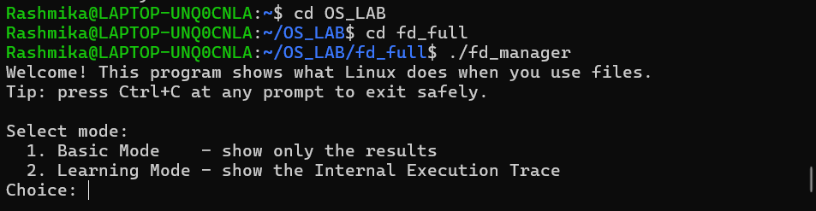

Fig 7.1 Compilation and start screen
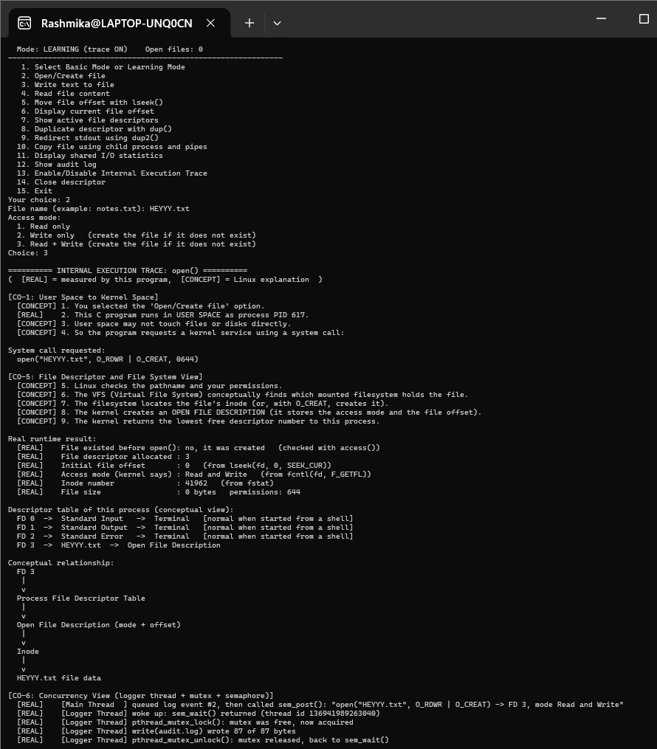

Fig 7.2 Opening a file (open())
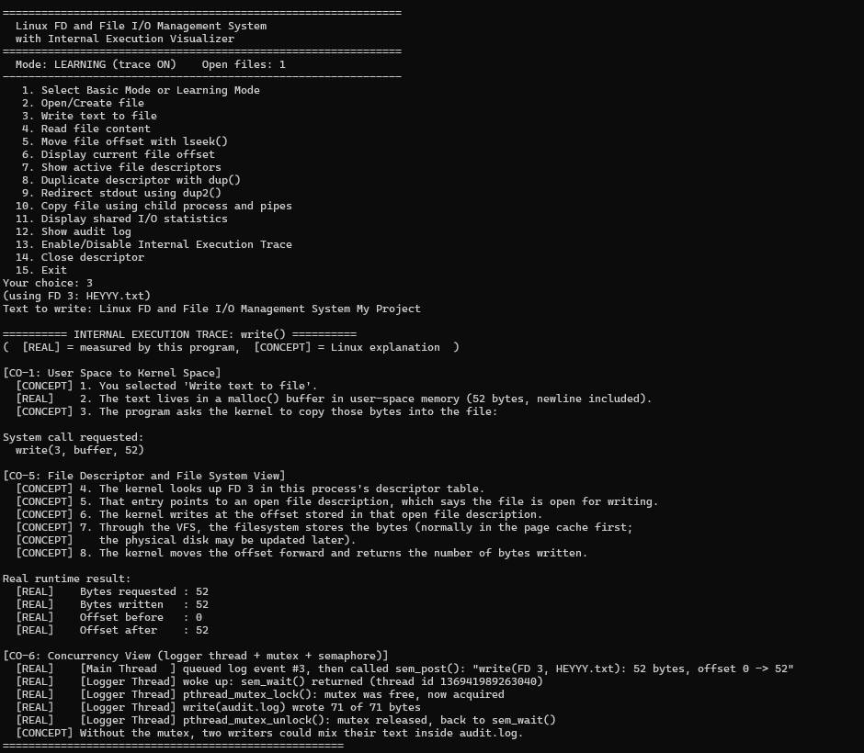
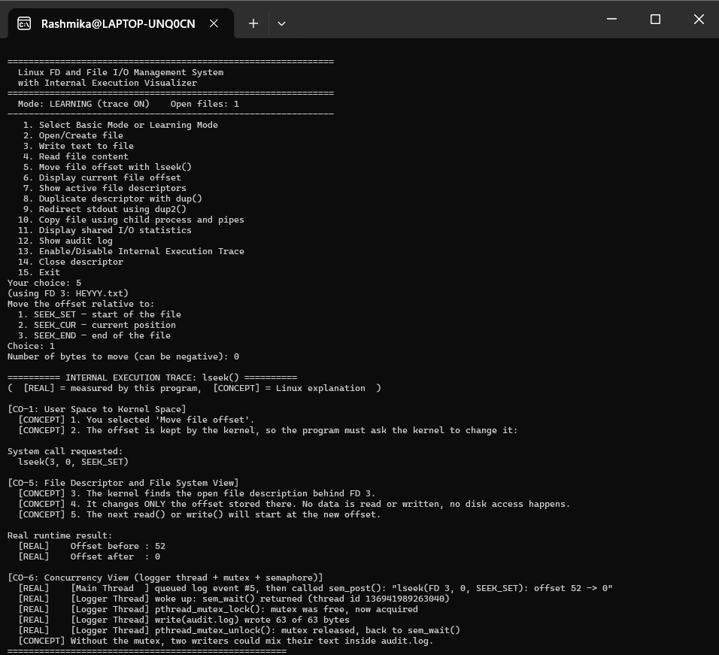

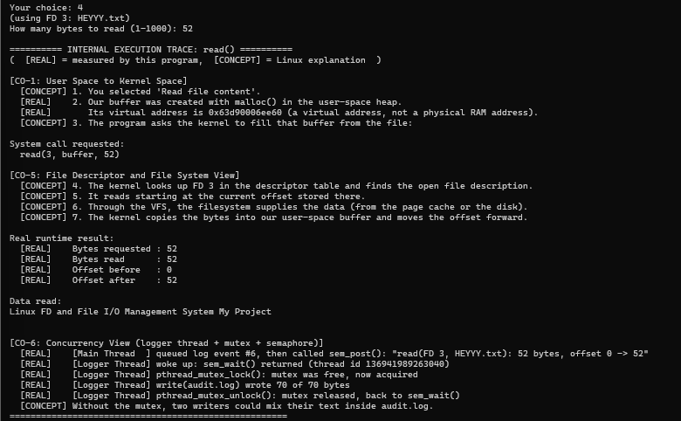 Fig 7.3 write(), lseek() and read()

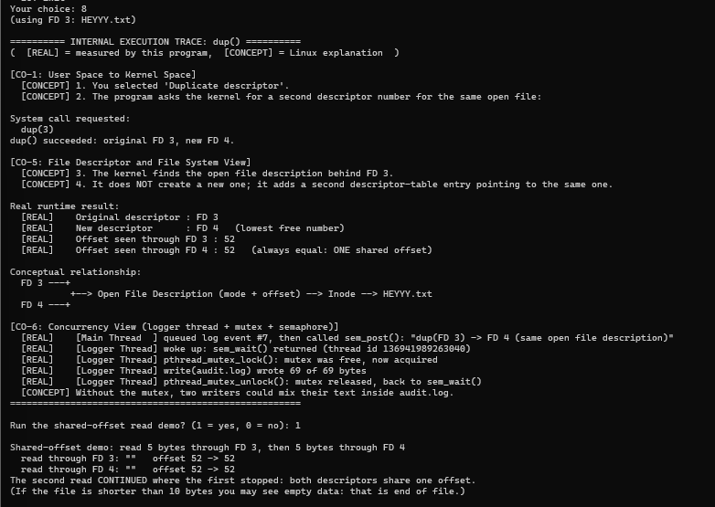
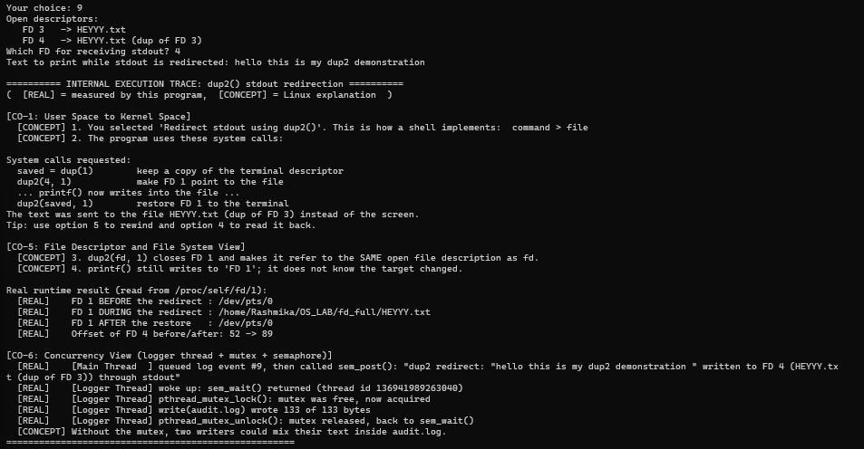

Fig 7.4 dup() and dup2() demonstration
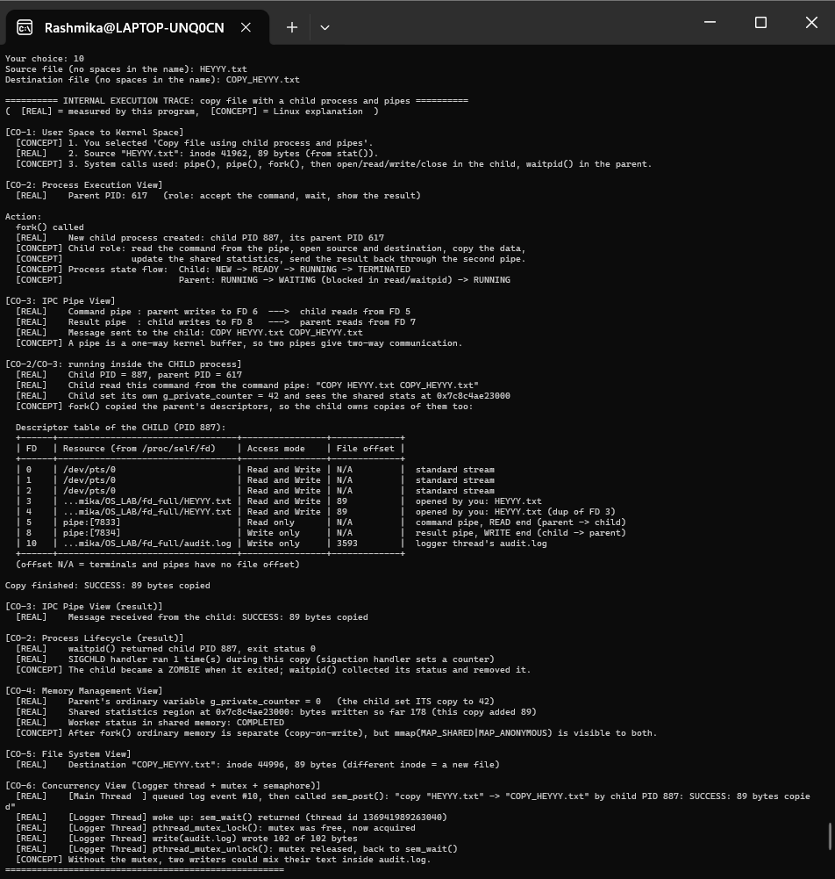

Fig 7.5 Copy using a child process and pipes
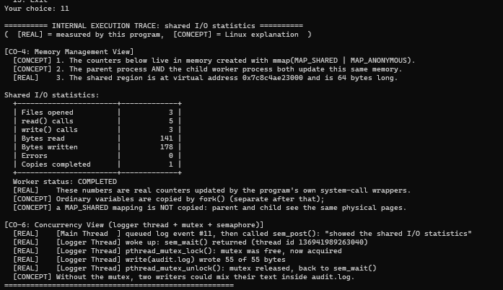
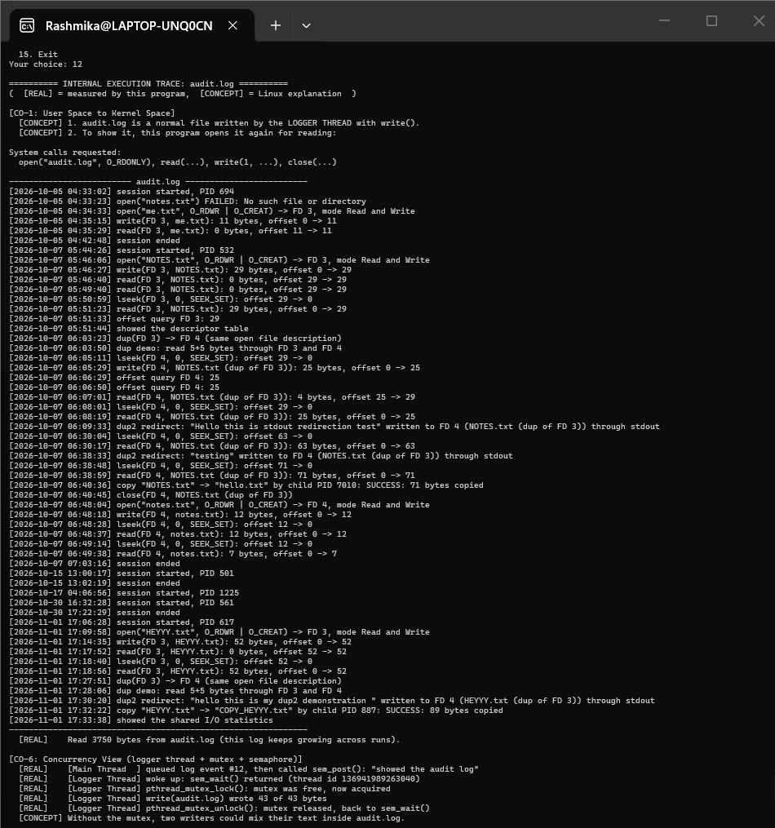

Fig 7.6 Shared statistics and audit log

7.5 Demonstration of OS Concepts

Table 7.1 OS concepts demonstrated
Concept | How it is demonstrated | What is observed
File descriptor | Open a file in option 2 | The first file gets FD 3, since 0, 1 and 2 are already used
File offset | write, then read, then lseek (options 3, 4, 5) | The offset moves forward after each call and returns to 0 after SEEK_SET
Shared open file description | dup() then read through both descriptors (option 8) | Reading through FD 3 and FD 4 continues from the same offset, and lseek on FD 4 also changes FD 3
Redirection | dup2() and printf (option 9) | Text meant for the screen is stored in the file, then the terminal is restored
Processes and IPC | Copy file (option 10) | Child PID, pipe descriptors, exit status from waitpid(), file copied byte for byte
Private and shared memory | Trace after the copy | g_private_counter is still 0 in the parent while the shared statistics include the bytes written by the child
Signals | Press Ctrl+C at a prompt | The handler sets a flag and the program cleans up and prints Goodbye
Threads and synchronization | Any operation in Learning Mode | The logger thread wakes with sem_wait(), takes and releases the mutex and writes one line to audit.log

CHAPTER- 8 CONCLUSION

8.1 Summary of the Project

We developed a menu-driven Linux application in C that performs file operations using system calls and shows how the operating system handles them. The program supports opening, writing, reading, seeking and closing files, duplicating descriptors, redirecting standard output, copying a file with a child process and two pipes, collecting statistics in shared memory, and recording every action in an audit log through a logger thread. Learning Mode adds an Internal Execution Trace that separates measured values from explanations of kernel behaviour.

8.2 Objectives Achieved

Table 8.1 Objectives and status
Objective | Status
File operations using system calls | Achieved: options 2 to 6 and 14 use open, write, read, lseek and close
Understand and show file descriptors | Achieved: descriptor numbers, descriptor table and dup() sharing are displayed
Analyse low-level file I/O | Achieved: offsets, byte counts, inode and access mode are measured and printed
Demonstrate OS concepts | Achieved: processes, pipes, signals, shared memory, threads and synchronization are covered in options 10 to 12

8.3 Results Achieved

The program compiles with -Wall -Wextra without warnings.

The menu options were tested with correct input as well as wrong input and missing files.

The dup() test showed that two descriptors share one offset, as expected from the theory.

The copy test with a child process copied NOTES.txt to hello.txt (71 bytes) and the result was received through the pipe.

audit.log recorded the sessions with timestamps, which made it easy to check the results later.

8.4 Skills and Learning Outcomes

Through this project we learned how to use system calls directly and to check their return values, how file descriptors, open file descriptions and inodes are related, how fork(), pipes and waitpid() work together, why a mutex and a semaphore are needed when two threads share data, and how to handle signals properly. We also learned practical things such as reading man pages, using errno and strerror(), debugging with printed values, and working as a team on one source file. Possible future work is adding directory operations, file locking with fcntl(), and a graphical front end.

CHAPTER- 9 REFERENCES

9.1 Books

Abraham Silberschatz, Peter B. Galvin and Greg Gagne, Operating System Concepts, 10th Edition, Wiley, 2018.

Michael Kerrisk, The Linux Programming Interface, No Starch Press, 2010.

W. Richard Stevens and Stephen A. Rago, Advanced Programming in the UNIX Environment, 3rd Edition, Addison-Wesley, 2013.

Andrew S. Tanenbaum and Herbert Bos, Modern Operating Systems, 4th Edition, Pearson, 2015.

9.2 Research Papers

Dennis M. Ritchie and Ken Thompson, The UNIX Time-Sharing System, Communications of the ACM, Vol. 17, No. 7, 1974.

S. R. Kleiman, Vnodes: An Architecture for Multiple File System Types in Sun UNIX, USENIX Summer Conference, 1986.

9.3 Linux / GNU Documentation

Linux manual pages: open(2), read(2), write(2), lseek(2), close(2), dup(2), pipe(2), fork(2), waitpid(2), mmap(2), sigaction(2), fcntl(2), pthreads(7), sem_overview(7). https://man7.org/linux/man-pages/

The GNU C Library Reference Manual. https://www.gnu.org/software/libc/manual/

GCC Online Documentation. https://gcc.gnu.org/onlinedocs/

9.4 Online Resources

Linux kernel documentation, Overview of the Linux Virtual File System. https://docs.kernel.org/filesystems/vfs.html

Course material of Operating Systems and Systems Programming (25CS2104E), K L (Deemed to be) University.

Project repository: https://github.com/Devaji-Rashmika/2520090152_OSSP

