PRACTICAL 1
Creating an AWS Account
Enabling Multi-Factor Authentication (MFA)
Name : Devaji Rashmika
Roll no.: 2520090152
Section: 11A

PART A: CREATING AN AWS ACCOUNT

Step 1: Open the AWS website and start account creation
Open https://aws.amazon.com/ in a browser. Select “Create an AWS Account” or the equivalent sign-up option to begin registration.
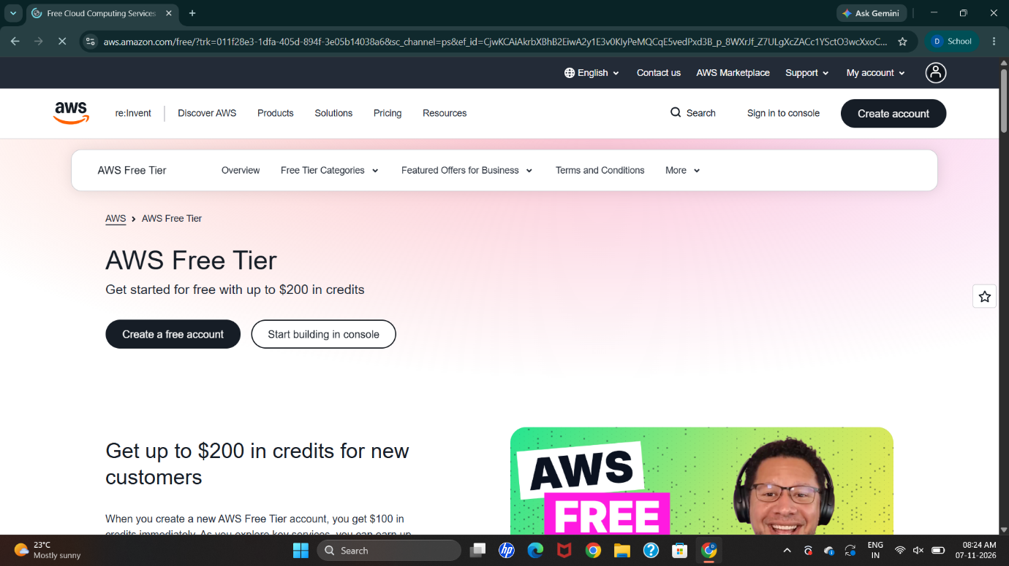

Step 2: Sign in using the root user email address
For the root user sign-in, use the email address registered with the AWS account and its password. The root user has full account access, so protect these credentials.
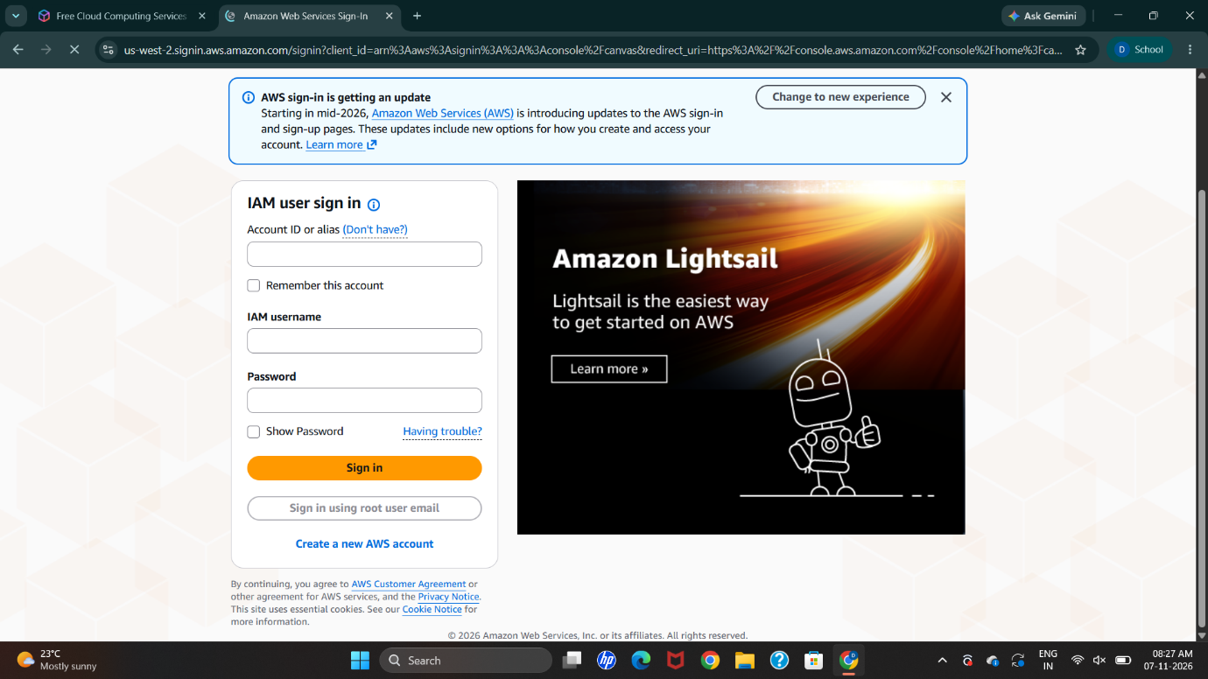

Step 3: Enter the account registration details
Enter an email address that you can access, choose an account name if requested, and provide the verification code sent to your email. Complete each registration field shown by AWS.
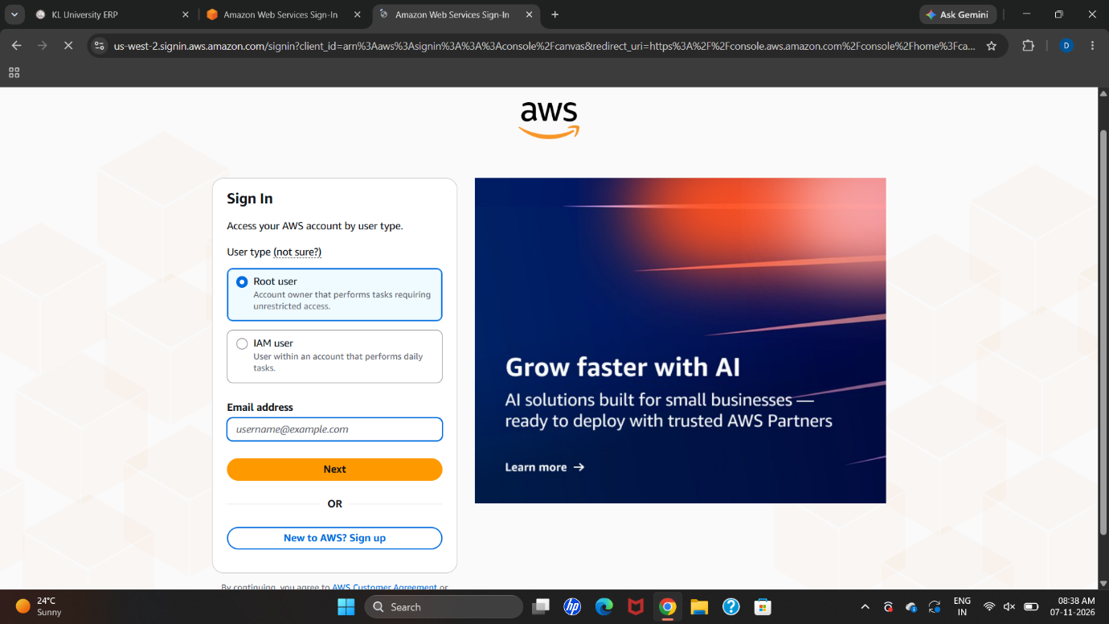
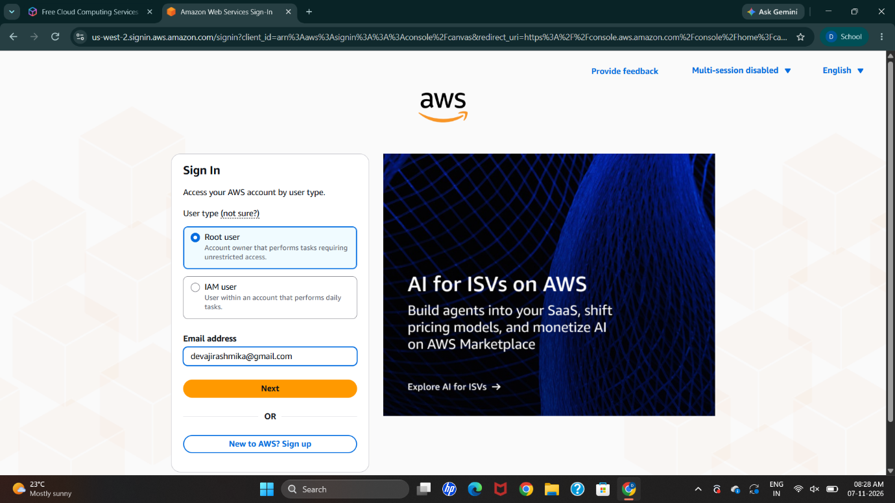
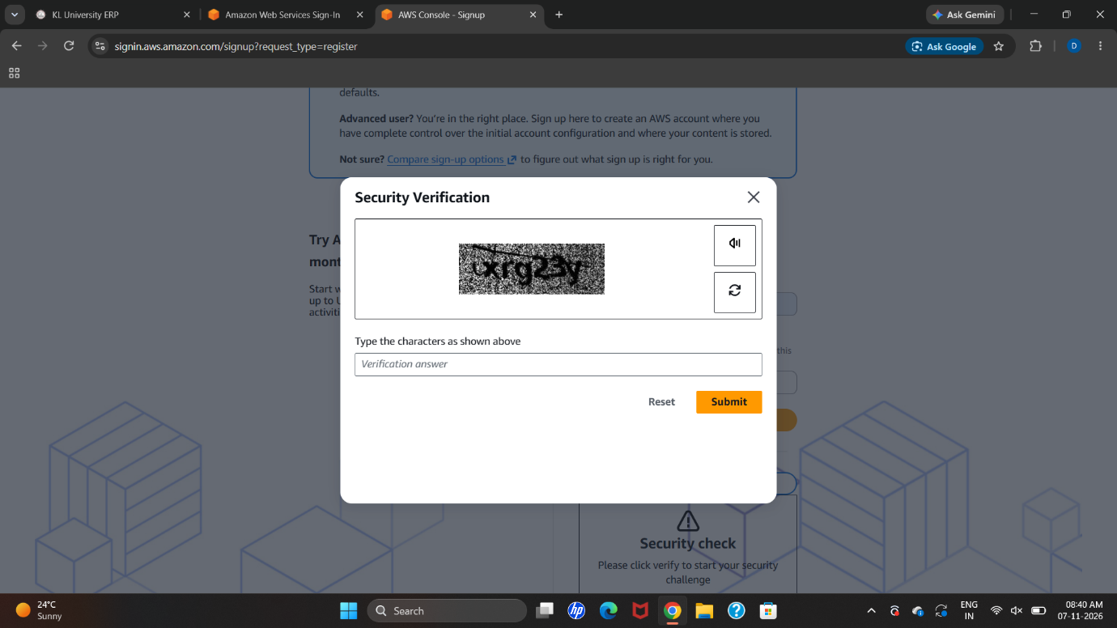
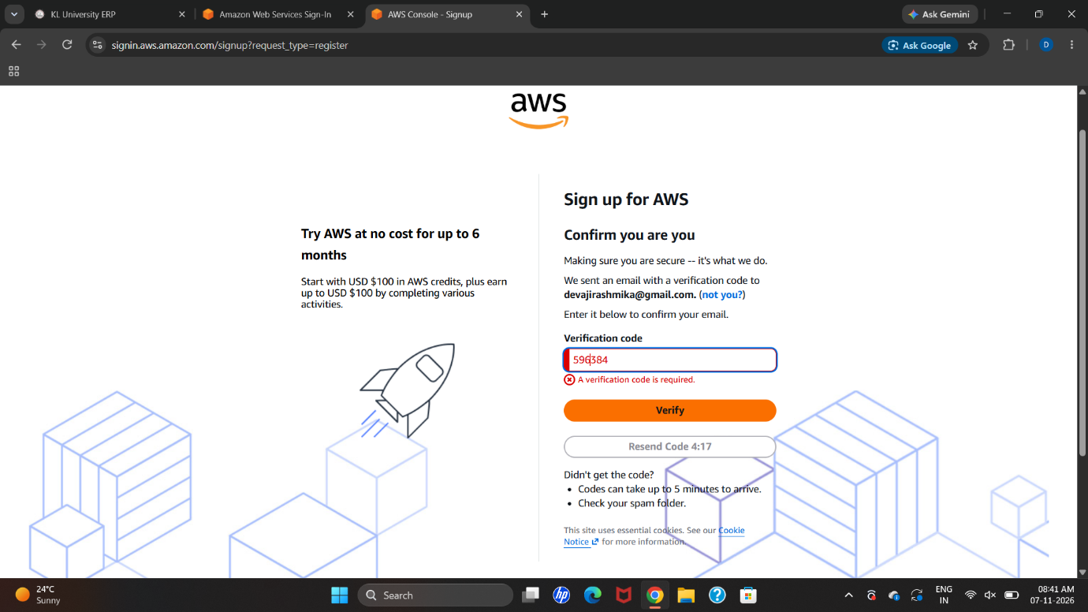

Step 4: Create a strong account password
Create a strong, unique password that meets the requirements displayed on the AWS page. Re-enter it wherever confirmation is requested.
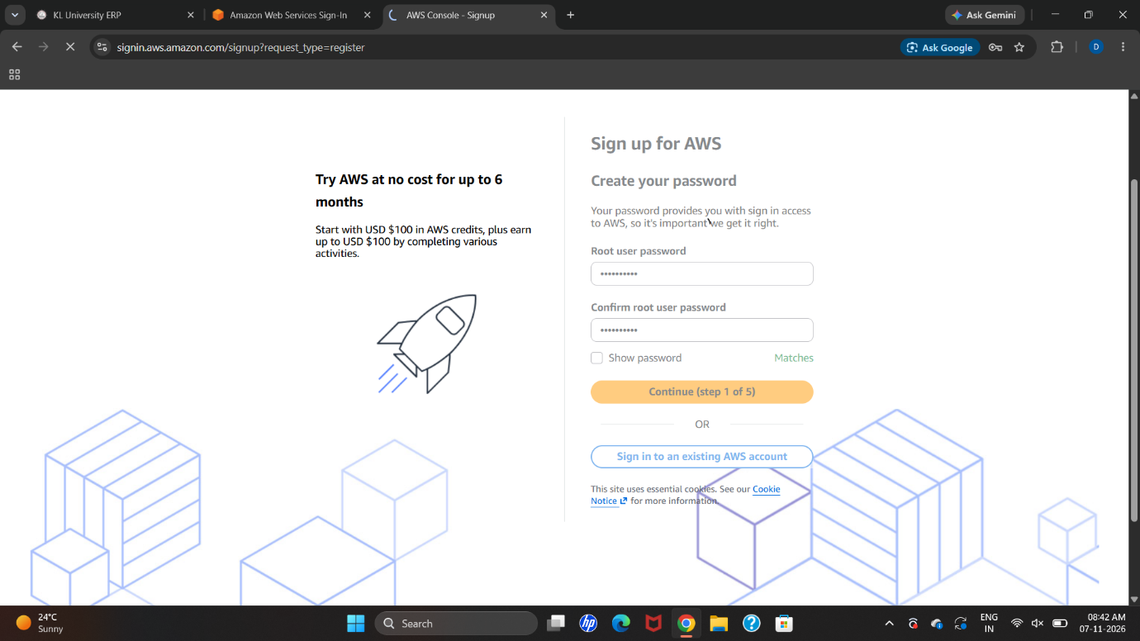

Step 5: Verify the payment method
Provide the payment information requested by AWS and complete the verification step. Review current pricing and Free Tier conditions before using services; some services may incur charges.
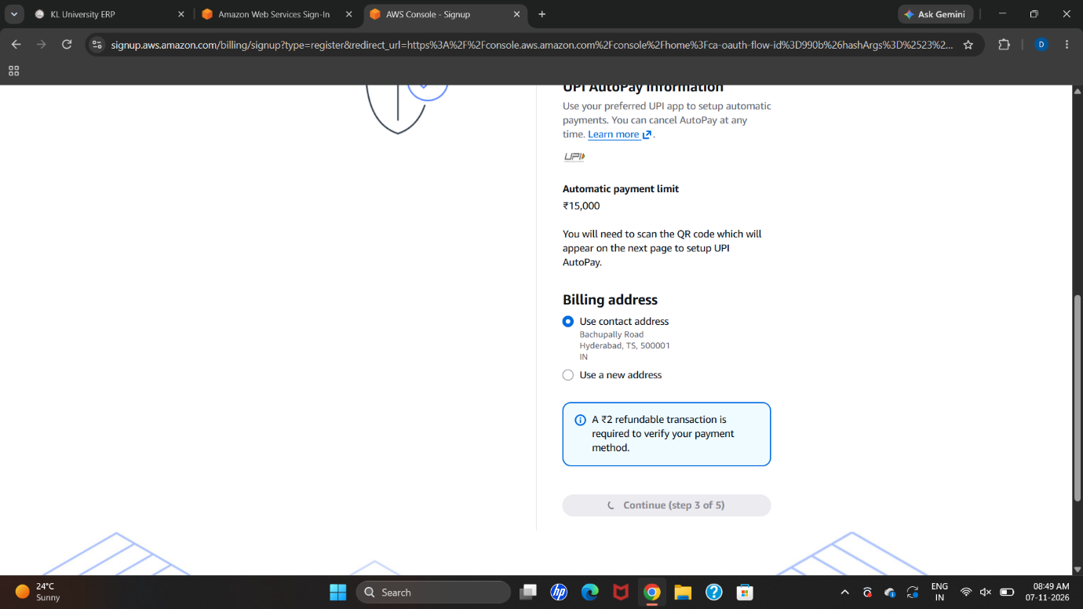

Step 6: Complete identity verification
Follow the on-screen identity verification process. AWS may request a phone call, text message, or another verification method.
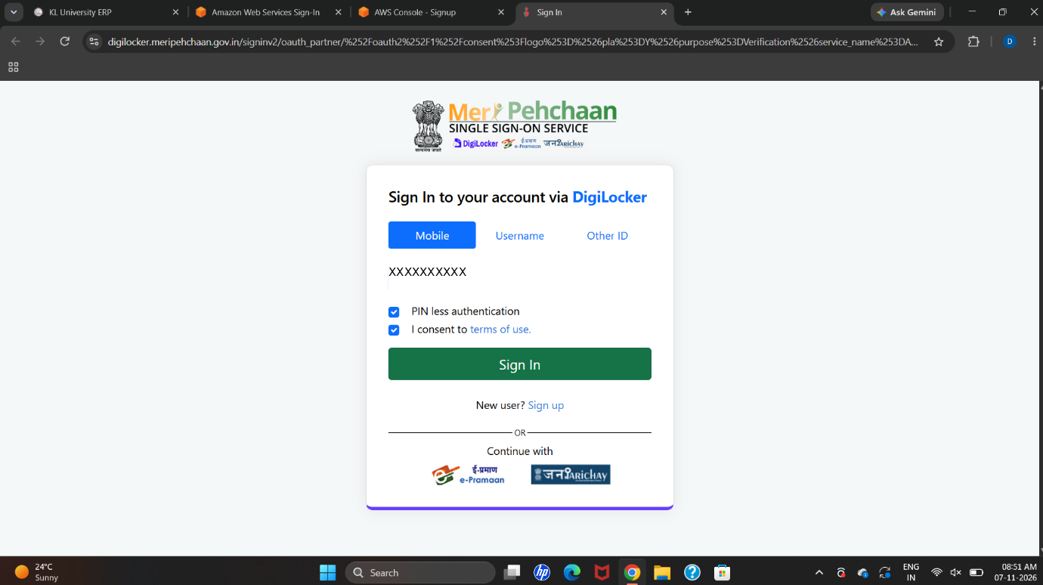
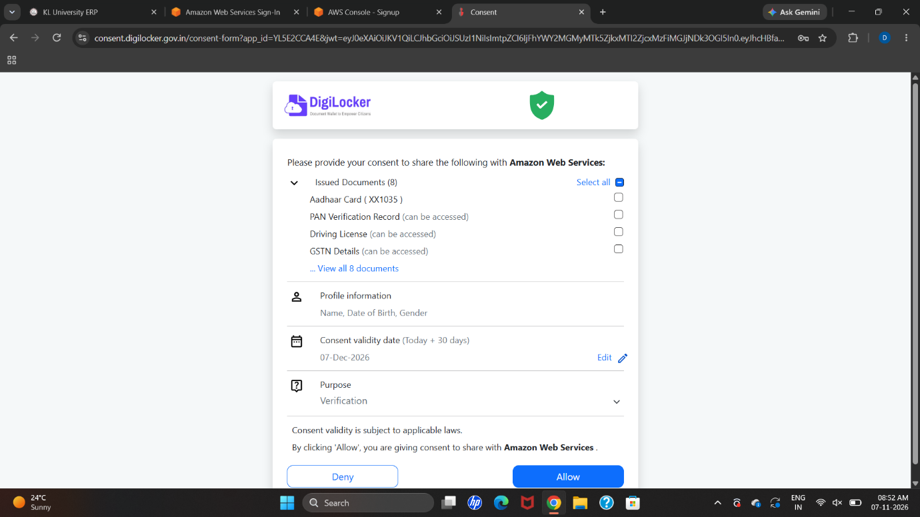

Step 7: Confirm the identity verification request
Enter the verification information requested on the page and continue only after AWS accepts the confirmation.
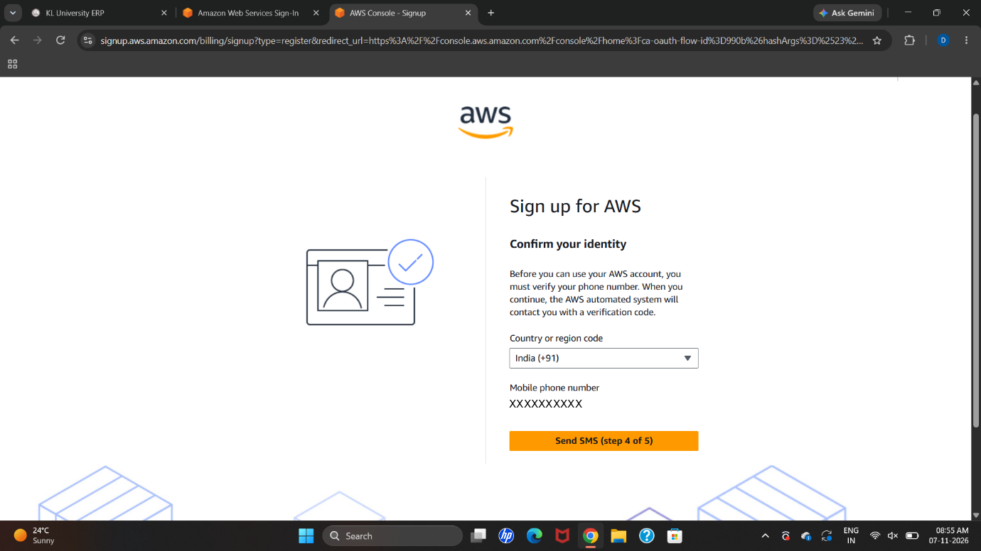

Step 8: Confirm that the AWS account has been created
Wait for the account creation or activation confirmation. Account activation may take some time; follow any instructions displayed by AWS.

Step 9: Complete any additional sign-in confirmation
If AWS asks to confirm that the sign-in is yours, complete the requested verification before continuing to the console.
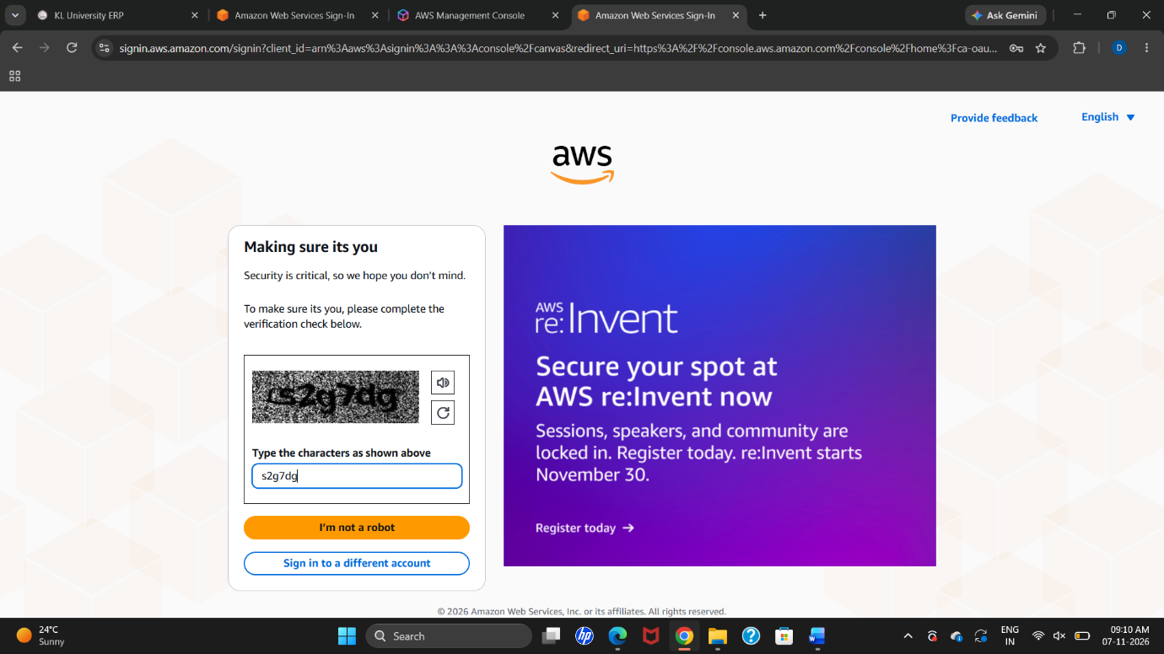

Step 10: Sign out and sign in again to verify access
Sign out of the AWS Management Console, then sign in again with the root user email address and password. This checks that the account login is working.
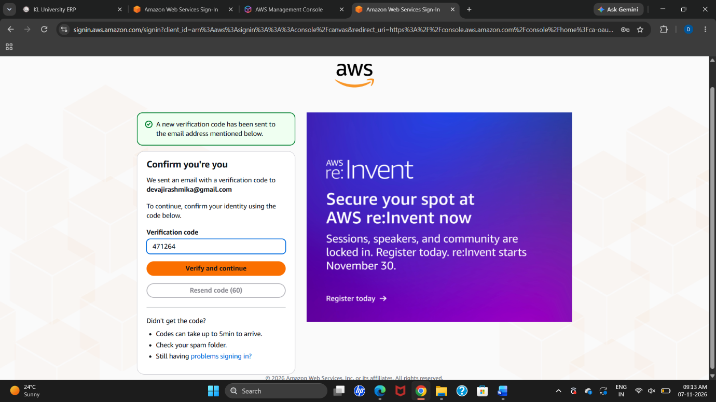

PART B: ENABLING MFA FOR THE ROOT USER

Step 11: Configure an authenticator application
In the AWS Console, open the root user security credentials or MFA settings. Choose the option to assign an MFA device, give it a recognizable name, and select an authenticator-app option. Scan the QR code using a compatible authenticator app. Enter the consecutive codes requested by AWS and submit the registration. Never share or publish the QR code, secret key, or one-time codes.
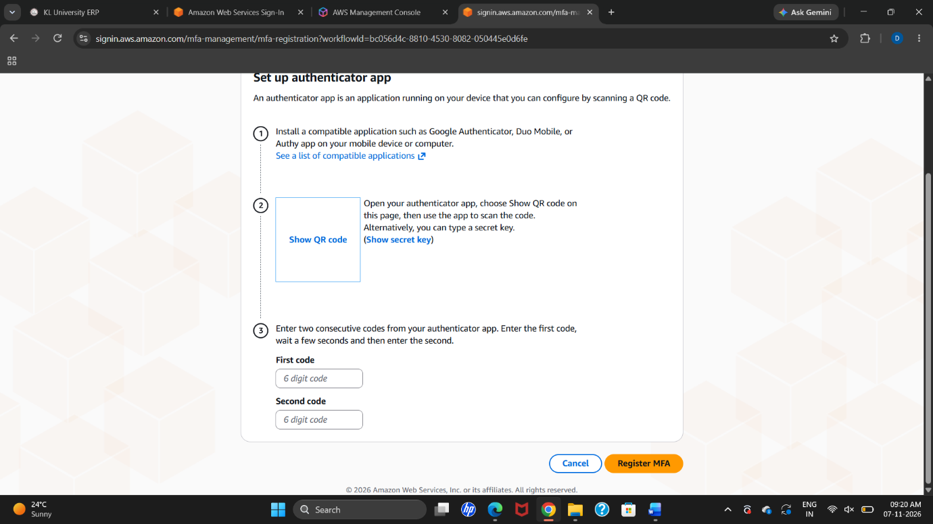
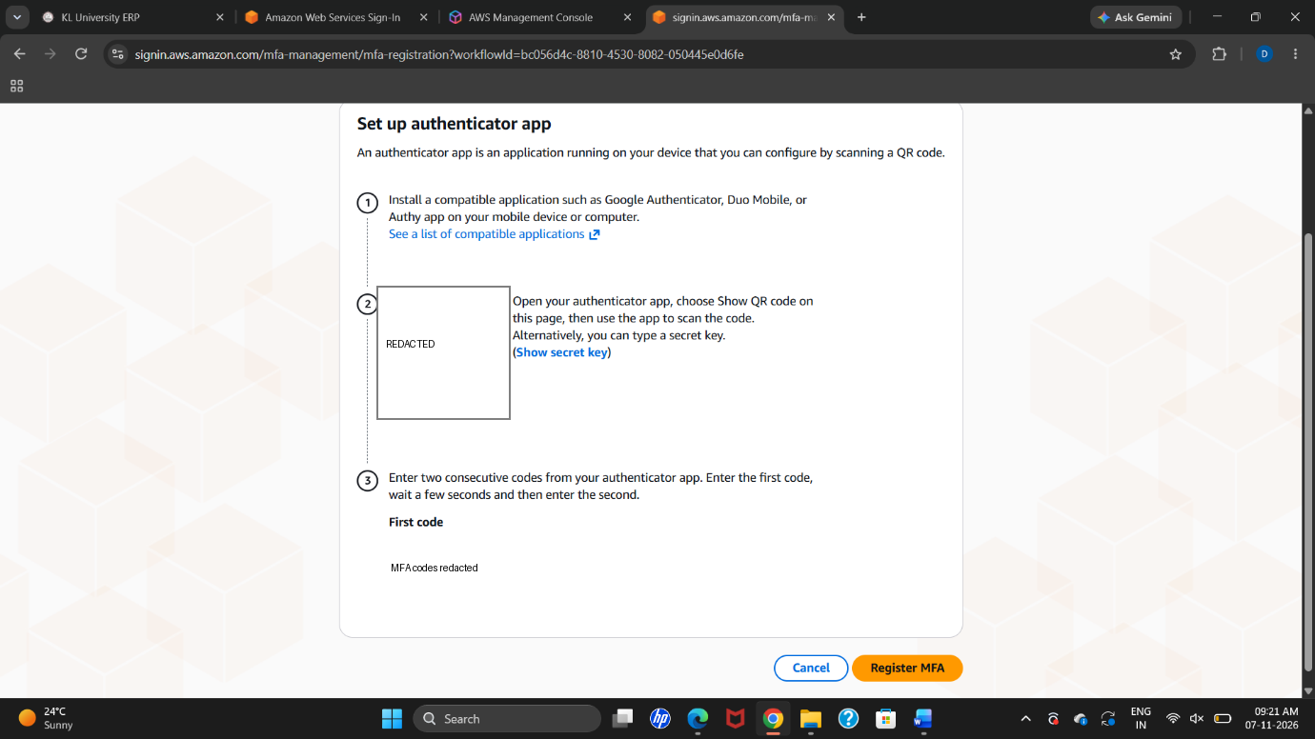
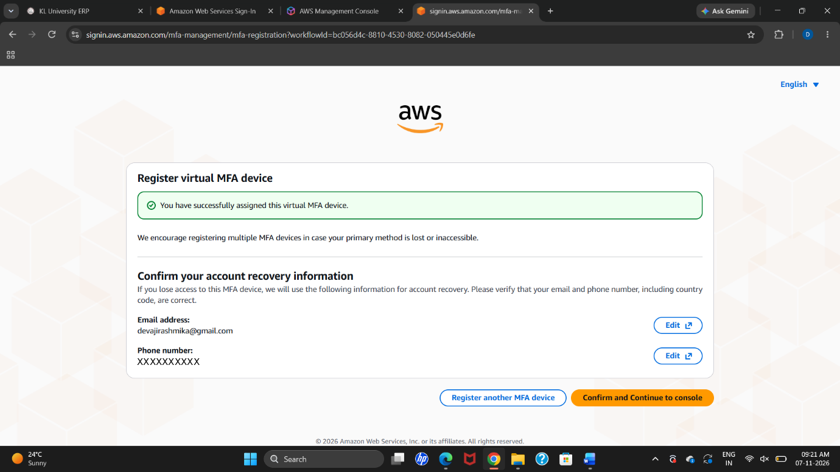

Step 12: Verify that MFA is enabled successfully
After AWS confirms registration, sign out and sign in again. Enter the current code from the authenticator app when prompted. Successful sign-in confirms that MFA is working.
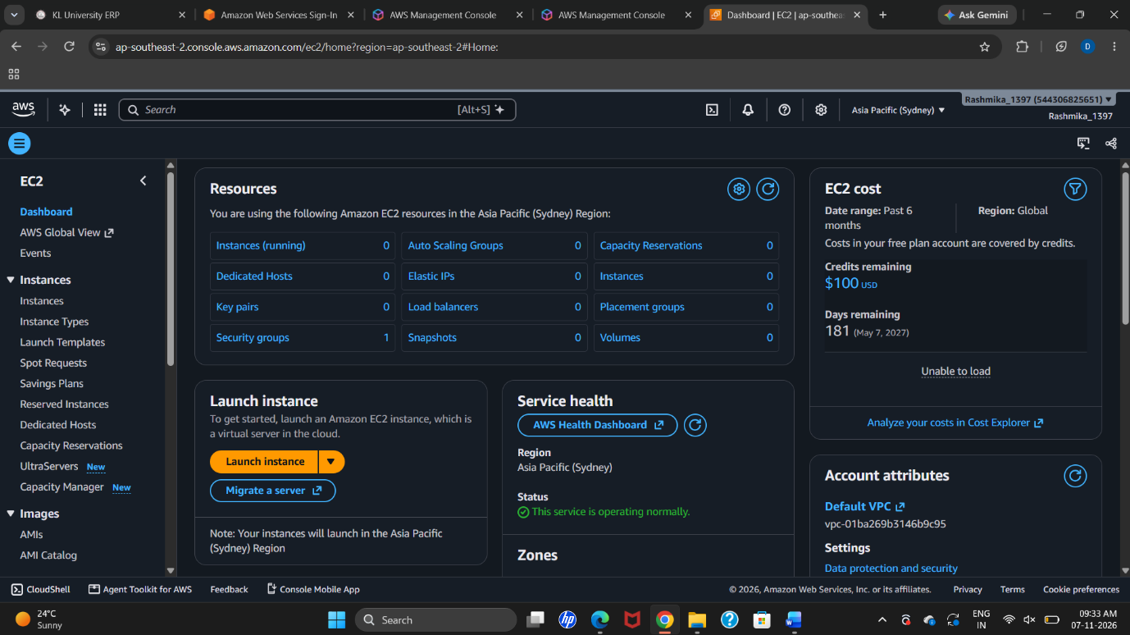

RESULT
The AWS account was created successfully, and Multi-Factor Authentication (MFA) was registered and verified for the root user, as shown in the practical screenshots.

