CIS
Skill1
Name : D.Rashmika
Roll no.: 2520090152
Section : 11A

Create an IAM user with programmatic access only, download the access key and secret key, and document the steps with screenshots. Then set up a billing alert for the account so that an email is received when the Free Tier limit is about to be crossed.

Step 1: Open the AWS IAM service
Open the AWS Management Console and sign in to your AWS account. In the search bar, type IAM and select IAM (Identity and Access Management) from the search results.
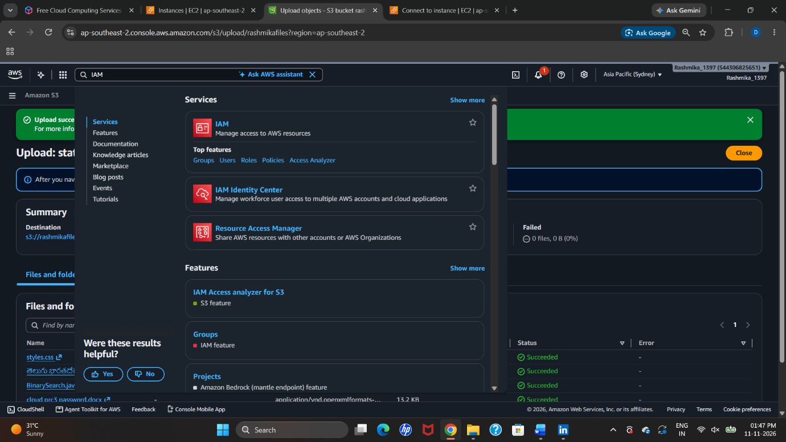

Step 2: Open the Users section
In the IAM dashboard, select Users from the left-side navigation panel. The IAM Users page displays the list of users. Click on Create user to create a new IAM user.
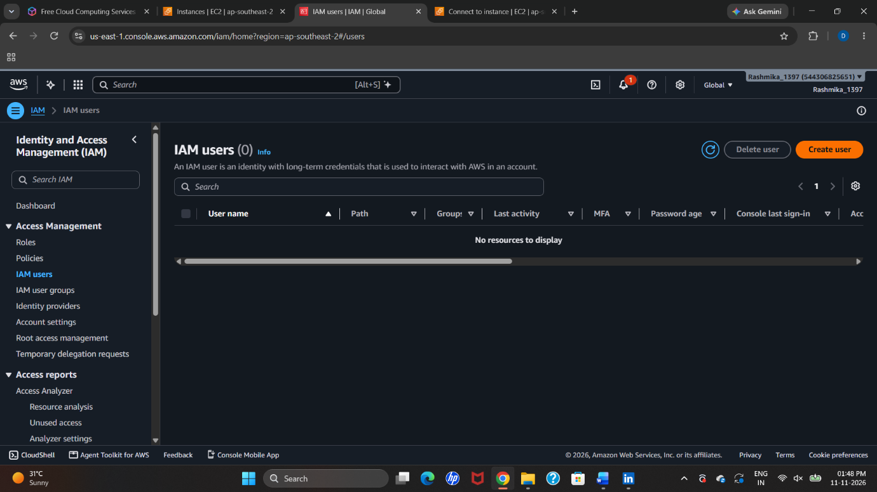
Step 3: Enter the user details
On the Specify user details page, enter the required IAM username in the User name field. This username will identify the user within the AWS account.
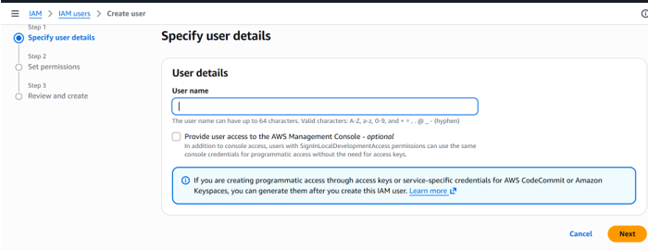

Step 4: Configure the user access option
Enter the username Student1. The screenshot shows the option Provide user access to the AWS Management Console unchecked. This means console access is not enabled at this stage.
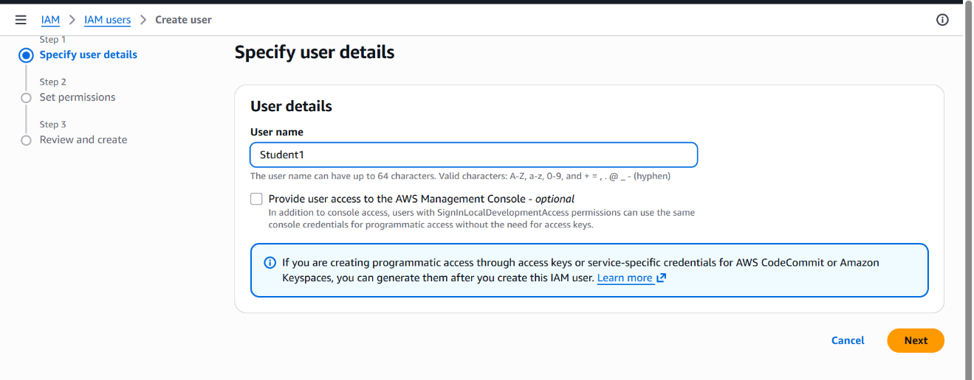
Step 5: Configure the access settings
The next screenshot shows AWS Management Console access enabled, with the Custom password option selected. A password is entered for console sign-in
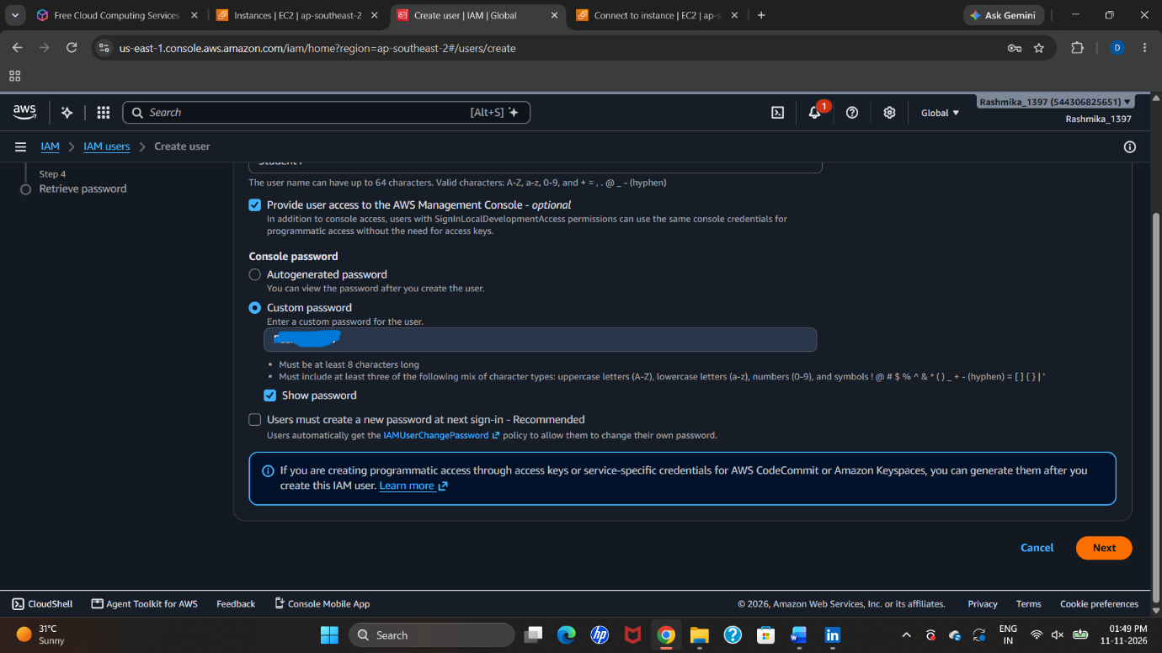

Step 6: Select the permission method
On the Set permissions page, select Attach policies directly. This option allows permissions to be assigned directly to the IAM user by selecting the required policies.
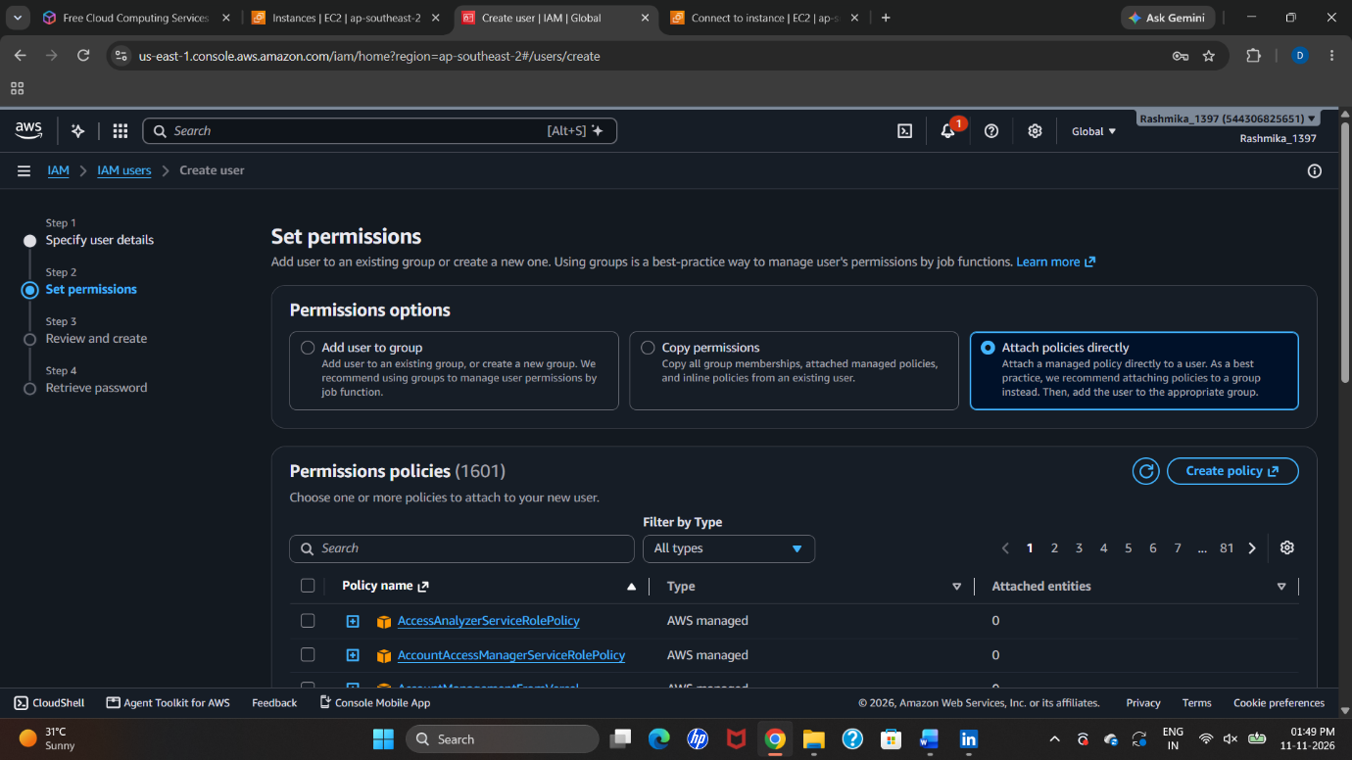
Step 7: Select the required permission policy
Browse through the available permission policies. Use the search option to find the required policy and select its checkbox to assign the permission to the IAM user.
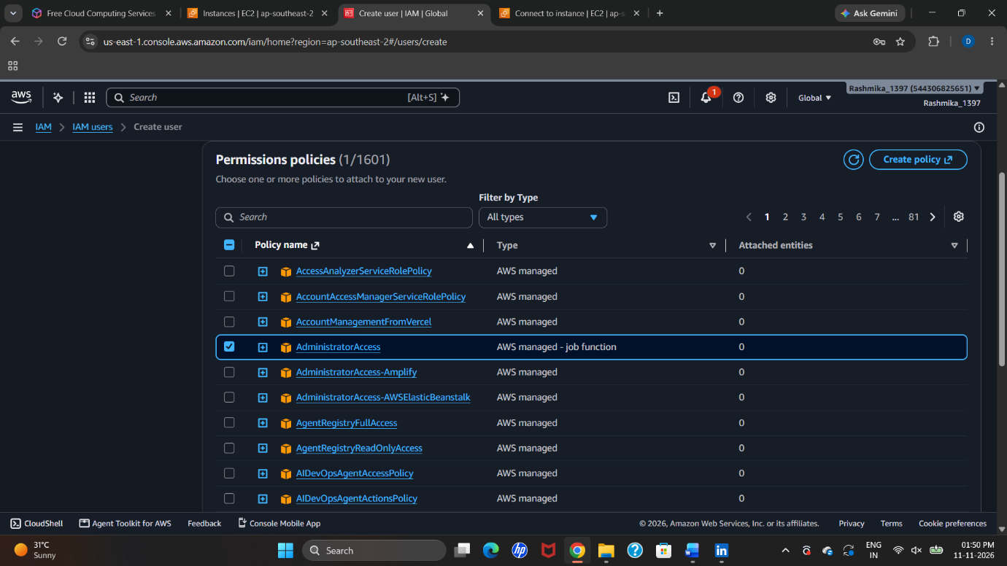

Step 8: Confirm the selected permissions
Review the selected policy and verify that the required permission is included. After checking the selection, click Next to proceed.
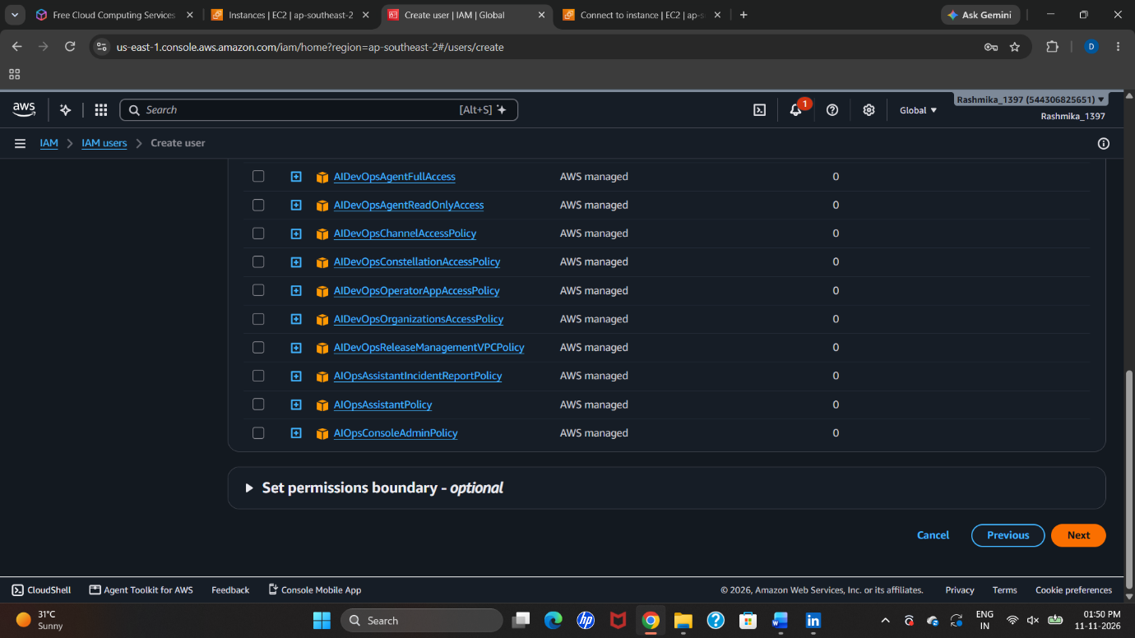
Step 9: Review and create the IAM user
On the Review and create page, verify the username and permission summary. Check the configuration and click Create user to complete the process.
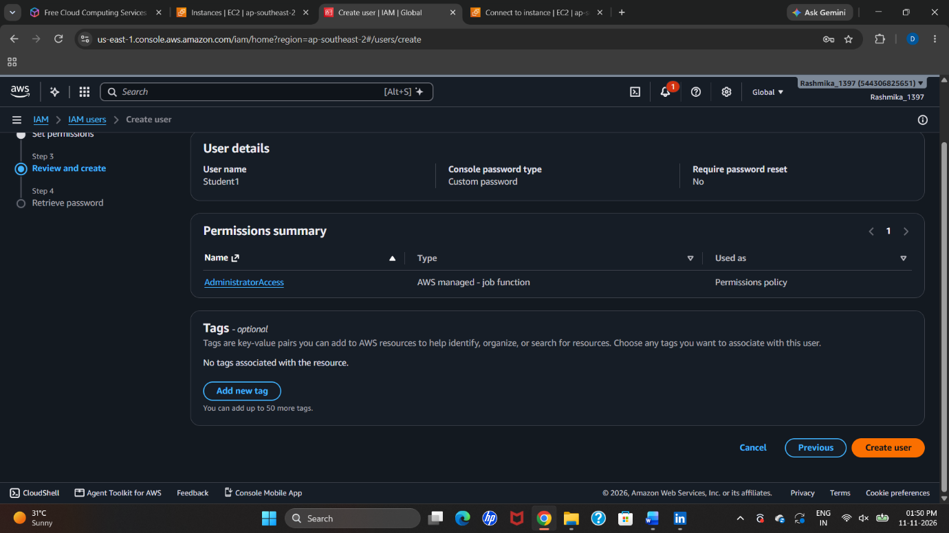

Step 10: Copy the Sign-in URL and Download the CSV File
After successfully creating the IAM user, AWS displays the user creation success page. On this page, copy the AWS Management Console sign-in URL for future login access. Click Download .csv file to download the login credentials and user details. Save the CSV file securely for future reference.
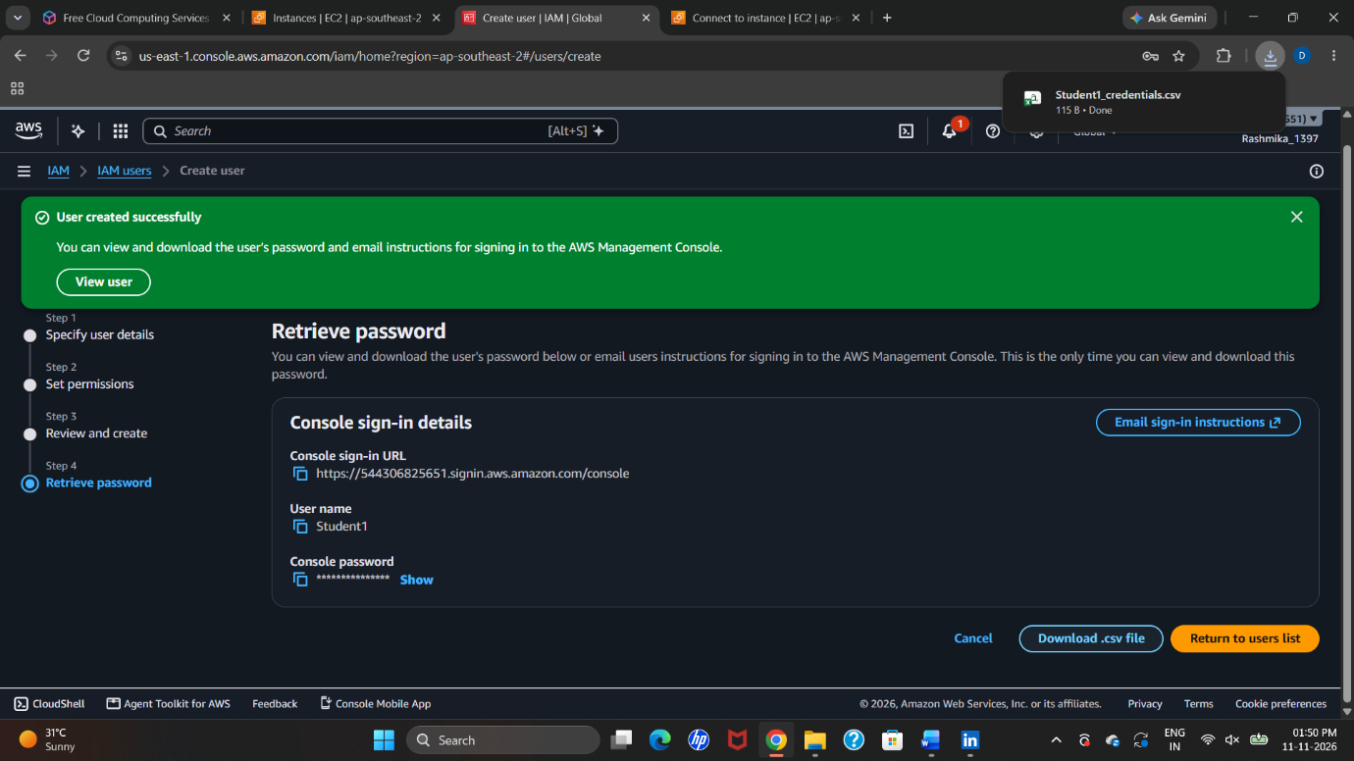
Step 11: Sign in as an IAM User
- Copy the AWS Management Console sign-in URL obtained in the previous step.
- Open a new tab in your web browser.
- Paste the copied sign-in URL into the browser's address bar and press Enter.
- On the AWS sign-in page, select IAM user as the sign-in type.
- Enter the AWS Account ID or account alias if requested.
- Enter the IAM username and password obtained from the downloaded CSV file.
- Click Sign in to access the AWS Management Console as the created IAM user.

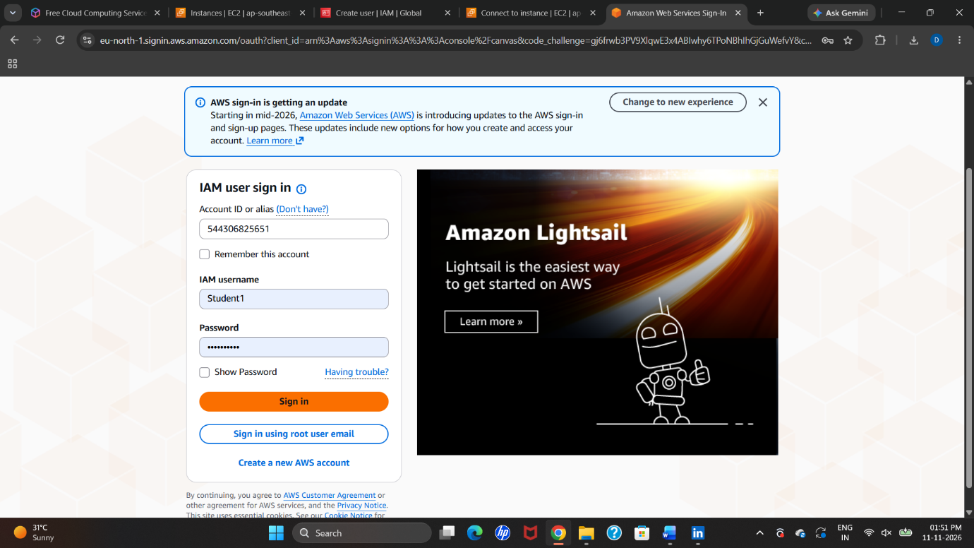
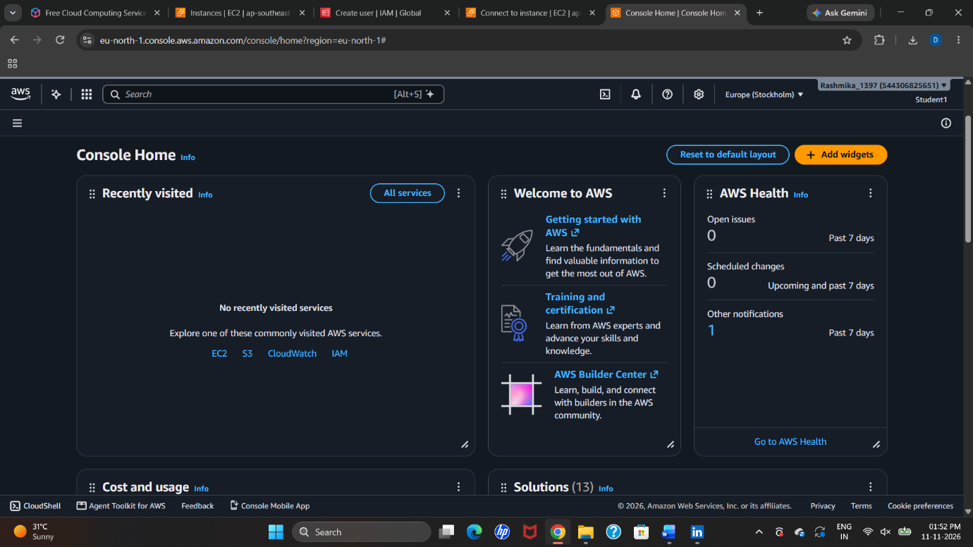

PART B – Creating a Zero-Spend Budget in AWS
Step 12: Open AWS Console Home
Open the AWS Management Console and go to the Console Home page.
Step 13: Search for Billing
Type Billing in the search bar and select Billing and Cost Management from the search results.
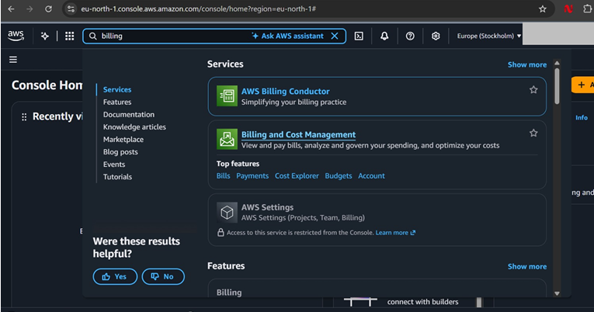
Step 14: Create a New Budget
Open Budgets from the Billing dashboard and click Create budget. Select Customize (advanced) and choose Cost budget.
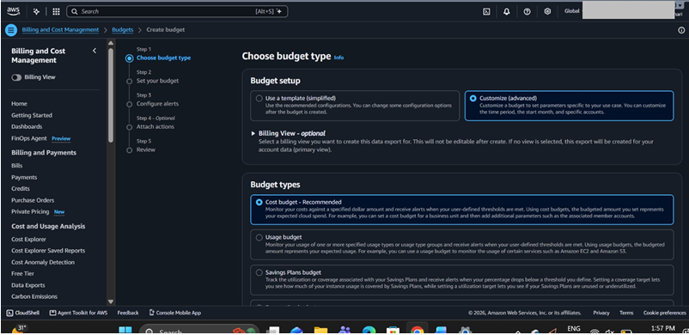
Step 15: Set the Budget Amount
Select November 2026 as the start month and choose Fixed as the budgeting method. Enter $0.01 as the budget amount, select All AWS services, and name the budget Zero_budget.
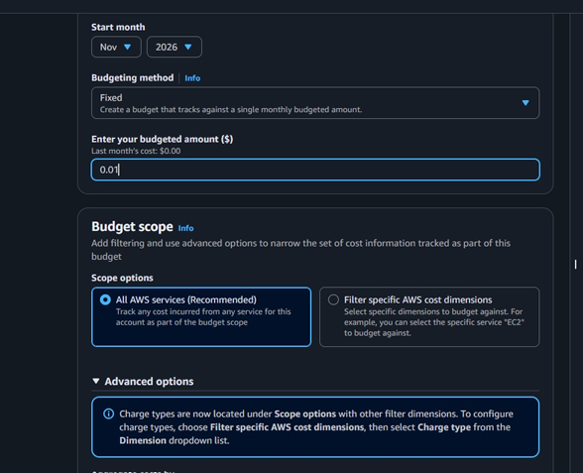
Step 16: Set Up Email Alerts
Set the alert threshold to 0.0% and select Actual as the trigger. Enter your email address to receive billing notifications and verify it through the email sent by AWS.
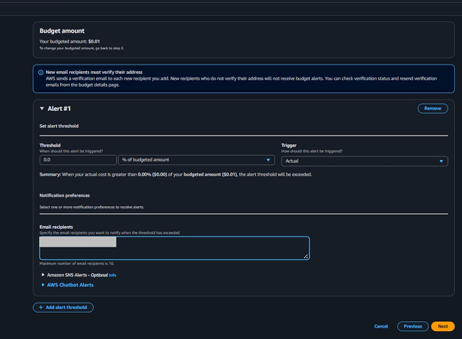
Step 17: Review the Budget
Check the budget name, amount, start month and alert settings. After verifying all the details, click Create budget.
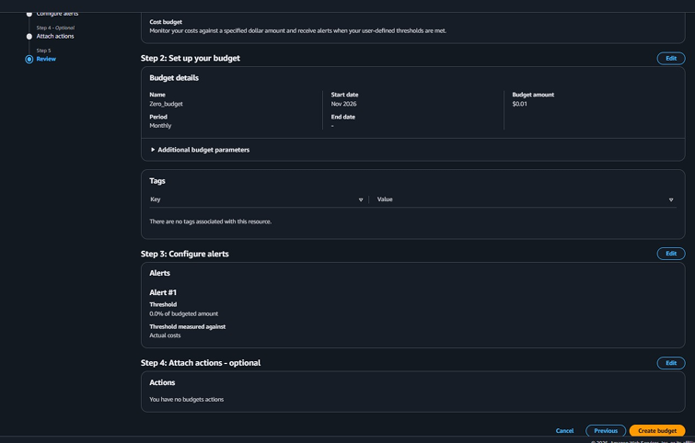

Step 18: Verify Budget Creation
AWS displays a success message after creating the budget. Check the Budgets page to confirm that Zero_budget appears with an OK/Healthy status.


