PRACTICAL 2
Creating an Instance in Amazon EC2
Name : Devaji Rashmika
Roll no.: 2520090152
Section: 11A

1.Opened Amazon Web Services (AWS)
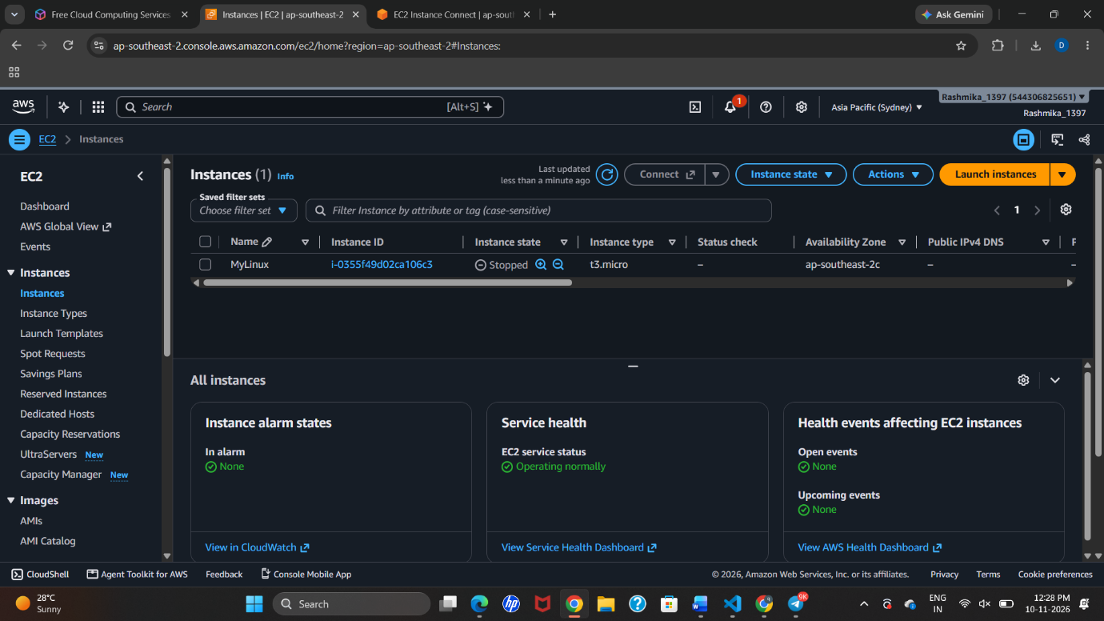
2. Launched an EC2 Instance
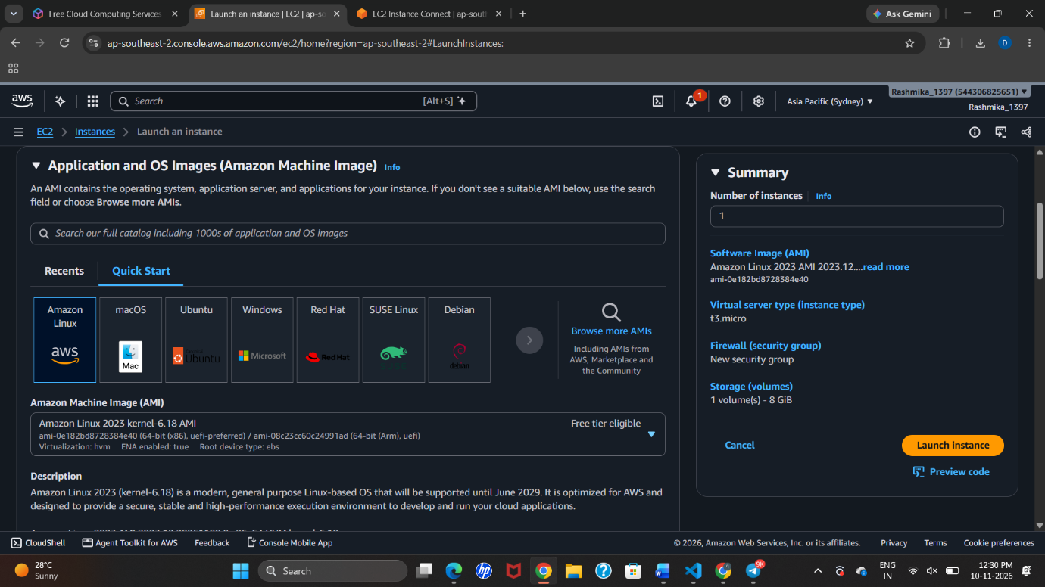

3. Created a Key Pair
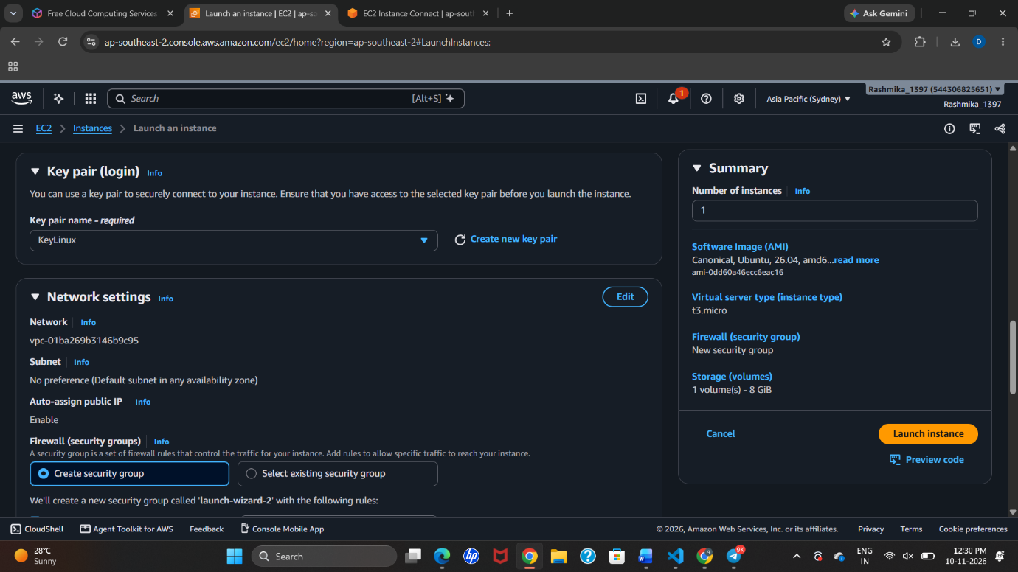

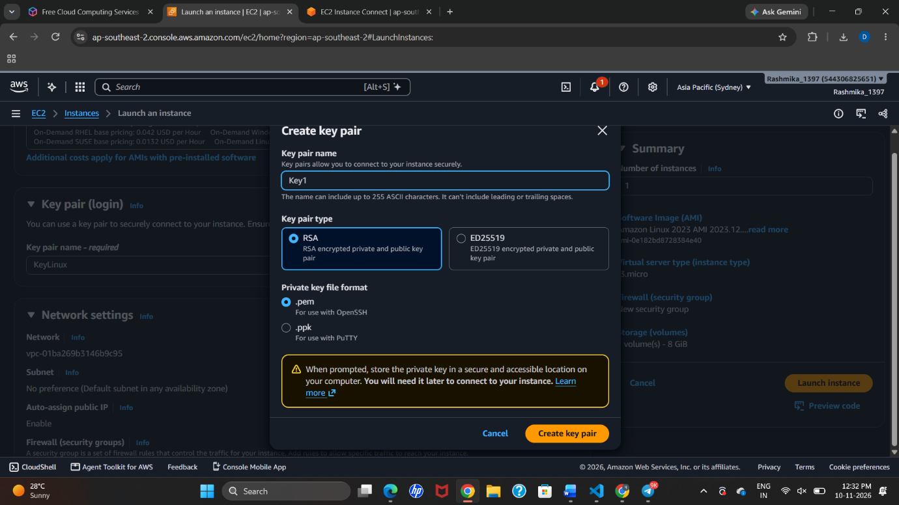

4.Configured Network Settings
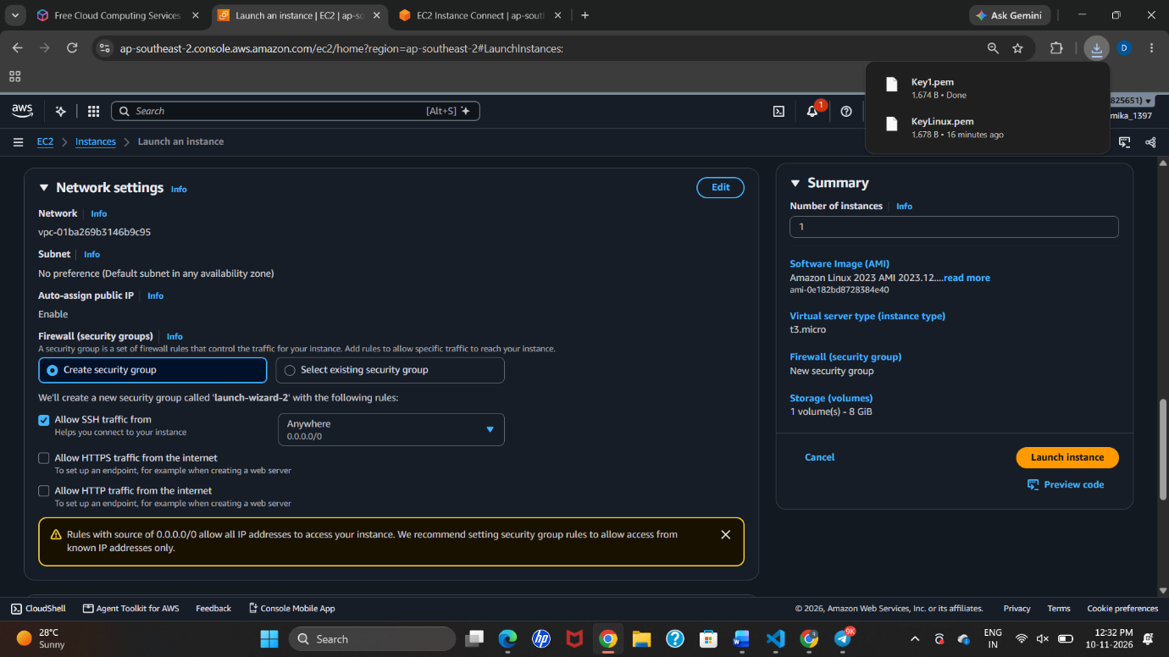
5.Launched the Instance
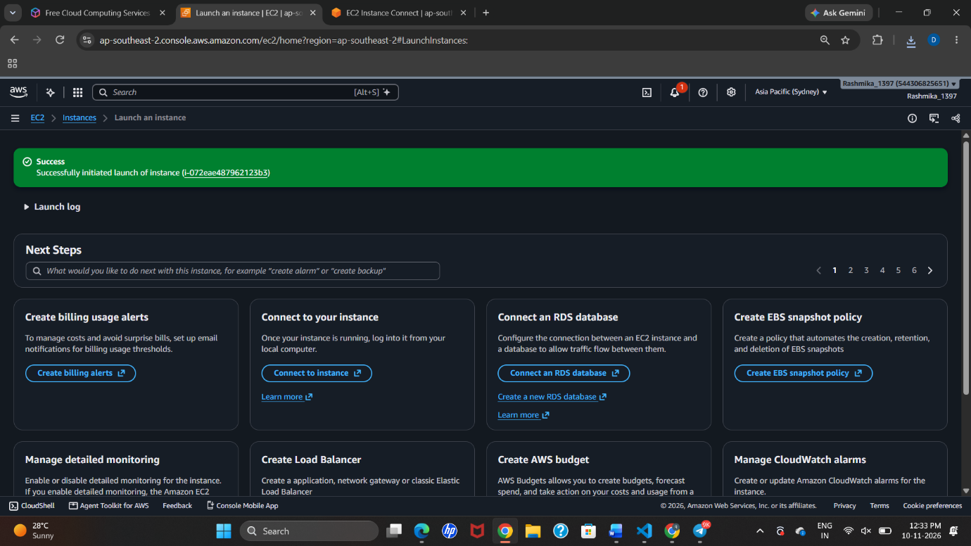

6. Connected to the Linux Instance
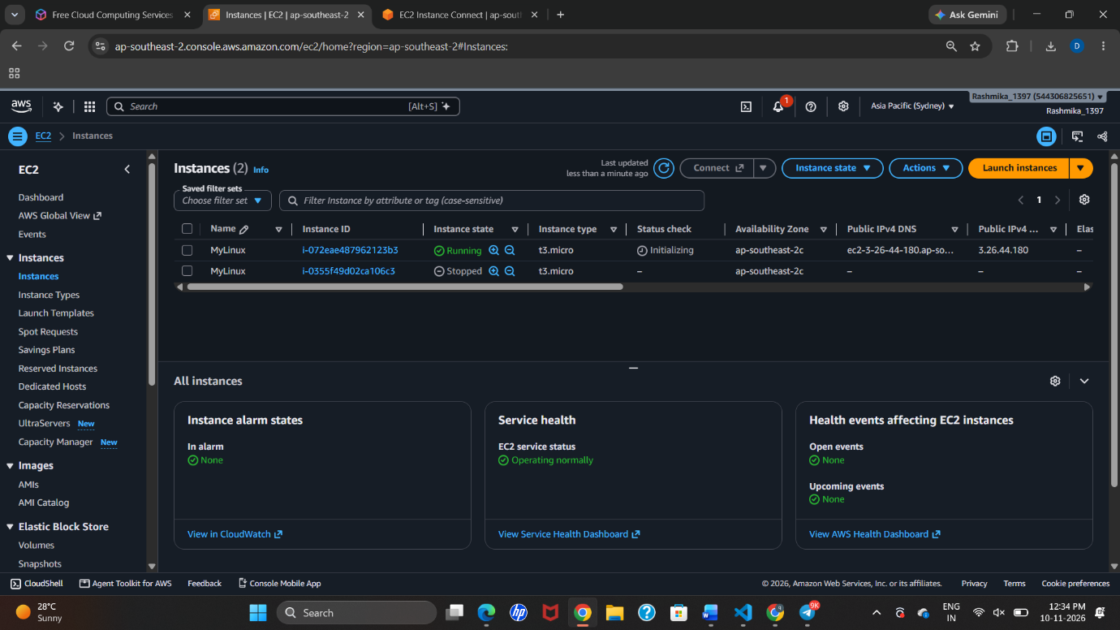
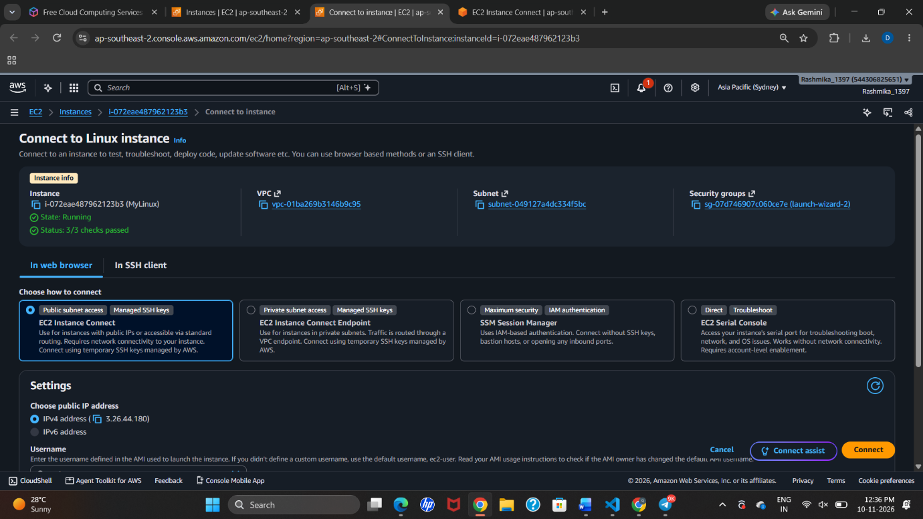

7. Created a Directory in Linux
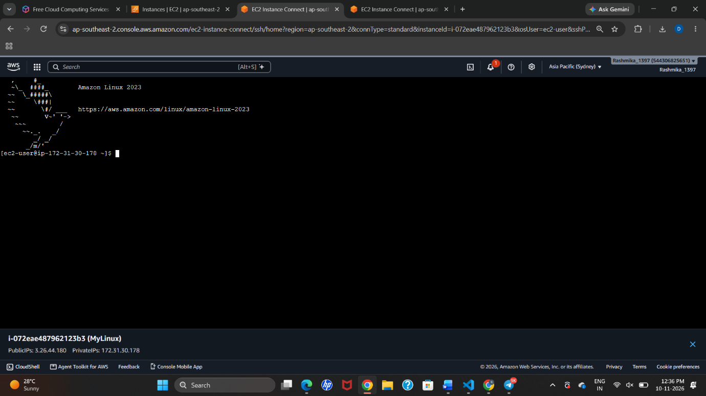
9. Verified the Created File
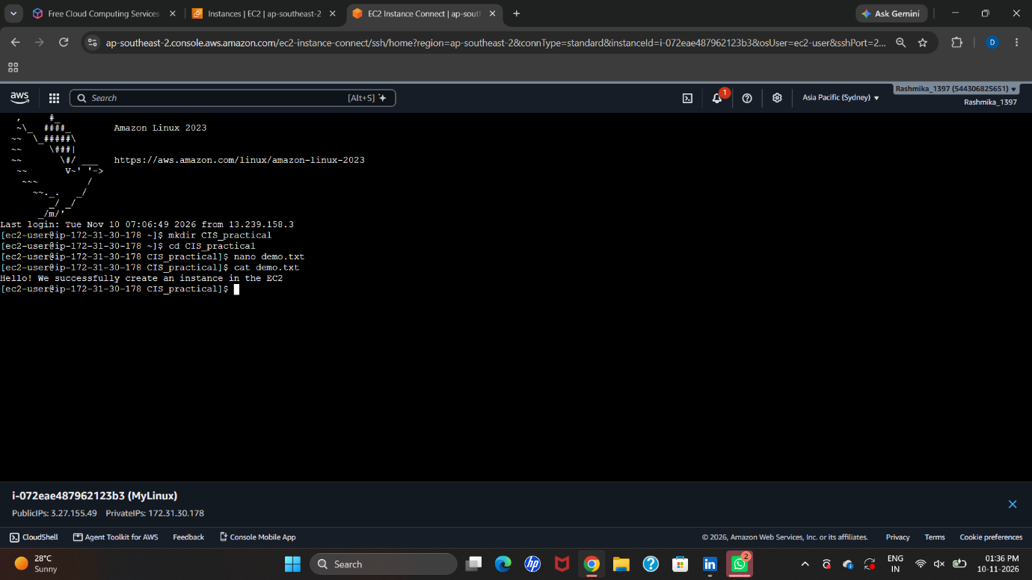
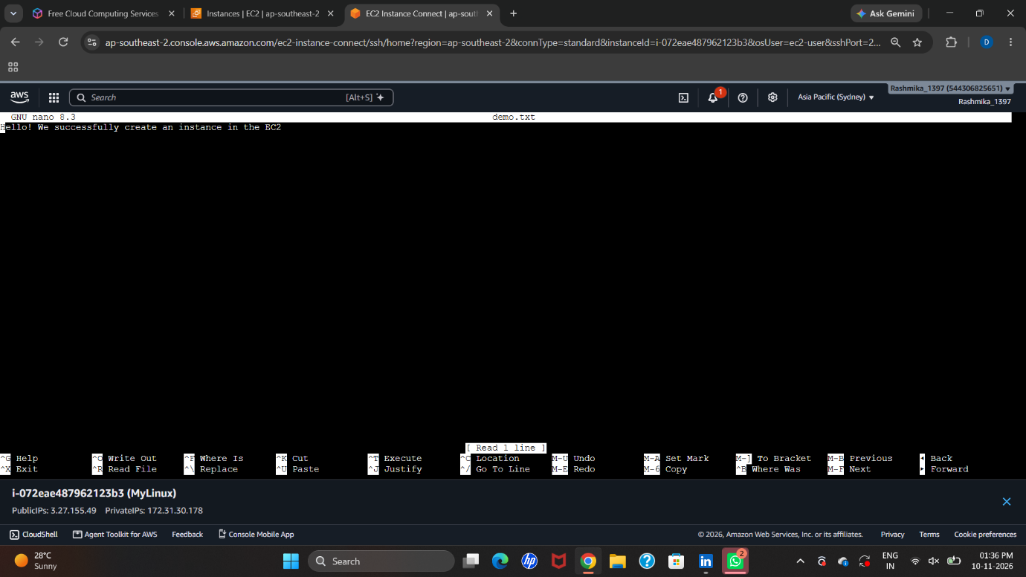
10. Result
Successfully created and launched an Amazon EC2 Linux instance using AWS, connected to it through EC2 Instance Connect, created a directory, created a text file using the Nano editor, and verified its contents using the Linux terminal.

