

BIG DATA ANAYLSIS WITH

IBM CLOUD DATABASES

From Department Of

**B.TECH(Artificial Intelligence And Data Science)**

**BY :**

Deva.N

III-YEAR(AI&DS)

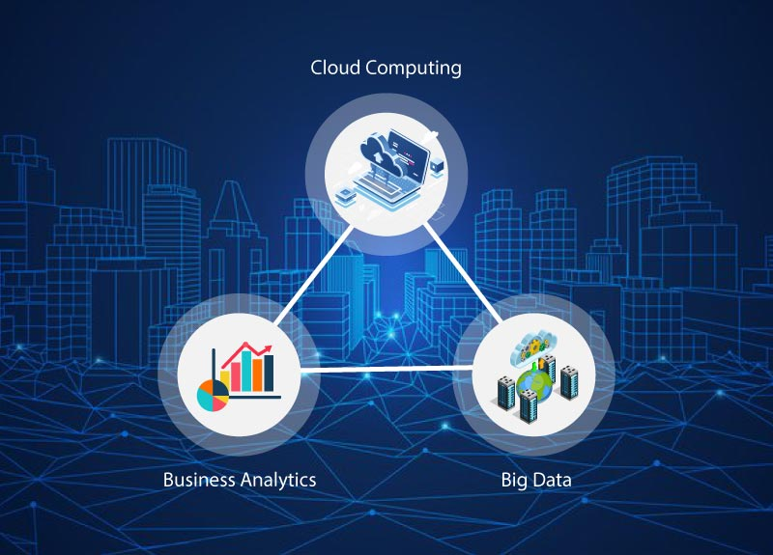

**MY UNDERSTANDING :**

My understanding on this project **“BIG DATA ANALYSIS WITH IBM CLOUD DATABASES”** is that how we shall manage the cloud databases using the big data analysis

**AIM OF MY PROJECT :**

The main aim is to efficiently manage and analyze the we IBM cloud databases use of big data analysis

**OBJECTIVES OF MY PROJECT:**

* **Data Ingestion and Storage**
* **Data Quality and Preparation**
* **Data Security and Compliance**
* **Scalability and Performance**
* **Real-time Analytics**

**Data Ingestion and Storage :**

**Data ingestion and storage are fundamental components of any Big Data Analysis project. Ensuring efficient and reliable data ingestion and storage processes is crucial for making data available for analysis**

**Data Quality and Preparation :**

**Data quality and data preparation are critical steps in the Big Data Analysis process. High-quality data that is properly prepared is essential for accurate and meaningful insights.**

**Data Security and Compliance:**

**Data security and compliance are critical aspects of any Big Data Analysis project, as they help protect sensitive information, maintain trust, and ensure adherence to legal and regulatory requirements**

**Scalability and Performance:**

**Scalability and performance are crucial considerations in Big Data Analysis to ensure that your system can handle large volumes of data efficiently and deliver timely insights**

**Real-time Analytics** **:**

**Real-time analytics in Big Data Analysis involves processing and analyzing data as it is generated or ingested, allowing organizations to make immediate decisions based on up-to-the-minute information**