4-1:

Create a fiscal hierarchy to include fiscal year, fiscal quarter, month, and date. Make sure all value labels are unique within the hierarchy and sort the display in order. Submit the screenshot.

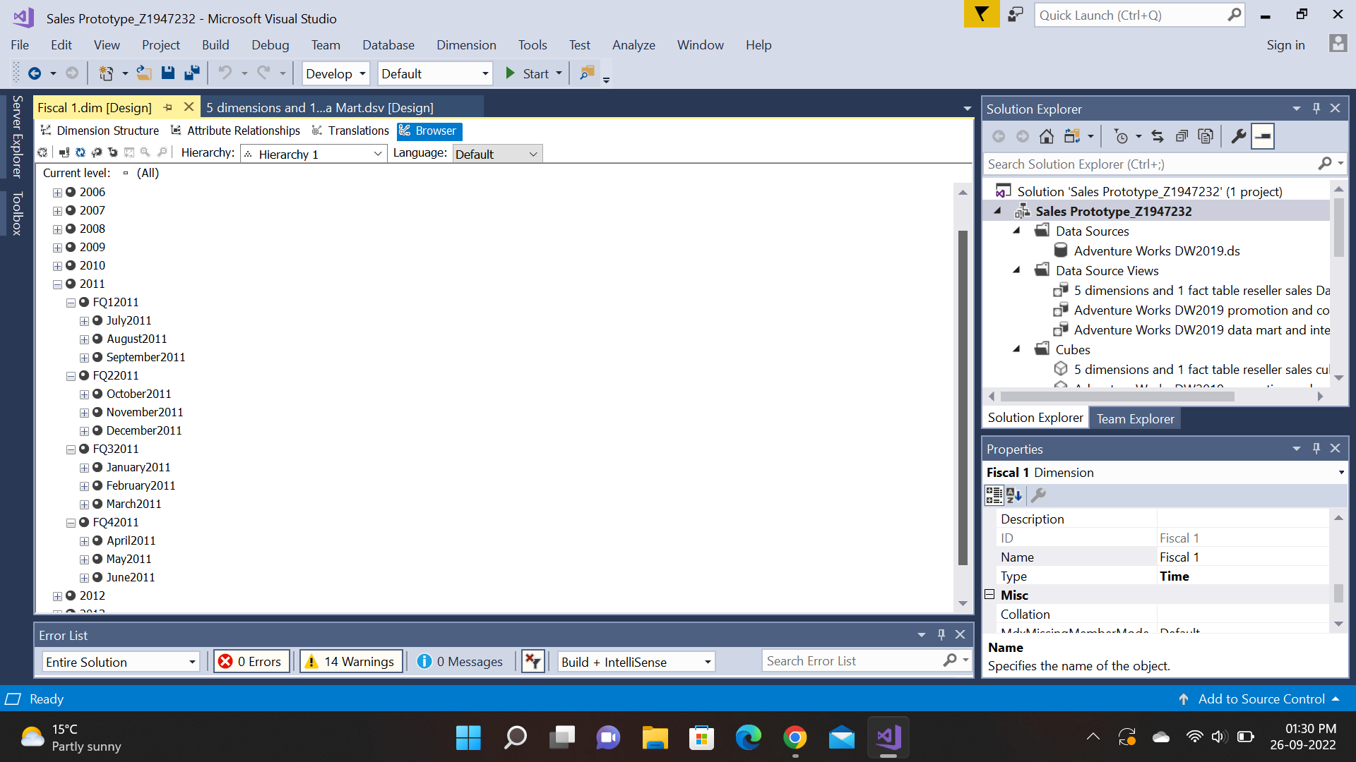

Assignment 4-2:

NIU COB wants your help designing a star schema to record grades completed by students. There are four dimension tables, with attributes as follows:

|  |  |
| --- | --- |
| CourseSection | Attributes: CourseID, SectionNumber, CourseName, Units, RoomID, and RoomCapacity. During a given semester, the COB offers an average of 500 course sections. |
| Professor | Attributes: ProfID, ProfName, Title, DepartmentID, and DepartmentName. There are typically 50 professors at any given time in the COB. |
| Student | Attributes: StudentID, StudentName, and Major. Each course section has an average of 30 students, and students typically take 5 courses per period. |
| Period | Attributes: SemesterID, and Year. The database will contain data for 30 periods (a total of 10 years). |

The only fact that is to be recorded in the fact table is CourseGrade.

1. Design a star schema for this problem.

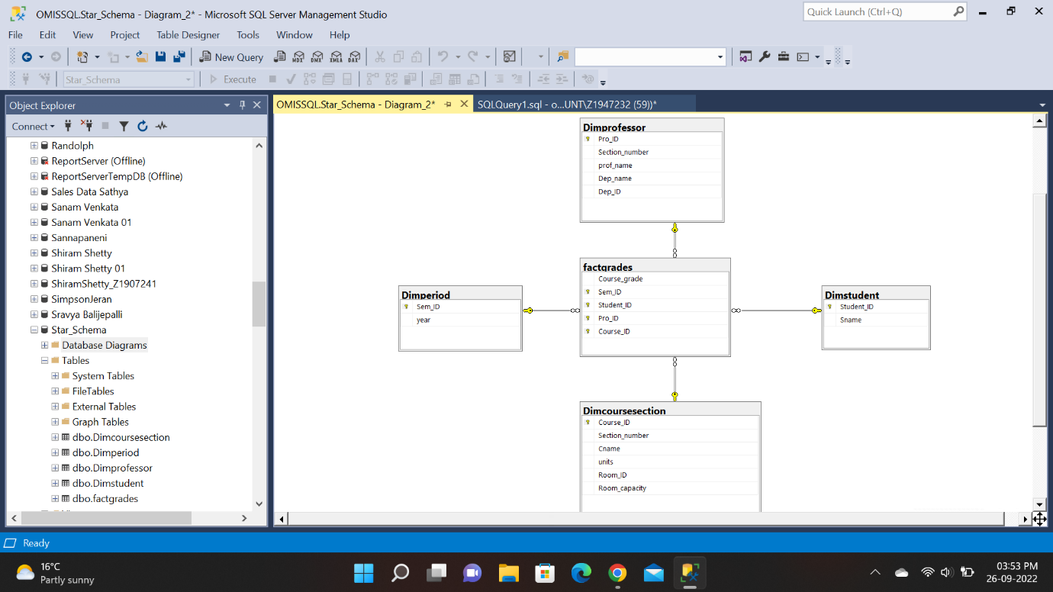

1. Estimate the number of rows in the fact table, using the assumption stated above.

Number of Rows = 500 (course Sections) *30 (Students)* 30 (Periods)

=450,000.

1. If you don’t want to stick with a strict star schema for this data mart, how would you change the design (Please draw your new design)?

I would change it to a snowflake schema by creating a new dimension table for room number and room capacity and assigning it to the course section dimension table.

