**2-1:**

1. Which material sold the most in terms of quantity?

Conception Palermo

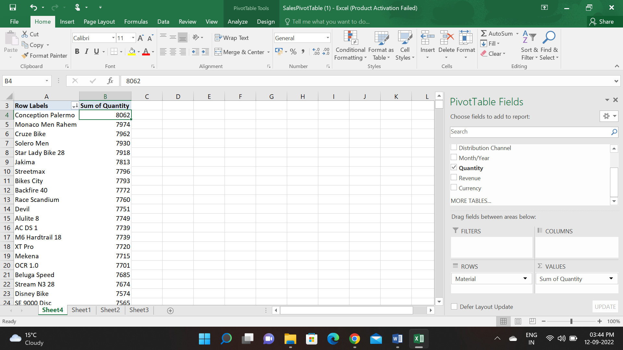

1. How many 7 Gear Bikes were sold in June 2007?

820

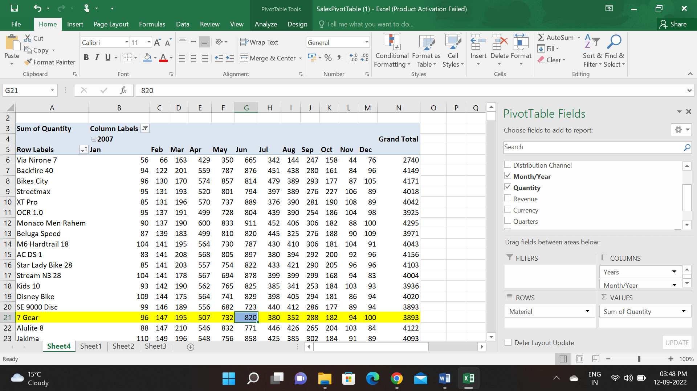

1. How many 7 Gear Bikes were sold in the entire year of 2007?

3893.

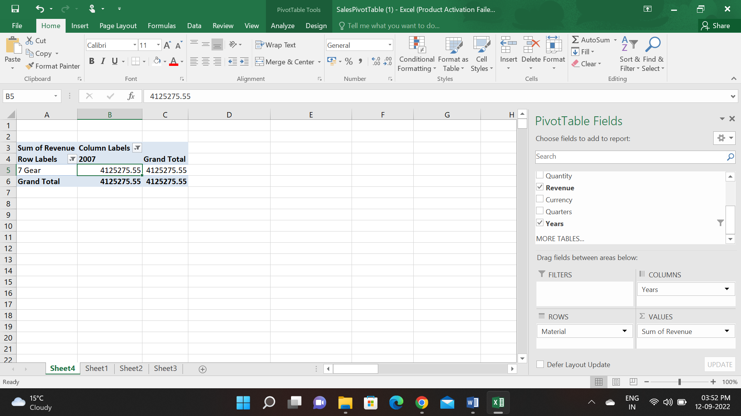

1. Which material provided the most revenue in Sydney?

AC DS1

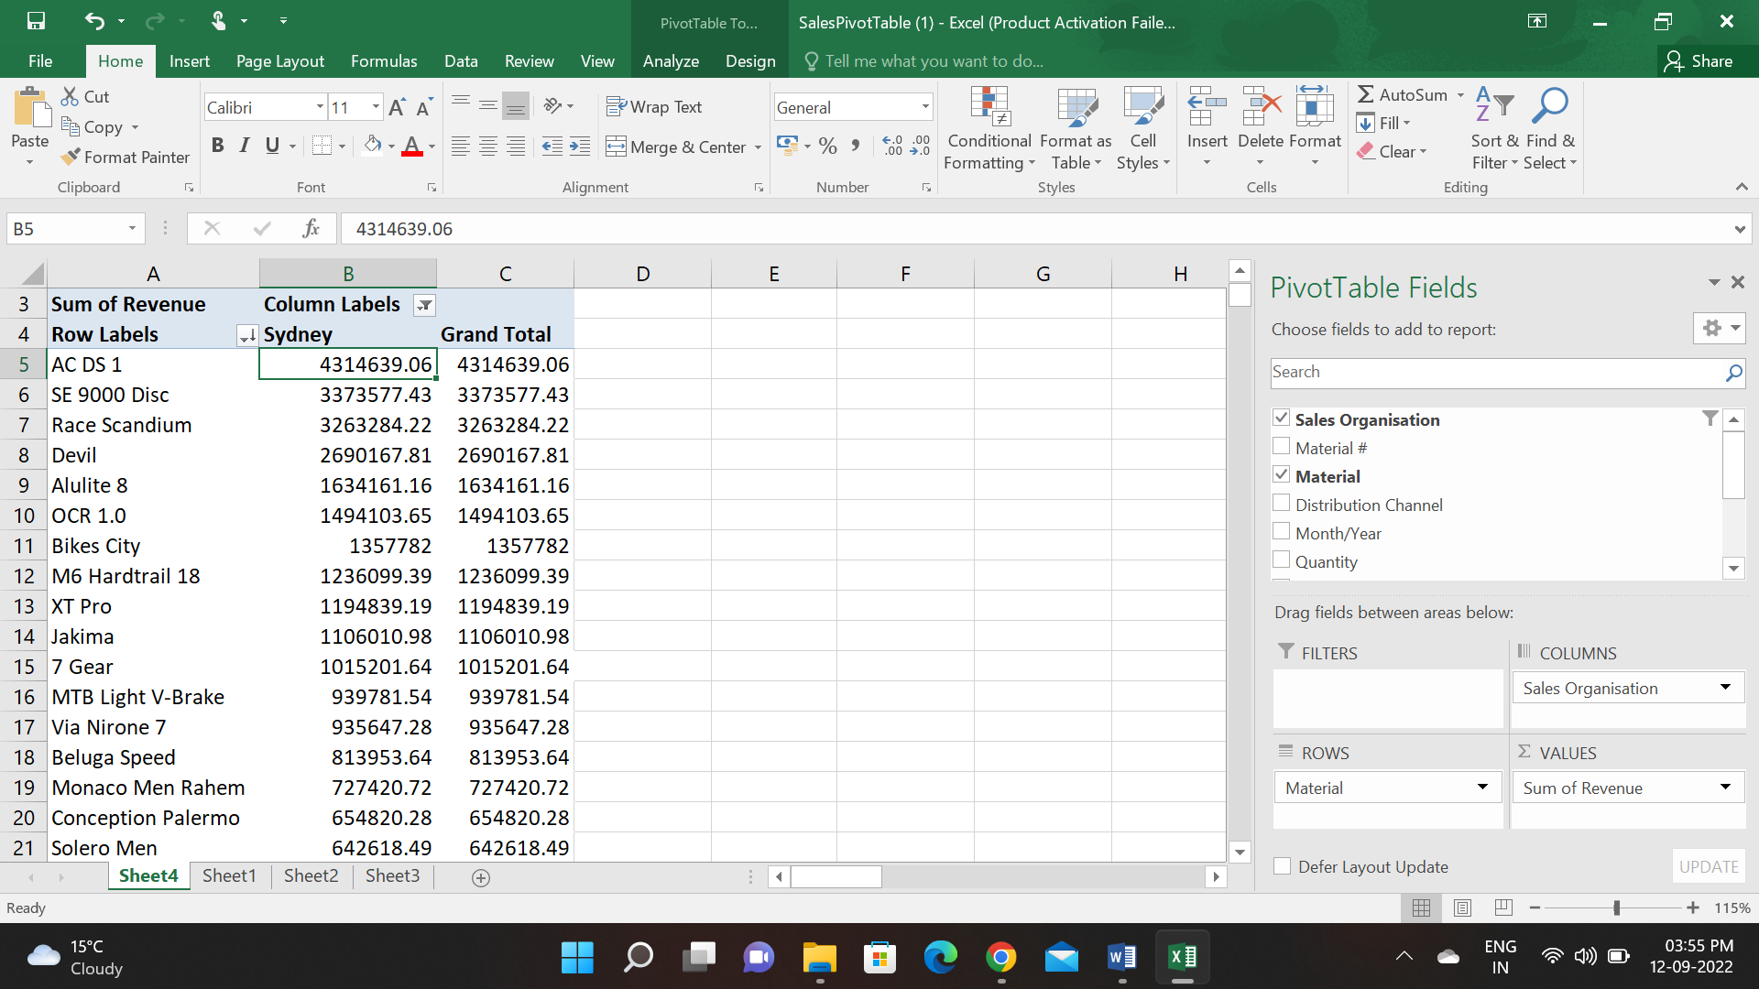

1. What is the total sales revenue for USA?

67,099,233.13

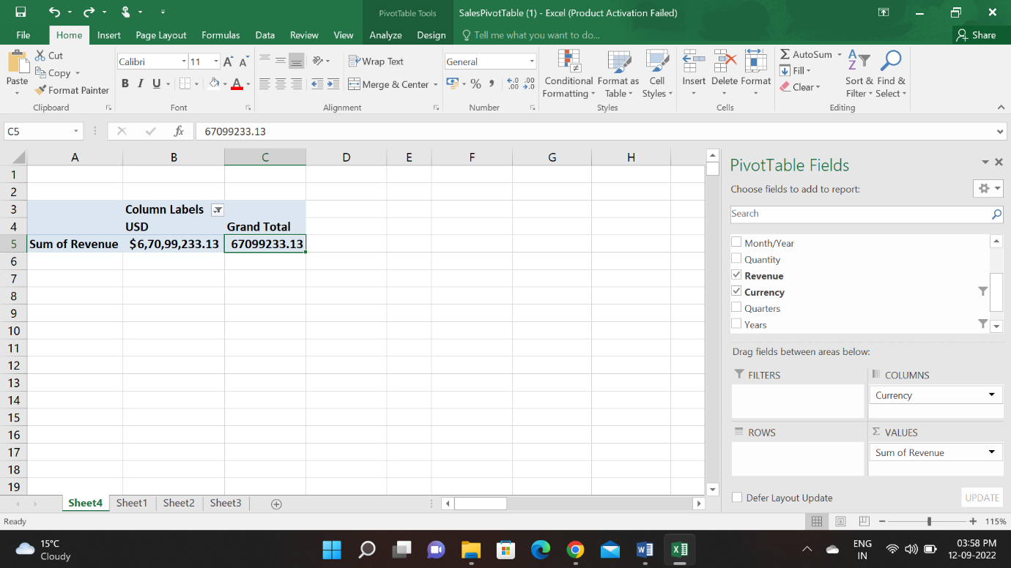

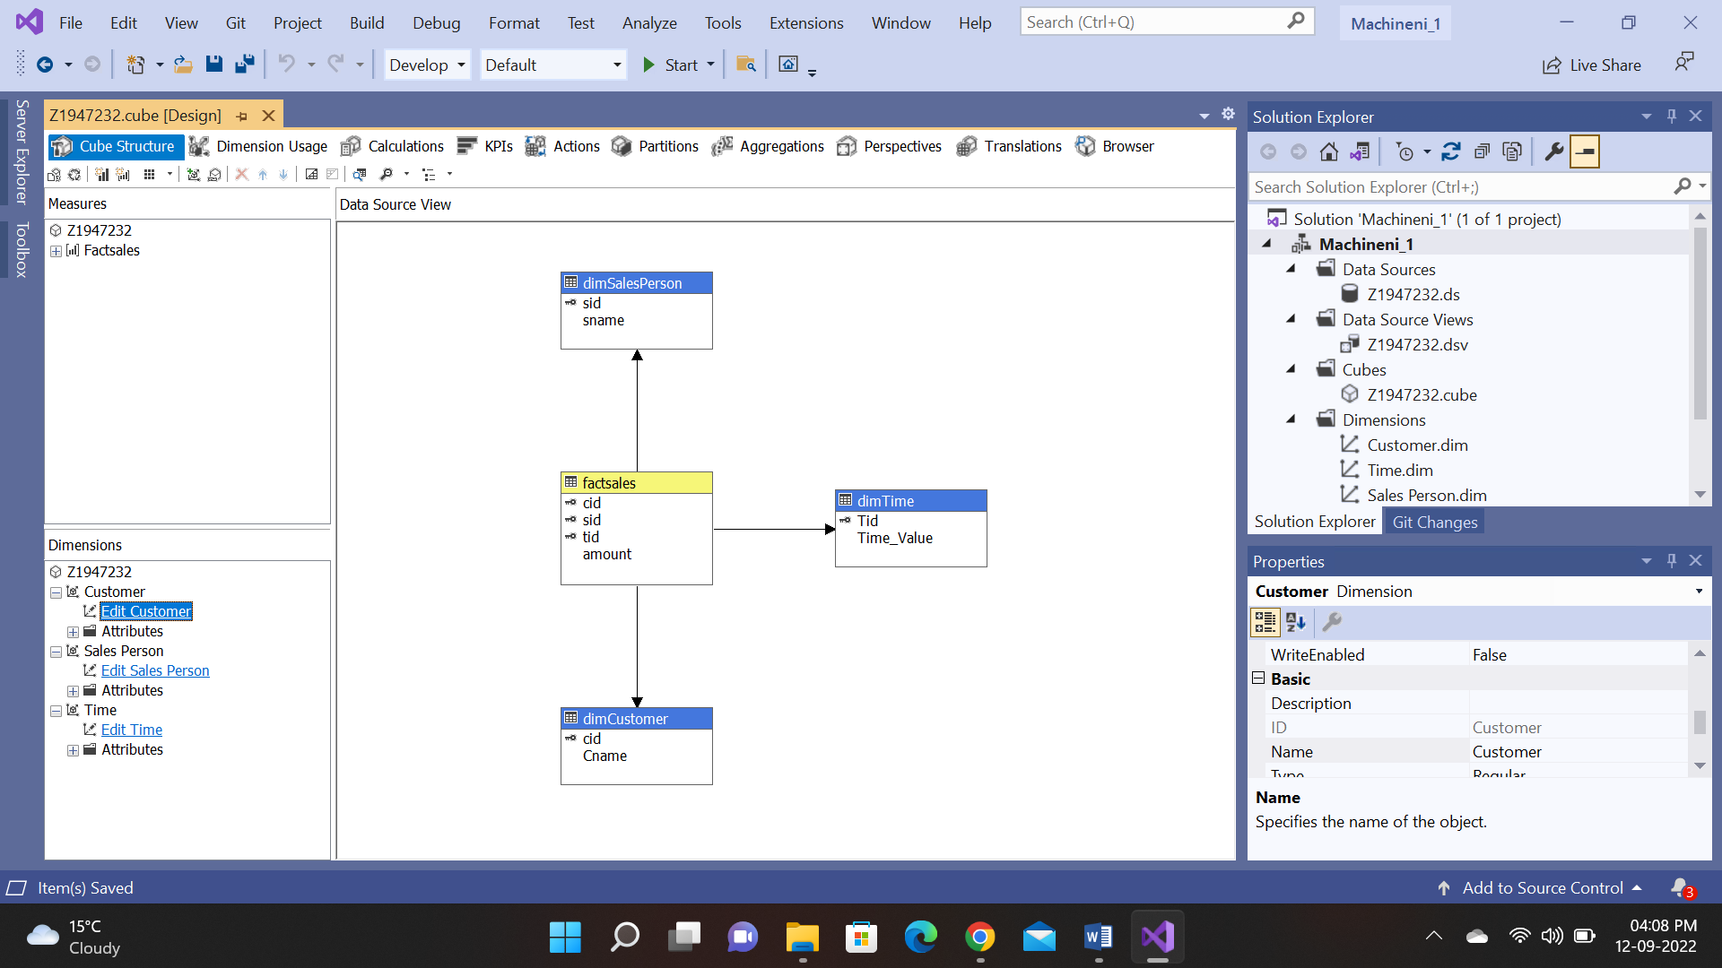

**Assignment 2-2:**

1. Who is your top salesperson?

Chang is the top performing salesperson.

2. Which salesperson does better with certain customer?

Gomez has the highest amount $88,980 with Acme Metal Works.

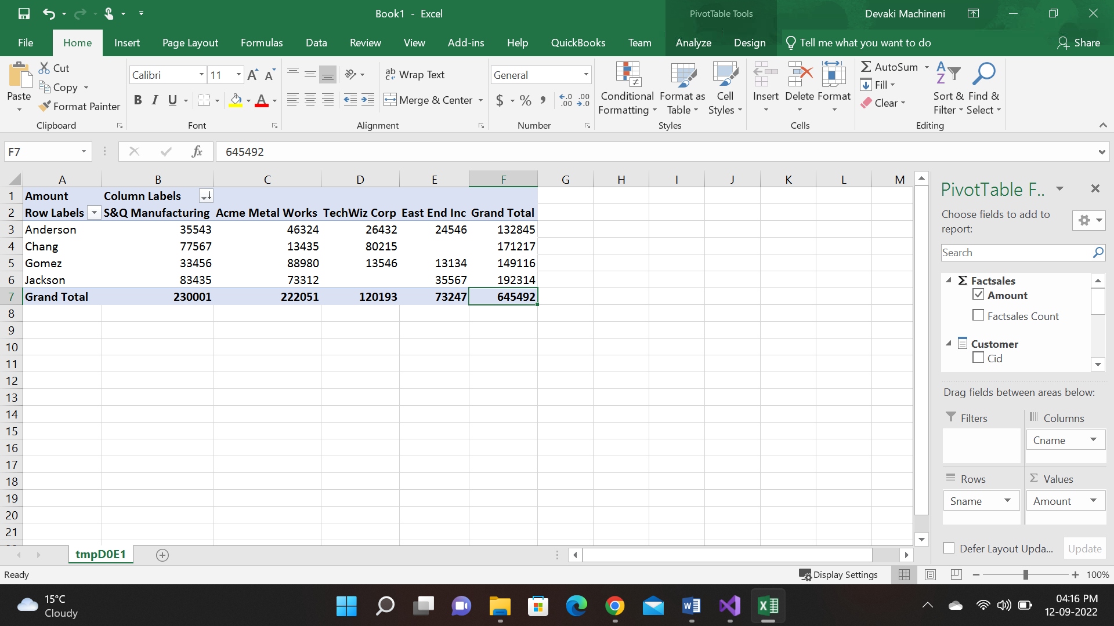

**Assignment 2-3:**

1.Analyze Internet Sales by Year and Month (Based on Order Date).

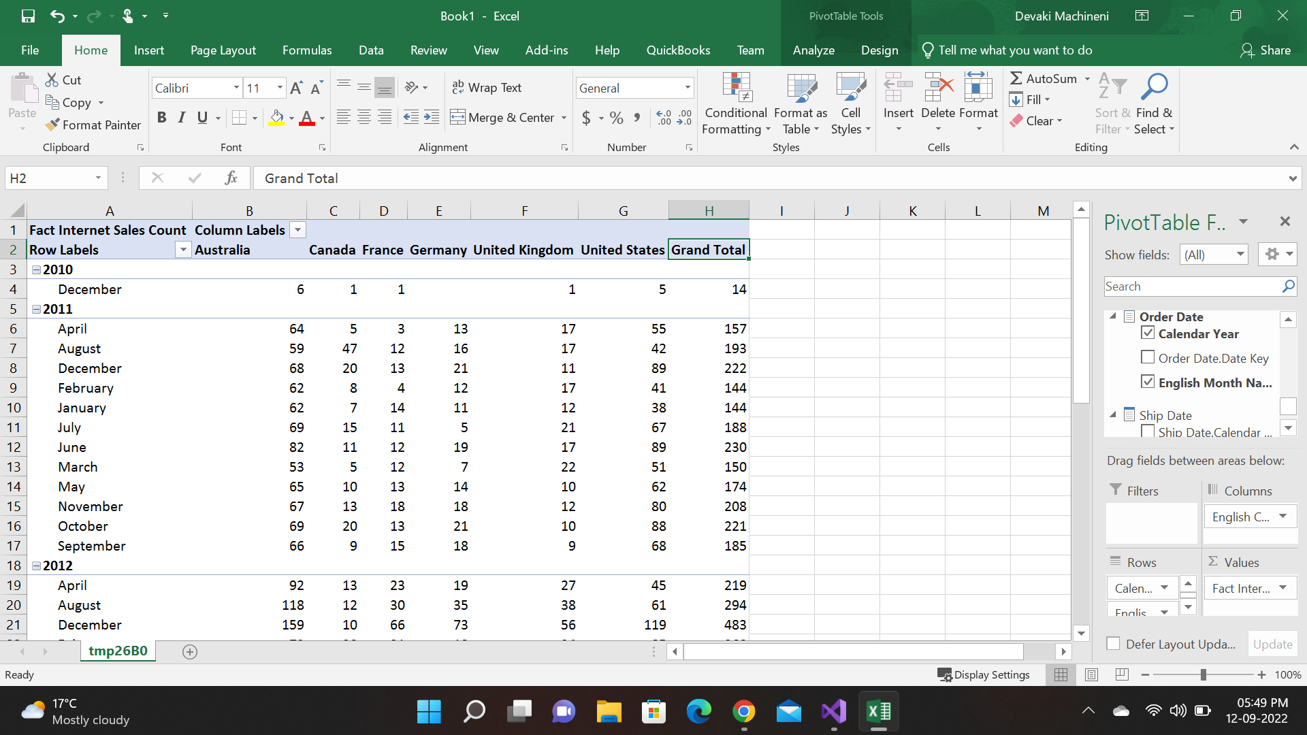

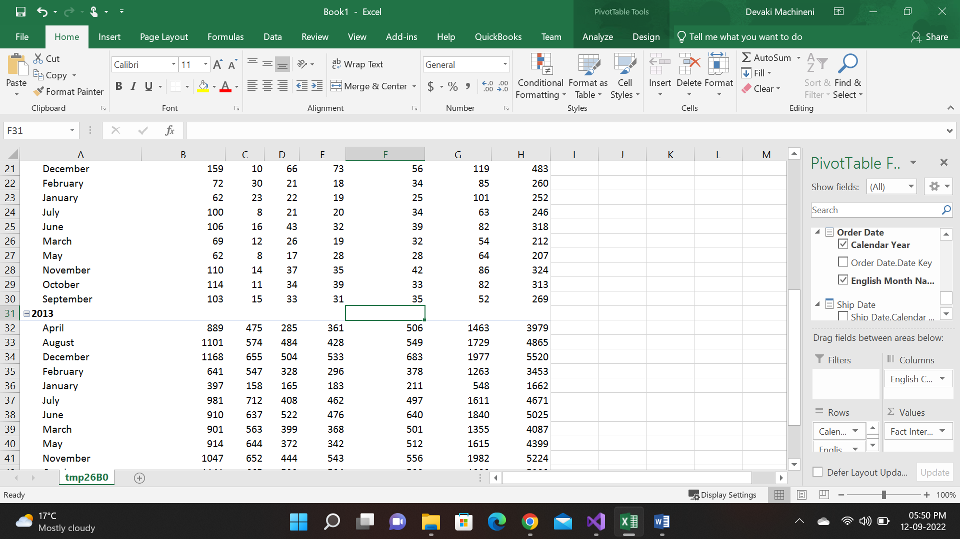

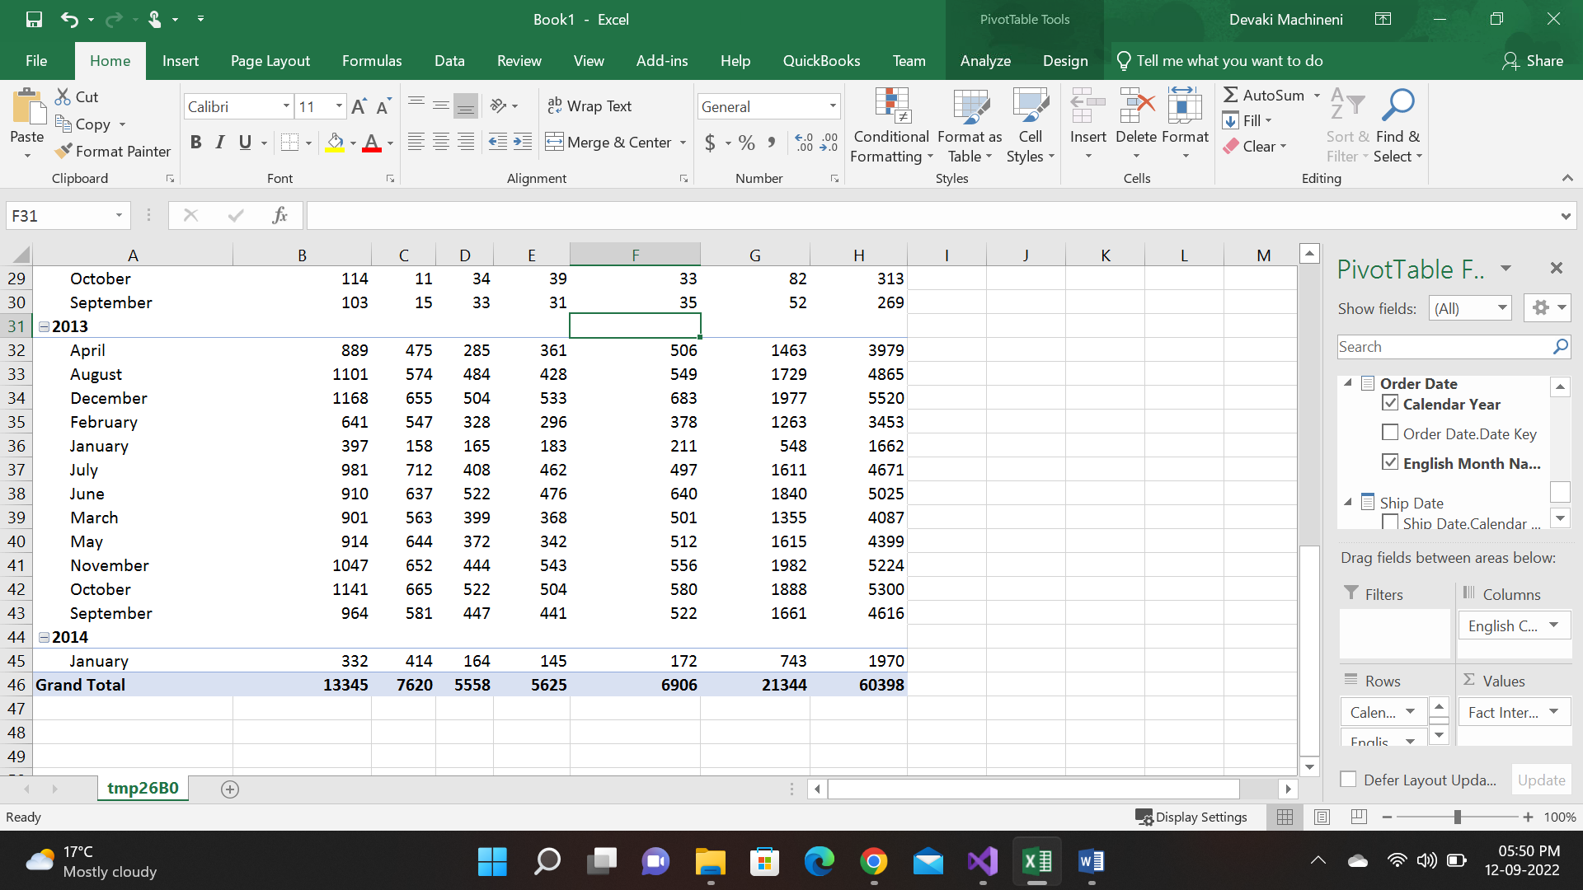

2.Analyze Geographical Reseller Sales.

