3-1:

Explore AdventureWorksDW2019 data warehouse to come up with ONE your own interesting question for data analysis and to present your solution for your question. Submit your business case, design, and solution using the cube technology exercised in the class.

What is the sales amount of the touring bikes?

Ans: 10451490.22

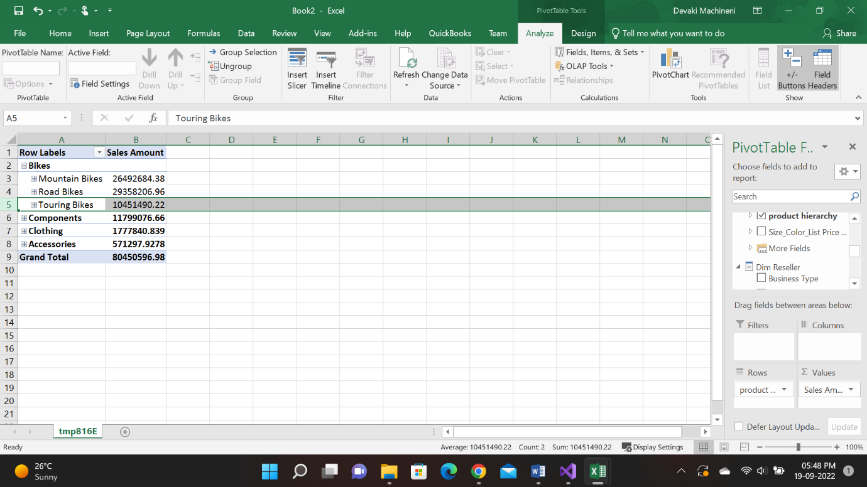

Assignment 3-2:

Create a Marketing role for the AventureWorksDW2019 cube you created in Lab 2. This role will restrict access to the “Clothing” product category. Show the result in the cube browser. Please submit the Screen Shot.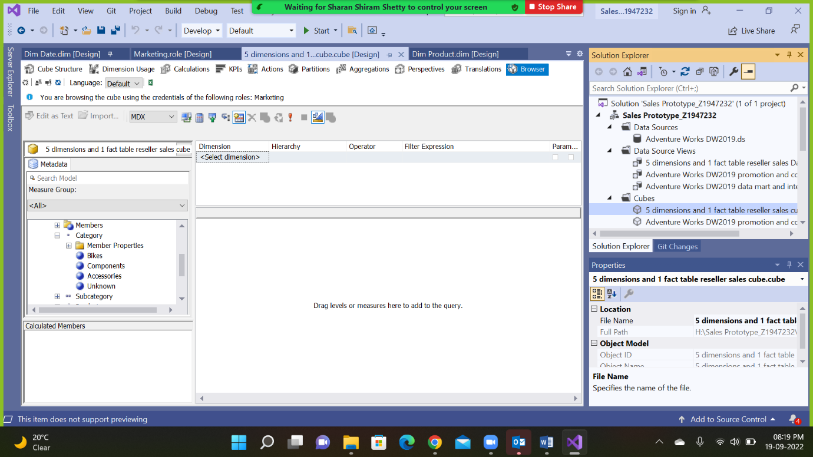

Assignment 3-3:

Complete the case study of SAP Analytics Cloud. Please submit the Screen Shots based on the case study requirements.

D1.2

Create a PivotTable to determine the total revenue for material groups in each sales organization.

D1.2

Create a PivotTable to determine the total revenue for material groups in each sales organization.

Ans:

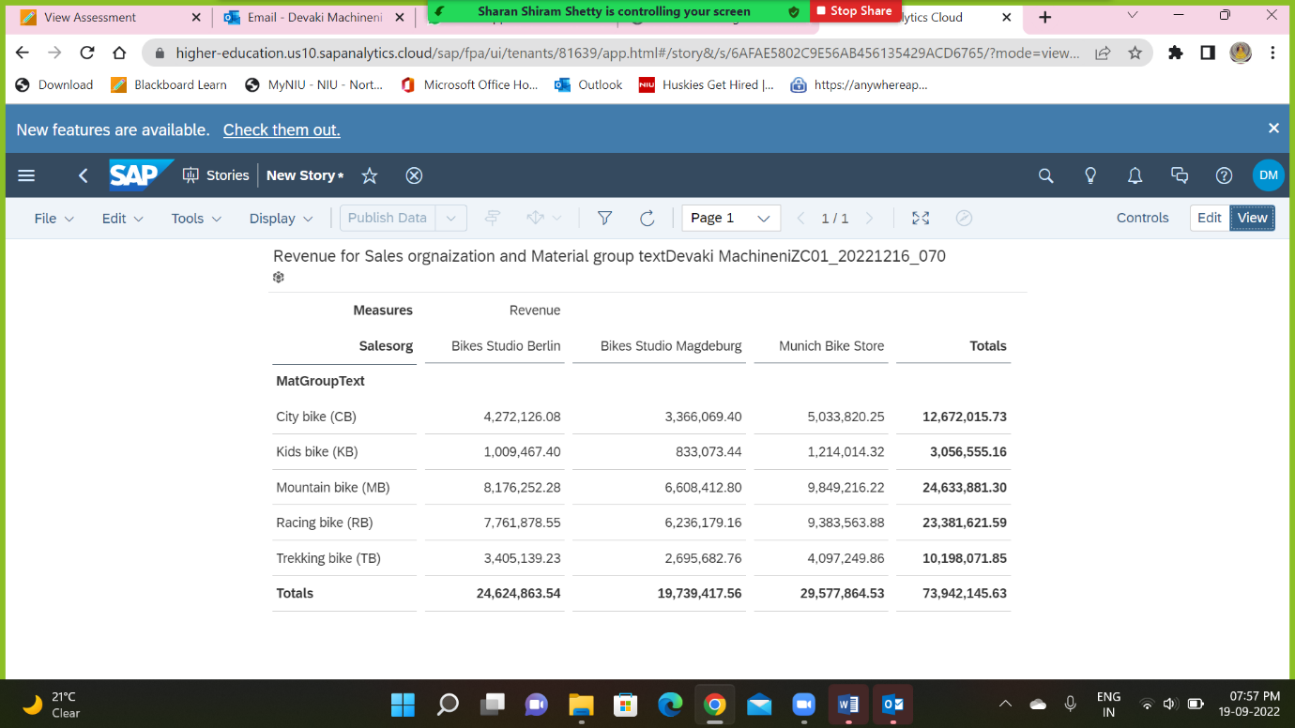

D1.3

Slice: restrict to internet sales.

Ans:

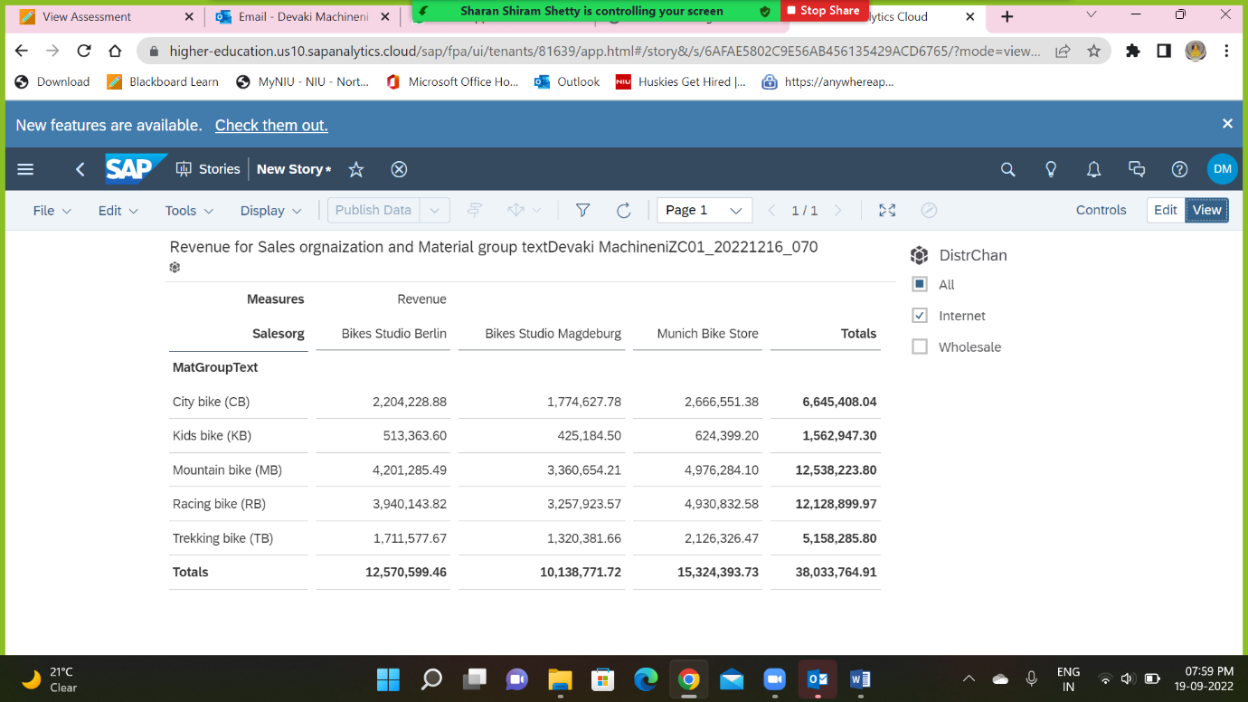

D1.4

Drill-Down: show all products for mountain bikes.

Ans:

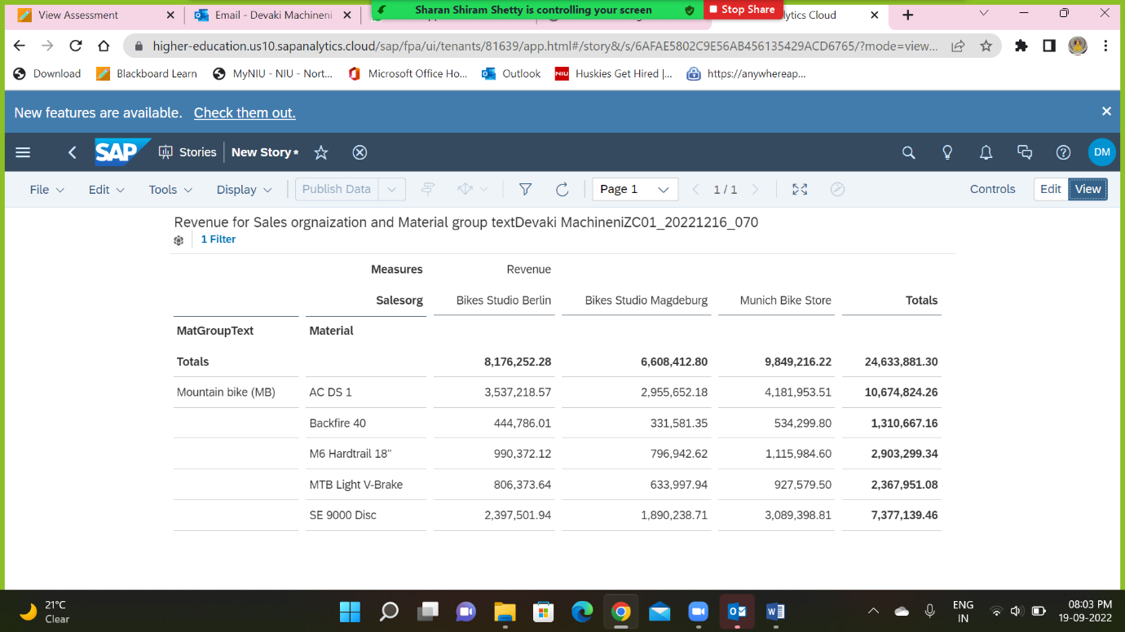

D1.5

Remove Drill-Down for material.

Dice: restrict to first quarter of 2007.

What is the sales revenue of Mountain Bike (MB) in Bikes Studio Berlin in the first quarter of 2007?

Ans:

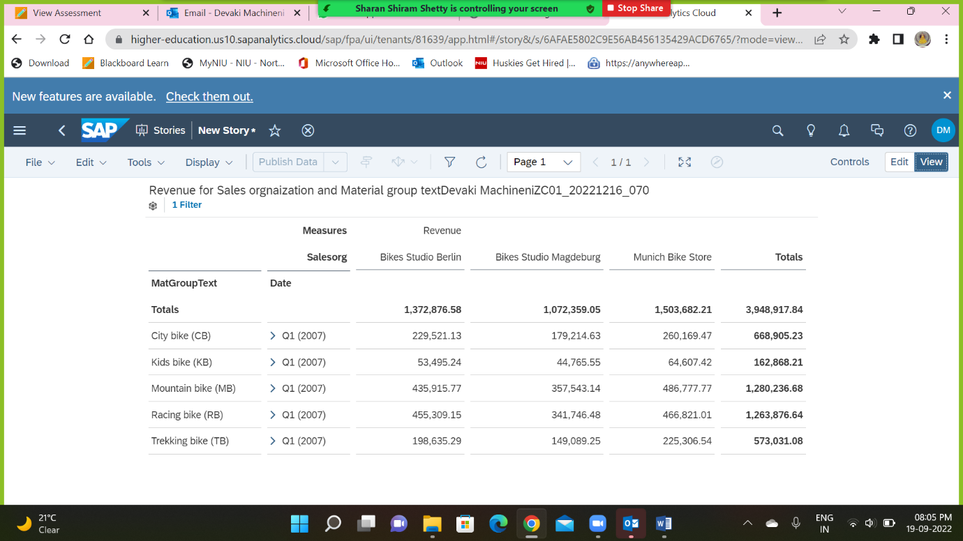

D1.6

Remove all filters.

Which product provided the most Contribution Margin Ratio?

Hint: Contribution Margin Ratio is defined as Percentage of Contribution Margin over Net Sales, where Net Sales is Revenue – Discount and Contribution Margin is

Net Sales – Cost Of Good Sold.

Ans:

