**Assignment : 1**

**Name : Radadiya Devalkumar Chandulal**

**Enrollment No. : 200802089**

**Roll No. : 48**

**Subject : ASP .net**

1. **Print the Hello with your name using Response.Write().**

**Code :**

<%@ Page Language="C#" AutoEventWireup="true" CodeBehind="WebForm1.aspx.cs" Inherits="WebApplication1.WebForm1" %>

<!DOCTYPE html PUBLIC "-//W3C//DTD XHTML 1.0 Transitional//EN" "http://www.w3.org/TR/xhtml1/DTD/xhtml1-transitional.dtd">

<html xmlns="http://www.w3.org/1999/xhtml">

<head runat="server">

<title></title>

</head>

<body>

<form id="form1" runat="server">

<div>

<%Response.Write("Hello Deval Radadiya"); %>

</div>

</form>

</body>

</html>

**Name :- Radadiya Devalkumar Chandulal**

**Enrollment No. :- 200802089**

**Output :**

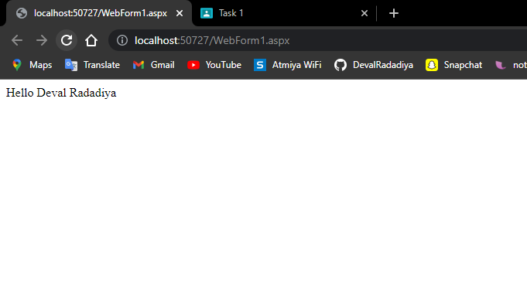

**Name :- Radadiya Devalkumar Chandulal**

**Enrollment No. :- 200802089**

1. **Design the Sign Up page as below using master page.**

**Code :**

<%@ Page Language="C#" AutoEventWireup="true" CodeBehind="WebForm1.aspx.cs" Inherits="WebApplication2.WebForm1" %>

<!DOCTYPE html PUBLIC "-//W3C//DTD XHTML 1.0 Transitional//EN" "http://www.w3.org/TR/xhtml1/DTD/xhtml1-transitional.dtd">

<html xmlns="http://www.w3.org/1999/xhtml">

<head id="Head1" runat="server">

<title></title>

<style>

<body>

{

font-family:sans-serif;

background: -webkit-linear-gradient(to right, #155799, #159957);

background: linear-gradient(to right, #155799, #159957);

color:whitesmoke;

}

h1{

text-align: center;

}

form{

width:35rem;

margin: auto;

color:whitesmoke;

backdrop-filter: blur(16px) saturate(180%);

-webkit-backdrop-filter: blur(16px) saturate(180%);

background-color: rgba(11, 15, 13, 0.582);

border-radius: 12px;

border: 1px solid rgba(255, 255, 255, 0.125);

padding: 20px 25px;

}

input[type=text], input[type=password]{

width: 100%;

margin: 10px 0;

border-radius: 5px;

**Name :- Radadiya Devalkumar Chandulal**

**Enrollment No. :- 200802089**

padding: 15px 18px;

box-sizing: border-box;

}

button {

background-color: #030804;

color: white;

padding: 14px 20px;

border-radius: 5px;

margin: 7px 0;

width: 100%;

font-size: 18px;

}

@media screen and (max-width: 600px) {

form{

width: 25rem;

}

}

@media screen and (max-width: 400px) {

form{

width: 20rem;

}

}

</style>

</head>

<body>

<h1>Login form using HTML and CSS</h1>

<form action="">

<div class="headingsContainer">

<h3>Sign in</h3>

<p>Sign in with your username and password</p>

</div>

<div class="mainContainer">

<label for="username">Your username</label>

<input type="text" placeholder="Enter Username" name="username" required>

<br><br>

<label for="pswrd">Your password</label>

<input type="password" placeholder="Enter Password" name="pswrd" required>

<div class="subcontainer">

<label>

<input type="checkbox" checked="checked" name="remember"> Remember me

</label>

<p class="forgotpsd"> <a href="#">Forgot Password?</a></p>

</div>

**Name :- Radadiya Devalkumar Chandulal**

**Enrollment No. :- 200802089**

<button type="submit">Login</button>

<p class="register">Not a member? <a href="#">Register here!</a></p>

</div>

</form>

</body>

</html>

</form>

</body>

</html>

**Output :**

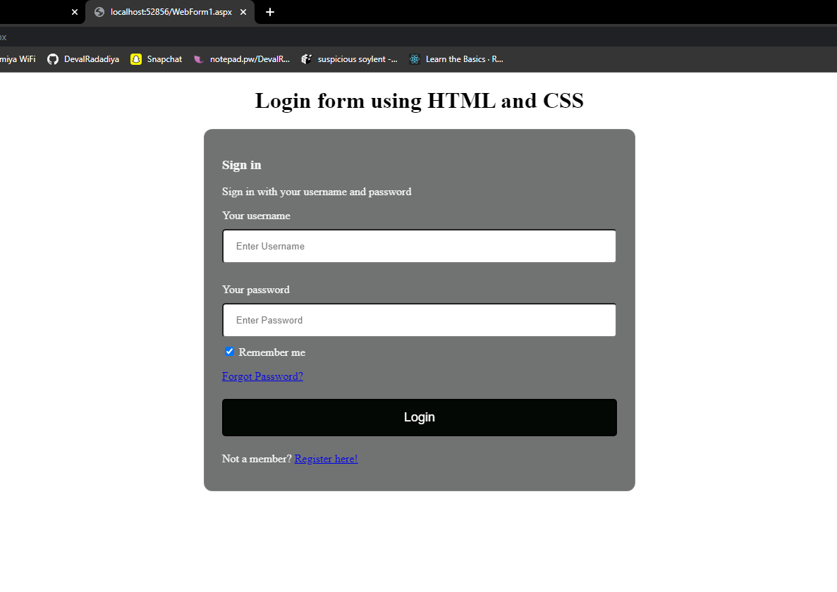

**Name :- Radadiya Devalkumar Chandulal**

**Enrollment No. :- 200802089**

1. **Design the webpage using the master page as below.**

**Code :**

<%@ Master Language="C#" AutoEventWireup="true" CodeBehind="Site1.master.cs" Inherits="WebApplication3.Site1" %>

<!DOCTYPE html PUBLIC "-//W3C//DTD XHTML 1.0 Transitional//EN" "http://www.w3.org/TR/xhtml1/DTD/xhtml1-transitional.dtd">

<html xmlns="http://www.w3.org/1999/xhtml">

<head runat="server">

<title></title>

<environment names="Development">

<link rel="stylesheet" href="~/lib/bootstrap/dist/css/bootstrap.css" />

<link rel="stylesheet" href="~/css/site.css" />

</environment>

<environment names="Staging,Production">

<link href="https://cdn.jsdelivr.net/npm/bootstrap@5.2.3/dist/css/bootstrap.min.css" rel="stylesheet" integrity="sha384-rbsA2VBKQhggwzxH7pPCaAqO46MgnOM80zW1RWuH61DGLwZJEdK2Kadq2F9CUG65" crossorigin="anonymous">

<link rel="stylesheet" href="~/css/site.min.css" asp-append-version="true" />

</environment>

<style>

img

{

height:500px !important;

width:100%;

}

</style>

</head>

<body>

<div>

<nav class="navbar navbar-expand-lg bg-light">

<div class="container-fluid">

<a class="navbar-brand" href="#">Navbar</a>

<button class="navbar-toggler" type="button" data-bs-toggle="collapse" data-bs-target="#navbarSupportedContent" aria-controls="navbarSupportedContent" aria-expanded="false" aria-label="Toggle navigation">

<span class="navbar-toggler-icon"></span>

</button>

<div class="collapse navbar-collapse" id="navbarSupportedContent">

<ul class="navbar-nav me-auto mb-2 mb-lg-0">

<li class="nav-item">

<a class="nav-link active" aria-current="page" href="#">Home</a>

</li>

<li class="nav-item">

<a class="nav-link" href="#">Link</a>

**Name :- Radadiya Devalkumar Chandulal**

**Enrollment No. :- 200802089**

</li>

<li class="nav-item dropdown">

<a class="nav-link dropdown-toggle" href="#" role="button" data-bs-toggle="dropdown" aria-expanded="false">

Dropdown

</a>

<ul class="dropdown-menu">

<li><a class="dropdown-item" href="#">Action</a></li>

<li><a class="dropdown-item" href="#">Another action</a></li>

<li><hr class="dropdown-divider"></li>

<li><a class="dropdown-item" href="#">Something else here</a></li>

</ul>

</li>

<li class="nav-item">

<a class="nav-link disabled">Disabled</a>

</li>

</ul>

<form class="d-flex" role="search">

<input class="form-control me-2" type="search" placeholder="Search" aria-label="Search"/>

<button class="btn btn-outline-success" type="submit">Search</button>

</form>

</div>

</div>

</nav>

<div>

<img src="https://upload.wikimedia.org/wikipedia/commons/b/b6/Image_created_with_a_mobile_phone.png" class="img-fluid">

</div>

<div class="container">

<div class="row d-flex justify-content-between mt-3">

<div class="card" style="width: 18rem">

<div class="card-body text-center">

<h5 class="card-title text-success">.NET</h5>

<h5 class="card-text">DevCraft</h5>

<span class="card-text">Some quick example text to build on the card title and make up the bulk of the card's content.</span><br />

<a href="#" class="btn btn-success">Go somewhere</a>

</div>

</div>

<div class="card" style="width: 18rem">

<div class="card-body text-center">

<h5 class="card-title text-primary">NATIVE MOBILE</h5>

<h5 class="card-title">NativeScript</h5>

<p class="card-text">Some quick example text to build on the card title and make up the bulk of the card's content.</p>

<a href="#" class="btn btn-primary">Go somewhere</a>

</div>

</div>

<div class="card" style="width: 18rem">

**Name :- Radadiya Devalkumar Chandulal**

**Enrollment No. :- 200802089**

<div class="card-body text-center">

<h5 class="card-title text-danger">HTML5</h5>

<h5 class="card-title">Kendo UI</h5>

<p class="card-text">Some quick example text to build on the card title and make up the bulk of the card's content.</p>

<a href="#" class="btn btn-danger">Go somewhere</a>

</div>

</div>

</div>

</div>

<div class="container">

<div class="row d-flex justify-content-between mt-3">

<div class="card" style="width: 18rem">

<div class="card-body">

<h5 class="card-title">Card title</h5>

<p class="card-text">Some quick example text to build on the card title and make up the bulk of the card's content.</p>

<a href="#" class="btn btn-primary">Go somewhere</a>

</div>

</div>

<div class="card" style="width: 18rem">

<div class="card-body">

<h5 class="card-title">Card title</h5>

<p class="card-text">Some quick example text to build on the card title and make up the bulk of the card's content.</p>

<a href="#" class="btn btn-primary">Go somewhere</a>

</div>

</div>

<div class="card" style="width: 18rem">

<div class="card-body">

<h5 class="card-title">Card title</h5>

<p class="card-text">Some quick example text to build on the card title and make up the bulk of the card's content.</p>

<a href="#" class="btn btn-primary">Go somewhere</a>

</div>

</div>

</div>

</div>

</div>

</body>

</html>

</body>

</html>

**Name :- Radadiya Devalkumar Chandulal**

**Enrollment No. :- 200802089**

**Output :-**

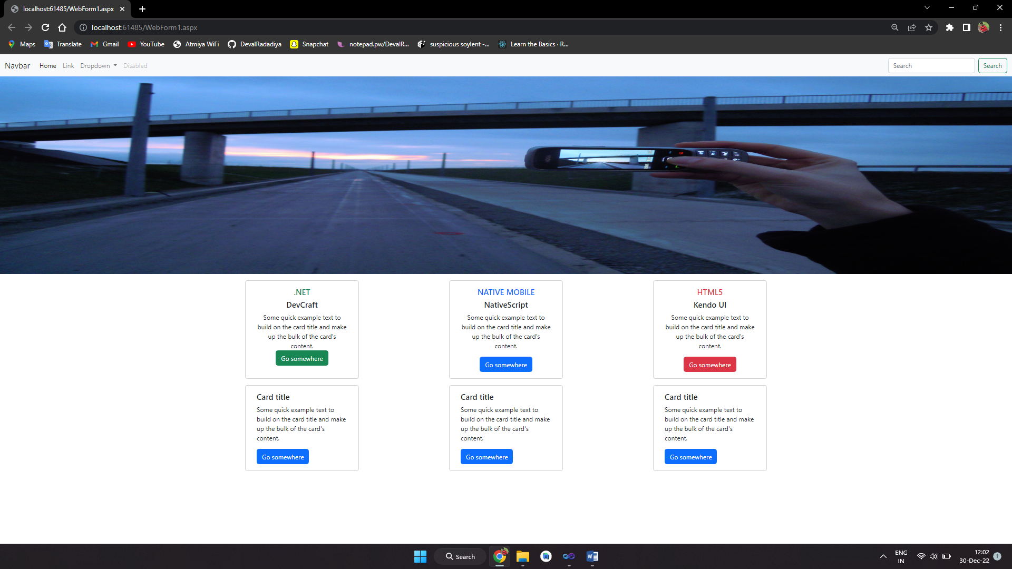

**Name :- Radadiya Devalkumar Chandulal**

**Enrollment No. :- 200802089**

1. **Create a table as below and display the same.**

**Code :**

<%@ Page Language="C#" AutoEventWireup="true" CodeBehind="WebForm1.aspx.cs" Inherits="WebApplication4.WebForm1" %>

<!DOCTYPE html PUBLIC "-//W3C//DTD XHTML 1.0 Transitional//EN" "http://www.w3.org/TR/xhtml1/DTD/xhtml1-transitional.dtd">

<html xmlns="http://www.w3.org/1999/xhtml">

<head runat="server">

<title></title>

</head>

<body>

<form id="form1" runat="server">

<div>

</div>

<asp:Table ID="Table1" runat="server" Height="288px" Width="497px">

<asp:TableRow ID="TableRow1" runat="server" BorderColor="Gray" BorderStyle="Solid" BorderWidth="2px" HorizontalAlign="Left">

<asp:TableCell ID="TableCell1" runat="server" BackColor="White" BorderColor="Silver" BorderStyle="Solid" BorderWidth="1px" Font-Bold="True">ID</asp:TableCell>

<asp:TableCell ID="TableCell2" runat="server" BackColor="White" BorderColor="Silver" BorderStyle="Solid" BorderWidth="1px" Font-Bold="True">Name</asp:TableCell>

<asp:TableCell ID="TableCell3" runat="server" BackColor="White" BorderColor="Silver" BorderStyle="Solid" BorderWidth="1px" Font-Bold="True">Salary</asp:TableCell>

</asp:TableRow>

<asp:TableRow ID="TableRow2" runat="server">

<asp:TableCell ID="TableCell4" runat="server" BorderColor="Silver" BorderStyle="Solid" BorderWidth="1px">100</asp:TableCell>

<asp:TableCell ID="TableCell5" runat="server" BorderStyle="Solid" BorderWidth="1px">Rishab</asp:TableCell>

<asp:TableCell ID="TableCell6" runat="server" BorderStyle="Solid" BorderWidth="1px">7000</asp:TableCell>

</asp:TableRow>

<asp:TableRow ID="TableRow3" runat="server">

<asp:TableCell ID="TableCell7" runat="server" BorderStyle="Solid" BorderWidth="1px">101</asp:TableCell>

<asp:TableCell ID="TableCell8" runat="server" BorderStyle="Solid" BorderWidth="1px">Dharani</asp:TableCell>

<asp:TableCell ID="TableCell9" runat="server" BorderStyle="Solid" BorderWidth="1px">7800</asp:TableCell>

</asp:TableRow>

<asp:TableRow ID="TableRow4" runat="server">

**Name :- Radadiya Devalkumar Chandulal**

**Enrollment No. :- 200802089**

<asp:TableCell ID="TableCell10" runat="server" BorderStyle="Solid" BorderWidth="1px">102</asp:TableCell>

<asp:TableCell ID="TableCell11" runat="server" BorderStyle="Solid" BorderWidth="1px">Joseph</asp:TableCell>

<asp:TableCell ID="TableCell12" runat="server" BorderStyle="Solid" BorderWidth="1px">8500</asp:TableCell>

</asp:TableRow>

<asp:TableRow ID="TableRow5" runat="server">

<asp:TableCell ID="TableCell13" runat="server" BorderStyle="Solid" BorderWidth="1px">103</asp:TableCell>

<asp:TableCell ID="TableCell14" runat="server" BorderStyle="Solid" BorderWidth="1px">Yamuna</asp:TableCell>

<asp:TableCell ID="TableCell15" runat="server" BorderStyle="Solid" BorderWidth="1px">9500</asp:TableCell>

</asp:TableRow>

</asp:Table>

<br />

</form>

</body>

</html>

**Output :**

**Name :- Radadiya Devalkumar Chandulal**

**Enrollment No. :- 200802089**

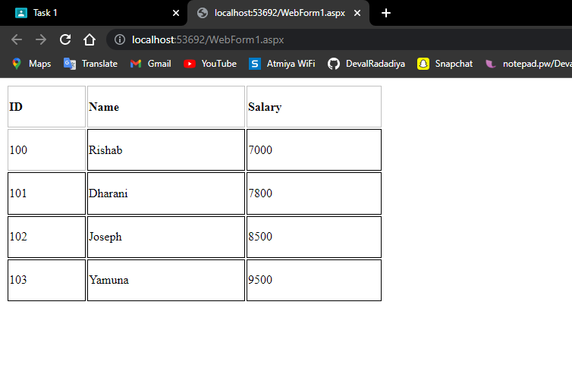

**Name :- Radadiya Devalkumar Chandulal**

**Enrollment No. :- 200802089**

**5. Write a program to print the current date and time using "The time is**

**@DateTime.Now".**

**Code :**

<%@ Page Language="C#" AutoEventWireup="true" CodeBehind="WebForm1.aspx.cs" Inherits="WebApplication5.WebForm1" %>

<!DOCTYPE html PUBLIC "-//W3C//DTD XHTML 1.0 Transitional//EN" "http://www.w3.org/TR/xhtml1/DTD/xhtml1-transitional.dtd">

<html xmlns="http://www.w3.org/1999/xhtml">

<head runat="server">

<title></title>

</head>

<body>

<form id="form1" runat="server">

<div>

<% Response.Write("Time is : " + @DateTime.Now); %>

</div>

</form>

</body>

</html>

**Name :- Radadiya Devalkumar Chandulal**

**Enrollment No. :- 200802089**

**Output :**

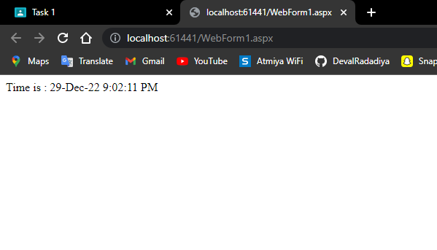

***Thank You***