**Assignment : 2**

**Name : Radadiya Devalkumar Chandulal**

**Enrollment No. : 200802089**

**Roll No. : 48**

**Subject : ASP .net**

1. **Write a program to print the message "welcome to radiant".**

**Code :**

**WebForm1.aspx.cs :**

using System;

using System.Collections.Generic;

using System.Linq;

using System.Web;

using System.Web.UI;

using System.Web.UI.WebControls;

namespace WebApplication2

{

public partial class WebForm1 : System.Web.UI.Page

{

protected void Page_Load(object sender, EventArgs e)

{

Label1.Text = "Devalkumar C Radadiya";

Label2.Text = "200802089";

}

protected void Button1_Click(object sender, EventArgs e)

{

Label3.Text = "Welcome to Radiand";

}

}

}

**WebForm1.aspx**

<%@ Page Language="C#" AutoEventWireup="true" CodeBehind="WebForm1.aspx.cs" Inherits="WebApplication1.WebForm1" %>

<!DOCTYPE html PUBLIC "-//W3C//DTD XHTML 1.0 Transitional//EN" "http://www.w3.org/TR/xhtml1/DTD/xhtml1-transitional.dtd">

<html xmlns="http://www.w3.org/1999/xhtml">

<head runat="server">

<title></title>

</head>

<body>

<form id="form1" runat="server">

<asp:Label ID="Label1" runat="server" Text="Label"></asp:Label>

<div>

<asp:Label ID="Label2" runat="server" Text="Label"></asp:Label>

</div>

<p>

&nbsp;</p>

<p>

&nbsp;&nbsp;&nbsp;&nbsp;&nbsp;&nbsp;&nbsp;&nbsp;&nbsp;&nbsp;&nbsp;&nbsp;&nbsp;&nbsp;&nbsp;&nbsp;&nbsp;&nbsp;&nbsp;&nbsp;&nbsp;&nbsp;&nbsp;&nbsp;&nbsp;&nbsp;&nbsp;&nbsp;&nbsp;&nbsp;&nbsp;&nbsp;&nbsp;&nbsp;&nbsp;&nbsp;&nbsp;&nbsp;&nbsp;&nbsp;&nbsp;&nbsp;&nbsp;&nbsp;&nbsp;&nbsp;&nbsp;&nbsp;&nbsp;&nbsp;&nbsp;&nbsp;&nbsp;&nbsp;&nbsp;&nbsp;&nbsp;&nbsp;&nbsp;&nbsp;&nbsp;&nbsp;&nbsp;&nbsp;&nbsp;&nbsp;&nbsp;&nbsp;&nbsp;&nbsp;&nbsp;&nbsp;&nbsp;

<asp:Button ID="Button1" runat="server" onclick="Button1_Click" Text="Button" />

</p>

<asp:Label ID="Label3" runat="server"></asp:Label>

</form>

</body>

</html>

**Output :**

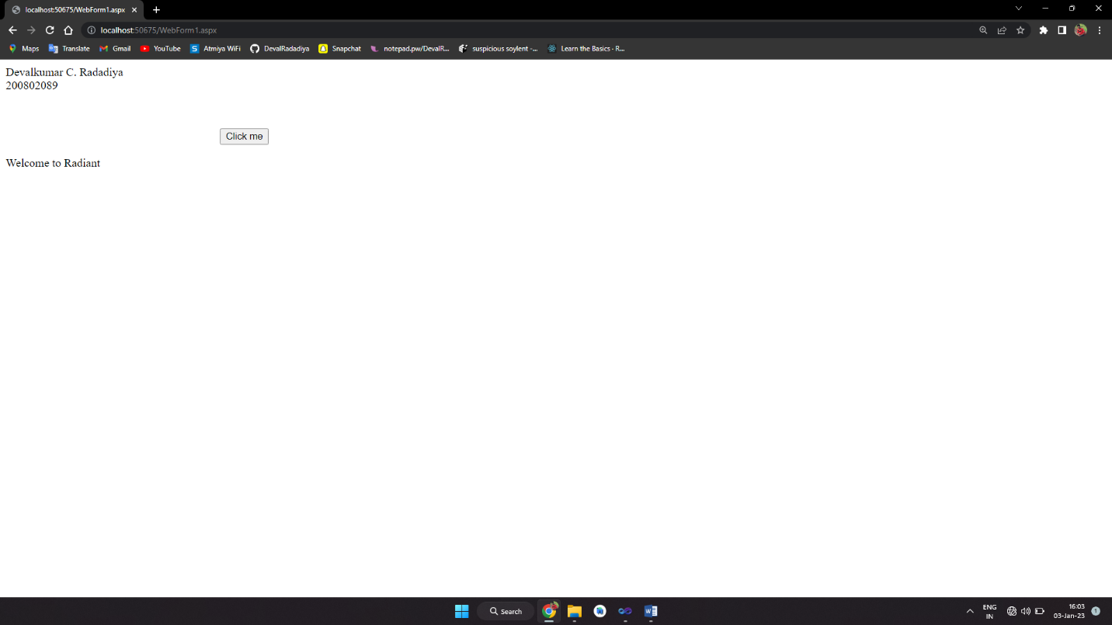

1. **Create the payment method application using asp.net controls.**

**Code :**

**WebForm1.aspx.cs :**

using System;

using System.Collections.Generic;

using System.Linq;

using System.Web;

using System.Web.UI;

using System.Web.UI.WebControls;

namespace WebApplication2

{

public partial class WebForm1 : System.Web.UI.Page

{

protected void Page_Load(object sender, EventArgs e)

{

Label5.Text = "Devalkumar C. Radadiya";

Label6.Text = "200802089";

}

protected void Button1_Click(object sender, EventArgs e)

{

Label4.Text = TextBox1.Text;

if (RadioButton1.Checked==true)

{

Label7.Text = RadioButton1.Text;

}

else

{

Label7.Text = RadioButton2.Text;

}

Label8.Text = DropDownList1.SelectedItem.ToString();

}

}

}

**WebForm1.aspx :**

<%@ Page Language="C#" AutoEventWireup="true" CodeBehind="WebForm1.aspx.cs" Inherits="WebApplication2.WebForm1" %>

<!DOCTYPE html PUBLIC "-//W3C//DTD XHTML 1.0 Transitional//EN" "http://www.w3.org/TR/xhtml1/DTD/xhtml1-transitional.dtd">

<html xmlns="http://www.w3.org/1999/xhtml">

<head runat="server">

<title></title>

</head>

<body style="background-color:Green">

<form id="form1" runat="server">

<div>

<asp:Label ID="Label5" runat="server" ForeColor="Yellow"></asp:Label>

<br />

<br />

<asp:Label ID="Label6" runat="server" ForeColor="Yellow"></asp:Label>

<br />

<br />

</div>

<asp:Label ID="Label1" runat="server" Text="Enter Your Name : "

ForeColor="Yellow"></asp:Label>

<asp:TextBox ID="TextBox1" runat="server"></asp:TextBox>

<p>

<asp:Label ID="Label2" runat="server" Text="Mode of Payment : "

ForeColor="Yellow"></asp:Label>

<asp:RadioButton ID="RadioButton1" runat="server" Text="Cash" />

<asp:RadioButton ID="RadioButton2" runat="server" Text="Card" />

</p>

<asp:Label ID="Label3" runat="server"

Text="Pleae select any one of this List : " ForeColor="Yellow"></asp:Label>

<asp:DropDownList ID="DropDownList1" runat="server">

<asp:ListItem>Visa</asp:ListItem>

<asp:ListItem>Master</asp:ListItem>

<asp:ListItem>RuPay</asp:ListItem>

</asp:DropDownList>

<p>

<asp:Button ID="Button1" runat="server" onclick="Button1_Click"

Text="Check for Validation" Font-Bold="True" ForeColor="#33CC33" />

</p>

<asp:Label ID="Label4" runat="server"></asp:Label>

<p>

<asp:Label ID="Label7" runat="server"></asp:Label>

</p>

<asp:Label ID="Label8" runat="server"></asp:Label>

</form>

</body>

</html>

**Output :**

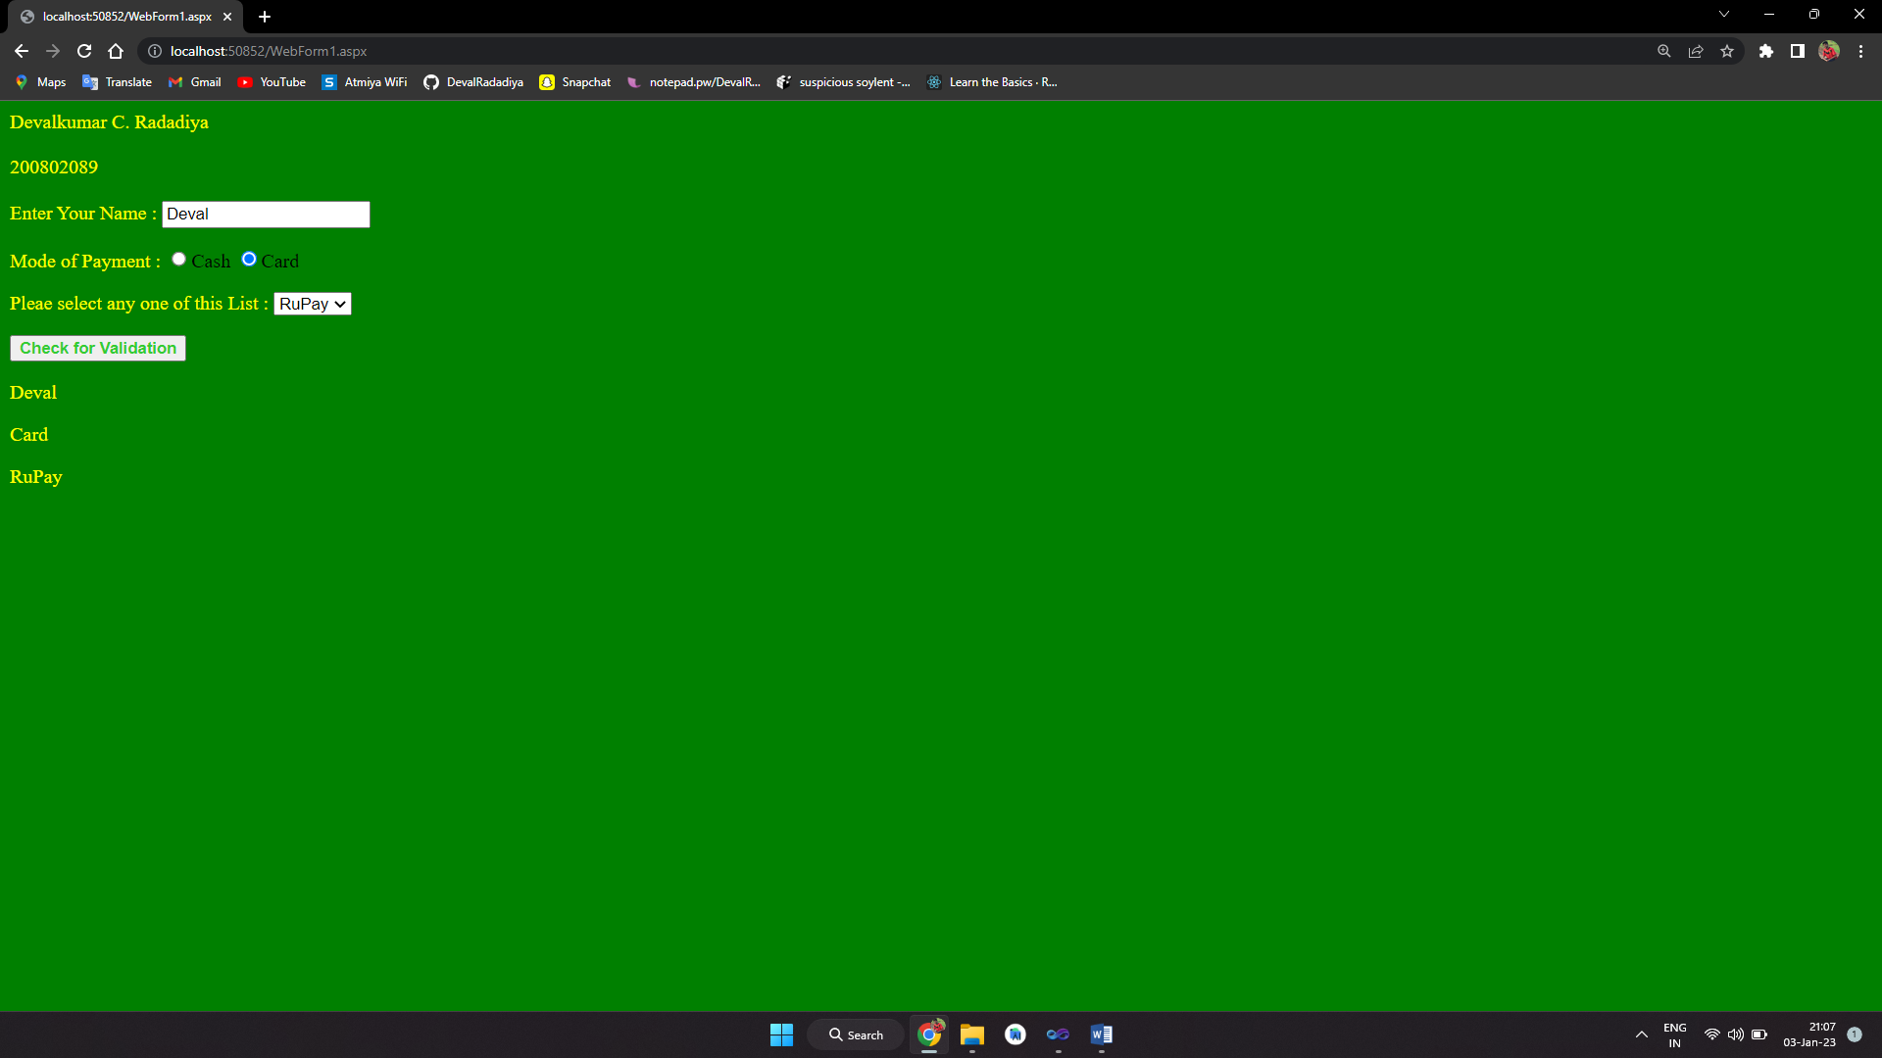

1. **Create a resume of the candidate using asp.net application.**

**WebForm1.aspx :**

<%@ Page Language="C#" AutoEventWireup="true" CodeBehind="WebForm1.aspx.cs" Inherits="Assignment2_3.WebForm1" %>

<!DOCTYPE html>

<html xmlns="http://www.w3.org/1999/xhtml">

<head runat="server">

<title></title>

</head>

<body>

<form id="form1" runat="server">

<div>

<strong>Devalkumar C. Radadiya<br />

200802089</strong><br /><br />

</div>

<asp:Label ID="Label8" runat="server"></asp:Label>

<br />

<br />

<asp:Label ID="Label1" runat="server" Font-Bold="True" Font-Size="Larger" Text="Please Fill Your Details Here ..."></asp:Label>

<br />

<br />

<asp:Label ID="Label2" runat="server" Text="Enter Your Name : "></asp:Label>

&nbsp;&nbsp;&nbsp;

<asp:TextBox ID="TextBox1" runat="server" Width="152px" required="required"></asp:TextBox>

<p>

<asp:Label ID="Label3" runat="server" Text="Enter Your Address : "></asp:Label>

&nbsp;<asp:TextBox ID="TextBox3" runat="server" Height="36px" TextMode="MultiLine" Width="133px" required="required"></asp:TextBox>

</p>

<asp:Label ID="Label4" runat="server" Text="Select Date Of Birth : "></asp:Label>

&nbsp;<asp:TextBox ID="TextBox4" runat="server" Height="16px" Width="134px"></asp:TextBox>

<br />

<br />

<asp:Label ID="Label5" runat="server" Text="Nationality : "></asp:Label>

&nbsp;&nbsp;&nbsp;&nbsp;&nbsp;&nbsp;&nbsp;&nbsp;&nbsp;&nbsp;&nbsp;&nbsp;&nbsp;&nbsp;

<asp:DropDownList ID="DropDownList1" runat="server" Height="20px" Width="107px" required="required">

<asp:ListItem>Indian</asp:ListItem>

<asp:ListItem>American</asp:ListItem>

<asp:ListItem>Italian</asp:ListItem>

<asp:ListItem>African</asp:ListItem>

<asp:ListItem>Japanese</asp:ListItem>

<asp:ListItem>Egyptians</asp:ListItem>

</asp:DropDownList>

<p>

<asp:Label ID="Label6" runat="server" Text="Mention Your Skills : "></asp:Label>

<asp:TextBox ID="TextBox2" runat="server" Width="178px" required="required" TextMode="MultiLine"></asp:TextBox>

</p>

<asp:Button ID="Button1" runat="server" Height="30px" OnClick="Button1_Click" Text="Submit" Width="98px" />

<br />

<br />

<asp:Label ID="Label7" runat="server"></asp:Label>

</form>

</body>

</html>

**WebForm1.aspx.cs :**

using System;

using System.Collections.Generic;

using System.Linq;

using System.Web;

using System.Web.UI;

using System.Web.UI.WebControls;

namespace Assignment2_3

{

public partial class WebForm1 : System.Web.UI.Page

{

protected void Page_Load(object sender, EventArgs e)

{

}

protected void Button1_Click(object sender, EventArgs e)

{

Label8.Text = "uname =" +TextBox1.Text+ " has visited the site.";

Label7.Text = "Thanks For Registering , You will be Contacted Soon...";

}

}

}

**OUTPUT :**

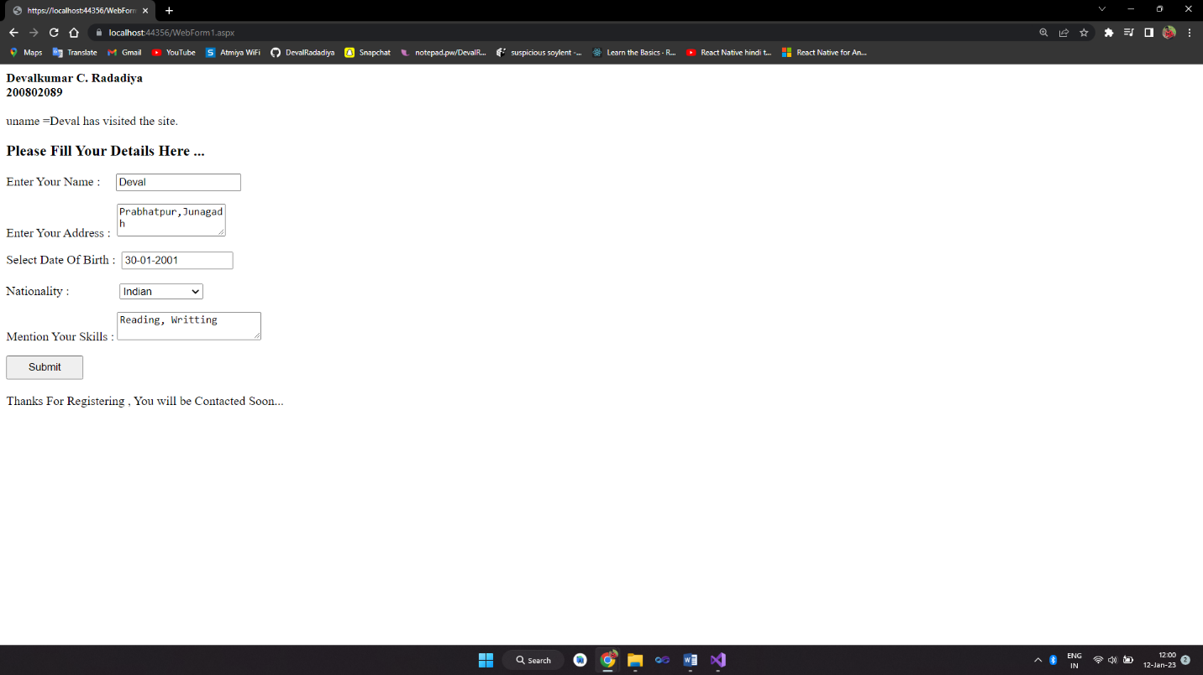

1. **Create an asp.net application for employee details and perform the operations (Add, count, clear, etc..) on dropdown control and display the same.**

**WebForm1.aspx :**

<%@ Page Language="C#" AutoEventWireup="true" CodeBehind="index.aspx.cs" Inherits="Assignment_2_4.index" %>

<!DOCTYPE html PUBLIC "-//W3C//DTD XHTML 1.0 Transitional//EN" "http://www.w3.org/TR/xhtml1/DTD/xhtml1-transitional.dtd">

<html xmlns="http://www.w3.org/1999/xhtml">

<head runat="server">

<title>Assignment_2_4</title>

<style type="text/css">

.auto-style1 {

height: 37px;

}

</style>

</head>

<body>

<div>

<asp:Label runat="server">Devalkumar C. Radadiya<br>200802089</br></asp:Label>

</div><br />

<form id="form1" runat="server">

<div style="height: 477px">

<asp:Label ID="Label1" runat="server" Font-Bold="True"

Font-Names="Adobe Gothic Std B" style="font-weight: 700"

Text="No, Name and Salary List of emp table" ForeColor="#3333CC"></asp:Label>

<br />

<br />

<table style=" text-align: right; height: 115px; width: 139px;" border="2px" cellpadding="5" cellspacing="3">

<tr>

<th>No </th>

<td><asp:DropDownList runat="server" ID="dropNo">

<asp:ListItem>1</asp:ListItem>

</asp:DropDownList></td>

</tr>

<tr>

<th>Name</th>

<td><asp:DropDownList runat="server" ID="dropName">

<asp:ListItem>Devalkumar</asp:ListItem>

</asp:DropDownList></td>

</tr>

<tr>

<th class="auto-style1">Salary</th>

<td class="auto-style1"><asp:DropDownList runat="server" ID="dropSalary">

<asp:ListItem>1,00,000</asp:ListItem>

</asp:DropDownList></td>

</tr>

</table>

<br />

<asp:Label ID="Label3" runat="server" Text="Enter Item Name :"></asp:Label>

<asp:Label ID="Label5" runat="server" Font-Bold="True"

Font-Names="Lucida Bright"></asp:Label>

<br />

<asp:TextBox ID="TextBox1" runat="server" ToolTip="enter dropdown item name"

Width="176px"></asp:TextBox>

<asp:Label ID="Label4" runat="server" ForeColor="Red"></asp:Label>

<br />

<br />

<asp:Label ID="Label2" runat="server" Text="Select DropDown :"></asp:Label>

<br />

<asp:DropDownList ID="dropSelect" runat="server">

<asp:ListItem>No.</asp:ListItem>

<asp:ListItem>Name</asp:ListItem>

<asp:ListItem>Salary</asp:ListItem>

</asp:DropDownList>

<br />

<br />

<asp:Button ID="Button1" runat="server" Text="Add Item" Width="86px" onclick="Button1_Click" />

&nbsp;

<asp:Button ID="Button2" runat="server" Text="Count Items"

onclick="Button2_Click" />

&nbsp;

<asp:Button ID="Button3" runat="server" Text="Clear All Items "

onclick="Button3_Click" />

</div>

</form>

</body>

</html>

**WebForm1.aspx.cs :**

using System;

using System.Collections.Generic;

using System.Linq;

using System.Web;

using System.Web.UI;

using System.Web.UI.WebControls;

namespace Assignment_2_4

{

public partial class index : System.Web.UI.Page

{

protected void Page_Load(object sender, EventArgs e)

{

}

protected void Button1_Click(object sender, EventArgs e)

{

if (!(TextBox1.Text.Equals(null)) && !(dropSelect.SelectedValue.Equals(null)))

{

string s = TextBox1.Text;

if (dropSelect.SelectedValue == "No")

dropNo.Items.Add(s);

else if (dropSelect.SelectedValue == "Name")

dropName.Items.Add(s);

else

dropSalary.Items.Add(s);

TextBox1.Text = "";

}

else

{

TextBox1.Text = "";

Label4.Text = "All fields are required!";

}

}

protected void Button2_Click(object sender, EventArgs e)

{

if (dropSelect.SelectedValue == "No")

Label5.Text = "Count items : " + dropNo.Items.Count;

else if (dropSelect.SelectedValue == "Name")

Label5.Text = "Count items : " + dropName.Items.Count;

else

Label5.Text = "Count items : " + dropSalary.Items.Count;

}

protected void Button3_Click(object sender, EventArgs e)

{

dropNo.Items.Clear();

dropName.Items.Clear();

dropSalary.Items.Clear();

}

}

}

**OUTPUT :**

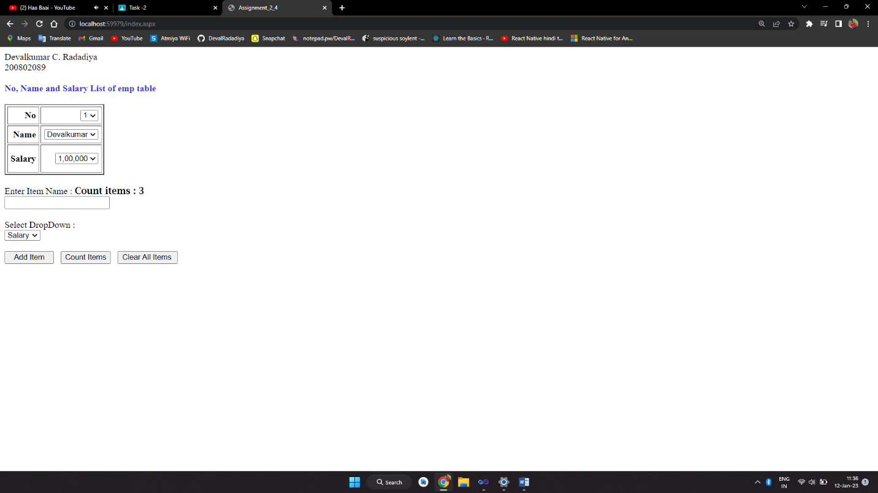

1. **Write a program to using the radio button and choose your favorite flower and display the same.**

**WebForm1.aspx :**

<%@ Page Language="C#" AutoEventWireup="true" CodeBehind="WebForm1.aspx.cs" Inherits="Assignment2_5.WebForm1" %>

<!DOCTYPE html PUBLIC "-//W3C//DTD XHTML 1.0 Transitional//EN" "http://www.w3.org/TR/xhtml1/DTD/xhtml1-transitional.dtd">

<html xmlns="http://www.w3.org/1999/xhtml">

<head runat="server">

<title></title>

</head>

<body>

<form id="form1" runat="server">

<div>

<asp:Label ID="l1" runat="server"><b>Devalkumar C. Radadiya <br />

200802089</b>

</asp:Label>

</div><br />

<div>

<asp:RadioButton ID="RadioButton1" runat="server" Text="Jasmine" GroupName="f" />

&nbsp;&nbsp;&nbsp;

<asp:RadioButton ID="RadioButton2" runat="server" Text="Lily" GroupName="f" />

</div>

<p>

<asp:RadioButton ID="RadioButton3" runat="server" Text="Rose" GroupName="f" />

&nbsp;&nbsp;&nbsp;&nbsp;&nbsp;&nbsp;&nbsp;

<asp:RadioButton ID="RadioButton4" runat="server" Text="Daisy" GroupName="f" />

</p>

<p>

<asp:RadioButton ID="RadioButton5" runat="server" Text="Lotus" GroupName="f" />

&nbsp;&nbsp;&nbsp;&nbsp;&nbsp;&nbsp

<asp:RadioButton ID="RadioButton6" runat="server" Text="Dahlia" GroupName="f" />

</p>

<p>

<asp:Button ID="Button1" runat="server" Height="26px" onclick="Button1_Click"

Text="Submit" Width="65px" />

</p>

<asp:Label ID="Label1" runat="server"></asp:Label>

</form>

</body>

</html>

**WebForm1.aspx.cs :**

using System;

using System.Collections.Generic;

using System.Linq;

using System.Web;

using System.Web.UI;

using System.Web.UI.WebControls;

namespace Assignment2_5

{

public partial class WebForm1 : System.Web.UI.Page

{

protected void Page_Load(object sender, EventArgs e)

{

}

protected void Button1_Click(object sender, EventArgs e)

{

if(RadioButton1.Checked)

Label1.Text = "Your Favourite Flower is : " + RadioButton1.Text;

if (RadioButton2.Checked)

Label1.Text = "Your Favourite Flower is : " + RadioButton2.Text;

if (RadioButton3.Checked)

Label1.Text = "Your Favourite Flower is : " + RadioButton3.Text;

if (RadioButton4.Checked)

Label1.Text = "Your Favourite Flower is : " + RadioButton4.Text;

if (RadioButton5.Checked)

Label1.Text = "Your Favourite Flower is : " + RadioButton5.Text;

if (RadioButton6.Checked)

Label1.Text = "Your Favourite Flower is : " + RadioButton6.Text;

}

}

}

**OUTPUT :**

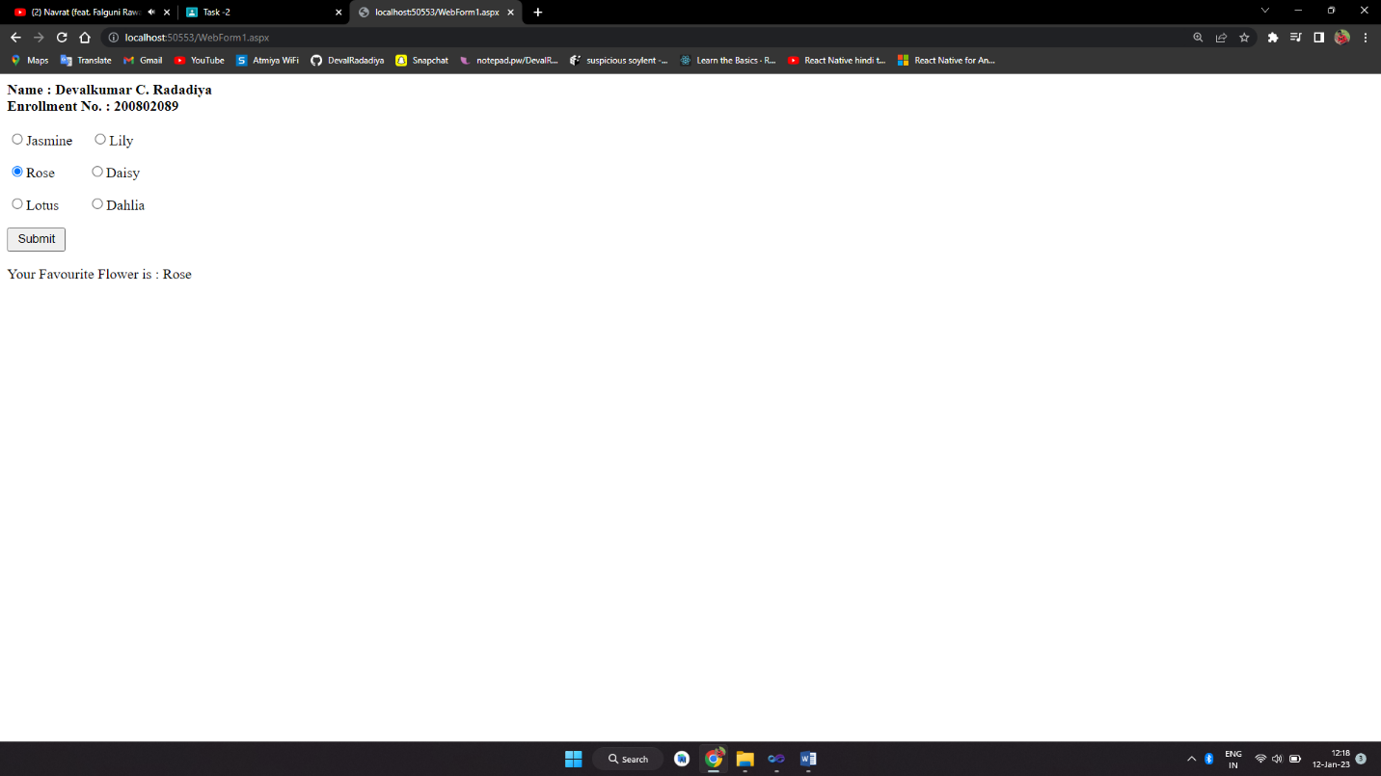

1. **Write a program to provide the list of available products at your shop**

**and print the list of selected items.**

**WebForm1.aspx :**

<%@ Page Language="C#" AutoEventWireup="true" CodeBehind="WebForm1.aspx.cs" Inherits="Assignment2_6.WebForm1" %>

<!DOCTYPE html PUBLIC "-//W3C//DTD XHTML 1.0 Transitional//EN" "http://www.w3.org/TR/xhtml1/DTD/xhtml1-transitional.dtd">

<html xmlns="http://www.w3.org/1999/xhtml">

<head runat="server">

<title></title>

</head>

<body>

<form id="form1" runat="server">

<div>

<asp:Label ID="l1" runat="server">

<b>Name : Devalkumar C. Radadiya <br />

Enrollment No. : 200802089</b>

</asp:Label>

</div>

<p>

<asp:Label ID="Label2" runat="server" Font-Bold="True"

Text="Following Is The List of Available Products : "></asp:Label>

</p>

<p>

<asp:CheckBox ID="CheckBox1" runat="server" Text="Rice" />

</p>

<asp:CheckBox ID="CheckBox2" runat="server" Text="Wheat" />

<p>

<asp:CheckBox ID="CheckBox3" runat="server" Text="Maize" />

</p>

<asp:CheckBox ID="CheckBox4" runat="server" Text="Corn" />

<p>

<asp:CheckBox ID="CheckBox5" runat="server" Text="Sugar" />

</p>

<asp:Button ID="Button1" runat="server" Text="Submit" onclick="Button1_Click" />

<p>

<asp:Label ID="Label1" runat="server"></asp:Label>

</p>

</form>

</body>

</html>

**WebForm1.aspx.cs :**

using System;

using System.Collections.Generic;

using System.Linq;

using System.Web;

using System.Web.UI;

using System.Web.UI.WebControls;

namespace Assignment2_6

{

public partial class WebForm1 : System.Web.UI.Page

{

protected void Page_Load(object sender, EventArgs e)

{

}

protected void Button1_Click(object sender, EventArgs e)

{

if (CheckBox1.Checked)

Label1.Text += CheckBox1.Text + "<br/>";

if (CheckBox2.Checked)

Label1.Text += CheckBox2.Text + "<br/>";

if (CheckBox3.Checked)

Label1.Text += CheckBox3.Text + "<br/>";

if (CheckBox4.Checked)

Label1.Text += CheckBox4.Text + "<br/>";

if (CheckBox5.Checked)

Label1.Text += CheckBox5.Text;

}

}

}

**OUTPUT :**

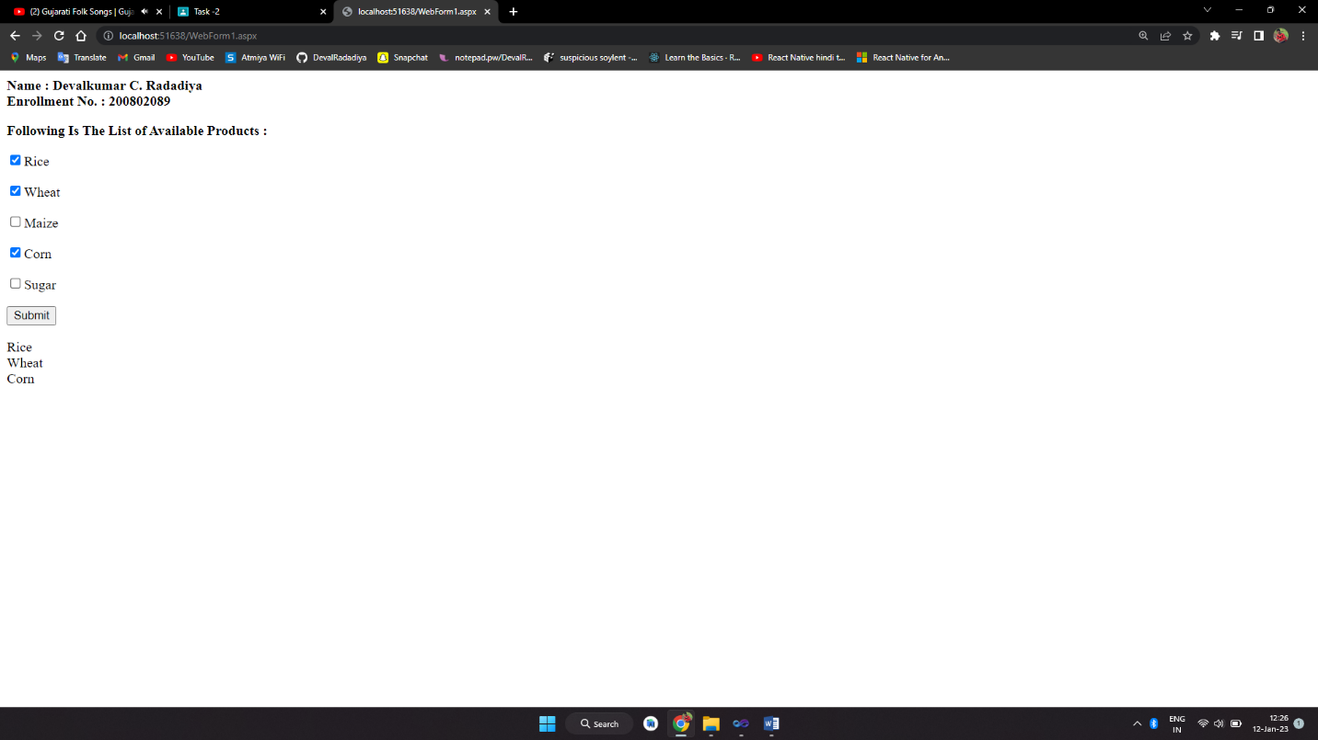

1. **Write a program to add, remove, count, and clear the data from the list box**

**note(data must be as given below)**

**WebForm1.aspx :**

<%@ Page Language="C#" AutoEventWireup="true" CodeBehind="index.aspx.cs" Inherits="Assignment_2_7.index" %>

<!DOCTYPE html PUBLIC "-//W3C//DTD XHTML 1.0 Transitional//EN" "http://www.w3.org/TR/xhtml1/DTD/xhtml1-transitional.dtd">

<html xmlns="http://www.w3.org/1999/xhtml">

<head runat="server">

<title>Assignment_2_7</title>

</head>

<body style="background-color:lightpink">

<div>

<asp:Label runat="server"><b>Name : Devalkumar C. Radadiya<br />

Enrollment No. : 200802089 <br /><br /></b>

</asp:Label>

</div>

<form id="form1" runat="server">

<div style="height: 430px">

<br />

&nbsp;&nbsp;

<asp:Label ID="Label1" runat="server" Text="Colors : "></asp:Label>

<asp:ListBox ID="ListBox1" runat="server">

<asp:ListItem>Green</asp:ListItem>

<asp:ListItem>Yellow</asp:ListItem>

<asp:ListItem>Blue</asp:ListItem>

<asp:ListItem>Gray</asp:ListItem>

</asp:ListBox>

<br />

<br />

&nbsp;&nbsp;

<asp:Button ID="Button1" runat="server" Text="Submit" Width="128px"

onclick="Button1_Click" /><br /><br />

&nbsp;&nbsp;&nbsp;

<asp:Label ID="Label2" runat="server"></asp:Label>

<br />

<br />

<asp:Button ID="Button2" runat="server" onclick="Button2_Click" Text="Add Item"

Width="86px" />

<asp:Button ID="Button3" runat="server" onclick="Button3_Click" Text="Count"

Width="82px" />

<asp:Button ID="Button4" runat="server" onclick="Button4_Click" Text="Clear"

Width="80px" />

<br />

<br />

&nbsp;&nbsp;

<asp:TextBox ID="TextBox1" runat="server"></asp:TextBox>

&nbsp;

&nbsp;

&nbsp;

</div>

</form>

</body>

</html>

**WebForm1.aspx.cs :**

using System;

using System.Collections.Generic;

using System.Linq;

using System.Web;

using System.Web.UI;

using System.Web.UI.WebControls;

namespace Assignment_2_7

{

public partial class index : System.Web.UI.Page

{

protected void Page_Load(object sender, EventArgs e)

{

}

protected void Button1_Click(object sender, EventArgs e)

{

if (ListBox1.SelectedValue != "")

{Label2.Text = "You have select the Color : <b>" + ListBox1.SelectedValue + "</b>";}

else {Label2.Text = "Please select any color!";}

}

protected void Button2_Click(object sender, EventArgs e)

{

TextBox1.BackColor = System.Drawing.Color.White;

TextBox1.ForeColor = System.Drawing.Color.Black;

if (TextBox1.Text != "") {

ListBox1.Items.Add(TextBox1.Text);

TextBox1.Text = "";

} else {

TextBox1.BackColor = System.Drawing.Color.Red;

TextBox1.ForeColor = System.Drawing.Color.White;

}

}

protected void Button3_Click(object sender, EventArgs e)

{Label2.Text = "Total item count is : <b>" + ListBox1.Items.Count + "</b>";}

protected void Button4_Click(object sender, EventArgs e)

{ListBox1.Items.Clear();}

}

}

**OUTPUT :**

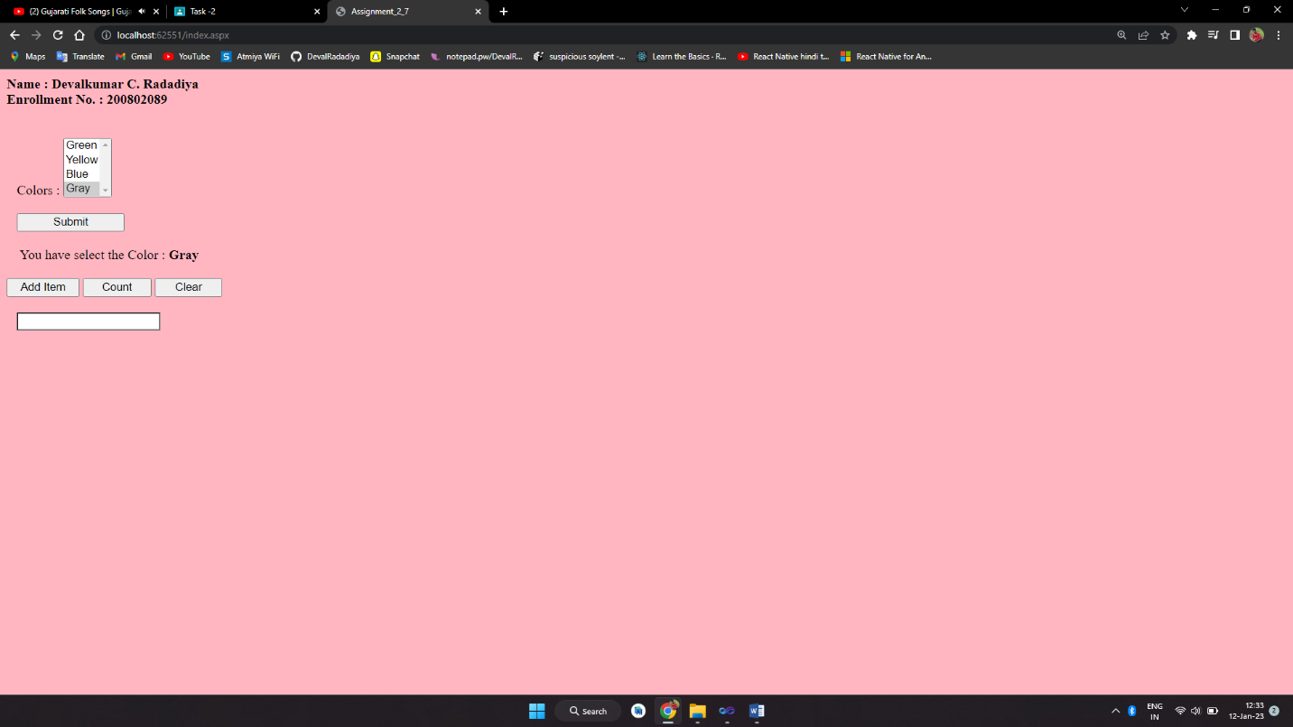

1. **Design the web page using hyperlink control ,when student click on the link color must be changed of the selected link.**

**WebForm1.aspx :**

<%@ Page Language="C#" AutoEventWireup="true" CodeBehind="WebForm1.aspx.cs" Inherits="WebApplication2_8.WebForm1" %>

<!DOCTYPE html PUBLIC "-//W3C//DTD XHTML 1.0 Transitional//EN" "http://www.w3.org/TR/xhtml1/DTD/xhtml1-transitional.dtd">

<html xmlns="http://www.w3.org/1999/xhtml">

<head runat="server">

<title></title>

</head>

<body>

<form id="form1" runat="server">

<div>

<asp:Label ID="Label1" runat="server">

<b>Devalkumar C. Radadiya <br />

200802089<br />

</b>

</asp:Label>

</div>

<p>

<asp:Label ID="Label3" runat="server" Text="Enter Roll no :" BorderStyle="Dotted"></asp:Label>

&nbsp;<asp:TextBox ID="TextBox1" runat="server"></asp:TextBox>

&nbsp;&nbsp;&nbsp;

<asp:Label ID="Label6" runat="server"></asp:Label>

</p>

<p>

<asp:Label ID="Label4" runat="server" Text="Enter Name :"></asp:Label>

&nbsp;&nbsp;

<asp:TextBox ID="TextBox2" runat="server"></asp:TextBox>

&nbsp;&nbsp;&nbsp;

<asp:Label ID="Label7" runat="server"></asp:Label>

</p>

<p>

<asp:Label ID="Label5" runat="server" Text="Enter Marks :"></asp:Label>

&nbsp;

<asp:TextBox ID="TextBox3" runat="server"></asp:TextBox>

&nbsp;&nbsp;&nbsp;

<asp:Label ID="Label8" runat="server"></asp:Label>

</p>

<asp:Button ID="Button1" runat="server" Text="Submit" OnClick="Button1_Click" />

&nbsp;&nbsp;&nbsp;

<asp:Button ID="Button2" runat="server" Text="Clear" />

<p>

<asp:HyperLink ID="HyperLink1" runat="server" NavigateUrl="~/bscit.aspx" Font-Size=XX-Large >BSC IT</asp:HyperLink>

</p>

<asp:HyperLink ID="HyperLink2" runat="server" NavigateUrl="~/baf.aspx" Font-Size="X-Large">BAF</asp:HyperLink>

<p>

<asp:HyperLink ID="HyperLink3" runat="server" NavigateUrl="~/bms.aspx" Font-Underline="True">BMS</asp:HyperLink>

</p>

<asp:HyperLink ID="HyperLink4" runat="server" NavigateUrl="~/cont.aspx" BackColor=DarkGray>Contact us</asp:HyperLink>

</form>

</body>

</html>

**WebForm1.aspx.cs :**

using System;

using System.Collections.Generic;

using System.Linq;

using System.Web;

using System.Web.UI;

using System.Web.UI.WebControls;

namespace WebApplication2_8

{

public partial class WebForm1 : System.Web.UI.Page

{

protected void Page_Load(object sender, EventArgs e)

{ }

protected void Button1_Click(object sender, EventArgs e)

{

Label6.Text = TextBox1.Text;

Label7.Text = TextBox2.Text;

Label8.Text = TextBox3.Text;

}

}

}

**OUTPUT :**

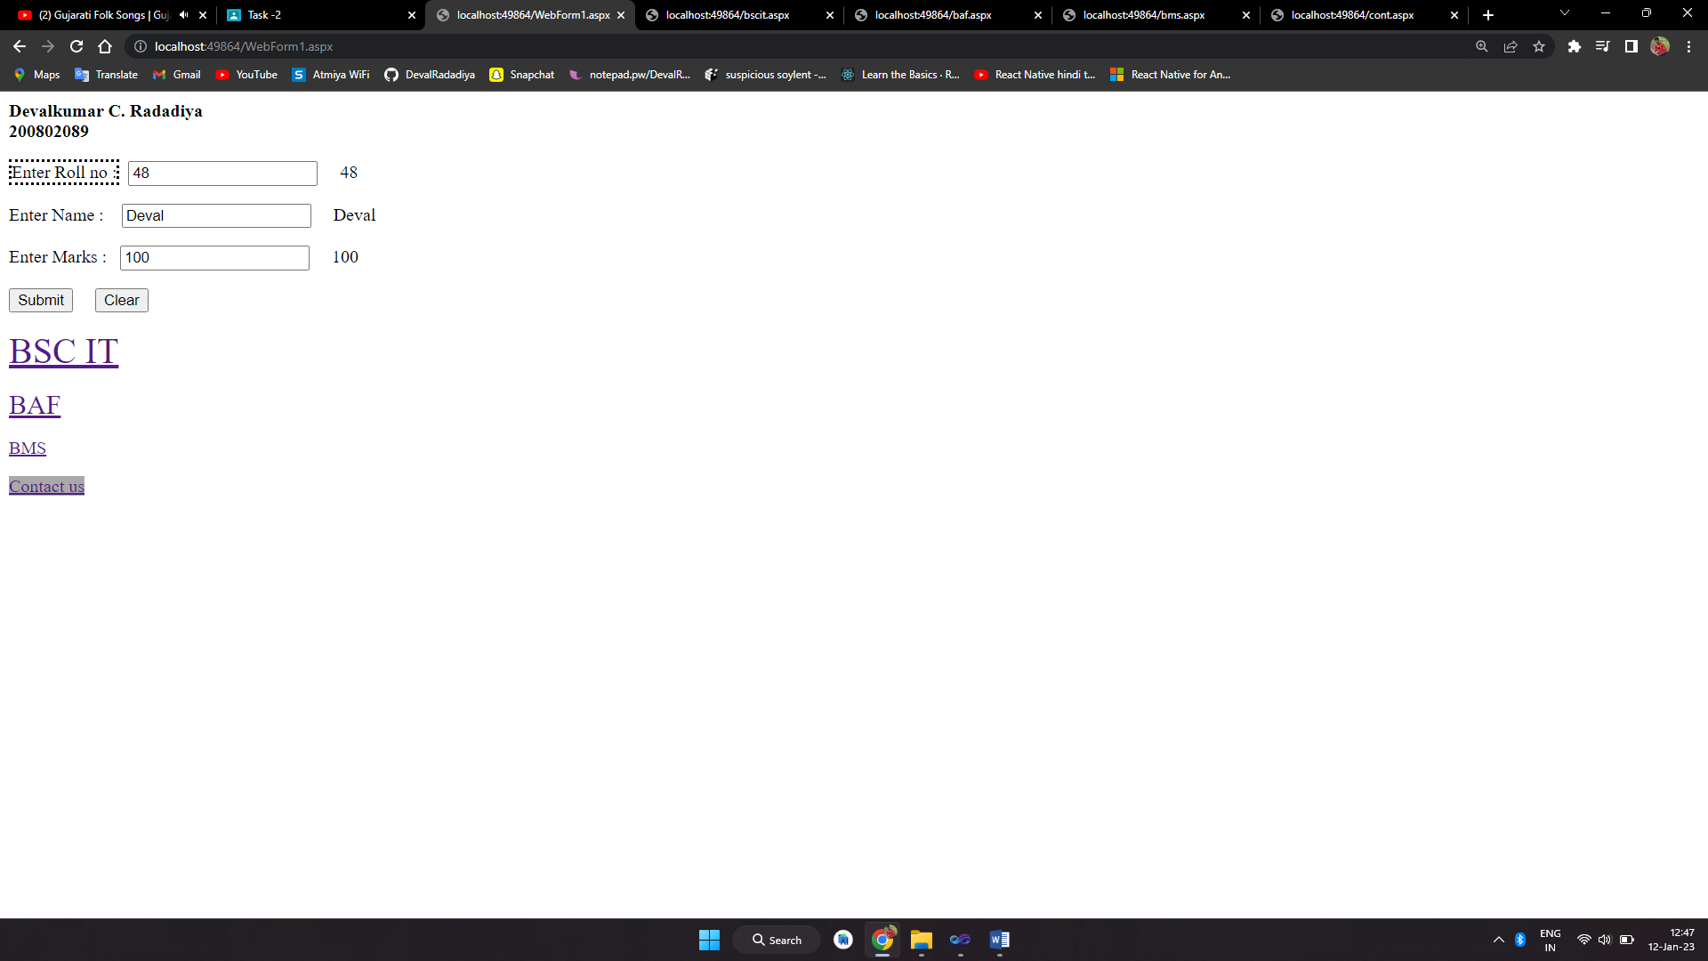

1. **Create hierarchies of folders and files using tree view as given below.**

**Index.aspx :**

<%@ Page Language="C#" AutoEventWireup="true" CodeBehind="index.aspx.cs" Inherits="Assignment_2_9.index" %>

<!DOCTYPE html PUBLIC "-//W3C//DTD XHTML 1.0 Transitional//EN" "http://www.w3.org/TR/xhtml1/DTD/xhtml1-transitional.dtd">

<html xmlns="http://www.w3.org/1999/xhtml">

<head runat="server">

<title>Assignment_2_9</title>

</head>

<body>

<div>

<asp:Label runat="server"><b>Devalkumar C. Radadiya<br />

200802089 <br /></b>

</asp:Label>

</div><br />

<form id="form1" runat="server">

<div style="height: 563px">

&nbsp;

<asp:Label ID="Label1" runat="server" style="font-weight: 700"

Text="Welcome to local bank of india."></asp:Label>

<br />

&nbsp;&nbsp;&nbsp;&nbsp;&nbsp;&nbsp;&nbsp;

<asp:TreeView ID="TreeView1" runat="server"

onselectednodechanged="TreeView1_SelectedNodeChanged">

<Nodes>

<asp:TreeNode Text="Local bank of India" Value="Local bank of india">

<asp:TreeNode Text="Home" Value="Home"></asp:TreeNode>

<asp:TreeNode Text="About Us" Value="About Us"></asp:TreeNode>

<asp:TreeNode Text="Statistics" Value="Statistics">

<asp:TreeNode Text="Data Releases" Value="Data Releases"></asp:TreeNode>

<asp:TreeNode Text="Database on indian Economy"

Value="Database on indian Economy"></asp:TreeNode>

<asp:TreeNode Text="Services" Value="Services"></asp:TreeNode>

</asp:TreeNode>

<asp:TreeNode Text="Publications" Value="Publications">

<asp:TreeNode Text="Annual" Value="Annual"></asp:TreeNode>

<asp:TreeNode Text="Monthly" Value="Monthly"></asp:TreeNode>

<asp:TreeNode Text="Reports" Value="Reports"></asp:TreeNode>

</asp:TreeNode>

<asp:TreeNode></asp:TreeNode>

</asp:TreeNode>

</Nodes>

</asp:TreeView>

<br />

&nbsp;&nbsp;&nbsp;&nbsp;&nbsp;&nbsp;&nbsp;

<asp:Label ID="Label2" runat="server"></asp:Label>

<br />

</div>

</form>

</body>

</html>

**Index.aspx.cs :**

using System;

using System.Collections.Generic;

using System.Linq;

using System.Web;

using System.Web.UI;

using System.Web.UI.WebControls;

namespace Assignment_2_9

{

public partial class index : System.Web.UI.Page

{

protected void Page_Load(object sender, EventArgs e)

{

}

protected void TreeView1_SelectedNodeChanged(object sender, EventArgs e)

{

Label2.Text = "<b>You Select : </b>" + TreeView1.SelectedValue;

}

}

}

**OUTPUT :**

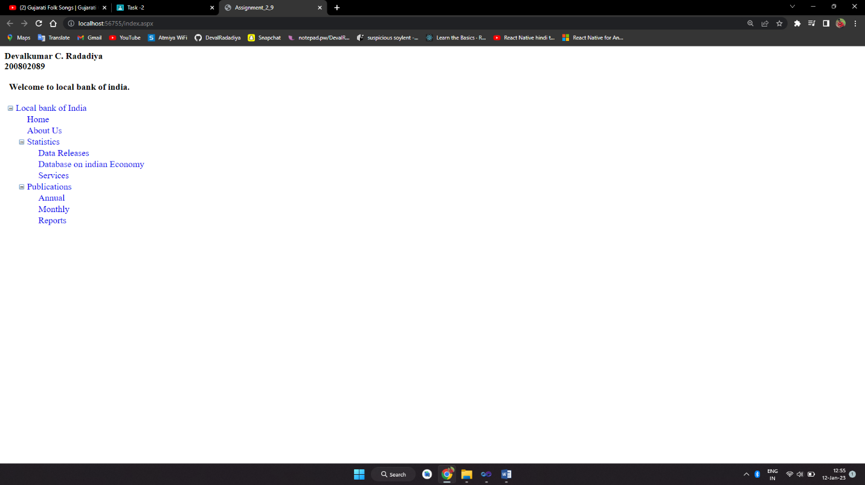

1. **Create the web page to add panel control and display as above and write all properties and descriptions of panel control.**

**Index.aspx.cs :**

using System;

using System.Collections.Generic;

using System.Linq;

using System.Web;

using System.Web.UI;

using System.Web.UI.WebControls;

namespace Assignment_2_10

{

public partial class index : System.Web.UI.Page

{

protected void Page_Load(object sender, EventArgs e)

{

}

protected void Button1_Click(object sender, EventArgs e)

{

Panel2.Visible = false;

Panel3.Visible = true;

Panel4.Visible = false;

}

protected void Button2_Click(object sender, EventArgs e)

{

Panel2.Visible = true;

Panel3.Visible = false;

Panel4.Visible = false;

}

protected void Button3_Click(object sender, EventArgs e)

{

Panel2.Visible = false;

Panel3.Visible = false;

Panel4.Visible = true;

}

protected void Button4_Click(object sender, EventArgs e)

{

Panel2.Visible = false;

Panel3.Visible = true;

Panel4.Visible = false;

}

protected void Button5_Click(object sender, EventArgs e)

{

// code for login

}

}

}

**Index.aspx :**

<%@ Page Language="C#" AutoEventWireup="true" CodeBehind="index.aspx.cs" Inherits="Assignment_2_10.index" %>

<!DOCTYPE html PUBLIC "-//W3C//DTD XHTML 1.0 Transitional//EN" "http://www.w3.org/TR/xhtml1/DTD/xhtml1-transitional.dtd">

<html xmlns="http://www.w3.org/1999/xhtml">

<head id="Head1" runat="server">

<title>Assignment_2_10</title>

</head>

<body>

<div>

<asp:Label runat="server">

<b>Devalkumar C. Radadiya<br />

200802089 <br /><br />

</b>

</asp:Label>

</div>

<form id="form1" runat="server">

<table style="z-index: 100; left: 137px; width: 583px; position: absolute; top: 64px">

<tr>

<td style="width: 100px">

<asp:Panel ID="Panel1" runat="server">

<asp:Panel ID="Panel2" runat="server">

<table style="border: thin solid black;"> <!-- thin = border-width -->

<tr>

<td colspan="2" style="text-align: center; border-bottom: maroon thin solid">

<span style="font-size: 16pt"><strong>Personal Detail :</strong></span>

</td>

</tr>

<tr>

<td style="width: 100px; text-align: right;">

Name :

</td>

<td style="width: 100px">

<asp:TextBox ID="TextBox1" runat="server"></asp:TextBox>

</td>

</tr>

<tr>

<td style="width: 100px; text-align: right;">

SurName :

</td>

<td style="width: 100px">

<asp:TextBox ID="TextBox2" runat="server"></asp:TextBox>

</td>

</tr>

<tr>

<td style="width: 100px; text-align: right;">

Gender :

</td>

<td style="width: 100px">

<asp:TextBox ID="TextBox3" runat="server"></asp:TextBox>

</td>

</tr>

<tr>

<td style="width: 100px; text-align: right;">

Mobile :

</td>

<td style="width: 100px">

<asp:TextBox ID="TextBox4" runat="server"></asp:TextBox>

</td>

</tr>

<tr>

<td style="width: 100px; height: 26px"></td>

<td style="width: 100px; height: 26px">

<asp:Button ID="Button1" runat="server" Text="Next" Width="72px" OnClick="Button1_Click" />

</td>

</tr>

</table>

</asp:Panel>

<asp:Panel ID="Panel3" runat="server" Visible="False">

<table style="border: thin solid black;"> <!-- thin = border-width -->

<tr>

<td colspan="2" style="text-align: center; border-bottom: maroon thin solid">

<strong><span style="font-size: 16pt">Address Detail :</span></strong>

</td>

</tr>

<tr>

<td style="width: 100px; text-align: right;">

Address :

</td>

<td style="width: 100px">

<asp:TextBox ID="TextBox5" runat="server"></asp:TextBox>

</td>

</tr>

<tr>

<td style="width: 100px; text-align: right;">

City :

</td>

<td style="width: 100px">

<asp:TextBox ID="TextBox6" runat="server"></asp:TextBox>

</td>

</tr>

<tr>

<td style="width: 100px; text-align: right;">

Pincode :

</td>

<td style="width: 100px">

<asp:TextBox ID="TextBox7" runat="server"></asp:TextBox>

</td>

</tr>

<tr>

<td style="width: 100px"></td>

<td style="width: 100px">

<asp:Button ID="Button2" runat="server" Text="Back" Width="56px" OnClick="Button2_Click" />

<asp:Button ID="Button3" runat="server" Text="Next" Width="56px" OnClick="Button3_Click" />

</td>

</tr>

</table>

</asp:Panel>

<asp:Panel ID="Panel4" runat="server" Visible="False">

<table style="border: thin solid black;"> <!-- thin = border-width -->

<tr>

<td colspan="2" style="text-align: center; border-bottom: maroon thin solid">

<strong><span style="font-size: 16pt">Login Area :</span></strong>

</td>

</tr>

<tr>

<td style="width: 100px; text-align: right;">

UserName :

</td>

<td style="width: 100px">

<asp:TextBox ID="TextBox8" runat="server"></asp:TextBox>

</td>

</tr>

<tr>

<td style="width: 100px; text-align: right;">

Password :

</td>

<td style="width: 100px">

<asp:TextBox ID="TextBox9" runat="server" TextMode="Password"></asp:TextBox>

</td>

</tr>

<tr>

<td style="width: 100px; height: 21px"></td>

<td style="width: 100px; height: 21px">

<asp:Button ID="Button4" runat="server" Text="Back" Width="56px" OnClick="Button4_Click" />

<asp:Button ID="Button5" runat="server" Text="Submit" onclick="Button5_Click" />

</td>

</tr>

<tr>

<td style="width: 100px"></td>

<td style="width: 100px"></td>

</tr>

</table>

</asp:Panel>

</asp:Panel>

</td>

</tr>

<tr>

<td style="width: 100px"></td>

</tr>

</table>

</form>

</body>

</html>

**OUTPUT :**

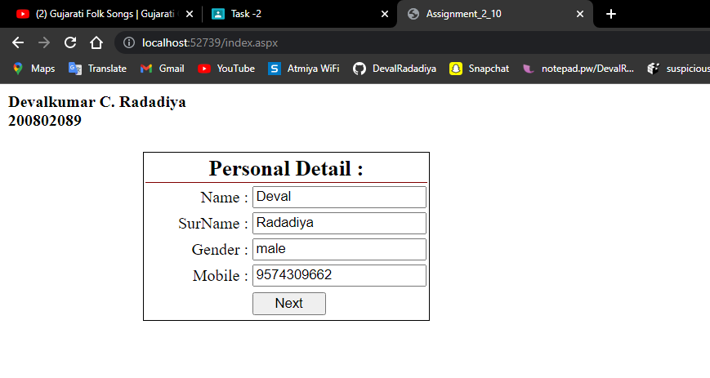

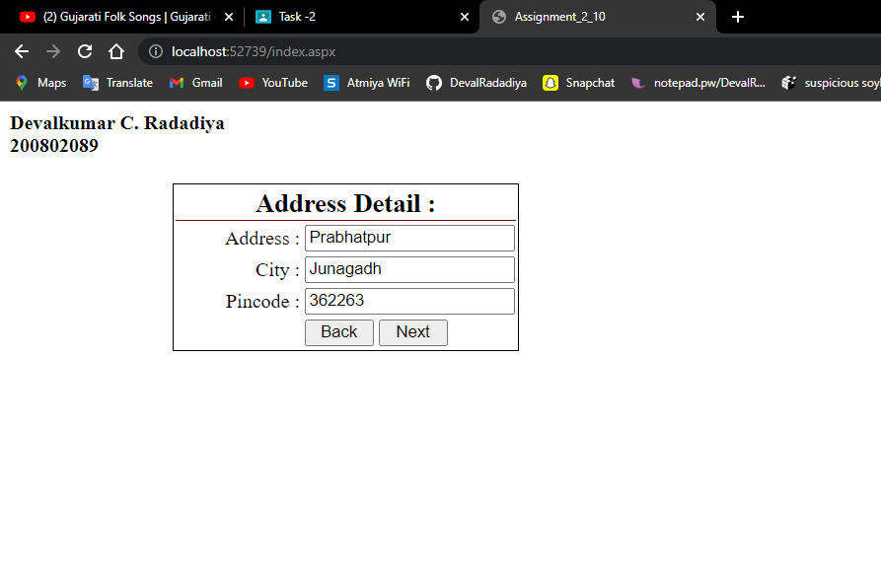

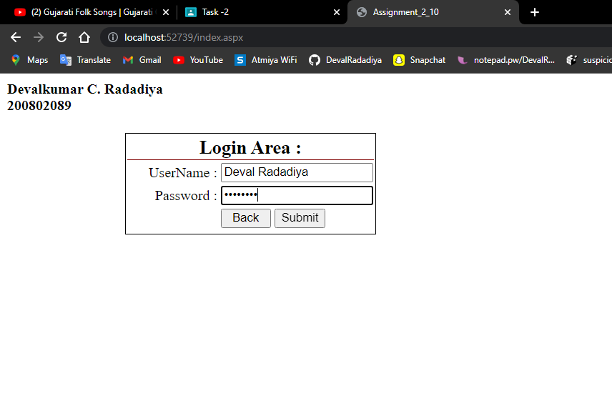

1. **Create the application to display the menus as below using menu**

**Control.**

**Index.aspx :**

<%@ Page Language="C#" AutoEventWireup="true" CodeFile="Default.aspx.cs" Inherits="_Default" %>

<!DOCTYPE html PUBLIC "-//W3C//DTD XHTML 1.0 Transitional//EN" "http://www.w3.org/TR/xhtml1/DTD/xhtml1-transitional.dtd">

<html xmlns="http://www.w3.org/1999/xhtml">

<head id="Head1" runat="server">

<title></title>

<style type="text/css">

</style>

</head>

<body>

<p style="float: right; margin: 0px; padding: 0px;">DEVALKUMAR C. RADADIYA</p><br/>

<p style="float: right; margin: 0px; padding: 0px;">200802089</p>

<form id="form1" runat="server">

<div>

</div>

<br/>

<br />

<br />

&nbsp;&nbsp;&nbsp;

<br />

<asp:Menu ID="Menu1" runat="server" Orientation="Horizontal"

RenderingMode="List" BackColor="#8AE0F2" BorderColor="White"

BorderStyle="None" Font-Names="Calibri" Font-Size="Large" ForeColor="Black">

<DynamicMenuItemStyle BackColor="Black" Font-Names="Calibri"

ForeColor="White" BorderColor="White" BorderStyle="Solid" Height="30px" />

<DynamicSelectedStyle BackColor="#852B91" Font-Names="Calibri"

ForeColor="White" BorderStyle="None" />

<Items>

<asp:MenuItem Text="Home" Value="Home"></asp:MenuItem>

<asp:MenuItem Text="Services" Value="Services">

<asp:MenuItem Text="Consulting" Value="Consulting"></asp:MenuItem>

<asp:MenuItem Text="Outsourcing" Value="Outsourcing"></asp:MenuItem>

</asp:MenuItem>

<asp:MenuItem Text="About" Value="New Item"></asp:MenuItem>

<asp:MenuItem Text="Contact" Value="New Item"></asp:MenuItem>

</Items>

<StaticMenuItemStyle BorderColor="White" BorderStyle="Solid"

ItemSpacing="4px" Height="30px" Width="80px" />

<StaticSelectedStyle BackColor="#852B91" BorderStyle="Solid"

ForeColor="White" />

</asp:Menu>

<hr/>

<br />

<br />

<asp:Label ID="Label2" runat="server" Text="Home" Font-Bold="True"

Font-Names="Calibri" Font-Size="XX-Large"></asp:Label>

</form>

</body>

</html>

**OUTPUT :**

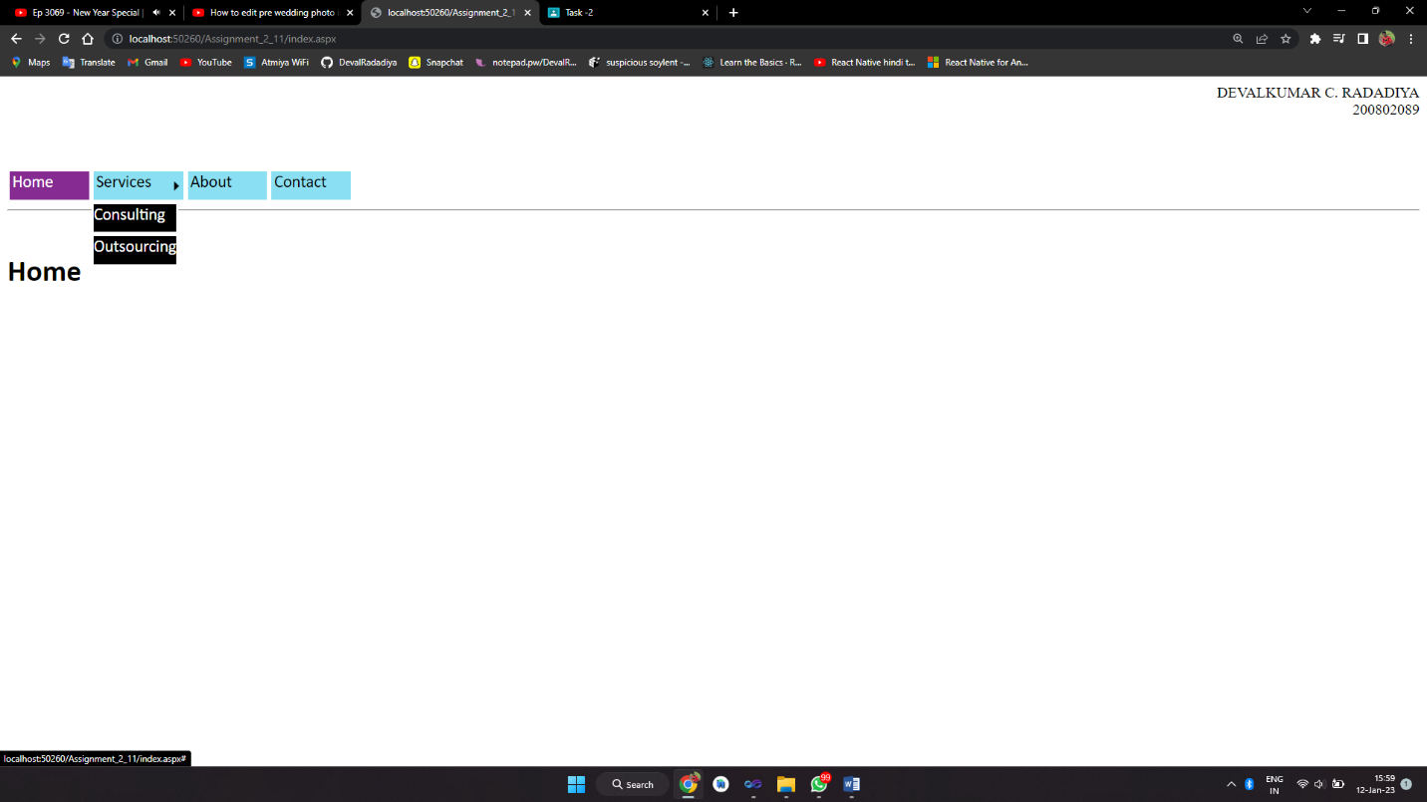

1. **Write a program to print today's day date and your birthday date**

**using calendar control.**

**Index.aspx.cs :**

using System;

using System.Collections.Generic;

using System.Linq;

using System.Web;

using System.Web.UI;

using System.Web.UI.WebControls;

namespace Assignment_2_12

{

public partial class index : System.Web.UI.Page

{

protected void Page_Load(object sender, EventArgs e)

{

}

protected void Button1_Click(object sender, EventArgs e)

{

Calendar1.TodaysDate = DateTime.Now;

Calendar1.SelectedDate = DateTime.Today;

Label1.Text = "Today's date is : <b>" + Calendar1.TodaysDate.ToShortDateString() + "</b>";

}

protected void Button2_Click(object sender, EventArgs e)

{

Calendar1.TodaysDate = new DateTime(2001, 01, 30);

Calendar1.SelectedDate = new DateTime(2001, 01, 30);

Label2.Text = "My birth date is : <b>" + Calendar1.SelectedDate.ToShortDateString() + "</b>";

}

}

}

**Index.aspx.cs :**

<%@ Page Language="C#" AutoEventWireup="true" CodeBehind="index.aspx.cs" Inherits="Assignment_2_12.index" %>

<!DOCTYPE html PUBLIC "-//W3C//DTD XHTML 1.0 Transitional//EN" "http://www.w3.org/TR/xhtml1/DTD/xhtml1-transitional.dtd">

<html xmlns="http://www.w3.org/1999/xhtml">

<head runat="server">

<title>Assignment_2_12</title>

</head>

<body>

<div>

Devalkumar C. Radadiya<br />

200802089<br />

<br />

</div>

<form id="form1" runat="server">

<div style="height: 486px">

<div >

<asp:Calendar ID="Calendar1" runat="server"></asp:Calendar>

<br />

<asp:Label ID="Label1" runat="server"></asp:Label>

<br />

<br />

<asp:Label ID="Label2" runat="server"></asp:Label>

<br />

<br />

<asp:Button ID="Button1" runat="server" onclick="Button1_Click"

style="margin-bottom: 0px" Text="Today's Date" Width="126px" />

&nbsp;

<asp:Button ID="Button2" runat="server" onclick="Button2_Click"

Text="My Birth Date" Width="168px" />

</div>

</div>

</form>

</body>

</html>

**OUTPUT :**

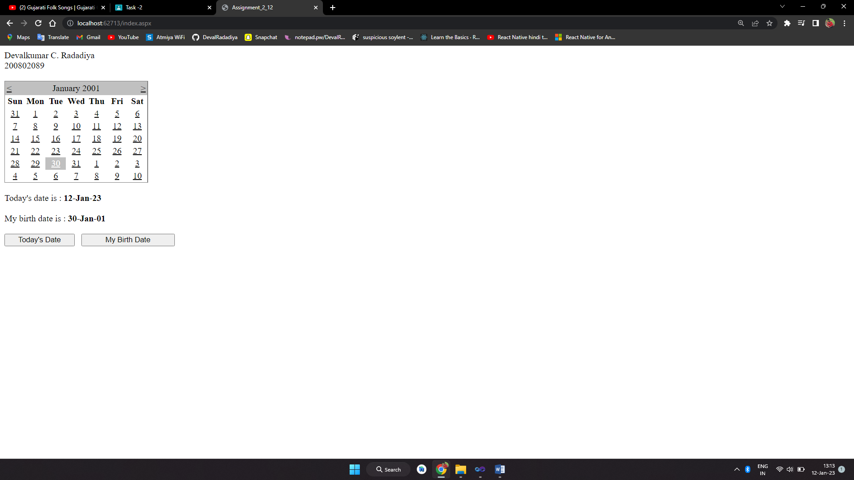

1. **Write a program to create a sitemap and the menus as given.**

**WebForm1.aspx :**

<%@ Page Language="C#" AutoEventWireup="true" CodeBehind="WebForm1.aspx.cs" Inherits="Assignment2_13.WebForm1" %>

<!DOCTYPE html>

<html xmlns="http://www.w3.org/1999/xhtml">

<head runat="server">

<title></title>

</head>

<body>

<div>

<asp:Label runat="server">

<b>Devalkumar C. Radadiya <br />

200802089 <br /><br /></b>

</asp:Label>

</div>

<form id="form1" runat="server">

<div>

<asp:TreeView ID="TreeView1" runat="server" DataSourceID="SiteMapDataSource1" LineImagesFolder="~/TreeLineImages" ShowLines="True">

<Nodes>

<asp:TreeNode Text="Home Page" Value="Home Page">

<asp:TreeNode Text="Departments" Value="Departments"></asp:TreeNode>

</asp:TreeNode>

</Nodes>

</asp:TreeView>

<asp:SiteMapDataSource ID="SiteMapDataSource1" runat="server" />

</div>

<asp:Menu ID="Menu1" runat="server" DataSourceID="SiteMapDataSource1">

<Items>

<asp:MenuItem Text="Home" Value="Home"></asp:MenuItem>

</Items>

<StaticItemTemplate>

<%# Eval("Text") %>

</StaticItemTemplate>

</asp:Menu>

</form>

</body>

</html>

**Web.sitemap :**

<?xml version="1.0" encoding="utf-8" ?>

<siteMap xmlns="http://schemas.microsoft.com/AspNet/SiteMap-File-1.0" >

<siteMapNode url="webForm1.aspx" title="Home Page" description="">

<siteMapNode url="dept.aspx" title="Departments" description="" />

</siteMapNode>

</siteMap>

**OUTPUT :**

