Assignment – 3

-------------------------------------------------------------

**Program 1😊**

<%@ Page Language="C#" AutoEventWireup="true" CodeBehind="WebForm1.aspx.cs" Inherits="WebApplication25.WebForm1" %>

<!DOCTYPE html

PUBLIC "-//W3C//DTD XHTML 1.0 Transitional//EN" "http://www.w3.org/TR/xhtml1/DTD/xhtml1-transitional.dtd">

<html xmlns="http://www.w3.org/1999/xhtml">

<head id="Head1" runat="server">

<title>Student Registration Form</title>

<link href="Styles/site.css" rel="Stylesheet" type="text/css" />

</head>

<body>

<font size="4">

<b>Name : </b>Gajera Rasendra <br />

<b>Enrollment No : </b>200802030

</font>

<form id="Form1" runat="server" method="post">

<asp:Table ID="Table1" runat="server" align="center" cellpadding="10" CssClass="table">

<asp:TableRow>

<asp:TableCell>First Name</asp:TableCell>

<asp:TableCell>

<asp:TextBox ID="txtFirstName" runat="server" CssClass="inputTypeBox" MaxLength="50"

placeholder="Ghanendra" />&nbsp;

<asp:Label ID="lblFirstNameMaxLength" runat="server" Text="(Max 50 Characters Allowed)"></asp:Label>

<br />

<asp:RequiredFieldValidator ID="rfvFirstName" runat="server" ControlToValidate="txtFirstName"

ErrorMessage="First Name is Required !" />

<asp:RegularExpressionValidator ID="revFirstName" runat="server" ControlToValidate="txtFirstName"

ErrorMessage="Only Alphabets are allowed !" ValidationExpression="[a-zA-Z]+$" />

</asp:TableCell>

</asp:TableRow>

<asp:TableRow>

<asp:TableCell>Last Name</asp:TableCell>

<asp:TableCell>

<asp:TextBox ID="txtLastName" runat="server" CssClass="inputTypeBox" MaxLength="50"

placeholder="Yadav"></asp:TextBox>&nbsp;

<asp:Label ID="lblLastNameMaxLength" runat="server" Text="(Max 50 Characters Allowed)"></asp:Label>

<br />

<asp:RequiredFieldValidator ID="rfvLastName" runat="server" ControlToValidate="txtLastName"

ErrorMessage="Last Name is Required !" InitialValue="" />

<asp:RegularExpressionValidator ID="revLastName" runat="server" ControlToValidate="txtLastName"

ErrorMessage="Only Alphabets are allowed !" ValidationExpression="^[a-zA-Z]+$" />

</asp:TableCell>

</asp:TableRow>

<asp:TableRow>

<asp:TableCell>Email ID</asp:TableCell>

<asp:TableCell>

<asp:TextBox CssClass="inputTypeBox" runat="server" ID="EmailID" TextMode="Email" MaxLength="100"

placeholder="yghanendra@gmail.com"></asp:TextBox>&nbsp;

<asp:RequiredFieldValidator ID="rfvEmailID" runat="server" ControlToValidate="EmailID"

ErrorMessage="Email is required !" InitialValue="" />

</asp:TableCell>

</asp:TableRow>

<asp:TableRow>

<asp:TableCell>Mobile Number</asp:TableCell>

<asp:TableCell>

<asp:TextBox CssClass="inputTypeBox" ID="MobileNumber" runat="server" MaxLength="10"

Placeholder="7842xxxxxx" />&nbsp;

<asp:Label ID="Label1" runat="server" Text="(10 Digits Allowed)"></asp:Label><br />

<asp:RequiredFieldValidator ID="RequiredFieldValidator1" runat="server" ControlToValidate="MobileNumber"

ErrorMessage="Mobile number is required !" /><br />

<%--asp:RegularExpressionValidator ID="RegularExpressionValidator1" runat="server" ControlToValidate="MobileNumber"

ErrorMessage="Mobile number should contain 10 digits !" ValidationExpression="\d{10}" />--%>

</asp:TableCell>

</asp:TableRow>

<asp:TableRow>

<asp:TableCell>Gender</asp:TableCell>

<asp:TableCell>

<asp:RadioButton ID="rbMale" runat="server" Text="Male" GroupName="Gender" Checked="true"

value="Male" />

<asp:RadioButton ID="rbFemale" runat="server" Text="Female" GroupName="Gender" value="Female" />

</asp:TableCell>

</asp:TableRow>

<asp:TableRow>

<asp:TableCell>Date of Birth(DOB)</asp:TableCell>

<asp:TableCell>

<asp:DropDownList ID="ddlBirthDay" runat="server">

<asp:ListItem Text="Day:" Value="-1" />

<asp:ListItem Text="1" Value="1" />

<asp:ListItem Text="2" Value="2" />

<asp:ListItem Text="3" Value="3" />

<asp:ListItem Text="4" Value="4" />

<asp:ListItem Text="5" Value="5" />

<asp:ListItem Text="6" Value="6" />

<asp:ListItem Text="7" Value="7" />

<asp:ListItem Text="8" Value="8" />

<asp:ListItem Text="9" Value="9" />

<asp:ListItem Text="10" Value="10" />

<asp:ListItem Text="11" Value="11" />

<asp:ListItem Text="12" Value="12" />

<asp:ListItem Text="13" Value="13" />

<asp:ListItem Text="14" Value="14" />

<asp:ListItem Text="15" Value="15" />

<asp:ListItem Text="16" Value="16" />

<asp:ListItem Text="17" Value="17" />

<asp:ListItem Text="18" Value="18" />

<asp:ListItem Text="19" Value="19" />

<asp:ListItem Text="20" Value="20" />

<asp:ListItem Text="21" Value="21" />

<asp:ListItem Text="22" Value="22" />

<asp:ListItem Text="23" Value="23" />

<asp:ListItem Text="24" Value="24" />

<asp:ListItem Text="25" Value="25" />

<asp:ListItem Text="26" Value="26" />

<asp:ListItem Text="27" Value="27" />

<asp:ListItem Text="28" Value="28" />

<asp:ListItem Text="29" Value="29" />

<asp:ListItem Text="30" Value="30" />

<asp:ListItem Text="31" Value="31" />

</asp:DropDownList>

<asp:DropDownList ID="BirthdayMonth" runat="server">

<asp:ListItem Text="Month:" Value="-1" />

<asp:ListItem Text="Jan(1)" Value="January" />

<asp:ListItem Text="Feb(2)" Value="February" />

<asp:ListItem Text="Mar(3)" Value="March" />

<asp:ListItem Text="Apr(4)" Value="April" />

<asp:ListItem Text="May(5)" Value="May" />

<asp:ListItem Text="Jun(6)" Value="June" />

<asp:ListItem Text="Jul(7)" Value="July" />

<asp:ListItem Text="Aug(8)" Value="August" />

<asp:ListItem Text="Sep(9)" Value="September" />

<asp:ListItem Text="Oct(10)" Value="October" />

<asp:ListItem Text="Nov(11)" Value="November" />

<asp:ListItem Text="Dec(12)" Value="December" />

</asp:DropDownList>

<asp:DropDownList ID="BirthdayYear" runat="server" CssClass="form-control">

<asp:ListItem Text="Year:" Value="-1" />

<asp:ListItem Text="2019" Value="2019" />

<asp:ListItem Text="2018" Value="2018" />

<asp:ListItem Text="2017" Value="2017" />

<asp:ListItem Text="2016" Value="2016" />

<asp:ListItem Text="2015" Value="2015" />

<asp:ListItem Text="2014" Value="2014" />

<asp:ListItem Text="2013" Value="2013" />

<asp:ListItem Text="2012" Value="2012" />

<asp:ListItem Text="2011" Value="2011" />

<asp:ListItem Text="2010" Value="2010" />

<asp:ListItem Text="2009" Value="2009" />

<asp:ListItem Text="2008" Value="2008" />

<asp:ListItem Text="2007" Value="2007" />

<asp:ListItem Text="2006" Value="2006" />

<asp:ListItem Text="2005" Value="2005" />

<asp:ListItem Text="2004" Value="2004" />

<asp:ListItem Text="2003" Value="2003" />

<asp:ListItem Text="2002" Value="2002" />

<asp:ListItem Text="2001" Value="2001" />

<asp:ListItem Text="2000" Value="2000" />

<asp:ListItem Text="1999" Value="1999" />

<asp:ListItem Text="1998" Value="1998" />

<asp:ListItem Text="1997" Value="1997" />

<asp:ListItem Text="1996" Value="1996" />

<asp:ListItem Text="1995" Value="1995" />

<asp:ListItem Text="1994" Value="1994" />

<asp:ListItem Text="1993" Value="1993" />

<asp:ListItem Text="1992" Value="1992" />

<asp:ListItem Text="1991" Value="1991" />

<asp:ListItem Text="1990" Value="1990" />

<asp:ListItem Text="1989" Value="1989" />

<asp:ListItem Text="1988" Value="1988" />

<asp:ListItem Text="1987" Value="1987" />

<asp:ListItem Text="1986" Value="1986" />

<asp:ListItem Text="1985" Value="1985" />

<asp:ListItem Text="1984" Value="1984" />

<asp:ListItem Text="1983" Value="1983" />

<asp:ListItem Text="1982" Value="1982" />

<asp:ListItem Text="1981" Value="1981" />

<asp:ListItem Text="1980" Value="1980" />

</asp:DropDownList>

<%-- <asp:RequiredFieldValidator ID="rfvBirthDay" runat="server" ControlToValidate="ddlBirthDay"

ErrorMessage="Please select birth date." InitialValue="-1" Display="Dynamic" /><br />

<asp:RequiredFieldValidator ID="rfvBirthdayMonth" runat="server" ControlToValidate="BirthdayMonth"

Display="Dynamic" ErrorMessage="Please select a month." InitialValue="-1" /><br />

<asp:RequiredFieldValidator ID="rfvBirthdayYear" runat="server" ControlToValidate="BirthdayYear"

ErrorMessage="Year is required." InitialValue="-1" Display="Dynamic" CssClass="text-danger" />

<br /> --%>

</asp:TableCell>

</asp:TableRow>

<asp:TableRow>

<asp:TableCell>Address<br /><br /><br /></asp:TableCell>

<asp:TableCell>

<asp:TextBox ID="Address" runat="server" TextMode="MultiLine" Rows="10" Columns="50"></asp:TextBox>

&nbsp;

<asp:RequiredFieldValidator ID="AddressValidator" runat="server" ControlToValidate="Address"

ErrorMessage="Address is required !"></asp:RequiredFieldValidator>

</asp:TableCell>

</asp:TableRow>

<asp:TableRow>

<asp:TableCell>City</asp:TableCell>

<asp:TableCell>

<asp:TextBox runat="server" ID="City" MaxLength="50" CssClass="inputTypeBox"

placeholder="Bangalore"></asp:TextBox>&nbsp;

<asp:Label ID="Label2" runat="server" Text="(Max 50 Characters Allowed)"></asp:Label><br />

<asp:RequiredFieldValidator ID="CityRequiredValidator" runat="server" ControlToValidate="City"

ErrorMessage="City is required !" Display="Dynamic"></asp:RequiredFieldValidator>&nbsp;

<asp:RegularExpressionValidator ID="CityMaxLengthValidator" runat="server" ControlToValidate="City"

ErrorMessage="City can't be more than 50 characters !" Display="Dynamic"

ValidationExpression="^.{0,50}$"></asp:RegularExpressionValidator>

</asp:TableCell>

</asp:TableRow>

<asp:TableRow>

<asp:TableCell>Pin Code</asp:TableCell>

<asp:TableCell>

<asp:TextBox ID="PinCode" runat="server" MaxLength="6" CssClass="inputTypeBox"

Placeholder="560068"></asp:TextBox>&nbsp;

<asp:Label ID="Label3" runat="server" Text="(Max 6 Numbers Allowed)"></asp:Label><br />

<asp:RequiredFieldValidator ID="PinCodeValidator" runat="server" ControlToValidate="PinCode"

ErrorMessage="Pin Code is Required !" Display="Dynamic"></asp:RequiredFieldValidator>&nbsp;

<asp:RegularExpressionValidator ID="PinCodeRegexValidator" runat="server"

ControlToValidate="PinCode"

ErrorMessage="Pin Code should contain only numbers and should have 6 digits !" Display="Dynamic"

ValidationExpression="^\d{6}$"></asp:RegularExpressionValidator>

</asp:TableCell>

</asp:TableRow>

<asp:TableRow>

<asp:TableCell>State</asp:TableCell>

<asp:TableCell>

<asp:TextBox ID="txtState" runat="server" MaxLength="50" CssClass="inputTypeBox"

Placeholder="Karnataka" />&nbsp;

<asp:Label ID="Label4" runat="server" Text="(Max 50 Characters Allowed)"></asp:Label><br />

<asp:RequiredFieldValidator ID="rfvState" runat="server" ControlToValidate="txtState"

ErrorMessage="State is required !" />&nbsp;

<asp:RegularExpressionValidator ID="revState" runat="server" ControlToValidate="txtState"

ErrorMessage="Only characters allowed !" ValidationExpression="^[a-zA-Z]+$" />

</asp:TableCell>

</asp:TableRow>

<asp:TableRow>

<asp:TableCell>Country</asp:TableCell>

<asp:TableCell>

<asp:TextBox ID="txtCountry" MaxLength="56" runat="server" CssClass="inputTypeBox"

Placeholder="India" />&nbsp;

<asp:RequiredFieldValidator ID="rfvtxtCountry" runat="server" ControlToValidate="txtCountry"

ErrorMessage="Country is required !" /><br />

<asp:RegularExpressionValidator ID="revCountry" runat="server" ControlToValidate="txtCountry"

ErrorMessage="Only characters allowed !" ValidationExpression="^[a-zA-Z]+$" />

</asp:TableCell>

</asp:TableRow>

<asp:TableRow>

<asp:TableCell>Hobbies <br /><br /><br /></asp:TableCell>

<asp:TableCell>

<asp:CheckBox ID="chkDrawing" runat="server" Text="Drawing" />

<asp:CheckBox ID="chkSinging" runat="server" Text="Singing" />

<asp:CheckBox ID="chkDancing" runat="server" Text="Dancing" />

<asp:CheckBox ID="chkCooking" runat="server" Text="Cooking" /><br />

<asp:CheckBox ID="chkOther" runat="server" Text="Others" />&nbsp;

<asp:TextBox ID="txtOtherHobby" CssClass="inputTypeBox" runat="server" Placeholder="Ex- Teaching"

MaxLength="50" />&nbsp; <asp:Label ID="Label5" runat="server" Text="(Max 50 Characters Allowed)"></asp:Label><br />

<asp:RegularExpressionValidator ID="revtxtOtherHobby" runat="server"

ControlToValidate="txtOtherHobby" ErrorMessage="Only characters allowed !"

ValidationExpression="^[a-zA-Z]+$" />

</asp:TableCell>

</asp:TableRow>

<asp:TableRow>

<asp:TableCell>Qualification <br /><br /><br /></asp:TableCell>

<asp:TableCell>

<br />

<asp:CheckBox ID="HighSchoolCheckBox" runat="server" Text="High School(10th)" Value="High School" />

<br />

<asp:CheckBox ID="HigherSchoolCheckBox" runat="server" Text="Higher School(12th)"

Value="Higher School" /><br />

<asp:CheckBox ID="GraduationCheckBox" runat="server" Text="Graduation(Bachelors)"

Value="Graduation" /><br />

<asp:CheckBox ID="PostGraduationCheckBox" runat="server" Text="Post Graduation(Masters)"

Value="Post Graduation" /><br />

<asp:CheckBox ID="PhdCheckBox" runat="server" Text="Phd" Value="Phd" /><br />

</asp:TableCell>

</asp:TableRow>

<asp:TableRow>

<asp:TableCell>Courses<br />Applied For</asp:TableCell>

<asp:TableCell>

<asp:RadioButton ID="BCA" runat="server" Checked="true"

Text="BCA (Bachelor of Computer Applications)" GroupName="Course" Value="BCA" />

<br />

<asp:RadioButton ID="BCom" runat="server" Text="B.Com (Bachelor of Commerce)" GroupName="Course"

Value="B.Com" />

<br />

<asp:RadioButton ID="BSc" runat="server" Text="B.Sc (Bachelor of Science)" GroupName="Course"

Value="B.Sc" />

<br />

<asp:RadioButton ID="BA" runat="server" Text="BA (Bachelor of Arts)" GroupName="Course"

Value="B.A" />

<br />

<asp:RadioButton ID="MCA" runat="server" Text="MCA (Master of Computer Applications)"

GroupName="Course" Value="MCA" />

<br />

<asp:RadioButton ID="MCom" runat="server" Text="M.Com (Master of Commerce)" GroupName="Course"

Value="M.Com" />

<br />

<asp:RadioButton ID="MSc" runat="server" Text="M.Sc (Master of Science)" GroupName="Course"

Value="M.Sc" />

<br />

<asp:RadioButton ID="MA" runat="server" Text="MA (Master of Arts)" GroupName="Course" Value="MA" />

<br />

</asp:TableCell>

</asp:TableRow>

<asp:TableRow>

<asp:TableCell ColumnSpan="2" HorizontalAlign="center">

<asp:Button ID="btnSubmit" CssClass="inputTypeButton" runat="server" Text="Submit" /> &nbsp;

<asp:Button ID="btnReset" CssClass="inputTypeButton" runat="server" Text="Reset"

CausesValidation="False" />

</asp:TableCell>

</asp:TableRow>

</asp:Table>

</form>

</body>

</html>

Css File Code😊

.h2{

font-family: Sans-serif;

font-size: 24px;

font-style: normal;

font-weight: bold;

color: blue;

text-align: center;

text-decoration: underline

}

.table {

font-family: verdana;

color:white;

font-size: 16px;

font-style: normal;

font-weight: bold;

background-color: #ff4242;

border-collapse: collapse;

border: 4px solid #000000;

border-style: dashed;

}

.table.inner{

border: 10px

}

.inputTypeBox {

width: 50%;

padding: 6px 12px;

margin: 5px 0;

box-sizing: border-box;

}

.inputTypeButton {

width: 15%;

padding: 8px 12px;

margin: 5px 0;

box-sizing: border-box;

}

**Output😊**

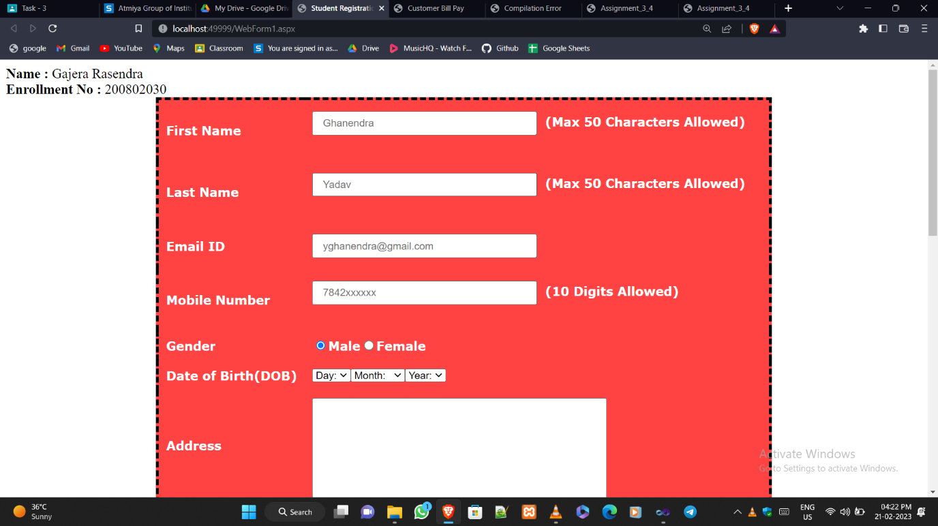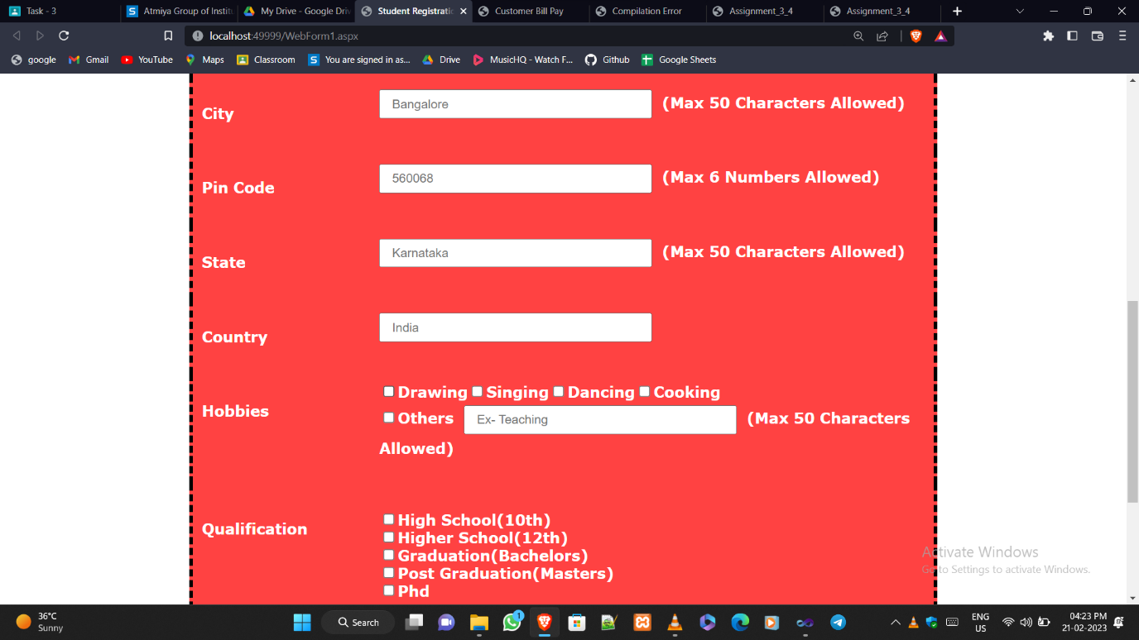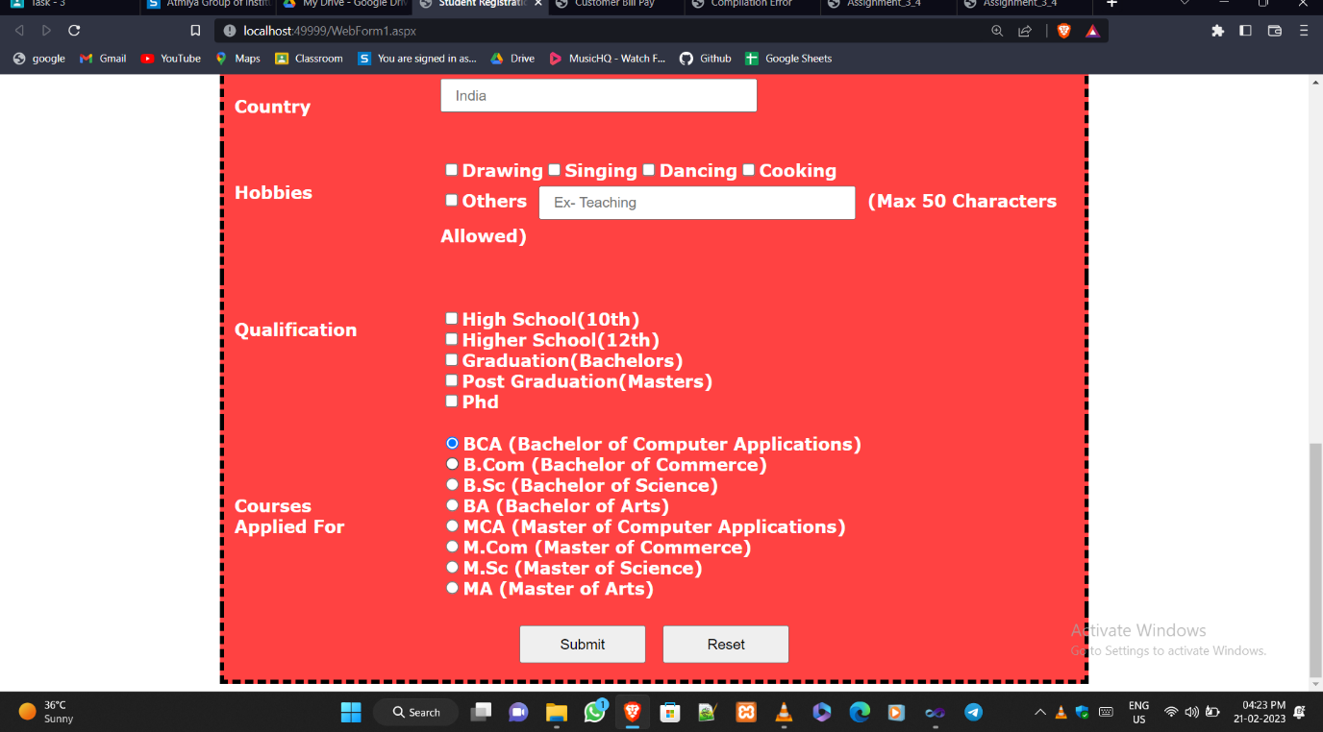

**Program 2😊**

<%@ Page Language="C#" AutoEventWireup="true" CodeBehind="WebForm1.aspx.cs" Inherits="WebApplication26.WebForm1" %>

<!DOCTYPE html>

<html xmlns="http://www.w3.org/1999/xhtml">

<head id="Head1" runat="server">

<title>Product Register Form</title>

<style type="text/css" >

#form1 {

background-color: #DDF4EE;

width: 600px;

}

.body {

padding: 30px;

}

.fontcolor {

color: #45664D;

font-size: small;

margin-bottom: 12px;

}

.fontcolor1 {

color: #45664D;

font-size: small;

}

.textbox {

padding: 10px;

border-color: #45664D;

background-color: #EDF9F7;

border-width: thin;

}

.labelsmall {

color: #9AAFA5;

font-size: 10px;

}

#Button1 {

width: 168px;

border-radius: 18px;

height: 30px;

background-color: green;

color: white;

}

</style>

</head>

<body>

<font size="4">

<b>Name : </b>Gajera Rasendra <br />

<b>Enrollment No : </b>200802030

</font>

<form id="form1" runat="server">

<div class="body">

<asp:Label ID="Label1" runat="server" class="fontcolor" style="

font-size: xx-large;" Text="Product Register Form"></asp:Label>

<br /><br />

<asp:Label ID="Label2" runat="server" class="fontcolor1"

Text="Register Your Product By Filling Below Rgister Form"></asp:Label>

<br />

<hr />

<br />

<asp:Label ID="Label3" runat="server" class="fontcolor" Text="Name"></asp:Label>

<br />

<asp:TextBox ID="TextBox1" class="textbox" runat="server" placeholder="First"></asp:TextBox>

&nbsp;&nbsp;&nbsp;&nbsp;&nbsp;&nbsp;&nbsp;&nbsp;&nbsp;&nbsp;&nbsp;&nbsp;&nbsp;&nbsp;&nbsp;&nbsp;&nbsp;&nbsp;&nbsp;&nbsp;&nbsp;&nbsp;&nbsp;&nbsp;&nbsp;

<asp:TextBox ID="TextBox2" class="textbox" runat="server" placeholder="Last"></asp:TextBox>

<br />

<br />

<asp:Label ID="Label4" runat="server" class="fontcolor1" Text="Email"></asp:Label>

&nbsp;&nbsp;&nbsp;&nbsp;&nbsp;&nbsp;&nbsp;&nbsp;&nbsp;&nbsp;&nbsp;&nbsp;&nbsp;&nbsp;&nbsp;&nbsp;&nbsp;&nbsp;&nbsp;&nbsp;&nbsp;&nbsp;&nbsp;&nbsp;&nbsp;&nbsp;&nbsp;&nbsp;&nbsp;&nbsp;&nbsp;&nbsp;&nbsp;&nbsp;&nbsp;&nbsp;&nbsp;&nbsp;&nbsp;&nbsp;&nbsp;&nbsp;&nbsp;&nbsp;&nbsp;&nbsp;&nbsp;&nbsp;&nbsp;&nbsp;&nbsp;&nbsp;&nbsp;&nbsp;&nbsp;&nbsp;&nbsp;&nbsp;&nbsp;&nbsp;&nbsp;&nbsp;&nbsp;&nbsp;&nbsp;

<asp:Label ID="Label5" runat="server" class="fontcolor1" Text="Phone"></asp:Label>

<br />

<asp:TextBox ID="TextBox3" runat="server" class="textbox" placeholder=""></asp:TextBox>

&nbsp;&nbsp;&nbsp;&nbsp;&nbsp;&nbsp;&nbsp;&nbsp;&nbsp;&nbsp;&nbsp;&nbsp;&nbsp;&nbsp;&nbsp;&nbsp;&nbsp;&nbsp;&nbsp;&nbsp;&nbsp;&nbsp;&nbsp;&nbsp;&nbsp;

<asp:TextBox ID="TextBox4" runat="server" class="textbox" placeholder="### ### ####"></asp:TextBox>

<br />

<br />

<asp:Label ID="Label6" runat="server" class="fontcolor1" Text="Address"></asp:Label>

<br />

<asp:TextBox ID="TextBox5" class="textbox" style="width:467px;" runat="server"></asp:TextBox>

<br />

<br />

<asp:TextBox ID="TextBox6" runat="server" class="textbox" placeholder="City"></asp:TextBox>

&nbsp;&nbsp;&nbsp;&nbsp;&nbsp;&nbsp;&nbsp;&nbsp;&nbsp;&nbsp;&nbsp;&nbsp;&nbsp;&nbsp;&nbsp;&nbsp;&nbsp;&nbsp;&nbsp;&nbsp;&nbsp;&nbsp;&nbsp;&nbsp;&nbsp;

<asp:DropDownList ID="DropDownList1" runat="server" value="State" class="textbox" Width="185px">

<asp:ListItem>State</asp:ListItem>

</asp:DropDownList>

<br />

<br />

<asp:TextBox ID="TextBox8" runat="server" placeholder="Postal / Zip Code" class="textbox"></asp:TextBox>

&nbsp;&nbsp;&nbsp;&nbsp;&nbsp;&nbsp;&nbsp;&nbsp;&nbsp;&nbsp;&nbsp;&nbsp;&nbsp;&nbsp;&nbsp;&nbsp;&nbsp;&nbsp;&nbsp;&nbsp;&nbsp;&nbsp;&nbsp;&nbsp;&nbsp;

<asp:DropDownList ID="DropDownList2" runat="server" value="State" class="textbox" Width="185px">

<asp:ListItem>Country</asp:ListItem>

</asp:DropDownList>

<br />

<br />

<asp:Label ID="Label7" runat="server" class="fontcolor" style="font-size: 27px;" Text="PRODUCT INFORMATION">

</asp:Label>

<br />

<br />

<asp:Label ID="Label8" runat="server" Text="Product Name" class="fontcolor1"></asp:Label>

&nbsp;&nbsp;&nbsp;&nbsp;&nbsp;&nbsp;&nbsp;&nbsp;&nbsp;&nbsp;&nbsp;&nbsp;&nbsp;&nbsp;&nbsp;&nbsp;&nbsp;&nbsp;&nbsp;&nbsp;&nbsp;&nbsp;&nbsp;&nbsp;&nbsp;&nbsp;&nbsp;&nbsp;&nbsp;&nbsp;&nbsp;&nbsp;&nbsp;&nbsp;&nbsp;&nbsp;&nbsp;&nbsp;&nbsp;&nbsp;&nbsp;&nbsp;&nbsp;&nbsp;&nbsp;&nbsp;&nbsp;&nbsp;&nbsp;&nbsp;&nbsp;&nbsp;&nbsp;&nbsp;

<asp:Label ID="Label9" runat="server" Text="Product Brand &amp; Model" class="fontcolor1"></asp:Label>

<br />

<asp:TextBox ID="TextBox9" runat="server" class="textbox" placeholder=""></asp:TextBox>

&nbsp;&nbsp;&nbsp;&nbsp;&nbsp;&nbsp;&nbsp;&nbsp;&nbsp;&nbsp;&nbsp;&nbsp;&nbsp;&nbsp;&nbsp;&nbsp;&nbsp;&nbsp;&nbsp;&nbsp;&nbsp;&nbsp;&nbsp;&nbsp;&nbsp;

<asp:TextBox ID="TextBox10" runat="server" class="textbox" placeholder=""></asp:TextBox>

<br />

<asp:Label ID="Label10" runat="server" Text="e g Laptop" calss="labelsmall" style="font-size: 10px;">

</asp:Label>

&nbsp;&nbsp;&nbsp;&nbsp;&nbsp;&nbsp;&nbsp;&nbsp;&nbsp;&nbsp;&nbsp;&nbsp;&nbsp;&nbsp;&nbsp;&nbsp;&nbsp;&nbsp;&nbsp;&nbsp;&nbsp;&nbsp;&nbsp;&nbsp;&nbsp;&nbsp;&nbsp;&nbsp;&nbsp;&nbsp;&nbsp;&nbsp;&nbsp;&nbsp;&nbsp;&nbsp;&nbsp;&nbsp;&nbsp;&nbsp;&nbsp;&nbsp;&nbsp;&nbsp;&nbsp;&nbsp;&nbsp;&nbsp;&nbsp;&nbsp;&nbsp;&nbsp;&nbsp;&nbsp;&nbsp;&nbsp;&nbsp;&nbsp;&nbsp;&nbsp;&nbsp;&nbsp;

<asp:Label ID="Label11" runat="server" Text="e g Acer Aspire Nitro" calss="labelsmall"

style="font-size: 10px;"></asp:Label>

<br />

<br />

<asp:Label ID="Label12" runat="server" Text="Product Model ID" class="fontcolor1"></asp:Label>

&nbsp;&nbsp;&nbsp;&nbsp;&nbsp;&nbsp;&nbsp;&nbsp;&nbsp;&nbsp;&nbsp;&nbsp;&nbsp;&nbsp;&nbsp;&nbsp;&nbsp;&nbsp;&nbsp;&nbsp;&nbsp;&nbsp;&nbsp;&nbsp;&nbsp;&nbsp;&nbsp;&nbsp;&nbsp;&nbsp;&nbsp;&nbsp;&nbsp;&nbsp;&nbsp;&nbsp;&nbsp;&nbsp;&nbsp;&nbsp;&nbsp;&nbsp;&nbsp;&nbsp;&nbsp;&nbsp;&nbsp;&nbsp;&nbsp;

<asp:Label ID="Label13" runat="server" Text="Product Febrication Year" class="fontcolor1"></asp:Label>

<br />

<asp:TextBox ID="TextBox11" runat="server" class="textbox"></asp:TextBox>

&nbsp;&nbsp;&nbsp;&nbsp;&nbsp;&nbsp;&nbsp;&nbsp;&nbsp;&nbsp;&nbsp;&nbsp;&nbsp;&nbsp;&nbsp;&nbsp;&nbsp;&nbsp;&nbsp;&nbsp;&nbsp;&nbsp;&nbsp;&nbsp;&nbsp;

<asp:TextBox ID="TextBox12" runat="server" class="textbox"></asp:TextBox>

<br />

<asp:Label ID="Label14" runat="server" Text="e g VSDFUBJB" calss="labelsmall" style="font-size: 10px;">

</asp:Label>

&nbsp;&nbsp;&nbsp;&nbsp;&nbsp;&nbsp;&nbsp;&nbsp;&nbsp;&nbsp;&nbsp;&nbsp;&nbsp;&nbsp;&nbsp;&nbsp;&nbsp;&nbsp;&nbsp;&nbsp;&nbsp;&nbsp;&nbsp;&nbsp;&nbsp;&nbsp;&nbsp;&nbsp;&nbsp;&nbsp;&nbsp;&nbsp;&nbsp;&nbsp;&nbsp;&nbsp;&nbsp;&nbsp;&nbsp;&nbsp;&nbsp;&nbsp;&nbsp;&nbsp;&nbsp;&nbsp;&nbsp;&nbsp;&nbsp;&nbsp;&nbsp;&nbsp;&nbsp;&nbsp;&nbsp;&nbsp;&nbsp;&nbsp;

<asp:Label ID="Label15" runat="server" Text="e g 2012" calss="labelsmall" style="font-size: 10px;">

</asp:Label>

<br />

<br />

<asp:Label ID="Label16" runat="server" Text="Purchase Date" class="fontcolor1"></asp:Label>

<br />

<asp:TextBox ID="TextBox13" runat="server" class="textbox" TextMode="Date" DateFormatString="{0:MM/dd/yyyy}"

src="C:\Users\dell\Downloads\calendar.png">

</asp:TextBox>

<br />

<asp:Label ID="Label17" runat="server" Text="e g 12/08/2017" calss="labelsmall" style="font-size: 10px;">

</asp:Label>

<br />

<br />

&nbsp;&nbsp;&nbsp;&nbsp;&nbsp;&nbsp;&nbsp;&nbsp;&nbsp;&nbsp;&nbsp;&nbsp;&nbsp;&nbsp;&nbsp;&nbsp;&nbsp;&nbsp;&nbsp;&nbsp;&nbsp;&nbsp;&nbsp;&nbsp;&nbsp;&nbsp;&nbsp;&nbsp;&nbsp;&nbsp;&nbsp;&nbsp;&nbsp;&nbsp;&nbsp;&nbsp;&nbsp;&nbsp;&nbsp;&nbsp;&nbsp;&nbsp;&nbsp;&nbsp;&nbsp;&nbsp;

<asp:Button ID="Button1" runat="server" Text="Register Products" />

</div>

</form>

</body>

</html>

**Output😊**

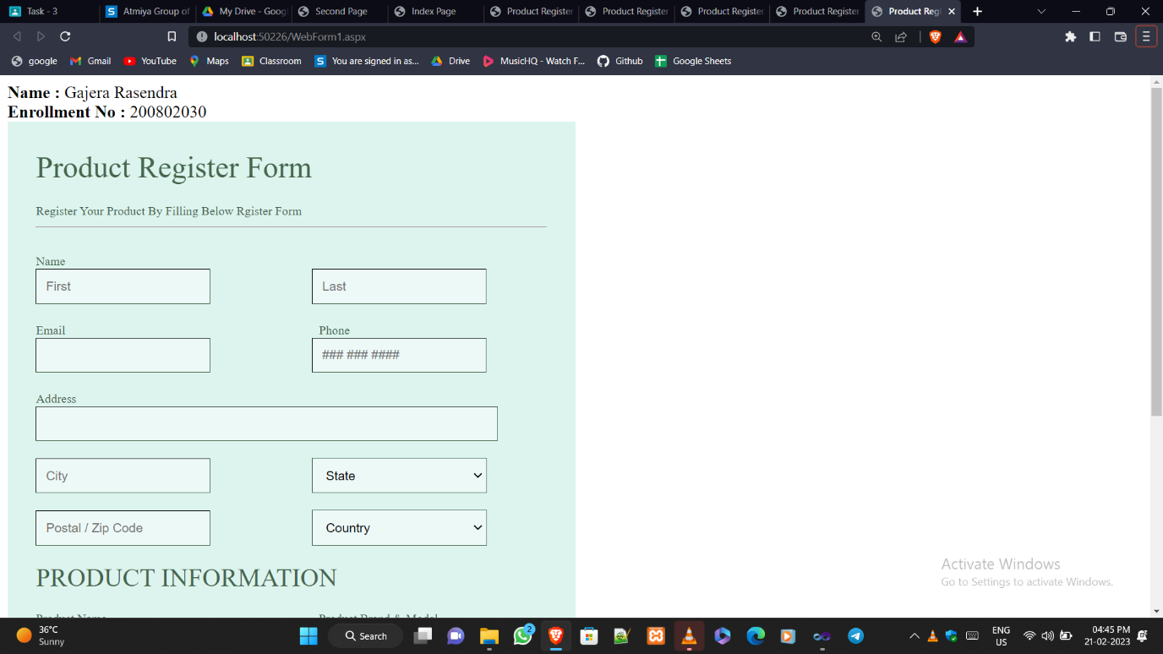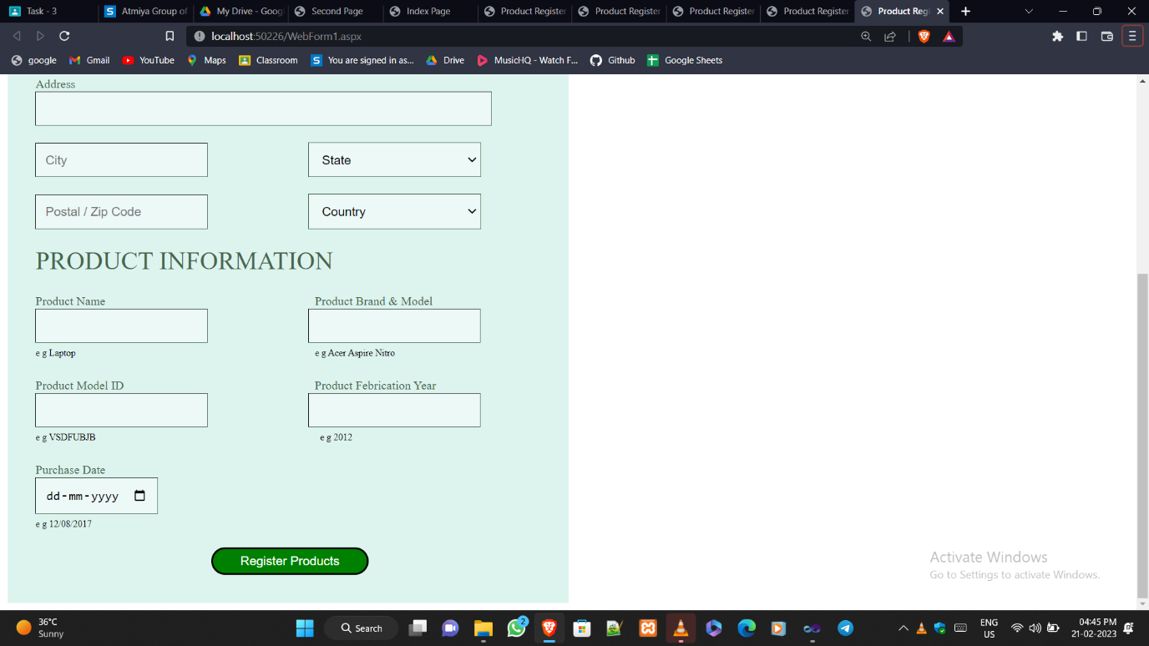

**Program 3😊**

<%@ Page Language="C#" AutoEventWireup="true" CodeBehind="WebForm1.aspx.cs" Inherits="WebApplication27.WebForm1" %>

<!DOCTYPE html PUBLIC "-//W3C//DTD XHTML 1.0 Transitional//EN" "http://www.w3.org/TR/xhtml1/DTD/xhtml1-transitional.dtd">

<html xmlns="http://www.w3.org/1999/xhtml">

<head id="Head1" runat="server">

<title>Customer Bill Pay</title>

<style type="text/css">

#Button1

{

border-radius: 20px;

}

#Button2

{

border-radius: 20px;

}

</style>

</head>

<body>

<font size="4">

<b>Name : </b>Gajera Rasendra <br />

<b>Enrollment No : </b>200802030

</font>

<form id="form1" runat="server">

<div style="height: 1491px; width: 869px">

<br />

&nbsp;&nbsp;<asp:Label ID="Label1" runat="server" Font-Bold="True" Font-Size="25pt"

Text="Customer Bill Pay"></asp:Label>

<br />

&nbsp;&nbsp;&nbsp;&nbsp;

<asp:Label ID="Label2" runat="server" Text="Pay your open invoices online"

Font-Bold="False" Font-Size="15pt" Width="215pt"></asp:Label>

<br />

<br />

<hr />

<br />

&nbsp;&nbsp;&nbsp;

<asp:Label ID="Label3" runat="server" Font-Bold="True" Text="Full Name"></asp:Label>

&nbsp;&nbsp;&nbsp;<asp:Label ID="Label7" runat="server" ForeColor="Red" Text="*"></asp:Label>

&nbsp;&nbsp;&nbsp;<asp:TextBox ID="TextBox1" runat="server" Height="20px" Width="129px"></asp:TextBox>

<asp:RequiredFieldValidator ID="RequiredFieldValidator2"

runat="server" ErrorMessage="Required" ControlToValidate="TextBox3"

ForeColor="Red" ></asp:RequiredFieldValidator>

<asp:TextBox ID="TextBox2" runat="server" Width="159px"

Height="21px"></asp:TextBox>

<asp:RequiredFieldValidator ID="RequiredFieldValidator1" runat="server"

ErrorMessage="Required" ControlToValidate="TextBox2" ForeColor="Red"></asp:RequiredFieldValidator>

<br />

&nbsp;&nbsp;&nbsp;&nbsp;&nbsp;&nbsp;&nbsp;&nbsp;&nbsp;&nbsp;&nbsp;&nbsp;&nbsp;&nbsp;&nbsp;&nbsp;&nbsp;&nbsp;&nbsp;&nbsp;&nbsp;&nbsp;&nbsp;&nbsp;&nbsp;&nbsp;&nbsp;&nbsp;&nbsp;&nbsp;&nbsp;&nbsp; <asp:Label ID="Label4" runat="server" Text="First Name"></asp:Label>

&nbsp;&nbsp;&nbsp;&nbsp;&nbsp;&nbsp;&nbsp;&nbsp;&nbsp;&nbsp;&nbsp;&nbsp;&nbsp;&nbsp;&nbsp;&nbsp;&nbsp;&nbsp;&nbsp;&nbsp;&nbsp;&nbsp;&nbsp;&nbsp;&nbsp;&nbsp;&nbsp;&nbsp;&nbsp;&nbsp;&nbsp; <asp:Label ID="Label5" runat="server" Text="Last Name"></asp:Label>

<br />

<br />

&nbsp;&nbsp;&nbsp;

<asp:Label ID="Label6" runat="server" Font-Bold="True" Text="Address"></asp:Label>

&nbsp;

<asp:Label ID="Label8" runat="server" ForeColor="Red" Text="*"></asp:Label>

&nbsp;&nbsp;&nbsp;&nbsp;&nbsp;&nbsp;&nbsp;

<asp:TextBox ID="TextBox3" runat="server" Height="20px" Width="372px"></asp:TextBox>

<asp:RequiredFieldValidator ID="RequiredFieldValidator3" runat="server"

ErrorMessage="Required" ControlToValidate="TextBox3" ForeColor="Red"></asp:RequiredFieldValidator>

<br />

&nbsp;&nbsp;&nbsp;&nbsp;&nbsp;&nbsp;&nbsp;&nbsp;&nbsp;&nbsp;&nbsp;&nbsp;&nbsp;&nbsp;&nbsp;&nbsp;&nbsp;&nbsp;&nbsp;&nbsp;&nbsp;&nbsp;&nbsp;&nbsp;&nbsp;&nbsp;&nbsp;&nbsp;&nbsp;&nbsp;&nbsp;

<asp:Label ID="Label9" runat="server" Text="Street Address"></asp:Label>

<br />

<br />

&nbsp;&nbsp;&nbsp;&nbsp;&nbsp;&nbsp;&nbsp;&nbsp;&nbsp;&nbsp;&nbsp;&nbsp;&nbsp;&nbsp;&nbsp;&nbsp;&nbsp;&nbsp;&nbsp;&nbsp;&nbsp;&nbsp;&nbsp;&nbsp;&nbsp;&nbsp;&nbsp;&nbsp;&nbsp;&nbsp;&nbsp;

<asp:TextBox ID="TextBox4" runat="server" Height="21px" Width="375px"></asp:TextBox>

<asp:RequiredFieldValidator ID="RequiredFieldValidator4" runat="server"

ErrorMessage="Required" ControlToValidate="TextBox4" ForeColor="Red"></asp:RequiredFieldValidator>

<br />

&nbsp;&nbsp;&nbsp;&nbsp;&nbsp;&nbsp;&nbsp;&nbsp;&nbsp;&nbsp;&nbsp;&nbsp;&nbsp;&nbsp;&nbsp;&nbsp;&nbsp;&nbsp;&nbsp;&nbsp;&nbsp;&nbsp;&nbsp;&nbsp;&nbsp;&nbsp;&nbsp;&nbsp;&nbsp;&nbsp;&nbsp;

<asp:Label ID="Label10" runat="server" Text="Street Address Line 2"></asp:Label>

<br />

&nbsp;&nbsp;&nbsp;&nbsp;&nbsp;&nbsp;&nbsp;&nbsp;&nbsp;&nbsp;&nbsp;&nbsp;&nbsp;&nbsp;&nbsp;&nbsp;&nbsp;&nbsp;&nbsp;&nbsp;&nbsp;&nbsp;&nbsp;&nbsp;&nbsp;&nbsp;&nbsp;&nbsp;&nbsp;&nbsp;&nbsp;

<br />

&nbsp;&nbsp;&nbsp;&nbsp;&nbsp;&nbsp;&nbsp;&nbsp;&nbsp;&nbsp;&nbsp;&nbsp;&nbsp;&nbsp;&nbsp;&nbsp;&nbsp;&nbsp;&nbsp;&nbsp;&nbsp;&nbsp;&nbsp;&nbsp;&nbsp;&nbsp;&nbsp;&nbsp;&nbsp;&nbsp;&nbsp;

<asp:TextBox ID="TextBox5" runat="server" Height="19px" Width="177px"></asp:TextBox>

<asp:RequiredFieldValidator ID="RequiredFieldValidator6" runat="server"

ControlToValidate="TextBox5" ErrorMessage="Required" ForeColor="Red"></asp:RequiredFieldValidator>

<asp:TextBox ID="TextBox6" runat="server" Height="20px" Width="174px"></asp:TextBox>

<asp:RequiredFieldValidator ID="RequiredFieldValidator5" runat="server"

ControlToValidate="TextBox6" ErrorMessage="Required" ForeColor="Red"></asp:RequiredFieldValidator>

<br />

&nbsp;&nbsp;&nbsp;&nbsp;&nbsp;&nbsp;&nbsp;&nbsp;&nbsp;&nbsp;&nbsp;&nbsp;&nbsp;&nbsp;&nbsp;&nbsp;&nbsp;&nbsp;&nbsp;&nbsp;&nbsp;&nbsp;&nbsp;&nbsp;&nbsp;&nbsp;&nbsp;&nbsp;&nbsp;&nbsp;&nbsp;

<asp:Label ID="Label11" runat="server" Text="City"></asp:Label>

&nbsp;&nbsp;&nbsp;&nbsp;&nbsp;&nbsp;&nbsp;&nbsp;&nbsp;&nbsp;&nbsp;&nbsp;&nbsp;&nbsp;&nbsp;&nbsp;&nbsp;&nbsp;&nbsp;&nbsp;&nbsp;&nbsp;&nbsp;&nbsp;&nbsp;&nbsp;&nbsp;&nbsp;&nbsp;&nbsp;&nbsp;&nbsp;&nbsp;&nbsp;&nbsp;&nbsp;&nbsp;&nbsp;&nbsp;&nbsp;&nbsp;&nbsp;&nbsp;&nbsp;&nbsp;&nbsp;&nbsp;&nbsp;&nbsp;&nbsp;&nbsp;&nbsp;&nbsp;&nbsp;&nbsp;

<asp:Label ID="Label12" runat="server" Text="State / Province"></asp:Label>

<br />

&nbsp;&nbsp;&nbsp;&nbsp;&nbsp;&nbsp;&nbsp;&nbsp;&nbsp;&nbsp;&nbsp;&nbsp;&nbsp;&nbsp;&nbsp;&nbsp;&nbsp;&nbsp;&nbsp;&nbsp;&nbsp;&nbsp;&nbsp;&nbsp;&nbsp;&nbsp;&nbsp;

<br />

&nbsp;&nbsp;&nbsp;&nbsp;&nbsp;&nbsp;&nbsp;&nbsp;&nbsp;&nbsp;&nbsp;&nbsp;&nbsp;&nbsp;&nbsp;&nbsp;&nbsp;&nbsp;&nbsp;&nbsp;&nbsp;&nbsp;&nbsp;&nbsp;&nbsp;&nbsp;&nbsp;&nbsp;&nbsp;&nbsp;&nbsp;

<asp:TextBox ID="TextBox7" runat="server" Height="17px"

style="margin-left: 0px" Width="180px"></asp:TextBox>

<asp:RequiredFieldValidator ID="RequiredFieldValidator7" runat="server"

ControlToValidate="TextBox7" ErrorMessage="Required" ForeColor="Red"></asp:RequiredFieldValidator>

<br />

&nbsp;&nbsp;&nbsp;&nbsp;&nbsp;&nbsp;&nbsp;&nbsp;&nbsp;&nbsp;&nbsp;&nbsp;&nbsp;&nbsp;&nbsp;&nbsp;&nbsp;&nbsp;&nbsp;&nbsp;&nbsp;&nbsp;&nbsp;&nbsp;&nbsp;&nbsp;&nbsp;&nbsp;&nbsp;&nbsp;&nbsp;

<asp:Label ID="Label13" runat="server" Text="Postal / Zip Code"></asp:Label>

<br />

<br />

&nbsp;&nbsp;&nbsp;&nbsp;&nbsp;&nbsp;&nbsp;&nbsp;&nbsp;&nbsp;&nbsp;&nbsp;&nbsp;&nbsp;&nbsp;&nbsp;&nbsp;&nbsp;&nbsp;&nbsp;&nbsp;&nbsp;&nbsp;&nbsp;&nbsp;&nbsp;&nbsp;&nbsp;&nbsp;&nbsp;&nbsp;

<br />

&nbsp;&nbsp;&nbsp;&nbsp;&nbsp;&nbsp;&nbsp;&nbsp;&nbsp;&nbsp;&nbsp;&nbsp;&nbsp;&nbsp;&nbsp;&nbsp;&nbsp;&nbsp;&nbsp;&nbsp;&nbsp;&nbsp;&nbsp;&nbsp;&nbsp;&nbsp;&nbsp;&nbsp;&nbsp;&nbsp;&nbsp;&nbsp;&nbsp;&nbsp;&nbsp;

<asp:RequiredFieldValidator ID="RequiredFieldValidator8" runat="server"

ControlToValidate="TextBox8" ErrorMessage="Required" ForeColor="Red"></asp:RequiredFieldValidator>

&nbsp;&nbsp;&nbsp;&nbsp;&nbsp;&nbsp;&nbsp;&nbsp;&nbsp;&nbsp;&nbsp;&nbsp;&nbsp;&nbsp;&nbsp;&nbsp;&nbsp;&nbsp;&nbsp;&nbsp;&nbsp;&nbsp;&nbsp;&nbsp;&nbsp;&nbsp;&nbsp;&nbsp;&nbsp;&nbsp;&nbsp;&nbsp;&nbsp;&nbsp;&nbsp;&nbsp;&nbsp;&nbsp;&nbsp;&nbsp;&nbsp;&nbsp;&nbsp;&nbsp;&nbsp;&nbsp;&nbsp;

<asp:RequiredFieldValidator ID="RequiredFieldValidator9" runat="server"

ControlToValidate="TextBox9" ErrorMessage="Required" ForeColor="Red"></asp:RequiredFieldValidator>

<br />

&nbsp;&nbsp;&nbsp;&nbsp;&nbsp;<b>Phone</b>&nbsp;&nbsp;&nbsp;&nbsp;

<asp:Label ID="Label14" runat="server" ForeColor="Red" Text="*"></asp:Label>

&nbsp;&nbsp;&nbsp;&nbsp;&nbsp;&nbsp;&nbsp;&nbsp;<asp:TextBox ID="TextBox8" runat="server" Height="21px" Width="236px"></asp:TextBox>

&nbsp;&nbsp;

<asp:TextBox ID="TextBox9" runat="server" Height="21px" Width="238px"></asp:TextBox>

<br />

&nbsp;&nbsp;&nbsp;&nbsp;&nbsp;<b>Number</b>&nbsp;&nbsp;&nbsp;&nbsp;&nbsp;&nbsp;&nbsp;&nbsp;&nbsp;&nbsp;&nbsp;

<asp:Label ID="Label15" runat="server" Text="Area Code"></asp:Label>

&nbsp;&nbsp;&nbsp;&nbsp;&nbsp;&nbsp;&nbsp;&nbsp;&nbsp;&nbsp;&nbsp;&nbsp;&nbsp;&nbsp;&nbsp;&nbsp;&nbsp;&nbsp;&nbsp;&nbsp;&nbsp;&nbsp;&nbsp;&nbsp;&nbsp;&nbsp;&nbsp;&nbsp;&nbsp;&nbsp;&nbsp;&nbsp;&nbsp;&nbsp;&nbsp;&nbsp;&nbsp;&nbsp;&nbsp;&nbsp;&nbsp;&nbsp;&nbsp;&nbsp;&nbsp;&nbsp;&nbsp;

<asp:Label ID="Label16" runat="server" Text="Phone Number"></asp:Label>

<br />

<br />

<br />

&nbsp;&nbsp;&nbsp;&nbsp;

<asp:Label ID="Label17" runat="server" Font-Bold="True" Text="E-mail"></asp:Label>

&nbsp;&nbsp;&nbsp;

<asp:Label ID="Label18" runat="server" ForeColor="Red" Text="*"></asp:Label>

&nbsp;&nbsp;&nbsp;&nbsp;&nbsp;&nbsp;&nbsp;<asp:TextBox ID="TextBox10" runat="server" Height="22px" Width="351px"></asp:TextBox>

<asp:RequiredFieldValidator ID="RequiredFieldValidator10" runat="server"

ControlToValidate="TextBox10" ErrorMessage="Required" ForeColor="Red"></asp:RequiredFieldValidator>

<br />

&nbsp;&nbsp;&nbsp;&nbsp;&nbsp;&nbsp;&nbsp;&nbsp;&nbsp;&nbsp;&nbsp;&nbsp;&nbsp;&nbsp;&nbsp;&nbsp;&nbsp;&nbsp;&nbsp;&nbsp;&nbsp;&nbsp;&nbsp;&nbsp;&nbsp;&nbsp;&nbsp;&nbsp;&nbsp;&nbsp;

<asp:Label ID="Label19" runat="server" Text="example@example.com"></asp:Label>

<br />

<br />

<br />

&nbsp;&nbsp;&nbsp; <b>&nbsp;Invoice</b>&nbsp;&nbsp;&nbsp;&nbsp;&nbsp;&nbsp;&nbsp;&nbsp;&nbsp;&nbsp;&nbsp;&nbsp;&nbsp;

<asp:TextBox ID="TextBox11" runat="server" Height="21px" Width="177px"></asp:TextBox>

<asp:RequiredFieldValidator ID="RequiredFieldValidator11" runat="server"

ControlToValidate="TextBox11" ErrorMessage="Required" ForeColor="Red"></asp:RequiredFieldValidator>

<br />

&nbsp;&nbsp;&nbsp;<b>&nbsp; Number&nbsp;&nbsp;&nbsp; </b><asp:Label ID="Label20"

runat="server" Text="*" ForeColor="Red"></asp:Label><br />

&nbsp;&nbsp;&nbsp;&nbsp;&nbsp;

<br />

<br />

&nbsp;&nbsp;&nbsp; <b>&nbsp;Invoice</b>&nbsp;&nbsp;&nbsp;&nbsp;&nbsp;&nbsp;&nbsp;&nbsp;&nbsp;&nbsp;&nbsp;&nbsp;&nbsp;&nbsp;

<asp:TextBox ID="TextBox12" runat="server" Height="20px" Width="176px"></asp:TextBox>

<asp:RequiredFieldValidator ID="RequiredFieldValidator12" runat="server"

ControlToValidate="TextBox12" ErrorMessage="Required" ForeColor="Red"></asp:RequiredFieldValidator>

<br />

&nbsp;&nbsp;&nbsp; <b>&nbsp;Amount&nbsp;&nbsp;&nbsp;&nbsp;&nbsp; </b>

<asp:Label ID="Label21" runat="server" ForeColor="Red" Text="*"></asp:Label>

<br />

<br />

&nbsp;&nbsp;&nbsp;

<br />

<br />

&nbsp;&nbsp;&nbsp;&nbsp;

<asp:Label ID="Label22" runat="server" Text="Calculation"></asp:Label>

&nbsp;&nbsp;&nbsp;&nbsp;&nbsp;&nbsp;&nbsp;&nbsp;<asp:TextBox ID="TextBox13" runat="server" Height="19px" Width="270px"></asp:TextBox>

<br />

<br />

<br />

&nbsp;&nbsp;&nbsp;&nbsp;

<asp:Label ID="Label23" runat="server" Font-Bold="True" Text="Total Due"></asp:Label>

&nbsp;&nbsp;

<asp:Label ID="Label24" runat="server" ForeColor="Red" Text="*"></asp:Label>

&nbsp;&nbsp;&nbsp;&nbsp;<asp:TextBox ID="TextBox14" runat="server" Height="22px" Width="176px"></asp:TextBox>

<asp:Label ID="Label25" runat="server" Text="USD"></asp:Label>

<asp:RequiredFieldValidator ID="RequiredFieldValidator13" runat="server"

ControlToValidate="TextBox14" ErrorMessage="Required" ForeColor="Red"></asp:RequiredFieldValidator>

<br />

&nbsp;&nbsp;&nbsp;&nbsp;&nbsp;&nbsp;&nbsp;&nbsp;&nbsp;&nbsp;&nbsp;&nbsp;&nbsp;&nbsp;&nbsp;&nbsp;&nbsp;&nbsp;&nbsp;&nbsp;&nbsp;&nbsp;&nbsp;&nbsp;&nbsp;&nbsp;&nbsp;&nbsp;&nbsp;&nbsp;&nbsp;&nbsp;

<asp:Label ID="Label26" runat="server" Text="Total Amount"></asp:Label>

<br />

<br />

&nbsp;&nbsp;&nbsp;

<br />

<hr style="margin-left:130px;">

<br />

&nbsp;&nbsp;&nbsp;&nbsp;&nbsp;&nbsp;&nbsp;&nbsp;&nbsp;&nbsp;&nbsp;&nbsp;&nbsp;&nbsp;&nbsp;&nbsp;&nbsp;&nbsp;&nbsp;&nbsp;&nbsp;&nbsp;&nbsp;&nbsp;&nbsp;&nbsp;&nbsp;&nbsp;&nbsp;&nbsp;&nbsp;&nbsp;&nbsp;<asp:Label ID="Label27" runat="server" Font-Bold="True"

Text="Credit Card Details"></asp:Label>

<br />

<br />

&nbsp;&nbsp;&nbsp;&nbsp;&nbsp;&nbsp;&nbsp;&nbsp;&nbsp;&nbsp;&nbsp;&nbsp;&nbsp;&nbsp;&nbsp;&nbsp;&nbsp;&nbsp;&nbsp;&nbsp;&nbsp;&nbsp;&nbsp;&nbsp;&nbsp;&nbsp;&nbsp;&nbsp;&nbsp;&nbsp;&nbsp;&nbsp;&nbsp;<asp:TextBox

ID="TextBox15" runat="server" Width="172px"

placeholder="First Name" Height="23px"></asp:TextBox>

&nbsp;&nbsp;&nbsp;&nbsp;

<asp:TextBox ID="TextBox16" runat="server" Height="23px" Width="178px"

placeholder="Last Name"></asp:TextBox>

<br />

&nbsp;&nbsp;&nbsp;&nbsp;&nbsp;&nbsp;&nbsp;&nbsp;&nbsp;&nbsp;&nbsp;&nbsp;&nbsp;&nbsp;&nbsp;&nbsp;&nbsp;&nbsp;&nbsp;&nbsp;&nbsp;&nbsp;&nbsp;&nbsp;&nbsp;&nbsp;&nbsp;&nbsp;&nbsp;&nbsp;&nbsp;&nbsp;&nbsp;&nbsp;<asp:Label ID="Label28" runat="server" Text="First Name"></asp:Label>

&nbsp;&nbsp;&nbsp;&nbsp;&nbsp;&nbsp;&nbsp;&nbsp;&nbsp;&nbsp;&nbsp;&nbsp;&nbsp;&nbsp;&nbsp;&nbsp;&nbsp;&nbsp;&nbsp;&nbsp;&nbsp;&nbsp;&nbsp;&nbsp;&nbsp;&nbsp;&nbsp;&nbsp;&nbsp;&nbsp;

<asp:Label ID="Label29" runat="server" Text="Last Name"></asp:Label>

<br />

<br />

&nbsp;&nbsp;&nbsp;&nbsp;&nbsp;&nbsp;&nbsp;&nbsp;&nbsp;&nbsp;&nbsp;&nbsp;&nbsp;&nbsp;&nbsp;&nbsp;&nbsp;&nbsp;&nbsp;&nbsp;&nbsp;&nbsp;&nbsp;&nbsp;&nbsp;&nbsp;&nbsp;&nbsp;&nbsp;&nbsp;&nbsp;&nbsp;&nbsp;<asp:TextBox ID="TextBox17" runat="server"

Width="174px" Height="20px" ></asp:TextBox>

&nbsp;&nbsp;&nbsp;

<asp:TextBox ID="TextBox18" runat="server" Height="22px" Width="185px"></asp:TextBox>

<br />

&nbsp;&nbsp;&nbsp;&nbsp;&nbsp;&nbsp;&nbsp;&nbsp;&nbsp;&nbsp;&nbsp;&nbsp;&nbsp;&nbsp;&nbsp;&nbsp;&nbsp;&nbsp;&nbsp;&nbsp;&nbsp;&nbsp;&nbsp;&nbsp;&nbsp;&nbsp;&nbsp;&nbsp;&nbsp;&nbsp;&nbsp;&nbsp;

<asp:Label ID="Label30" runat="server" Text="Credit Card Number"></asp:Label>

&nbsp;&nbsp;&nbsp;&nbsp;&nbsp;&nbsp;&nbsp;&nbsp;&nbsp;&nbsp;&nbsp;&nbsp;&nbsp;&nbsp;&nbsp;

<asp:Label ID="Label31" runat="server" Text="Security Code"></asp:Label>

<br />

&nbsp;&nbsp;&nbsp;&nbsp;&nbsp;&nbsp;&nbsp;

<br />

&nbsp;&nbsp;&nbsp;&nbsp;&nbsp;&nbsp;&nbsp;&nbsp;&nbsp;&nbsp;&nbsp;&nbsp;&nbsp;&nbsp;&nbsp;&nbsp;&nbsp;&nbsp;&nbsp;&nbsp;&nbsp;&nbsp;&nbsp;&nbsp;&nbsp;&nbsp;&nbsp;&nbsp;&nbsp;&nbsp;&nbsp;&nbsp;

<asp:TextBox ID="TextBox19" runat="server" Height="23px" Width="173px"></asp:TextBox>

<br />

<br />

<br />

<br />

&nbsp;&nbsp;&nbsp;&nbsp;&nbsp;

<asp:CheckBox ID="CheckBox1" Checked="true" runat="server" Text=" I agree to" />

&nbsp;

<asp:Label ID="Label32" runat="server" Font-Bold="True" ForeColor="#33CCFF"

Text="terms &amp; condition."></asp:Label>

<asp:Label ID="Label33" runat="server" ForeColor="Red" Text="*"></asp:Label>

<br />

<br />

<br />

<br />

&nbsp;&nbsp;&nbsp;&nbsp;&nbsp;&nbsp;&nbsp;&nbsp;&nbsp;&nbsp;&nbsp;&nbsp;&nbsp;&nbsp;&nbsp;&nbsp;&nbsp;&nbsp;&nbsp;&nbsp;&nbsp;&nbsp;&nbsp;&nbsp;&nbsp;&nbsp;&nbsp;&nbsp;&nbsp;&nbsp;&nbsp;&nbsp;&nbsp;&nbsp;&nbsp;&nbsp;&nbsp;&nbsp;&nbsp;&nbsp;&nbsp;&nbsp;&nbsp;&nbsp;&nbsp;&nbsp;&nbsp;&nbsp;&nbsp;&nbsp;

<asp:Button ID="Button1" runat="server" BackColor="Black" ForeColor="White"

Height="35px" Text="Submit" Width="88px" style="border-radius:20px"/>

&nbsp;

<asp:Button ID="Button2" CausesValidation="false" runat="server" BackColor="Black" BorderStyle="Outset"

ForeColor="White" Height="36px" Text="Clear Form" Width="109px" />

</div>

</form>

</body>

</html>

**Output😊**

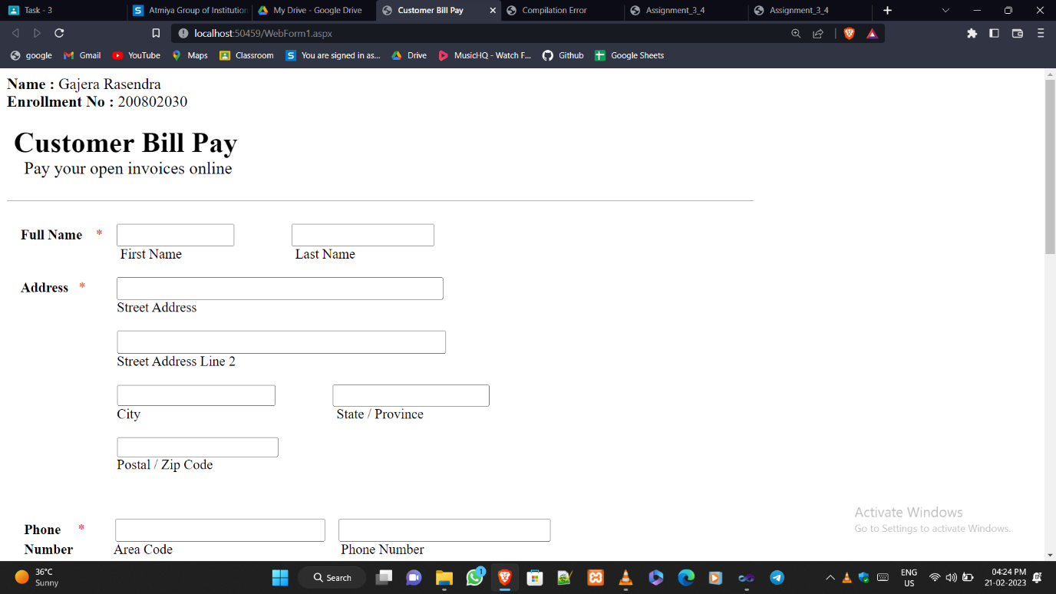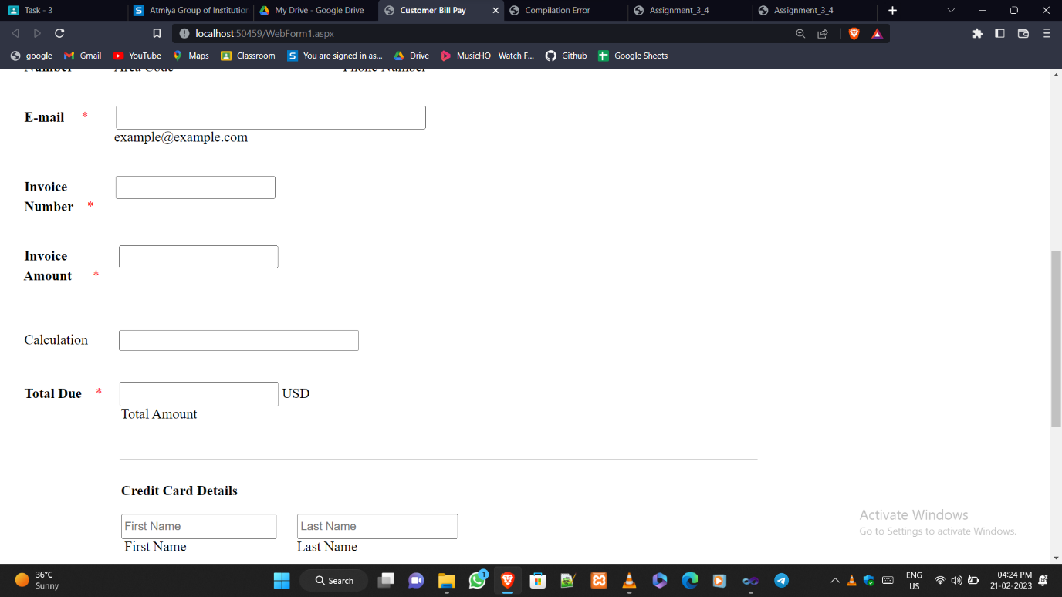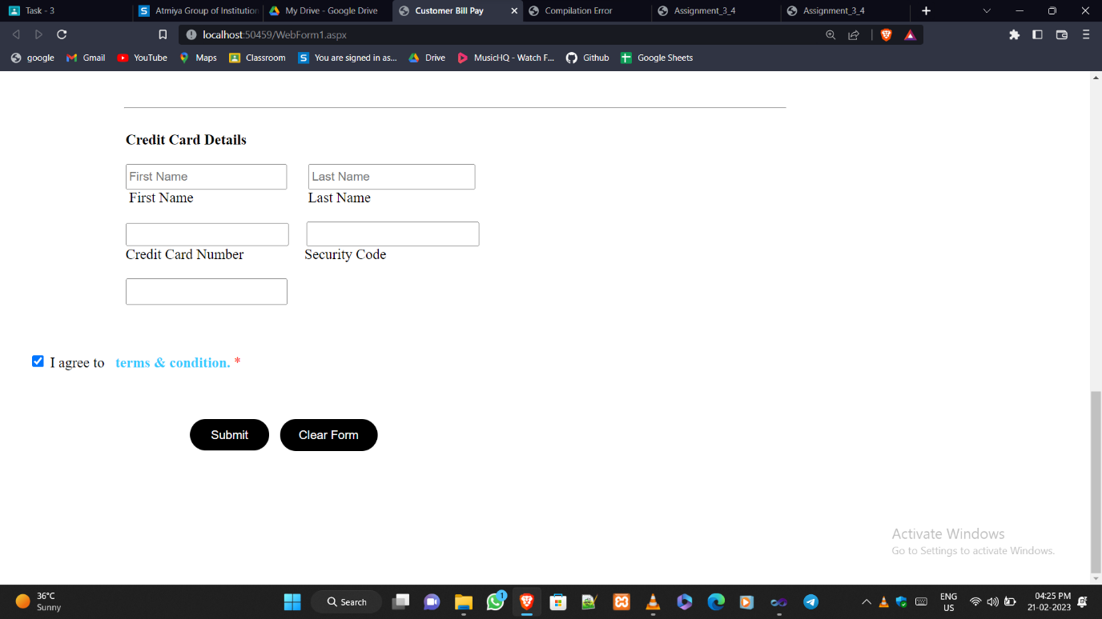

**Program 4😊**

<%@ Page Language="C#" AutoEventWireup="true" CodeBehind="index.aspx.cs" Inherits="WebApplication29.WebForm1" %>

<!DOCTYPE html>

<script runat="server">

</script>

<html xmlns="http://www.w3.org/1999/xhtml">

<head id="Head1" runat="server">

<title>Assignment_3_4</title>

<meta http-equiv="refresh" content='10' url='index.aspx' />

</head>

<body runat="server" id="BodyOfIndex">

<font size="4">

<b>Name : </b>Rasendra Gajera<br />

<b>Enrollment No : </b>200802030

</font>

<form id="form1" runat="server">

<div style="height: 644px">

&nbsp;<br />

&nbsp;&nbsp;&nbsp;

<br />

&nbsp;&nbsp;&nbsp;

<br />

&nbsp;&nbsp;&nbsp;&nbsp;&nbsp;&nbsp;&nbsp;&nbsp;&nbsp;&nbsp;&nbsp;&nbsp;&nbsp;&nbsp;&nbsp;

<asp:Label ID="Label1" runat="server"></asp:Label>

<br />

&nbsp;&nbsp;&nbsp;&nbsp;&nbsp;&nbsp;&nbsp;&nbsp;&nbsp;&nbsp;&nbsp;&nbsp;&nbsp;&nbsp;&nbsp;

<br />

&nbsp;&nbsp;&nbsp;&nbsp;&nbsp;&nbsp;&nbsp;&nbsp;&nbsp;&nbsp;&nbsp;&nbsp;&nbsp;&nbsp;&nbsp;

<asp:Label ID="Label2" runat="server"></asp:Label>

<br />

<br />

&nbsp;&nbsp;&nbsp;&nbsp;&nbsp;&nbsp;&nbsp;&nbsp;&nbsp;&nbsp;&nbsp;&nbsp;&nbsp;&nbsp;&nbsp;

<asp:Button ID="Button1" runat="server" OnClick="Button1_Click" Text="Set Cookies &amp; Change Color" Width="190px" />

</div>

</form>

</body>

</html>

**Code For Button 😊**

using System;

using System.Collections.Generic;

using System.Linq;

using System.Web;

using System.Web.UI;

using System.Web.UI.WebControls;

namespace WebApplication29

{

public partial class WebForm1 : System.Web.UI.Page

{

protected void Page_Load(object sender, EventArgs e)

{

Label1.Text = "<b>Username : </b>" + "Not Found !";

Label2.Text = "<b>Email : </b>" + "Not Found !";

}

protected void Button1_Click(object sender, EventArgs e)

{

if (Response.Cookies["username"].Value == null && Response.Cookies["email"].Value == null)

{

Response.Cookies["username"].Value = "GajeraRasendra";

Response.Cookies["username"].Expires = DateTime.Now.AddSeconds(5);

Response.Cookies["email"].Value = "rasendragajera@gmail.com";

Response.Cookies["email"].Expires = DateTime.Now.AddSeconds(5);

BodyOfIndex.Style.Add("background-color", "white");

}

Label1.Text = "<b>Username : </b>" + Response.Cookies["username"].Value;

Label2.Text = "<b>Email : </b>" + Response.Cookies["email"].Value;

BodyOfIndex.Style.Add("background-color", "aqua");

}

}

}

**Output 😊**

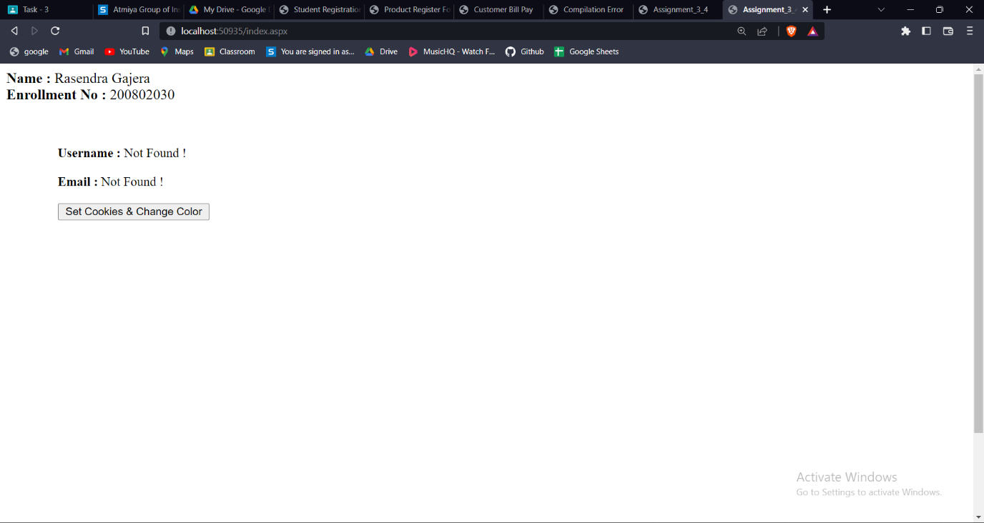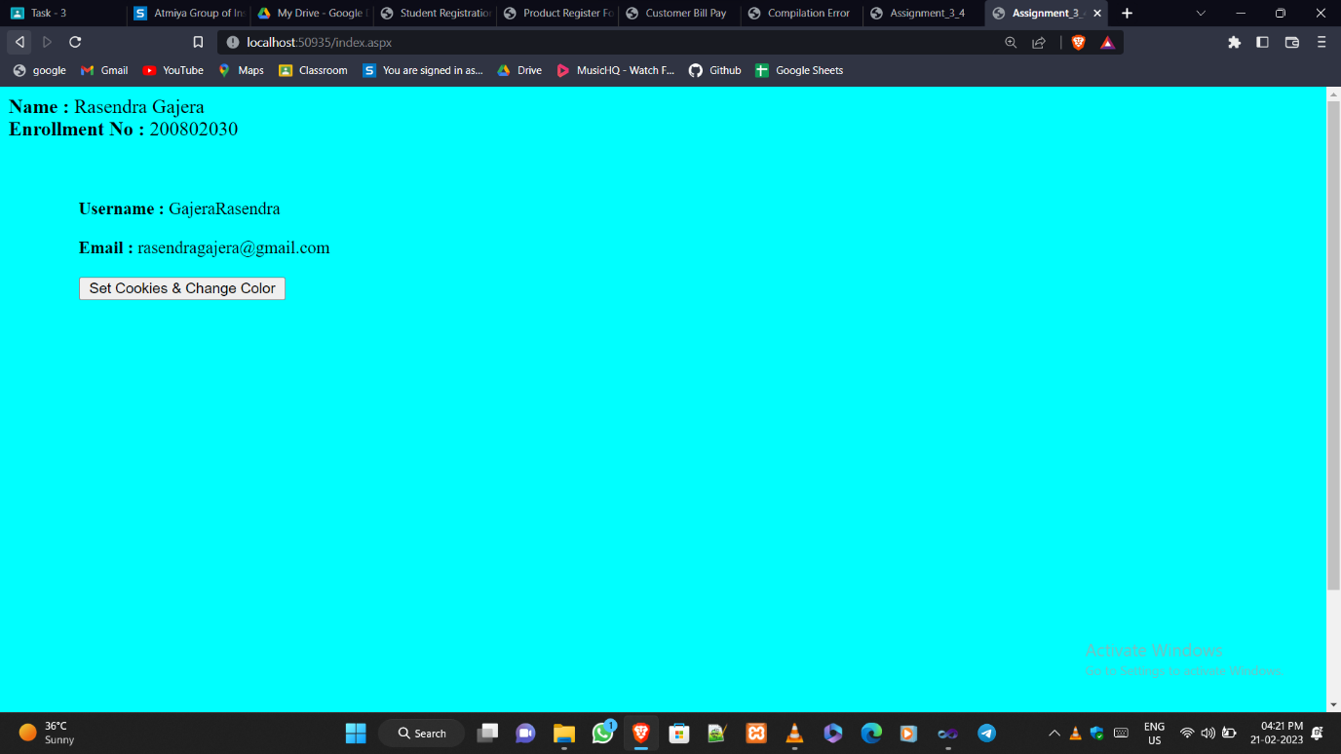

**Program 5😊**

<%@ Page Language="C#" AutoEventWireup="true" CodeBehind="index.aspx.cs" Inherits="WebApplication30.WebForm1" %>

<!DOCTYPE html>

<html xmlns="http://www.w3.org/1999/xhtml">

<head id="Head1" runat="server">

<title>Current Date and Time</title>

</head>

<body>

<font size="4">

<b>Name : </b>Rasendra Gajera<br />

<b>Enrollment No : </b>200802030

</font>

<form id="form1" runat="server">

<div style="height: 521px">

&nbsp;&nbsp;&nbsp;&nbsp;

<br />

&nbsp;&nbsp;&nbsp;&nbsp;&nbsp;&nbsp;&nbsp;&nbsp;&nbsp;&nbsp;&nbsp;

<br />

&nbsp;&nbsp;&nbsp;&nbsp;&nbsp;&nbsp;&nbsp;&nbsp;&nbsp;&nbsp;&nbsp;

<br />

&nbsp;&nbsp;&nbsp;&nbsp;&nbsp;&nbsp;&nbsp;&nbsp;&nbsp;&nbsp;&nbsp;&nbsp;&nbsp;&nbsp;&nbsp;

<asp:Label ID="Label1" runat="server"></asp:Label>

<br />

&nbsp;&nbsp;&nbsp;&nbsp;&nbsp;&nbsp;&nbsp;&nbsp;&nbsp;&nbsp;&nbsp;&nbsp;&nbsp;&nbsp;&nbsp;

<asp:Label ID="Label2" runat="server"></asp:Label>

<br />

<br />

&nbsp;&nbsp;&nbsp;&nbsp;&nbsp;&nbsp;&nbsp;&nbsp;&nbsp;&nbsp;&nbsp;&nbsp;&nbsp;&nbsp;&nbsp;

<asp:Button ID="Button1" runat="server" Text="Refresh" Width="70px"

PostBackUrl="~/index.aspx" onclick="Button1_Click" />

</div>

</form>

</body>

</html>

**Code For Button😊**

using System;

using System.Collections.Generic;

using System.Linq;

using System.Web;

using System.Web.UI;

using System.Web.UI.WebControls;

namespace WebApplication30

{

public partial class WebForm1 : System.Web.UI.Page

{

protected void Page_Load(object sender, EventArgs e)

{

}

protected void Button1_Click(object sender, EventArgs e)

{

ViewState["currentDate"] = System.DateTime.Now.ToLongDateString();

ViewState["currentTime"] = System.DateTime.Now.ToLongTimeString();

Label1.Text = "<b>Current Date : </b>" + ViewState["currentDate"].ToString();

Label2.Text = "<b>Current Time : </b>" + ViewState["currentTime"].ToString();

}

}

}

**Output😊**

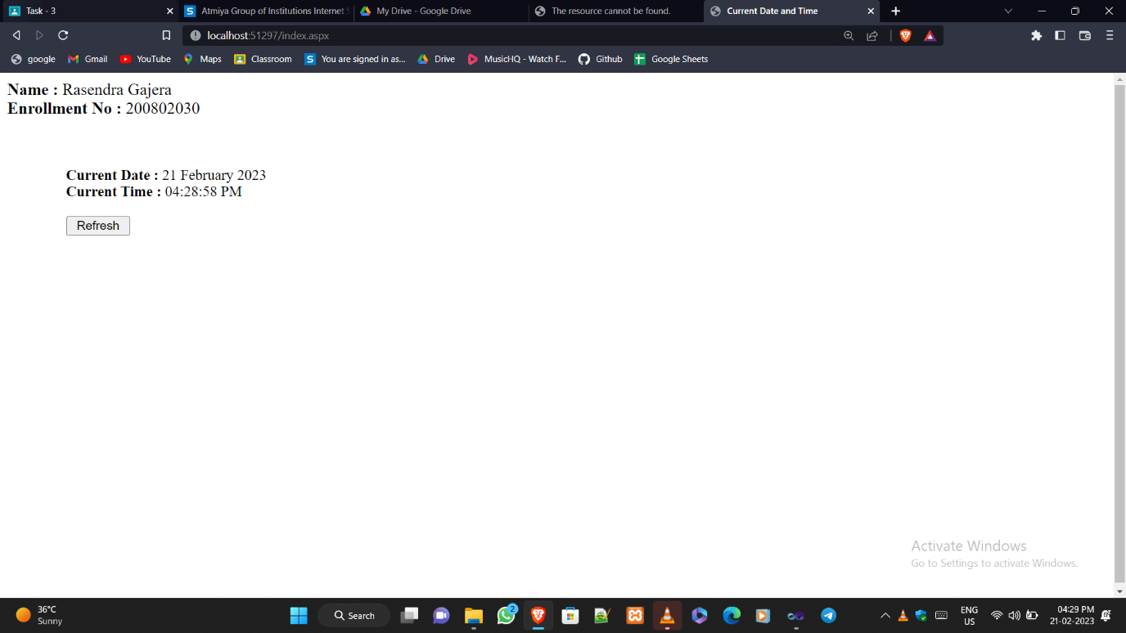

**Program 6😊**

**Code For First Page😊**

<%@ Page Language="C#" AutoEventWireup="true" CodeBehind="index.aspx.cs" Inherits="WebApplication32.index" %>

<!DOCTYPE html>

<html xmlns="http://www.w3.org/1999/xhtml">

<head id="Head1" runat="server">

<title>Index Page</title>

</head>

<body>

<font size="4">

<b>Name : </b>Rasendra Gajera <br />

<b>Enrollment No : </b>200802030

</font>

<form id="form1" runat="server">

<div style="height: 527px">

&nbsp;&nbsp;&nbsp;&nbsp;

<br />

&nbsp;&nbsp;&nbsp;

<br />

&nbsp;&nbsp;&nbsp;

<br />

&nbsp;&nbsp;&nbsp;

<br />

&nbsp;&nbsp;&nbsp;&nbsp;&nbsp;&nbsp;&nbsp;&nbsp;&nbsp;&nbsp;&nbsp;&nbsp;&nbsp;&nbsp;&nbsp;&nbsp;&nbsp;&nbsp;&nbsp;

<asp:Label ID="Label1" runat="server" Text="Usename : "></asp:Label>

<asp:TextBox ID="TextBox1" runat="server"></asp:TextBox>

<br />

&nbsp;&nbsp;&nbsp;&nbsp;&nbsp;&nbsp;&nbsp;&nbsp;&nbsp;&nbsp;&nbsp;&nbsp;&nbsp;&nbsp;&nbsp;&nbsp;&nbsp;&nbsp;&nbsp;

<br />

&nbsp;&nbsp;&nbsp;&nbsp;&nbsp;&nbsp;&nbsp;&nbsp;&nbsp;&nbsp;&nbsp;&nbsp;&nbsp;&nbsp;&nbsp;&nbsp;&nbsp;&nbsp;&nbsp;

<asp:Label ID="Label2" runat="server" Text="Password : "></asp:Label>

<asp:TextBox ID="TextBox2" runat="server" TextMode="Password"></asp:TextBox>

<br />

<br />

&nbsp;&nbsp;&nbsp;&nbsp;&nbsp;&nbsp;&nbsp;&nbsp;&nbsp;&nbsp;&nbsp;&nbsp;&nbsp;&nbsp;&nbsp;&nbsp;&nbsp;&nbsp;&nbsp;

<asp:Button ID="Button1" runat="server" OnClick="Button1_Click" Text="Submit" Width="66px" />

</div>

</form>

</body>

</html>

**Code For Button😊**

using System;

using System.Collections.Generic;

using System.Linq;

using System.Web;

using System.Web.UI;

using System.Web.UI.WebControls;

namespace WebApplication32

{

public partial class index : System.Web.UI.Page

{

protected void Page_Load(object sender, EventArgs e)

{

}

protected void Button1_Click(object sender, EventArgs e)

{

if (TextBox1.Text != "" && TextBox2.Text != "")

{

Session["username"] = TextBox1.Text;

Session["password"] = TextBox2.Text;

Response.Redirect("secondpage.aspx");

}

}

}

}

**Code For Second Page😊**

<%@ Page Language="C#" AutoEventWireup="true" CodeBehind="secondpage.aspx.cs" Inherits="WebApplication32.secondpage" %>

<!DOCTYPE html>

<html xmlns="http://www.w3.org/1999/xhtml">

<head id="Head1" runat="server">

<title>Second Page</title>

</head>

<body>

<font size="4">

<b>Name : </b>Rasendra Gajera <br />

<b>Enrollment No : </b>200802030

</font>

<form id="form1" runat="server">

<div style="height: 546px" runat="server" id="DivOfSecoundPage">

&nbsp;&nbsp;&nbsp;&nbsp;

<br />

&nbsp;&nbsp;&nbsp;&nbsp;&nbsp;&nbsp;&nbsp;

<br />

&nbsp;&nbsp;&nbsp;&nbsp;&nbsp;&nbsp;&nbsp;&nbsp;&nbsp;&nbsp;&nbsp;

<asp:Label ID="Label1" runat="server" Text="Username : "></asp:Label>

<br />

&nbsp;&nbsp;&nbsp;&nbsp;&nbsp;&nbsp;&nbsp;&nbsp;&nbsp;&nbsp;&nbsp;

<asp:Label ID="Label2" runat="server" Text="Password : "></asp:Label>

</div>

</form>

</body>

</html>

**Code For Button😊**

using System;

using System.Collections.Generic;

using System.Linq;

using System.Web;

using System.Web.UI;

using System.Web.UI.WebControls;

namespace WebApplication32

{

public partial class secondpage : System.Web.UI.Page

{

protected void Page_Load(object sender, EventArgs e)

{

if (Session["username"] != null && Session["password"] != null)

{

Label1.Text = "<b>Usename : </b>" + Session["username"].ToString();

Label2.Text = "<b>Password : </b>" + Session["password"].ToString();

}

else

{

Label1.Text = "";

Label2.Text = "<b> Session is not set yet ! </b>";

}

}

}

}

**Output😊**

