**Assignment :- 3**

Name : Radadiya Devalkumar Chandulal

Enrollment No. :- 200802089

Roll No. :- 48

Subject :- ASP .net

1. Create the “Student Registration form ” and apply all the validations which are mentioned in the image.

WebForm1.aspx :

<%@ Page Language="C#" AutoEventWireup="true" CodeBehind="WebForm1.aspx.cs" Inherits="Program_1.WebForm1" %>

<!DOCTYPE html PUBLIC "-//W3C//DTD XHTML 1.0 Transitional//EN" "http://www.w3.org/TR/xhtml1/DTD/xhtml1-transitional.dtd">

<html xmlns="http://www.w3.org/1999/xhtml">

<head runat="server">

<title></title>

<style type="text/css">

body {

border:dashed;

border-width:5px;

}

</style>

</head>

<body bgcolor="#ff4242" >

<form id="form1" runat="server" style="font-weight: bold">

<br />

<asp:Label ID="Label16" runat="server" Text="Devalkumar C. Radadiya"

ForeColor="White"></asp:Label>

<br />

p;&nbsp;

<asp:Label ID="Label17" runat="server" ForeColor="White" Text="200802089"></asp:Label>

<br />

<br />

<asp:Label ID="Label1" runat="server" ForeColor="White" Text="First Name"></asp:Label>

&nbsp;&nbsp;&nbsp;&nbsp;&nbsp;&nbsp;&nbsp;&nbsp;&nbsp;&nbsp;&nbsp;&nbsp;&nbsp;&nbsp; &nbsp;&nbsp;&nbsp;&nbsp;

<asp:TextBox ID="TextBox1" runat="server" MaxLength="70" ForeColor="#999966"

Width="200px">Ghanendra</asp:TextBox>

&nbsp;<asp:RequiredFieldValidator ID="RequiredFieldValidator1" runat="server"

ControlToValidate="TextBox1" ErrorMessage="(Max 50 Charactors Allowed)"

ForeColor="White" BorderWidth="0px"></asp:RequiredFieldValidator>

<br />

<br />

<asp:Label ID="Label2" runat="server" ForeColor="White" Text="Last Name"></asp:Label>

&nbsp;&nbsp;&nbsp;&nbsp;&nbsp;&nbsp;&nbsp;&nbsp;&nbsp;&nbsp;&nbsp;&nbsp;&nbsp;&nbsp;&nbsp;&nbsp; &nbsp;&nbsp;

<asp:TextBox ID="TextBox2" runat="server" MaxLength="50" ForeColor="#999966"

Width="200px">Yadav</asp:TextBox>

&nbsp;<asp:RequiredFieldValidator ID="RequiredFieldValidator2" runat="server"

ErrorMessage="Max 50 Charactors Allowed)" ControlToValidate="TextBox2" ForeColor="White"></asp:RequiredFieldValidator>

<br />

&nbsp;<br />

<asp:Label ID="Label3" runat="server" ForeColor="White" Text="Email ID"></asp:Label>

&nbsp;&nbsp;&nbsp;&nbsp;&nbsp;&nbsp;&nbsp;&nbsp;&nbsp;&nbsp;&nbsp;&nbsp;&nbsp; &nbsp;&nbsp;&nbsp;&nbsp;&nbsp;&nbsp;&nbsp;&nbsp;&nbsp;

<asp:TextBox ID="TextBox3" runat="server" ControlToValidate="TextBox3" ForeColor="#999966" Width="200px">yghanendra@gmail.com</asp:TextBox>

<br />

<br />

<asp:Label ID="Label4" runat="server" ForeColor="White" Text="Mobile Number"></asp:Label>

&nbsp;&nbsp;&nbsp;&nbsp;&nbsp;&nbsp;&nbsp;&nbsp;&nbsp;&nbsp;&nbsp;

<asp:TextBox ID="TextBox4" runat="server" ForeColor="#999966" Width="200px">7842******</asp:TextBox>

&nbsp;<asp:RequiredFieldValidator ID="RequiredFieldValidator3" runat="server"

ErrorMessage="( 10 Digits Allowed )" ControlToValidate="TextBox4" ForeColor="White"></asp:RequiredFieldValidator>

<br />

<br />

<asp:Label ID="Label5" runat="server" ForeColor="White" Text="Gender"></asp:Label>

&nbsp;&nbsp;&nbsp;&nbsp;&nbsp;&nbsp;&nbsp;&nbsp;&nbsp;&nbsp;&nbsp;&nbsp;&nbsp;&nbsp;&nbsp;&nbsp;&nbsp;&nbsp;&nbsp;&nbsp;&nbsp;&nbsp;&nbsp;&nbsp;

<asp:RadioButton ID="RadioButton1" runat="server" ForeColor="White"

Text="Male" />

&nbsp;&nbsp;&nbsp;&nbsp;

<asp:RadioButton ID="RadioButton2" runat="server" ForeColor="White"

Text="Female" />

<br />

<br />

<asp:Label ID="Label6" runat="server" ForeColor="White" Text="Date Of Birth"></asp:Label>

&nbsp;&nbsp;&nbsp;&nbsp;&nbsp;&nbsp;&nbsp;&nbsp;&nbsp;&nbsp;&nbsp;&nbsp;&nbsp;&nbsp;&nbsp;&nbsp;<asp:DropDownList

ID="DropDownList1" runat="server">

<asp:ListItem>Day:</asp:ListItem>

<asp:ListItem>1</asp:ListItem>

<asp:ListItem>2</asp:ListItem>

<asp:ListItem>3</asp:ListItem>

<asp:ListItem>4</asp:ListItem>

<asp:ListItem>5</asp:ListItem>

<asp:ListItem>6</asp:ListItem>

<asp:ListItem>7</asp:ListItem>

<asp:ListItem>8</asp:ListItem>

<asp:ListItem>9</asp:ListItem>

<asp:ListItem>10</asp:ListItem>

<asp:ListItem>11</asp:ListItem>

<asp:ListItem>12</asp:ListItem>

<asp:ListItem>13</asp:ListItem>

<asp:ListItem>14</asp:ListItem>

<asp:ListItem>15</asp:ListItem>

<asp:ListItem>16</asp:ListItem>

<asp:ListItem>17</asp:ListItem>

<asp:ListItem>18</asp:ListItem>

<asp:ListItem>19</asp:ListItem>

<asp:ListItem>20</asp:ListItem>

<asp:ListItem>21</asp:ListItem>

<asp:ListItem>22</asp:ListItem>

<asp:ListItem>23</asp:ListItem>

<asp:ListItem>24</asp:ListItem>

<asp:ListItem>25</asp:ListItem>

<asp:ListItem>26</asp:ListItem>

<asp:ListItem>27</asp:ListItem>

<asp:ListItem>28</asp:ListItem>

<asp:ListItem>29</asp:ListItem>

<asp:ListItem>30</asp:ListItem>

<asp:ListItem>31</asp:ListItem>

</asp:DropDownList>

&nbsp;&nbsp;&nbsp;<asp:DropDownList ID="DropDownList2" runat="server">

<asp:ListItem>Month:</asp:ListItem>

<asp:ListItem>January</asp:ListItem>

<asp:ListItem>February</asp:ListItem>

<asp:ListItem>March</asp:ListItem>

<asp:ListItem>April</asp:ListItem>

<asp:ListItem>May</asp:ListItem>

<asp:ListItem>June</asp:ListItem>

<asp:ListItem>July</asp:ListItem>

<asp:ListItem>August</asp:ListItem>

<asp:ListItem>Sepetember</asp:ListItem>

<asp:ListItem>October</asp:ListItem>

<asp:ListItem>November</asp:ListItem>

<asp:ListItem>December</asp:ListItem>

</asp:DropDownList>

&nbsp; &nbsp;

<asp:DropDownList ID="DropDownList3" runat="server">

</asp:DropDownList>

<br />

<br />

<asp:Label ID="Label7" runat="server" ForeColor="White" Text="Address"></asp:Label>

&nbsp;&nbsp;&nbsp;&nbsp;&nbsp;&nbsp;&nbsp;&nbsp;&nbsp;&nbsp;&nbsp;&nbsp;&nbsp;&nbsp;&nbsp;&nbsp;&nbsp;&nbsp;&nbsp;&nbsp;&nbsp;&nbsp;&nbsp;

<asp:TextBox ID="TextBox5" runat="server" ControlToValidate="TextBox5" Height="100px" Width="300px"></asp:TextBox>

<br />

<br />

<asp:Label ID="Label8" runat="server" ForeColor="White" Text="City"></asp:Label>

&nbsp;&nbsp;&nbsp;&nbsp;&nbsp;&nbsp;&nbsp;&nbsp;&nbsp;&nbsp;&nbsp;&nbsp;&nbsp;&nbsp;&nbsp;&nbsp;&nbsp;&nbsp;&nbsp;&nbsp;&nbsp;&nbsp;&nbsp;&nbsp;&nbsp;&nbsp;&nbsp;&nbsp;&nbsp;

<asp:TextBox ID="TextBox6" runat="server" ControlToValidate="TextBox6" ForeColor="#999966" Width="200px">Bangalore</asp:TextBox>

&nbsp;

<asp:RequiredFieldValidator ID="RequiredFieldValidator4" ControlToValidate="TextBox6" runat="server"

ErrorMessage="Max 50 Charactors Allowed" ForeColor="White"></asp:RequiredFieldValidator>

<br />

<br />

&nbsp;<asp:Label ID="Label9" runat="server" ForeColor="White" Text="Pin Code"></asp:Label>

&nbsp;&nbsp;&nbsp;&nbsp;&nbsp;&nbsp;&nbsp;&nbsp;&nbsp;&nbsp;&nbsp;&nbsp;&nbsp;&nbsp;&nbsp;&nbsp;&nbsp;&nbsp;&nbsp;&nbsp;

<asp:TextBox ID="TextBox7" runat="server" ControlToValidate="TextBox7" ForeColor="#999966" Width="200px">560068</asp:TextBox>

&nbsp;

<asp:RequiredFieldValidator ID="RequiredFieldValidator5" ControlToValidate="TextBox7" runat="server"

ErrorMessage="Max 6 Numbers Allowed" ForeColor="White"></asp:RequiredFieldValidator>

<br />

<br />

<asp:Label ID="Label10" runat="server" ForeColor="White" Text="State"></asp:Label>

&nbsp;&nbsp;&nbsp;&nbsp;&nbsp;&nbsp;&nbsp;&nbsp;&nbsp;&nbsp;&nbsp;&nbsp;&nbsp;&nbsp;&nbsp;&nbsp;&nbsp;&nbsp;&nbsp;&nbsp;&nbsp;&nbsp;&nbsp;&nbsp;&nbsp;&nbsp;&nbsp;

<asp:TextBox ID="TextBox8" runat="server" ControlToValidate="TextBox8" ForeColor="#999966" Width="200px">Karnataka</asp:TextBox>

&nbsp;

<asp:RequiredFieldValidator ID="RequiredFieldValidator6" ControlToValidate="TextBox8" runat="server"

ErrorMessage="Max 50 Charactor Allowed" ForeColor="White"></asp:RequiredFieldValidator>

<br />

<br />

<asp:Label ID="Label11" runat="server" ForeColor="White" Text="Country"></asp:Label>

&nbsp;&nbsp;&nbsp;&nbsp;&nbsp;&nbsp;&nbsp;&nbsp;&nbsp;&nbsp;&nbsp;&nbsp;&nbsp;&nbsp;&nbsp;&nbsp;&nbsp;&nbsp;&nbsp;&nbsp;&nbsp;&nbsp;

<asp:TextBox ID="TextBox9" runat="server" ControlToValidate="TextBox9" ForeColor="#999966" Width="200px">India</asp:TextBox>

<br />

<br />

<asp:Label ID="Label12" runat="server" ForeColor="White" Text="Hobbies"></asp:Label>

&nbsp;&nbsp;&nbsp;&nbsp;&nbsp;&nbsp;&nbsp;&nbsp;&nbsp;&nbsp;&nbsp;&nbsp;&nbsp;&nbsp;&nbsp;&nbsp;&nbsp;&nbsp;&nbsp;&nbsp;&nbsp;

<asp:CheckBox ID="CheckBox1" runat="server" ForeColor="White" Text="Drawing" />

&nbsp;

<asp:CheckBox ID="CheckBox2" runat="server" ForeColor="White" Text="Singing" />

&nbsp;

<asp:CheckBox ID="CheckBox3" runat="server" ForeColor="White" Text="Dancing" />

&nbsp;

<asp:CheckBox ID="CheckBox4" runat="server" ForeColor="White"

Text="Sketching" />

<br />

&nbsp;&nbsp;&nbsp;&nbsp;&nbsp;&nbsp;&nbsp;&nbsp;&nbsp;&nbsp;&nbsp;&nbsp;&nbsp;&nbsp;&nbsp;&nbsp;&nbsp;&nbsp;&nbsp;&nbsp;&nbsp;&nbsp;&nbsp;&nbsp;&nbsp;&nbsp;&nbsp;&nbsp;&nbsp;&nbsp;&nbsp;&nbsp;&nbsp;&nbsp;&nbsp;

<asp:CheckBox ID="CheckBox5" runat="server" ForeColor="White" Text="Others" />

&nbsp;

<asp:TextBox ID="TextBox10" runat="server" ControlToValidate="TextBox10" ForeColor="#999966" Width="200px">Ex- Teaching</asp:TextBox>

&nbsp;

<asp:RequiredFieldValidator ID="RequiredFieldValidator7" ControlToValidate="TextBox10" runat="server"

ErrorMessage="(Max 50 Charactors Allowed)" ForeColor="White"></asp:RequiredFieldValidator>

<br />

<br />

<asp:Label ID="Label13" runat="server" ForeColor="White" Text="Qualification"></asp:Label>

&nbsp;&nbsp;&nbsp;&nbsp;&nbsp;&nbsp;&nbsp;&nbsp;&nbsp;&nbsp;&nbsp;&nbsp;&nbsp;&nbsp;

<asp:CheckBox ID="CheckBox6" runat="server" ForeColor="White"

Text="High School(10th)" />

&nbsp;&nbsp;

<br />

&nbsp;&nbsp;&nbsp;&nbsp;&nbsp;&nbsp;&nbsp;&nbsp;&nbsp;&nbsp;&nbsp;&nbsp;&nbsp;&nbsp;&nbsp;&nbsp;&nbsp;&nbsp;&nbsp;&nbsp;&nbsp;&nbsp;&nbsp;&nbsp;&nbsp;&nbsp;&nbsp;&nbsp;&nbsp;&nbsp;&nbsp;&nbsp;&nbsp;&nbsp;&nbsp;

<asp:CheckBox ID="CheckBox7" runat="server" ForeColor="White"

Text="Higher School(12th)" />

<br />

&nbsp;&nbsp;&nbsp;&nbsp;&nbsp;&nbsp;&nbsp;&nbsp;&nbsp;&nbsp;&nbsp;&nbsp;&nbsp;&nbsp;&nbsp;&nbsp;&nbsp;&nbsp;&nbsp;&nbsp;&nbsp;&nbsp;&nbsp;&nbsp;&nbsp;&nbsp;&nbsp;&nbsp;&nbsp;&nbsp;&nbsp;&nbsp;&nbsp;&nbsp;&nbsp;

<asp:CheckBox ID="CheckBox8" runat="server" ForeColor="White"

Text="Graduation(Bachelors)" />

<br />

&nbsp;&nbsp;&nbsp;&nbsp;&nbsp;&nbsp;&nbsp;&nbsp;&nbsp;&nbsp;&nbsp;&nbsp;&nbsp;&nbsp;&nbsp;&nbsp;&nbsp;&nbsp;&nbsp;&nbsp;&nbsp;&nbsp;&nbsp;&nbsp;&nbsp;&nbsp;&nbsp;&nbsp;&nbsp;&nbsp;&nbsp;&nbsp;&nbsp;&nbsp;&nbsp;

<asp:CheckBox ID="CheckBox9" runat="server" ForeColor="White"

Text="Post Graduation(Masters)" />

<br />

&nbsp;&nbsp;&nbsp;&nbsp;&nbsp;&nbsp;&nbsp;&nbsp;&nbsp;&nbsp;&nbsp;&nbsp;&nbsp;&nbsp;&nbsp;&nbsp;&nbsp;&nbsp;&nbsp;&nbsp;&nbsp;&nbsp;&nbsp;&nbsp;&nbsp;&nbsp;&nbsp;&nbsp;&nbsp;&nbsp;&nbsp;&nbsp;&nbsp;&nbsp;&nbsp;

<asp:CheckBox ID="CheckBox10" runat="server" ForeColor="White" Text="Phd" />

<br />

<br />

<asp:Label ID="Label14" runat="server" ForeColor="White" Text="Courses"></asp:Label>

&nbsp;&nbsp;&nbsp;&nbsp;&nbsp;&nbsp;&nbsp;&nbsp;&nbsp;&nbsp;&nbsp;&nbsp;&nbsp;&nbsp;&nbsp;&nbsp;&nbsp;&nbsp;&nbsp;&nbsp;&nbsp;&nbsp;

<br />

<asp:Label ID="Label15" runat="server" ForeColor="White" Text="Applied For"></asp:Label>

&nbsp;&nbsp;&nbsp;&nbsp;&nbsp;&nbsp;&nbsp;&nbsp;&nbsp;&nbsp;&nbsp;&nbsp;&nbsp;&nbsp;&nbsp;

<asp:RadioButton ID="RadioButton3" runat="server" ForeColor="White"

Text="BCA(Bachelor of Computer Appllications)" />

<br />

&nbsp;&nbsp;&nbsp;&nbsp;&nbsp;&nbsp;&nbsp;&nbsp;&nbsp;&nbsp;&nbsp;&nbsp;&nbsp;&nbsp;&nbsp;&nbsp;&nbsp;&nbsp;&nbsp;&nbsp;&nbsp;&nbsp;&nbsp;&nbsp;&nbsp;&nbsp;&nbsp;&nbsp;&nbsp;&nbsp;&nbsp;&nbsp;&nbsp;&nbsp;&nbsp;

<asp:RadioButton ID="RadioButton4" runat="server" ForeColor="White"

Text="B.Com(Bachelor of Commerce)" />

<br />

&nbsp;&nbsp;&nbsp;&nbsp;&nbsp;&nbsp;&nbsp;&nbsp;&nbsp;&nbsp;&nbsp;&nbsp;&nbsp;&nbsp;&nbsp;&nbsp;&nbsp;&nbsp;&nbsp;&nbsp;&nbsp;&nbsp;&nbsp;&nbsp;&nbsp;&nbsp;&nbsp;&nbsp;&nbsp;&nbsp;&nbsp;&nbsp;&nbsp;&nbsp;&nbsp;

<asp:RadioButton ID="RadioButton5" runat="server" ForeColor="White"

Text="B.Sc.(Bachelor of Science)" />

<br />

&nbsp;&nbsp;&nbsp;&nbsp;&nbsp;&nbsp;&nbsp;&nbsp;&nbsp;&nbsp;&nbsp;&nbsp;&nbsp;&nbsp;&nbsp;&nbsp;&nbsp;&nbsp;&nbsp;&nbsp;&nbsp;&nbsp;&nbsp;&nbsp;&nbsp;&nbsp;&nbsp;&nbsp;&nbsp;&nbsp;&nbsp;&nbsp;&nbsp;&nbsp;&nbsp;

<asp:RadioButton ID="RadioButton6" runat="server" ForeColor="White"

Text="BA(Bachelor of Arts)" />

<br />

&nbsp;&nbsp;&nbsp;&nbsp;&nbsp;&nbsp;&nbsp;&nbsp;&nbsp;&nbsp;&nbsp;&nbsp;&nbsp;&nbsp;&nbsp;&nbsp;&nbsp;&nbsp;&nbsp;&nbsp;&nbsp;&nbsp;&nbsp;&nbsp;&nbsp;&nbsp;&nbsp;&nbsp;&nbsp;&nbsp;&nbsp;&nbsp;&nbsp;&nbsp;&nbsp;

<asp:RadioButton ID="RadioButton7" runat="server" ForeColor="White"

Text="MCA(Master of Computer Applications)" />

<br />

&nbsp;&nbsp;&nbsp;&nbsp;&nbsp;&nbsp;&nbsp;&nbsp;&nbsp;&nbsp;&nbsp;&nbsp;&nbsp;&nbsp;&nbsp;&nbsp;&nbsp;&nbsp;&nbsp;&nbsp;&nbsp;&nbsp;&nbsp;&nbsp;&nbsp;&nbsp;&nbsp;&nbsp;&nbsp;&nbsp;&nbsp;&nbsp;&nbsp;&nbsp;&nbsp;

<asp:RadioButton ID="RadioButton8" runat="server" ForeColor="White"

Text="M.Com(Master of Commerce)" />

<br />

&nbsp;&nbsp;&nbsp;&nbsp;&nbsp;&nbsp;&nbsp;&nbsp;&nbsp;&nbsp;&nbsp;&nbsp;&nbsp;&nbsp;&nbsp;&nbsp;&nbsp;&nbsp;&nbsp;&nbsp;&nbsp;&nbsp;&nbsp;&nbsp;&nbsp;&nbsp;&nbsp;&nbsp;&nbsp;&nbsp;&nbsp;&nbsp;&nbsp;&nbsp;&nbsp;

<asp:RadioButton ID="RadioButton9" runat="server" ForeColor="White"

Text="M.Sc.(Master of Science)" />

<br />

&nbsp;&nbsp;&nbsp;&nbsp;&nbsp;&nbsp;&nbsp;&nbsp;&nbsp;&nbsp;&nbsp;&nbsp;&nbsp;&nbsp;&nbsp;&nbsp;&nbsp;&nbsp;&nbsp;&nbsp;&nbsp;&nbsp;&nbsp;&nbsp;&nbsp;&nbsp;&nbsp;&nbsp;&nbsp;&nbsp;&nbsp;&nbsp;&nbsp;&nbsp;&nbsp;

<asp:RadioButton ID="RadioButton10" runat="server" ForeColor="White"

Text="MA(Master of Arts)" />

<br />

<br />

&nbsp;&nbsp;&nbsp;&nbsp;&nbsp;&nbsp;&nbsp;&nbsp;&nbsp;&nbsp;&nbsp;&nbsp;&nbsp;&nbsp;&nbsp;&nbsp;&nbsp;&nbsp;&nbsp;&nbsp;&nbsp;&nbsp;&nbsp;&nbsp;&nbsp;&nbsp;&nbsp;&nbsp;&nbsp;&nbsp;&nbsp;&nbsp;&nbsp;&nbsp;&nbsp;&nbsp;&nbsp;&nbsp;&nbsp;&nbsp;&nbsp;&nbsp;&nbsp;&nbsp;&nbsp;&nbsp;&nbsp;&nbsp;&nbsp;&nbsp;&nbsp;

<asp:Button ID="Button1" runat="server" Text="Submit" />

&nbsp;

<asp:Button ID="Button2" runat="server" Text="Reset" />

</form>

</body>

</html>

**OUTPUT :-**

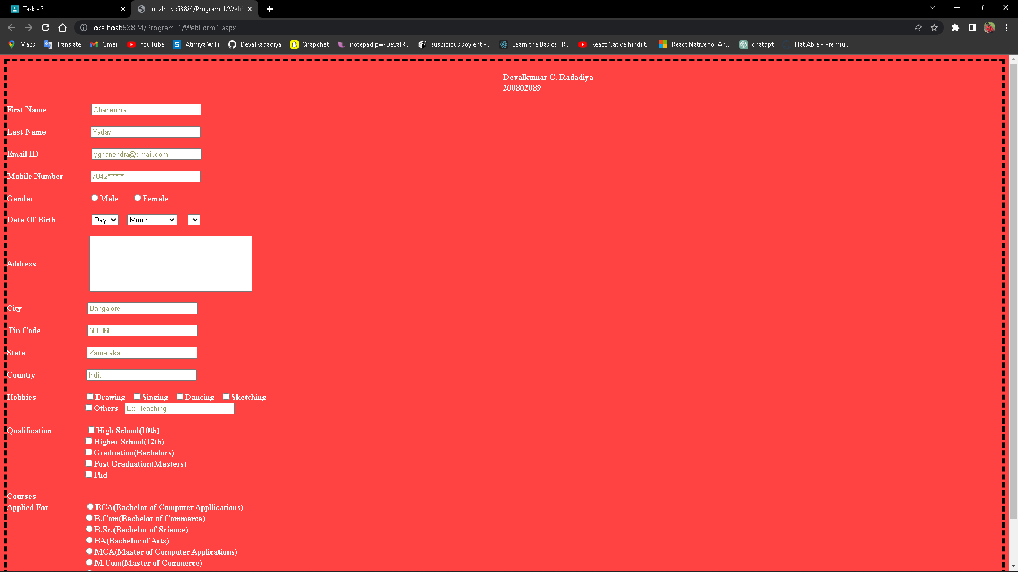

1. **Create the “Product Registration form ” and apply all the appropriate validations.**

**WebForm1.aspx :-**

<%@ Page Language="C#" AutoEventWireup="true" CodeBehind="WebForm1.aspx.cs" Inherits="Program_2.WebForm1" %>

<!DOCTYPE html PUBLIC "-//W3C//DTD XHTML 1.0 Transitional//EN" "http://www.w3.org/TR/xhtml1/DTD/xhtml1-transitional.dtd">

<html xmlns="http://www.w3.org/1999/xhtml">

<head runat="server">

<title></title>

<style type="text/css">body{background-color:lightcyan}</style>

</head>

<body>

<form id="form1" runat="server">

<asp:Label ID="Label1" runat="server" Font-Bold="False" Font-Size="XX-Large"

ForeColor="#48755A" Text="Product Registration Form"></asp:Label>

<br />

<br />

<div>

<asp:Label ID="Label2" runat="server"

Text="Register your product by filling in the product registration form below."

ForeColor="#006666" Font-Bold="True" Font-Size="Medium"></asp:Label>

<br />

<br />

<br />

<hr>

<br />

<asp:Label ID="Label3" runat="server" Font-Bold="True" ForeColor="#006666"

Text="Name"></asp:Label>

<br />

<asp:TextBox ID="TextBox1" runat="server" ForeColor="#EDF9F7" Height="35px" placeholder=" First"

Width="250px"></asp:TextBox>

&nbsp;&nbsp;&nbsp;&nbsp;

<asp:TextBox ID="TextBox2" runat="server" ForeColor="#EDF9F7" Height="35px" placeholder=" Last"

style="margin-top: 0px" Width="250px"></asp:TextBox>

<br />

<br />

<asp:Label ID="Label4" runat="server" Font-Bold="True" ForeColor="#006666"

Text="Email"></asp:Label>

&nbsp;&nbsp;&nbsp;&nbsp;&nbsp;&nbsp;&nbsp;&nbsp;&nbsp;&nbsp;&nbsp;&nbsp;&nbsp;&nbsp;&nbsp;&nbsp;&nbsp;&nbsp;&nbsp;&nbsp;&nbsp;&nbsp;&nbsp;&nbsp;&nbsp;&nbsp;&nbsp;&nbsp;&nbsp;&nbsp;&nbsp;&nbsp;&nbsp;&nbsp;&nbsp;&nbsp;&nbsp;&nbsp;&nbsp;&nbsp;&nbsp;&nbsp;&nbsp;&nbsp;&nbsp;&nbsp;&nbsp;&nbsp;&nbsp;&nbsp;&nbsp;&nbsp;&nbsp;&nbsp;&nbsp;&nbsp;&nbsp;&nbsp;&nbsp;&nbsp;

<asp:Label ID="Label5" runat="server" Font-Bold="True" ForeColor="#006666"

Text="Phone"></asp:Label>

<br />

<asp:TextBox ID="TextBox3" runat="server" ForeColor="#EDF9F7" Height="35px"

Width="250px"></asp:TextBox>

&nbsp;&nbsp;&nbsp;&nbsp;

<asp:TextBox ID="TextBox4" runat="server" ForeColor="#EDF9F7" Height="35px" placeholder="### ### ###"

Width="250px"></asp:TextBox>

<br />

<br />

<asp:Label ID="Label6" runat="server" Font-Bold="True" ForeColor="#006666"

Text="Adderess"></asp:Label>

<br /><asp:TextBox ID="TextBox5" runat="server" ForeColor="#EDF9F7"

Height="35px" placeholder=" Street Address"

Width="530px"></asp:TextBox>

<br />

<br />

<asp:TextBox ID="TextBox6" runat="server" ForeColor="#EDF9F7" Height="35px"

Width="250px" placehodler=" City"></asp:TextBox>

&nbsp;&nbsp;

<br />

<br />

<asp:TextBox ID="TextBox7" runat="server" ForeColor="#EDF9F7" Height="35px"

Width="250px" placehodler=" Postal / Zip Code"></asp:TextBox>

<br />

<br />

<asp:Label ID="Label7" runat="server" Font-Size="XX-Large" ForeColor="#48755A"

Text="PRODUCT INFORMATION"></asp:Label>

<br />

<br />

<asp:Label ID="Label8" runat="server" Font-Bold="True" ForeColor="#006666"

Text="Product Name"></asp:Label>

&nbsp;&nbsp;&nbsp;&nbsp;&nbsp;&nbsp;&nbsp;&nbsp;&nbsp;&nbsp;&nbsp;&nbsp;&nbsp;&nbsp;&nbsp;&nbsp;&nbsp;&nbsp;&nbsp;&nbsp;&nbsp;&nbsp;&nbsp;&nbsp;&nbsp;&nbsp;&nbsp;&nbsp;&nbsp;&nbsp;&nbsp;&nbsp;&nbsp;&nbsp;&nbsp;&nbsp;&nbsp;&nbsp;&nbsp;&nbsp;&nbsp;&nbsp;&nbsp;

<asp:Label ID="Label9" runat="server" Font-Bold="True" ForeColor="#006666"

Text="Product Brand &amp; Model"></asp:Label>

<br />

<asp:TextBox ID="TextBox8" runat="server" ForeColor="#EDF9F7" Height="35px"

Width="250px" placehodler=" Postal / Zip Code"></asp:TextBox>

&nbsp;&nbsp;&nbsp;

<asp:TextBox ID="TextBox9" runat="server" ForeColor="#EDF9F7" Height="35px"

Width="250px" placehodler=" Postal / Zip Code"></asp:TextBox>

<br />

<asp:Label ID="Label10" runat="server" Font-Size="Small" ForeColor="#666666"

Text="e.g. Laptop"></asp:Label>

&nbsp;&nbsp;&nbsp;&nbsp;&nbsp;&nbsp;&nbsp;&nbsp;&nbsp;&nbsp;&nbsp;&nbsp;&nbsp;&nbsp;&nbsp;&nbsp;&nbsp;&nbsp;&nbsp;&nbsp;&nbsp;&nbsp;&nbsp;&nbsp;&nbsp;&nbsp;&nbsp;&nbsp;&nbsp;&nbsp;&nbsp;&nbsp;&nbsp;&nbsp;&nbsp;&nbsp;&nbsp;&nbsp;&nbsp;&nbsp;&nbsp;&nbsp;&nbsp;&nbsp;&nbsp;&nbsp;&nbsp;&nbsp;&nbsp;&nbsp;&nbsp;

<asp:Label ID="Label11" runat="server" Font-Size="Small" ForeColor="#666666"

Text="e.g. Acer Aspire Nitro"></asp:Label>

<br />

<br />

<asp:Label ID="Label12" runat="server" Font-Bold="True" ForeColor="#006666"

Text="Product Model ID"></asp:Label>

&nbsp;&nbsp;&nbsp;&nbsp;&nbsp;&nbsp;&nbsp;&nbsp;&nbsp;&nbsp;&nbsp;&nbsp;&nbsp;&nbsp;&nbsp;&nbsp;&nbsp;&nbsp;&nbsp;&nbsp;&nbsp;&nbsp;&nbsp;&nbsp;&nbsp;&nbsp;&nbsp;&nbsp;&nbsp;&nbsp;&nbsp;&nbsp;&nbsp;&nbsp;&nbsp;&nbsp;

<asp:Label ID="Label13" runat="server" Font-Bold="True" ForeColor="#006666"

Text="Product Febrication Year"></asp:Label>

<br />

<asp:TextBox ID="TextBox10" runat="server" ForeColor="#EDF9F7" Height="35px"

Width="250px" placehodler=" Postal / Zip Code"></asp:TextBox>

&nbsp;&nbsp;&nbsp;

<asp:TextBox ID="TextBox11" runat="server" ForeColor="#EDF9F7" Height="35px"

Width="250px" placehodler=" Postal / Zip Code"></asp:TextBox>

<br />

<asp:Label ID="Label14" runat="server" Font-Size="Small" ForeColor="#666666"

Text="e.g. VN7793G750Z"></asp:Label>

&nbsp;&nbsp;&nbsp;&nbsp;&nbsp;&nbsp;&nbsp;&nbsp;&nbsp;&nbsp;&nbsp;&nbsp;&nbsp;&nbsp;&nbsp;&nbsp;&nbsp;&nbsp;&nbsp;&nbsp;&nbsp;&nbsp;&nbsp;&nbsp;&nbsp;&nbsp;&nbsp;&nbsp;&nbsp;&nbsp;&nbsp;&nbsp;&nbsp;&nbsp;&nbsp;&nbsp;&nbsp;&nbsp;&nbsp;&nbsp;&nbsp;

<asp:Label ID="Label15" runat="server" Font-Size="Small" ForeColor="#666666"

Text="e.g. 2012"></asp:Label>

<br />

<br />

<asp:Label ID="Label16" runat="server" Font-Bold="True" ForeColor="#006666"

Text="Purchase Date"></asp:Label>

<br />

<asp:Calendar ID="Calendar1" runat="server" BackColor="White"

BorderColor="#3366CC" BorderWidth="1px" CellPadding="1"

DayNameFormat="Shortest" Font-Names="Verdana" Font-Size="8pt"

ForeColor="#003399" Height="200px" Width="220px">

<DayHeaderStyle BackColor="#99CCCC" ForeColor="#336666" Height="1px" />

<NextPrevStyle Font-Size="8pt" ForeColor="#CCCCFF" />

<OtherMonthDayStyle ForeColor="#999999" />

<SelectedDayStyle BackColor="#009999" Font-Bold="True" ForeColor="#CCFF99" />

<SelectorStyle BackColor="#99CCCC" ForeColor="#336666" />

<TitleStyle BackColor="#003399" BorderColor="#3366CC" BorderWidth="1px"

Font-Bold="True" Font-Size="10pt" ForeColor="#CCCCFF" Height="25px" />

<TodayDayStyle BackColor="#99CCCC" ForeColor="White" />

<WeekendDayStyle BackColor="#CCCCFF" />

</asp:Calendar>

<asp:Label ID="Label17" runat="server" Font-Size="Small" ForeColor="#666666"

Text="e.g. 12/04/2017"></asp:Label>

<br />

<br />

&nbsp;&nbsp;&nbsp;&nbsp;&nbsp;&nbsp;&nbsp;&nbsp;&nbsp;&nbsp;&nbsp;&nbsp;&nbsp;&nbsp;&nbsp;&nbsp;&nbsp;&nbsp;&nbsp;&nbsp;&nbsp;&nbsp;&nbsp;&nbsp;&nbsp;&nbsp;&nbsp;&nbsp;&nbsp;&nbsp;&nbsp;&nbsp;&nbsp;&nbsp;&nbsp;

<asp:Button ID="Button1" runat="server" Text="REGISTER PRODUCT"

BackColor="#009900" Font-Bold="True" ForeColor="White" />

<br />

</div>

</form>

</body>

</html>

**OUTPUT :**

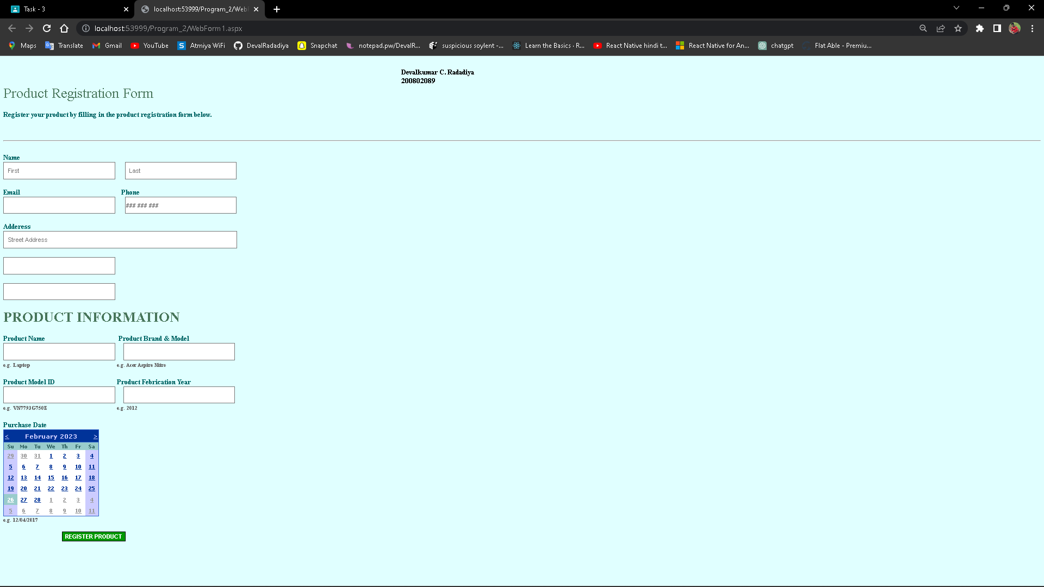

1. Create the “Bill payment application” and apply all the appropriate validations for the same.

WebForm1.aspx :

<%@ Page Language="C#" AutoEventWireup="true" CodeBehind="WebForm1.aspx.cs" Inherits="Assigntment_3_3.WebForm1" %>

<!DOCTYPE html PUBLIC "-//W3C//DTD XHTML 1.0 Transitional//EN" "http://www.w3.org/TR/xhtml1/DTD/xhtml1-transitional.dtd">

<html xmlns="http://www.w3.org/1999/xhtml">

<head runat="server">

<title></title>

<style type="text/css">

#Button1

{

border-radius: 20px;

}

#Button2

{

border-radius: 20px;

}

</style>

</head>

<body>

<form id="form1" runat="server">

<div style="height: 1491px; width: 869px">

&nbsp;&nbsp;

<asp:Label ID="Label1" runat="server" Font-Bold="True" Font-Size="25pt"

Text="Customer Bill Pay"></asp:Label>

<br />

&nbsp;&nbsp;&nbsp;&nbsp;

<asp:Label ID="Label2" runat="server" Text="Pay your open invoices online"

Font-Bold="False" Font-Size="15pt" Width="215pt"></asp:Label>

<br />

<br />

<hr />

<br />

&nbsp;&nbsp;&nbsp;

<asp:Label ID="Label3" runat="server" Font-Bold="True" Text="Full Name"></asp:Label>

&nbsp;&nbsp;&nbsp;<asp:Label ID="Label7" runat="server" ForeColor="Red" Text="*"></asp:Label>

&nbsp;&nbsp;&nbsp;<asp:TextBox ID="TextBox1" runat="server" Height="20px" Width="129px"></asp:TextBox>

<asp:RequiredFieldValidator ID="RequiredFieldValidator2"

runat="server" ErrorMessage="Required" ControlToValidate="TextBox3"

ForeColor="Red" ></asp:RequiredFieldValidator>

<asp:TextBox ID="TextBox2" runat="server" Width="159px"

Height="21px"></asp:TextBox>

<asp:RequiredFieldValidator ID="RequiredFieldValidator1" runat="server"

ErrorMessage="Required" ControlToValidate="TextBox2" ForeColor="Red"></asp:RequiredFieldValidator>

<br />

&nbsp;&nbsp;&nbsp;&nbsp;&nbsp;&nbsp;&nbsp;&nbsp;&nbsp;&nbsp;&nbsp;&nbsp;&nbsp;&nbsp;&nbsp;&nbsp;&nbsp;&nbsp;&nbsp;&nbsp;&nbsp;&nbsp;&nbsp;&nbsp;&nbsp;&nbsp;&nbsp;&nbsp;&nbsp;&nbsp;&nbsp;&nbsp; <asp:Label ID="Label4" runat="server" Text="First Name"></asp:Label>

&nbsp;&nbsp;&nbsp;&nbsp;&nbsp;&nbsp;&nbsp;&nbsp;&nbsp;&nbsp;&nbsp;&nbsp;&nbsp;&nbsp;&nbsp;&nbsp;&nbsp;&nbsp;&nbsp;&nbsp;&nbsp;&nbsp;&nbsp;&nbsp;&nbsp;&nbsp;&nbsp;&nbsp;&nbsp;&nbsp;&nbsp; <asp:Label ID="Label5" runat="server" Text="Last Name"></asp:Label>

<br />

<br />

&nbsp;&nbsp;&nbsp;

<asp:Label ID="Label6" runat="server" Font-Bold="True" Text="Address"></asp:Label>

&nbsp;

<asp:Label ID="Label8" runat="server" ForeColor="Red" Text="*"></asp:Label>

&nbsp;&nbsp;&nbsp;&nbsp;&nbsp;&nbsp;&nbsp;

<asp:TextBox ID="TextBox3" runat="server" Height="20px" Width="372px"></asp:TextBox>

<asp:RequiredFieldValidator ID="RequiredFieldValidator3" runat="server"

ErrorMessage="Required" ControlToValidate="TextBox3" ForeColor="Red"></asp:RequiredFieldValidator>

<br />

&nbsp;&nbsp;&nbsp;&nbsp;&nbsp;&nbsp;&nbsp;&nbsp;&nbsp;&nbsp;&nbsp;&nbsp;&nbsp;&nbsp;&nbsp;&nbsp;&nbsp;&nbsp;&nbsp;&nbsp;&nbsp;&nbsp;&nbsp;&nbsp;&nbsp;&nbsp;&nbsp;&nbsp;&nbsp;&nbsp;&nbsp;

<asp:Label ID="Label9" runat="server" Text="Street Address"></asp:Label>

<br />

<br />

&nbsp;&nbsp;&nbsp;&nbsp;&nbsp;&nbsp;&nbsp;&nbsp;&nbsp;&nbsp;&nbsp;&nbsp;&nbsp;&nbsp;&nbsp;&nbsp;&nbsp;&nbsp;&nbsp;&nbsp;&nbsp;&nbsp;&nbsp;&nbsp;&nbsp;&nbsp;&nbsp;&nbsp;&nbsp;&nbsp;&nbsp;

<asp:TextBox ID="TextBox4" runat="server" Height="21px" Width="375px"></asp:TextBox>

<asp:RequiredFieldValidator ID="RequiredFieldValidator4" runat="server"

ErrorMessage="Required" ControlToValidate="TextBox4" ForeColor="Red"></asp:RequiredFieldValidator>

<br />

&nbsp;&nbsp;&nbsp;&nbsp;&nbsp;&nbsp;&nbsp;&nbsp;&nbsp;&nbsp;&nbsp;&nbsp;&nbsp;&nbsp;&nbsp;&nbsp;&nbsp;&nbsp;&nbsp;&nbsp;&nbsp;&nbsp;&nbsp;&nbsp;&nbsp;&nbsp;&nbsp;&nbsp;&nbsp;&nbsp;&nbsp;

<asp:Label ID="Label10" runat="server" Text="Street Address Line 2"></asp:Label>

<br />

&nbsp;&nbsp;&nbsp;&nbsp;&nbsp;&nbsp;&nbsp;&nbsp;&nbsp;&nbsp;&nbsp;&nbsp;&nbsp;&nbsp;&nbsp;&nbsp;&nbsp;&nbsp;&nbsp;&nbsp;&nbsp;&nbsp;&nbsp;&nbsp;&nbsp;&nbsp;&nbsp;&nbsp;&nbsp;&nbsp;&nbsp;

<br />

&nbsp;&nbsp;&nbsp;&nbsp;&nbsp;&nbsp;&nbsp;&nbsp;&nbsp;&nbsp;&nbsp;&nbsp;&nbsp;&nbsp;&nbsp;&nbsp;&nbsp;&nbsp;&nbsp;&nbsp;&nbsp;&nbsp;&nbsp;&nbsp;&nbsp;&nbsp;&nbsp;&nbsp;&nbsp;&nbsp;&nbsp;

<asp:TextBox ID="TextBox5" runat="server" Height="19px" Width="177px"></asp:TextBox>

<asp:RequiredFieldValidator ID="RequiredFieldValidator6" runat="server"

ControlToValidate="TextBox5" ErrorMessage="Required" ForeColor="Red"></asp:RequiredFieldValidator>

<asp:TextBox ID="TextBox6" runat="server" Height="20px" Width="174px"></asp:TextBox>

<asp:RequiredFieldValidator ID="RequiredFieldValidator5" runat="server"

ControlToValidate="TextBox6" ErrorMessage="Required" ForeColor="Red"></asp:RequiredFieldValidator>

<br />

&nbsp;&nbsp;&nbsp;&nbsp;&nbsp;&nbsp;&nbsp;&nbsp;&nbsp;&nbsp;&nbsp;&nbsp;&nbsp;&nbsp;&nbsp;&nbsp;&nbsp;&nbsp;&nbsp;&nbsp;&nbsp;&nbsp;&nbsp;&nbsp;&nbsp;&nbsp;&nbsp;&nbsp;&nbsp;&nbsp;&nbsp;

<asp:Label ID="Label11" runat="server" Text="City"></asp:Label>

&nbsp;&nbsp;&nbsp;&nbsp;&nbsp;&nbsp;&nbsp;&nbsp;&nbsp;&nbsp;&nbsp;&nbsp;&nbsp;&nbsp;&nbsp;&nbsp;&nbsp;&nbsp;&nbsp;&nbsp;&nbsp;&nbsp;&nbsp;&nbsp;&nbsp;&nbsp;&nbsp;&nbsp;&nbsp;&nbsp;&nbsp;&nbsp;&nbsp;&nbsp;&nbsp;&nbsp;&nbsp;&nbsp;&nbsp;&nbsp;&nbsp;&nbsp;&nbsp;&nbsp;&nbsp;&nbsp;&nbsp;&nbsp;&nbsp;&nbsp;&nbsp;&nbsp;&nbsp;&nbsp;&nbsp;

<asp:Label ID="Label12" runat="server" Text="State / Province"></asp:Label>

<br />

&nbsp;&nbsp;&nbsp;&nbsp;&nbsp;&nbsp;&nbsp;&nbsp;&nbsp;&nbsp;&nbsp;&nbsp;&nbsp;&nbsp;&nbsp;&nbsp;&nbsp;&nbsp;&nbsp;&nbsp;&nbsp;&nbsp;&nbsp;&nbsp;&nbsp;&nbsp;&nbsp;

<br />

&nbsp;&nbsp;&nbsp;&nbsp;&nbsp;&nbsp;&nbsp;&nbsp;&nbsp;&nbsp;&nbsp;&nbsp;&nbsp;&nbsp;&nbsp;&nbsp;&nbsp;&nbsp;&nbsp;&nbsp;&nbsp;&nbsp;&nbsp;&nbsp;&nbsp;&nbsp;&nbsp;&nbsp;&nbsp;&nbsp;&nbsp;

<asp:TextBox ID="TextBox7" runat="server" Height="17px"

style="margin-left: 0px" Width="180px"></asp:TextBox>

<asp:RequiredFieldValidator ID="RequiredFieldValidator7" runat="server"

ControlToValidate="TextBox7" ErrorMessage="Required" ForeColor="Red"></asp:RequiredFieldValidator>

<br />

&nbsp;&nbsp;&nbsp;&nbsp;&nbsp;&nbsp;&nbsp;&nbsp;&nbsp;&nbsp;&nbsp;&nbsp;&nbsp;&nbsp;&nbsp;&nbsp;&nbsp;&nbsp;&nbsp;&nbsp;&nbsp;&nbsp;&nbsp;&nbsp;&nbsp;&nbsp;&nbsp;&nbsp;&nbsp;&nbsp;&nbsp;

<asp:Label ID="Label13" runat="server" Text="Postal / Zip Code"></asp:Label>

<br />

<br />

&nbsp;&nbsp;&nbsp;&nbsp;&nbsp;&nbsp;&nbsp;&nbsp;&nbsp;&nbsp;&nbsp;&nbsp;&nbsp;&nbsp;&nbsp;&nbsp;&nbsp;&nbsp;&nbsp;&nbsp;&nbsp;&nbsp;&nbsp;&nbsp;&nbsp;&nbsp;&nbsp;&nbsp;&nbsp;&nbsp;&nbsp;

<br />

&nbsp;&nbsp;&nbsp;&nbsp;&nbsp;&nbsp;&nbsp;&nbsp;&nbsp;&nbsp;&nbsp;&nbsp;&nbsp;&nbsp;&nbsp;&nbsp;&nbsp;&nbsp;&nbsp;&nbsp;&nbsp;&nbsp;&nbsp;&nbsp;&nbsp;&nbsp;&nbsp;&nbsp;&nbsp;&nbsp;&nbsp;&nbsp;&nbsp;&nbsp;&nbsp;

<asp:RequiredFieldValidator ID="RequiredFieldValidator8" runat="server"

ControlToValidate="TextBox8" ErrorMessage="Required" ForeColor="Red"></asp:RequiredFieldValidator>

&nbsp;&nbsp;&nbsp;&nbsp;&nbsp;&nbsp;&nbsp;&nbsp;&nbsp;&nbsp;&nbsp;&nbsp;&nbsp;&nbsp;&nbsp;&nbsp;&nbsp;&nbsp;&nbsp;&nbsp;&nbsp;&nbsp;&nbsp;&nbsp;&nbsp;&nbsp;&nbsp;&nbsp;&nbsp;&nbsp;&nbsp;&nbsp;&nbsp;&nbsp;&nbsp;&nbsp;&nbsp;&nbsp;&nbsp;&nbsp;&nbsp;&nbsp;&nbsp;&nbsp;&nbsp;&nbsp;&nbsp;

<asp:RequiredFieldValidator ID="RequiredFieldValidator9" runat="server"

ControlToValidate="TextBox9" ErrorMessage="Required" ForeColor="Red"></asp:RequiredFieldValidator>

<br />

&nbsp;&nbsp;&nbsp;&nbsp;&nbsp;<b>Phone</b>&nbsp;&nbsp;&nbsp;&nbsp;

<asp:Label ID="Label14" runat="server" ForeColor="Red" Text="*"></asp:Label>

&nbsp;&nbsp;&nbsp;&nbsp;&nbsp;&nbsp;&nbsp;&nbsp;<asp:TextBox ID="TextBox8" runat="server" Height="21px" Width="236px"></asp:TextBox>

&nbsp;&nbsp;

<asp:TextBox ID="TextBox9" runat="server" Height="21px" Width="238px"></asp:TextBox>

<br />

&nbsp;&nbsp;&nbsp;&nbsp;&nbsp;<b>Number</b>&nbsp;&nbsp;&nbsp;&nbsp;&nbsp;&nbsp;&nbsp;&nbsp;&nbsp;&nbsp;&nbsp;

<asp:Label ID="Label15" runat="server" Text="Area Code"></asp:Label>

&nbsp;&nbsp;&nbsp;&nbsp;&nbsp;&nbsp;&nbsp;&nbsp;&nbsp;&nbsp;&nbsp;&nbsp;&nbsp;&nbsp;&nbsp;&nbsp;&nbsp;&nbsp;&nbsp;&nbsp;&nbsp;&nbsp;&nbsp;&nbsp;&nbsp;&nbsp;&nbsp;&nbsp;&nbsp;&nbsp;&nbsp;&nbsp;&nbsp;&nbsp;&nbsp;&nbsp;&nbsp;&nbsp;&nbsp;&nbsp;&nbsp;&nbsp;&nbsp;&nbsp;&nbsp;&nbsp;&nbsp;

<asp:Label ID="Label16" runat="server" Text="Phone Number"></asp:Label>

<br />

<br />

<br />

&nbsp;&nbsp;&nbsp;&nbsp;

<asp:Label ID="Label17" runat="server" Font-Bold="True" Text="E-mail"></asp:Label>

&nbsp;&nbsp;&nbsp;

<asp:Label ID="Label18" runat="server" ForeColor="Red" Text="*"></asp:Label>

&nbsp;&nbsp;&nbsp;&nbsp;&nbsp;&nbsp;&nbsp;<asp:TextBox ID="TextBox10" runat="server" Height="22px" Width="351px"></asp:TextBox>

<asp:RequiredFieldValidator ID="RequiredFieldValidator10" runat="server"

ControlToValidate="TextBox10" ErrorMessage="Required" ForeColor="Red"></asp:RequiredFieldValidator>

<br />

&nbsp;&nbsp;&nbsp;&nbsp;&nbsp;&nbsp;&nbsp;&nbsp;&nbsp;&nbsp;&nbsp;&nbsp;&nbsp;&nbsp;&nbsp;&nbsp;&nbsp;&nbsp;&nbsp;&nbsp;&nbsp;&nbsp;&nbsp;&nbsp;&nbsp;&nbsp;&nbsp;&nbsp;&nbsp;&nbsp;

<asp:Label ID="Label19" runat="server" Text="example@example.com"></asp:Label>

<br />

<br />

<br />

&nbsp;&nbsp;&nbsp; <b>&nbsp;Invoice</b>&nbsp;&nbsp;&nbsp;&nbsp;&nbsp;&nbsp;&nbsp;&nbsp;&nbsp;&nbsp;&nbsp;&nbsp;&nbsp;

<asp:TextBox ID="TextBox11" runat="server" Height="21px" Width="177px"></asp:TextBox>

<asp:RequiredFieldValidator ID="RequiredFieldValidator11" runat="server"

ControlToValidate="TextBox11" ErrorMessage="Required" ForeColor="Red"></asp:RequiredFieldValidator>

<br />

&nbsp;&nbsp;&nbsp;<b>&nbsp; Number&nbsp;&nbsp;&nbsp; </b><asp:Label ID="Label20"

runat="server" Text="*" ForeColor="Red"></asp:Label><br />

&nbsp;&nbsp;&nbsp;&nbsp;&nbsp;

<br />

<br />

&nbsp;&nbsp;&nbsp; <b>&nbsp;Invoice</b>&nbsp;&nbsp;&nbsp;&nbsp;&nbsp;&nbsp;&nbsp;&nbsp;&nbsp;&nbsp;&nbsp;&nbsp;&nbsp;&nbsp;

<asp:TextBox ID="TextBox12" runat="server" Height="20px" Width="176px"></asp:TextBox>

<asp:RequiredFieldValidator ID="RequiredFieldValidator12" runat="server"

ControlToValidate="TextBox12" ErrorMessage="Required" ForeColor="Red"></asp:RequiredFieldValidator>

<br />

&nbsp;&nbsp;&nbsp; <b>&nbsp;Amount&nbsp;&nbsp;&nbsp;&nbsp;&nbsp; </b>

<asp:Label ID="Label21" runat="server" ForeColor="Red" Text="*"></asp:Label>

<br />

<br />

&nbsp;&nbsp;&nbsp;

<br />

<br />

&nbsp;&nbsp;&nbsp;&nbsp;

<asp:Label ID="Label22" runat="server" Text="Calculation"></asp:Label>

&nbsp;&nbsp;&nbsp;&nbsp;&nbsp;&nbsp;&nbsp;&nbsp;<asp:TextBox ID="TextBox13" runat="server" Height="19px" Width="270px"></asp:TextBox>

<br />

<br />

<br />

&nbsp;&nbsp;&nbsp;&nbsp;

<asp:Label ID="Label23" runat="server" Font-Bold="True" Text="Total Due"></asp:Label>

&nbsp;&nbsp;

<asp:Label ID="Label24" runat="server" ForeColor="Red" Text="*"></asp:Label>

&nbsp;&nbsp;&nbsp;&nbsp;<asp:TextBox ID="TextBox14" runat="server" Height="22px" Width="176px"></asp:TextBox>

<asp:Label ID="Label25" runat="server" Text="USD"></asp:Label>

<asp:RequiredFieldValidator ID="RequiredFieldValidator13" runat="server"

ControlToValidate="TextBox14" ErrorMessage="Required" ForeColor="Red"></asp:RequiredFieldValidator>

<br />

&nbsp;&nbsp;&nbsp;&nbsp;&nbsp;&nbsp;&nbsp;&nbsp;&nbsp;&nbsp;&nbsp;&nbsp;&nbsp;&nbsp;&nbsp;&nbsp;&nbsp;&nbsp;&nbsp;&nbsp;&nbsp;&nbsp;&nbsp;&nbsp;&nbsp;&nbsp;&nbsp;&nbsp;&nbsp;&nbsp;&nbsp;&nbsp;

<asp:Label ID="Label26" runat="server" Text="Total Amount"></asp:Label>

<br />

<br />

&nbsp;&nbsp;&nbsp;

<br />

<hr style="margin-left:130px;">

<br />

&nbsp;&nbsp;&nbsp;&nbsp;&nbsp;&nbsp;&nbsp;&nbsp;&nbsp;&nbsp;&nbsp;&nbsp;&nbsp;&nbsp;&nbsp;&nbsp;&nbsp;&nbsp;&nbsp;&nbsp;&nbsp;&nbsp;&nbsp;&nbsp;&nbsp;&nbsp;&nbsp;&nbsp;&nbsp;&nbsp;&nbsp;&nbsp;&nbsp;<asp:Label ID="Label27" runat="server" Font-Bold="True"

Text="Credit Card Details"></asp:Label>

<br />

<br />

&nbsp;&nbsp;&nbsp;&nbsp;&nbsp;&nbsp;&nbsp;&nbsp;&nbsp;&nbsp;&nbsp;&nbsp;&nbsp;&nbsp;&nbsp;&nbsp;&nbsp;&nbsp;&nbsp;&nbsp;&nbsp;&nbsp;&nbsp;&nbsp;&nbsp;&nbsp;&nbsp;&nbsp;&nbsp;&nbsp;&nbsp;&nbsp;&nbsp;<asp:TextBox

ID="TextBox15" runat="server" Width="172px"

placeholder="First Name" Height="23px"></asp:TextBox>

&nbsp;&nbsp;&nbsp;&nbsp;

<asp:TextBox ID="TextBox16" runat="server" Height="23px" Width="178px"

placeholder="Last Name"></asp:TextBox>

<br />

&nbsp;&nbsp;&nbsp;&nbsp;&nbsp;&nbsp;&nbsp;&nbsp;&nbsp;&nbsp;&nbsp;&nbsp;&nbsp;&nbsp;&nbsp;&nbsp;&nbsp;&nbsp;&nbsp;&nbsp;&nbsp;&nbsp;&nbsp;&nbsp;&nbsp;&nbsp;&nbsp;&nbsp;&nbsp;&nbsp;&nbsp;&nbsp;&nbsp;&nbsp;<asp:Label ID="Label28" runat="server" Text="First Name"></asp:Label>

&nbsp;&nbsp;&nbsp;&nbsp;&nbsp;&nbsp;&nbsp;&nbsp;&nbsp;&nbsp;&nbsp;&nbsp;&nbsp;&nbsp;&nbsp;&nbsp;&nbsp;&nbsp;&nbsp;&nbsp;&nbsp;&nbsp;&nbsp;&nbsp;&nbsp;&nbsp;&nbsp;&nbsp;&nbsp;&nbsp;

<asp:Label ID="Label29" runat="server" Text="Last Name"></asp:Label>

<br />

<br />

&nbsp;&nbsp;&nbsp;&nbsp;&nbsp;&nbsp;&nbsp;&nbsp;&nbsp;&nbsp;&nbsp;&nbsp;&nbsp;&nbsp;&nbsp;&nbsp;&nbsp;&nbsp;&nbsp;&nbsp;&nbsp;&nbsp;&nbsp;&nbsp;&nbsp;&nbsp;&nbsp;&nbsp;&nbsp;&nbsp;&nbsp;&nbsp;&nbsp;<asp:TextBox ID="TextBox17" runat="server"

Width="174px" Height="20px" ></asp:TextBox>

&nbsp;&nbsp;&nbsp;

<asp:TextBox ID="TextBox18" runat="server" Height="22px" Width="185px"></asp:TextBox>

<br />

&nbsp;&nbsp;&nbsp;&nbsp;&nbsp;&nbsp;&nbsp;&nbsp;&nbsp;&nbsp;&nbsp;&nbsp;&nbsp;&nbsp;&nbsp;&nbsp;&nbsp;&nbsp;&nbsp;&nbsp;&nbsp;&nbsp;&nbsp;&nbsp;&nbsp;&nbsp;&nbsp;&nbsp;&nbsp;&nbsp;&nbsp;&nbsp;

<asp:Label ID="Label30" runat="server" Text="Credit Card Number"></asp:Label>

&nbsp;&nbsp;&nbsp;&nbsp;&nbsp;&nbsp;&nbsp;&nbsp;&nbsp;&nbsp;&nbsp;&nbsp;&nbsp;&nbsp;&nbsp;

<asp:Label ID="Label31" runat="server" Text="Security Code"></asp:Label>

<br />

&nbsp;&nbsp;&nbsp;&nbsp;&nbsp;&nbsp;&nbsp;

<br />

&nbsp;&nbsp;&nbsp;&nbsp;&nbsp;&nbsp;&nbsp;&nbsp;&nbsp;&nbsp;&nbsp;&nbsp;&nbsp;&nbsp;&nbsp;&nbsp;&nbsp;&nbsp;&nbsp;&nbsp;&nbsp;&nbsp;&nbsp;&nbsp;&nbsp;&nbsp;&nbsp;&nbsp;&nbsp;&nbsp;&nbsp;&nbsp;

<asp:TextBox ID="TextBox19" runat="server" Height="23px" Width="173px"></asp:TextBox>

<br />

<br />

<br />

<br />

&nbsp;&nbsp;&nbsp;&nbsp;&nbsp;

<asp:CheckBox ID="CheckBox1" runat="server" Text=" I agree to" />

&nbsp;

<asp:Label ID="Label32" runat="server" Font-Bold="True" ForeColor="#33CCFF"

Text="terms &amp; condition."></asp:Label>

<asp:Label ID="Label33" runat="server" ForeColor="Red" Text="*"></asp:Label>

<br />

<br />

<br />

<br />

&nbsp;&nbsp;&nbsp;&nbsp;&nbsp;&nbsp;&nbsp;&nbsp;&nbsp;&nbsp;&nbsp;&nbsp;&nbsp;&nbsp;&nbsp;&nbsp;&nbsp;&nbsp;&nbsp;&nbsp;&nbsp;&nbsp;&nbsp;&nbsp;&nbsp;&nbsp;&nbsp;&nbsp;&nbsp;&nbsp;&nbsp;&nbsp;&nbsp;&nbsp;&nbsp;&nbsp;&nbsp;&nbsp;&nbsp;&nbsp;&nbsp;&nbsp;&nbsp;&nbsp;&nbsp;&nbsp;&nbsp;&nbsp;&nbsp;&nbsp;

<asp:Button ID="Button1" runat="server" BackColor="Black" ForeColor="White"

Height="35px" Text="Submit" Width="88px" style="border-radius:20px"/>

&nbsp;

<asp:Button ID="Button2" runat="server" BackColor="Black" BorderStyle="Outset"

ForeColor="White" Height="36px" Text="Clear Form" Width="109px" />

</div>

</form>

</body> </html>

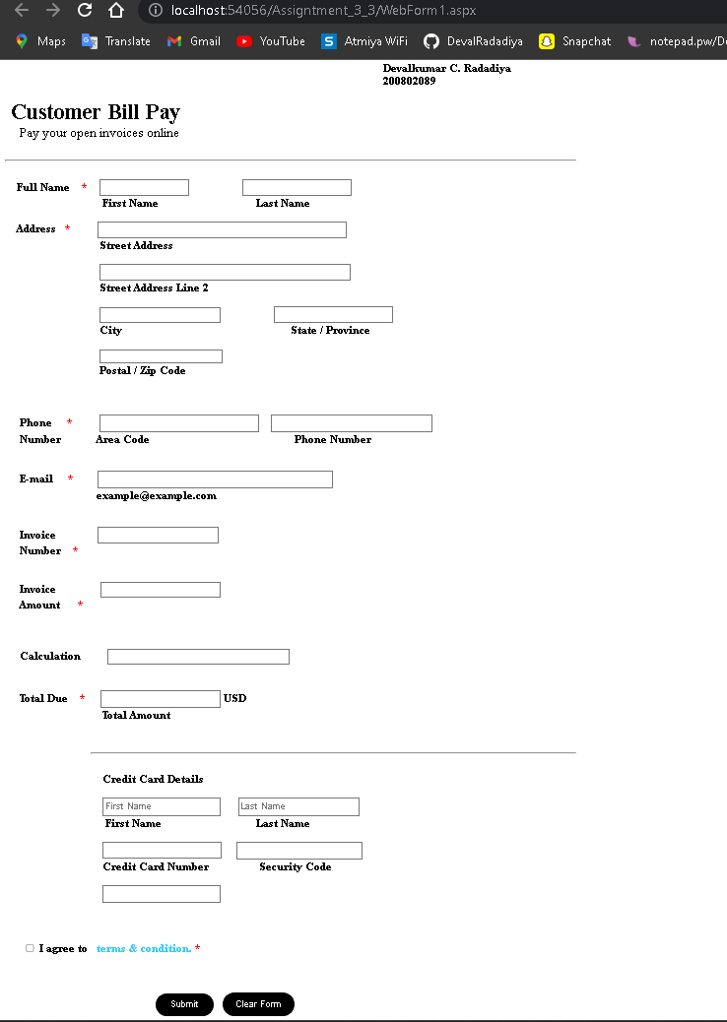

1. Create a cookie that contains the information like Username and gmail. Add a button to the Web Form when the user clicks on the button changes the background color of the Form you want.

WebForm1.aspx :

<%@ Page Language="C#" AutoEventWireup="true" CodeBehind="index.aspx.cs" Inherits="WebApplication3.WebForm1" %>

<!DOCTYPE html>

<script runat="server">

</script>

<html xmlns="http://www.w3.org/1999/xhtml">

<head id="Head1" runat="server">

<title>Assignment_3_4</title>

<meta http-equiv="refresh" content='10' url='index.aspx' />

</head>

<body runat="server" id="BodyOfIndex">

<font size="4">

Devalkumar C. Radadiya

<br />

200802089

</font>

<form id="form1" runat="server">

<div style="height: 644px">

&nbsp;<br />

&nbsp;&nbsp;&nbsp;

<br />

&nbsp;&nbsp;&nbsp;

<br />

&nbsp;&nbsp;&nbsp;&nbsp;&nbsp;&nbsp;&nbsp;&nbsp;&nbsp;&nbsp;&nbsp;&nbsp;&nbsp;&nbsp;&nbsp;

<asp:Label ID="Label1" runat="server"></asp:Label>

<br />

&nbsp;&nbsp;&nbsp;&nbsp;&nbsp;&nbsp;&nbsp;&nbsp;&nbsp;&nbsp;&nbsp;&nbsp;&nbsp;&nbsp;&nbsp;

<br />

&nbsp;&nbsp;&nbsp;&nbsp;&nbsp;&nbsp;&nbsp;&nbsp;&nbsp;&nbsp;&nbsp;&nbsp;&nbsp;&nbsp;&nbsp;

<asp:Label ID="Label2" runat="server"></asp:Label>

<br />

<br />

&nbsp;&nbsp;&nbsp;&nbsp;&nbsp;&nbsp;&nbsp;&nbsp;&nbsp;&nbsp;&nbsp;&nbsp;&nbsp;&nbsp;&nbsp;

<asp:Button ID="Button1" runat="server" OnClick="Button1_Click" Text="Set Cookies &amp; Change Color" Width="190px" />

</div>

</form>

</body> </html>

Index.aspx.cs :

using System;

using System.Collections.Generic;

using System.Linq;

using System.Web;

using System.Web.UI;

using System.Web.UI.WebControls;

namespace WebApplication29

{

public partial class WebForm1 : System.Web.UI.Page

{

protected void Page_Load(object sender, EventArgs e)

{

Label1.Text = "<b>Username : </b>" + "Not Found !";

Label2.Text = "<b>Email : </b>" + "Not Found !";

}

protected void Button1_Click(object sender, EventArgs e)

{

if (Response.Cookies["username"].Value == null && Response.Cookies["email"].Value == null)

{

Response.Cookies["username"].Value = "Debalkumar C. Radadiya";

Response.Cookies["username"].Expires = DateTime.Now.AddSeconds(5);

Response.Cookies["email"].Value = "devalradadiya@gmail.com";

Response.Cookies["email"].Expires = DateTime.Now.AddSeconds(5);

BodyOfIndex.Style.Add("background-color", "white");

}

Label1.Text = "<b>Username : </b>" + Response.Cookies["username"].Value;

Label2.Text = "<b>Email : </b>" + Response.Cookies["email"].Value;

BodyOfIndex.Style.Add("background-color", "lightblue");

}

}

}

OUTPUT :

1)

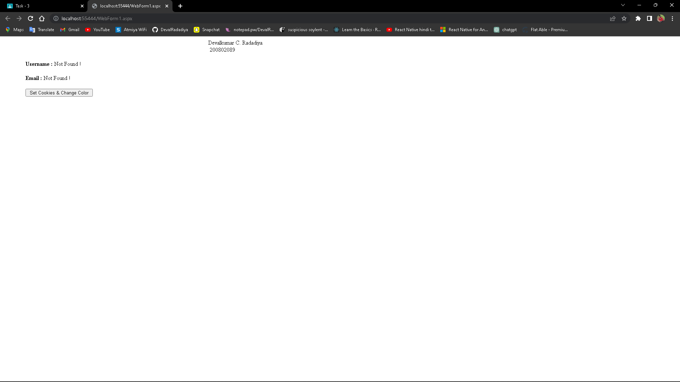

2)

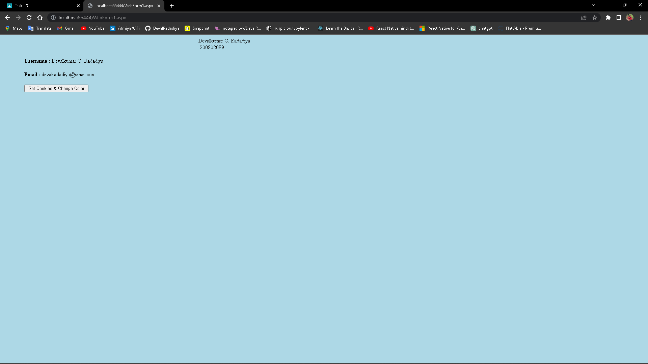

**5) Create a view state that displays the current date and time. Include it in a Web Form and refresh it each time a button is clicked.**

WebForm1.aspx :

<%@ Page Language="C#" AutoEventWireup="true" CodeBehind="index.aspx.cs" Inherits="Assignment_3_5.index" %>

<!DOCTYPE html>

<html xmlns="http://www.w3.org/1999/xhtml">

<head runat="server">

<title>Current Date and Time</title>

</head>

<body>

<font size="4" style="font-weight: 700">

Devalkumar C. Radadiya<br />

200802089

</font>

<form id="form1" runat="server">

<div style="height: 521px">

&nbsp;&nbsp;&nbsp;&nbsp;

<br />

&nbsp;&nbsp;&nbsp;&nbsp;&nbsp;&nbsp;&nbsp;&nbsp;&nbsp;&nbsp;&nbsp;

<br />

&nbsp;&nbsp;&nbsp;&nbsp;&nbsp;&nbsp;&nbsp;&nbsp;&nbsp;&nbsp;&nbsp;

<br />

&nbsp;&nbsp;&nbsp;&nbsp;&nbsp;&nbsp;&nbsp;&nbsp;&nbsp;&nbsp;&nbsp;&nbsp;&nbsp;&nbsp;&nbsp;

<asp:Label ID="Label1" runat="server"></asp:Label>

<br />

&nbsp;&nbsp;&nbsp;&nbsp;&nbsp;&nbsp;&nbsp;&nbsp;&nbsp;&nbsp;&nbsp;&nbsp;&nbsp;&nbsp;&nbsp;

<asp:Label ID="Label2" runat="server"></asp:Label>

<br />

<br />

&nbsp;&nbsp;&nbsp;&nbsp;&nbsp;&nbsp;&nbsp;&nbsp;&nbsp;&nbsp;&nbsp;&nbsp;&nbsp;&nbsp;&nbsp;

<asp:Button ID="Button1" runat="server" Text="Refresh" Width="70px" PostBackUrl="~/index.aspx" />

</div>

</form>

</body>

</html>

OUTPUT :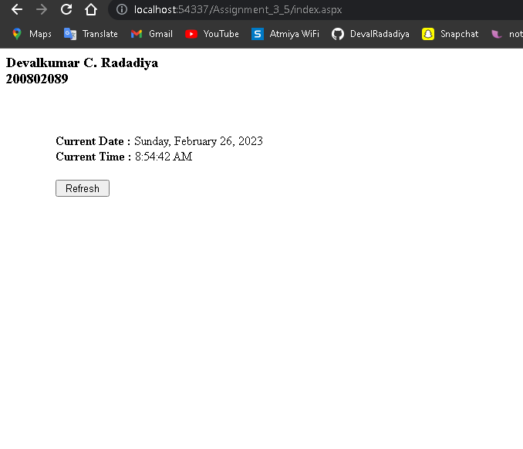

**6) Create the session variables and store the information like Username & password and print the same on the next page using session state.**

index.aspx:

<%@ Page Language="C#" AutoEventWireup="true" CodeBehind="index.aspx.cs" Inherits="Assignment_3_6.index" %>

<!DOCTYPE html>

<html xmlns="http://www.w3.org/1999/xhtml">

<head runat="server">

<title>Index Page</title>

</head>

<body>

<font size="4">

<b>Devalkumar C. Radadiya</br>

<b>200802089</b>

</font>

<form id="form1" runat="server">

<div style="height: 527px">

&nbsp;&nbsp;&nbsp;&nbsp;

<br />

&nbsp;&nbsp;&nbsp;

<br />

&nbsp;&nbsp;&nbsp;

<br />

&nbsp;&nbsp;&nbsp;

<br />

&nbsp;&nbsp;&nbsp;&nbsp;&nbsp;&nbsp;&nbsp;&nbsp;&nbsp;&nbsp;&nbsp;&nbsp;&nbsp;&nbsp;&nbsp;&nbsp;&nbsp;&nbsp;&nbsp;

<asp:Label ID="Label1" runat="server" Text="Usename : "></asp:Label>

<asp:TextBox ID="TextBox1" runat="server"></asp:TextBox>

<br />

&nbsp;&nbsp;&nbsp;&nbsp;&nbsp;&nbsp;&nbsp;&nbsp;&nbsp;&nbsp;&nbsp;&nbsp;&nbsp;&nbsp;&nbsp;&nbsp;&nbsp;&nbsp;&nbsp;

<br />

&nbsp;&nbsp;&nbsp;&nbsp;&nbsp;&nbsp;&nbsp;&nbsp;&nbsp;&nbsp;&nbsp;&nbsp;&nbsp;&nbsp;&nbsp;&nbsp;&nbsp;&nbsp;&nbsp;

<asp:Label ID="Label2" runat="server" Text="Password : "></asp:Label>

<asp:TextBox ID="TextBox2" runat="server" TextMode="Password"></asp:TextBox>

<br />

<br />

&nbsp;&nbsp;&nbsp;&nbsp;&nbsp;&nbsp;&nbsp;&nbsp;&nbsp;&nbsp;&nbsp;&nbsp;&nbsp;&nbsp;&nbsp;&nbsp;&nbsp;&nbsp;&nbsp;

<asp:Button ID="Button1" runat="server" OnClick="Button1_Click" Text="Submit" Width="66px" />

</div>

</form>

</body></html>

**index.aspx.cs:**

using System;

using System.Collections.Generic;

using System.Linq;

using System.Web;

using System.Web.UI;

using System.Web.UI.WebControls;

namespace Assignment_3_6

{

public partial class index : System.Web.UI.Page

{

protected void Page_Load(object sender, EventArgs e)

{

}

protected void Button1_Click(object sender, EventArgs e)

{

if (TextBox1.Text != "" && TextBox2.Text != "")

{

Session["username"] = TextBox1.Text;

Session["password"] = TextBox2.Text;

Response.Redirect("secondpage.aspx");

}

}

}

}

**OUTPUT :**

