ASSIGNMENT – 2

U21CS501 – WEB TECHNOLOGY

Devamithra A
24CS045

Question 1:
Scenario: The student admission portal requires a well‑designed registration form with
proper validation and styling.
Task:
i. Create HTML forms for student registration (name, roll number, email, course, file
upload).
ii. Apply CSS styles for layout, colors, and responsive design (e.g., styled input fields,
buttons, error messages).
iii. Implement client‑side validation (JavaScript) for required fields, email format, and
password strength.
Index.html:

<!DOCTYPE html>
<html lang="en">
<head>
<meta charset="UTF-8">
<meta name="viewport" content="width=device-width, initial-scale=1.0">
<title>Student Registration</title>
<link rel="stylesheet" href="style.css">
</head>
<body>
<div class="container">
<h1>Student Registration</h1>
<p class="subtitle">Fill in your details to register</p>

<form id="registrationForm">
<label for="name">Full Name</label>
<input type="text" id="name" placeholder="Enter your full name">
<span class="error" id="nameError"></span>

<label for="roll">Roll Number</label>
<input type="text" id="roll" placeholder="Enter your roll number">
<span class="error" id="rollError"></span>

<label for="email">Email Address</label>
<input type="email" id="email" placeholder="Enter your email">
<span class="error" id="emailError"></span>

<label for="course">Select Course</label>
<select id="course">
<option value="">-- Select Course --</option>
<option value="CSE">Computer Science Engineering</option>
<option value="IT">Information Technology</option>
<option value="ECE">Electronics and Communication</option>
<option value="EEE">Electrical and Electronics</option>
<option value="MECH">Mechanical Engineering</option>
</select>
<span class="error" id="courseError"></span>

<label for="password">Password</label>
<input type="password" id="password"
placeholder="Create a strong password">
<span class="error" id="passwordError"></span>

<label for="file">Upload Student Document</label>
<input type="file" id="file" accept=".pdf,.jpg,.jpeg,.png">
<span class="error" id="fileError"></span>

<button type="submit">Register Now</button>
<p id="successMessage"></p>
</form>
</div>

<script src="validation.js"></script>
</body>
</html>

Style.css:

* {
margin: 0;
padding: 0;
box-sizing: border-box;
}

body {
font-family: Arial, sans-serif;
background: linear-gradient(135deg, #dbeafe, #ede9fe);
min-height: 100vh;
display: flex;
justify-content: center;
align-items: center;
padding: 20px;
}

.container {
background: white;
width: 100%;
max-width: 500px;
padding: 30px;
border-radius: 15px;
box-shadow: 0 8px 25px rgba(0, 0, 0, 0.15);
}

h1 {
text-align: center;
color: #4338ca;
margin-bottom: 10px;
}

.subtitle {
text-align: center;
color: #666;
margin-bottom: 25px;
}

label {
display: block;
margin-top: 15px;
margin-bottom: 7px;
font-weight: bold;
color: #333;
}

input, select {
width: 100%;
padding: 12px;
border: 1px solid #ccc;
border-radius: 7px;
font-size: 15px;
background: #fff;
}

input:focus, select:focus {
outline: none;
border-color: #4338ca;
box-shadow: 0 0 5px #c7d2fe;
}

button {
width: 100%;
padding: 13px;
margin-top: 25px;
background: #4338ca;
color: white;
border: none;
border-radius: 7px;
font-size: 16px;
font-weight: bold;
cursor: pointer;
}

button:hover {
background: #312e81;
}

.error {
display: block;
color: #dc2626;
font-size: 13px;
margin-top: 5px;
}

#successMessage {
text-align: center;
color: #15803d;
margin-top: 15px;
font-weight: bold;
}

@media (max-width: 480px) {
.container {
padding: 20px;
}

h1 {
font-size: 24px;
}
}

Script.js

const form = document.getElementById("registrationForm");

form.addEventListener("submit", function(event) {
event.preventDefault();

document.querySelectorAll(".error").forEach(function(error) {
error.textContent = "";
});

document.getElementById("successMessage").textContent = "";

let valid = true;

const name = document.getElementById("name").value.trim();
const roll = document.getElementById("roll").value.trim();
const email = document.getElementById("email").value.trim();
const course = document.getElementById("course").value;
const password = document.getElementById("password").value;
const file = document.getElementById("file").files[0];

if (name === "") {
document.getElementById("nameError").textContent =
"Name is required";
valid = false;
}

if (roll === "") {
document.getElementById("rollError").textContent =
"Roll number is required";
valid = false;
}

const emailPattern = /^[^\s@]+@[^\s@]+\.[^\s@]+$/;

if (email === "") {
document.getElementById("emailError").textContent =
"Email is required";
valid = false;
} else if (!emailPattern.test(email)) {
document.getElementById("emailError").textContent =
"Enter a valid email address";
valid = false;
}

if (course === "") {
document.getElementById("courseError").textContent =
"Please select a course";
valid = false;
}

const passwordPattern =
/^(?=.*[a-z])(?=.*[A-Z])(?=.*\d)(?=.*[@$!%*?&]).{8,}$/;

if (password === "") {
document.getElementById("passwordError").textContent =
"Password is required";
valid = false;
} else if (!passwordPattern.test(password)) {
document.getElementById("passwordError").textContent =
"Use 8+ characters with uppercase, lowercase, number and special character";
valid = false;
}

if (!file) {
document.getElementById("fileError").textContent =
"Please upload a document";
valid = false;
} else if (file.size > 2 * 1024 * 1024) {
document.getElementById("fileError").textContent =
"File size must be below 2 MB";
valid = false;
} else if (!/\.(pdf|jpg|jpeg|png)$/i.test(file.name)) {
document.getElementById("fileError").textContent =
"Upload a PDF, JPG or PNG file";
valid = false;
}

if (valid) {
document.getElementById("successMessage").textContent =
"Registration form validated successfully!";
form.reset();
}
});
Output:
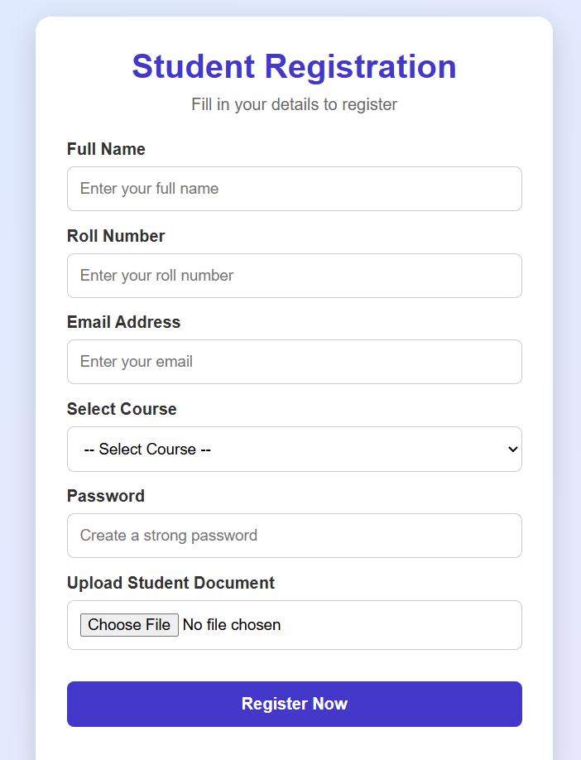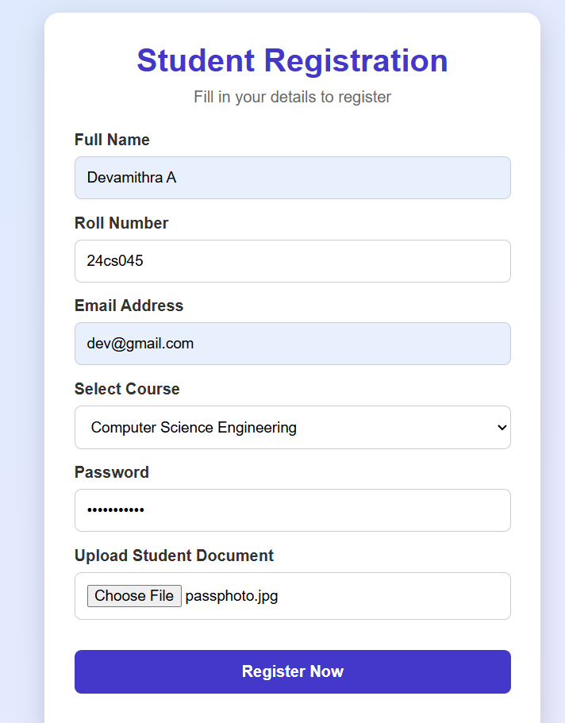

Conclusion:
Thus, the Student Registration Form was successfully created using HTML, CSS, and JavaScript. HTML provides the registration fields, CSS enhances the layout and responsive design, and JavaScript validates required fields, email format, password strength, and file uploads. The form provides a user-friendly interface with clear error messages. This improves data accuracy and the overall user experience.

Github repo link:

Question 2:
Scenario: The college admin panel must manage student records and their profile
documents/images.
Task: Create PHP pages that:
1. CRUD Operations (Add, Edit, Delete, View) for student details (name, roll number,
course, etc.) using MySQL.
2. File Upload Handling for profile images and documents (e.g., ID proof, certificates).
3. Store Metadata in MySQL — file path, file type, upload date linked to the student
record.
4. Display Uploaded Files when viewing student details.
5. Validation &amp; Error Handling — check file size, type, and prevent overwriting.

db.php:
<?php
// Connect PHP to the MySQL database using PDO
$host = "localhost";
$dbname = "student_admin";
$username = "root";
$password = ""; // Default XAMPP password is often empty

try {
// Create a PDO connection and enable error reporting
$pdo = new PDO(
"mysql:host=$host;dbname=$dbname;charset=utf8mb4",
$username,
$password
);

$pdo->setAttribute(PDO::ATTR_ERRMODE, PDO::ERRMODE_EXCEPTION);
} catch (PDOException $e) {
// Show a general error instead of exposing database credentials
die("Database connection failed.");
}

// Escape output before displaying user-supplied data in HTML
function e($value) {
return htmlspecialchars((string)$value, ENT_QUOTES, "UTF-8");
}
?>

Add.php
<?php
require "db.php";

$error = "";

// Process the form when the user submits it
if ($_SERVER["REQUEST_METHOD"] === "POST") {
$name = trim($_POST["name"] ?? "");
$roll = trim($_POST["roll_number"] ?? "");
$email = trim($_POST["email"] ?? "");
$course = trim($_POST["course"] ?? "");

// Validate required fields and email format
if ($name === "" || $roll === "" || $course === "") {
$error = "Name, roll number and course are required.";
} elseif ($email !== "" && !filter_var($email, FILTER_VALIDATE_EMAIL)) {
$error = "Enter a valid email address.";
} else {
try {
// Prepared statements prevent SQL injection
$stmt = $pdo->prepare(
"INSERT INTO students (name, roll_number, email, course)
VALUES (?, ?, ?, ?)"
);

$stmt->execute([$name, $roll, $email, $course]);

// Redirect to the upload page for the new student
header("Location: upload.php?id=" . $pdo->lastInsertId());
exit;
} catch (PDOException $e) {
// Handle duplicate roll numbers and other database errors
$error = $e->getCode() === "23000"
? "This roll number already exists."
: "Unable to add student.";
}
}
}
?>

<h2>Add Student</h2>

<!-- Display validation or database errors -->
<p style="color:red"><?= e($error) ?></p>

<form method="post">
<label>Name:</label>
<input type="text" name="name" required>

<br><br>

<label>Roll Number:</label>
<input type="text" name="roll_number" required>

<br><br>

<label>Email:</label>
<input type="email" name="email">

<br><br>

<label>Course:</label>
<input type="text" name="course" required>

<br><br>

<button type="submit">Add Student</button>
</form>

<a href="index.php">Back to Student List</a>

Edit.php
<?php
require "db.php";

// Get the student ID from the URL
$id = filter_input(INPUT_GET, "id", FILTER_VALIDATE_INT);

if (!$id) {
die("Invalid student ID.");
}

// Fetch the existing student record
$stmt = $pdo->prepare("SELECT * FROM students WHERE id = ?");
$stmt->execute([$id]);
$student = $stmt->fetch(PDO::FETCH_ASSOC);

if (!$student) {
die("Student not found.");
}

$error = "";

// Update the record after form submission
if ($_SERVER["REQUEST_METHOD"] === "POST") {
$name = trim($_POST["name"] ?? "");
$roll = trim($_POST["roll_number"] ?? "");
$email = trim($_POST["email"] ?? "");
$course = trim($_POST["course"] ?? "");

// Validate the submitted details
if ($name === "" || $roll === "" || $course === "") {
$error = "Name, roll number and course are required.";
} elseif ($email !== "" && !filter_var($email, FILTER_VALIDATE_EMAIL)) {
$error = "Enter a valid email address.";
} else {
try {
// Update the existing student using a prepared statement
$stmt = $pdo->prepare(
"UPDATE students
SET name = ?, roll_number = ?, email = ?, course = ?
WHERE id = ?"
);

$stmt->execute([$name, $roll, $email, $course, $id]);

// Return to the updated student's details
header("Location: view.php?id=" . $id);
exit;
} catch (PDOException $e) {
$error = $e->getCode() === "23000"
? "This roll number is already in use."
: "Unable to update student.";
}
}
}
?>

<h2>Edit Student</h2>

<p style="color:red"><?= e($error) ?></p>

<!-- Pre-fill the form with the existing student information -->
<form method="post">
<label>Name:</label>
<input type="text" name="name"
value="<?= e($student["name"]) ?>" required>

<br><br>

<label>Roll Number:</label>
<input type="text" name="roll_number"
value="<?= e($student["roll_number"]) ?>" required>

<br><br>

<label>Email:</label>
<input type="email" name="email"
value="<?= e($student["email"]) ?>">

<br><br>

<label>Course:</label>
<input type="text" name="course"
value="<?= e($student["course"]) ?>" required>

<br><br>

<button type="submit">Update Student</button>
</form>

<a href="index.php">Back to Student List</a>
Delete.php
<?php
require "db.php";

// Allow deletion only through a POST request
if ($_SERVER["REQUEST_METHOD"] !== "POST") {
die("Invalid request.");
}

// Validate the student ID
$id = filter_input(INPUT_POST, "id", FILTER_VALIDATE_INT);

if (!$id) {
die("Invalid student ID.");
}

try {
// Fetch the file paths before deleting their metadata
$stmt = $pdo->prepare(
"SELECT file_path FROM student_files WHERE student_id = ?"
);
$stmt->execute([$id]);
$files = $stmt->fetchAll(PDO::FETCH_COLUMN);

// Delete the student; ON DELETE CASCADE removes associated metadata
$stmt = $pdo->prepare("DELETE FROM students WHERE id = ?");
$stmt->execute([$id]);

// Remove the corresponding physical files from the uploads folder
foreach ($files as $path) {
// Only delete files within this project's uploads directory
$fullPath = realpath(__DIR__ . "/" . $path);
$uploadDir = realpath(__DIR__ . "/uploads");

if ($fullPath && $uploadDir &&
dirname($fullPath) === $uploadDir &&
is_file($fullPath)) {
unlink($fullPath);
}
}

// Return to the student list after deletion
header("Location: index.php");
exit;
} catch (PDOException $e) {
// Display a generic message if the operation fails
die("Unable to delete student.");
}
?>

Index.php
<?php
require "db.php";

// Retrieve all students from the database
$stmt = $pdo->query("SELECT * FROM students ORDER BY id DESC");
$students = $stmt->fetchAll(PDO::FETCH_ASSOC);
?>

<!DOCTYPE html>
<html lang="en">
<head>
<meta charset="UTF-8">
<title>Student Admin Panel</title>
</head>
<body>
<h1>Student Admin Panel</h1>

<!-- Navigate to the page for adding a student -->
<a href="add.php">Add New Student</a>

<table border="1" cellpadding="10">
<tr>
<th>Name</th>
<th>Roll Number</th>
<th>Email</th>
<th>Course</th>
<th>Actions</th>
</tr>

<?php foreach ($students as $student): ?>
<tr>
<td><?= e($student["name"]) ?></td>
<td><?= e($student["roll_number"]) ?></td>
<td><?= e($student["email"]) ?></td>
<td><?= e($student["course"]) ?></td>
<td>
<!-- Open the selected student's details -->
<a href="view.php?id=<?= (int)$student["id"] ?>">View</a>

<!-- Open the edit form -->
<a href="edit.php?id=<?= (int)$student["id"] ?>">Edit</a>

<!-- Delete using POST rather than a GET link -->
<form action="delete.php" method="post"
style="display:inline"
onsubmit="return confirm('Delete this student?')">
<input type="hidden" name="id"
value="<?= (int)$student["id"] ?>">
<button type="submit">Delete</button>
</form>
</td>
</tr>
<?php endforeach; ?>
</table>
</body>
</html>

Upload.php
<?php
require "db.php";

// Accept only a valid student ID
$id = filter_input(INPUT_GET, "id", FILTER_VALIDATE_INT);

if (!$id) {
die("Invalid student ID.");
}

// Check that the student exists before allowing uploads
$stmt = $pdo->prepare("SELECT id, name FROM students WHERE id = ?");
$stmt->execute([$id]);
$student = $stmt->fetch(PDO::FETCH_ASSOC);

if (!$student) {
die("Student not found.");
}

$message = "";

// Process the upload form
if ($_SERVER["REQUEST_METHOD"] === "POST") {
if (!isset($_FILES["document"]) ||
$_FILES["document"]["error"] !== UPLOAD_ERR_OK) {
$message = "Please select a file and try again.";
} else {
$file = $_FILES["document"];

// Limit uploads to 2 MB
$maxSize = 2 * 1024 * 1024;

// Allow only these extensions and corresponding MIME types
$allowed = [
"pdf" => ["application/pdf"],
"jpg" => ["image/jpeg"],
"jpeg" => ["image/jpeg"],
"png" => ["image/png"]
];

// Determine the extension from the original filename
$extension = strtolower(
pathinfo($file["name"], PATHINFO_EXTENSION)
);

// Detect the real file type rather than trusting browser input
$finfo = new finfo(FILEINFO_MIME_TYPE);
$mime = $finfo->file($file["tmp_name"]);

// Validate size, extension and MIME type
if ($file["size"] > $maxSize) {
$message = "File size must not exceed 2 MB.";
} elseif (!isset($allowed[$extension]) ||
!in_array($mime, $allowed[$extension], true)) {
$message = "Only valid PDF, JPG and PNG files are allowed.";
} else {
// Create the upload directory if it does not exist
$directory = __DIR__ . "/uploads/";

if (!is_dir($directory)) {
mkdir($directory, 0755, true);
}

// Generate a random filename so existing files are not overwritten
$filename = bin2hex(random_bytes(16)) . "." . $extension;
$destination = $directory . $filename;

// Store a relative path in the database
$relativePath = "uploads/" . $filename;

if (move_uploaded_file($file["tmp_name"], $destination)) {
try {
// Save file metadata and link it to the student
$stmt = $pdo->prepare(
"INSERT INTO student_files
(student_id, file_path, file_type, original_name)
VALUES (?, ?, ?, ?)"
);

$stmt->execute([
$id,
$relativePath,
$mime,
basename($file["name"])
]);

$message = "File uploaded successfully.";
} catch (PDOException $e) {
// Remove the uploaded file if its metadata cannot be saved
if (is_file($destination)) {
unlink($destination);
}

$message = "Unable to save file information.";
}
} else {
$message = "File upload failed. Check folder permissions.";
}
}
}
}
?>

<h2>Upload Student Documents</h2>

<p>Student: <?= e($student["name"]) ?></p>

<!-- Display the upload result -->
<p><?= e($message) ?></p>

<!-- enctype is required for file uploads -->
<form method="post" enctype="multipart/form-data">
<label>Select profile image or document (PDF, JPG, PNG):</label>
<input type="file" name="document"
accept=".pdf,.jpg,.jpeg,.png" required>

<br><br>

<button type="submit">Upload File</button>
</form>

<a href="view.php?id=<?= (int)$id ?>">View Student Details</a>

View.php:
<?php
require "db.php";

// Read and validate the student ID
$id = filter_input(INPUT_GET, "id", FILTER_VALIDATE_INT);

if (!$id) {
die("Invalid student ID.");
}

// Retrieve the student's details
$stmt = $pdo->prepare("SELECT * FROM students WHERE id = ?");
$stmt->execute([$id]);
$student = $stmt->fetch(PDO::FETCH_ASSOC);

if (!$student) {
die("Student not found.");
}

// Retrieve all uploaded files linked to this student
$stmt = $pdo->prepare(
"SELECT * FROM student_files WHERE student_id = ? ORDER BY upload_date DESC"
);
$stmt->execute([$id]);
$files = $stmt->fetchAll(PDO::FETCH_ASSOC);
?>

<h2>Student Details</h2>

<!-- Display the student's personal information -->
<p><b>Name:</b> <?= e($student["name"]) ?></p>
<p><b>Roll Number:</b> <?= e($student["roll_number"]) ?></p>
<p><b>Email:</b> <?= e($student["email"]) ?></p>
<p><b>Course:</b> <?= e($student["course"]) ?></p>

<a href="edit.php?id=<?= (int)$id ?>">Edit Student</a> |
<a href="upload.php?id=<?= (int)$id ?>">Upload Another File</a>

<h3>Uploaded Files</h3>

<?php if (count($files) > 0): ?>
<?php foreach ($files as $file): ?>
<div style="border:1px solid #ccc; padding:10px; margin:10px 0;">

<!-- Display an image preview for image files -->
<?php if (strpos($file["file_type"], "image/") === 0): ?>
<img src="<?= e($file["file_path"]) ?>"
alt="Student document"
style="max-width:200px; max-height:200px;">
<br>
<?php endif; ?>

<!-- Show the original filename and file metadata -->
<p><b>File:</b> <?= e($file["original_name"]) ?></p>
<p><b>Type:</b> <?= e($file["file_type"]) ?></p>
<p><b>Uploaded:</b> <?= e($file["upload_date"]) ?></p>

<!-- Open or download the uploaded file -->
<a href="<?= e($file["file_path"]) ?>" target="_blank"
rel="noopener">View / Download File</a>
</div>
<?php endforeach; ?>
<?php else: ?>
<p>No files uploaded for this student.</p>
<?php endif; ?>

<br>
<a href="index.php">Back to Student List</a>

SQL:
CREATE DATABASE student_admin;
USE student_admin;
-- Stores the basic details of each student
CREATE TABLE students (
id INT AUTO_INCREMENT PRIMARY KEY,
name VARCHAR(100) NOT NULL,
roll_number VARCHAR(30) NOT NULL UNIQUE,
email VARCHAR(100),
course VARCHAR(100) NOT NULL
);
-- Stores file metadata and links each file to a student
CREATE TABLE student_files (
id INT AUTO_INCREMENT PRIMARY KEY,
student_id INT NOT NULL,
file_path VARCHAR(255) NOT NULL,
file_type VARCHAR(100) NOT NULL,
upload_date TIMESTAMP DEFAULT CURRENT_TIMESTAMP,
original_name VARCHAR(255) NOT NULL,
FOREIGN KEY (student_id) REFERENCES students(id)
ON DELETE CASCADE
);
Output:
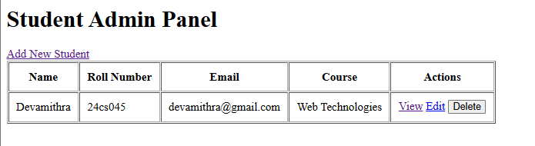
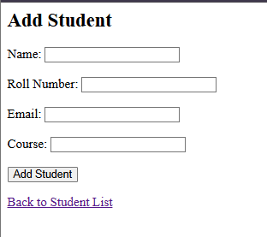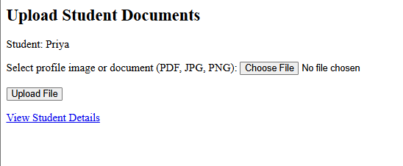
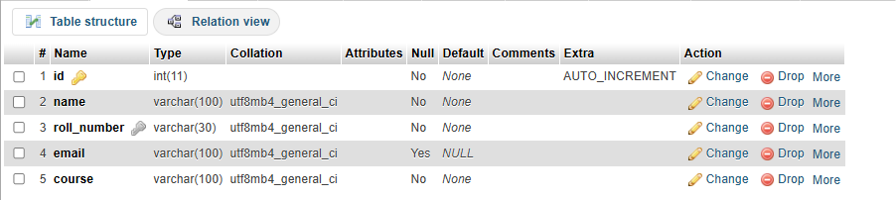

Conclusion:
Thus, the Student Admin Panel was successfully developed using PHP and MySQL to manage student records through CRUD operations. File upload functionality was implemented to store profile images and documents. File metadata, including path, type, and upload date, is stored in the database. Validation and error handling help ensure secure and reliable file management.

Github repo link:

Question 3:
Scenario: The front‑end portal must allow users to view student profiles along with their
uploaded images/documents.
Task: Develop Servlet pages that:
1. Connect to MySQL using JDBC to fetch student details and associated file paths.
2. Retrieve and stream images/documents from the folder where they are stored.
3. Display student profiles dynamically in an HTML/JSP page with &lt;img&gt; tags
pointing to the Servlet.
4. Implement looping and conditional logic to list multiple students and their files.
5. Ensure session handling so that only logged‑in users can access the portal securely.

Pom.xml:
<project xmlns="http://maven.apache.org/POM/4.0.0"
xmlns:xsi="http://www.w3.org/2001/XMLSchema-instance"
xsi:schemaLocation="http://maven.apache.org/POM/4.0.0 https://maven.apache.org/xsd/maven-4.0.0.xsd">

<modelVersion>4.0.0</modelVersion>

<groupId>com.college</groupId>
<artifactId>StudentPortal</artifactId>
<version>1.0-SNAPSHOT</version>
<packaging>war</packaging>

<properties>
<maven.compiler.source>17</maven.compiler.source>
<maven.compiler.target>17</maven.compiler.target>
<project.build.sourceEncoding>UTF-8</project.build.sourceEncoding>
</properties>

<dependencies>
<dependency>
<groupId>jakarta.servlet</groupId>
<artifactId>jakarta.servlet-api</artifactId>
<version>6.0.0</version>
<scope>provided</scope>
</dependency>

<dependency>
<groupId>com.mysql</groupId>
<artifactId>mysql-connector-j</artifactId>
<version>9.4.0</version>
</dependency>

<dependency>
<groupId>jakarta.servlet.jsp.jstl</groupId>
<artifactId>jakarta.servlet.jsp.jstl-api</artifactId>
<version>3.0.2</version>
</dependency>

<dependency>
<groupId>org.glassfish.web</groupId>
<artifactId>jakarta.servlet.jsp.jstl</artifactId>
<version>3.0.1</version>
</dependency>
</dependencies>

<build>
<finalName>StudentPortal</finalName>
<plugins>
<plugin>
<groupId>org.apache.maven.plugins</groupId>
<artifactId>maven-compiler-plugin</artifactId>
<version>3.13.0</version>
</plugin>

<plugin>
<groupId>org.apache.maven.plugins</groupId>
<artifactId>maven-war-plugin</artifactId>
<version>3.4.0</version>
</plugin>
</plugins>
</build>
</project>

DBConnection.java:
package com.college;

import java.sql.Connection;
import java.sql.DriverManager;
import java.sql.SQLException;

public class DBConnection {

private static final String URL =
"jdbc:mysql://localhost:3306/student_portal";
private static final String USER = "root";
private static final String PASSWORD = "";

public static Connection getConnection() throws SQLException {
return DriverManager.getConnection(URL, USER, PASSWORD);
}
}

StudentFile.java:
package com.college;

public class StudentFile {

private int id;
private String originalName;
private String fileType;

public StudentFile(int id, String originalName, String fileType) {
this.id = id;
this.originalName = originalName;
this.fileType = fileType;
}

public int getId() {
return id;
}

public String getOriginalName() {
return originalName;
}

public String getFileType() {
return fileType;
}
}

Student.java:
package com.college;

import java.util.ArrayList;
import java.util.List;

public class Student {

private int id;
private String name;
private String rollNumber;
private String course;
private List<StudentFile> files = new ArrayList<>();

public Student(int id, String name, String rollNumber, String course) {
this.id = id;
this.name = name;
this.rollNumber = rollNumber;
this.course = course;
}

public int getId() {
return id;
}

public String getName() {
return name;
}

public String getRollNumber() {
return rollNumber;
}

public String getCourse() {
return course;
}

public List<StudentFile> getFiles() {
return files;
}

public void addFile(StudentFile file) {
files.add(file);
}
}
LoginServlet.java:
package com.college;

import java.io.IOException;
import jakarta.servlet.ServletException;
import jakarta.servlet.annotation.WebServlet;
import jakarta.servlet.http.HttpServlet;
import jakarta.servlet.http.HttpServletRequest;
import jakarta.servlet.http.HttpServletResponse;
import jakarta.servlet.http.HttpSession;

@WebServlet("/login")
public class LoginServlet extends HttpServlet {

@Override
protected void doPost(HttpServletRequest request,
HttpServletResponse response)
throws ServletException, IOException {

String username = request.getParameter("username");
String password = request.getParameter("password");

if ("admin".equals(username) &&
"admin123".equals(password)) {

HttpSession session = request.getSession(true);
request.changeSessionId();
session.setAttribute("loggedIn", true);
session.setAttribute("username", username);

response.sendRedirect(
request.getContextPath() + "/students");
} else {
request.setAttribute(
"error", "Invalid username or password.");

request.getRequestDispatcher("/login.jsp")
.forward(request, response);
}
}
}

StudentServlet.java:
package com.college;

import java.io.IOException;
import java.sql.Connection;
import java.sql.PreparedStatement;
import java.sql.ResultSet;
import java.sql.SQLException;
import java.util.LinkedHashMap;
import java.util.Map;

import jakarta.servlet.ServletException;
import jakarta.servlet.annotation.WebServlet;
import jakarta.servlet.http.HttpServlet;
import jakarta.servlet.http.HttpServletRequest;
import jakarta.servlet.http.HttpServletResponse;
import jakarta.servlet.http.HttpSession;

@WebServlet("/students")
public class StudentServlet extends HttpServlet {

@Override
protected void doGet(HttpServletRequest request,
HttpServletResponse response)
throws ServletException, IOException {

HttpSession session = request.getSession(false);

if (session == null ||
!Boolean.TRUE.equals(session.getAttribute("loggedIn"))) {
response.sendRedirect(
request.getContextPath() + "/login.jsp");
return;
}

Map<Integer, Student> students = new LinkedHashMap<>();

String sql = "SELECT s.id, s.name, s.roll_number, s.course, " +
"f.id AS file_id, f.original_name, f.file_type " +
"FROM students s " +
"LEFT JOIN student_files f ON s.id = f.student_id " +
"ORDER BY s.id, f.id";

try (Connection con = DBConnection.getConnection();
PreparedStatement ps = con.prepareStatement(sql);
ResultSet rs = ps.executeQuery()) {

while (rs.next()) {
int studentId = rs.getInt("id");

Student student = students.get(studentId);

if (student == null) {
student = new Student(
studentId,
rs.getString("name"),
rs.getString("roll_number"),
rs.getString("course"));

students.put(studentId, student);
}

int fileId = rs.getInt("file_id");

if (!rs.wasNull()) {
StudentFile file = new StudentFile(
fileId,
rs.getString("original_name"),
rs.getString("file_type"));

student.addFile(file);
}
}

} catch (SQLException e) {
throw new ServletException(
"Unable to retrieve student records.", e);
}

request.setAttribute(
"students", students.values());

request.getRequestDispatcher("/students.jsp")
.forward(request, response);
}
}

FileServlet.java:
package com.college;

import java.io.IOException;
import java.io.InputStream;
import java.nio.file.Files;
import java.nio.file.Path;
import java.nio.file.Paths;
import java.sql.Connection;
import java.sql.PreparedStatement;
import java.sql.ResultSet;
import java.sql.SQLException;

import jakarta.servlet.ServletException;
import jakarta.servlet.annotation.WebServlet;
import jakarta.servlet.http.HttpServlet;
import jakarta.servlet.http.HttpServletRequest;
import jakarta.servlet.http.HttpServletResponse;
import jakarta.servlet.http.HttpSession;

@WebServlet("/file")
public class FileServlet extends HttpServlet {

private static final Path UPLOAD_DIR =
Paths.get("C:/studentportal-uploads")
.toAbsolutePath().normalize();

@Override
protected void doGet(HttpServletRequest request,
HttpServletResponse response)
throws ServletException, IOException {

HttpSession session = request.getSession(false);

if (session == null ||
!Boolean.TRUE.equals(session.getAttribute("loggedIn"))) {
response.sendError(HttpServletResponse.SC_UNAUTHORIZED);
return;
}

int fileId;

try {
fileId = Integer.parseInt(request.getParameter("id"));
} catch (NumberFormatException e) {
response.sendError(HttpServletResponse.SC_BAD_REQUEST);
return;
}

String filePath = null;
String fileType = null;

String sql = "SELECT file_path, file_type " +
"FROM student_files WHERE id = ?";

try (Connection con = DBConnection.getConnection();
PreparedStatement ps = con.prepareStatement(sql)) {

ps.setInt(1, fileId);

try (ResultSet rs = ps.executeQuery()) {
if (rs.next()) {
filePath = rs.getString("file_path");
fileType = rs.getString("file_type");
}
}

} catch (SQLException e) {
throw new ServletException("Unable to retrieve file.", e);
}

if (filePath == null || fileType == null) {
response.sendError(HttpServletResponse.SC_NOT_FOUND);
return;
}

if (!fileType.equals("image/jpeg") &&
!fileType.equals("image/png") &&
!fileType.equals("application/pdf")) {
response.sendError(HttpServletResponse.SC_FORBIDDEN);
return;
}

Path fileName = Paths.get(filePath);

if (fileName.isAbsolute() ||
fileName.getNameCount() != 1 ||
filePath.contains("/") ||
filePath.contains("\\")) {
response.sendError(HttpServletResponse.SC_FORBIDDEN);
return;
}

Path fullPath = UPLOAD_DIR.resolve(fileName).normalize();

if (!fullPath.startsWith(UPLOAD_DIR) ||
!Files.isRegularFile(fullPath)) {
response.sendError(HttpServletResponse.SC_NOT_FOUND);
return;
}

response.setContentType(fileType);
response.setHeader("X-Content-Type-Options", "nosniff");
response.setContentLengthLong(Files.size(fullPath));

try (InputStream in = Files.newInputStream(fullPath)) {
in.transferTo(response.getOutputStream());
}
}}
login.jsp:
<%@ page contentType="text/html;charset=UTF-8" language="java" %>
<!DOCTYPE html>
<html>
<head>
<title>Student Portal Login</title>
<style>
body {
font-family: Arial, sans-serif;
background: #eef4fb;
display: flex;
justify-content: center;
align-items: center;
min-height: 100vh;
margin: 0;
}

.login-box {
background: white;
padding: 30px;
width: 320px;
border-radius: 10px;
box-shadow: 0 4px 15px #ccd5e0;
}

h2 {
text-align: center;
color: #1769c2;
}

input, button {
width: 100%;
padding: 11px;
margin-top: 12px;
box-sizing: border-box;
}

button {
background: #1769c2;
color: white;
border: none;
border-radius: 5px;
cursor: pointer;
}

.error {
color: red;
text-align: center;
}
</style>
</head>
<body>
<div class="login-box">
<h2>Student Profile Portal</h2>
<p>Login to view student profiles and documents.</p>

<% if (request.getAttribute("error") != null) { %>
<p class="error">
<%= request.getAttribute("error") %>
</p>
<% } %>

<form action="${pageContext.request.contextPath}/login"
method="post">

<input type="text" name="username"
placeholder="Username" required>

<input type="password" name="password"
placeholder="Password" required>

<button type="submit">Login</button>
</form>
</div>
</body>
</html>

students.jsp:
<%@ page contentType="text/html;charset=UTF-8" language="java" %>
<%@ taglib prefix="c" uri="jakarta.tags.core" %>

<!DOCTYPE html>
<html>
<head>
<title>Student Profiles</title>
<style>
body {
font-family: Arial, sans-serif;
background: #f2f6fc;
margin: 0;
}

header {
background: #1769c2;
color: white;
padding: 18px;
}

.container {
padding: 25px;
}

.student {
background: white;
padding: 20px;
margin-bottom: 20px;
border-radius: 8px;
box-shadow: 0 2px 8px #d8e0eb;
}

img {
width: 120px;
height: 120px;
object-fit: cover;
border-radius: 8px;
}

a {
color: #1769c2;
margin-right: 12px;
}
</style>
</head>
<body>
<header>
<h2>Student Profile Portal</h2>
<p>Welcome, admin |
<a href="${pageContext.request.contextPath}/logout"
style="color:white">Logout</a>
</p>
</header>

<div class="container">
<h2>Student Profiles</h2>

<c:if test="${empty students}">
<p>No student records found.</p>
</c:if>

<c:forEach var="student" items="${students}">
<div class="student">
<h3>
<c:out value="${student.name}"/>
</h3>

<p>
Roll Number:
<c:out value="${student.rollNumber}"/>
</p>

<p>
Course:
<c:out value="${student.course}"/>
</p>

<h4>Profile Images and Documents</h4>

<c:set var="hasFiles" value="false"/>

<c:forEach var="file" items="${student.files}">
<c:if test="${file.fileType == 'image/jpeg' ||
file.fileType == 'image/png'}">
<c:set var="hasFiles" value="true"/>
<p>
<img
src="${pageContext.request.contextPath}/file?id=${file.id}"
alt="Student image">
</p>
</c:if>
</c:forEach>

<c:forEach var="file" items="${student.files}">
<c:if test="${file.fileType == 'application/pdf'}">
<c:set var="hasFiles" value="true"/>
<p>
<a href="${pageContext.request.contextPath}/file?id=${file.id}"
target="_blank">
<c:out value="${file.originalName}"/>
</a>
</p>
</c:if>
</c:forEach>

<c:if test="${not hasFiles}">
<p>No files available.</p>
</c:if>
</div>
</c:forEach>
</div>
</body>
</html>

web.xml:
<?xml version="1.0" encoding="UTF-8"?>

<web-app xmlns="https://jakarta.ee/xml/ns/jakartaee"
xmlns:xsi="http://www.w3.org/2001/XMLSchema-instance"
xsi:schemaLocation="https://jakarta.ee/xml/ns/jakartaee
https://jakarta.ee/xml/ns/jakartaee/web-app_6_0.xsd"
version="6.0">

<display-name>Student Profile Portal</display-name>

<welcome-file-list>
<welcome-file>login.jsp</welcome-file>
</welcome-file-list>

</web-app>

MySQL database code:
CREATE DATABASE IF NOT EXISTS student_portal;

USE student_portal;

CREATE TABLE students (
id INT AUTO_INCREMENT PRIMARY KEY,
name VARCHAR(100) NOT NULL,
roll_number VARCHAR(30) NOT NULL,
course VARCHAR(100) NOT NULL
);

CREATE TABLE student_files (
id INT AUTO_INCREMENT PRIMARY KEY,
student_id INT NOT NULL,
file_path VARCHAR(255) NOT NULL,
file_type VARCHAR(100) NOT NULL,
original_name VARCHAR(255) NOT NULL,
FOREIGN KEY (student_id)
REFERENCES students(id)
ON DELETE CASCADE
);

INSERT INTO students (name, roll_number, course)
VALUES
('Arun Kumar', '101', 'CSE'),
('Priya Devi', '102', 'IT');

INSERT INTO student_files
(student_id, file_path, file_type, original_name)
VALUES
(1, 'arun.jpg', 'image/jpeg', 'arun.jpg'),
(1, 'arun_certificate.pdf',
'application/pdf', 'Certificate.pdf'),
(2, 'priya.png', 'image/png', 'priya.png');

Output:
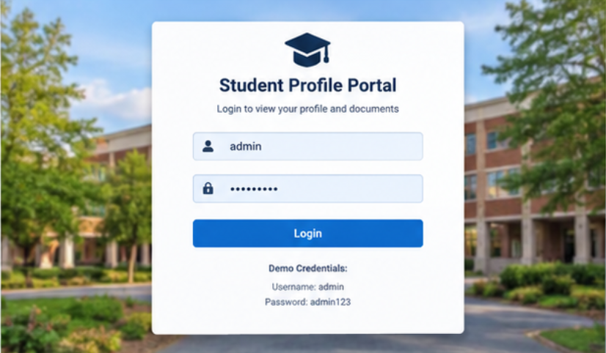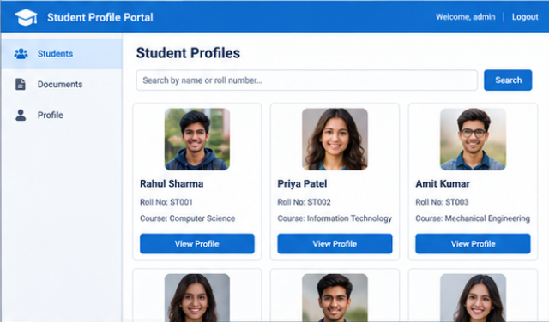

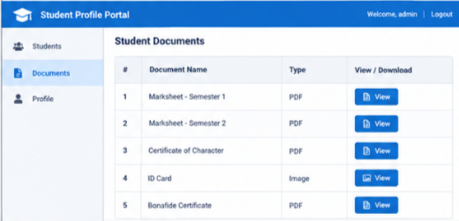

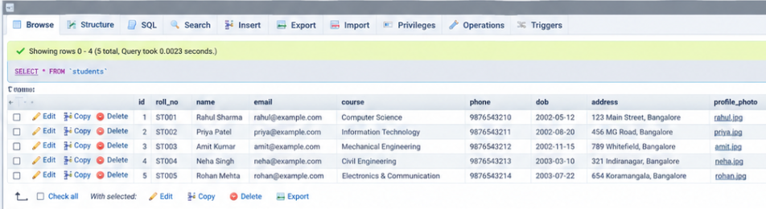

Conclusion:
The Student Profile Portal was developed using Java Servlets, JSP, JDBC, and MySQL. It displays student details and provides access to images and documents dynamically. Session management helps restrict access to authorized users. The project demonstrates database connectivity, file handling, and web application development. It can be enhanced with additional features such as student registration and profile editing.

Github Repo Link:

