Assignment - 2

Code:

import cv2
import numpy as np
import matplotlib.pyplot as plt
from google.colab.patches import cv2_imshowA

image = cv2.imread("/content/img2.jpeg")
cv2_imshow(image)
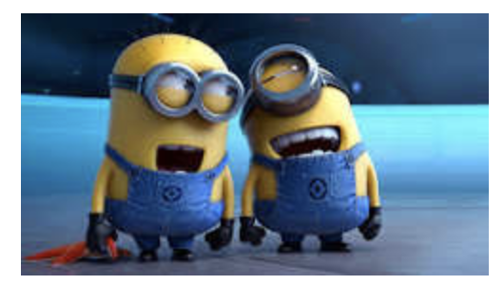

# Convert BGR to RGB for display
rgb_image = cv2.cvtColor(image, cv2.COLOR_BGR2RGB)
cv2_imshow(rgb_image)
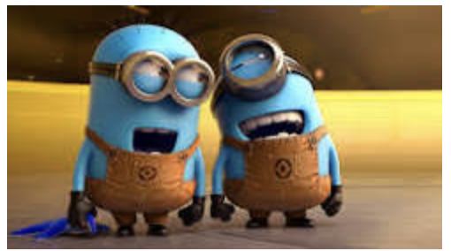

# Convert to Grayscale
gray_image = cv2.cvtColor(image, cv2.COLOR_BGR2GRAY)
cv2_imshow(gray_image)
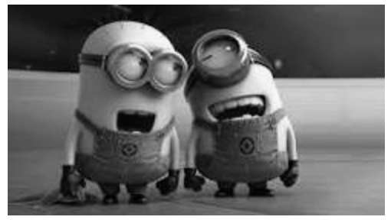

# Convert to HSV
hsv_image = cv2.cvtColor(image, cv2.COLOR_BGR2HSV)
cv2_imshow(hsv_image)
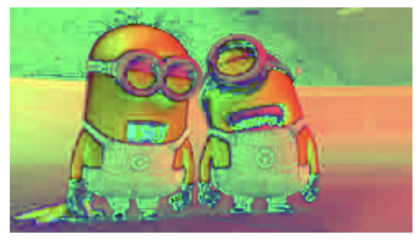

# Convert to LAB
lab_image = cv2.cvtColor(image, cv2.COLOR_BGR2LAB)
cv2_imshow(lab_image)
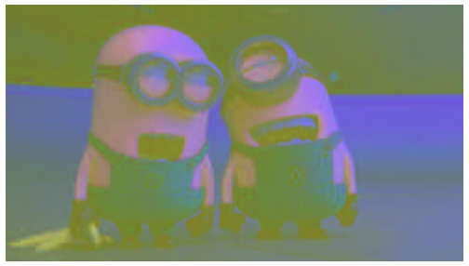

# Convert to YCrCb
ycrcb_image = cv2.cvtColor(image, cv2.COLOR_BGR2YCrCb)
cv2_imshow(ycrcb_image)
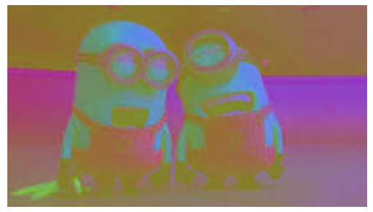

# Display images
titles = [
"Original RGB",
"Grayscale",
"HSV",
"LAB",
"YCrCb"
]
images = [
rgb_image,
gray_image,
hsv_image,
lab_image,
ycrcb_image
]
plt.figure(figsize=(15, 8))

for i in range(len(images)):
plt.subplot(2, 3, i + 1)
if i == 1:
plt.imshow(images[i], cmap="gray")
else:
plt.imshow(images[i])
plt.title(titles[i])
plt.axis("off")

plt.tight_layout()
plt.show()
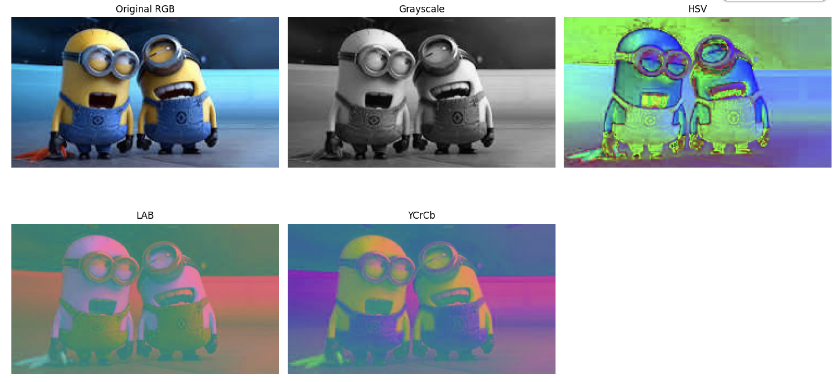

Questions

Q1. Convert an image into the CMYK color model and explain the process.

Answer: CMYK stands for Cyan, Magenta, Yellow, and Key (Black). It is mainly used in color printing. The RGB image is converted into CMYK by calculating the Cyan, Magenta,Yellow, and Black values from the RGB components. CMYK provides better color reproduction for printed materials.

Q2. Compare RGB and HSV using suitable examples.

Answer: RGB HSV Uses Red, Green, Blue components Uses Hue, Saturation, Value
Suitable for image display Suitable for color detection Difficult to separate colors Easy to identify colors Example: Computer screens Example: Traffic light detection

Q3. Perform color-based object detection using the HSV color space.

Answer: In HSV color space, a specific color range is selected using Hue values. A mask is created to highlight only the desired color, and objects having that color are detected. HSV is widely used for object tracking and color segmentation.

Q4. Extract only the luminance channel from a YCrCb image.

Answer: In the YCrCb color model, the Y channel represents luminance (brightness). To extract luminance, the image is converted to YCrCb format and only the Y channel is selected. This channel contains brightness information without color details.

Q5. Plot histograms for grayscale and RGB images and compare them.

Answer: A histogram shows the distribution of pixel intensities in an image.
• Grayscale Histogram: Displays intensity values from black (0) to white (255).
• RGB Histogram: Displays separate distributions for Red, Green, and Blue
channels.

