图像超分辨处理程序使用说明
汕头大学 机器视觉课题组
Image Super-Resolution Processing Program User Manual Shantou University Machine Vision Research Group
- 环境配置Environment Configuration：
所需要的函数库The required library of functions：
opencv-python
scikit-image
pillow
torchvision
hdf5storage
ninja
lmdb
requests
timm
einops
torch>=1.7

直接在工程目录下输入Enter directly in the project directory.：pip install –r requirement.txt,即可自动安装整套环境You can automatically install the entire environment.。

- 文件说明Document Description：
model文件夹Folder：放置模型网络代码文件Place the model network code file；
model文件夹：放置模型Folder: Place the model pth类型的权重文件Type weight file；
requirement.txt文件 Document：模型所需要的环境配置文件The environment configuration file required by the model；
SR_GUI.py文件 Document：超分辨GUI程序文件Super Resolution GUI Program File。

- 使用说明 Instructions for Use：
运行SR_GUI.py程序文件Run the SR_GUI.py program file，本程序提供两个模式进行超分辨率推理This program provides two modes for super-resolution inference.：
- 模式一：整张图片推理Whole image inference
- 模式二：手动截取推理Manually capturing inference
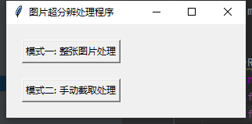
图1 程序主界面Program main interface
模式一：整张图片推理Whole image inference
由于图片的尺寸可能过大，模式一会将原图分解成若干个小块（子图），分别进行超分辨率处理。处理完成后，程序会将这些子图重新拼接，得到最终的超分辨率图片。Due to the large size of the image, mode one will decompose the original image into several smaller pieces (sub-images) for super-resolution processing. After processing is completed, the program will reassemble these sub-images to obtain the final super-resolution image.
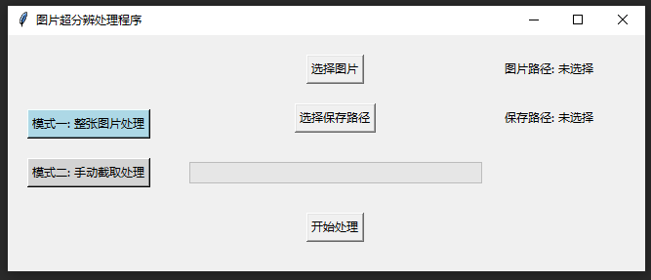
图2 模式一主界面Main Interface of Mode One
- 选择图片1. Select an image
点击“选择图片”按钮，从文件路径中选取需要进行处理的图片。Click the 'Select Image' button to choose the image you want to process from the file path.
- 选择保存路径 Choose save path
点击“选择保存路径”按钮，指定处理后的图片保存路径。Click the 'Select Save Path' button to specify the save path for the processed image.
- 开始处理 Start processing
点击“开始处理”按钮，程序会将图片分解为多个小块进行超分辨率处理。由于需要处理多个子图，因此此过程可能会比较耗时。您可以通过下方的进度条实时查看处理进度。Click the 'Start Processing' button, and the program will decompose the image into multiple small blocks for super-resolution processing. Since multiple sub-images need to be processed, this process may take some time. You can view the processing progress in real-time through the progress bar below.
- 处理结果Processing results
处理完成后，您将在指定的保存路径下找到一个名为 Patches 的文件夹，里面保存了所有处理过的子图。同时，程序会自动合并所有子图，生成一张超分辨率的完整图像。After processing is complete, you will find a folder named 'Patches' at the designated save path, which contains all the processed sub-images. At the same time, the program will automatically merge all the sub-images to generate a complete super-resolution image.
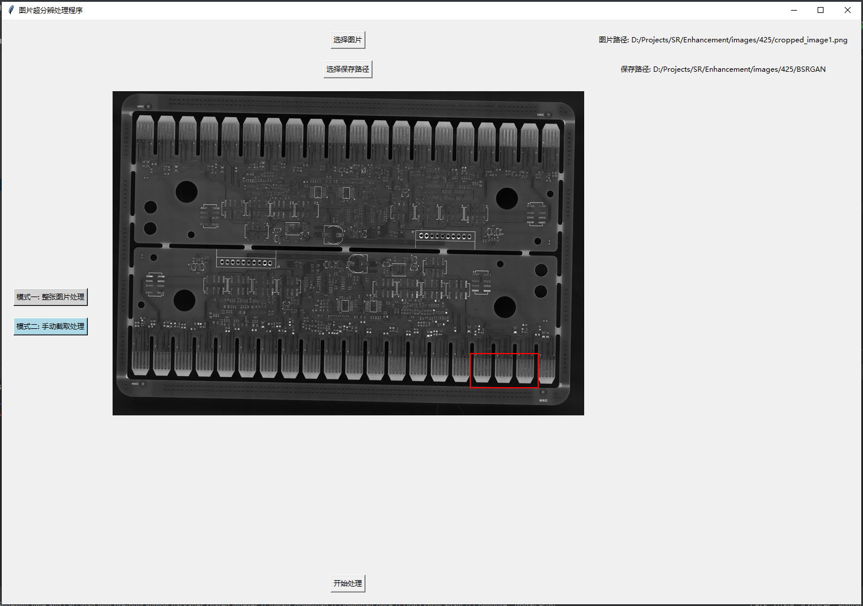
图3 模式二主界面Main Interface of Mode Two
模式二：手动截取推理，对图片部分手动截取局部，对局部进行超分辨处理，将截取原图和超分辨图同时保存。Mode 2: Manual inference by manually cropping parts of the image, performing super-resolution processing on the cropped sections, and saving both the cropped original image and the super-resolved image simultaneously.
- 选择图片Select an image
点击“选择图片”按钮，从文件路径中选取需要进行处理的图片。Click the 'Select Image' button to choose the image you want to process from the file path.
- 选择保存路径Choose save path
点击“选择保存路径”按钮，指定处理后的图片保存路径。Click the 'Select Save Path' button to specify the save path for the processed image.
- 截取区域Capture area
直接对下方图片进行局部区域截取（红色方框内），截取后的区域会对应保存至选择路径。Directly crop the local area of the image below (within the red box), and the cropped area will be saved to the selected path.
- 开始处理Start processing
点击“开始处理”，将区域内的图片进行超分辨处理并保存至对应路径。如果区域太大或者硬件显存不足会提示报错，需要缩小截取区域。Click 'Start Processing' to perform super-resolution processing on the images within the area and save them to the corresponding path. If the area is too large or if there is insufficient hardware memory, an error message will be displayed, and you will need to reduce the capture area.
- 处理结果Processing results
处理完成后，对应保存文件夹会出现两张图片，一张为截取区域的原图，另外一张为超分辨处理后图片。After the processing is complete, the corresponding saved folder will contain two images: one is the original image of the cropped area, and the other is the image after super-resolution processing.

