**CASE STUDY REPORT**

# SUSTAINABLE DEVELOPMENT

Submitted by,

**DEVANAND V**

191CS151

Submitted to,

### Dr. PACHAMUTHU P

Assistant professor Department of Chemistry



### BANNARI AMMAN INSTITUTE OF TECHNOLOGY

(An autonomous institution affiliate d to Anna University, Chennai)

**SATHYAMANGLAM** - 638410

**TABLE OF CONTENTS**

|  |  |  |
| --- | --- | --- |
| **TITLE NO.** | **TITLE** | **PAGE NO.** |
| **1.** | **ABSTRACT** | **3** |
| **2.** | **INTRODUCTION** | 3 |
| **3.** | **LITERATURE REVIEW** | 3 |
| **4** | **THE OUT COME OF THE SURVEY** | 8 |
| **5** | **CONCLUSION** | 9 |
| **6** | **REFERENCE** | 9 |

# SUSTAINABLE DEVELOPMENT

## ABSTRACT

As wiki says, **Sustainable development** can be defined as **development** that meets the needs of the present lifestyle going on without compromising the ability of future generations to meet their own needs and organizing principle for meeting human development goals while simultaneously sustaining the ability of natural systems to provide the natural resources and ecosystem services on which the economy and society depend. Goals we are talking about are of 17 types by now. From the following article, we are going to attain an idea about the basic and most important goals among the others.

## INTRODUCTION

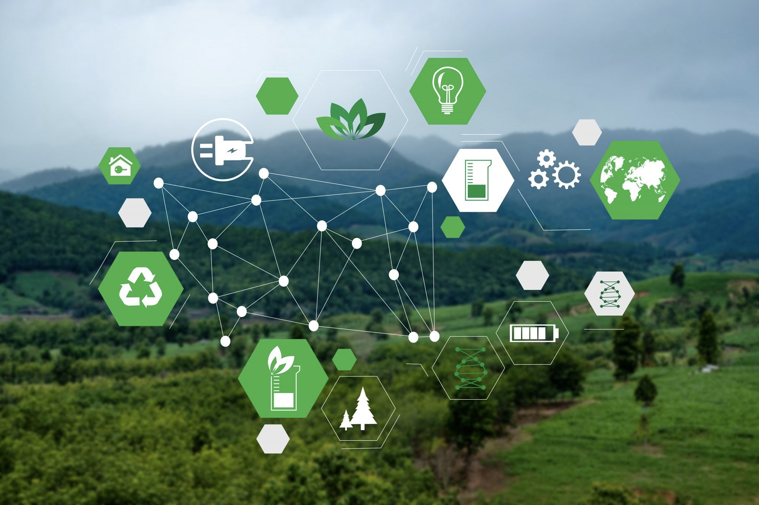According to the United Nations, the goals should be achieved primarily are classified into seventeen in numbers. They are No Poverty, Zero Hunger, Good health and wellbeing, Quality Education,Gender equality, Clean Water and Sanitation, Affordable and clean Energy, Decent work and Economic growth, Industry, Innovation and Infrastructure, Reduced Inequalities, Sustainable cities and Communities, Responsible consumption and production, Climate action, Life below water,

Life on land, Partnerships for the goals and finally Peace, Justice and Strong Institutions. Among these ‘Affordable and clean Energy’ plays a major role in the sustainable system and it helps the entire system to do their responsibilities. So, it must be viewed as the most important one and the measures to be taken as quickly as can.

**LITERATURE REVIEW**

### SUSTAINABLE ENERGY

Across all dimensions of sustainable energy for all— whether access, efficiency, or renewables—the rate of progress during the 2010–12 tracking period falls substantially short of the rate that would be needed to ensure that the three objectives are met by 2030. Nevertheless, the 2010–12 tracking period does present some encouraging acceleration in progress relative to what was observed in prior decades. Efforts must be redoubled to get back on track; particularly in

countries with large access deficits and high energy consumption whose rate of progress carries substantial weight in the global aggregate.

The first SE4All Global Tracking Framework (GTF 2013) established a consensus-based methodology and identified concrete indicators for tracking global progress toward the three SE4All objectives. One is to ensure universal access to modern energy services. The second is to double the global rate of improvement in energy efficiency. And the third is to double the share of renewable energy in the global energy mix. GTF 2013 also presented a data platform drawing on national data records for more than 180 countries, which together account for more than 95 percent of the global population. And it documented the historical evolution of selected indicators over 1990–2010, establishing a baseline for charting progress.

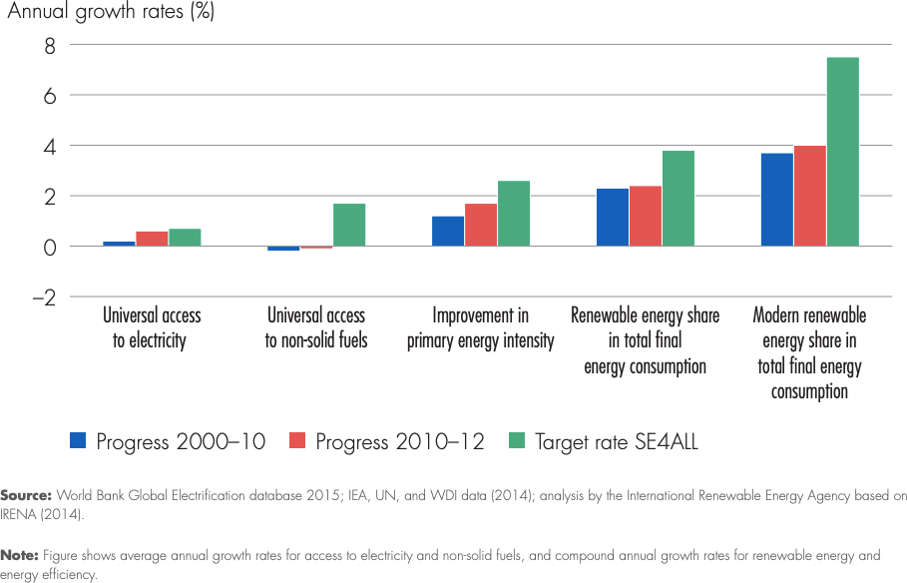

Fig. 1

### ELECTRIC ENERGY

**The annual growth in access to electricity during the tracking period reached 0.6 percent, approaching the target growth rate of 0.7 percent required to reach universal access by 2030, and certainly much higher than the growth of 0.2 percent registered over 2000–2010.** As a result, the global electrification rate rose from 83 percent in 2010 to 85 percent in 2012. This means that an additional 222

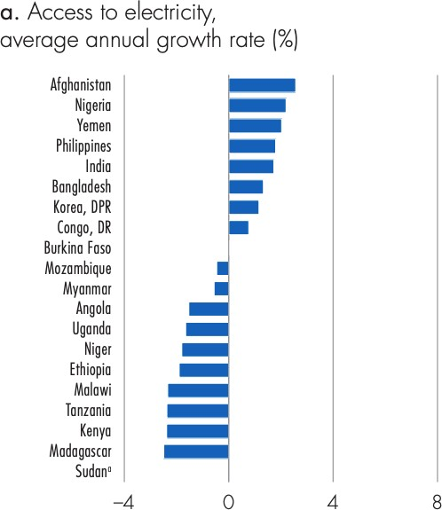Fig. 2

million people—mainly in urban areas— gained first time access to electricity; more people than the population of Brazil, and well ahead of the 138 million population increase that took place over the same period. Overall, the global electricity deficit declined from 1.2 billion to 1.1 billion. Global progress was driven by significant advances in India, where 55 million people gained access over 2010–12. As the electricity are most important even in nowadays, in the future where some more technology developments are going to arise, it will play a super most role in future too. So sustaining energy is must needed. As India showing growing rate in electricity, we can double the usage by 2022.

### INDIA IN THE ROLE OF ENERGY

However, India’s renewable energy market has slowed this year. Challenges—import duties on solar panels, land availability issues, slow development of electricity evacuation infrastructure, uncertainty of power purchase agreements, and artificially low ceilings on solar tenders—are dampening market progress. The national government is working with stakeholders to get the market back on track. Currently, around 31.1 GW of renewable capacity is under various stages of construction, and another 39 GW likely to be constructed by 2021 is in the biding stage. Based on these projects, it is likely that India’s 175 GW by 2022 may be extended.

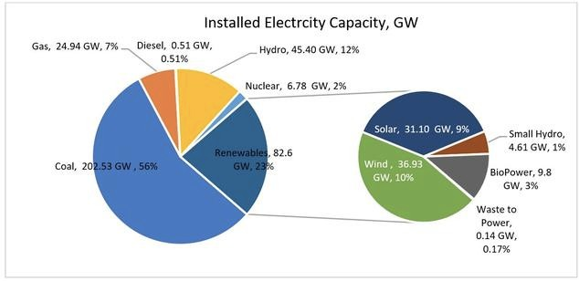

Fig. 3

**“The renewable energy capacity in India is currently 136 gigawatts ( GW) according to Economic Times. This is about 36 per cent of our total capacity. By 2022, the share of renewable capacity will increase to over 220 GW,” said Modi in his inaugural speech at RE-Invest 2020. “In the past six years, we increased our installed renewable energy capacity by two-and-half times. And in the same period, the installed solar energy capacity increased 13 times,” he added.**

### GROSS INSTALLED CAPACITY OF RENEWABLE ENERGY

State government, central government, and private players drive the Indian energy sector. The private sector leads the way in renewable energy investment. Fig. 4 shows the installed gross renewable energy and conventional energy capacity (percentage)—ownership wise. It is evident that 95% of the installed renewable capacity derives from private companies, 2% from the central government, and 3% from the state government. The top private companies in the field of non- conventional energy generation are Tata Power Solar, Suzlon, and ReNew Power. Tata Power Solar System Limited are the most significant integrated solar power players in the country, Suzlon realizes wind energy projects, and ReNew Power Ventures operate with solar and wind power.

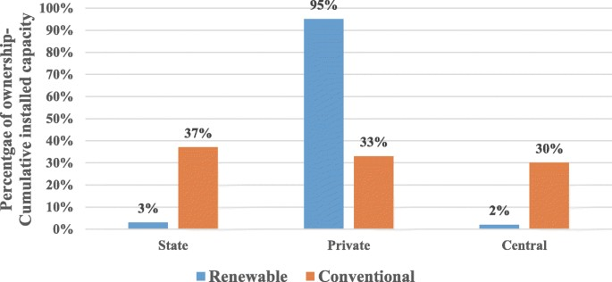

Fig. 4

### STEPS TAKEN IN & BY INDIA

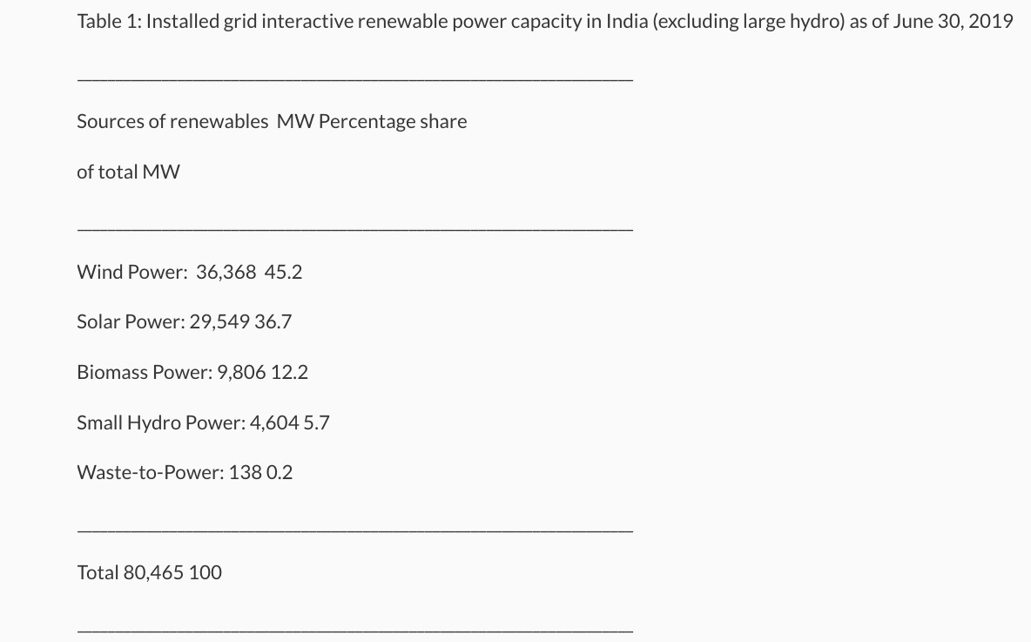The renewable energy sector in India has been growing steadfastly in the last few years, with the country now home to some of the largest solar and wind installations in the world. The sector received a major boost after 2015 following the government’s decision to create 175 gigawatt (GW) of renewable energy capacity in the country by 2022. The new target redefined the scale and scope of the sector, especially for wind and

Fig. 5

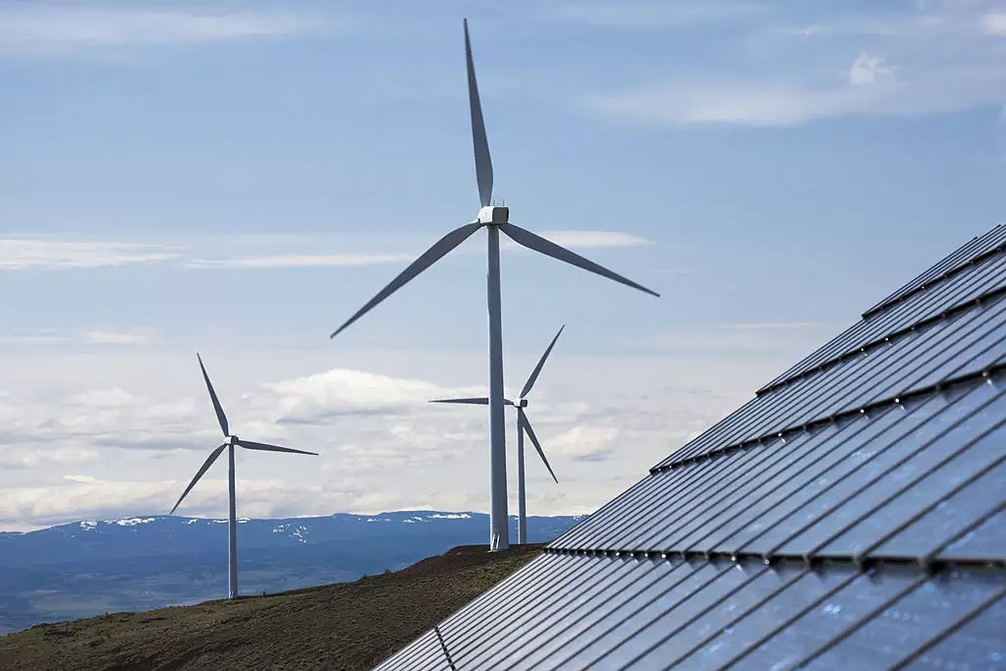solar which comprise 60 GW and 100 GW (the original goal for solar was 20 GW), respectively, of the goal. Over the last few years, the

government has launched a series of supportive policies and schemes to encourage the building up of renewable capacity in the country. The dramatic fall in the price of photovoltaic cells by more than 50% over the last 5 years in domestic markets has further been spurring the demand and investments in renewables sector. With fast expanding demand and a steep fall in prices, the market size of the

renewables is further set to expand and deepen. Fig.5 shows the installed renewable power capacity in India and Wind energy plays the vital by providing the most power of 45.2% as of June 2019 excluding the large hydro.

### INDIA - PARIS AGREEMENT

India is a signatory to the Paris agreement and continues to stay the course with a slew of measures including a strong focus on renewable energy, investments in green technologies, gradually reducing dependence on fossil fuel and enabling policy frameworks to provide continuity through involvement of sub regional governments. One such measure that the Indian government in tandem

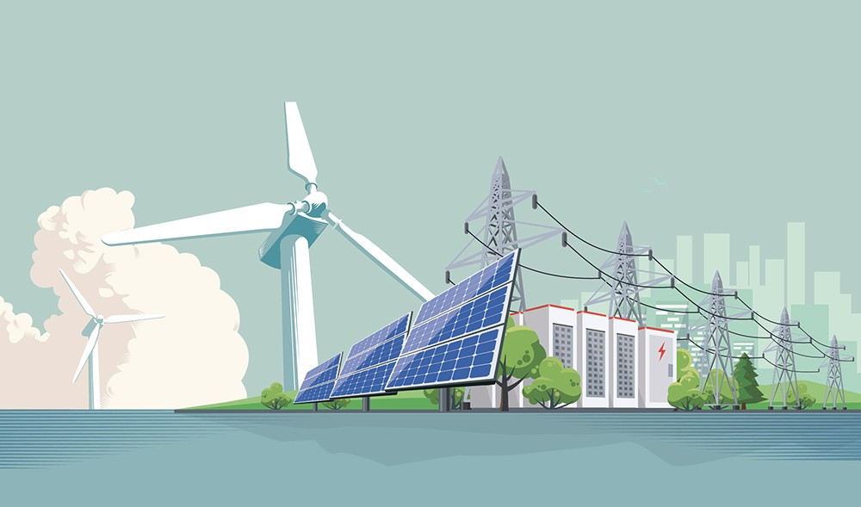with the private sector has taken up is to step up its efforts to expand the markets around renewables, scale production and deepen consumption, spur investments and deploy extensive financial capital in the area of clean energy and renewables. India has already set a target of 175 GW out of which 73 GW is already achieved with a clear focus on reducing dependence on fossil fuel. Given the size and scale of the tasks involved these measures will

need a constant oversight by domestic actors on implementation of measures as set by India. Renewables are key to advancing green climate while keeping emissions within permissible limits, going forward. However, India’s march towards a clean and green environment can effectively be sustained by backing the country’s current performance levels with enforceable policies for country’s Paris Climate commitment of 1.5 degrees Celsius to stay course in run up to 2030.

### GOVERNMENT INITIATIVES

Some initiatives by the Government of India to boost the Indian renewable energy sector are as follows:

* A new Hydropower policy for 2018-28 has been drafted for the growth of hydro projects in the country.
* The Government of India has announced plans to implement a US$238 million National Mission on advanced ultra-supercritical technologies for cleaner coal utilisation. (https://pib.gov.in/newsite/PrintRelease.aspx?relid=165512)
* The Ministry of New and Renewable Energy (MNRE) has decided to provide custom and excise duty benefits to the solar rooftop sector, which in turn will lower the cost of setting up as well as generate power, thus boosting growth. (www.mnre.gov.in)
* The Indian Railways is taking increased efforts through sustained energy efficient measures and maximum use of clean fuel to cut down emission levels by 33% by 2030.

**THE OUTCOME OF THE SURVEY**

**STRENGHTS**

* Continuous adjustments of actions to improve performance and achieve targets.
* Delineates consequences of alternative practices, which gives clear directions for choosing.
* Allows for a firm risk assessment.
* Measures the gap between current and desired states, which allows for scaling of investments.
* Clear basis for accreditation and marketing.
* Benchmarking can motive individual responsibility. Credibility of the process (in and instrumentally
* Rational sense).
* Sets sustainability as a definite target to be reached.

**WEAKNESS**

* Steers by what is possible (and easy) to measure.
* Neglects the unknown consequences.
* The means become the targets, and the targets may not lead to the overall goal of sustainability.
* Quantification and indexation hide contextual information.
* Petrifies value discussions and value basis of tools.
* Neglects agents of changes as individual decision-makers.
* Agents of changes do not get ownership of the values.

### CONCLUSION

As many factors say, energy matters the most in the formation of the clean and super enabled future. By the end of 2030, India will be at one of the top performers in the role of producing renewable energy source. India has started taking steps already and doing now also for the better creation of renewable energy for the Sustainable Future itself. Therefore the Sustainable Development through Renewable Energy is in development by India for the better tomorrow. Besides every citizens have to take steps on their own for their upcoming century.

### REFRENCES

* https://sdgs.un.org/publications/progress-towards-sustainable-energy-17855
* https://energsustainsoc.biomedcentral.com/articles/10.1186/s13705-019-0232-1
* https://[www.climatescorecard.org/2019/11/india-is-taking-steps-forward-to-make-use-of-its-](http://www.climatescorecard.org/2019/11/india-is-taking-steps-forward-to-make-use-of-its-) extensive-renewable-energy-resources/
* https://energsustainsoc.biomedcentral.com/articles/10.1186/s13705-019-0232-1
* https://[www.nrdc.org/experts/anjali-jaiswal/transitioning-indias-economy-clean-energy](http://www.nrdc.org/experts/anjali-jaiswal/transitioning-indias-economy-clean-energy)
* https://economictimes.indiatimes.com/small-biz/sme-sector/solar-revolution-far-from-it- says-industry/articleshow/71734062.cms