Name: Devang A Garibnawaz

Subject: OSWD

Roll No: 08

Exam No:

Assignment: Practical Assignment – 2

**Admin Home:**

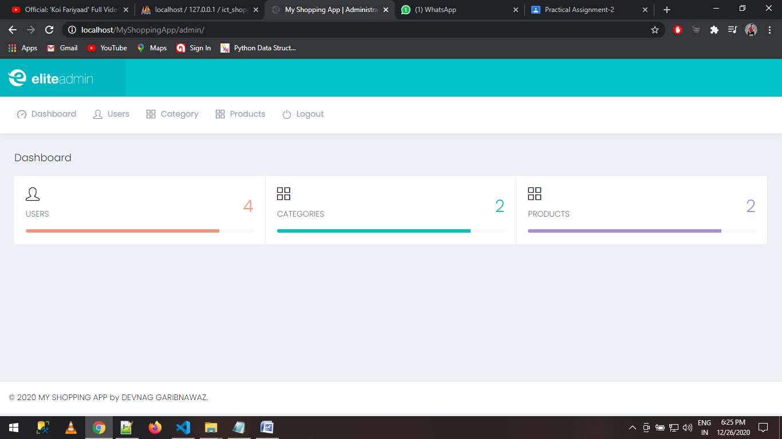

**Category List:**

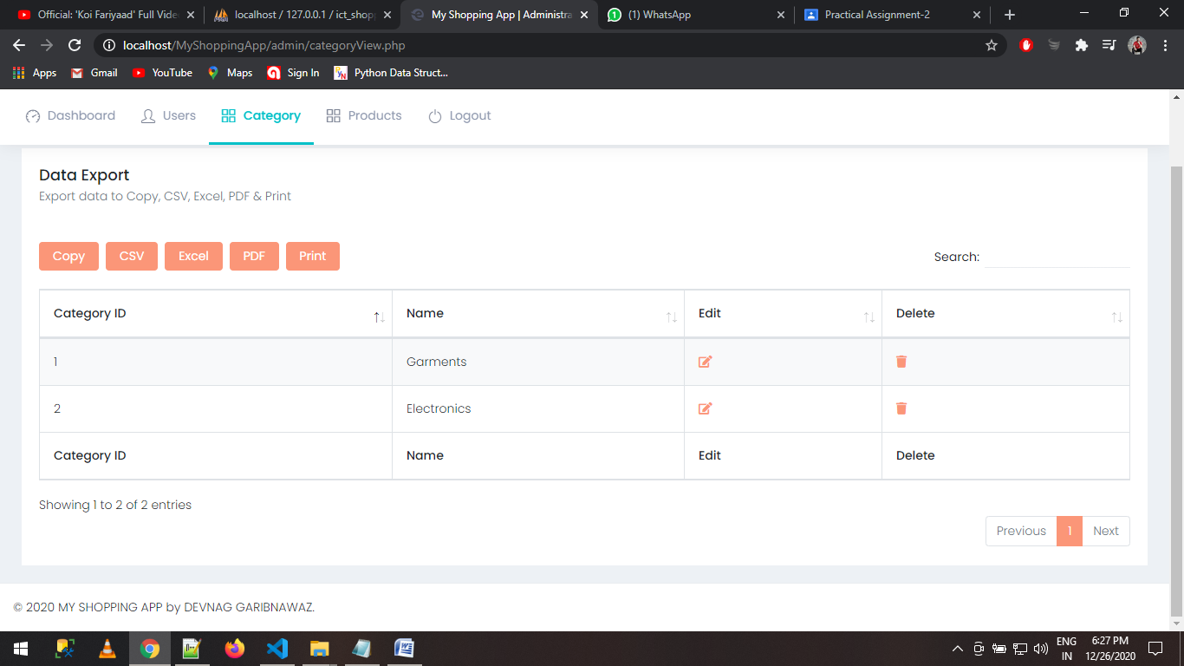

**Update Category:**

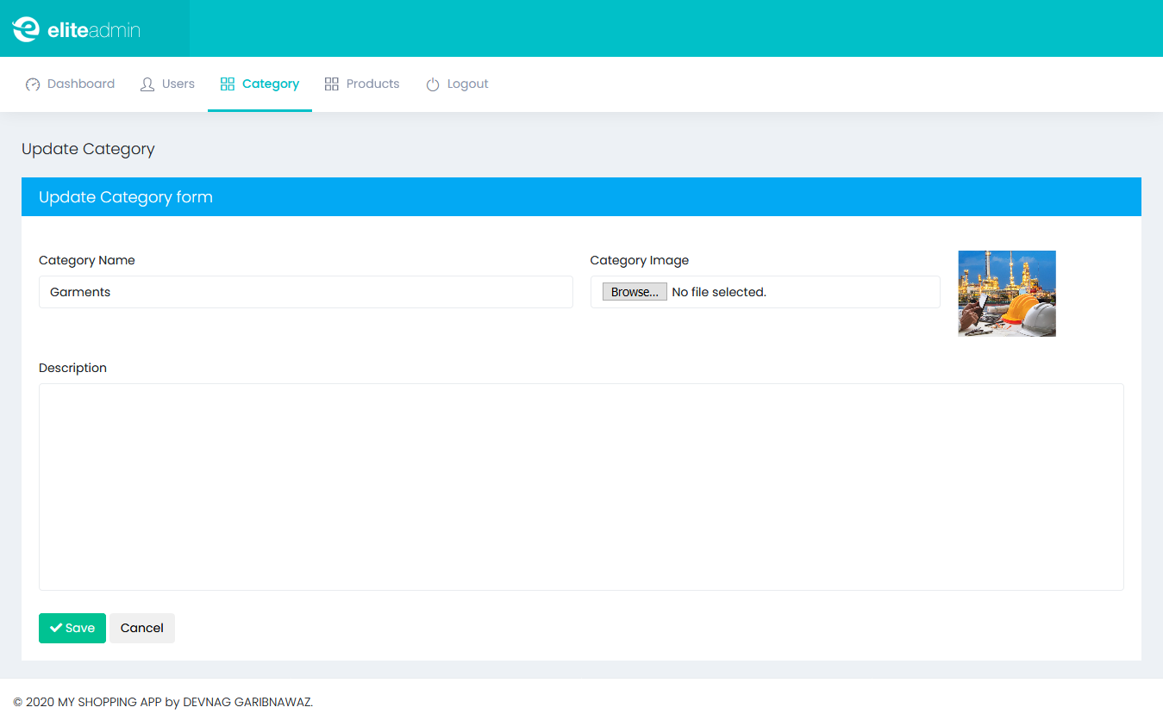

**Product List:**

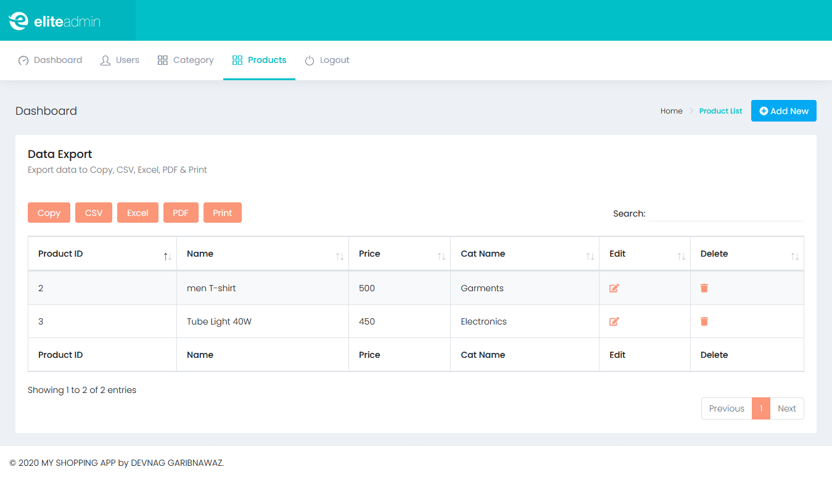

**Update Product:**

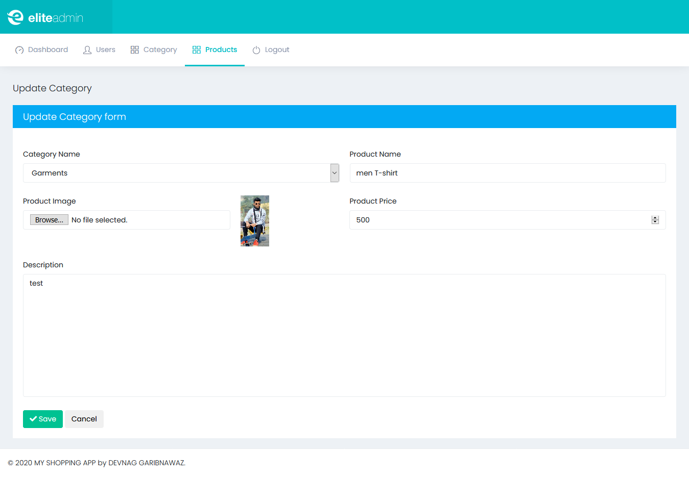

**Login Page:**

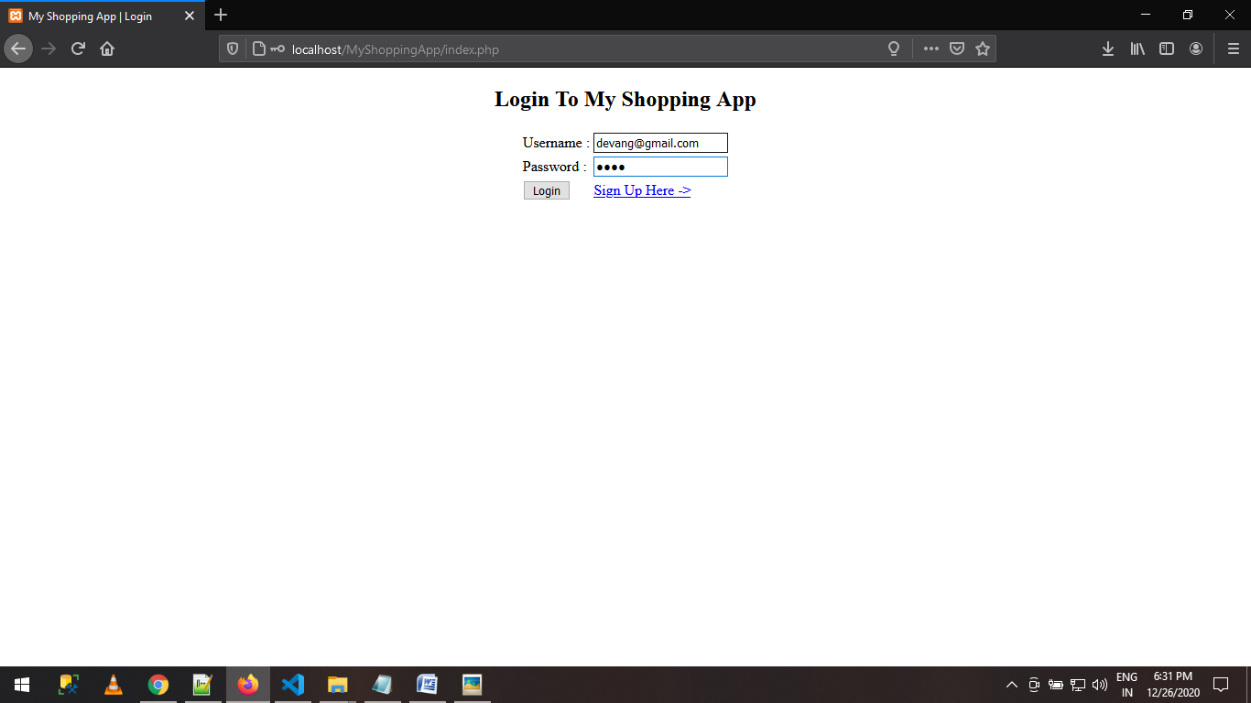

**Registration Page:**

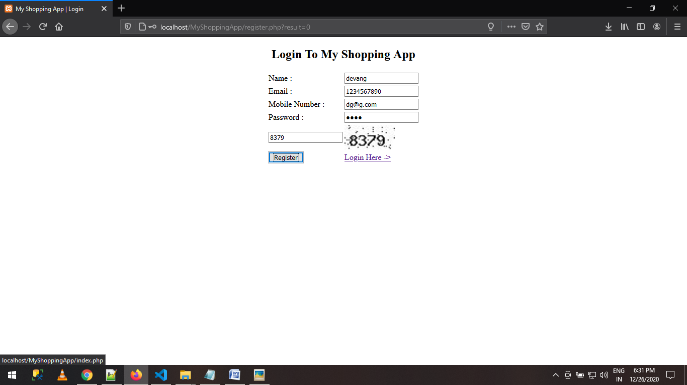

**User Home:**

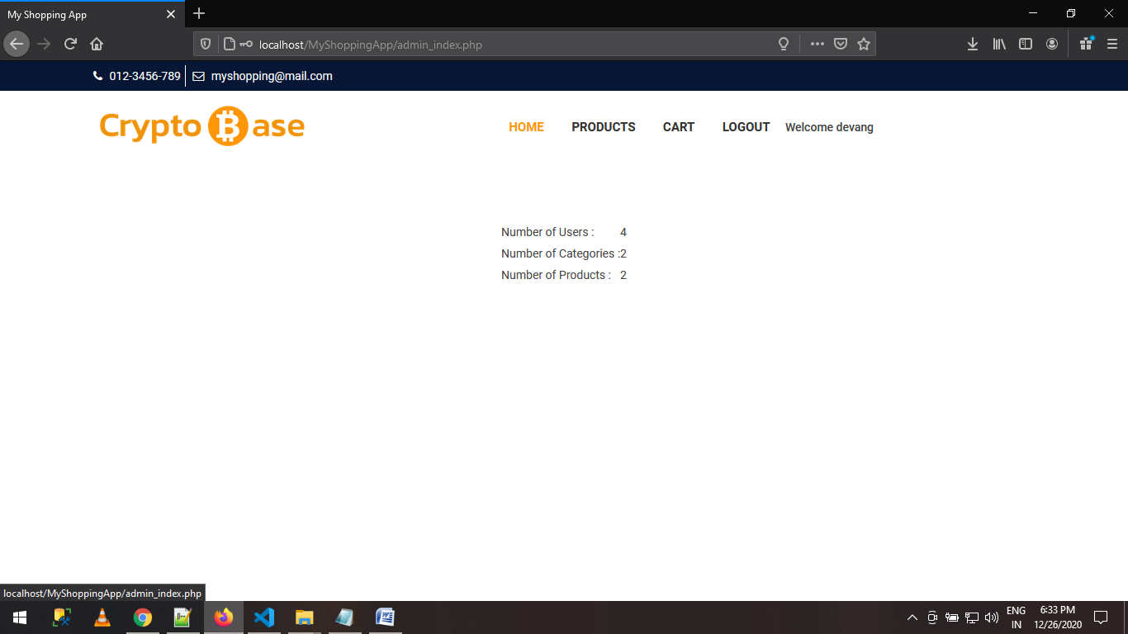

**Customer Side Category:**

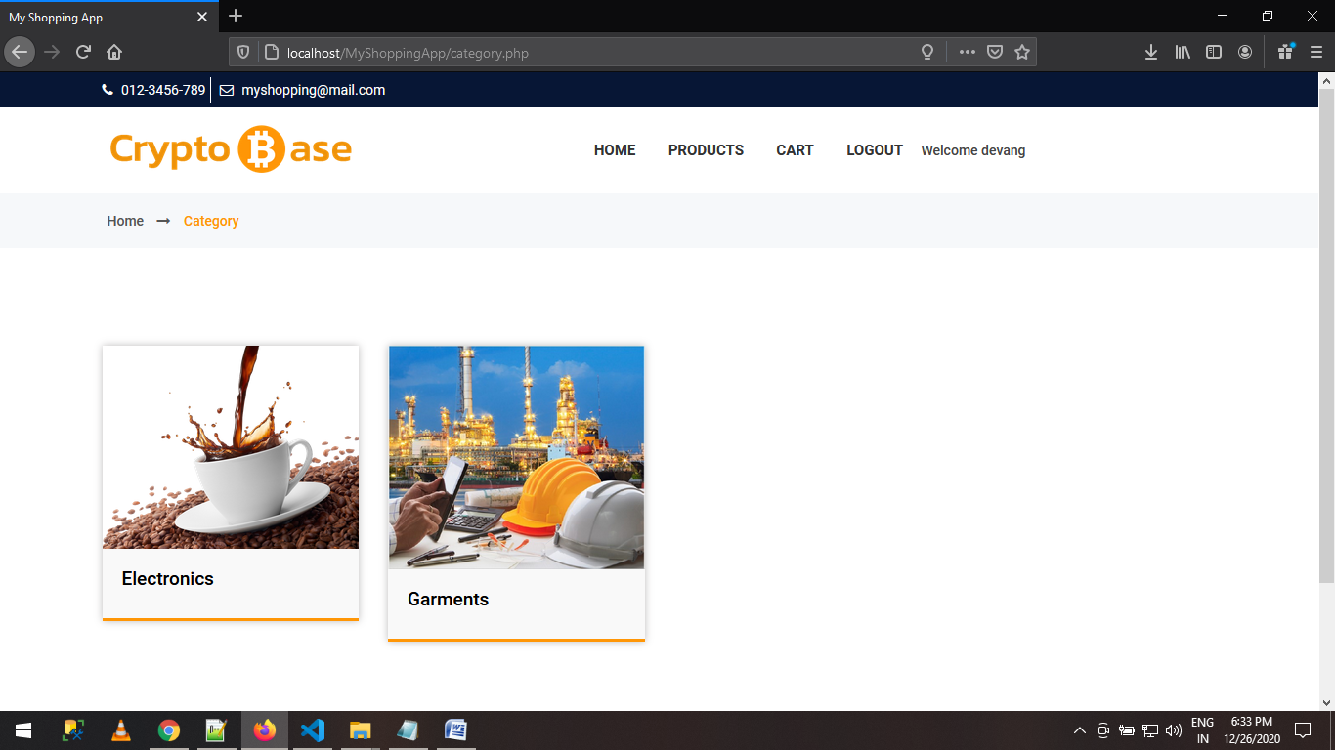

**Customer Side Products:**

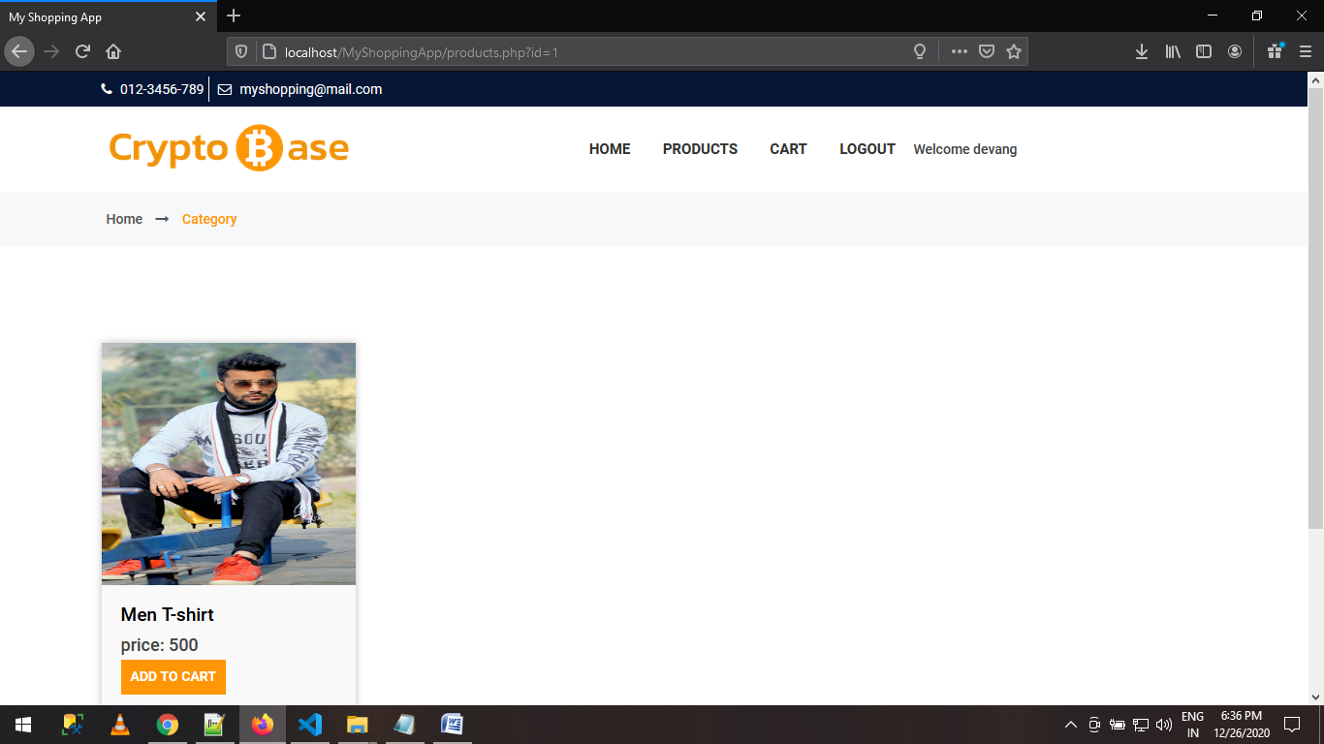

**Cart:**

