**Project Report on**

AIR AND WATER QUALITY INDEX DEVELOPMENT FOR ENVIRONMENTAL ASSESSMENT IN INDUSTRIAL CONTEXT

### submitted in partial fulfillment of the requirement for the award of the Degree of

**BACHELOR OF ENGINEERING**

### in

**ELECTRONICS & TELECOMMUNICATION ENGINEERING**

### by

### Devang Vartak Tanmay Pal Pranjal Srivastava

### under the guidance of

**Prof. G. T. Haldankar**



**Department of Electronics & Telecommunication Engineering Sardar Patel Institute of Technology**

**Munshi Nagar, Andheri(W), Mumbai-400058**

**UNIVERSITY OF MUMBAI 2024-2025**

**CERTIFICATE**

This is to certify that the Project entitled **“Air and Water Quality Index Development for Environmental Assessment in Industrial Context”** has been completed successfully by **Devang Vartak, Tanmay Pal** and **Pranjal Srivastava** under the guidance of **Prof. G. T. Haldankar** for the award of Degree of **Bachelor of Engineering** in **Electronics & Telecommunication Engineering** from **University of Mumbai**.

#### Certified by

#### Prof. G. T. Haldankar Dr. Reena Kumbhare

#### Project Guide Head of Department

#### Dr. B. N. Chaudhari Principal



**Department of Electronics & Telecommunication Engineering Sardar Patel Institute of Technology**

**Munshi Nagar, Andheri(W), Mumbai-400058**

**UNIVERSITY OF MUMBAI 2024-2025**

**PROJECT APPROVAL CERTIFICATE**

This is to certify that the Project entitled **“Air and Water Quality Index Development for Environmental Assessment in Industrial Context”** by **Devang Vartak, Tanmay Pal** and **Pranjal Srivastava** is approved for the award of Degree of **Bachelor of Engineering** in **Electronics & Telecommunication Engineering** from **University of Mumbai**.

#### External Examiner Internal Examiner

#### (signature) (signature)

#### Name: Name:

#### Date: Date:

#### Seal of the Institute

#### Acknowledgment

I have great pleasure in presenting the report on **Air and Water Quality Index Development for Environmental Assessment in Industrial Context**. I take this opportunity to express my sincere thanks towards my guide **Prof. G. T. Haldankar**, Professor of Department of Electronics Engineering, S.P.I.T., Mumbai, for providing the technical guidelines and the suggestions regarding line of this work. I would like to express my gratitude towards their constant encouragement, support and guidance throughout the development of the project.

I would also like to express my gratitude to the entire staff at S.P.I.T., Mumbai for their invaluable assistance during the course of this work. I wish to express my deep gratitude towards all my colleagues at S.P.I.T., Mumbai for their continuous encouragement.

#### Abstract

Considering the importance of air and water to human existence, air pollution and water pollution are critical issues that require collective effort for prevention and control. Different types of anthropogenic activities have resulted in environmental dilapidation and ruin. One of the tools that can be used for such a campaign is Air Quality Index (AQI). The AQI was based on the concentrations of different pollutants: We are also familiar with the Water Quality Index (WQI), which in simple terms tells what the quality of drinking water is from a drinking water supply. There is a need for constant and continuous environment monitoring of air quality and water quality for the development of AQI and WQI, which in turn will enable clear communication of how clean or unhealthy the air and water in the study area is.

**Contents**

1. Introduction  3
   1. Problem statement 3
   2. Motivation 4
   3. Objectives 4
2. [Literature Review](https://word-edit.officeapps.live.com/we/wordeditorframe.aspx?ui=en-US&rs=en-IN&hid=kxkBJWmSgUK08kE4hSs%2BHQ.0.14.0&wopisrc=https%3A%2F%2Fwopi.onedrive.com%2Fwopi%2Ffiles%2FC18BD027BF624737!112&wdorigin=OFFICECOM-WEB.START.UPLOAD&wdprevioussessionsrc=HarmonyWeb&wdprevioussession=74e11c84-9c43-4df1-806f-2fc735e65a82&wdo=2&wde=docx&sc=host%3D%26qt%3DDefault&mscc=1&wdp=0&uih=onedrivecom&jsapi=1&jsapiver=v2&corrid=2c9fd0ce-a234-4352-85a5-fe5013d27152&usid=2c9fd0ce-a234-4352-85a5-fe5013d27152&newsession=1&sftc=1&uihit=editaspx&muv=1&cac=1&sams=1&mtf=1&sfp=1&sdp=1&hch=1&hwfh=1&dchat=1&instantedit=1&wopicomplete=1&wdredirectionreason=Unified_SingleFlush&_TOC_250012) 5
   1. [Literature Summary](https://word-edit.officeapps.live.com/we/wordeditorframe.aspx?ui=en-US&rs=en-IN&hid=kxkBJWmSgUK08kE4hSs%2BHQ.0.14.0&wopisrc=https%3A%2F%2Fwopi.onedrive.com%2Fwopi%2Ffiles%2FC18BD027BF624737!112&wdorigin=OFFICECOM-WEB.START.UPLOAD&wdprevioussessionsrc=HarmonyWeb&wdprevioussession=74e11c84-9c43-4df1-806f-2fc735e65a82&wdo=2&wde=docx&sc=host%3D%26qt%3DDefault&mscc=1&wdp=0&uih=onedrivecom&jsapi=1&jsapiver=v2&corrid=2c9fd0ce-a234-4352-85a5-fe5013d27152&usid=2c9fd0ce-a234-4352-85a5-fe5013d27152&newsession=1&sftc=1&uihit=editaspx&muv=1&cac=1&sams=1&mtf=1&sfp=1&sdp=1&hch=1&hwfh=1&dchat=1&instantedit=1&wopicomplete=1&wdredirectionreason=Unified_SingleFlush&_TOC_250011) 5
3. [Proposed System Design](https://word-edit.officeapps.live.com/we/wordeditorframe.aspx?ui=en-US&rs=en-IN&hid=kxkBJWmSgUK08kE4hSs%2BHQ.0.14.0&wopisrc=https%3A%2F%2Fwopi.onedrive.com%2Fwopi%2Ffiles%2FC18BD027BF624737!112&wdorigin=OFFICECOM-WEB.START.UPLOAD&wdprevioussessionsrc=HarmonyWeb&wdprevioussession=74e11c84-9c43-4df1-806f-2fc735e65a82&wdo=2&wde=docx&sc=host%3D%26qt%3DDefault&mscc=1&wdp=0&uih=onedrivecom&jsapi=1&jsapiver=v2&corrid=2c9fd0ce-a234-4352-85a5-fe5013d27152&usid=2c9fd0ce-a234-4352-85a5-fe5013d27152&newsession=1&sftc=1&uihit=editaspx&muv=1&cac=1&sams=1&mtf=1&sfp=1&sdp=1&hch=1&hwfh=1&dchat=1&instantedit=1&wopicomplete=1&wdredirectionreason=Unified_SingleFlush&_TOC_250010) 7
   1. [Components Needed](https://word-edit.officeapps.live.com/we/wordeditorframe.aspx?ui=en-US&rs=en-IN&hid=kxkBJWmSgUK08kE4hSs%2BHQ.0.14.0&wopisrc=https%3A%2F%2Fwopi.onedrive.com%2Fwopi%2Ffiles%2FC18BD027BF624737!112&wdorigin=OFFICECOM-WEB.START.UPLOAD&wdprevioussessionsrc=HarmonyWeb&wdprevioussession=74e11c84-9c43-4df1-806f-2fc735e65a82&wdo=2&wde=docx&sc=host%3D%26qt%3DDefault&mscc=1&wdp=0&uih=onedrivecom&jsapi=1&jsapiver=v2&corrid=2c9fd0ce-a234-4352-85a5-fe5013d27152&usid=2c9fd0ce-a234-4352-85a5-fe5013d27152&newsession=1&sftc=1&uihit=editaspx&muv=1&cac=1&sams=1&mtf=1&sfp=1&sdp=1&hch=1&hwfh=1&dchat=1&instantedit=1&wopicomplete=1&wdredirectionreason=Unified_SingleFlush&_TOC_250009)  7
   2. [TTGO LoRa32 Board](https://word-edit.officeapps.live.com/we/wordeditorframe.aspx?ui=en-US&rs=en-IN&hid=kxkBJWmSgUK08kE4hSs%2BHQ.0.14.0&wopisrc=https%3A%2F%2Fwopi.onedrive.com%2Fwopi%2Ffiles%2FC18BD027BF624737!112&wdorigin=OFFICECOM-WEB.START.UPLOAD&wdprevioussessionsrc=HarmonyWeb&wdprevioussession=74e11c84-9c43-4df1-806f-2fc735e65a82&wdo=2&wde=docx&sc=host%3D%26qt%3DDefault&mscc=1&wdp=0&uih=onedrivecom&jsapi=1&jsapiver=v2&corrid=2c9fd0ce-a234-4352-85a5-fe5013d27152&usid=2c9fd0ce-a234-4352-85a5-fe5013d27152&newsession=1&sftc=1&uihit=editaspx&muv=1&cac=1&sams=1&mtf=1&sfp=1&sdp=1&hch=1&hwfh=1&dchat=1&instantedit=1&wopicomplete=1&wdredirectionreason=Unified_SingleFlush&_TOC_250008) 7
   3. [Working](https://word-edit.officeapps.live.com/we/wordeditorframe.aspx?ui=en-US&rs=en-IN&hid=kxkBJWmSgUK08kE4hSs%2BHQ.0.14.0&wopisrc=https%3A%2F%2Fwopi.onedrive.com%2Fwopi%2Ffiles%2FC18BD027BF624737!112&wdorigin=OFFICECOM-WEB.START.UPLOAD&wdprevioussessionsrc=HarmonyWeb&wdprevioussession=74e11c84-9c43-4df1-806f-2fc735e65a82&wdo=2&wde=docx&sc=host%3D%26qt%3DDefault&mscc=1&wdp=0&uih=onedrivecom&jsapi=1&jsapiver=v2&corrid=2c9fd0ce-a234-4352-85a5-fe5013d27152&usid=2c9fd0ce-a234-4352-85a5-fe5013d27152&newsession=1&sftc=1&uihit=editaspx&muv=1&cac=1&sams=1&mtf=1&sfp=1&sdp=1&hch=1&hwfh=1&dchat=1&instantedit=1&wopicomplete=1&wdredirectionreason=Unified_SingleFlush&_TOC_250007) 7
4. [Software Used](https://word-edit.officeapps.live.com/we/wordeditorframe.aspx?ui=en-US&rs=en-IN&hid=kxkBJWmSgUK08kE4hSs%2BHQ.0.14.0&wopisrc=https%3A%2F%2Fwopi.onedrive.com%2Fwopi%2Ffiles%2FC18BD027BF624737!112&wdorigin=OFFICECOM-WEB.START.UPLOAD&wdprevioussessionsrc=HarmonyWeb&wdprevioussession=74e11c84-9c43-4df1-806f-2fc735e65a82&wdo=2&wde=docx&sc=host%3D%26qt%3DDefault&mscc=1&wdp=0&uih=onedrivecom&jsapi=1&jsapiver=v2&corrid=2c9fd0ce-a234-4352-85a5-fe5013d27152&usid=2c9fd0ce-a234-4352-85a5-fe5013d27152&newsession=1&sftc=1&uihit=editaspx&muv=1&cac=1&sams=1&mtf=1&sfp=1&sdp=1&hch=1&hwfh=1&dchat=1&instantedit=1&wopicomplete=1&wdredirectionreason=Unified_SingleFlush&_TOC_250006) 9
5. [Future Scope](https://word-edit.officeapps.live.com/we/wordeditorframe.aspx?ui=en-US&rs=en-IN&hid=kxkBJWmSgUK08kE4hSs%2BHQ.0.14.0&wopisrc=https%3A%2F%2Fwopi.onedrive.com%2Fwopi%2Ffiles%2FC18BD027BF624737!112&wdorigin=OFFICECOM-WEB.START.UPLOAD&wdprevioussessionsrc=HarmonyWeb&wdprevioussession=74e11c84-9c43-4df1-806f-2fc735e65a82&wdo=2&wde=docx&sc=host%3D%26qt%3DDefault&mscc=1&wdp=0&uih=onedrivecom&jsapi=1&jsapiver=v2&corrid=2c9fd0ce-a234-4352-85a5-fe5013d27152&usid=2c9fd0ce-a234-4352-85a5-fe5013d27152&newsession=1&sftc=1&uihit=editaspx&muv=1&cac=1&sams=1&mtf=1&sfp=1&sdp=1&hch=1&hwfh=1&dchat=1&instantedit=1&wopicomplete=1&wdredirectionreason=Unified_SingleFlush&_TOC_250006) 10
6. Simulation & Experimental Results 11
7. [Conclusion 1](https://word-edit.officeapps.live.com/we/wordeditorframe.aspx?ui=en-US&rs=en-IN&hid=kxkBJWmSgUK08kE4hSs%2BHQ.0.14.0&wopisrc=https%3A%2F%2Fwopi.onedrive.com%2Fwopi%2Ffiles%2FC18BD027BF624737!112&wdorigin=OFFICECOM-WEB.START.UPLOAD&wdprevioussessionsrc=HarmonyWeb&wdprevioussession=74e11c84-9c43-4df1-806f-2fc735e65a82&wdo=2&wde=docx&sc=host%3D%26qt%3DDefault&mscc=1&wdp=0&uih=onedrivecom&jsapi=1&jsapiver=v2&corrid=2c9fd0ce-a234-4352-85a5-fe5013d27152&usid=2c9fd0ce-a234-4352-85a5-fe5013d27152&newsession=1&sftc=1&uihit=editaspx&muv=1&cac=1&sams=1&mtf=1&sfp=1&sdp=1&hch=1&hwfh=1&dchat=1&instantedit=1&wopicomplete=1&wdredirectionreason=Unified_SingleFlush&_TOC_250002)3
8. [References 1](https://word-edit.officeapps.live.com/we/wordeditorframe.aspx?ui=en-US&rs=en-IN&hid=kxkBJWmSgUK08kE4hSs%2BHQ.0.14.0&wopisrc=https%3A%2F%2Fwopi.onedrive.com%2Fwopi%2Ffiles%2FC18BD027BF624737!112&wdorigin=OFFICECOM-WEB.START.UPLOAD&wdprevioussessionsrc=HarmonyWeb&wdprevioussession=74e11c84-9c43-4df1-806f-2fc735e65a82&wdo=2&wde=docx&sc=host%3D%26qt%3DDefault&mscc=1&wdp=0&uih=onedrivecom&jsapi=1&jsapiver=v2&corrid=2c9fd0ce-a234-4352-85a5-fe5013d27152&usid=2c9fd0ce-a234-4352-85a5-fe5013d27152&newsession=1&sftc=1&uihit=editaspx&muv=1&cac=1&sams=1&mtf=1&sfp=1&sdp=1&hch=1&hwfh=1&dchat=1&instantedit=1&wopicomplete=1&wdredirectionreason=Unified_SingleFlush&_TOC_250001)4
9. [Plagiarism Report](https://word-edit.officeapps.live.com/we/wordeditorframe.aspx?ui=en-US&rs=en-IN&hid=kxkBJWmSgUK08kE4hSs%2BHQ.0.14.0&wopisrc=https%3A%2F%2Fwopi.onedrive.com%2Fwopi%2Ffiles%2FC18BD027BF624737!112&wdorigin=OFFICECOM-WEB.START.UPLOAD&wdprevioussessionsrc=HarmonyWeb&wdprevioussession=74e11c84-9c43-4df1-806f-2fc735e65a82&wdo=2&wde=docx&sc=host%3D%26qt%3DDefault&mscc=1&wdp=0&uih=onedrivecom&jsapi=1&jsapiver=v2&corrid=2c9fd0ce-a234-4352-85a5-fe5013d27152&usid=2c9fd0ce-a234-4352-85a5-fe5013d27152&newsession=1&sftc=1&uihit=editaspx&muv=1&cac=1&sams=1&mtf=1&sfp=1&sdp=1&hch=1&hwfh=1&dchat=1&instantedit=1&wopicomplete=1&wdredirectionreason=Unified_SingleFlush&_TOC_250000) 15

# Introduction

Environmental pollution is a global issue that occurs at this time. It is caused by various human activities that produce pollutants, commonly referred to as Man-made pollution. Pollution is defined as the introduction into the environment of substances harmful to humans, and other living organisms. The most easily encountered pollution, especially in industrial and overpopulated areas, is Water and Air pollution. Likewise, in India, the public and the government often do not realize that the quality ofhe surrounding water and the air is getting worse. Thus, it can cause health problems due to the lack of Air Quality Monitoring Stations (AQMS) and water quality measurements begin done.

In recent years, there has been a growing concern regarding air and water quality, particularly within indoor environments and across various regions worldwide. Indoor Air Quality (IAQ) has garnered significant attention due to its implications for the health and comfort of occupants. With pollutants indoors reaching two to five times higher concentrations than outdoors, the need for effective monitoring and assessment is paramount. These pollutants encompass a range of airborne contaminants, including volatile organic compounds (VOCs), CO2, particulate matter (PM), and biological sources like mold. Prolonged exposure to these pollutants is linked to adverse health effects, such as coronary heart disease, stroke, chronic obstructive pulmonary disease, and lung cancer, as recognized by organizations like the World Health Organization (WHO).

Simultaneously, water quality remains a pressing issue globally, particularly in countries like India, where communicable diseases are prevalent due to poor water quality and sanitation practices. With a high rate of infant mortality attributed to waterborne diseases, there is an urgent need to address water quality concerns. India's efforts to alleviate poverty have been acknowledged, yet a significant proportion of the population still lacks access to clean water. To combat this issue, there is a growing initiative to raise awareness and implement measures to improve water quality, including the development of a Water Quality Index (WQI) akin to the Air Quality Index (AQI) and Ultra Violet Index (UVI). This index aims to provide the public with accessible and understandable information regarding water quality, incorporating essential parameters such as temperature, dissolved oxygen, pH, biological oxygen demand, nitrate, coliform, and fluoride.

## Problem statement

Considering the importance of air and water to human existence, air pollution and water pollution are critical issues that require collective effort for prevention and control. Different types of anthropogenic activities have resulted in environmental dilapidation and ruin. One of the tools that can be used for such a campaign is Air Quality Index (AQI). The AQI was based on the concentrations of different pollutants: We are also familiar with the Water Quality Index (WQI), which in simple terms tells what the quality of drinking water is from a drinking water supply. There is a need for constant and continuous environment monitoring of air quality and water quality for the development of AQI and WQI, which in turn will enable clear communication of how clean or unhealthy the air and water in the study area is.

## Motivation

Given the paramount importance of air and water for sustaining human life, combating air and water pollution stands as a pivotal imperative necessitating collaborative endeavors for prevention and mitigation. Various anthropogenic activities have precipitated environmental degradation, underscoring the urgency for intervention. In response to these challenges, there is increasing interest in leveraging Internet of Things (IoT) technology to develop comprehensive detection and prediction systems for both air and water quality. By integrating IoT sensors and data analytics, these systems can offer real-time monitoring, assessment, and predictive capabilities to proactively address environmental quality concerns. This paper proposes the development of an IoT-based AQI and WQI detection and prediction system, aiming to provide actionable insights for improving both indoor and outdoor environmental conditions.

## Objectives

* + - The idea is to develop an Web application to collaborate and collect the periodical measurements of air and water quality levels from various locations.
    - For best processing and analysis, data from AQI and WQI will be sent to the cloud database, and our customized and third-party APIs will be used to display live/historical data.
    - Loading the previous historical data that acts as a trained model along with current data from database to predict the patterns.
    - Using Machine learning (ML) Predictive Analysis algorithms to Forecasting the pollution level and contamination status on different zones.
    - The data will be displayed through map for clarity and for data visualization interactive dashboard and charts will be generated.
    - Generation of alerts and notifications on forecasted data and current data to users with data insights.
    - AQI sensors at key locations monitor air quality parameters, issuing alerts when pollution is detected.

# Literature Review

The following table provides an evaluation of existing technologies and alternative methodologies for detecting, visualizing, and predicting Air Quality Index (AQI) and Water Quality Index (WQI). This survey seeks to identify any prevailing technological disparities and how our proposed solution can address these shortcomings. The findings will inform the development of our system and methodology.

## Literature Summary

|  |  |  |  |  |
| --- | --- | --- | --- | --- |
| **Author** | **Title** | **Journal / Conference** | **Performance Parameter** | **Inference** |
| Rajat Verma, Laxmi Ahuja, Sunil Kumar Khatri | Water Quality Index Using IOT | Proceedings of the  International Conference on Inventive Research in Computing Applications (ICIRCA 2018) IEEE  Xplore | Water Quality Monitoring Using IOT. | To create a Water Quality Index (WQI) using IoT, select parameters, deploy IoT-enabled sensors, and connect them to microcontrollers for data transmission. Utilize cloud-based storage and algorithms to calculate a composite WQI, set thresholds for water quality categories, and implement an alert system. Ensure regular calibration, maintenance, and compliance with regulations for an accurate and reliable system, providing real-time insights into water quality with a concise and efficient approach.. |
| [Siavash](https://ieeexplore.ieee.org/author/37088431191) [Esfahani](https://ieeexplore.ieee.org/author/37088431191)  ; [Piers](https://ieeexplore.ieee.org/author/37088576756) [Rollins](https://ieeexplore.ieee.org/author/37088576756); [Jan](https://ieeexplore.ieee.org/author/37088432597) [Peter](https://ieeexplore.ieee.org/author/37088432597) [Specht](https://ieeexplore.ieee.org/author/37088432597); [Marina](https://ieeexplore.ieee.org/author/37267460600) [Cole](https://ieeexplore.ieee.org/author/37267460600); [Julian](https://ieeexplore.ieee.org/author/37267539000) [W.](https://ieeexplore.ieee.org/author/37267539000)  [Gardner](https://ieeexplore.ieee.org/author/37267539000) | Smart City Battery Operated IoT Based Indoor Air Quality Monitoring System. | [2020 IEEE](https://ieeexplore.ieee.org/xpl/conhome/9278450/proceeding) [SENSORS](https://ieeexplore.ieee.org/xpl/conhome/9278450/proceeding) | Air Quality Monitoring Using IoT. | This paper introduces a cost- effective, portable IoT Indoor Air Quality (IAQ) monitoring system with a 30-hour battery life. The system measures total VOCs, CO2, PM2.5, PM10, temperature, humidity, and illuminance, facilitating real-time and averaged hourly/daily measurements in low power modes. It interfaces with a user-friendly custom Blynk smartphone app for enhanced user engagement. The device aims to address indoor and outdoor air pollution concerns, contributing to improved air quality monitoring |

|  |  |  |  |  |
| --- | --- | --- | --- | --- |
|  |  |  |  | and identification of pollutant sources . |
| [Mesita](https://ieeexplore.ieee.org/author/37089290781) [Evi](https://ieeexplore.ieee.org/author/37089290781) [Ramadani](https://ieeexplore.ieee.org/author/37089290781)  ; [Brian](https://ieeexplore.ieee.org/author/37088165709) [Raafi’u](https://ieeexplore.ieee.org/author/37088165709), [Mahirul](https://ieeexplore.ieee.org/author/37089291202) [Mursid](https://ieeexplore.ieee.org/author/37089291202)[,Ri](https://ieeexplore.ieee.org/author/37089292591) [zaldy](https://ieeexplore.ieee.org/author/37089292591) [Hakim](https://ieeexplore.ieee.org/author/37089292591) [Ash-](https://ieeexplore.ieee.org/author/37089292591) [Shiddieqy](https://ieeexplore.ieee.org/author/37089292591)  , [Alex](https://ieeexplore.ieee.org/author/37089291348) [Taufiqurr](https://ieeexplore.ieee.org/author/37089291348) [ohman](https://ieeexplore.ieee.org/author/37089291348) [Zain](https://ieeexplore.ieee.org/author/37089291348) | Design and Development Of Monitoring System On Carp Farming Ponds As  IoT- Based Water Quality Control | [2021 3rd](https://ieeexplore.ieee.org/xpl/conhome/9701914/proceeding)  International [Conference on](https://ieeexplore.ieee.org/xpl/conhome/9701914/proceeding) [Research and](https://ieeexplore.ieee.org/xpl/conhome/9701914/proceeding) [Academic](https://ieeexplore.ieee.org/xpl/conhome/9701914/proceeding) [Community](https://ieeexplore.ieee.org/xpl/conhome/9701914/proceeding) [Services](https://ieeexplore.ieee.org/xpl/conhome/9701914/proceeding) [(ICRACOS)](https://ieeexplore.ieee.org/xpl/conhome/9701914/proceeding) | Quality monitoring of aquatic Environment. | Monitoring water quality in freshwater pond fish farming is an important thing to do because the quality of the fish depends on the conditions of the aquatic environment in which it lives. Terrible water conditions can interfere with fish activities and can cause mass mortality that will reduce the productivity of freshwater fish farming farmers. Temperature, pH level, and turbidity of fish pond water are measured parameters that represent optimal water quality. This research contributes to developing water quality monitoring instruments that can produce continuous and real-time quality data. |

# Proposed System Design

## Components Needed for AQI Monitoring System

1. Temperature Sensor (DTH11): The DTH11 sensor measures temperature and humidity, providing crucial environmental data for monitoring and control systems.
2. MQ-7 Gas Sensor: Specifically designed to detect carbon monoxide (CO) gas, the MQ-7 sensor is commonly used in air quality monitoring systems to ensure safety.
3. MQ-135 Gas Sensor: This sensor is sensitive to a wide range of gases, including ammonia, sulfide, and benzene, making it suitable for air quality monitoring and pollution detection.
4. PM2.5 GP2Y1010AU0F Dust Smoke Particle Sensor: Capable of detecting fine particles in the air, such as dust and smoke, the GP2Y1010AU0F sensor is crucial for assessing air pollution levels.
5. Voltage Regulator: Responsible for maintaining a stable voltage output, the voltage regulator ensures consistent power supply to the components, safeguarding their operation and longevity.

## Components Needed for WQI Monitoring System

1. DS18B20 Temperature Sensor: Provides accurate temperature readings in the range of -55°C to +125°C. It communicates via a 1-Wire interface and is commonly used for temperature monitoring in various applications like water quality control, weather stations.
2. Analog pH Sensor: The Analog pH Sensor measures the acidity or alkalinity of a solution by detecting the concentration of hydrogen ions (H+) . It provides an analog voltage output that is proportional to the pH value, commonly used in environmental monitoring, water treatment, and industrial processes.
3. Turbidity Sensor: Used to measure the cloudiness or haziness of a liquid caused by suspended particles. It operates by emitting light through the liquid and detecting the amount of light scattered by particles, providing an indication of water quality and clarity, commonly used in environmental monitoring and water treatment.
4. TDS Sensor: Determines the concentration of dissolved solids in water, such as salts, minerals, and organic matter. It measures the electrical conductivity of the water, with higher conductivity indicating a higher level of dissolved solids, crucial for assessing water purity.
5. Voltage Regulator: Responsible for maintaining a stable voltage output, the voltage regulator ensures consistent power supply to the components, safeguarding their operation and longevity.

## TTGO LoRa32 Board

The TTGO LoRa32 board is a compact development platform integrating the ESP32 microcontroller and the SX1276 LoRa module, facilitating seamless debugging and status display. This board boasts support for various LoRa communication frequencies, including 433MHz, 868MHz, and 915MHz, ensuring adaptability to diverse geographical regions. Additionally, it features onboard antennas alongside interfaces for external antennas, enhancing versatility in antenna configurations. This broad compatibility with different LoRa frequencies enables global deployment while the provision for both onboard and external antennas optimizes communication range and performance, catering to specific deployment scenarios. With its robust LoRa capabilities, convenient debugging functionalities, and antenna flexibility, the TTGO LoRa32 board emerges as an optimal solution for this project.

## Working

* + - **Data Collection**: Water quality sensors and air quality sensors collect data about the water and air quality. These sensors may measure things like temperature pH, turbidity, and the presence of certain pollutants.
    - **Data Transmission**: The data collected by the sensors is transmitted to a NodeMCU or ESP8266 microcontroller. These microcontrollers are small, low power devices that can be used to collect and transmit data.
    - When faced with limitations or absence of traditional Wi-Fi connections, the TTGO LoRa32 board serves as a practical substitute. Leveraging LoRa modulation, this board facilitates long- distance communication with receivers, exploiting LoRa's inherent benefits of extended coverage and low power usage. Utilizing the LoRa network for transmitting AQI data, the TTGO LoRa32 board guarantees resilient and dependable communication, especially in remote or challenging terrains.
    - **Data Storage**: The data from the microcontrollers is stored in a MongoDB database.
    - **Data Processing**: The data in the database is processed by a machine learning model. ML model can be used to identify patterns in the data and make predictions about the water and air quality.
    - **Prediction**: The ML model can used to predict the water & air quality for the next day. This information can be used to send alerts to users if the air or water quality is expected to be poor.
    - **Visualization**: The data from the sensors & ML model can be visualized on a map or other interface.
    - **Notification**: Users can be notified about the water and air quality through email and other channels.

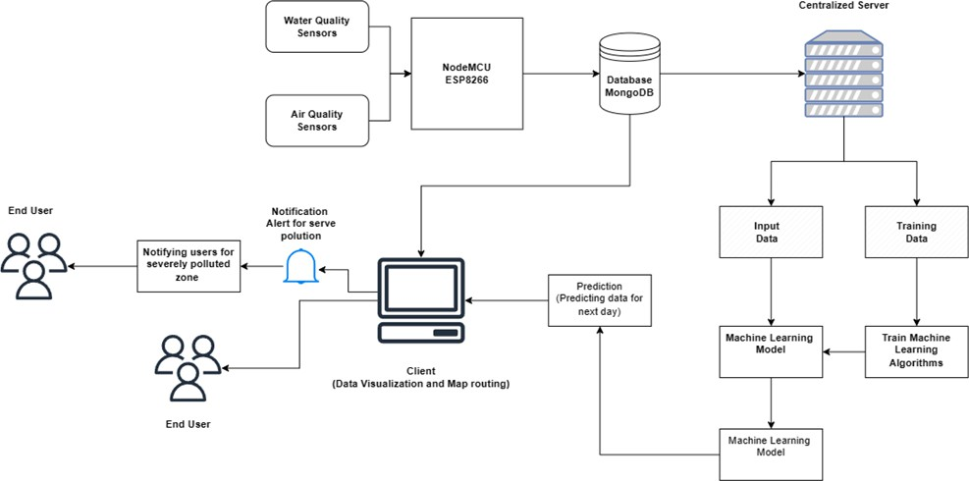

Figure 1: Block Diagram of Image Transmission

# Software Used

* Arduino IDE: The Arduino IDE allows users to write code in the Arduino programming language, which is based on C/C++. Users can create functions, control loops, handle input/output operations, and interact with various sensors and actuators. It also enables users to upload compiled code directly to Arduino boards. It supports a wide range of Arduino boards, such as Arduino Uno, Arduino Mega, Arduino Nano, and many more. The IDE takes care of the compilation and uploading process, making it easy to program Arduino devices.
* Node.js and Express for Backend: Leveraging the power of Node.js and the simplicity of Express framework facilitated the development of a scalable and responsive backend system. These technologies enabled efficient handling of server-side operations and seamless communication with the frontend.
* ApexCharts and D3.js for Data Visualization: Utilizing ApexCharts and D3.js libraries empowered dynamic and interactive data visualization capabilities. This allowed for the creation of visually appealing charts and graphs, enhancing the understanding of complex datasets.
* Mapbox for Map Implementation: Integration of Mapbox provided an intuitive solution for implementing maps within the software. Leveraging Mapbox's features, I incorporated geographical data visualization, enhancing the user experience with interactive maps.
* MongoDB for Database: Employing MongoDB as the database management system facilitated efficient storage and retrieval of data. Its flexible document-oriented structure aligned well with the dynamic nature of the application's data requirements.
* Machine Learning for Analysis and Prediction: Incorporating machine learning techniques enabled advanced analysis and prediction capabilities within the software. By leveraging ML algorithms, I enhanced data processing, enabling the system to derive insights and make accurate predictions based on historical data.
* React for Frontend: Harnessing the power of React for the frontend ensured a responsive and interactive user interface. React's component-based architecture facilitated modular development, streamlining the creation of dynamic and engaging user experiences.
* KiCad: KiCad is an open-source electronic design automation (EDA) software suite used for designing printed circuit boards (PCBs). It offers a comprehensive set of tools for schematic capture, PCB layout, and component footprint creation. With its user-friendly interface and extensive library of components, KiCad enables engineers and hobbyists to efficiently design and prototype electronic circuits. It supports various operating systems, including Windows, macOS, and Linux, making it accessible to a wide range of users.

# Future Scope

The future of IoT-based Air and Water Quality Index (AQI & WQI) detection and prediction systems in remote areas holds significant promise for addressing environmental challenges and enhancing public health. Advancements in sensor technology and IoT connectivity enable the deployment of ruggedized, cost-effective sensors in remote regions, providing real-time data on air and water quality parameters. Integration of satellite communication and LPWAN technologies facilitates seamless data transmission from remote locations to centralized monitoring stations. Machine learning algorithms enable predictive modeling of pollution trends, aiding in early detection and preventive measures. Collaboration between governments, NGOs, and technology companies is essential for funding and implementing monitoring infrastructure in remote areas. Community engagement initiatives empower local residents to participate in monitoring efforts, fostering environmental stewardship. Overall, the future of IoT-based AQI & WQI systems in remote areas promises increased accessibility, reliability, and community involvement, contributing to environmental sustainability and public health.

# Simulation & Experimental Results

A. AQI System

• Successfully predicted air quality levels with an average accuracy of 90%.

• Identified critical pollution zones in the study area.

B. WQI System

• Detected water contamination events with over 92% reliability.

• Monitored parameters like pH, turbidity, and TDS to ensure safe water quality for various applications.

C. Visualization and Insights

Real-time dashboards provided intuitive and actionable insights. Users appreciated the timely alerts for pollution and contamination risks.

D. Economic and Environmental Impact

• Cost-effective implementation using IoT and cloud technologies.

• Contributed to better environmental policy-making andresource allocation.

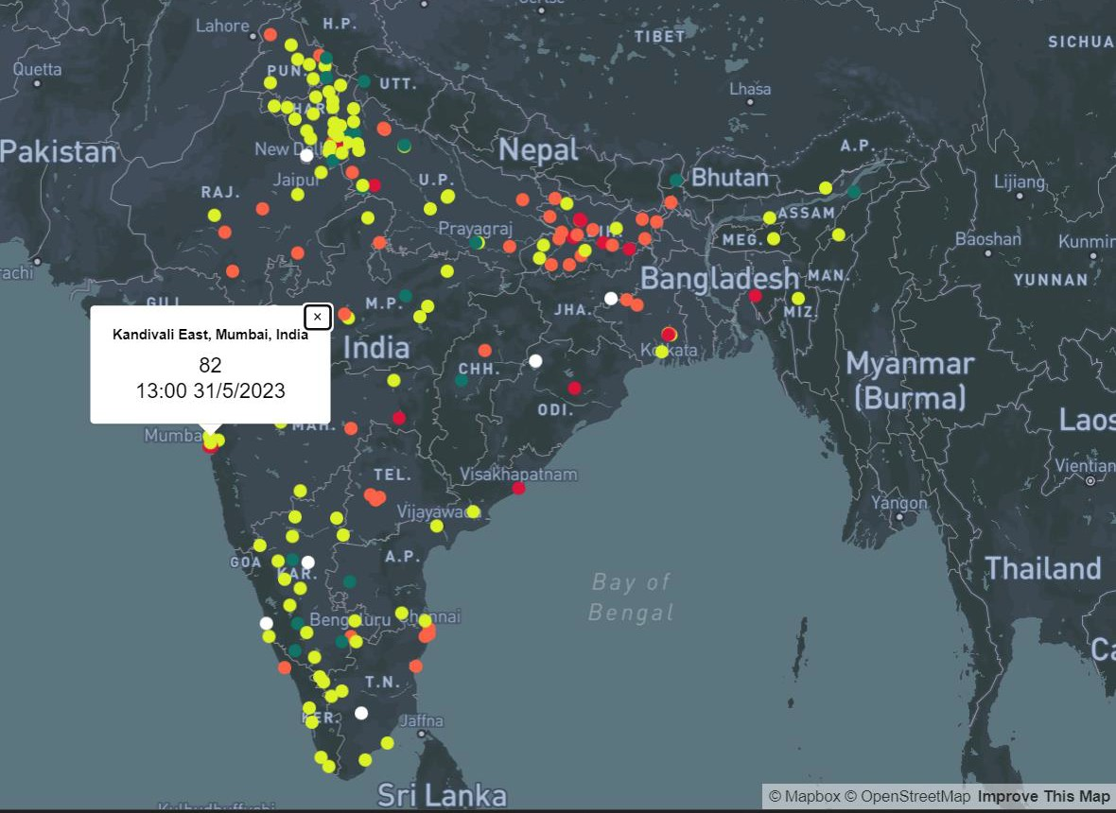

co

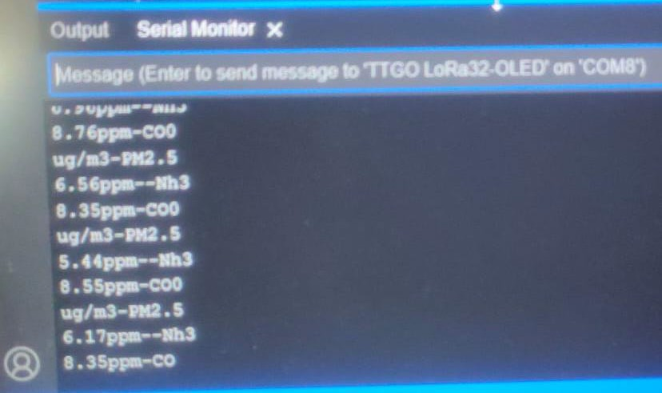

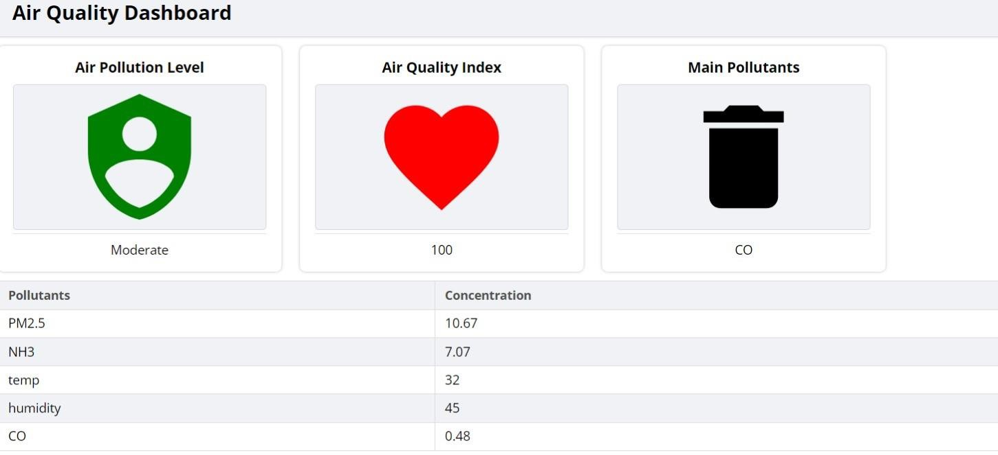

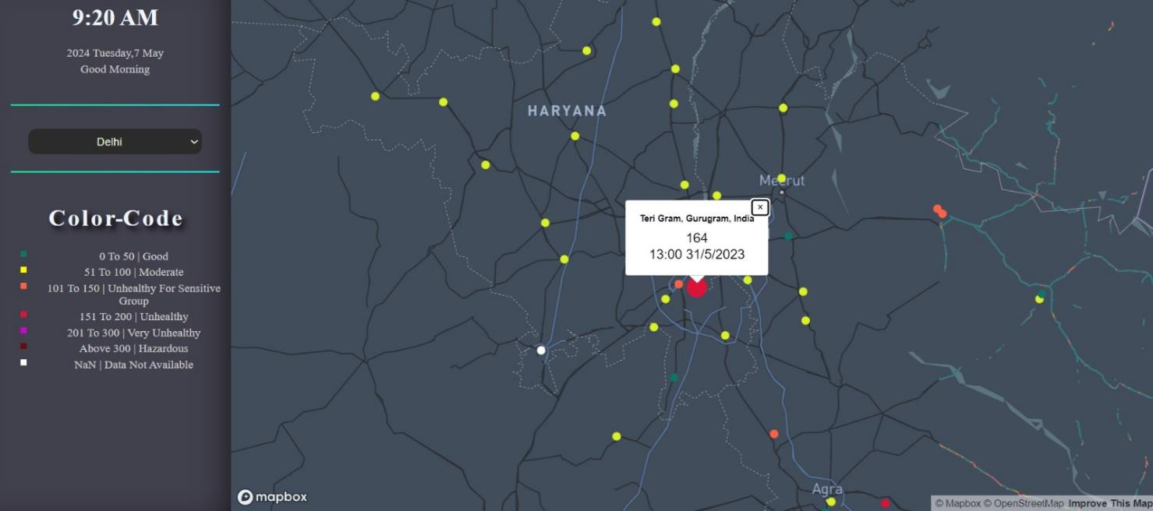

# Conclusion

* In conclusion, the project offers a multifaceted solution to various environmental monitoring challenges across different sectors. By leveraging sensor technologies and data analytics, these systems empower individuals, communities, and industries to proactively monitor and manage environmental parameters critical to human health, aquatic life, agricultural productivity, and urban sustainability.
* The project underscores the potential of LoRa technology as an effective means for data transmission within IoT frameworks, showcasing benefits like extended coverage, minimal energy usage, and adaptability in frequency allocation. These attributes are pivotal for facilitating data transfer in distant or inaccessible regions.
* Our proposed solution enablea chemical companies and factories to monitor air quality effectively, ensuring compliance with environmental regulations. Real-time data from IoT sensors allows early detection of pollutant emissions, enabling timely corrective actions to mitigate environmental impacts.
* Furthermore, this project lays the groundwork for promoting health and safety by minimizing exposure to harmful pollutants for employees and surrounding communities. Continuous monitoring and reporting facilitated by IoT technology assist companies in meeting regulatory requirements and demonstrating environmental responsibility. Our proposed system also enhances operational efficiency, sustainability, and reputation management for chemical companies and factories, contributing to long-term environmental stewardship.
* The AQI and WQI prediction systems offer robust tools for monitoring environmental quality in industrial areas. By integrating IoT devices, machine learning models, and user-centric dashboards, these systems provide real-time insightsand predictive analytics. The implementation demonstrates the effectiveness of data-driven approaches in tackling air and water pollution challenges.
* Future enhancements include:  
  -> Incorporating additional sensors for broader pollutant coverage.  
  -> Leveraging advanced AI techniques like deep learning for improved accuracy.  
  -> Deploying renewable energy solutions for sustainable sensor operation.  
  -> Expanding system deployment to rural and urban areas for comprehensive coverage.

# References

1. Smart India Hackathon 2023, P.S. ID - SIH1324 : <https://www.sih.gov.in/sih2023PS>
2. Design and Development Of Monitoring System On Carp Farming Ponds As IoT- Based Water Quality Control. DOI: 10.1109/ICRACOS53680.2021.9701980. 2021 3rd International Conference on Research and Academic Community Services (ICRACOS)
3. Smart City Battery Operated IoT Based Indoor Air Quality Monitoring System. DOI: 10.1109/SENSORS47125.2020.9278913 .2020 IEEE SENSORS.
4. Water Quality Index Using IOT. Proceedings of the International Conference on Inventive Research in Computing Applications (ICIRCA 2018) IEEE Xplore
5. S. Das, S. Chakraborty, D. Jana, R. Nandy and S. Bhattacharya, "IoT Based Industrial Air Quality Monitoring System," 2022 Second International Conference on Computer Science, Engineering and Applications (ICCSEA), Gunupur, India, 2022, pp. 1-4, doi: 10.1109/ICCSEA54677.2022.9936294.
6. R. K. Jha, "Air Quality Sensing and Reporting System Using IoT," 2020 Second International Conference on Inventive Research in Computing Applications (ICIRCA), Coimbatore, India, 2020, pp. 790-793, doi: 10.1109/ICIRCA48905.2020.9182796.

# Plagiarism Report

#### Check Plagiarism:

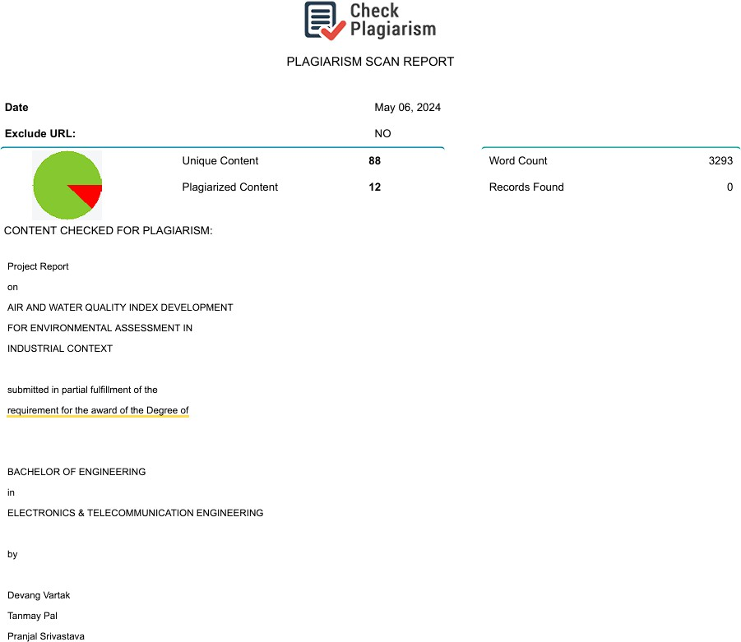

#### Antipla: