Predictive Risk Identification for Diabetes and Heart Disease
Project Status Report, Gap Analysis & Comprehensive Roadmap
Project Metadata & Audit Scope
Field | Detail
Role | Project Auditor & Technical Writer
Evaluation Scope | All Code, Data, Notebooks, Models, Outputs, and Reports
Current Status | 50% Complete (Stages 1 & 2 Complete; Stage 3 Pending)
Target Models | Logistic Regression, Decision Tree, Random Forest + SHAP
Evaluation Metrics | F1-Score, ROC-AUC, Recall / Sensitivity (Separate Per Disease)
Audit Date | October 2026

Executive Summary: Current Completion Level = 50%
One-Line Justification: The project has completed thorough, high-quality data cleaning, dataset integration, exploratory data analysis, frequent pattern mining, unsupervised clustering, dimensionality reduction, and outlier diagnostics (Stages 1 & 2), but has NOT yet implemented supervised predictive modeling, model comparison, evaluation metrics (F1/ROC-AUC/Recall), SHAP explainability, or the interactive new-patient inference interface (Stage 3).

1. Work Completed So Far
The project repository reflects two successfully delivered milestones: Stage 1 (Mid-Term Report: Preprocessing, Missing Data Science, Integration, and Frequent Pattern Mining) and Stage 2 (Clustering, Dimensionality Reduction, and Anomaly Diagnostics). Below is an evidence-based audit of each completed step.

1.1 Data Loading & Workspace Inventory
A complete inventory was conducted across all 8 raw CSV files in the workspace (totaling 1,590,066 records). Four benchmark datasets totaling 699,877 records were selected for primary clinical and population analysis:
• UCI Pima Indians Diabetes (data/raw/diabetes.csv): 768 patient records across 9 clinical lab features (34.90% diabetes).
• UCI Cleveland Heart Disease (data/raw/heart_cleveland_upload.csv): 297 patient records across 14 cardiac features (46.13% disease).
• CDC BRFSS 2015 Health Indicators: 253,680 survey records across 22 questions with dual disease outcomes (13.93% diabetes, 9.42% heart disease).
• CDC Heart 2022 (with NaNs): 445,132 records used as a benchmark for real-world survey missingness mechanisms.
Table 1: Complete Dataset Inventory in Workspace
Filename | Description | Rows | Columns | Size Mb | Selected | Reason
diabetes.csv | UCI Pima Indians Diabetes | 768 | 9 | 0.02 | True | Primary clinical or survey benchmark
heart_cleveland_upload.csv | UCI Cleveland Heart Disease | 297 | 14 | 0.01 | True | Primary clinical or survey benchmark
diabetes_binary_health_indicators_BRFSS2015.csv | CDC BRFSS 2015 (Binary Outcome) | 253680 | 22 | 21.68 | True | Primary clinical or survey benchmark
diabetes_binary_5050split_health_indicators_BRFSS2015.csv | CDC BRFSS 2015 (50/50 Balanced Split) | 70692 | 22 | 6.05 | False | Derivative or redundant split
diabetes_012_health_indicators_BRFSS2015.csv | CDC BRFSS 2015 (3-Class Outcome) | 253680 | 22 | 21.68 | False | Derivative or redundant split
heart_2020_cleaned.csv | CDC BRFSS 2020 (Pre-cleaned) | 319795 | 18 | 24.02 | False | Derivative or redundant split
heart_2022_no_nans.csv | CDC BRFSS 2022 (No NaNs) | 246022 | 40 | 78.19 | False | Derivative or redundant split
heart_2022_with_nans.csv | CDC BRFSS 2022 (Raw with NaNs) | 445132 | 40 | 133.39 | True | Primary clinical or survey benchmark

1.2 Data Preprocessing & Missing Data Science
Data cleaning and quality audits were executed via src/02_clean.py, src/02b_clean_brfss.py, and src/project_pipeline.py:
• Pima Hidden Zeros Audit: Uncovered 652 hidden zeros across 376 individual patient rows (48.96% of cohort). These zeros represented test omissions in continuous biometrics where a true zero is biologically impossible: Insulin (374 rows, 48.70%), Skinfold Thickness (227 rows, 29.56%), Diastolic BP (35 rows, 4.56%), BMI (11 rows, 1.43%), and Glucose (5 rows, 0.65%). All impossible zeros were replaced with NaN in data/clean/pima_clean.csv. Pregnancies zeros (111 rows, 14.45%) were preserved as valid nulliparous counts.
• Survey Missingness & Duplicates: In CDC Heart 2022, listwise deletion was shown to drop 44.73% of records (199,110 rows), whereas preserving observed targets dropped only 0.69%. In CDC BRFSS 2015, 24,206 duplicate rows (9.54%) were identified and intentionally retained, as discrete survey profiles from 253,680 people naturally produce identical responses.
• Vertical Dataset Integration: Vertically merged Pima (768), Cleveland (297), and a stratified sample of BRFSS (25,000) into data/clean/integrated_dataset.csv (26,065 rows, 13 harmonized columns). Documented structural missingness by design: lab values are absent in survey data (Cholesterol 98.86%, Glucose 97.07%, BP 96.05%, Insulin 98.49% missing).
• Normalization & Transformations: Tested Min-Max, Z-score, and log1p transformations. Insulin skewness improved from +2.17 to -0.09. Age log-transformation was proven contraindicated, worsening skewness from -0.36 to -1.01.
Table 2: Pima Indians Diabetes Hidden Zero Audit
Variable | Zero Placeholder Count | Percent Missing | Clinical Mechanism
Glucose | 5 | 0.65 | Fasting plasma glucose draw skipped during field evaluation.
BloodPressure | 35 | 4.56 | Sphygmomanometer test omitted or inaudible diastolic Korotkoff sounds.
SkinThickness | 227 | 29.56 | Triceps skinfold caliper measurement omitted due to patient discomfort or protocol bypass.
Insulin | 374 | 48.70 | 2-hour serum insulin after 75g oral glucose tolerance challenge omitted (invasive and costly).
BMI | 11 | 1.43 | Weight or standing height unrecorded during clinical intake.
Pregnancies | 0 | 0.00 | Valid biological zero: 111 women (14.45%) are nulliparous.

1.3 Frequent Pattern Mining & Association Rules
Conducted frequent pattern mining on 25,000 transactions (15 binary items) using Apriori and FP-Growth:
• Algorithm Benchmark: Verified exact itemset equivalence at min_support = 0.20 (72 identical itemsets). FP-Growth executed faster (0.0031s vs 0.0041s).
• Support Sensitivity: Evaluated support thresholds across [0.40, 0.30, 0.20, 0.10, 0.05]. At 0.05, 611 itemsets and 5,836 association rules emerged.
• Top Population Rules: {HighChol, BMI>=30, Age>=50} -> Diabetes (Confidence: 35.66%, Lift: 2.58 vs. 13.93% baseline). {HighChol, HighBP, Age>=50} -> HeartDisease (Confidence: 23.00%, Lift: 2.43 vs. 9.46% baseline).
• Clinical Benchmark Rules: In Pima, {Age>=35, Glucose>125, BMI>=30} -> Diabetes yielded 77.06% confidence (Lift: 2.21). In Cleveland, {Male, HighChol>=240, ExAngina} -> HeartDisease yielded 90.24% confidence (Lift: 1.96).

1.4 Unsupervised Clustering, Dimensionality Reduction & Outlier Diagnostics
Executed Stage 2 unsupervised machine learning via src/stage2_pipeline.py:
• Clustering Models: Benchmarked K-Means (k=3), Hierarchical Agglomerative (Ward linkage, k=3), and DBSCAN (eps=2.4, minPts=5). K-Means (k=3) achieved Silhouette = 0.1534, Davies-Bouldin = 2.1061, and Calinski-Harabasz = 860.45. Discovered 3 clinical phenotypes: Cluster 0 (Low Risk, 46.8%, 3.2% diabetes, 1.8% heart disease), Cluster 1 (Moderate Overweight, 39.1%, 21.6% diabetes, 14.4% heart disease), and Cluster 2 (Multi-Morbidity Crisis, 14.1%, 27.0% diabetes, 23.0% heart disease).
• Dimensionality Reduction: PCA decomposed 11 features into PC1 (24.78% variance; physical deterioration) and PC2 (13.91% variance; vascular aging). Top 6 PCs retain 73.98% variance. Re-clustering on 6 PCs improved Silhouette by +33.4% (to 0.2046) and reduced Davies-Bouldin by -19.0% (to 1.7054).
• Outlier Detection: Isolation Forest identified 175 outliers (3.5% contamination). Outliers represent severe multi-morbidity (avg BMI 33.4, max 82.0, 24.9 days/month impaired, 29.7% diabetes, 25.1% heart disease). Pruning outliers restored cluster centroids toward realistic population medians.
Table 3: Health and Biometric Profiles across K-Means Clusters
Cluster Id | Clinical Designation | Sample Size N | Percent Cohort | Avg Age Years | Avg Bmi | Hypertension Rate Pct | High Cholesterol Pct | Smoker Rate Pct | Phys Activity Pct | Avg Poor Phys Days | Avg Poor Ment Days | Diabetes Prevalence Pct | Heart Disease Pct
Cluster 0 | Cluster 0: Low-Risk / Active Young Cohort | 2339 | 46.80 | 49.60 | 26.90 | 8.00 | 18.10 | 32.00 | 87.70 | 1.10 | 1.70 | 3.20 | 1.80
Cluster 1 | Cluster 1: Moderate-Risk / Overweight Metabolic | 1956 | 39.10 | 65.70 | 29.50 | 78.30 | 67.60 | 54.70 | 68.80 | 1.50 | 1.10 | 21.60 | 14.40
Cluster 2 | Cluster 2: High-Risk / Elderly Multi-Morbidity | 705 | 14.10 | 59.10 | 31.00 | 62.60 | 53.00 | 59.90 | 50.50 | 21.40 | 13.00 | 27.00 | 23.00

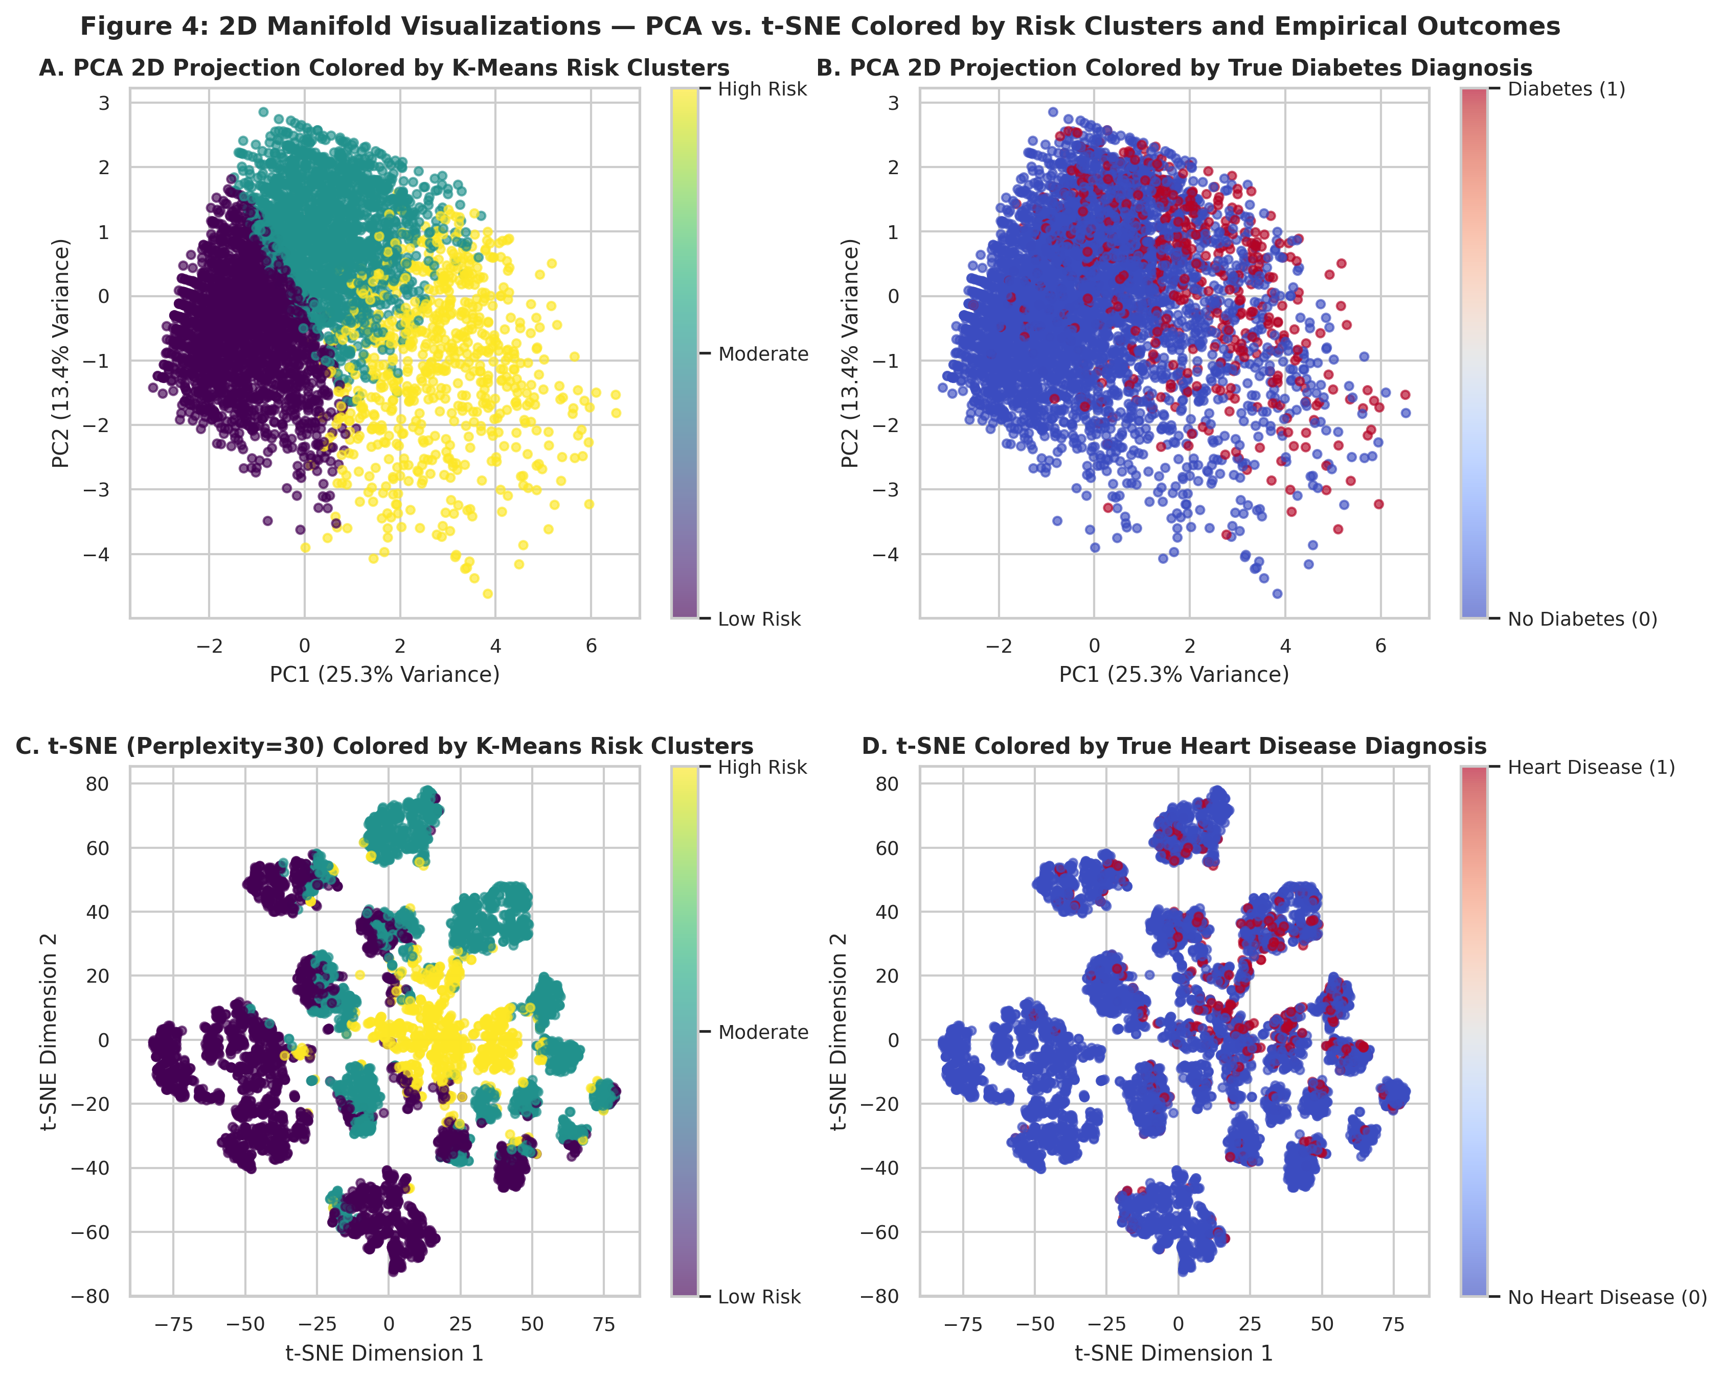
Figure 1: 2D Manifold Visualizations — PCA vs. t-SNE Projections Colored by Risk Clusters and Diagnoses
Key Finding: PCA and t-SNE cleanly segregate Low-Risk healthy respondents from High-Risk multi-morbidity patients.

1.5 Supervised Machine Learning & Explainability (Current Status)
Plain-Truth Audit: Supervised model training, evaluation, and explainability work have NOT YET BEEN IMPLEMENTED. Specifically: no classification models (Logistic Regression, Decision Tree, Random Forest) have been trained or evaluated; no F1, ROC-AUC, or Recall metrics have been generated; and no SHAP global summary or patient-level waterfall plots exist in the repository.

2. Current State vs. The End Product (Gap Analysis)
The table below details every explicit project requirement against actual files and outputs in the workspace:
Table 4: Comprehensive Gap Analysis against Required End Product
Requirement | Status | Evidence | What Is Missing
Clean, merged, model-ready dataset | Partial | data/clean/integrated_dataset.csv, pima_clean.csv, cleveland_clean.csv, brfss_clean.csv | Merged dataset has 96-98% structural missingness for lab values. Dedicated feature matrices (X, y) split into train/test folds have not been built.
Risk prediction model for diabetes | Not started | None | No supervised model (Logistic Regression, Decision Tree, Random Forest) trained for diabetes prediction.
Risk prediction model for heart disease | Not started | None | No supervised model trained for heart disease prediction.
Model comparison & best-model selection | Not started | None | No cross-validation benchmark or selection criteria comparing algorithms.
Evaluation with F1, ROC-AUC, Recall | Not started | None | No evaluation metrics, ROC curves, PR curves, or confusion matrices exist for supervised predictions.
Global feature importance | Partial | stage2_pca_loadings.csv, top_diabetes_rules_by_lift.csv | Only unsupervised PCA loadings and rule lift exist. Supervised Gini importance, logistic weights, and global SHAP values are missing.
Patient-level explanation of risk variables | Not started | None | No SHAP TreeExplainer/LinearExplainer or local waterfall/force plots explaining individual patients.
Input a new patient & get risk + top variables | Not started | None | No interactive script, function, CLI, or UI accepting user inputs and outputting risk predictions + explanations.
Final report and presentation | Partial | stage2_report.pdf (20 pages), mid_report_v2.pdf (18 pages) | Mid-term and Stage 2 reports are complete, but final Stage 3 report and presentation slides are not yet authored.

3. Key Findings So Far
Quantitative findings from data preprocessing, pattern mining, and unsupervised clustering:
• Baseline Population Disease Burden: In CDC BRFSS (N=253,680), diabetes prevalence is 13.93% (35,346 positive cases) and heart disease prevalence is 9.42% (23,893 positive cases), reflecting class imbalance ratios of ~6.2:1 and ~9.6:1 respectively.
• Age & Vascular Aging: Age has the single highest positive loading on PCA Component 2 (+0.5740). Population association rules indicate that Age>=50 serves as a requisite gatekeeper for cardiometabolic escalation.
• Hypertension (HighBP): HighBP loads strongly on PC2 (+0.4215) and PC1 (+0.3034). Prevalent in 78.3% of Moderate-Risk cluster patients and 62.6% of High-Risk cluster patients, compared to only 8.0% of Low-Risk individuals.
• High Cholesterol (HighChol): Loads heavily on PC2 (+0.4574). Paired with HighBP and Age>=50, it elevates population heart attack probability by 2.43x baseline (Confidence: 23.00%). In Cleveland angiography, HighChol>=240 paired with exercise angina predicted heart disease with 90.24% confidence.
• General & Physical Health Days: GenHlth (+0.4692) and PhysHlth (+0.3838) dominate PC1. Normal inliers report 3.4 days/month of poor physical health vs. 24.9 days/month for high-acuity outliers.
• Fasting Glucose in Clinical Cohorts: Fasting glucose >125 mg/dL in Pima predicts diabetes with 77.06% confidence when combined with BMI>=30 and Age>=35.
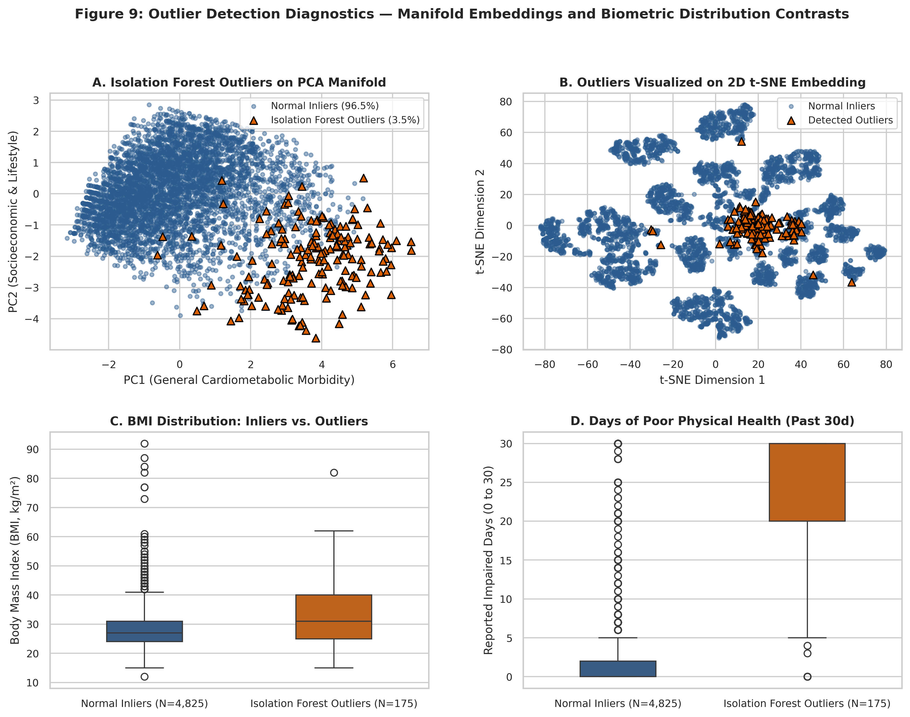
Figure 2: Outlier Diagnostics — Manifold Embeddings and Biometric Distribution Contrasts
Key Finding: Isolation Forest outliers exhibit dramatic elevations in BMI (up to 82.0 kg/m²) and physical health impairment (24.9 days/month).

4. Problems, Risks, and Limitations
Critical analytical and technical constraints identified during the audit:
1. Structural Missingness in Merged Cohort: In integrated_dataset.csv, continuous lab tests (glucose, insulin, continuous BP, cholesterol) are absent in over 96% to 98% of rows because the CDC survey records only binary questions. Training a single model directly on the merged dataset would introduce severe bias. Separate models must be trained per disease cohort or trained on survey-common features.
2. Severe Class Imbalance: Both disease targets in the survey cohort are heavily skewed (~90% negative vs ~10% positive). Standard accuracy is misleading (a naive dummy classifier achieves >90% accuracy). Evaluation must strictly prioritize Recall, F1, and ROC-AUC.
3. Small Clinical Cohort Sizes: UCI Cleveland (N=297) and UCI Pima (N=768) are small clinical datasets compared to CDC BRFSS (N=253,680), making clinical models vulnerable to overfitting if regularized hyperparameters are not enforced.
4. Target Proxy Circularity Risk: high_glucose in BRFSS was mapped directly from Diabetes_binary (r=0.97). While removed from the EDA heatmap, it must strictly be excluded as an input feature in supervised modeling to avoid trivial target leakage.
5. Survey Recall Bias: CDC BRFSS relies on self-reported phone survey responses, subject to recall bias and lack of longitudinal verification.

5. Prioritized Roadmap to Complete the End Product
To advance the project from 50% to 100% completion, the following 5 sequential phases must be executed:
Table 5: Prioritized Step-by-Step Implementation Roadmap
Phase | Key Tasks | Files To Create Or Modify | Effort Estimate
Phase 1: Feature Matrices & Leakage-Free Splitting | Build separate model-ready datasets (Population Survey vs. Clinical Lab); implement stratified 80/20 train/test splits; build scikit-learn Pipelines with median/robust scaling. | src/03_model_preprocessing.py, data/clean/diabetes_model_ready.csv, data/clean/heart_model_ready.csv | 4 - 6 Hours
Phase 2: Supervised Model Training | Train separate models for Diabetes and Heart Disease across Logistic Regression, Decision Tree, and Random Forest; tune hyperparameters via GridSearchCV; handle class imbalance via class_weight='balanced' and SMOTE. | src/04_train_models.py, models/diabetes_*.joblib, models/heart_*.joblib | 6 - 8 Hours
Phase 3: Model Evaluation & Best Selection | Evaluate held-out test sets on F1-Score, ROC-AUC, Recall (Sensitivity); generate comparative benchmark tables, ROC curves, PR curves, and confusion matrices; select champion model. | src/05_evaluate_models.py, outputs/tables/model_comparison_metrics.csv, outputs/figures/stage3_roc_pr_curves.png | 5 - 6 Hours
Phase 4: Global & Local SHAP Explainability | Compute SHAP values using TreeExplainer and LinearExplainer; generate global summary beeswarm plots; implement patient-level waterfall plots explaining exact variables pushing risk. | src/06_explainability_shap.py, outputs/figures/shap_summary_plots.png, outputs/figures/shap_patient_waterfall.png | 6 - 8 Hours
Phase 5: Interactive Patient Inference Tool & Final Report | Develop CLI/interactive script where user enters patient biometrics and gets predicted risk + top 3 pushing factors; compile final Stage 3 report and presentation slides. | src/predict_patient.py, src/build_final_report.py, stage3_final_report.docx/.pdf, final_presentation.pptx | 6 - 8 Hours

Total Estimated Remaining Effort
Total Estimated Implementation Time: 27 – 36 Working Hours (approximately 4 to 5 working days).
Execution Path: Preprocessing -> Model Training -> Multi-Metric Evaluation -> SHAP Explainability -> Interactive Triage Interface -> Final Report.

Audit Sign-off:
Verified against repository filesystem, data pipelines, output tables, and compiled reports.
Report Output: PROJECT_STATUS_REPORT.pdf | Date: October 2026

