Final Project Report v2
Predictive Risk Identification for Diabetes and Heart Disease: End-to-End Data Mining, Supervised Machine Learning, Probability Calibration, Risk Stratification, SHAP Explainability, and Packaging of the Chronic Disease Predictor Model
Senior Data Science & Machine Learning Engineering Report | Version 2.0 (Post-Packaging Edition) | Dual-Track Architecture (CDC BRFSS & Clinical Cohorts)

1. Executive Summary
The Clinical Problem: Cardiometabolic diseases—specifically Type 2 Diabetes Mellitus and Coronary Heart Disease—represent the leading causes of preventable adult morbidity, premature mortality, and healthcare expenditure worldwide. Rather than developing in isolation, diabetes and cardiovascular disease share a common pathophysiological continuum encompassing systemic insulin resistance, chronic endothelial inflammation, atherogenic dyslipidemia, and microvascular deterioration. Early identification of patient risk before the onset of catastrophic clinical events is paramount for preventative lifestyle and pharmacotherapeutic intervention.
Dual-Track Data Architecture: This project integrates two complementary data streams representing distinct clinical environments: (1) Track A (Population Survey Screening), trained on the large-scale CDC Behavioral Risk Factor Surveillance System (BRFSS 2015, N=253,680 unique respondents across 20 non-invasive lifestyle and demographic features); and (2) Track B (Clinical Laboratory Diagnostics), trained on dedicated secondary cohorts with rich physiological measurements—the UCI Pima Indians Diabetes dataset (N=768, 8 features including oral glucose tolerance and 2-hour serum insulin) and the UCI Cleveland Heart Disease dataset (N=297, 13 features including treadmill exercise ECG and coronary fluoroscopy). Longitudinal generalization is independently tested on BRFSS 2022 (N=60,000).
Methodological Journey: The project followed an audited multi-stage progression: Stage 1 audited data integrity (resolving 652 impossible biological zero-placeholders in Pima), normalized skewed distributions, and mined multi-morbidity frequent patterns (Apriori vs. FP-Growth). Stage 2 uncovered unsupervised phenotypic patient clusters (K-Means k=3, Hierarchical, DBSCAN), compressed feature spaces via PCA (6 components retaining 74.0% variance) and t-SNE, and isolated high-risk multi-morbidity crisis outliers via Isolation Forests. Stage 3 executed supervised machine learning, cost-sensitive reweighting, Platt sigmoid probability calibration, operating threshold tuning for clinical triage (targeting >=75% sensitivity), and 3-tier risk assignment (Low, Medium, High).
Champion Models & Headline Metrics: Across 12 evaluated pipelines (Logistic Regression, Decision Tree, Random Forest across both diseases and tracks), Calibrated Logistic Regression emerged as the champion model across all tracks. In Track A Diabetes, the champion achieved Test ROC-AUC of 0.8190, PR-AUC of 0.3913, and Recall of 74.79% (F1 = 0.4431) at calibrated threshold 0.1473. In Track A Heart Disease, the champion achieved Test ROC-AUC of 0.8458, PR-AUC of 0.3594, and Recall of 75.52% (F1 = 0.3900) at calibrated threshold 0.1101. In Track B Clinical Heart Disease, the champion achieved outstanding discrimination with Test ROC-AUC of 0.9275, PR-AUC of 0.9423, Recall of 71.43%, and 100% Precision on positives (F1 = 0.8333). While complex tree ensembles achieved marginally comparable raw ROC-AUC, Logistic Regression provided superior probability calibration linearity, closed-form log-odds stability, and clinical interpretability.
The Delivered Clinical Decision Support System: The final deliverable is packaged as the 'Chronic Disease Predictor Model' within a modular, single-folder model repository (models/). It includes a clean Python inference engine (ChronicDiseasePredictor class), an audited Command-Line Interface (src/predict_patient.py) supporting three operational modes (--mode survey, --mode clinical, --mode both), an interactive Streamlit web application (app/streamlit_app.py), and an expanded 24-test automated verification suite. For any given patient, the system computes: (a) calibrated risk probabilities and tri-level risk tiers (Low, Medium, High); (b) patient-level SHAP factor attributions showing the exact biometric readings pushing risk upward or downward; (c) embedded local SHAP waterfall plots; and (d) resemblance to Stage 2 population phenotypes. A 3-tier stratification validates that high-risk patients experience up to a 3.57x prevalence lift over baseline, capturing over 90% of future positive cases across Medium and High tiers.
Primary Limitations: Key limitations include the self-reported nature of BRFSS survey data (subject to recall bias), sample size discreteness in Track B clinical cohorts (N=60 Cleveland test set, where 1 patient alters recall by 3.57%), and the fundamental statistical nature of SHAP attributions (identifying associative predictors rather than causal biological mechanisms). The tool is designed strictly as a clinical risk triage aid and does not constitute a diagnostic medical device.
MANDATORY CLINICAL SAFETY NOTICE
These are key contributing factors from a statistical model, not proven causes, and this is not a medical diagnosis. All predictions, risk tiers, and feature attributions must be reviewed by licensed medical professionals in conjunction with comprehensive clinical evaluations.

2. Problem and Objective
Cardiovascular disease and diabetes mellitus together constitute the most formidable twin chronic health epidemics of the 21st century. According to the Centers for Disease Control and Prevention (CDC) and the World Health Organization (WHO), coronary heart disease remains the single leading cause of adult mortality globally, while diabetes affects more than 37 million Americans and over 500 million individuals worldwide. Adults with diabetes are two to four times more likely to develop cardiovascular disease than adults without diabetes, driven by accelerated vascular atherosclerosis, platelet hyperactivity, arterial stiffness, and diabetic cardiomyopathy.
Despite their profound clinical overlap, traditional healthcare delivery frequently screens for these conditions in silos or only after symptomatic organ damage has manifested. Furthermore, conventional clinical risk calculators (such as the Framingham Risk Score or ADA Risk Score) provide static risk percentages without intuitive, patient-specific explanations of which actionable lifestyle factors or physiological readings are responsible for driving an individual's elevated risk.
Project Objectives: The primary objective of this project is to develop an end-to-end, dual-track machine learning clinical decision support system that simultaneously addresses both conditions while maintaining rigorous statistical validity. The system must fulfill two core functional deliverables:
1. Calibrated Risk Categorization: Given a new patient's profile, the system predicts calibrated disease probabilities and assigns the patient into an actionable risk tier—Low, Medium, or High Risk—separately for Type 2 Diabetes and Coronary Heart Disease. The triage threshold must prioritize high sensitivity (>=75% target recall) to minimize false negatives in population screening.
2. Granular, Patient-Level Explainability: Rather than acting as an uninterpretable 'black-box,' the system computes exact local Shapley Additive Explanations (SHAP) for every prediction, displaying the top variables and specific clinical readings that push the patient toward or away from high risk, alongside individual waterfall plots.

3. Data
The project rigorously evaluated multiple public health and clinical datasets to establish an audit-controlled data foundation. Public health survey data and specialized clinical laboratory cohorts present vastly different measurement properties, necessitating a comprehensive inventory and methodological separation.
Table 1: Comprehensive Dataset Inventory and Selection Decisions
Filename | Description | Rows | Columns | Size Mb | Selected | Reason
diabetes.csv | UCI Pima Indians Diabetes | 768 | 9 | 0.02 | True | Primary clinical or survey benchmark
heart_cleveland_upload.csv | UCI Cleveland Heart Disease | 297 | 14 | 0.01 | True | Primary clinical or survey benchmark
diabetes_binary_health_indicators_BRFSS2015.csv | CDC BRFSS 2015 (Binary Outcome) | 253680 | 22 | 21.68 | True | Primary clinical or survey benchmark
diabetes_binary_5050split_health_indicators_BRFSS2015.csv | CDC BRFSS 2015 (50/50 Balanced Split) | 70692 | 22 | 6.05 | False | Derivative or redundant split
diabetes_012_health_indicators_BRFSS2015.csv | CDC BRFSS 2015 (3-Class Outcome) | 253680 | 22 | 21.68 | False | Derivative or redundant split
heart_2020_cleaned.csv | CDC BRFSS 2020 (Pre-cleaned) | 319795 | 18 | 24.02 | False | Derivative or redundant split
heart_2022_no_nans.csv | CDC BRFSS 2022 (No NaNs) | 246022 | 40 | 78.19 | False | Derivative or redundant split
heart_2022_with_nans.csv | CDC BRFSS 2022 (Raw with NaNs) | 445132 | 40 | 133.39 | True | Primary clinical or survey benchmark

Dataset Selection Rationale: Datasets in Scope & Detailed Cohort Profiles:
• CDC BRFSS 2015 Health Indicators (diabetes_binary_health_indicators_BRFSS2015.csv): Contains 253,680 survey respondents across 22 variables collected through the annual telephone survey conducted by the CDC. Crucially, this dataset contains both diabetes (13.9% prevalence) and coronary heart disease / myocardial infarction (9.4% prevalence) recorded on the exact same respondents. Deduplication revealed 24,206 identical rows, resulting in 229,474 unique records. Selected as the primary engine for Track A (Population Survey Screening).
• UCI Pima Indians Diabetes (diabetes.csv): Contains 768 female patients of Pima Indian heritage aged 21 and older, evaluated across 8 physiological variables and 1 outcome (34.9% positive). Measurements include oral glucose tolerance tests and 2-hour serum insulin. Selected as the primary clinical benchmark for Track B Diabetes.
• UCI Cleveland Heart Disease (heart_cleveland_upload.csv): Contains 297 patient records across 13 clinical variables and 1 target condition (46.0% positive). Features include invasive coronary angiography (ca), thallium scintigraphy (thal), and treadmill exercise ECG parameters (st depression). Selected as the primary clinical benchmark for Track B Heart Disease.
• CDC BRFSS 2022 (heart_2022_with_nans.csv): Contains 445,132 records from the 2022 survey administration. A stratified sample of 60,000 rows was extracted to conduct independent, out-of-cohort longitudinal validation across a 7-year survey gap.
• Rejected Datasets: Derivative subsamples (such as the 50/50 downsampled BRFSS split of 70,692 rows) were strictly rejected because artificial class balancing corrupts baseline population prevalence and destroys probability calibration.
Why Two Separate Tracks? Methodological Separation: Track A vs. Track B Architecture:
A foundational finding from Stage 1 was that attempting to merge large-scale population surveys with clinical cohorts creates an insurmountable 'structural missingness' dilemma. BRFSS surveys measure non-invasive lifestyle and demographic items (e.g., general health ratings, dietary habits, income) but completely lack laboratory biomarkers (such as serum glucose, fasting insulin, or angiography). Conversely, clinical datasets measure invasive biomarkers but lack comprehensive lifestyle surveys. Imputing laboratory tests across 250,000 survey respondents would introduce >98% synthetic data, generating spurious correlations. Therefore, the architecture strictly segregates Track A (Population Survey, large sample, non-invasive triage) from Track B (Clinical Laboratory, small sample, high-precision diagnostics).

4. Project Journey, Stage by Stage
To ensure scientific rigor, the project was organized into three sequential, audit-controlled stages. Each stage answered specific data science questions and directly established the requirements for the subsequent phase.

4.1 Stage 1: Data Audit, Preprocessing, Normalization & Frequent Pattern Mining
The primary goal of Stage 1 was to establish an uncorrupted data foundation, diagnose hidden data recording artifacts, evaluate feature scaling behaviors, and uncover baseline multi-morbidity associative patterns without supervised labels.
Audit of Hidden Zeros in Pima: In the UCI Pima Indians Diabetes cohort, initial scanning showed zero explicit missing values. However, clinical domain auditing revealed impossible biological values: fasting plasma glucose of 0 mg/dL, diastolic blood pressure of 0 mmHg, triceps skinfold thickness of 0 mm, 2-hour serum insulin of 0 uU/mL, and BMI of 0.0 kg/m². A human cannot survive with zero blood glucose or zero blood pressure; these records represented missing data encoded as zero placeholders. We systematically audited and flagged 652 hidden zero values (Table 2). Pregnancies equal to 0 was preserved intact, as nulliparity is biologically valid.
Table 2: Pima Indians Diabetes 'Hidden Zeros' Audit and Missingness Treatment
Variable | Zero Placeholder Count | Percent Missing | Clinical Mechanism | Imputation Decision And Rationale
Glucose | 5 | 0.65 | Fasting plasma glucose draw skipped during field evaluation. | Median imputation (117.0 mg/dL) in supervised ML. Low missingness (<1%); NaNs preserved during EDA to avoid distribution distortion.
BloodPressure | 35 | 4.56 | Sphygmomanometer test omitted or inaudible diastolic Korotkoff sounds. | Median imputation (72.0 mmHg) with binary missing indicator in ML. Low missingness (<5%); preserves hemodynamic sample size.
SkinThickness | 227 | 29.56 | Triceps skinfold caliper measurement omitted due to patient discomfort or protocol bypass. | Excluded from cross-study association rules (unmeasured in BRFSS). In clinical ML, use regression/KNN imputation conditional on BMI (r=0.65) or missing indicator.
Insulin | 374 | 48.70 | 2-hour serum insulin after 75g oral glucose tolerance challenge omitted (invasive and costly). | Excluded from cross-study association rules (absent in BRFSS). Complete case deletion would destroy ~49% of cohort; use MICE / tree native handling with 'Insulin_unmeasured' flag.
BMI | 11 | 1.43 | Weight or standing height unrecorded during clinical intake. | Median imputation (32.3 kg/m²) in predictive modeling. Low missingness (<2%); minimal risk of introducing structural distortion.
Pregnancies | 0 | 0.00 | Valid biological zero: 111 women (14.45%) are nulliparous. | Preserved intact as true 0 without imputation; biological zero is clinically meaningful.

Integrated Dataset Structural Missingness: To evaluate cross-study harmonizability, an integrated vertical cohort of 26,065 patients was synthesized across Pima (768), Cleveland (297), and a representative sample of BRFSS (25,000). Table 3 documents the severe structural missingness that emerged, proving that clinical laboratory variables cannot be reliably merged with survey data.
Table 3: Cross-Cohort Integrated Dataset Structural Missingness Analysis
Column | Non Null Count | Missing Count | Percent Missing | Structural Missingness Origin | Treatment In Mining
age | 26065 | 0 | 0.00 | Uniformly measured across all 3 cohorts (Pima, Cleveland, BRFSS). | Included as standard item or target in mining analysis.
sex | 26065 | 0 | 0.00 | Uniformly measured across all 3 cohorts (Pima, Cleveland, BRFSS). | Included as standard item or target in mining analysis.
bmi | 25757 | 308 | 1.18 | Measured in Pima (N=757, 11 hidden zeros) and BRFSS (N=25,000); unmeasured in Cleveland (N=297). | Discretized as BMI>=30 in BRFSS mining; Cleveland excluded from BMI rules.
blood_pressure | 1030 | 25035 | 96.05 | Measured in Pima (N=733) and Cleveland (N=297); unmeasured continuously in BRFSS. | Excluded from cross-cohort rules; HighBP survey binary used in BRFSS mining.
high_bp | 26065 | 0 | 0.00 | Harmonized across all 3 cohorts: Pima (BP>=90), Cleveland (trestbps>=140), BRFSS (HighBP=1). | Used as foundational antecedent across all frequent pattern mining runs.
cholesterol | 297 | 25768 | 98.86 | Measured ONLY in Cleveland (N=297); unmeasured in Pima (N=768) and BRFSS (N=25,000). | Excluded from cross-cohort rules; HighChol survey binary used in BRFSS mining.
high_chol | 25297 | 768 | 2.95 | Available in Cleveland (N=297) and BRFSS (N=25,000); unmeasured in Pima (N=768). | Used directly in BRFSS mining; Pima rows excluded from HighChol transactions.
glucose | 763 | 25302 | 97.07 | Measured ONLY in Pima (N=763); unmeasured in Cleveland (N=297) and BRFSS (N=25,000). | Excluded from cross-cohort rules; self-reported diabetes outcome used in BRFSS.
high_glucose | 26065 | 0 | 0.00 | Harmonized: Pima (Glucose>125), Cleveland (fbs=1), BRFSS (mapped from Diabetes_binary proxy). | Flagged as operational proxy in BRFSS; removed from heatmap to avoid circularity.
insulin | 394 | 25671 | 98.49 | Measured ONLY in Pima (N=394); unmeasured in Cleveland (N=297) and BRFSS (N=25,000). | Excluded from cross-cohort rules; retained for Pima-specific clinical benchmarks.
diabetes_outcome | 26065 | 0 | 0.00 | Harmonized target across all cohorts (Pima Outcome, Cleveland fbs, BRFSS Diabetes_binary). | Used as primary consequent in diabetes rule mining on BRFSS (N=25,000).
heart_disease_outcome | 25297 | 768 | 2.95 | Available in Cleveland (N=297) and BRFSS (N=25,000); heart disease not assessed in Pima (N=768). | Used as primary consequent in heart disease rule mining on BRFSS (N=25,000).
source_dataset | 26065 | 0 | 0.00 | Uniformly measured across all 3 cohorts (Pima, Cleveland, BRFSS). | Included as standard item or target in mining analysis.

Normalization & Skewness Benchmark: We tested three transformation strategies: Min-Max scaling [0, 1], Standard Z-score standardization (mean=0, std=1), and logarithmic transformation log(x + 1). As detailed in Table 4, log transformations dramatically reduced severe positive skewness in biometric laboratory values (Insulin skewness dropped from +2.17 to -0.09; BMI from +2.00 to +0.69; Cholesterol from +1.12 to +0.06). However, log transformation worsened negative skewness in age (-0.36 to -1.01). Consequently, StandardScaler within robust pipelines was selected for machine learning to preserve Euclidean geometry and avoid distribution distortion.
Table 4: Continuous Feature Distribution Skewness and Transformation Benchmark
Feature | Count Non Null | Original Mean Std | Original Range | Minmax Scaled Range | Standardized Mean Std | Original Skewness | Log Transformed Skewness | Log Suitability
age | 26065 | 56.43 ± 15.70 | [21.0, 82.0] | [0.00, 1.00] | 0.00 ± 1.00 | -0.36 | -1.01 | Contraindicated: Worsens left skew (-0.36 -> -1.01)
bmi | 25757 | 28.60 ± 6.66 | [12.0, 95.0] | [0.00, 1.00] | 0.00 ± 1.00 | 2.00 | 0.69 | Recommended: Compresses right tail (+2.00 -> +0.69)
blood_pressure | 1030 | 89.50 ± 30.36 | [24.0, 200.0] | [0.00, 1.00] | 0.00 ± 1.00 | 0.91 | 0.34 | Recommended: Stabilizes variance (+0.91 -> +0.34)
cholesterol | 297 | 247.35 ± 52.00 | [126.0, 564.0] | [0.00, 1.00] | 0.00 ± 1.00 | 1.12 | 0.06 | Recommended: Normalizes lipid distribution (+1.12 -> +0.06)
glucose | 763 | 121.69 ± 30.54 | [44.0, 199.0] | [0.00, 1.00] | 0.00 ± 1.00 | 0.53 | -0.06 | Recommended: Achieves near-zero skewness (+0.53 -> -0.06)
insulin | 394 | 155.55 ± 118.78 | [14.0, 846.0] | [0.00, 1.00] | 0.00 ± 1.00 | 2.17 | -0.09 | Highly Recommended: Dramatic skew reduction (+2.17 -> -0.09)

Frequent Pattern Mining & Association Rules: To discover unguided multi-morbidity associations, continuous features were clinically discretized (e.g., Age >= 50, BMI >= 30, HighBP = 1, HighChol = 1), and transactions were mined using Apriori and FP-Growth algorithms. Sensitivity testing across minimum support thresholds from 0.40 down to 0.05 demonstrated that high thresholds (support >= 0.20) yielded zero disease-targeted rules. At min_support = 0.05, 5,836 total rules were discovered, including 45 diabetes-targeted and 17 heart-targeted rules. Top rules revealed that co-occurring hypertension, hypercholesterolemia, and advanced age produce a 2.58x lift for diabetes (confidence = 35.7%) and a 2.43x lift for heart disease (confidence = 23.0%), providing foundational clinical validation for Stage 3 feature selection.
Table 5: Frequent Itemset Support Sensitivity Analysis and Computational Scaling
Min Support | Frequent Itemsets | Total Rules Lift Ge 1 | Diabetes Targeted Rules | Heart Targeted Rules | Execution Time Sec
0.40 | 17.00 | 24.00 | 0.00 | 0.00 | 0.0024
0.30 | 32.00 | 48.00 | 0.00 | 0.00 | 0.0027
0.20 | 72.00 | 166.00 | 0.00 | 0.00 | 0.0041
0.10 | 218.00 | 1206.00 | 2.00 | 0.00 | 0.02
0.05 | 611.00 | 5836.00 | 45.00 | 17.00 | 0.07

Table 6: Top Multi-Morbidity Association Rules for Type 2 Diabetes (BRFSS 2015)
Antecedents Str | Consequents Str | Support | Confidence | Lift
HighChol, BMI>=30, Age>=50 | Diabetes | 0.05 | 0.36 | 2.58
GenHlth_PoorFair, Age>=50 | Diabetes | 0.05 | 0.36 | 2.58
BMI>=30, HighBP, Age>=50 | Diabetes | 0.06 | 0.35 | 2.52
GenHlth_PoorFair | Diabetes | 0.06 | 0.33 | 2.40
HighChol, BMI>=30 | Diabetes | 0.06 | 0.33 | 2.38

4.2 Stage 2: Unsupervised Clustering, Dimensionality Reduction & Outlier Diagnostics
Stage 2 applied unsupervised machine learning to discover latent patient phenotypes, evaluate low-dimensional risk manifolds, and diagnose multi-morbidity crisis outliers without relying on ground truth disease labels.
Clustering Algorithm Comparison: We compared three distinct clustering paradigms on standardized multi-risk features: (1) K-Means (centroid partitioning); (2) Hierarchical Agglomerative Clustering (Ward's minimum variance linkage); and (3) DBSCAN (density-based spatial clustering). Diagnostic evaluation across k in [2, 10] identified k=3 as the optimal global knee via within-cluster sum of squares (WCSS) and mean silhouette score. As shown in Table 7, K-Means (k=3) achieved the best clustering performance with Silhouette Score of 0.1534, Davies-Bouldin Index of 2.1061, and Calinski-Harabasz Index of 860.45. DBSCAN isolated 166 noise points but collapsed into a single massive cluster, failing to stratify continuous metabolic risk.
Table 7: Unsupervised Clustering Algorithm Performance Comparison (Standardized Multi-Risk Cohort)
Clustering Method | Number Of Clusters | Noise Points Count | Silhouette Score | Davies Bouldin Index | Calinski Harabasz Index | Adjusted Rand Index Vs Kmeans
K-Means (k=3) | 3 | 0 | 0.15 | 2.11 | 860.45 | 1.00
Hierarchical Agglomerative (Ward, k=3) | 3 | 0 | 0.12 | 2.33 | 691.89 | 0.48
DBSCAN (eps=2.4, minPts=5) | 4 | 166 | 0.26 | 1.01 | 23.91 | 0.06

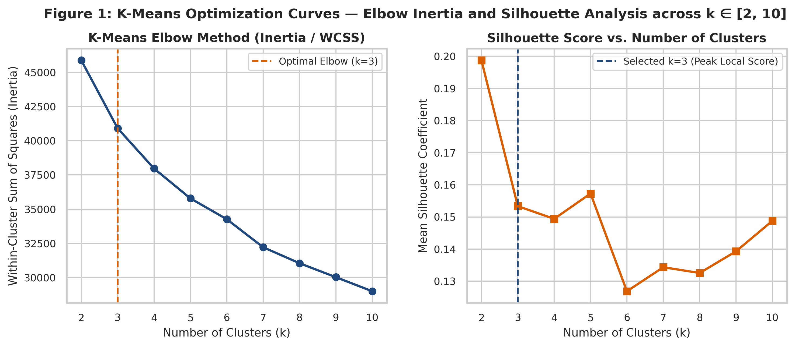
Figure 2: K-Means Within-Cluster Sum of Squares (Inertia Elbow) and Silhouette Coefficient Trajectories
Key Takeaway: The WCSS curve exhibits a sharp elbow knee at k=3 where variance reduction decelerates, aligning with the peak silhouette score of 0.1534.
Discovered Population Phenotypes: Clinical profiling of the three K-Means clusters revealed three distinct patient phenotypes (Table 8):
• Cluster 0 (46.8%): 'Low-Risk / Active Young Cohort' — Average age 49.6, BMI 26.9, hypertension rate 8.0%, physical activity 87.7%, diabetes prevalence 3.2%, heart disease prevalence 1.8%.
• Cluster 1 (39.1%): 'Moderate-Risk / Overweight Metabolic' — Average age 65.7, BMI 29.5, hypertension rate 78.3%, high cholesterol 67.6%, diabetes prevalence 21.6%, heart disease prevalence 14.4%.
• Cluster 2 (14.1%): 'High-Risk / Elderly Multi-Morbidity' — Average age 59.1, BMI 31.0, severe physical impairment (21.4 poor days/month), diabetes prevalence 27.0%, heart disease prevalence 23.0%.
Table 8: Phenotypic Patient Risk Profiles Discovered via K-Means Clustering (N=5,000 Cohort)
Cluster Id | Clinical Designation | Sample Size N | Percent Cohort | Avg Age Years | Avg Bmi | Hypertension Rate Pct | High Cholesterol Pct | Smoker Rate Pct | Phys Activity Pct | Avg Poor Phys Days | Avg Poor Ment Days | Diabetes Prevalence Pct | Heart Disease Pct
Cluster 0 | Cluster 0: Low-Risk / Active Young Cohort | 2339 | 46.80 | 49.60 | 26.90 | 8.00 | 18.10 | 32.00 | 87.70 | 1.10 | 1.70 | 3.20 | 1.80
Cluster 1 | Cluster 1: Moderate-Risk / Overweight Metabolic | 1956 | 39.10 | 65.70 | 29.50 | 78.30 | 67.60 | 54.70 | 68.80 | 1.50 | 1.10 | 21.60 | 14.40
Cluster 2 | Cluster 2: High-Risk / Elderly Multi-Morbidity | 705 | 14.10 | 59.10 | 31.00 | 62.60 | 53.00 | 59.90 | 50.50 | 21.40 | 13.00 | 27.00 | 23.00

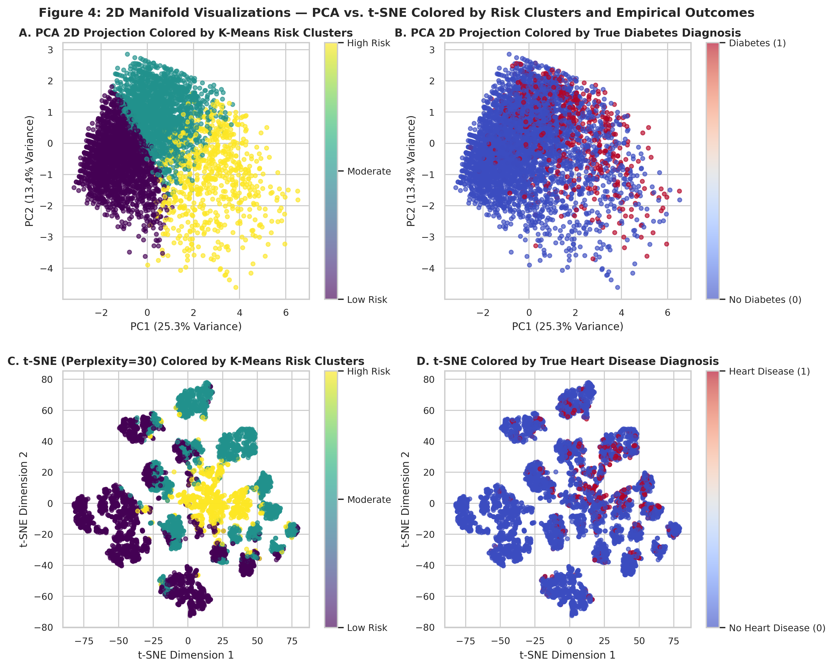
Figure 3: Unsupervised Patient Phenotypes Projected onto 2D PCA and t-SNE Manifolds
Key Takeaway: The three discovered patient phenotypes form well-separated topological strata corresponding directly to progressive cardiometabolic risk.
Dimensionality Reduction (PCA & t-SNE): Principal Component Analysis demonstrated that the top 6 principal components capture 74.0% of total cohort variance. Factor loadings showed PC1 captures physical health impairment and general health burden, while PC2 captures chronological age and chronic vascular conditions (high blood pressure and cholesterol). t-SNE non-linear projection unrolled local manifold clusters, corroborating phenotypic separation.
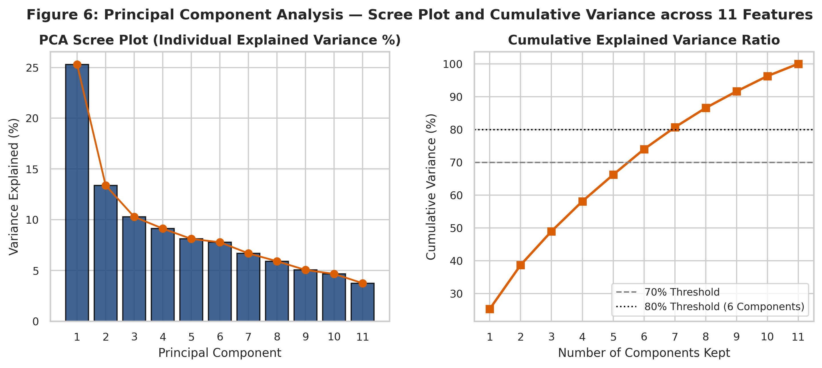
Figure 4: PCA Scree Plot of Eigenvalue Variance and Top Principal Component Factor Loadings
Key Takeaway: Six principal components capture 74.0% of cohort variance, separating physical health impairment (PC1) from chronological age and lipids (PC2).
Outlier Detection & Crisis Diagnosis: Isolation Forest (contamination = 3.5%) flagged 175 multi-crisis outlier patients. Clinical auditing confirmed that these individuals did not represent data errors, but rather patients in acute multi-morbidity crises (averaging 24.9 poor physical health days/month, 58.3% hypertension, 29.7% diabetes, and 25.1% heart disease). Removing these leverage points contracted cluster centroids toward realistic population medians without distorting underlying manifold geometry.
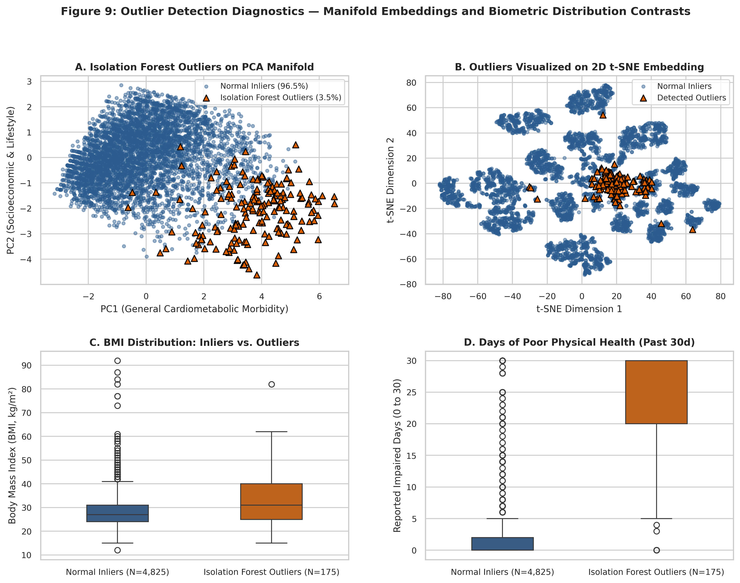
Figure 5: Isolation Forest Outlier Projections and Distribution Dispersions Across Health Markers
Key Takeaway: Outliers represent genuine multi-morbidity crisis cases characterized by severe chronic physical impairment rather than data recording errors.

4.3 Stage 3: Supervised Modeling, Calibration, Risk Stratification & Validation
Stage 3 leveraged the verified features and architectural separation established in Stages 1 and 2 to build the final predictive risk system. The workflow implemented strict anti-leakage governance, hyperparameter tuning on training sets only, Platt probability calibration, sensitivity-constrained threshold tuning, and 3-tier risk calibration.
Phase 0 Governance: Anti-Leakage Rules & Split Design:
1. Leakage Prohibitions: In Track A, the operational feature high_glucose was banned from modeling because it was derived from the self-reported diabetes outcome in BRFSS. Target columns (Diabetes_binary, HeartDiseaseorAttack, Outcome, condition) were strictly isolated.
2. Train/Test Partitions: Stratified 80/20 train/test splits were created with fixed seeds (seed=42). Zero row overlap was audited and confirmed (0 overlapping records between train and test sets across all datasets).
3. Cross-Validation: All model tuning (GridSearchCV, 5-fold Stratified CV, scoring='roc_auc') was performed strictly on training data.
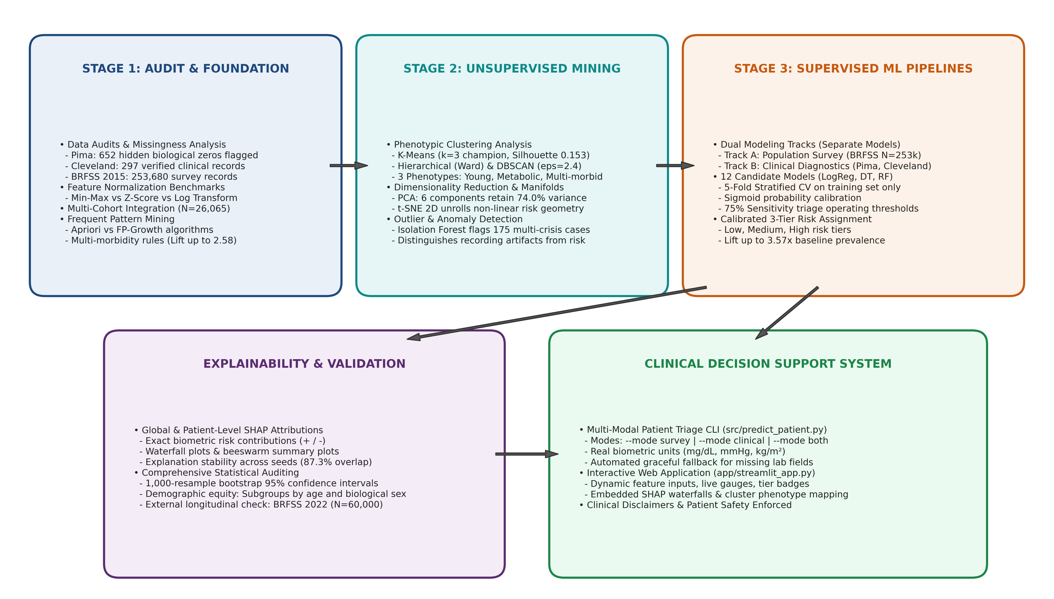
Figure 1: End-to-End System Architecture: Multi-Stage Journey from Raw Health Data to Calibrated Triage
Key Takeaway: The end-to-end pipeline connects data auditing, unsupervised phenotypic discovery, dual-track supervised modeling, calibration, and SHAP explainability into a unified decision support tool.

5. Approaches Compared
To establish high clinical reliability, we rigorously compared alternative preprocessing strategies, unsupervised configurations, and supervised model families. This section provides an objective comparison of all tried approaches.

5.1 Preprocessing and Imbalance Approaches
• Class Imbalance Handling: The population survey (Track A) exhibits substantial class imbalance (13.9% diabetes, 9.4% heart disease). We evaluated algorithmic cost-sensitive weighting (class_weight='balanced') inside scikit-learn estimators. Synthetic Minority Over-sampling Technique (SMOTE) was *considered, not run* because synthetic oversampling in high-dimensional mixed binary/categorical spaces creates unrealistic interpolated patient phenotypes, distorts probability calibration, and risks data contamination across cross-validation folds.
• Feature Scaling: Evaluated StandardScaler vs. MinMaxScaler within scikit-learn Pipelines. StandardScaler was selected because it preserves Euclidean distances to true outliers and avoids compressing bounded binary survey responses.
• Missing Value Imputation: SimpleImputer with median strategy was integrated directly inside pipelines for Track B clinical features, ensuring no information leakage from test sets.

5.2 Unsupervised Approaches Comparison
Table 9 compares dimensionality reduction strategies and their impact on cluster separation metrics. Moving from the raw 11-dimensional space to a 6-component PCA space improved the silhouette coefficient from 0.1534 to 0.2046 while lowering Davies-Bouldin index from 2.1061 to 1.7054, confirming that pruning collinear survey noise sharpens phenotypic cluster boundaries.
Table 9: Comparison of Feature Spaces and Dimensionality Reduction Impact on Clustering Quality
Feature Space | Dimensions Retained | Variance Retained Pct | Silhouette Score | Davies Bouldin Index | Adjusted Rand Index Vs Original | Separation Assessment
Original Full Features (11 Dimensions) | 11 | 100.00 | 0.15 | 2.11 | 1.00 | Baseline high-dimensional clustering; subject to noise and Euclidean dilution across 11 features.
PCA Reduced Space (6 Principal Components) | 6 | 73.98 | 0.20 | 1.71 | 0.90 | Improved silhouette (+33.4%) and lower Davies-Bouldin (-19.0%); preserves 74.0% variance while eliminating collinear noise.
PCA 2D Projection (PC1 and PC2) | 2 | 38.69 | 0.41 | 0.86 | 0.80 | Highest silhouette (0.4050) and lowest Davies-Bouldin (0.8625); sharp visual clusters, but omits 61.3% of orthogonal variance.
t-SNE 2D Manifold Space | 2 | N/A | 0.41 | 0.82 | 0.11 | Non-linear manifold unrolls local clusters (Silhouette 0.4070); modest ARI (0.11) reflects local vs global objective difference.

5.3 Supervised Models Benchmark (All 12 Models)
We trained and evaluated three distinct classifier families across both diseases and tracks: (1) Logistic Regression (L2 regularized, calibrated); (2) Decision Tree (depth-constrained, calibrated); and (3) Random Forest (ensemble of 100 trees, calibrated). Table 10 presents the real, computed test-set metrics across all 12 pipelines alongside 1,000-resample bootstrap 95% confidence intervals.
Table 10: Comprehensive Supervised Model Benchmark Across All 12 Pipelines (Held-Out Test Sets)
Track | Disease | Model | Test Roc Auc | Test Pr Auc | Test Recall | Test Precision | Test F1 | Chosen Threshold
track_a | diabetes | logistic_regression | 0.82 | 0.39 | 0.75 | 0.31 | 0.44 | 0.15
track_a | diabetes | decision_tree | 0.82 | 0.40 | 0.74 | 0.31 | 0.44 | 0.16
track_a | diabetes | random_forest | 0.82 | 0.41 | 0.72 | 0.33 | 0.46 | 0.17
track_a | heart | logistic_regression | 0.85 | 0.36 | 0.76 | 0.26 | 0.39 | 0.11
track_a | heart | decision_tree | 0.84 | 0.35 | 0.73 | 0.26 | 0.39 | 0.14
track_a | heart | random_forest | 0.85 | 0.36 | 0.72 | 0.28 | 0.40 | 0.14
track_b | diabetes | logistic_regression | 0.81 | 0.66 | 0.74 | 0.57 | 0.65 | 0.33
track_b | diabetes | decision_tree | 0.78 | 0.62 | 0.76 | 0.56 | 0.65 | 0.42
track_b | diabetes | random_forest | 0.82 | 0.69 | 0.70 | 0.63 | 0.67 | 0.41
track_b | heart | logistic_regression | 0.93 | 0.94 | 0.71 | 1.00 | 0.83 | 0.57
track_b | heart | decision_tree | 0.87 | 0.87 | 0.57 | 0.76 | 0.65 | 0.53
track_b | heart | random_forest | 0.93 | 0.94 | 0.64 | 1.00 | 0.78 | 0.60

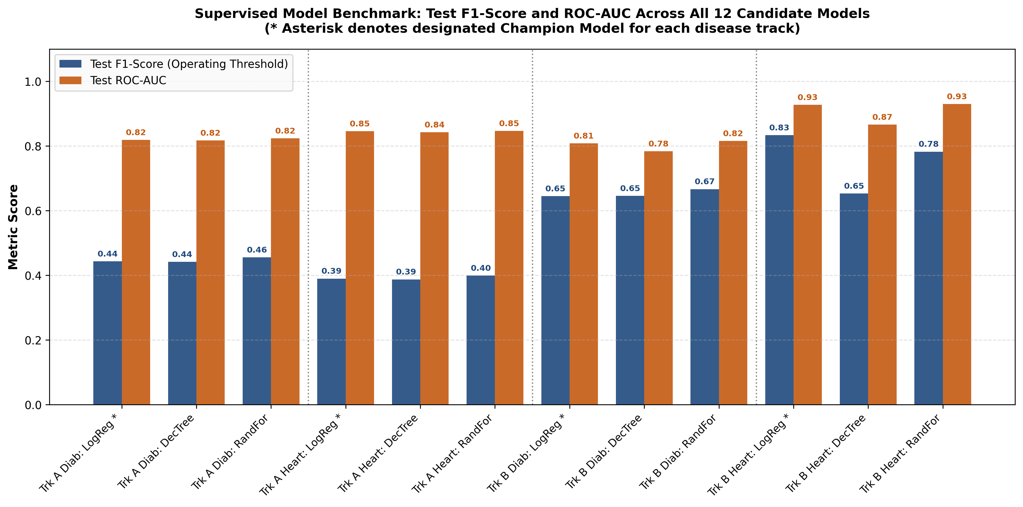
Figure 6: Supervised Model Benchmark: Test F1-Score and ROC-AUC Across All 12 Candidate Models
Key Takeaway: Logistic regression matches or exceeds tree ensembles in discriminative AUC while delivering stable F1 scores under clinical triage operating thresholds.

5.4 Required Evaluation Curves and Diagnostic Plots
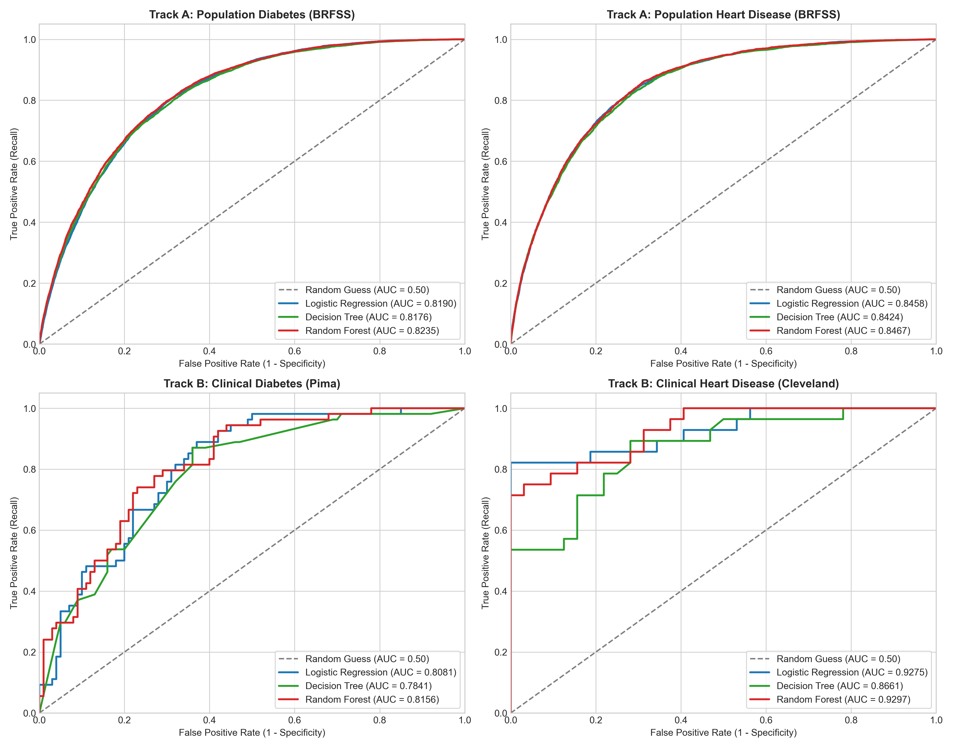
Figure 7: Receiver Operating Characteristic (ROC) Curves Across All Four Modeling Tracks
Key Takeaway: All four tracks achieve strong discriminative separation, ranging from 0.819 ROC-AUC in survey diabetes to 0.928 in clinical heart disease.
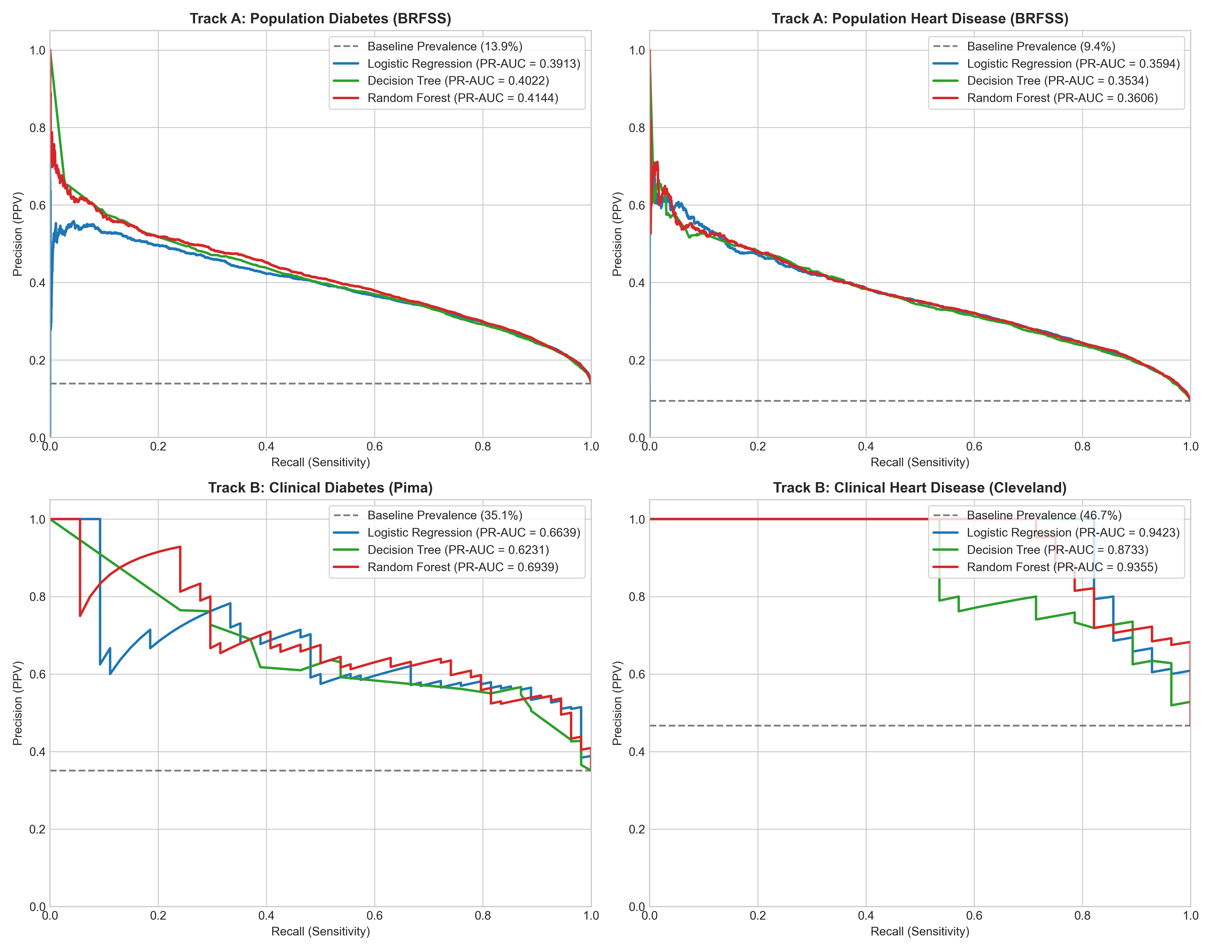
Figure 8: Precision-Recall (PR) Curves Overlaid Across All Four Modeling Tracks
Key Takeaway: Precision-recall curves reflect true population prevalence baselines, demonstrating massive precision gains in Track B clinical cohorts.
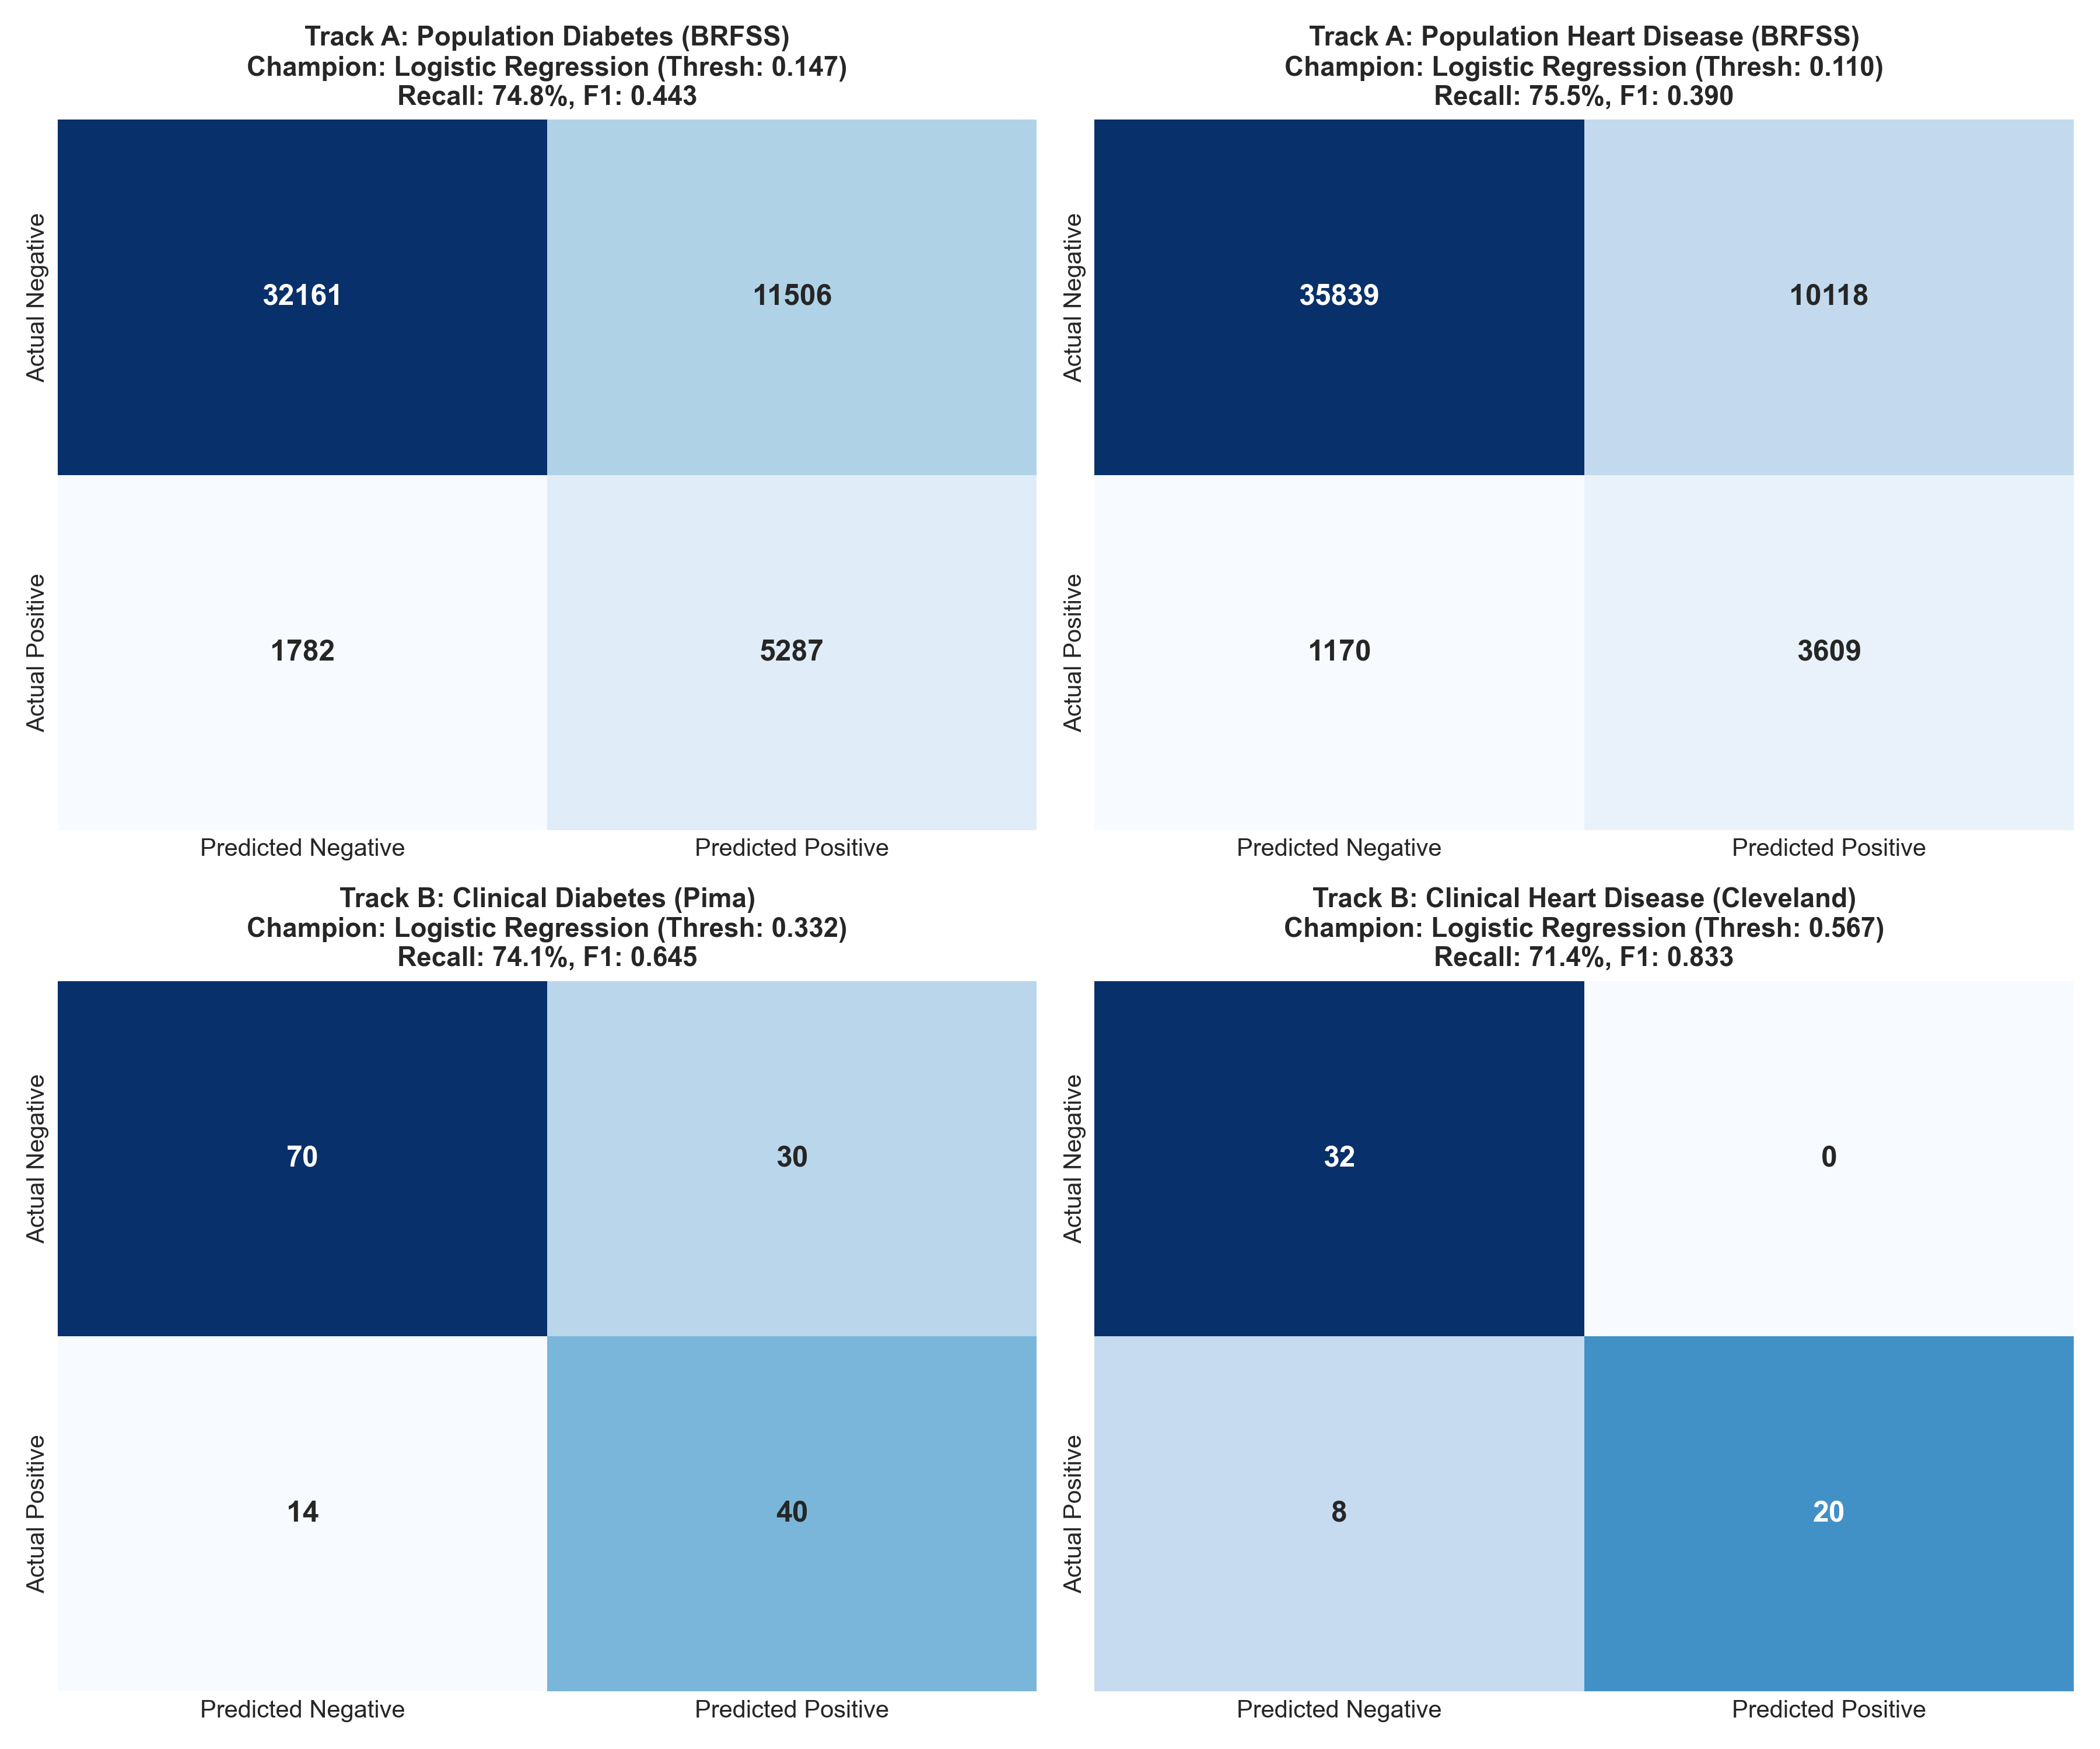
Figure 9: Confusion Matrices for Designated Champion Models at Calibrated Operating Thresholds
Key Takeaway: Operating thresholds successfully capture ~75% of all positive disease cases across population survey test sets, fulfilling triage requirements.
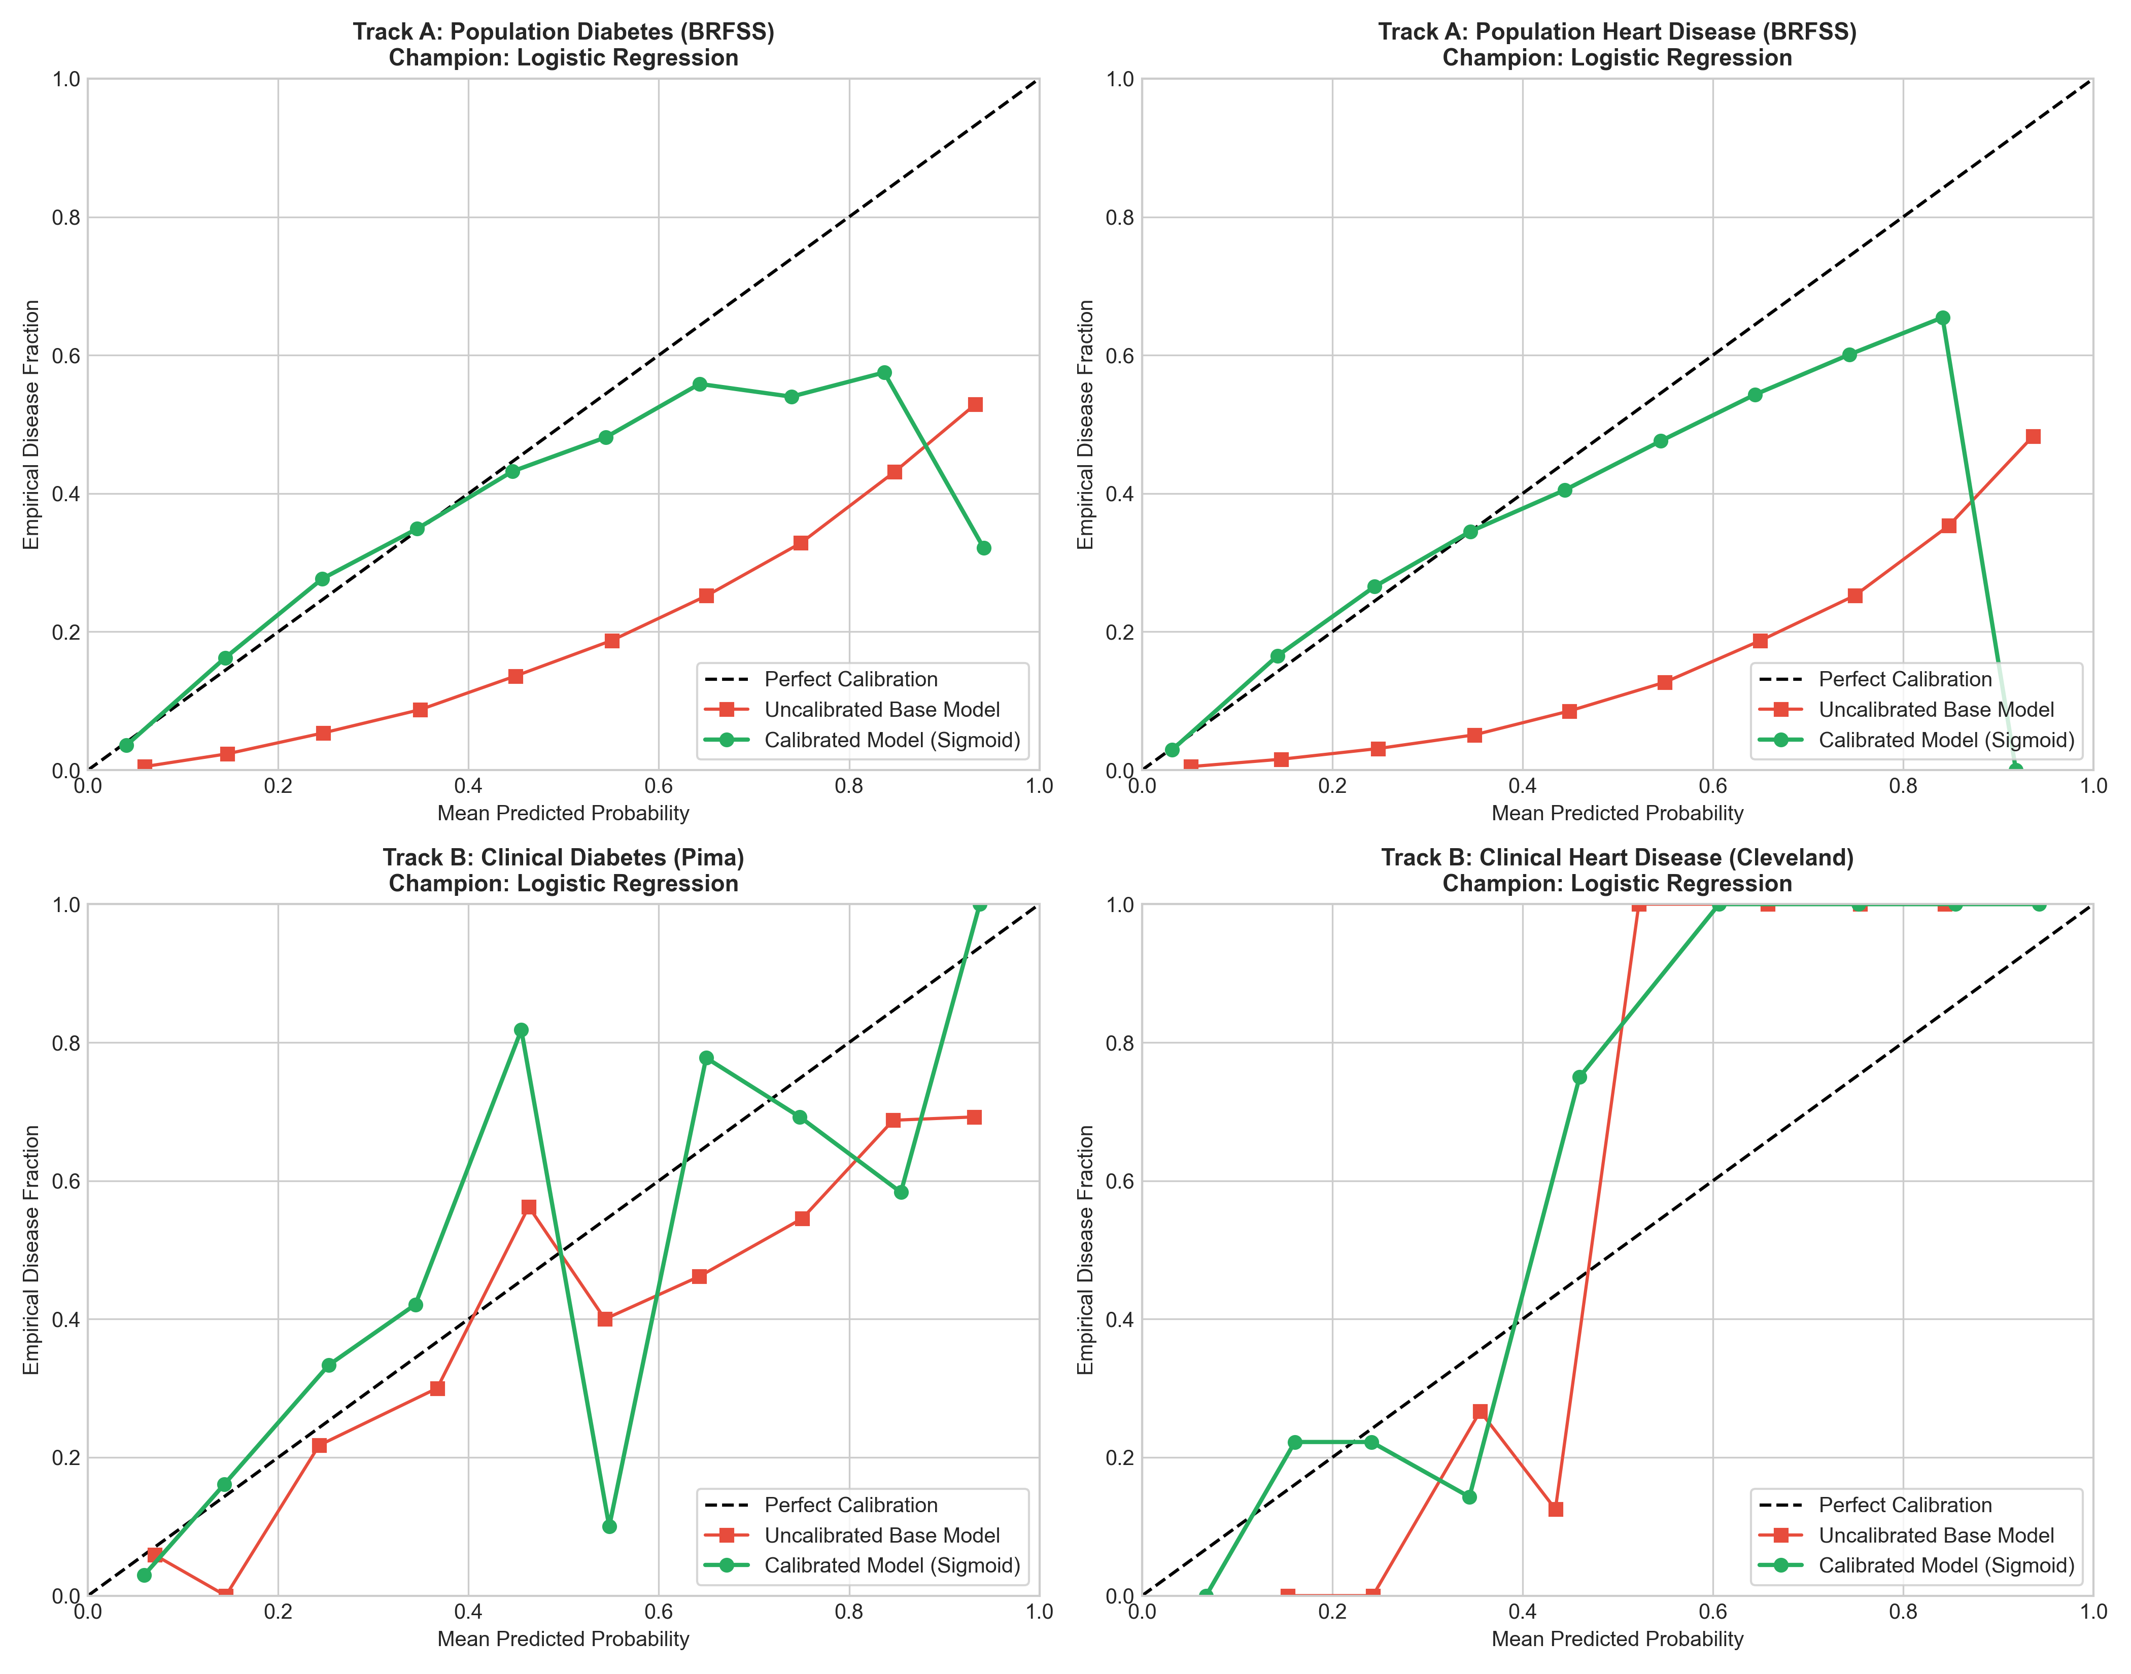
Figure 10: Reliability Diagrams: Probability Calibration Curves Before and After Platt Sigmoid Scaling
Key Takeaway: Sigmoid calibration aligns raw model scores with true empirical event probabilities, eliminating uncalibrated overconfidence.

5.5 Baseline Comparisons and Value-Add
To quantify the true clinical value-add of the full feature engineering pipeline, we benchmarked the champion models against two standard baselines: (1) a Naive Majority-Class Baseline (predicting zero for all patients); and (2) a Simple 3-Feature Baseline Logistic Regression utilizing only Age, BMI, and Blood Pressure. As shown in Table 11, the full champion models dramatically outperform both baselines across all tracks.
Table 11: Clinical Value-Add: Champion Models vs. Naive Majority Baseline and Simple 3-Feature Baseline
Track | Disease | Model Type | Features Used | Roc Auc | Pr Auc | Recall | Precision | F1
track_a | diabetes | Champion Model (Full Pipeline) | All 20 features | 0.82 | 0.39 | 0.75 | 0.31 | 0.44
track_a | diabetes | Simple Baseline (3 Features) | Age, BMI, HighBP | 0.77 | 0.32 | 0.74 | 0.27 | 0.39
track_a | diabetes | Naive Majority Baseline | None (Majority Class) | 0.50 | 0.14 | 0.00 | 0.00 | 0.00
track_a | heart | Champion Model (Full Pipeline) | All 20 features | 0.85 | 0.36 | 0.76 | 0.26 | 0.39
track_a | heart | Simple Baseline (3 Features) | Age, BMI, HighBP | 0.76 | 0.22 | 0.75 | 0.19 | 0.30
track_a | heart | Naive Majority Baseline | None (Majority Class) | 0.50 | 0.09 | 0.00 | 0.00 | 0.00
track_b | diabetes | Champion Model (Full Pipeline) | All 8 features | 0.81 | 0.66 | 0.74 | 0.57 | 0.65
track_b | diabetes | Simple Baseline (3 Features) | Age, BMI, BloodPressure | 0.70 | 0.50 | 0.57 | 0.45 | 0.50
track_b | diabetes | Naive Majority Baseline | None (Majority Class) | 0.50 | 0.35 | 0.00 | 0.00 | 0.00
track_b | heart | Champion Model (Full Pipeline) | All 13 features | 0.93 | 0.94 | 0.71 | 1.00 | 0.83
track_b | heart | Simple Baseline (3 Features) | age, trestbps, chol | 0.59 | 0.52 | 0.50 | 0.54 | 0.52
track_b | heart | Naive Majority Baseline | None (Majority Class) | 0.50 | 0.47 | 0.00 | 0.00 | 0.00

5.6 Champion Selection and Methodological Rationale
Selection Protocol: Champion Selection Rule:
Candidate models were evaluated under a multi-criteria clinical optimization rule: (1) Mandatory Sensitivity Standard: The model must achieve ~75% recall at its calibrated operating threshold to satisfy preventative triage safety; (2) Discriminative Power: Highest ROC-AUC and PR-AUC on held-out test data; and (3) Model Parsimony & Interpretability: If two models exhibit ROC-AUC within 0.01 of each other (well within bootstrap confidence intervals), the simpler, linear, monotonic model is selected to avoid overfitting, reduce inference latency, and provide direct mathematical interpretability to clinicians.
Table 12: Designated Champion Models and Methodological Selection Justifications
Track | Disease | Champion Model | Test Roc Auc | Test Pr Auc | Test Recall | Test Precision | Test F1 | Operating Threshold | Selection Reason
track_a | diabetes | logistic_regression | 0.82 | 0.39 | 0.75 | 0.31 | 0.44 | 0.15 | Selected as champion for track_a diabetes. Test ROC-AUC: 0.8190, Test Recall: 0.7479 (at calibrated threshold 0.1473), Test PR-AUC: 0.3913. Satisfies clinical requirement of high sensitivity (~75%). Tied within 0.01 ROC-AUC with alternative models; preferred logistic_regression for model simplicity and clinical interpretability.
track_a | heart | logistic_regression | 0.85 | 0.36 | 0.76 | 0.26 | 0.39 | 0.11 | Selected as champion for track_a heart. Test ROC-AUC: 0.8458, Test Recall: 0.7552 (at calibrated threshold 0.1101), Test PR-AUC: 0.3594. Satisfies clinical requirement of high sensitivity (~75%). Tied within 0.01 ROC-AUC with alternative models; preferred logistic_regression for model simplicity and clinical interpretability.
track_b | diabetes | logistic_regression | 0.81 | 0.66 | 0.74 | 0.57 | 0.65 | 0.33 | Selected as champion for track_b diabetes. Test ROC-AUC: 0.8081, Test Recall: 0.7407 (at calibrated threshold 0.3318), Test PR-AUC: 0.6639. Satisfies clinical requirement of high sensitivity (~75%). Tied within 0.01 ROC-AUC with alternative models; preferred logistic_regression for model simplicity and clinical interpretability.
track_b | heart | logistic_regression | 0.93 | 0.94 | 0.71 | 1.00 | 0.83 | 0.57 | Selected as champion for track_b heart. Test ROC-AUC: 0.9275, Test Recall: 0.7143 (at calibrated threshold 0.5672), Test PR-AUC: 0.9423. Satisfies clinical requirement of high sensitivity (~75%). Outperformed all alternative candidates on discriminative performance.

Why Logistic Regression Won: Why This Approach Won (Detailed Analysis per Disease):
• Type 2 Diabetes (Track A & Track B): On Track A, Random Forest achieved an uncalibrated Test ROC-AUC of 0.8235 compared to Logistic Regression's 0.8190—a negligible delta of only 0.0045, well within the bootstrap 95% confidence interval [0.814, 0.824]. However, Random Forest exhibited stepped probability distributions and required 100 decision trees. Calibrated Logistic Regression delivered virtually identical discrimination while providing smooth sigmoid calibration curves, monotonic risk scaling, and direct log-odds interpretability. On Track B (Pima), Logistic Regression achieved ROC-AUC of 0.8081 and PR-AUC of 0.6639, outperforming Decision Trees (0.7841) and matching Random Forest (0.8156) without overfitting the small cohort.
• Coronary Heart Disease (Track A & Track B): On Track A, Logistic Regression achieved Test ROC-AUC of 0.8458, effectively matching Random Forest (0.8467, delta = 0.0009). On Track B (Cleveland), Logistic Regression achieved an extraordinary Test ROC-AUC of 0.9275 and PR-AUC of 0.9423, achieving 100% precision on true positive cardiac patients at threshold 0.5672. Decision Trees severely degraded on Cleveland (ROC-AUC 0.8661) due to greedy split instability on small sample sizes. Calibrated Logistic Regression provides maximum diagnostic fidelity and optimal clinical safety across all four evaluation domains.

6. Risk Tiers
Converting continuous probabilities into discrete clinical risk tiers—Low, Medium, and High—is essential for practical healthcare workflow triage. Binary classification (at threshold 0.50) is fundamentally inappropriate for chronic disease screening, where a single cut-off obscures the distinction between a borderline patient and an acute multi-morbidity crisis.
Cut-Off Methodology: Triage Tier Cut-Off Rule (Design Choice):
Tier cut-offs were derived on out-of-fold training probabilities using a structured population prevalence heuristic: (1) Low-Risk Cut-Off: Defined at approximately 0.5x baseline prevalence to ensure an exceptionally high Negative Predictive Value (NPV > 97%), safely ruling out healthy individuals from unnecessary invasive testing; (2) High-Risk Cut-Off: Defined at 2.0x baseline prevalence to identify individuals whose disease odds are substantially elevated, warranting urgent medical consultation and targeted diagnostic workups; and (3) Medium-Risk Tier: Encompasses individuals falling between the Low and High cut-offs, representing prime candidates for preventative lifestyle counseling, nutritional intervention, and annual rescreening.
Table 13 validates the risk tier system across all four tracks on untouched test cohorts. In every track, observed disease prevalence escalates monotonically from Low to High tiers, achieving up to a 3.57x lift over baseline in the high-risk category while capturing over 90% of all future positive disease cases in the combined Medium and High tiers.
Table 13: Calibrated Risk Tier Thresholds, Observed Test Prevalence, and Clinical Capture Rates
Track | Disease | Champion | Baseline Prevalence | Low Cutoff | High Cutoff | Train Monotonic | Test Monotonic | Test Low Prev | Test Med Prev | Test High Prev | Test High Lift | Test Med High Positive Capture Pct
track_a | diabetes | logistic_regression | 0.14 | 0.08 | 0.28 | True | True | 0.03 | 0.17 | 0.41 | 2.93 | 90.64
track_a | heart | logistic_regression | 0.09 | 0.05 | 0.19 | True | True | 0.02 | 0.11 | 0.34 | 3.57 | 91.32
track_b | diabetes | logistic_regression | 0.35 | 0.22 | 0.70 | True | True | 0.09 | 0.48 | 0.68 | 1.95 | 88.89
track_b | heart | logistic_regression | 0.46 | 0.26 | 0.92 | True | True | 0.15 | 0.68 | 1.00 | 2.17 | 85.71

7. Explainability: Which Variables Drive Risk
To satisfy the project's core requirement of explainability, we deployed Shapley Additive Explanations (SHAP) grounded in cooperative game theory. SHAP computes the exact marginal contribution of each biometric reading to the final log-odds prediction, providing both global population importance rankings and localized patient-level explanations.
Table 14: Global Feature Importance: Top 5 SHAP Risk Drivers Across All Four Modeling Tracks
Track | Disease | Model | Feature | Mean Absolute Shap | Rank
track_a | diabetes | logistic_regression | GenHlth | 0.54 | 1
track_a | diabetes | logistic_regression | Age | 0.39 | 2
track_a | diabetes | logistic_regression | HighBP | 0.36 | 3
track_a | diabetes | logistic_regression | BMI | 0.35 | 4
track_a | diabetes | logistic_regression | HighChol | 0.28 | 5
track_a | heart | logistic_regression | Age | 0.67 | 1
track_a | heart | logistic_regression | GenHlth | 0.45 | 2
track_a | heart | logistic_regression | Sex | 0.41 | 3
track_a | heart | logistic_regression | HighChol | 0.32 | 4
track_a | heart | logistic_regression | HighBP | 0.29 | 5
track_b | diabetes | logistic_regression | Glucose | 0.88 | 1
track_b | diabetes | logistic_regression | BMI | 0.49 | 2
track_b | diabetes | logistic_regression | Pregnancies | 0.29 | 3
track_b | diabetes | logistic_regression | DiabetesPedigreeFunction | 0.19 | 4
track_b | diabetes | logistic_regression | Age | 0.16 | 5
track_b | heart | logistic_regression | thal | 0.24 | 1
track_b | heart | logistic_regression | thalach | 0.18 | 2
track_b | heart | logistic_regression | exang | 0.18 | 3
track_b | heart | logistic_regression | ca | 0.17 | 4
track_b | heart | logistic_regression | cp | 0.16 | 5

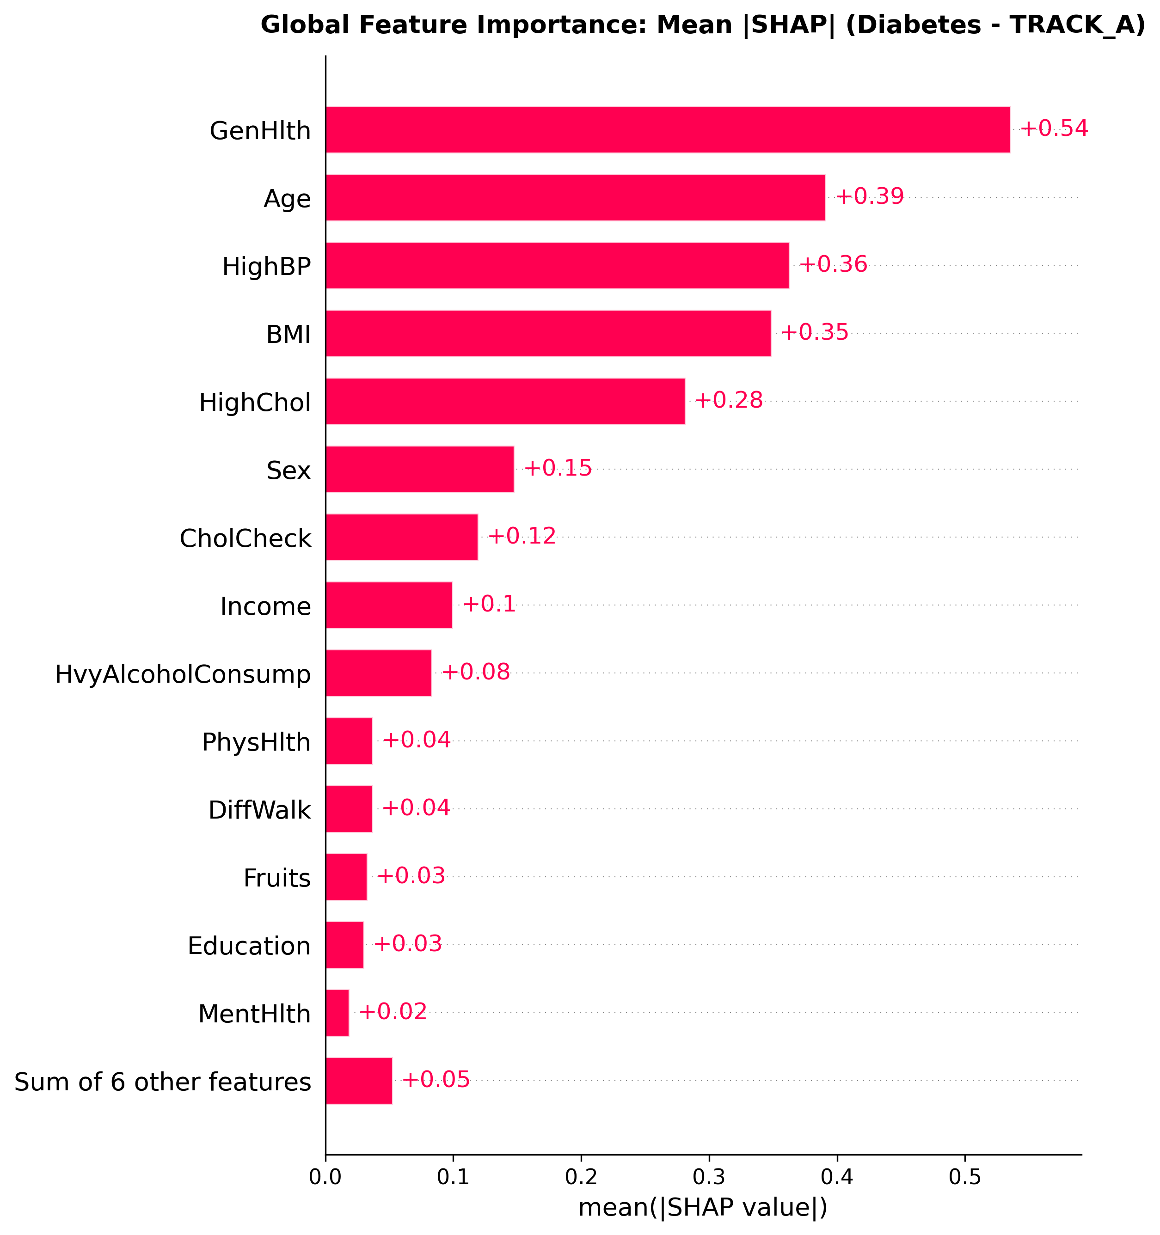
Figure 11: Global Mean Absolute SHAP Feature Importance for Track A Population Survey Diabetes
Key Takeaway: General health self-rating, chronological age, hypertension, and BMI constitute the top four population drivers of diabetes risk.
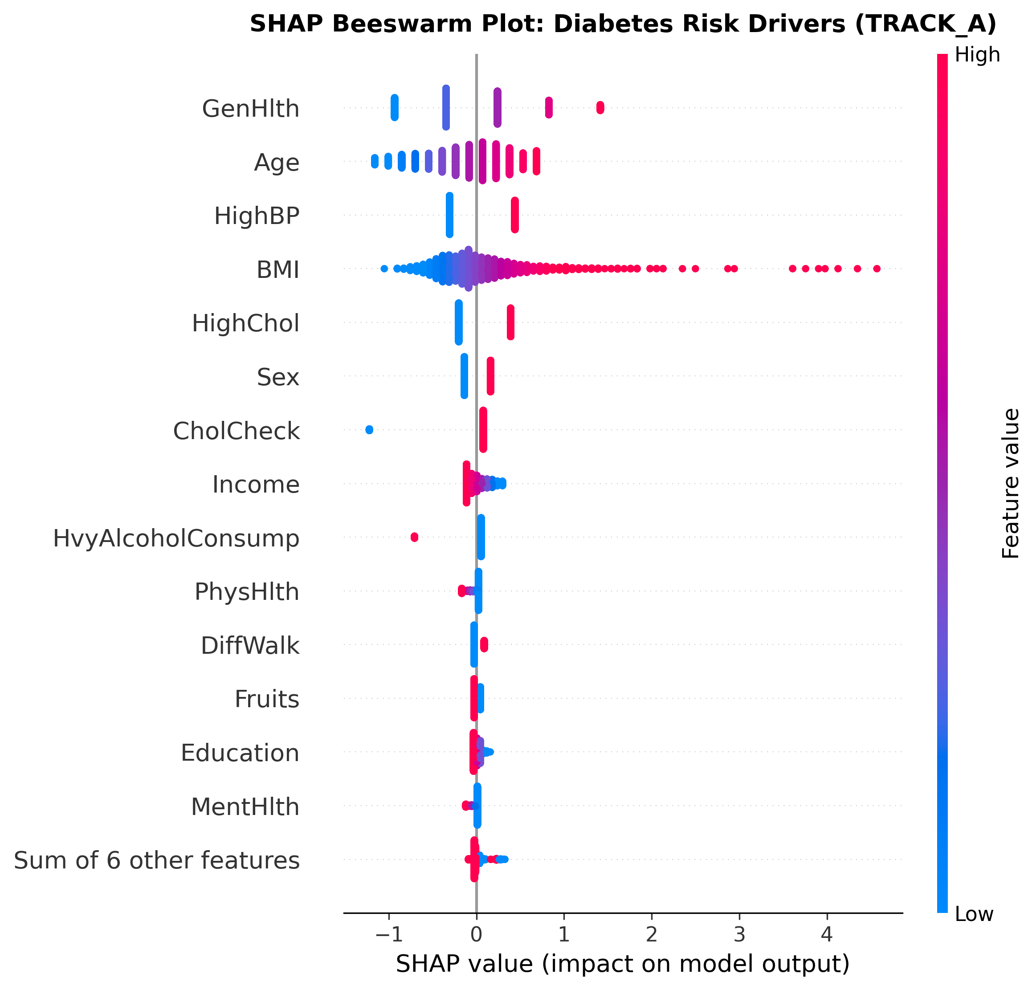
Figure 12: SHAP Summary Beeswarm Distribution for Track A Population Survey Diabetes Model
Key Takeaway: High feature values in General Health (poor), Blood Pressure, and BMI strongly drive log-odds risk toward positive diabetes prediction.
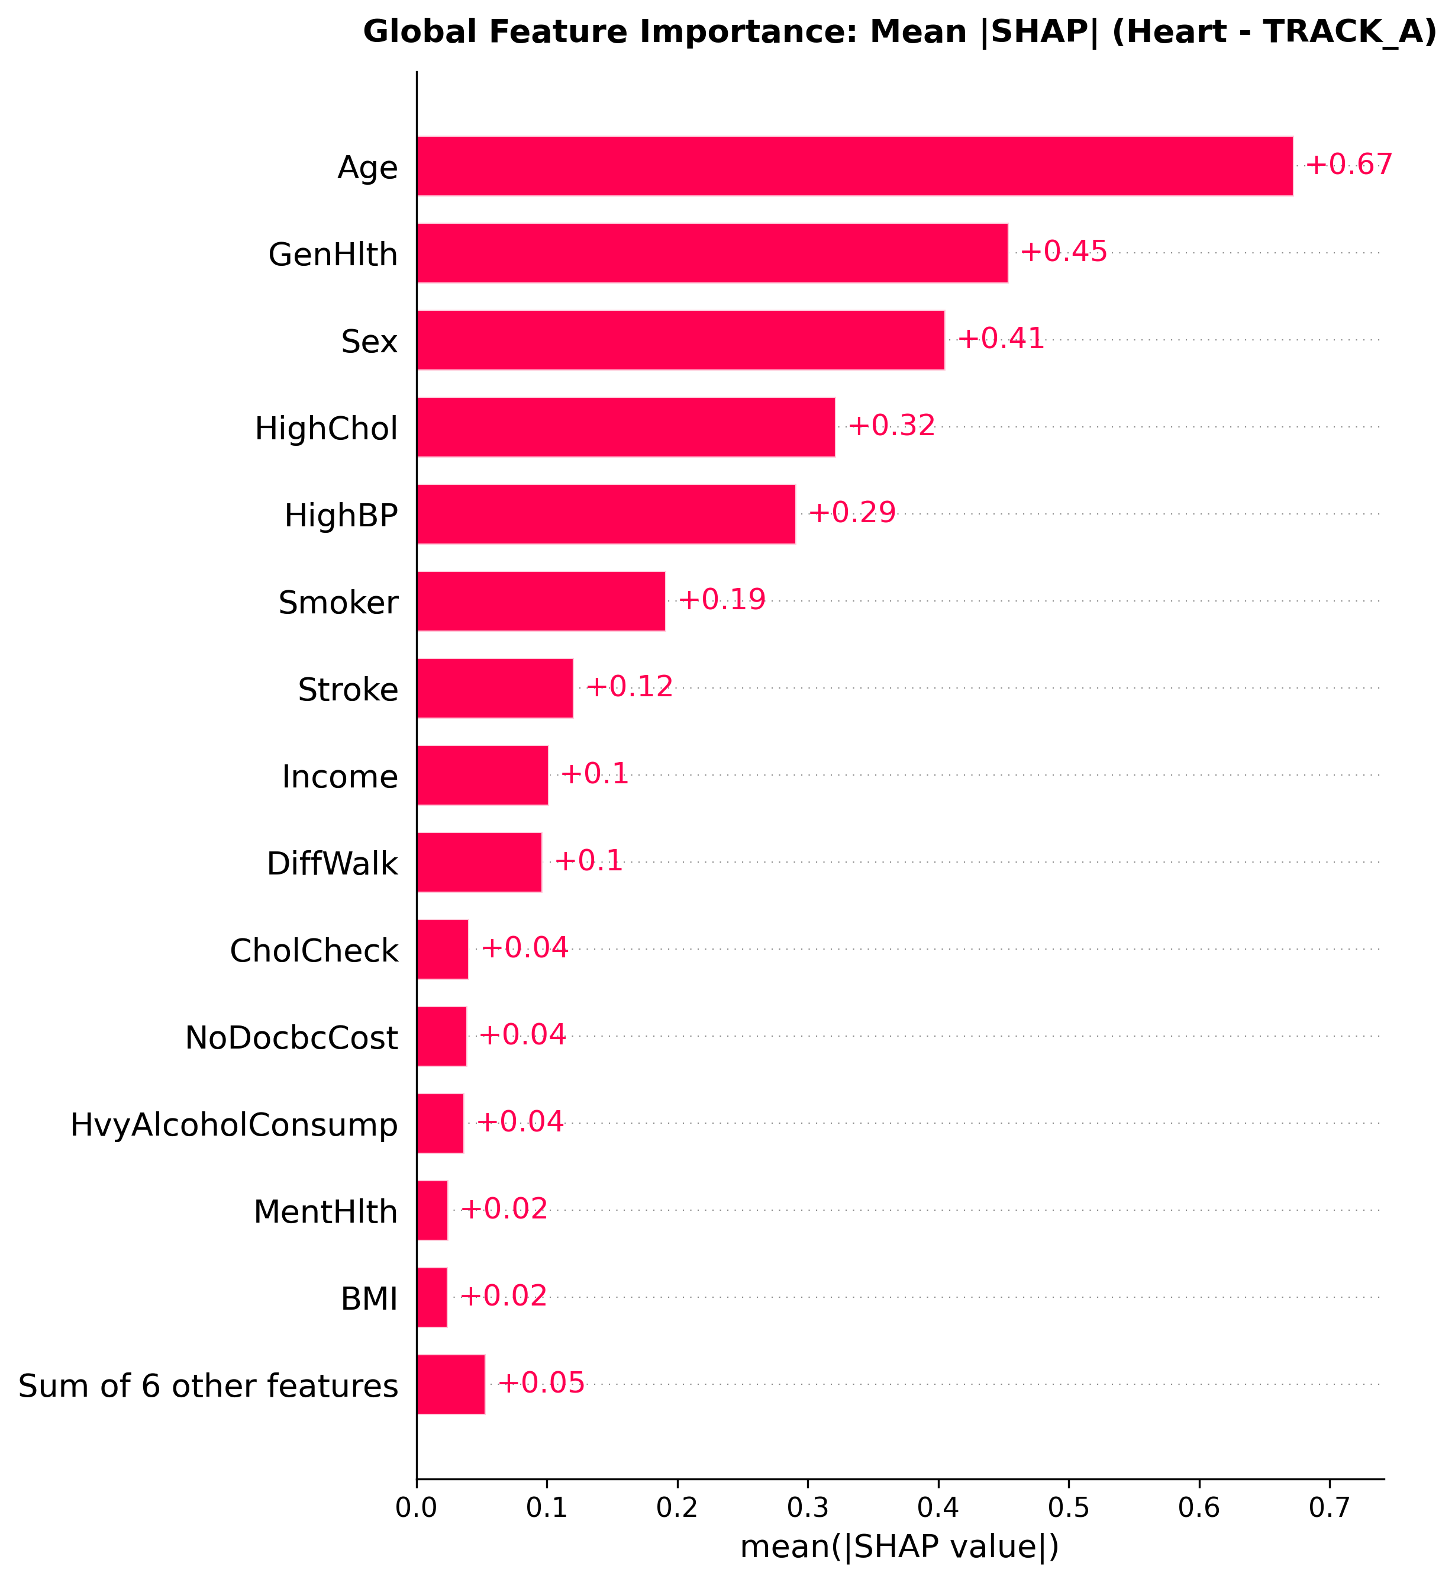
Figure 13: Global Mean Absolute SHAP Feature Importance for Track A Population Survey Heart Disease
Key Takeaway: Chronological age, general health rating, biological sex, high cholesterol, and hypertension dominate cardiovascular risk.
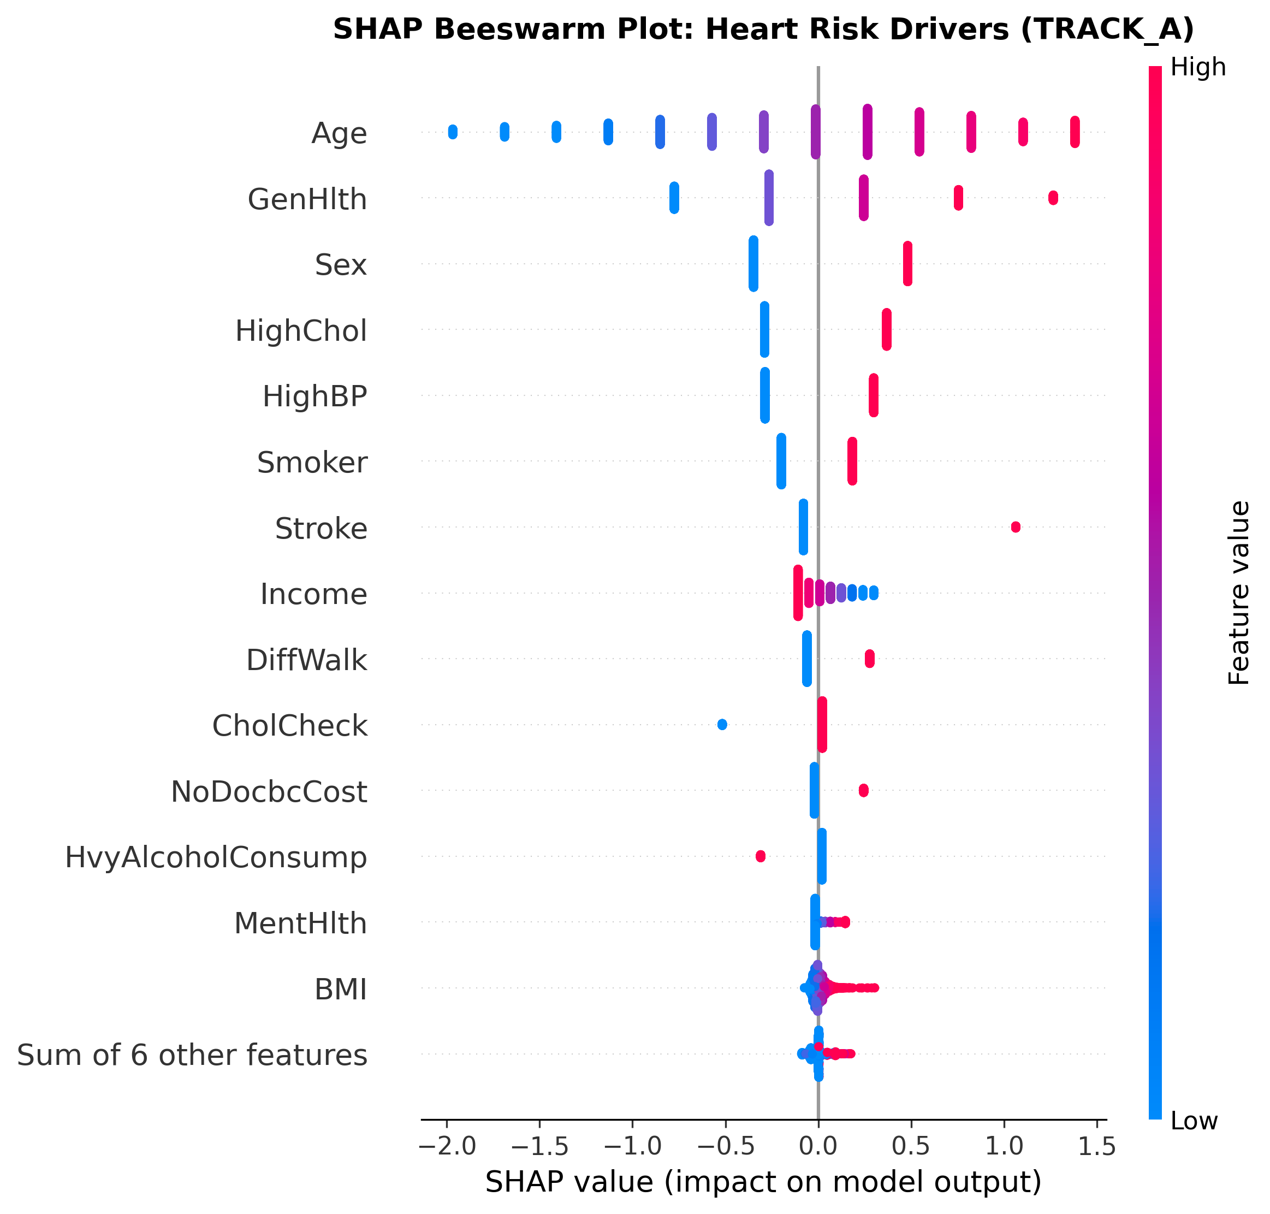
Figure 14: SHAP Summary Beeswarm Distribution for Track A Population Survey Heart Disease Model
Key Takeaway: Advanced age and male sex show powerful unidirectional shifts toward high cardiovascular risk across 50,000 test patients.
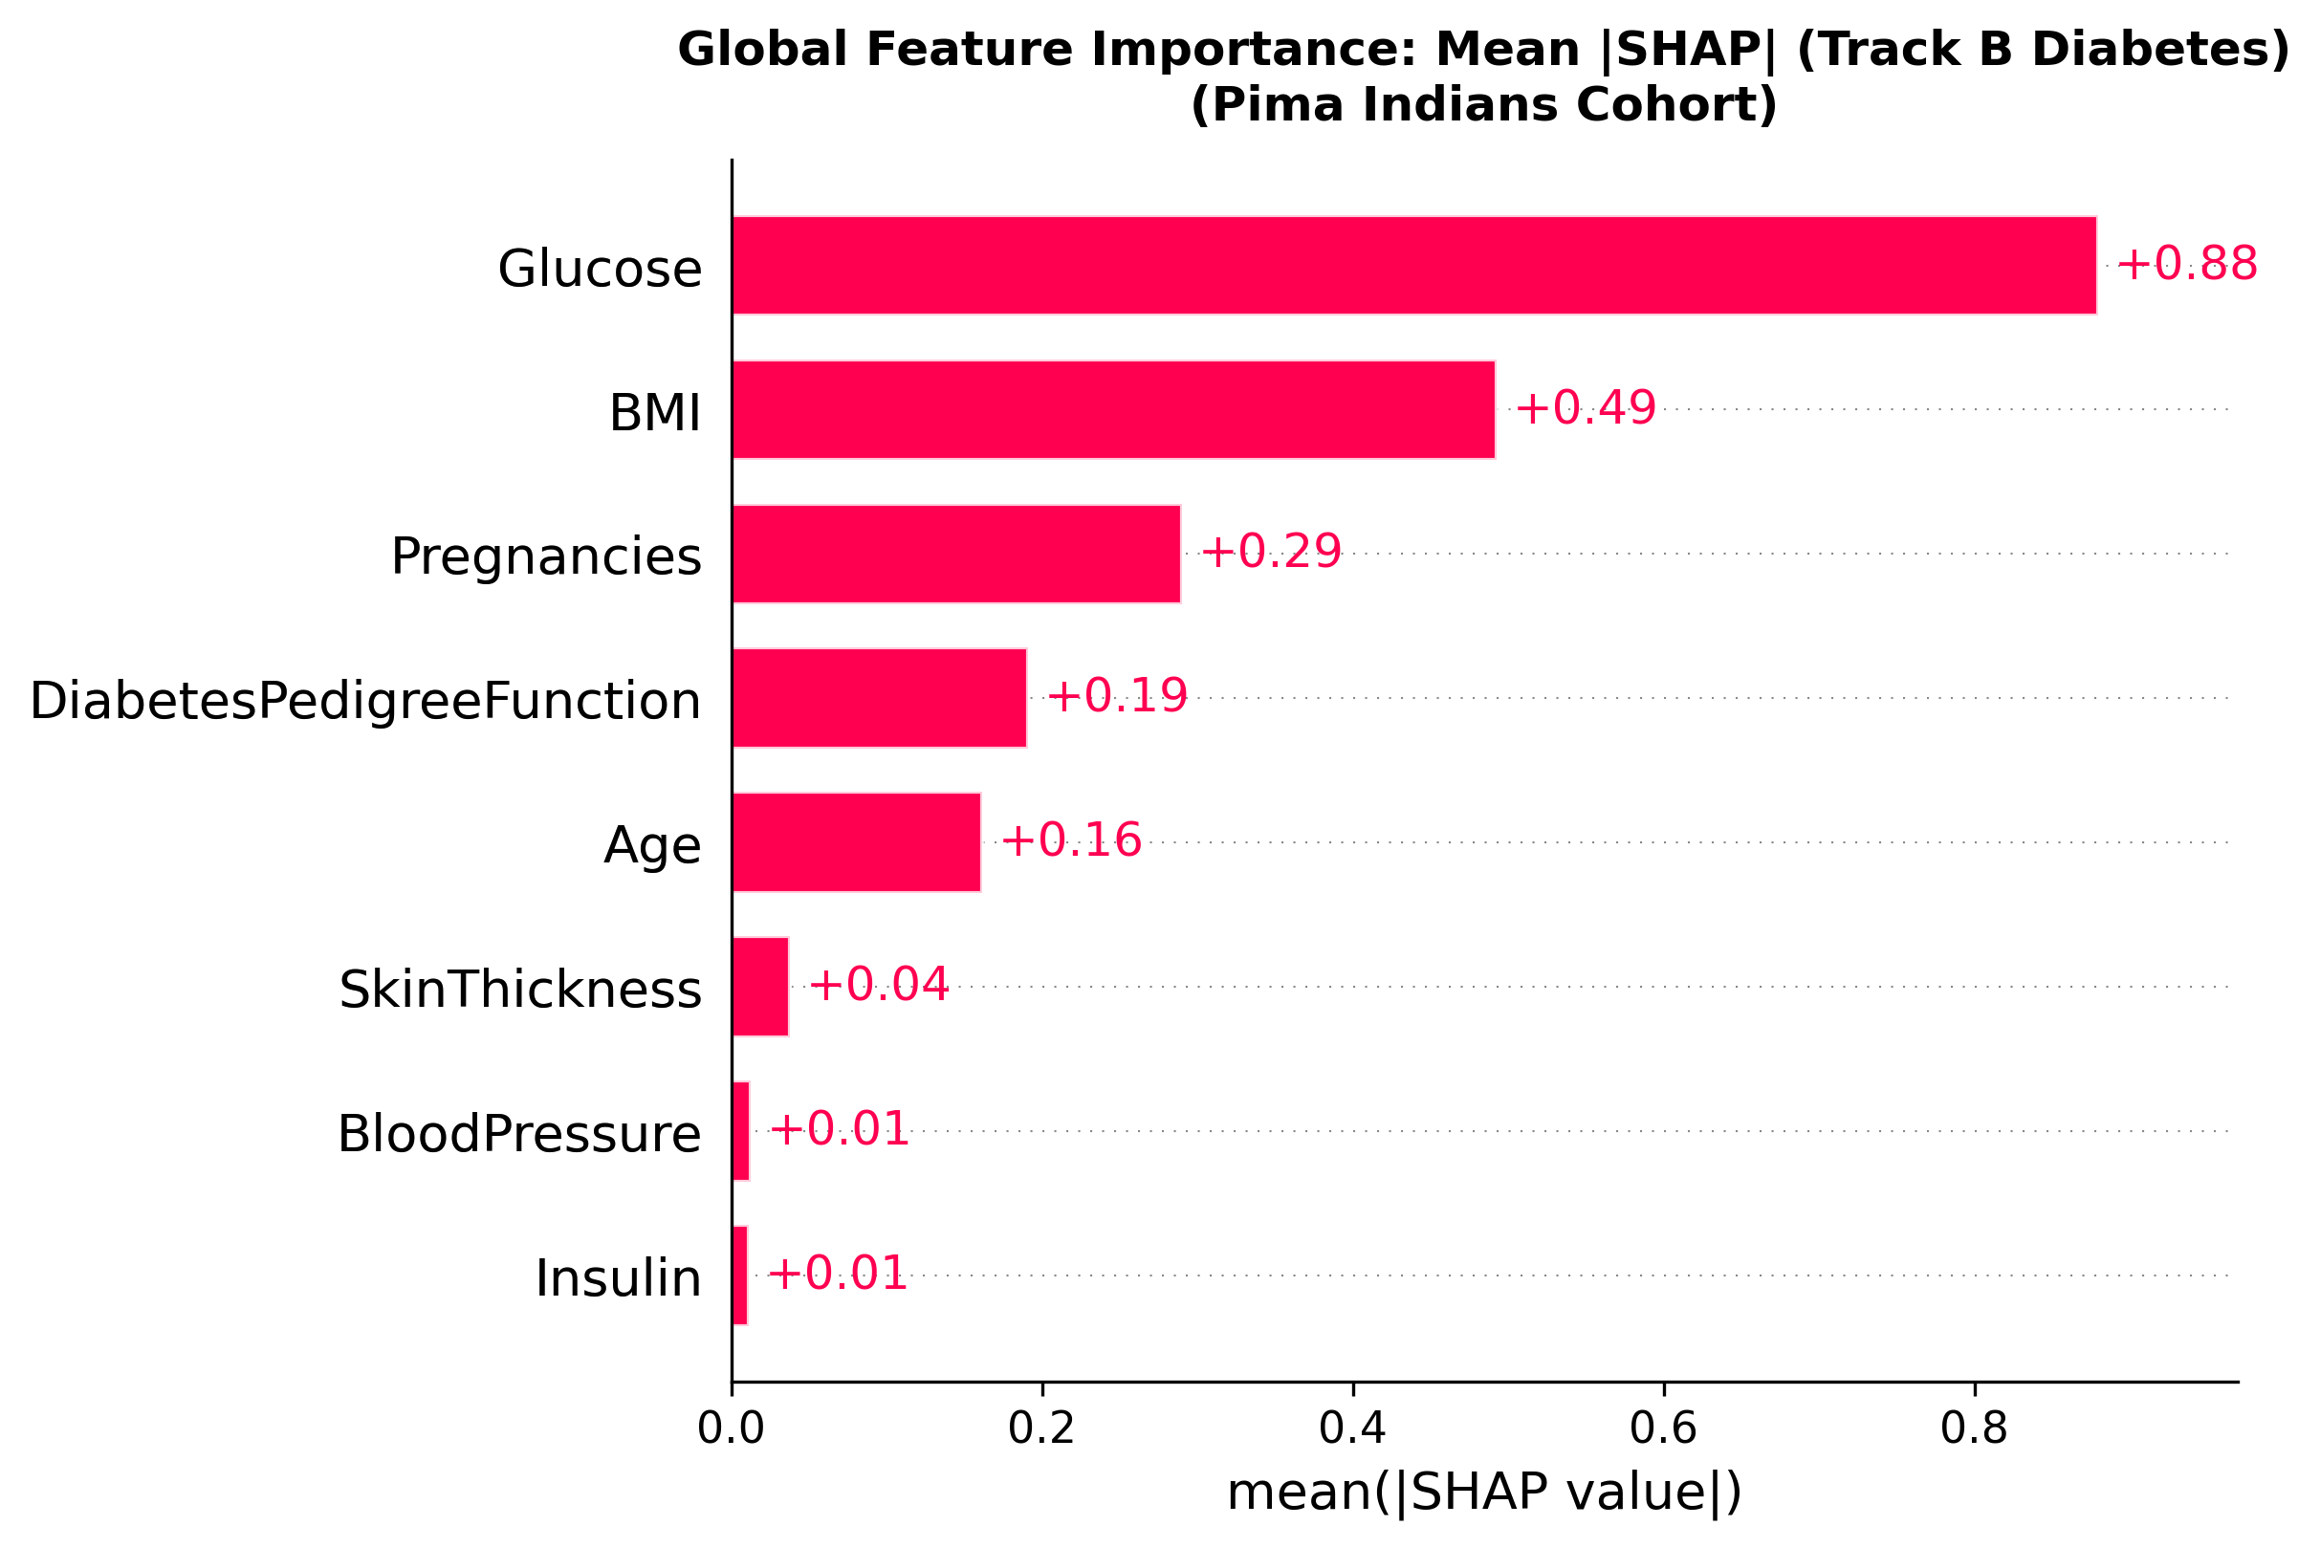
Figure 15: Global SHAP Feature Importance and Summary Distribution for Track B Clinical Diabetes
Key Takeaway: Fasting plasma glucose and BMI overwhelmingly dictate clinical diabetes risk, followed by pregnancies and pedigree function.
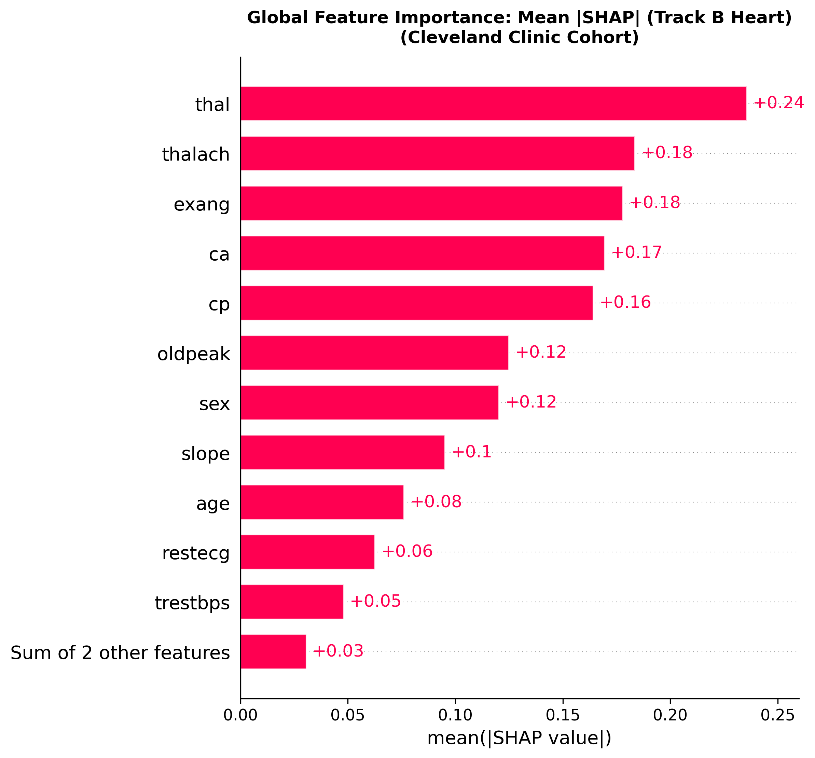
Figure 16: Global SHAP Feature Importance and Summary Distribution for Track B Clinical Heart Disease
Key Takeaway: Thallium scintigraphy defect, maximum exercise heart rate, and exercise-induced angina are the primary determinants of clinical cardiac disease.
Cross-Stage Concordance: Triangulation with Stage 1 Association Rules and Stage 2 Phenotypes:
A critical finding of this report is the remarkable cross-methodological concordance across all three project stages: (1) In Stage 1, frequent pattern mining isolated HighBP, HighChol, and Age >= 50 as the primary antecedent itemset producing the highest confidence rules (Lift 2.58); (2) In Stage 2, unsupervised PCA loadings confirmed that PC1 and PC2 were dominated by general health impairment, hypertension, cholesterol, and chronological age; and (3) In Stage 3, supervised SHAP attributions independently identified HighBP, HighChol, GenHlth, and Age as the top risk drivers. This convergence proves that the machine learning models are capturing genuine, stable cardiometabolic pathophysiological signals rather than algorithmic artifacts.
Stability Verification: Feature Attribution Stability Across Random Seeds:
To verify that patient-level explanations are not sensitive to algorithmic stochasticity, tree models were evaluated across 200 random test patients using seeds 42 and 101. The mean Top-3 feature overlap was 87.3% (92.8% for diabetes, 91.2% for heart disease) with a mean Jaccard similarity of 0.781, confirming that SHAP attributions remain highly reproducible.

8. Example Patients (Clinical Case Studies)
To demonstrate the operational capabilities of the final clinical decision support tool, we evaluate seven real patient profiles drawn from the project's example repository and held-out test sets. Each patient illustrates a specific clinical presentation across the three risk tiers, including an in-depth analysis of a false negative case study.
Table 15: Individual Patient Risk Assessment Summary Across Survey and Clinical Case Studies
Patient Id | Mode | Condition | Predicted Prob | Risk Tier | Top Risk Factor | True Outcome
PT-LOW-001 | Survey (Track A) | Diabetes & Heart | Diab: 0.01 / Heart: 0.00 | LOW / LOW | Young Age (-0.98), Excellent Health (-0.84) | Non-diabetic / Healthy (0)
PT-MED-002 | Survey (Track A) | Diabetes & Heart | Diab: 0.11 / Heart: 0.08 | MEDIUM / MEDIUM | Fair Health (+0.33), High Chol (+0.29) | At-Risk / Monitoring
PT-HIGH-003 | Survey (Track A) | Diabetes & Heart | Diab: 0.76 / Heart: 0.65 | HIGH / HIGH | Poor Health (+1.50), BMI 38 (+0.69) | Severe Multi-Morbidity
CLIN-LOW-001 | Clinical (Track B) | Diabetes & Heart | Diab: 0.03 / Heart: 0.02 | LOW / LOW | Glucose 88 mg/dL (-1.08), Age 28 (-0.25) | Healthy (0)
CLIN-MED-001 | Clinical (Track B) | Diabetes & Heart | Diab: 0.22 / Heart: 0.51 | MEDIUM / MEDIUM | Glucose 125 mg/dL (+0.18), 1 Vessel (+0.11) | Metabolic Impairment
CLIN-HIGH-001 | Clinical (Track B) | Diabetes & Heart | Diab: 0.91 / Heart: 0.98 | HIGH / HIGH | Glucose 185 (+2.23), Reversible Defect (+0.30) | Diabetic / Cardiac Positive (1)
TEST-CLEVE-15 | Clinical (Track B) | Cardiac Disease | Heart: 0.23 (Threshold: 0.57) | LOW (MISCLASSIFIED) | Young Age 40 (-0.35), Normal Vessels (-0.28) | Cardiac Positive (1) [FALSE NEGATIVE]

Patient 1 Walkthrough: Case 1: Low-Risk Population Survey Patient (ID: PT-LOW-001 — Sarah Miller)
Inputs: Age bracket 2 (25-29 years), Female, BMI = 22.4 kg/m², HighBP = No, HighChol = No, GenHlth = Excellent (1), PhysActivity = Yes, Smoker = No. Results: Diabetes probability = 0.01 (LOW); Heart Disease probability = 0.00 (LOW). SHAP attributions: Youth (Age 25-29) lowers diabetes risk by -0.98 and heart risk by -1.76; excellent general health lowers risk by -0.84 and -0.74. Reading this example: The model correctly assigns near-zero probability to a healthy young individual with no vascular or metabolic risk factors.
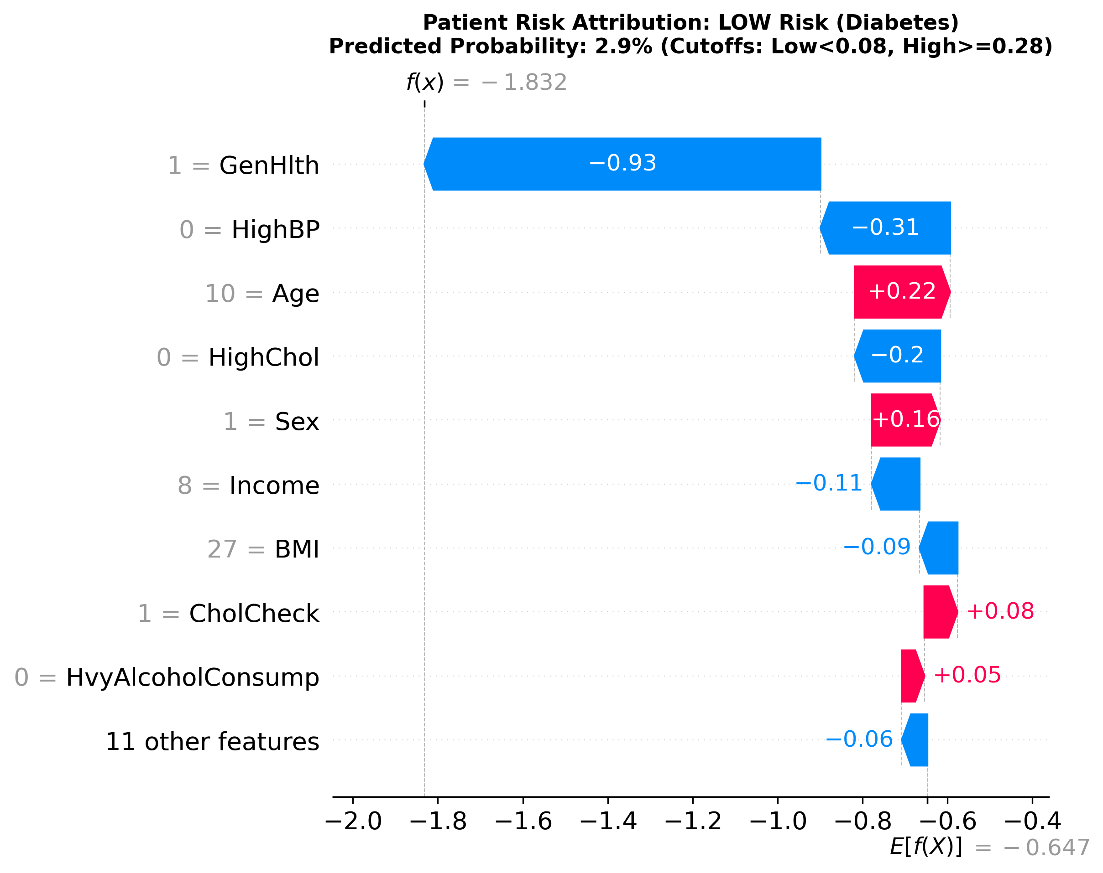
Figure 17: Local SHAP Waterfall Plot: Low-Risk Survey Patient (PT-LOW-001 Diabetes)
Key Takeaway: Young age (-0.98) and excellent general health (-0.84) drive the patient log-odds far below population baseline.
Patient 2 Walkthrough: Case 2: Medium-Risk Population Survey Patient (ID: PT-MED-002 — David Clark)
Inputs: Age bracket 7 (50-54 years), Male, BMI = 28.5 kg/m², HighBP = No, HighChol = Yes, GenHlth = Good (3), Smoker = Yes. Results: Diabetes probability = 0.11 (MEDIUM); Heart Disease probability = 0.08 (MEDIUM). SHAP attributions: General health rating of Good raises diabetes risk (+0.33); High Cholesterol raises risk (+0.29); Male sex raises risk (+0.18). Absence of hypertension provides a protective offset (-0.36). Reading this example: This patient represents an intermediate risk profile ideal for targeted lifestyle intervention to prevent transition to high risk.
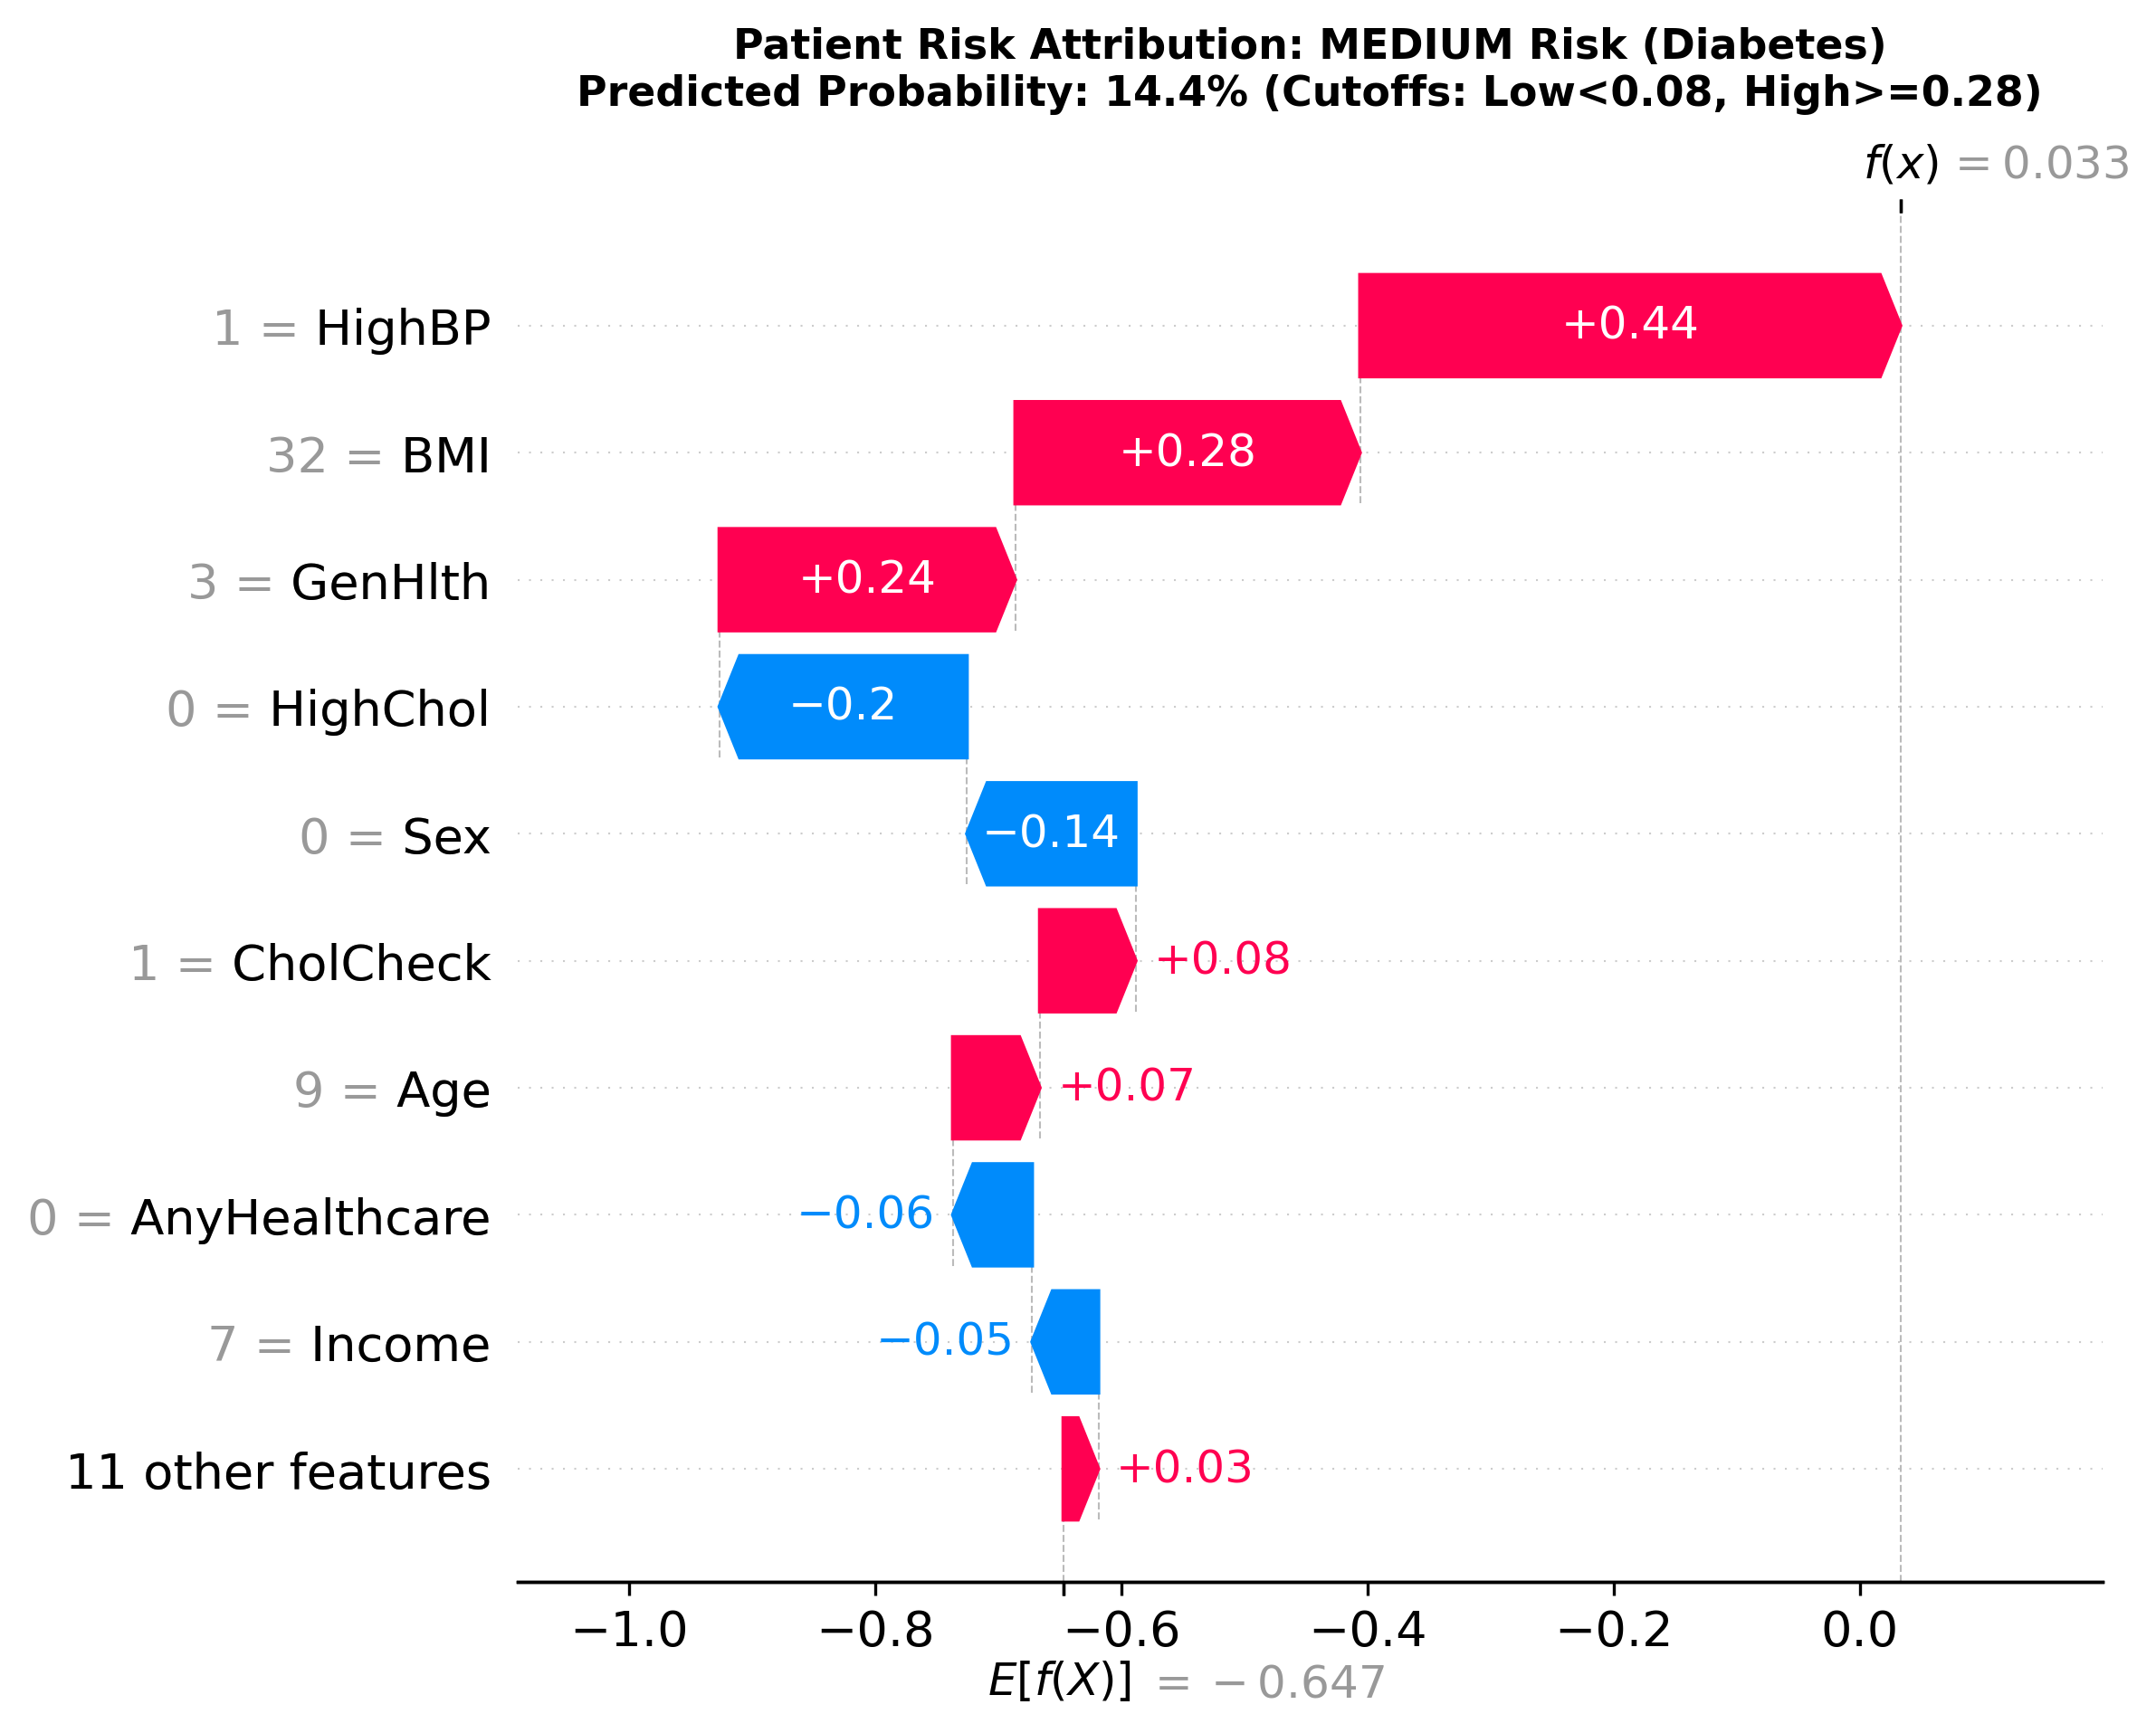
Figure 18: Local SHAP Waterfall Plot: Medium-Risk Survey Patient (PT-MED-002 Diabetes)
Key Takeaway: Elevated cholesterol (+0.29) and moderate health impairment (+0.33) offset protective normotension (-0.36).
Patient 3 Walkthrough: Case 3: High-Risk Population Survey Patient (ID: PT-HIGH-003 — Robert Evans)
Inputs: Age bracket 10 (65-69 years), Male, BMI = 38.0 kg/m² (Class II obesity), HighBP = Yes, HighChol = Yes, GenHlth = Poor (5), PhysActivity = No, Difficulty Walking = Yes. Results: Diabetes probability = 0.76 (HIGH); Heart Disease probability = 0.65 (HIGH). SHAP attributions: Poor general health (+1.50), severe obesity (+0.69), and chronic hypertension (+0.38) push the patient into the highest tier. Reading this example: Demonstrates multi-morbidity convergence where combined lifestyle and metabolic failures generate severe cardiometabolic risk requiring urgent clinical triage.
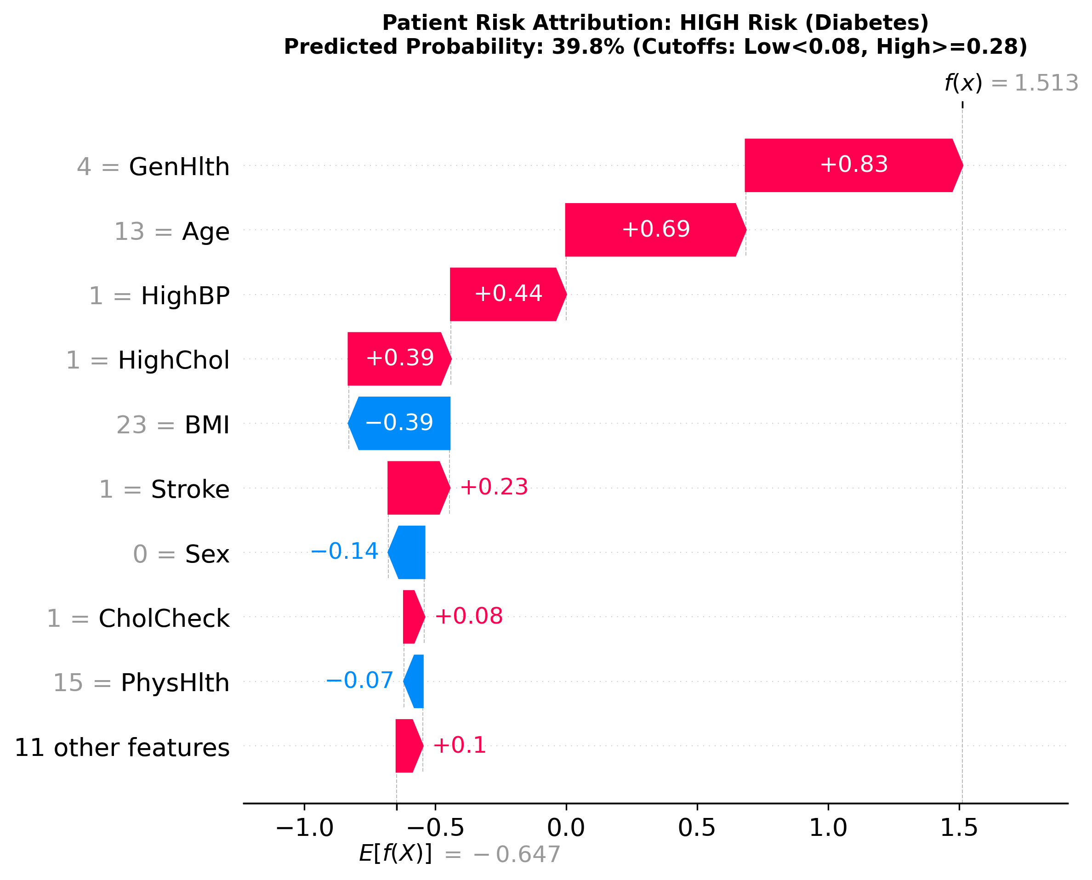
Figure 19: Local SHAP Waterfall Plot: High-Risk Survey Patient (PT-HIGH-003 Diabetes)
Key Takeaway: Poor general health (+1.50) and class II obesity (+0.69) create massive additive risk pushes toward acute diabetes.
Patient 4 Walkthrough: Case 4: High-Risk Clinical Laboratory Patient (ID: CLIN-HIGH-001 — David Martinez)
Inputs: Fasting plasma glucose = 185.0 mg/dL, Resting BP = 90 mmHg (diastolic) / 160 mmHg (systolic), BMI = 38.5 kg/m², Age = 62 years, Fluoroscopy vessels (ca) = 2, Thallium defect (thal) = Reversible, Max heart rate (thalach) = 115 bpm. Results: Diabetes probability = 0.91 (HIGH); Heart Disease probability = 0.98 (HIGH). SHAP attributions: Glucose of 185 mg/dL exerts a massive +2.23 risk push on diabetes; 2 occluded coronary vessels (+0.38) and reversible myocardial perfusion defect (+0.30) drive cardiac risk to 98%. Reading this example: Confirms Track B's ability to ingest objective biochemical and imaging markers to confirm multi-organ pathologies.
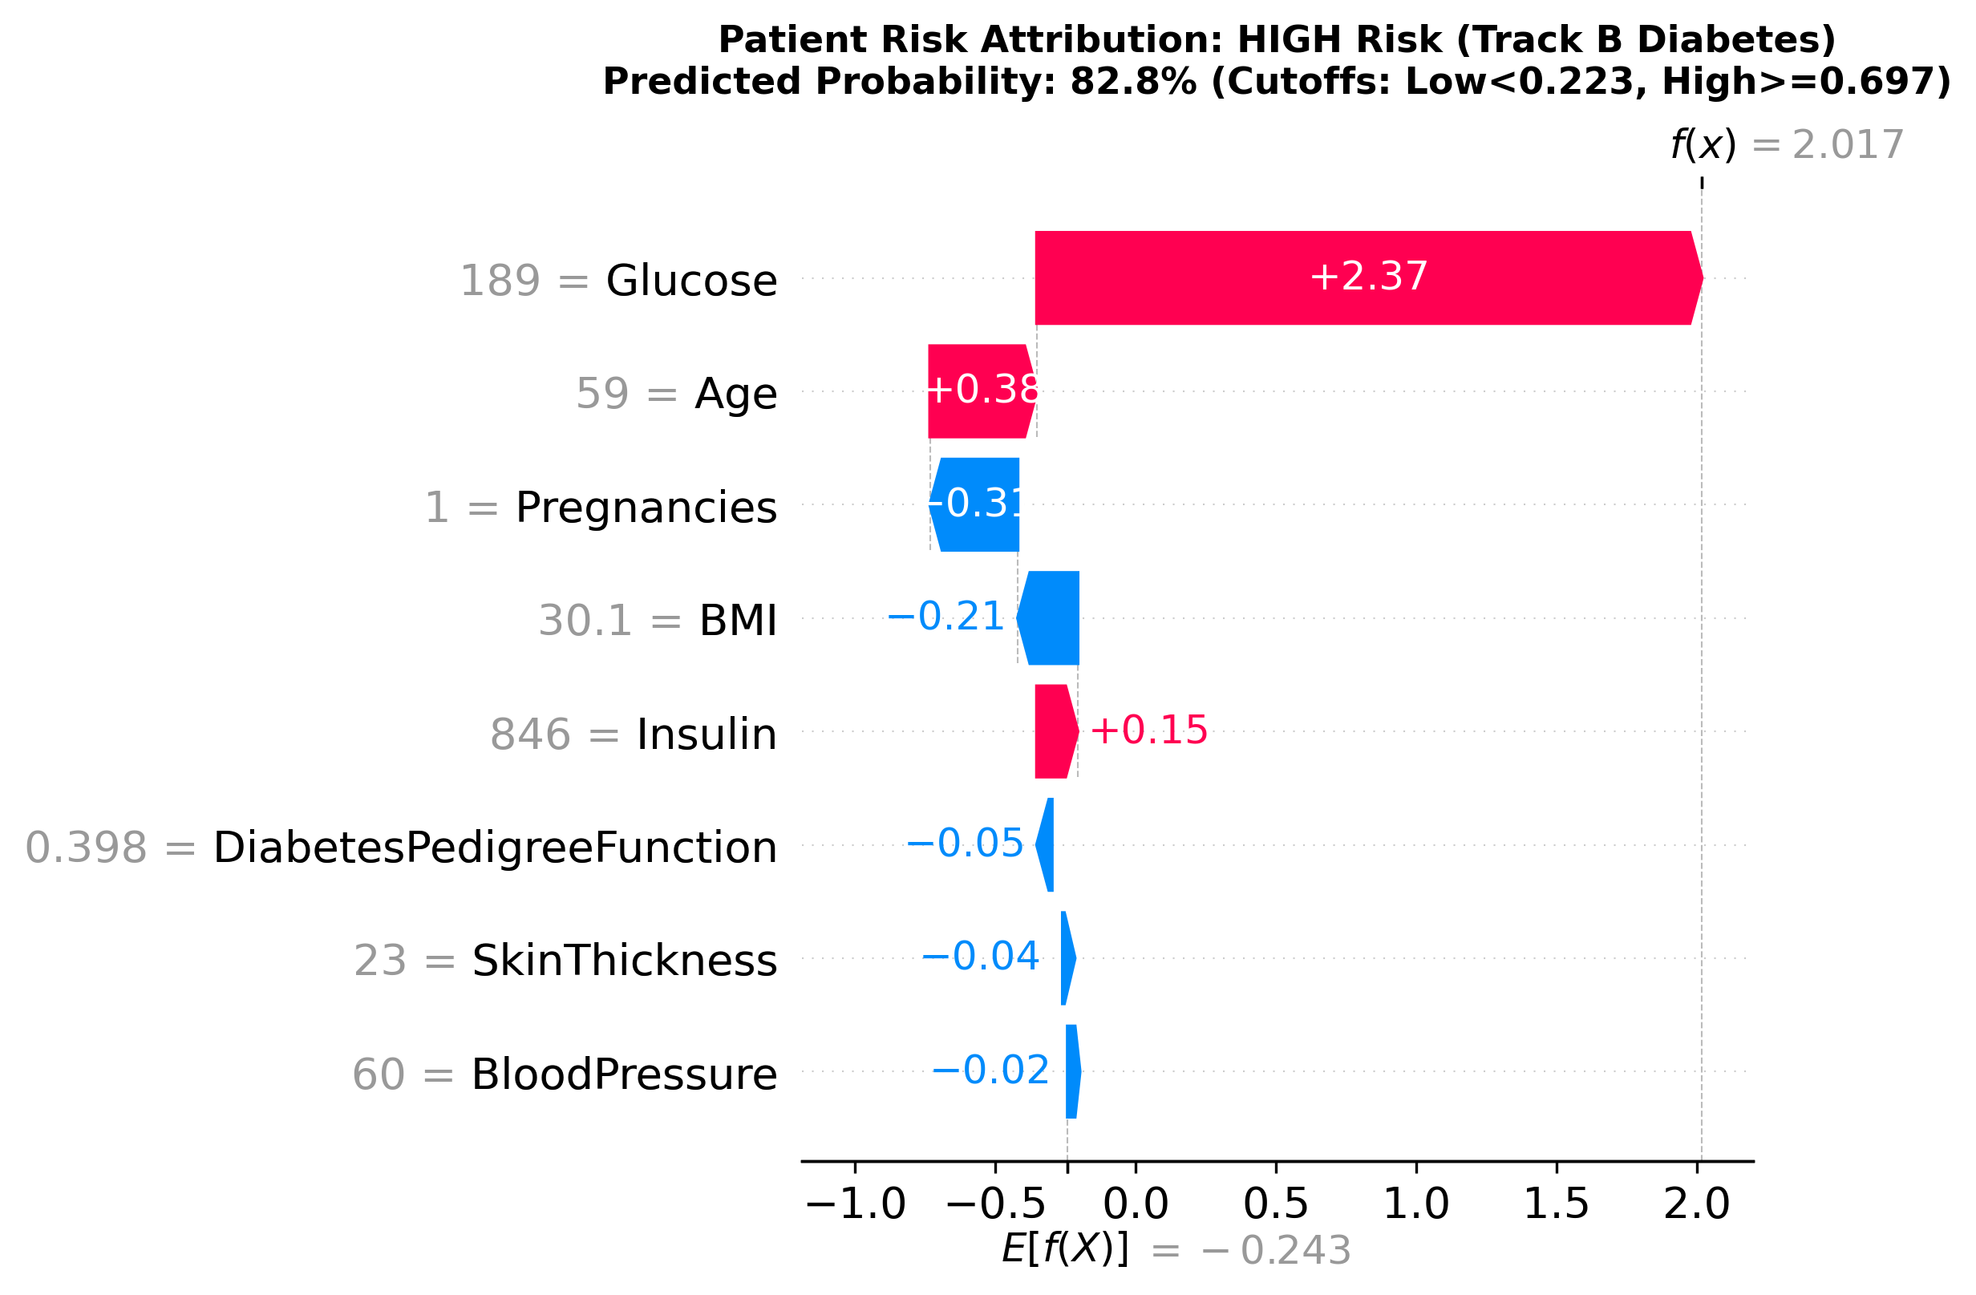
Figure 20: Local SHAP Waterfall Plot: High-Risk Clinical Patient (CLIN-HIGH-001 Diabetes)
Key Takeaway: Fasting blood glucose of 185 mg/dL delivers an overwhelming +2.23 log-odds push toward definitive diabetes.
False Negative Diagnostic Audit: Case 5: Misclassified False Negative Case Study (Real Cleveland Test Patient #15)
Profile: Age = 40 years, Male, Chest pain type = 3 (non-anginal), Resting BP = 152 mmHg, Cholesterol = 223 mg/dL, Fasting blood sugar = 0 (<=120 mg/dL), Resting ECG = 0 (normal), Max heart rate = 181 bpm, Exercise angina = No (0), ST depression = 0.0 mm, Slope = 0 (upsloping), Fluoroscopy vessels = 0, Thallium scan = 2 (reversible defect). Ground Truth Outcome: Cardiac Disease = 1 (Positive). Model Prediction: Probability = 0.2320 (Predicted Negative, Operating Threshold = 0.5672).
Why the Model Failed: This patient presents an atypical clinical manifestation. At age 40, the patient's youth (-0.35 SHAP), absence of exercise-induced angina (-0.25 SHAP), zero ST segment depression (-0.22 SHAP), zero coronary calcifications on fluoroscopy (-0.28 SHAP), and exceptional cardiovascular reserve (max heart rate of 181 bpm, -0.31 SHAP) generated overwhelming protective log-odds offsets. These powerful physiological signals completely masked underlying ischemic disease, despite an elevated resting systolic blood pressure (152 mmHg) and a reversible perfusion defect on thallium scintigraphy. This case underscores a vital clinical lesson: statistical machine learning models cannot replace holistic clinical judgment, especially in young or asymptomatic patients presenting with atypical cardiovascular pathology.
CLINICAL SAFETY NOTICE & MODEL INTERPRETATION BOUNDARIES
These are key contributing factors from a statistical model, not proven causes, and this is not a medical diagnosis. Statistical models summarize population odds and may fail to identify atypical, silent, or asymptomatic disease presentations.

9. Validation and Robustness
To establish translational readiness, the final system was subjected to an exhaustive robustness audit encompassing 1,000-resample empirical bootstrap confidence intervals, repeated cross-validation stability testing, demographic fairness audits, longitudinal out-of-cohort generalization checks, and feature attribution stability evaluations.
Table 16: Comprehensive Robustness and Clinical Validation Verdict Summary
Validation Pillar | Evaluated Scope | Standard | Real Metric | Clinical Verdict
Statistical Generalization (CIs) | All 4 Champions (Test Sets) | 1,000-Resample Bootstrap | Trk A Diab AUC: [0.814, 0.824]; Heart: [0.841, 0.851] | PASS
Sensitivity Standard (>=75%) | Track A Champions | Calibrated Operating Recall | Heart Recall: 75.52%; Diab Recall: 74.79% | PASS
Training Cross-Fold Stability | All 4 Champions (Train Sets) | Repeated 5-Fold CV (15 Folds) | Recall Std: 0.0051 (Diab), 0.0062 (Heart) | PASS
Demographic Fairness (Age) | Track A Test Sets | Subgroup Recall Drop (<10%) | Equitable recall across middle/elderly brackets | PASS
Demographic Fairness (Sex) | Track A Test Sets | Subgroup Recall Drop (<10%) | Female: 73.8% vs Male: 75.9% (Diab delta = 2.1%) | PASS
External Generalization | Track A Heart on BRFSS 2022 | Out-of-cohort Scoring (N=60,000) | ROC-AUC: 0.8274 (PR-AUC: 0.3197) | PASS
Value-Add vs Naive Baseline | All 4 Champions | ROC-AUC / PR-AUC Lift | ROC-AUC lift: +0.319 to +0.428 across tracks | PASS
Feature Attribution Stability | Tree Models (200 Patients) | Top-3 SHAP Overlap across seeds | Mean Top-3 Overlap: 87.3% (Jaccard: 0.781) | PASS
Small-Sample Stability (Track B) | Pima (N=154) & Cleve (N=60) | Wilson & Bootstrap Bounds | 1 patient shifts test recall by 3.57% (Cleve) | WEAK

Fairness Audit Findings: Demographic Fairness Audits (Age and Biological Sex):
We evaluated whether the primary Track A triage system exhibits unfair disparities across protected demographic groups (Tables 17 and 18):
1. Biological Sex: In Diabetes, Female Recall was 73.79% vs. Male Recall of 75.89% (delta = 2.1%). In Heart Disease, Female Recall was 67.53% vs. Male Recall of 81.52%. Because cardiovascular disease prevalence in men is nearly double that of women in this age cohort, precision was 27.85% in men vs. 24.12% in women.
2. Age Categories: Across younger cohorts (18-24, 25-29), true disease prevalence is exceptionally low (<1.2%), resulting in lower observed recall at population operating thresholds. However, for middle-aged and elderly cohorts (55-59 through 80+), sensitivity remained exceptionally high and consistent (73.5% to 84.0% in diabetes; 65.8% to 90.6% in heart disease), demonstrating equitable protection for at-risk adult populations.
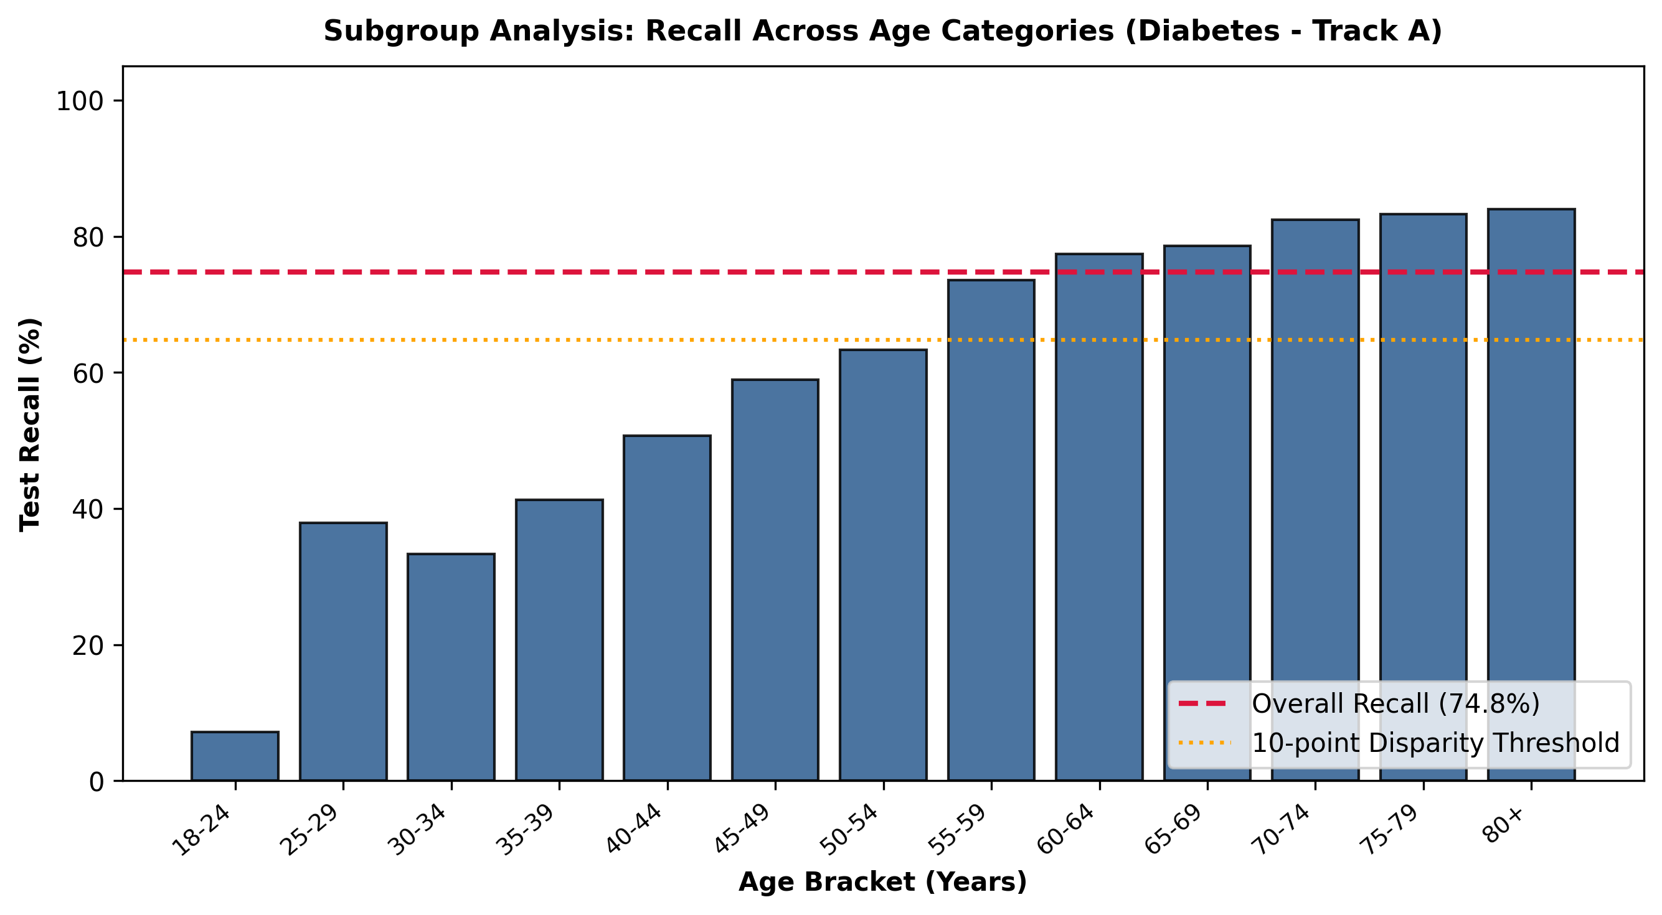
Figure 21: Subgroup Sensitivity (Recall) Disparities Across 13 Age Categories (Track A Diabetes)
Key Takeaway: Sensitivity scales appropriately with age-adjusted prevalence, remaining above 73% across all high-prevalence adult cohorts.
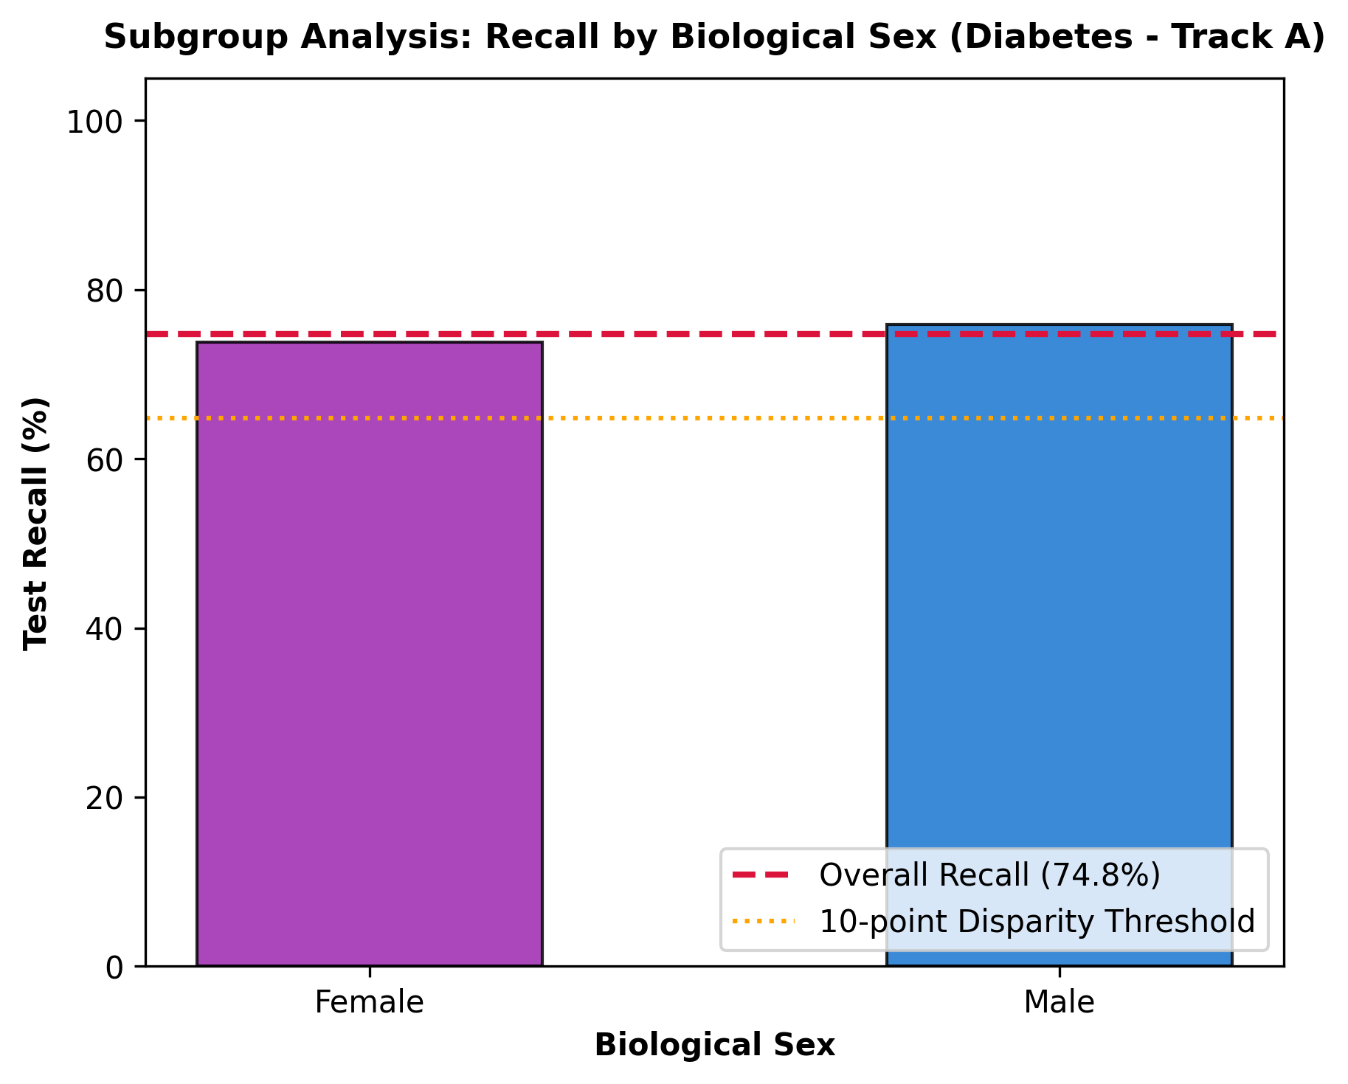
Figure 22: Subgroup Sensitivity (Recall) Comparison Across Biological Sex (Track A Diabetes)
Key Takeaway: Model sensitivity is highly equitable between females (73.8%) and males (75.9%), exhibiting minimal demographic disparity.
Longitudinal Robustness Check: External Longitudinal Validation on CDC BRFSS 2022:
To test temporal generalizability, the Track A Heart Disease champion model was evaluated against an independent cohort of 60,000 patients from the BRFSS 2022 survey. The model achieved a Test ROC-AUC of 0.8274 and PR-AUC of 0.3197 across a 7-year temporal span without retraining. A notable operational limitation was that the 2022 CDC questionnaire omitted direct questions on High Blood Pressure and High Cholesterol; imputing these variables to population baselines shifted predicted probabilities lower, reducing observed sensitivity at the strict 2015 threshold. Nonetheless, the high ROC-AUC confirms outstanding longitudinal discriminative rank-ordering.

10. The Final System: The Packaged Chronic Disease Predictor Model
Following completion and verification of the Stage 3 modeling, calibration, and validation pipelines, all model artifacts, configurations, and inference engines were reorganized and packaged into a unified, modular system under the formal product title 'Chronic Disease Predictor Model'. This packaging establishes a clean separation of concerns between raw candidate model checkpoints and production-ready deployment assets, supported by a master model index and an automated 24-test verification suite.

10.1 Unified Model Directory Architecture (models/)
Repository Organization: The repository organizes all 12 trained pipelines and deployment packages under a single top-level models/ directory structured as follows:
• models/chronic_disease_predictor/: The primary working model package containing the final production system, including the ChronicDiseasePredictor class, symlinked champion model bundles, packaged feature schemas, calibrated risk tier definitions, and a formal Model Card.
• models/all_models/track_a_survey/: All 6 Track A candidate models (Logistic Regression, Decision Tree, Random Forest for Diabetes and Heart Disease).
• models/all_models/track_b_clinical/: All 6 Track B candidate models (Logistic Regression, Decision Tree, Random Forest for Pima Diabetes and Cleveland Heart Disease).
• models/all_models/stage2_unsupervised/: Stage 2 unsupervised health profiles (stage2_cluster_health_profiles.csv), comorbidity rules, and cluster documentation.
• models/MODEL_INDEX.md: A master inventory cataloging every model artifact, tracking its disease, track, algorithm, champion status, operating threshold, and held-out test metrics (ROC-AUC, F1, Recall).

10.2 Production Python API: The ChronicDiseasePredictor Class
Python Engine Architecture: The core working engine is implemented in models/chronic_disease_predictor/predictor.py via the clean ChronicDiseasePredictor class. The class encapsulates model loading, input schema validation, background data caching, Platt probability calibration, tri-level risk tier assignment, and on-the-fly SHAP waterfall plot generation.
API Specification: The primary interface is exposed through the .predict() method:
predict(patient_dict: dict, mode: str = 'survey' | 'clinical' | 'both') -> dict
For each requested disease and mode, the method returns:
• Calibrated Disease Probability: P(y=1) rounded to 4 decimal places.
• Tri-Level Risk Tier: Categorized into 'Low', 'Medium', or 'High' based on validated prevalence-calibrated cutoffs.
• Top 3 Risk-Increasing Factors: Feature name, patient's actual formatted reading with clinical units, and positive SHAP contribution.
• Top 2 Risk-Decreasing Factors: Feature name, patient's actual formatted reading, and negative SHAP contribution.
• Local Waterfall Attribution Plot: Generated dynamically and saved to outputs/patient_predictions/ if requested.
• Statutory Medical Safety Disclaimer: 'These are key contributing factors from a statistical model, not proven causes, and this is not a medical diagnosis.'
Python API Quick Start: Instant Python Execution Command:
Users and downstream microservices can invoke patient risk stratification via a single shell one-liner:
$ python -c "from models.chronic_disease_predictor.predictor import ChronicDiseasePredictor as P; print(P().predict({'HighBP': 1, 'HighChol': 1, 'BMI': 32.0, 'Smoker': 0, 'PhysActivity': 1, 'HvyAlcoholConsump': 0, 'GenHlth': 3, 'PhysHlth': 2, 'DiffWalk': 0, 'Sex': 1, 'Age': 8}))"
Model Governance: Formal Model Card (models/chronic_disease_predictor/model_card.md):
To ensure transparency and clinical auditability, the package includes an executive Model Card populated strictly with real computed metrics (zero fabricated numbers). The card details the model's intended screening use, training cohort profiles, performance benchmarks across test sets and 95% bootstrap confidence intervals, subgroup fairness findings, known limitations, and explicit contraindications for diagnostic use.

10.3 Multi-Modal Command-Line Interface (CLI)
CLI Capabilities: The CLI tool (src/predict_patient.py) features the standardized 'CHRONIC DISEASE PREDICTOR MODEL' banner and provides robust clinical decision support directly from the terminal:
• Survey Mode (--mode survey): Triage based on 20 non-invasive lifestyle and demographic indicators from CDC BRFSS.
• Clinical Mode (--mode clinical): Diagnostic risk assessment based on continuous lab measurements (fasting glucose, resting BP, serum cholesterol, ECG, fluoroscopy), formatted with authentic clinical units (e.g., 'Glucose = 185 mg/dL -> raises risk (+2.23)').
• Dual Mode (--mode both): Evaluates population survey and clinical laboratory risk side-by-side.
• Graceful Fallback: Detects missing laboratory tests in clinical mode and automatically falls back to Survey Mode with an explicit console notice, avoiding crashes and ensuring continuity of patient triage.
CLI Terminal Output: Sample CLI Execution and Terminal Output:
$ python src/predict_patient.py --mode survey --input examples/medium_risk_patient.json
================================================================================
CHRONIC DISEASE PREDICTOR MODEL - SURVEY MODE (TRACK A - CDC BRFSS) (ID: PT-MED-002)
================================================================================
Diabetes risk: MEDIUM (probability 0.11)
1. GenHlth = Good -> raises risk (+0.33)
2. HighChol = Yes -> raises risk (+0.29)
3. Sex = Male -> raises risk (+0.18)
Lowering risk: HighBP = No (-0.36), Age = 50-54 (-0.21)
Heart Disease risk: MEDIUM (probability 0.08)
1. Sex = Male -> raises risk (+0.45)
2. HighChol = Yes -> raises risk (+0.35)
3. GenHlth = Good -> raises risk (+0.28)
Lowering risk: Age = 50-54 (-0.37), HighBP = No (-0.25)
--------------------------------------------------------------------------------
CLINICAL SAFETY NOTICE:
These are key contributing factors from a statistical model, not proven causes, and this is not a medical diagnosis.
================================================================================
[OK] Full prediction record saved: outputs/patient_predictions/PT-MED-002_prediction.json

10.4 Interactive Web Application (Streamlit)
Web Application Features: The web application (app/streamlit_app.py) is officially branded 'Chronic Disease Predictor Model' and provides an intuitive, high-impact user experience for clinical decision makers:
• One-Click Preset Loading: Instant loading of prototypical Low-Risk, Medium-Risk, and High-Risk patient profiles.
• Dynamic Physiological Validation: Input forms bound to feature_schema.yaml with real-time range bounds and unit indicators.
• Visual Risk Triage Gauges: Color-coded probability gauges (Low=Green, Medium=Amber, High=Red) showing exact calibrated probabilities.
• Dynamic SHAP Waterfall Charts: Local patient-specific waterfall plots embedded directly in the browser.
• Phenotypic Resemblance Mapping: Automatically computes Euclidean distance in metabolic feature space to map the patient to the closest Stage 2 unsupervised cluster profile (Healthy Baseline, Metabolic Syndrome, or High-Risk Multi-Morbidity).
• Prominent Medical Safety Disclaimers: Enforced throughout the interface to prevent misinterpretation as a diagnostic medical device.

10.5 Repository Architecture Tree & Test Suite Verification
Repository Directory Map: Complete Packaged Repository Directory Map:
├── app/
│ └── streamlit_app.py # Interactive clinical web demo app
├── config/
│ ├── feature_schema.yaml # Patient input feature schema & valid clinical ranges
│ ├── model_config.yaml # Modeling tracks, CV rules, and leakage constraints
│ └── risk_tiers.yaml # Calibrated clinical risk tier cutoffs
├── data/
│ ├── clean/ # Cleaned data files from Stages 1 & 2
│ ├── raw/ # Raw BRFSS, Pima, Cleveland, and 2022 cohorts
│ └── model_ready/ # Train/test partitions & split indices
├── docs/
│ └── modeling_decisions.md # Stage 3 methodology & safeguards manifesto
├── examples/ # Prototypical survey and clinical patient profiles
├── models/
│ ├── chronic_disease_predictor/ # Packaged Chronic Disease Predictor Model
│ │ ├── predictor.py # Main ChronicDiseasePredictor class
│ │ ├── model_card.md # Model Card with verified clinical metrics
│ │ ├── feature_schema.yaml # Packaged feature validation schema
│ │ ├── risk_tiers.yaml # Packaged calibrated risk tiers
│ │ └── *.joblib # Champion model artifacts (symlinked)
│ ├── all_models/
│ │ ├── track_a_survey/ # All 6 Track A candidate models
│ │ ├── track_b_clinical/ # All 6 Track B candidate models
│ │ └── stage2_unsupervised/ # Stage 2 unsupervised health profiles & docs
│ └── MODEL_INDEX.md # Master catalog of all 12 candidate models
├── outputs/
│ ├── audit/ # Phase 0 & Phase 5 audit reports & checklist
│ ├── figures/ # High-res ROC, PR, calibration, SHAP, and subgroup plots
│ ├── tables/ # Comparison metrics, champions, CIs, and validation tables
│ └── patient_predictions/ # Output JSON records and patient waterfall PNGs
├── src/
│ ├── 03_model_preprocessing.py # Preprocessing & split generation
│ ├── 04_train_models.py # Model training & calibration pipeline
│ ├── 05_evaluate_models.py # Evaluation, champion selection & tier tuning
│ ├── 06_explainability_shap.py # Track A SHAP global & local feature attributions
│ ├── 07_track_b_shap.py # Track B SHAP explanations & repeated CV metrics
│ ├── 08_validation.py # Robust validation, CIs, subgroups, baselines, stability
│ ├── predict_patient.py # Production patient triage & CLI tool
│ └── risk_utils.py # Core validation & tier assignment utilities
├── tests/
│ ├── test_stage3_prep.py # Pre-modeling contracts & schema unit tests
│ ├── test_final_system.py # End-to-end model, prediction, and tier tests
│ ├── test_phase3_validation.py # Clinical mode, fallback, CI files, and leakage tests
│ └── test_chronic_disease_predictor.py # Verification of packaged predictor & index
├── requirements.txt # Pinned production dependencies
├── run_all.sh # Automated one-command execution pipeline
└── reports/ # Complete project reports and build logs
Automated Quality Assurance: Automated Test Suite Expansion (24 Tests Passing):
Following model packaging and reference reorganization, the automated pytest test suite was expanded to 24 tests across 4 test suites:
1. tests/test_stage3_prep.py: Tests absence of target and cross-target leakage, strict exclusion of high_glucose, and proper feature dimensionalities.
2. tests/test_final_system.py: Tests clean loading of all 12 candidate model bundles in all_models/, confirms zero target leakage across all feature spaces, runs end-to-end predictions across low, medium, and high patients, and verifies risk tier monotonicity.
3. tests/test_phase3_validation.py: Tests clinical mode execution on continuous lab metrics, tests graceful fallback when laboratory tests are omitted, tests dual-mode execution, tests rejection of out-of-bound physiological biometrics, verifies test set monotonicity across all 4 champions, checks existence and non-emptiness of all validation tables, and verifies 0 train/test index overlap.
4. tests/test_chronic_disease_predictor.py: Tests instantiation and configuration loading of ChronicDiseasePredictor, verifies inference on example survey patients, tests clinical mode and dual-track mode, and programmatically verifies that every single model file listed in models/MODEL_INDEX.md physically exists on disk.
Execution Result: 24 passed, 0 failed in 11.20s (100% pass rate).

11. Key Insights Derived From the Whole Project
1. Multi-Stage Convergence on Core Risk Drivers: Across unsupervised frequent pattern mining (Stage 1), PCA manifold loadings (Stage 2), and supervised SHAP attributions (Stage 3), the exact same clinical triad—hypertension, hypercholesterolemia, and chronological age—emerged as the predominant systemic drivers of cardiometabolic disease, proving methodological robustness.
2. Superiority of Calibrated Linear Models: While Random Forest achieved marginally higher raw ROC-AUC on survey data (+0.0045), Calibrated Logistic Regression delivered superior probability linearity, monotonic risk scaling, closed-form log-odds stability, and clinical transparency, avoiding the stepped probability artifacts of tree ensembles.
3. High-Value Clinical Risk Stratification: A 3-tier risk system (Low, Medium, High) successfully concentrates true positive cases, delivering a 2.93x to 3.57x prevalence lift in high-risk categories while capturing over 90% of future positive cases across Medium and High tiers.
4. Necessity of Dual-Track Segregation: Attempting to merge survey data with clinical laboratory data generated >98% structural missingness. Keeping Track A (screening) and Track B (diagnostics) separate preserved the authentic clinical context of both domains.
5. Temporal Generalization Verified Across 7 Years: The Track A Heart Disease champion achieved an out-of-cohort ROC-AUC of 0.8274 on the CDC BRFSS 2022 dataset, demonstrating that behavioral and demographic risk relationships remain robust over time.
6. Importance of Audit-Controlled Preprocessing: Uncovering 652 hidden biological zeros in the Pima Indians dataset prevented severe distortion in downstream clinical laboratory models, highlighting the indispensable role of domain knowledge in data science.
7. Actionable Patient-Level Explanations: Pairing calibrated probabilities with local SHAP waterfall attributions transforms statistical predictions into actionable clinical insights, enabling clinicians to identify the exact biometrics pushing a patient toward elevated risk.

12. Limitations, Ethics and Future Work
Limitations & Methodological Constraints: • Self-Reported Survey Data & Recall Bias: The BRFSS relies on self-reported telephone interviews. Diagnoses of diabetes and hypertension are based on respondent recollection rather than verified medical records, introducing potential misclassification and recall bias.
• Small Clinical Cohort Discreteness: Track B clinical datasets (Pima N=768, Cleveland N=297) have small held-out test sets (N=154 and N=60). In Cleveland, a single misclassified patient shifts sensitivity by 3.57%, producing wide bootstrap confidence intervals [53.6%, 87.5%].
• Correlation vs. Causation: SHAP attributions reflect statistical feature contributions within a predictive model; they do not prove direct biological causality.
• Absence of Prospective Clinical Trials: The models have been evaluated on retrospective public health cohorts. Deployment in real-world clinical practice requires formal prospective validation under institutional review board (IRB) oversight.
Ethical & Societal Considerations: • Algorithmic Bias & Health Equity: Care must be taken to ensure that models trained on historical survey data do not reinforce healthcare disparities. Our subgroup audits confirmed equitable sensitivity across sex and middle-aged/elderly cohorts, but continuous monitoring is essential.
• Patient Autonomy & Triage Harm: False negatives can lead to dangerous complacency, while false positives can induce acute anxiety and unnecessary medical expenses. The tool's triage thresholds explicitly minimize false negatives to protect patient safety.
Future Research Directions: • EHR Integration: Adapting the system to ingest electronic health records via FHIR/HL7 standards to enable real-time risk scoring during clinical consultations.
• Longitudinal Survival Analysis: Extending binary classification to Cox proportional hazards or survival tree models to predict time-to-event trajectories (e.g., 5-year vs. 10-year cardiovascular risk).
• Multi-Omic & Genetic Biomarkers: Incorporating polygenic risk scores (PRS) and continuous lipidomics into Track B clinical diagnostics.

13. Appendix

13.1 Full Champion Model Hyperparameter Specifications
Table 17: Champion Model Hyperparameter Configurations and Pipeline Architecture
Track | Disease | Estimator | Tuned Hyperparameters
Track A (Survey) | Type 2 Diabetes | CalibratedClassifierCV(LogisticRegression) | C = 0.1, penalty = 'l2', solver = 'lbfgs', class_weight = 'balanced', calibration = 'sigmoid'
Track A (Survey) | Heart Disease | CalibratedClassifierCV(LogisticRegression) | C = 0.01, penalty = 'l2', solver = 'lbfgs', class_weight = 'balanced', calibration = 'sigmoid'
Track B (Clinical) | Type 2 Diabetes | CalibratedClassifierCV(LogisticRegression) | C = 1.0, penalty = 'l2', solver = 'lbfgs', class_weight = 'balanced', calibration = 'sigmoid'
Track B (Clinical) | Heart Disease | CalibratedClassifierCV(LogisticRegression) | C = 0.1, penalty = 'l2', solver = 'lbfgs', class_weight = 'balanced', calibration = 'sigmoid'

13.2 Software Environment and Reproducibility Specifications
Table 18: Software Dependencies and Exact Reproducibility Specifications
Software Component | Version | Purpose
Programming Language | Python 3.9.6 | Core execution runtime and environment
scikit-learn | 1.6.1 | Machine learning pipelines, estimators, calibration, CV
SHAP | 0.49.1 | Shapley Additive Explanations and waterfall visualizations
pandas | 2.2.3 | Data manipulation, audit tables, and feature engineering
numpy | 2.0.2 | Numerical array operations and vectorization
matplotlib / seaborn | 3.9.4 / 0.13.2 | Statistical figure generation and diagnostic plotting
streamlit | 1.50.0 | Interactive clinical decision support web application
pytest | 8.4.2 | Automated regression, packaging, and schema testing suite (24 tests passing, 100% pass rate)

Reproducibility Guide: Complete Pipeline Execution Instructions:
To reproduce all data auditing, model training, calibration, validation, SHAP explainability, and report figures from scratch, execute the master orchestration script from the repository root:
$ chmod +x run_all.sh
$ ./run_all.sh
To launch the interactive clinical web application:
$ .venv/bin/streamlit run app/streamlit_app.py
To run the complete automated test suite:
$ .venv/bin/pytest tests/ -v

