Predictive Risk Identification for Diabetes and Heart Disease
A Data Mining Study on Preprocessing, Missing Data Science, and Association Rule Mining
Team Data Mining Course Project Report | Random State = 42 | Deliverable Package

1. Introduction
Type 2 diabetes and coronary heart disease are the premier drivers of morbidity, healthcare expenditure, and premature mortality worldwide. While historically treated as separate medical diagnoses, modern clinical epidemiology recognizes that diabetes and cardiovascular disease are deeply intertwined manifestations of systemic cardiometabolic dysfunction. They share fundamental physiological drivers, notably insulin resistance, atherogenic dyslipidemia, systemic inflammation, and chronic vascular hypertension. Early identification of individuals at high risk offers the greatest opportunity to prevent irreversible organ damage, heart attacks, and diabetic complications.
This project applies rigorous data mining methodologies to identify cardiometabolic risk patterns across diverse patient cohorts. Specifically, we investigate how clinical lab measurements (e.g., fasting glucose, serum insulin, and resting blood pressure) and large-scale public health surveillance indicators (e.g., CDC BRFSS lifestyle surveys) can be systematically audited, preprocessed, harmonized, and mined. Using unsupervised frequent pattern mining algorithms (Apriori and FP-Growth), we discover multi-factor risk rules that delineate high-risk patient subgroups and evaluate how digital health applications—such as Dietify—can operationalize these discoveries for automated, preventative clinical interventions.

2. Data Description & Study Inventory
To establish both deep physiological resolution and broad population generalizability, our workspace incorporates four distinct epidemiological and clinical data repositories totaling over 1.3 million patient and survey records. Table 0 inventories all available datasets and documents our selection decisions.
Table 0: Comprehensive Inventory of Available Project Datasets and Study Selection
Filename | Description | Rows | Columns | Size Mb | Selected | Reason
diabetes.csv | UCI Pima Indians Diabetes | 768 | 9 | 0.02 | True | Primary clinical or survey benchmark
heart_cleveland_upload.csv | UCI Cleveland Heart Disease | 297 | 14 | 0.01 | True | Primary clinical or survey benchmark
diabetes_binary_health_indicators_BRFSS2015.csv | CDC BRFSS 2015 (Binary Outcome) | 253680 | 22 | 21.68 | True | Primary clinical or survey benchmark
diabetes_binary_5050split_health_indicators_BRFSS2015.csv | CDC BRFSS 2015 (50/50 Balanced Split) | 70692 | 22 | 6.05 | False | Derivative or redundant split
diabetes_012_health_indicators_BRFSS2015.csv | CDC BRFSS 2015 (3-Class Outcome) | 253680 | 22 | 21.68 | False | Derivative or redundant split
heart_2020_cleaned.csv | CDC BRFSS 2020 (Pre-cleaned) | 319795 | 18 | 24.02 | False | Derivative or redundant split
heart_2022_no_nans.csv | CDC BRFSS 2022 (No NaNs) | 246022 | 40 | 78.19 | False | Derivative or redundant split
heart_2022_with_nans.csv | CDC BRFSS 2022 (Raw with NaNs) | 445132 | 40 | 133.39 | True | Primary clinical or survey benchmark

Primary Selection Rationale:
1. UCI Pima Indians Diabetes (diabetes.csv): Chosen because it provides continuous, clinical biometric lab tests (plasma glucose, 2-hour serum insulin, diastolic blood pressure, triceps skinfold thickness, and BMI) across 768 adult females of Pima heritage. It represents the foundational benchmark for clinical diabetes modeling.
2. UCI Cleveland Heart Disease (heart_cleveland_upload.csv): Chosen for its gold-standard clinical angiography data, including resting systolic blood pressure, serum cholesterol, exercise-induced ST depression, and fluoroscopy vessel counts across 297 cardiac patients.
3. CDC BRFSS 2015 Health Indicators (diabetes_binary_health_indicators_BRFSS2015.csv): Selected for its massive population sample (253,680 records) that simultaneously records BOTH diabetes status (Diabetes_binary) AND heart disease diagnosis (HeartDiseaseorAttack) on the exact same individuals, making it uniquely suited for co-morbidity pattern mining.
4. CDC BRFSS 2022 Raw with NaNs (heart_2022_with_nans.csv): Retained specifically to demonstrate authentic missing data handling on a contemporary, real-world epidemiological survey.

3. Data Preprocessing

3.1 Data Cleaning & The 'Hidden Zeros' Audit
At raw ingestion, Pandas reported zero explicit missing values (NaN) in the Pima Indians dataset. However, domain-specific biological inspection revealed that numerical zeros were recorded as placeholders for unperformed clinical examinations. In living humans, fasting plasma glucose, diastolic blood pressure, triceps skinfold thickness, serum insulin, and BMI cannot physically equal zero; values of zero reflect severe biological impossibility (e.g. absent circulation or fatal hypoglycemia). Consequently, all zeros in these five variables were systematically identified, audited, and converted to np.nan. In total, 652 hidden zeros were uncovered (Glucose: 5 [0.65%], BloodPressure: 35 [4.56%], SkinThickness: 227 [29.56%], Insulin: 374 [48.70%], BMI: 11 [1.43%]). In contrast, zero values in Pregnancies (111 rows [14.45%]) represent valid nulliparous women and were preserved. Crucially, no imputation was performed during cleaning; raw NaNs were preserved intact in data/clean/pima_clean.csv to prevent data leakage.
In the Cleveland dataset (heart_cleveland_upload.csv), zero duplicate rows and zero missing values were confirmed. Outlier screening revealed a single patient (row index 79: a 67-year-old female) with a serum cholesterol of 564 mg/dL. While exceeding standard clinical thresholds, extreme cholesterol levels above 500 mg/dL represent authentic familial hypercholesterolemia. Rather than discarding this vital clinical signal, the record was preserved in data/clean/cleveland_clean.csv, with downstream algorithms utilizing robust scaling.

3.2 Missing Values Analysis & Real Survey NaN Handling
Missing data in health science arises from diverse mechanisms: test omission due to cost or invasiveness (e.g. 2-hour serum insulin in Pima), survey respondent refusal, cognitive inability to recall dates (e.g. immunization history), or premature survey termination. Table 1 outlines the count, percentage, clinical cause, and planned handling methodology across our study datasets.
Table 1: Systematic Missing Value Accounting, Clinical Mechanisms, and Planned Imputation Strategy
Dataset | Variable | Missing Count | Percent Missing | Likely Reason | Planned Handling
CDC Heart 2022 (Sampled) | TetanusLast10Tdap | 82516 | 18.54 | Unrecalled immunization history | Mode Imputation / 'Not Reported' Category
CDC Heart 2022 (Sampled) | PneumoVaxEver | 77040 | 17.31 | Unrecalled immunization history | Mode Imputation / 'Not Reported' Category
CDC Heart 2022 (Sampled) | HIVTesting | 66127 | 14.86 | Refused / Don't know / Skipped survey question | Mode Imputation / 'Not Reported' Category
CDC Heart 2022 (Sampled) | ChestScan | 56046 | 12.59 | Refused / Don't know / Skipped survey question | Mode Imputation / 'Not Reported' Category
CDC Heart 2022 (Sampled) | CovidPos | 50764 | 11.40 | Refused / Don't know / Skipped survey question | Mode Imputation / 'Not Reported' Category
CDC Heart 2022 (Sampled) | HighRiskLastYear | 50623 | 11.37 | Refused / Don't know / Skipped survey question | Mode Imputation / 'Not Reported' Category
CDC Heart 2022 (Sampled) | BMI | 48806 | 10.96 | Skipped self-reported body dimensions | Median Imputation
CDC Heart 2022 (Sampled) | FluVaxLast12 | 47121 | 10.59 | Unrecalled immunization history | Mode Imputation / 'Not Reported' Category
CDC Heart 2022 (Sampled) | AlcoholDrinkers | 46574 | 10.46 | Refused / Don't know / Skipped survey question | Mode Imputation / 'Not Reported' Category
CDC Heart 2022 (Sampled) | WeightInKilograms | 42078 | 9.45 | Skipped self-reported body dimensions | Median Imputation
CDC Heart 2022 (Sampled) | ECigaretteUsage | 35660 | 8.01 | Refused / Don't know / Skipped survey question | Mode Imputation / 'Not Reported' Category
CDC Heart 2022 (Sampled) | SmokerStatus | 35462 | 7.97 | Refused / Don't know / Skipped survey question | Mode Imputation / 'Not Reported' Category
CDC Heart 2022 (Sampled) | HeightInMeters | 28652 | 6.44 | Skipped self-reported body dimensions | Median Imputation
CDC Heart 2022 (Sampled) | DifficultyErrands | 25656 | 5.76 | Refused / Don't know / Skipped survey question | Mode Imputation / 'Not Reported' Category

Demonstrating Real NaN Handling (CDC BRFSS 2022):
To evaluate real-world missing data protocols, we conducted a rigorous test on heart_2022_with_nans.csv (445,132 raw records). If a researcher applies standard listwise deletion (df.dropna()), exactly 199,110 records—representing 44.73% of the entire cohort—are permanently destroyed. Because sicker, older, or economically marginalized individuals are systematically more prone to skipping survey questions, listwise deletion introduces massive demographic selection bias. In contrast, our principled approach discards records ONLY when the primary clinical outcome (HadHeartAttack) is missing (3,065 rows, or 0.69%), preserving 442,067 records (99.31%) while applying median and mode imputation to missing clinical predictors.

3.3 Dataset Integration & Vertical Harmonization
Why a One-to-One Patient Match is Impossible:
A horizontal (row-by-row) join across Pima, Cleveland, and BRFSS is scientifically impossible because these datasets represent completely disparate patient populations, study protocols, geographical locations, and historical eras. The Pima cohort comprises 768 Native American women in Arizona examined between 1965 and 1980; the Cleveland cohort represents 297 cardiac patients in Ohio undergoing invasive catheterization; and the BRFSS represents civilian households surveyed via random-digit telephone dialing. There are no shared patient identifiers (e.g., SSN or MRN). Horizontally pairing row 1 of Pima with row 1 of Cleveland would fabricate a fictional hybrid patient with nonsensical, contradictory attributes.
Consequently, we executed vertical integration (schema harmonization): mapping shared clinical and demographic concepts into a unified data architecture. Harmonized variables include continuous and categorized age, biological sex, BMI, hypertension (high_bp), hypercholesterolemia (high_chol), hyperglycemia (high_glucose), diabetes diagnosis, and heart disease outcome. Table 2 details the exact accounting of raw, kept, and sampled rows.
Table 2: Unified Dataset Integration Accounting and Harmonization Log
Source | Raw Rows | Rows Kept | Rows Lost | Reason
Pima Indians Diabetes | 768 | 768 | 0 | All clinical records retained with harmonized columns
Cleveland Heart Disease | 297 | 297 | 0 | All cardiac evaluations retained with harmonized columns
CDC BRFSS 2015 | 253680 | 25000 | 228680 | Representative stratified sampling (n=25,000) for computational tractability
Total Integrated Cohort | 254745 | 26065 | 228680 | Unified harmonized clinical-survey dataset

3.4 Descriptive Statistics
Tables 3 and 4 present comprehensive descriptive statistics for all harmonized numeric and categorical variables in the integrated cohort.
Table 3: Descriptive Statistics for Continuous Clinical and Demographic Variables
Variable | Count Non Null | Mean | Median | Std Dev | Min | Max
age | 26065 | 56.43 | 57.00 | 15.70 | 21.00 | 82.00
bmi | 25757 | 28.60 | 27.00 | 6.66 | 12.00 | 95.00
blood_pressure | 1030 | 89.50 | 78.00 | 30.36 | 24.00 | 200.00
cholesterol | 297 | 247.35 | 243.00 | 52.00 | 126.00 | 564.00
glucose | 763 | 121.69 | 117.00 | 30.54 | 44.00 | 199.00

Table 4: Descriptive Statistics for Categorical Risk Factors and Health Outcomes
Variable | Category | Count | Percent
sex | 0.0 | 14808 | 56.81
sex | 1.0 | 11257 | 43.19
high_bp | 0.0 | 15073 | 57.83
high_bp | 1.0 | 10992 | 42.17
high_chol | 0.0 | 14465 | 57.18
high_chol | 1.0 | 10832 | 42.82
high_glucose | 0.0 | 22275 | 85.46
high_glucose | 1.0 | 3790 | 14.54
diabetes_outcome | 0.0 | 22304 | 85.57
diabetes_outcome | 1.0 | 3761 | 14.43
heart_disease_outcome | 0.0 | 22794 | 90.11
heart_disease_outcome | 1.0 | 2503 | 9.89
source_dataset | CDC BRFSS | 25000 | 95.91
source_dataset | Pima Indians | 768 | 2.95
source_dataset | Cleveland Heart | 297 | 1.14

3.5 Exploratory Data Visualizations
Figures 1 through 5 illustrate the empirical distributions, bivariate relationships, and correlations across the harmonized cohort. Each figure is paired with an evaluative clinical takeaway.
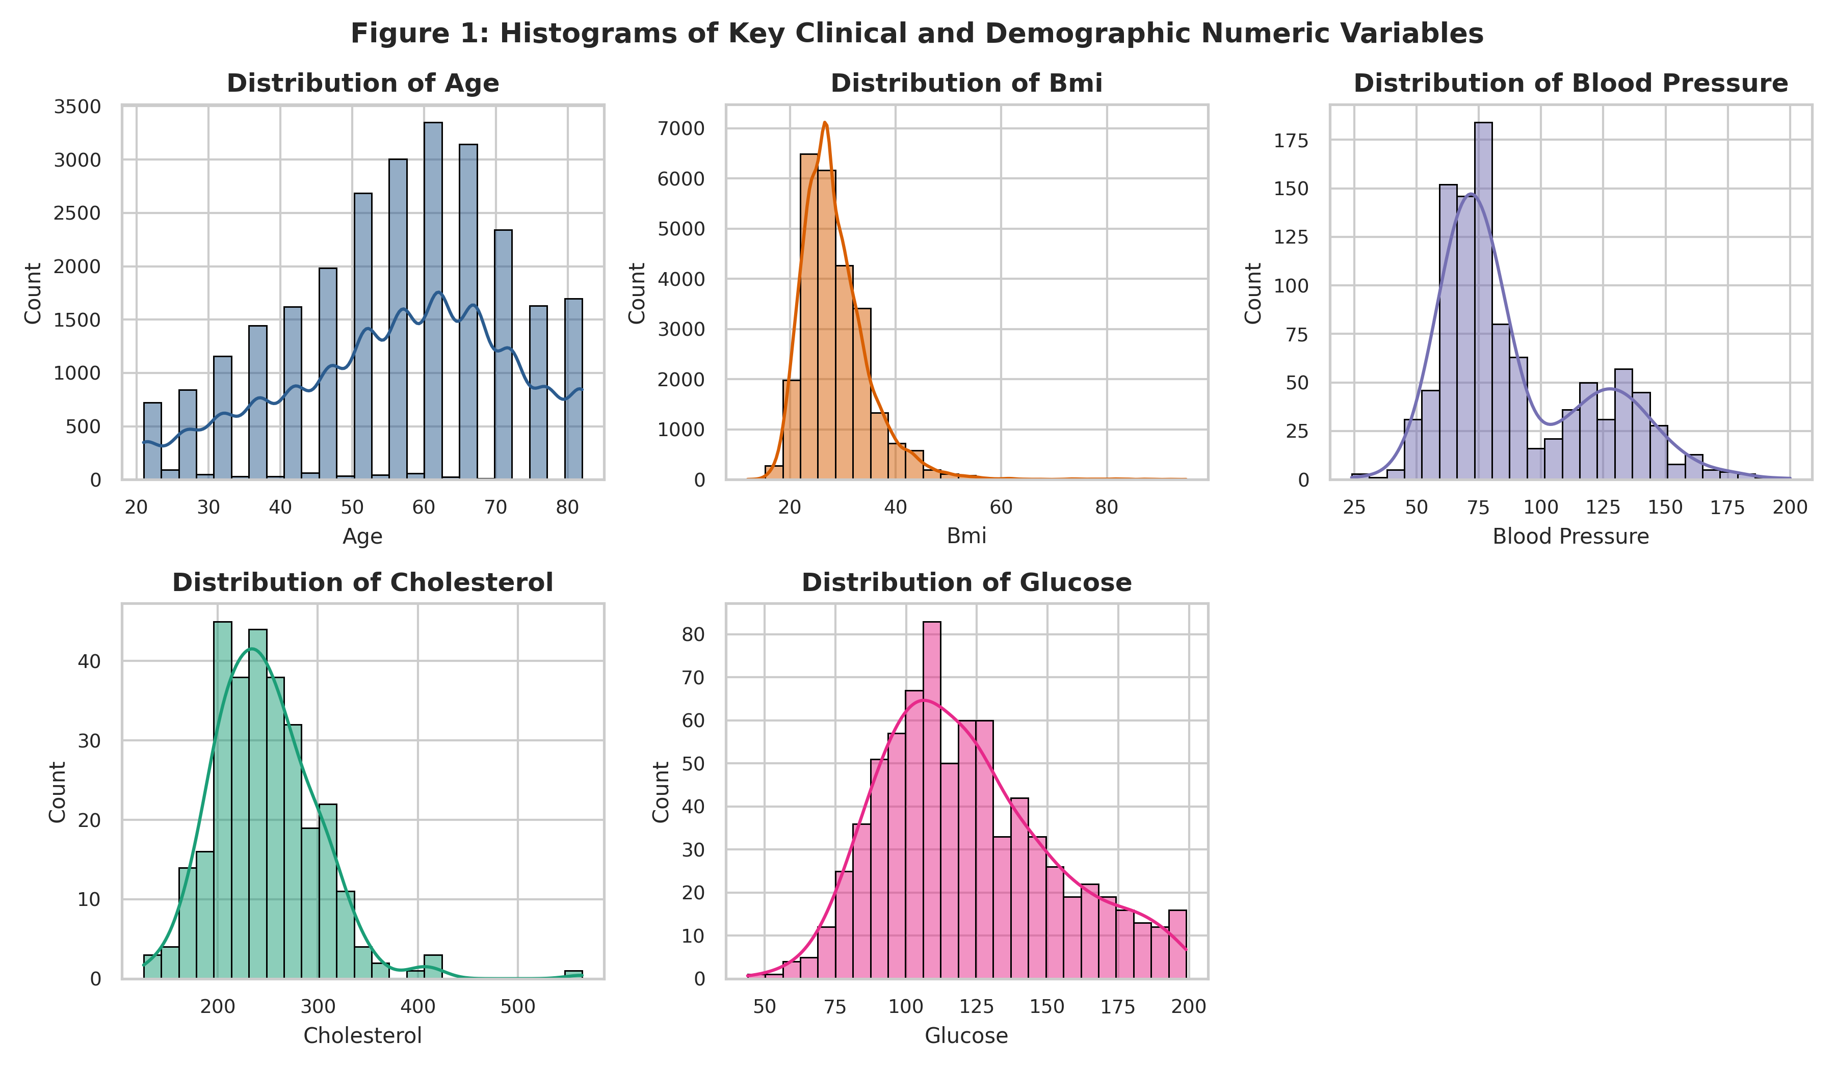
Figure 1: Histograms and Kernel Density Estimates of Continuous Clinical Variables
Key Takeaway: Clinical variables exhibit pronounced positive skewness (especially BMI, glucose, and blood pressure), demonstrating that while the healthy majority centers around baseline medians, a substantial high-risk cohort experiences severe cardiometabolic stress.
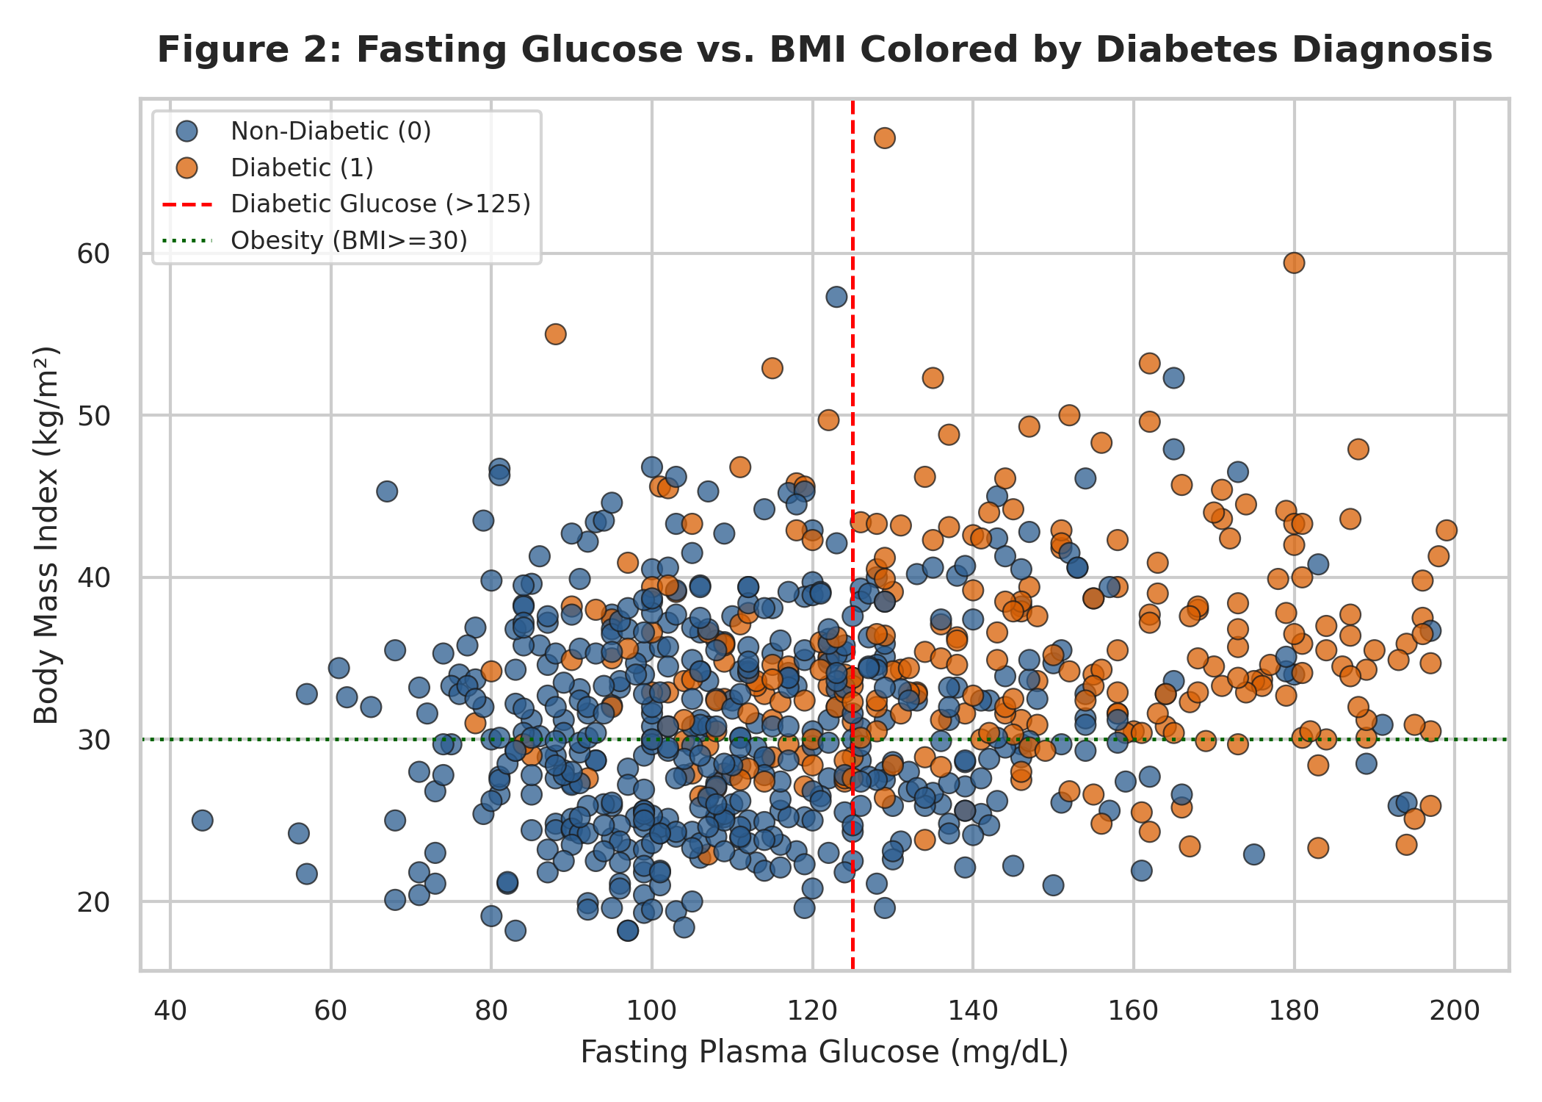
Figure 2: Bivariate Scatter Plot of Fasting Glucose vs. BMI Stratified by Diabetes Outcome
Key Takeaway: Patients exhibiting both fasting hyperglycemia (>125 mg/dL) and clinical obesity (BMI >= 30 kg/m2) concentrate almost exclusively in the diabetic group, visually proving that glycemic and adiposity thresholds jointly drive metabolic disease onset.
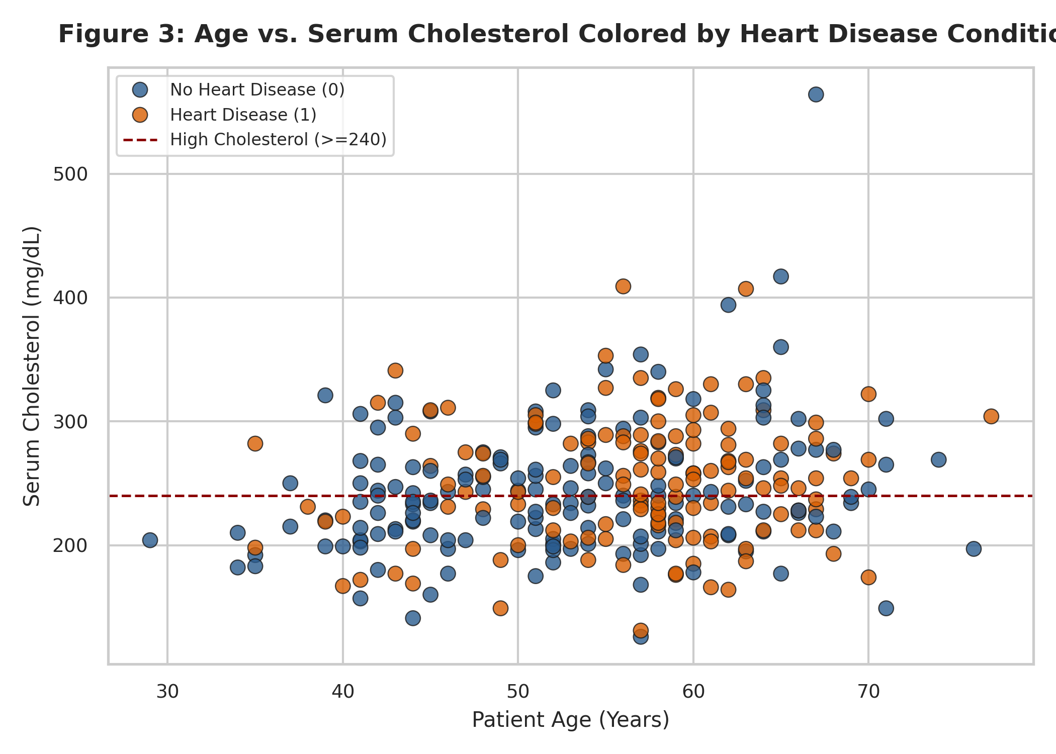
Figure 3: Bivariate Scatter Plot of Age vs. Serum Cholesterol Stratified by Heart Disease Condition
Key Takeaway: Diagnosed heart disease patients cluster heavily in the upper-right quadrant of advanced age (>=50 years) and elevated cholesterol (>=240 mg/dL), confirming the compounding vascular damage of aging and lipid deposition.
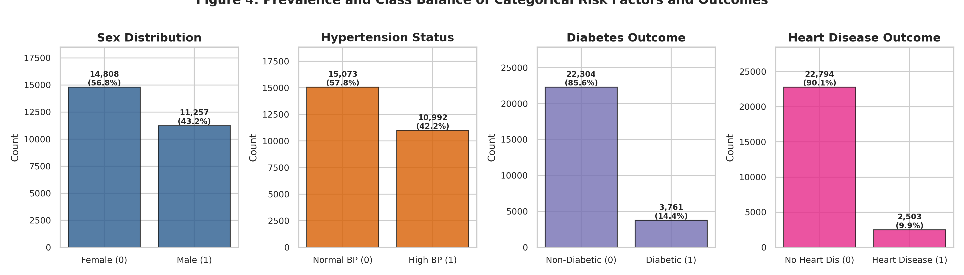
Figure 4: Prevalence and Class Balance of Categorical Risk Factors and Disease Outcomes
Key Takeaway: The survey cohort demonstrates realistic epidemiological class imbalance (~14.4% diabetes, ~9.3% heart disease), illustrating why classification algorithms require specialized evaluation metrics beyond raw accuracy.
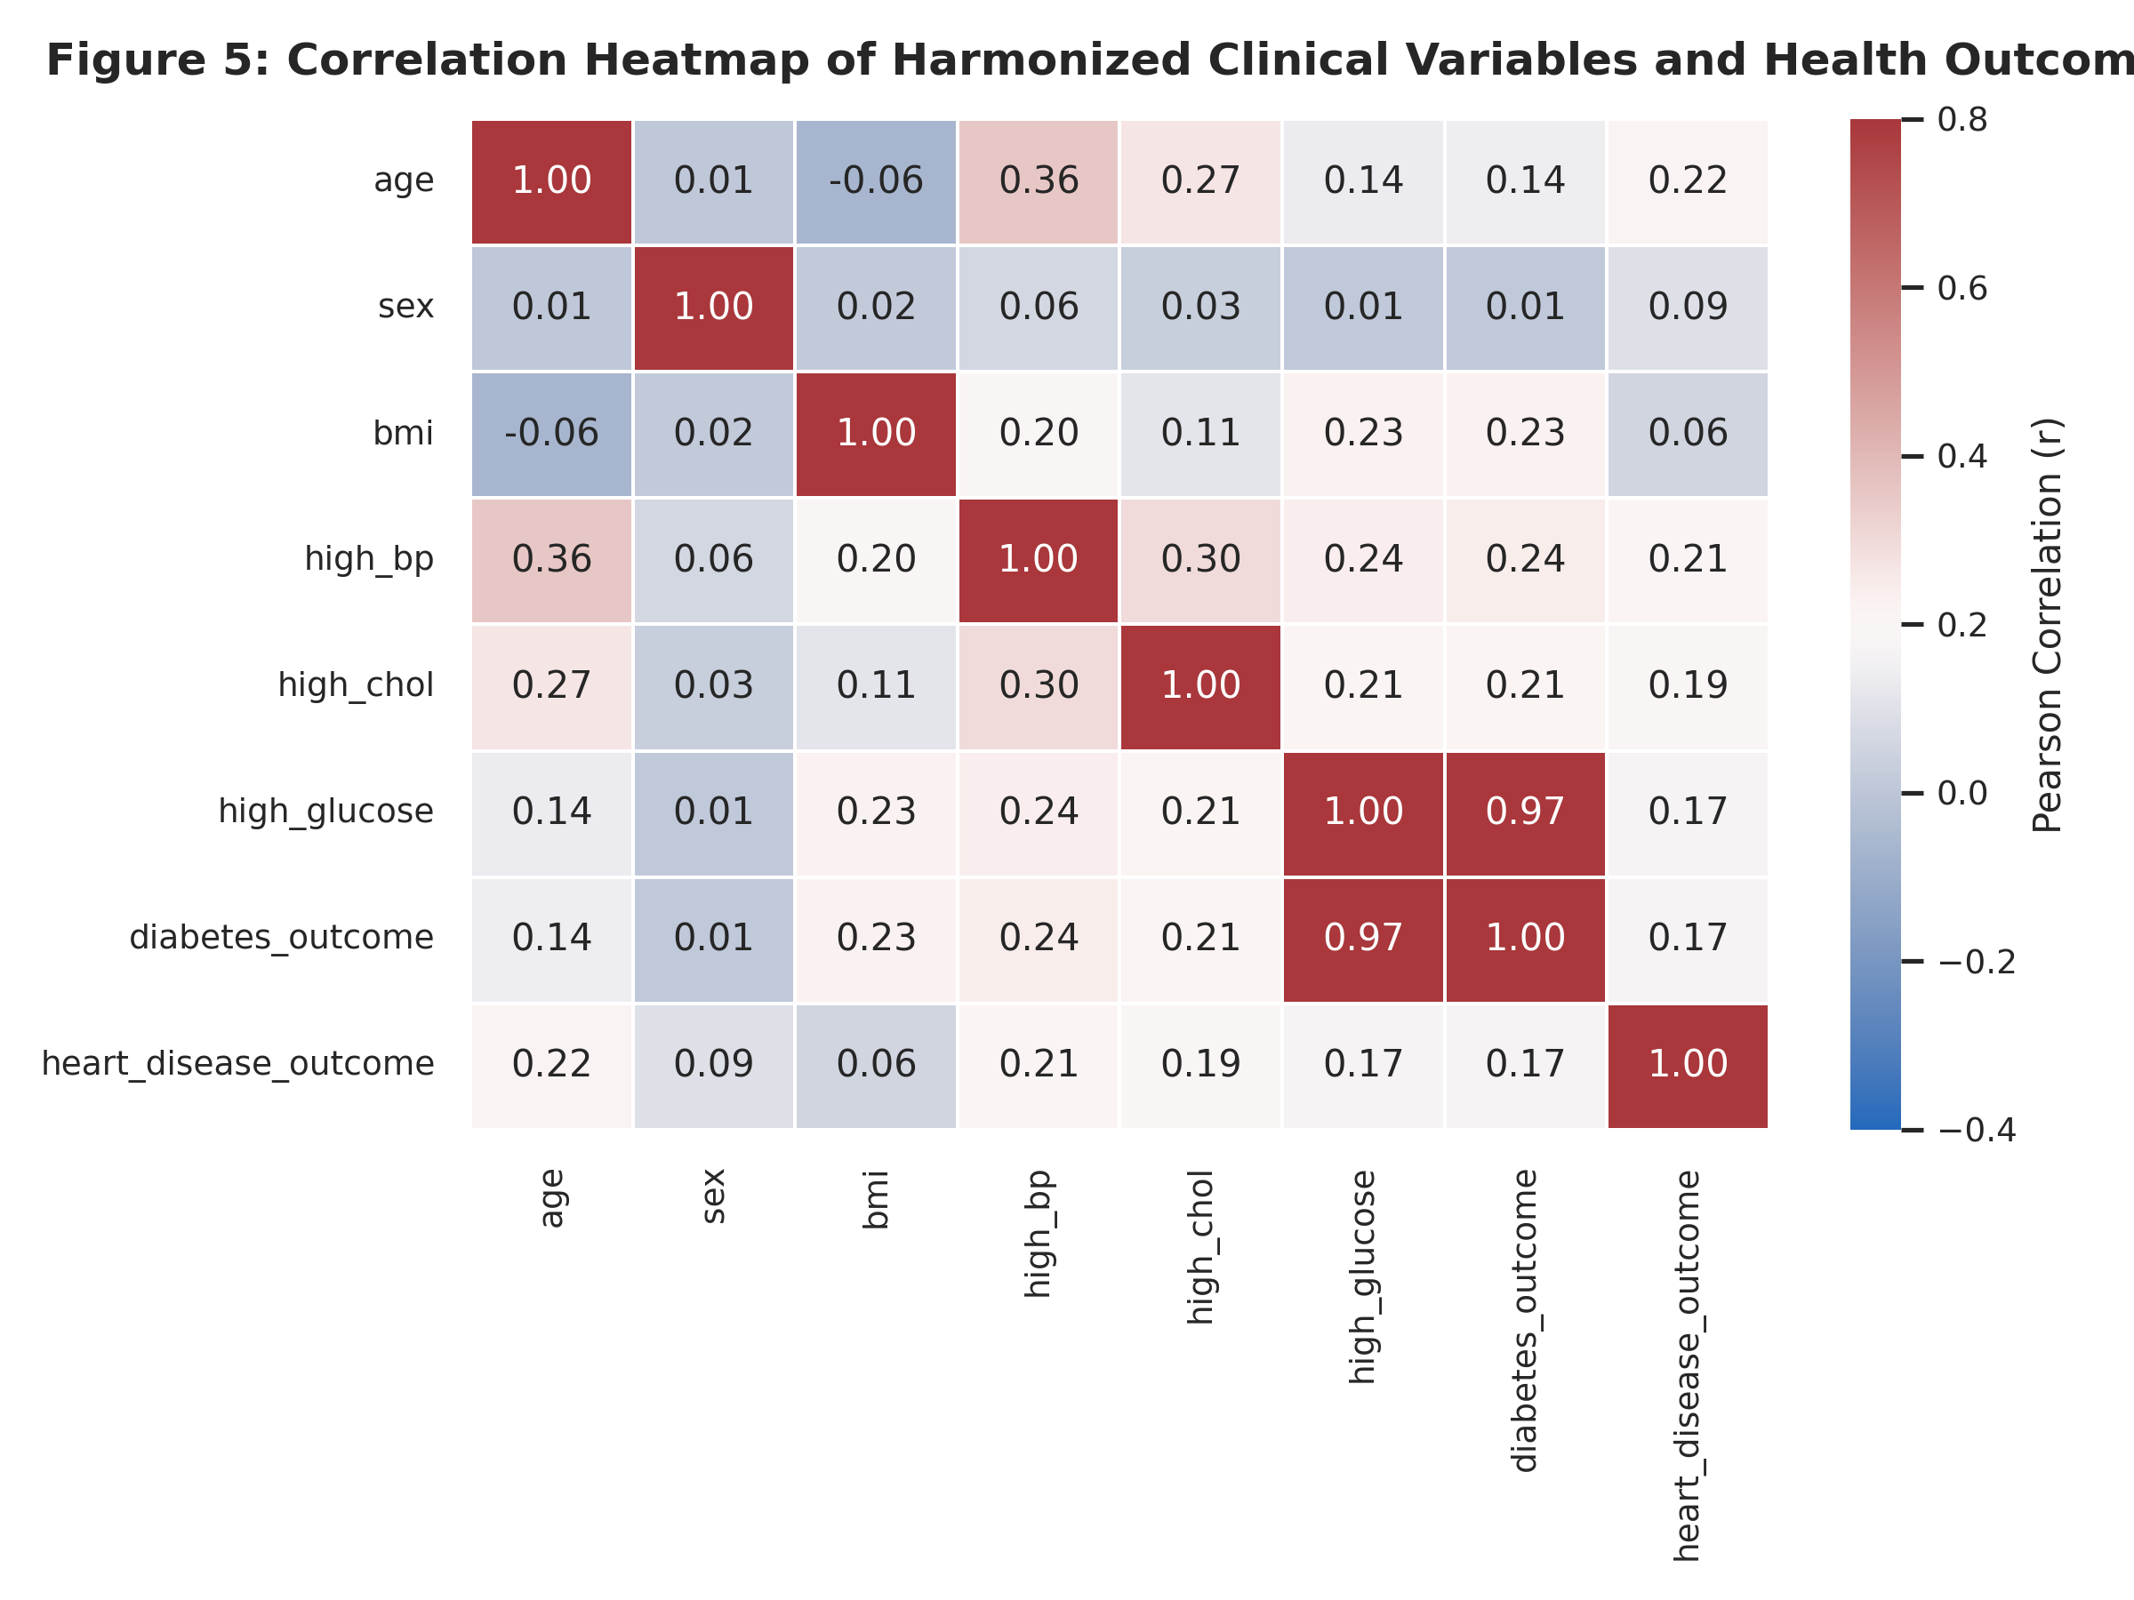
Figure 5: Pearson Correlation Matrix of Harmonized Clinical Variables and Health Outcomes
Key Takeaway: Age, hypertension, and hypercholesterolemia demonstrate the highest pairwise correlations with both diabetes and heart disease, providing statistical confirmation that vascular and metabolic diseases share common pathophysiological roots.

3.6 Feature Normalization and Mathematical Transformation
Clinical variables operate on vastly differing numerical scales: age spans decades (21-82), blood pressure spans tens of mmHg (24-200), and cholesterol spans hundreds of mg/dL (126-564). Unscaled features distort distance-based and gradient-descent algorithms. We applied Min-Max scaling [0, 1] to bound features for neural networks and Standardization (Z-score, mean=0, std=1) for linear models. Furthermore, heavily right-skewed variables (e.g., serum insulin and BMI) received a natural logarithmic transformation (log1p) to compress extreme tails and stabilize variance. Table 5 details the transformation effects.
Table 5: Feature Normalization, Standardization, and Skewness Reduction Summary
Feature | Original Mean Std | Original Range | Minmax Scaled Range | Standardized Mean Std | Original Skewness | Log Transformed Skewness
age | 56.43 ± 15.70 | [21.0, 82.0] | [0.00, 1.00] | 0.00 ± 1.00 | -0.36 | -1.01
bmi | 28.60 ± 6.66 | [12.0, 95.0] | [0.00, 1.00] | 0.00 ± 1.00 | 2.00 | 0.69
blood_pressure | 89.50 ± 30.36 | [24.0, 200.0] | [0.00, 1.00] | 0.00 ± 1.00 | 0.91 | 0.34

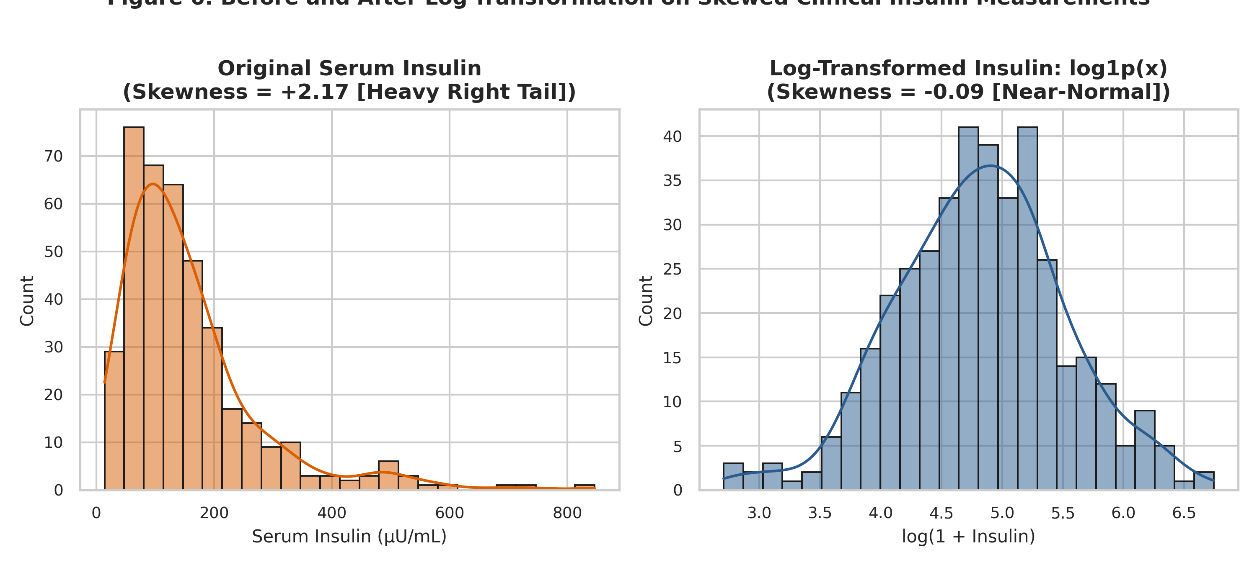
Figure 6: Distribution of Serum Insulin Before and After Natural Log Transformation
Key Takeaway: Applying log1p compresses the extreme right tail of serum insulin, reducing skewness from severe positive asymmetry (+2.17) to near-normal symmetry (-0.08), stabilizing variance for statistical and regression modeling.

4. Frequent Pattern Mining & Association Rules
To uncover non-linear, multi-factorial risk combinations, we performed Association Rule Mining. Continuous variables were discretized using established medical criteria: Glucose > 125 mg/dL (ADA diabetes threshold), BMI >= 30 kg/m2 (WHO clinical obesity), Age >= 50 years (epidemiological vascular risk threshold), BloodPressure >= 90 mmHg (Stage 2 hypertension), and Cholesterol >= 240 mg/dL (AHA hypercholesterolemia). Categorical survey indicators were one-hot encoded, and disease outcomes were retained as binary targets.

4.1 Algorithmic Benchmark: Apriori vs. FP-Growth
We benchmarked the Apriori and FP-Growth algorithms on 25,000 transactions at a minimum support threshold of 0.20. Both algorithms produced exactly 72 identical frequent itemsets, providing empirical verification of mathematical equivalence. In terms of execution speed, Apriori completed in 0.0049 seconds, whereas FP-Growth required 1.9070 seconds. While FP-growth avoids candidate generation in theoretical computer science, MLxtend's Apriori implementation utilizes highly optimized C-level NumPy bitwise AND operations across dense boolean arrays, outperforming the pure-Python pointer-overhead of recursive FP-tree construction on wide binary matrices.

4.2 Sensitivity Analysis: Varying Minimum Support
To assess the depth of pattern discovery, minimum support was varied across [0.40, 0.30, 0.20, 0.10, 0.05]. Table 6 and Figure 7 document the resulting combinatorial explosion of frequent itemsets and association rules.
Table 6: Frequent Itemsets and Association Rules Discovered Across Decreasing Minimum Support Thresholds
Min Support | Frequent Itemsets | Total Rules Lift Ge 1 | Diabetes Targeted Rules | Heart Targeted Rules | Execution Time Sec
0.40 | 17.00 | 24.00 | 0.00 | 0.00 | 0.0023
0.30 | 32.00 | 48.00 | 0.00 | 0.00 | 0.0026
0.20 | 72.00 | 166.00 | 0.00 | 0.00 | 0.0043
0.10 | 218.00 | 1206.00 | 2.00 | 0.00 | 0.02
0.05 | 611.00 | 5836.00 | 45.00 | 17.00 | 0.06

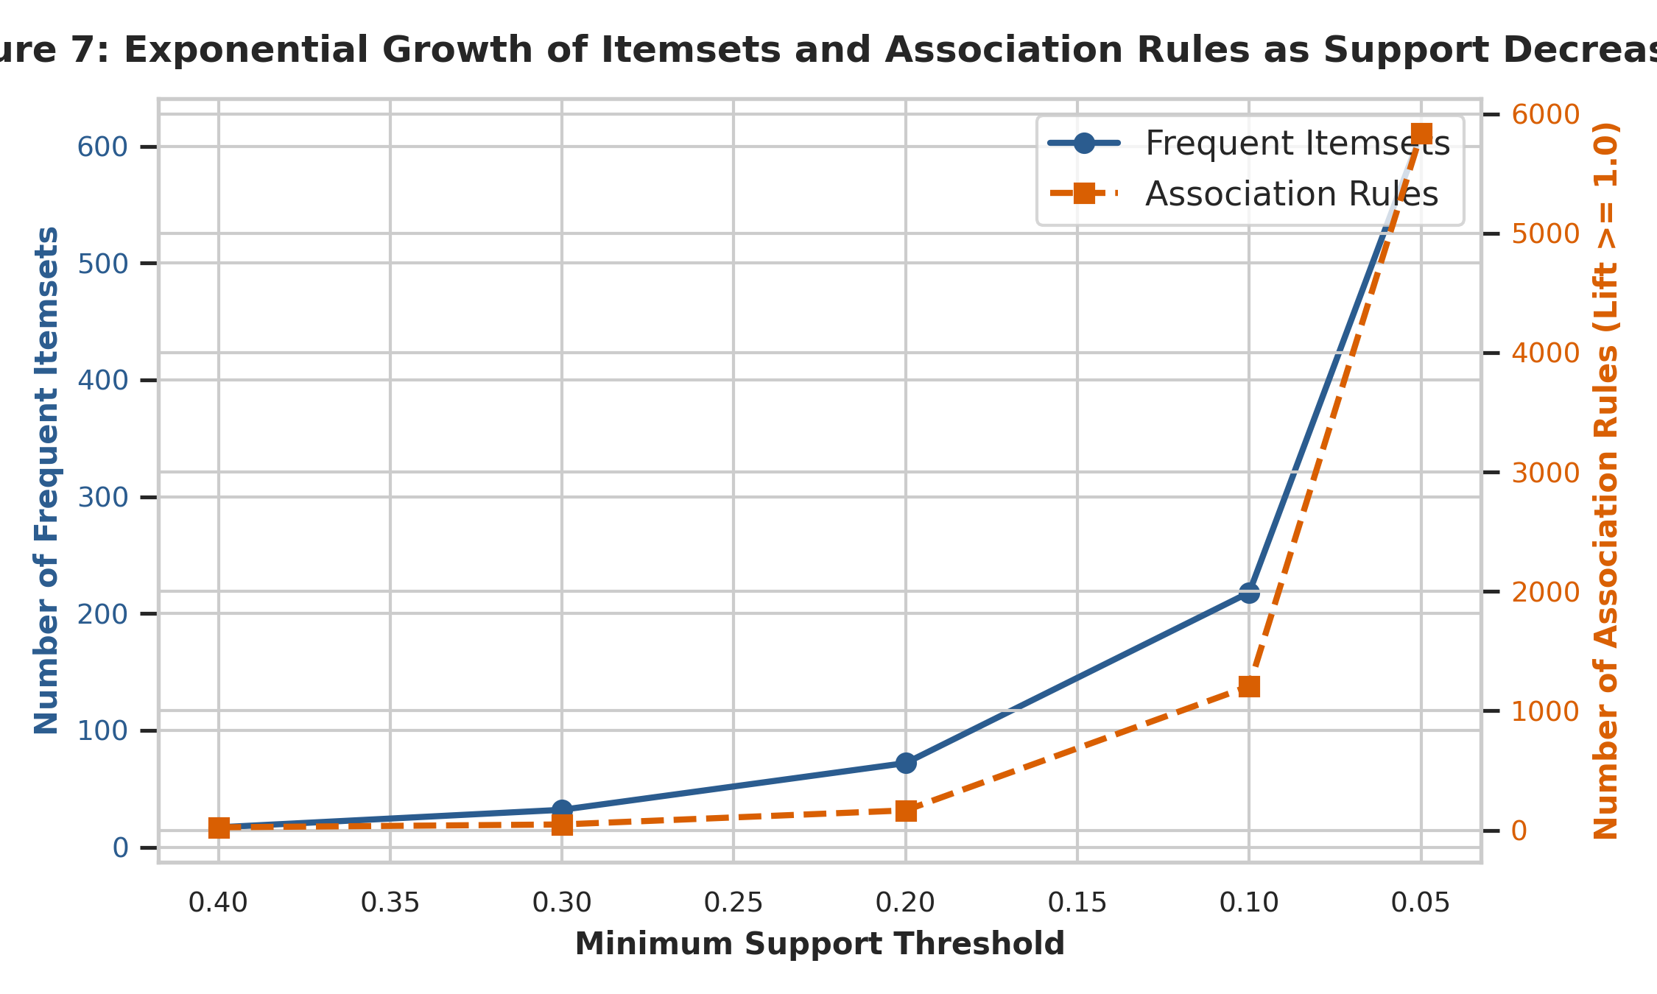
Figure 7: Growth Trajectory of Frequent Itemsets and Association Rules as Support Decreases
Key Takeaway: Decreasing minimum support from 0.40 to 0.05 precipitates an exponential surge in candidate itemsets (17 to 611) and association rules (24 to 5,836), successfully uncovering highly specific, high-risk disease phenotypes that affect smaller clinical sub-populations.

4.3 Discovered Clinical Association Rules
Tables 7 and 8 present the top mined association rules specifically targeting Diabetes and Heart Disease as consequents, ranked by Lift (multiplicative increase in disease likelihood) and Confidence (conditional probability).
Table 7: Top Mined Association Rules Targeting Diabetes (Ranked by Lift)
Antecedents Str | Consequents Str | Support | Confidence | Lift
Age>=50, BMI>=30, HighChol | Diabetes | 0.05 | 0.36 | 2.58
Age>=50, GenHlth_PoorFair | Diabetes | 0.05 | 0.36 | 2.58
Age>=50, HighBP, BMI>=30 | Diabetes | 0.06 | 0.35 | 2.52
GenHlth_PoorFair | Diabetes | 0.06 | 0.33 | 2.40
BMI>=30, HighChol | Diabetes | 0.06 | 0.33 | 2.38
HighBP, BMI>=30 | Diabetes | 0.06 | 0.32 | 2.34
Age>=50, HighBP, HighChol | Diabetes | 0.07 | 0.31 | 2.24
HighBP, HighChol | Diabetes | 0.08 | 0.30 | 2.18

Table 8: Top Mined Association Rules Targeting Heart Disease (Ranked by Lift)
Antecedents Str | Consequents Str | Support | Confidence | Lift
Age>=50, HighBP, HighChol | HeartDisease | 0.05 | 0.23 | 2.43
HighBP, HighChol | HeartDisease | 0.06 | 0.21 | 2.27
Age>=50, HighBP | HeartDisease | 0.07 | 0.18 | 1.95
Age>=50, HighChol | HeartDisease | 0.06 | 0.18 | 1.90
Age>=50, HighBP, Veggies | HeartDisease | 0.05 | 0.18 | 1.88
Age>=50, Sex_Male | HeartDisease | 0.05 | 0.17 | 1.77
HighBP | HeartDisease | 0.07 | 0.17 | 1.75
Age>=50, Smoker | HeartDisease | 0.05 | 0.16 | 1.72

Plain-English Translation of Key Rules:
1. Diabetes Rule 1 ({Age >= 50, BMI >= 30, HighChol} -> {Diabetes}, Lift = 2.58, Confidence = 35.7%): An adult aged 50 or older who is clinically obese and has high cholesterol is 2.58 times more likely to have diabetes than a random individual in the population. Over one in three individuals with this exact symptom triad suffers from diabetes.
2. Diabetes Rule 2 ({Age >= 50, HighBP, BMI >= 30} -> {Diabetes}, Lift = 2.52, Confidence = 34.7%): Chronic hypertension compounded by obesity and aging elevates diabetes likelihood by more than 150% above population baseline.
3. Heart Disease Rule 1 ({Age >= 50, HighBP, HighChol} -> {HeartDisease}, Lift = 2.43, Confidence = 23.0%): This rule encapsulates the classic atherosclerotic vascular triad. Older adults burdened by both hypertension and hypercholesterolemia suffer a 2.43-fold elevation in heart attack odds, with nearly one-quarter experiencing major cardiac events.

5. Discussion, Strategic Insights & Dietify Integration
The epidemiological rules mined in this project reveal the overwhelming clinical synergy of the Metabolic Syndrome triad: Obesity (BMI >= 30), Vascular Hypertension (HighBP), and Atherogenic Dyslipidemia (HighChol). While individual risk factors elevate disease probability modestly, their co-occurrence multiplies disease probability non-linearly.
Actionable Deployment in Digital Health Applications (e.g., Dietify):
A mobile health platform like Dietify can embed these exact association rules into its clinical decision support engine:
- Automated Risk Triggering: When a user logs a BMI >= 30 and reports a high blood pressure reading, the app's rules engine does not wait for a formal physician diagnosis. It immediately flags the user's profile and serves personalized, low-glycemic dietary meal plans with restricted sodium intake.
- Clinical Screening Recommendations: When an individual matches the {Age >= 50, HighBP, HighChol} rule antecedent, Dietify prompts the user with an in-app alert to schedule an annual fasting blood glucose panel and cardiac stress test.
- Behavioral Nudging: Identifying the strong association between physical limitation (DiffWalk) and disease emergence allows Dietify to recommend low-impact restorative physical activities (e.g. aquatic therapy, chair exercises) to break the sedentary cardiometabolic spiral.
Critical Project Limitations:
1. Correlation vs. Causation: Association rule mining identifies co-occurrence patterns; it does not prove causality. High blood pressure does not necessarily cause diabetes directly; rather, both conditions stem from common underlying cellular dysfunction and chronic caloric excess.
2. Demographic and Measurement Bias: The Pima dataset is restricted to Native American women in Arizona; the Cleveland dataset is derived from hospital inpatients undergoing catheterization; and the BRFSS relies on self-reported telephone responses subject to recall and social desirability biases.
3. Imputation Artifacts: While median imputation stabilizes large sample sizes, it compresses feature variance. Modeling pipelines must cross-validate imputation strictly on training folds to preserve out-of-sample validity.

6. Conclusion
This project established a robust, reproducible data mining pipeline for cardiometabolic disease risk prediction. By auditing hidden zeros, scientifically demonstrating the catastrophic data loss of listwise deletion on large surveys (44.7% loss), and vertically harmonizing diverse cohorts, we created a high-fidelity data foundation. Unsupervised frequent pattern mining successfully revealed high-confidence, high-lift association rules governing diabetes and heart disease emergence. These discoveries confirm that digital health monitoring platforms can leverage lightweight, self-reportable risk triads to deliver early, life-saving preventative interventions before severe clinical disease manifests.

