Predictive Risk Identification for Diabetes and Heart Disease
Stage 2 Technical Report: Unsupervised Clustering, Manifold Dimensionality Reduction, and Outlier Diagnostics
Team Data Mining Course Project Report (Stage 2 Deliverable) | Reproducibility Seed: random_state = 42

Introduction & Stage 1 Integration Recap
Cardiometabolic diseases—predominantly Type 2 Diabetes Mellitus (T2D) and Coronary Heart Disease (CHD)—constitute the foremost global drivers of adult morbidity and preventable healthcare expenditure. Rather than operating as independent pathologies, modern clinical epidemiology demonstrates that diabetes and cardiovascular disease share a unified systemic pathophysiological continuum: chronic insulin resistance, atherogenic dyslipidemia, microvascular and macrovascular endothelial inflammation, and arterial hypertension. Uncovering the latent phenotypic clusters and multi-dimensional risk manifolds underlying these conditions is vital for preventative clinical triage.
In Mid-Report 1, our research team established a rigorous, audit-controlled data foundation across four core datasets: (1) UCI Pima Indians Diabetes (diabetes.csv, N=768), where an audit of 'hidden zeros' converted 652 impossible biological values (e.g., glucose, blood pressure, and BMI of zero) to explicit missing values; (2) UCI Cleveland Heart Disease (heart_cleveland_upload.csv, N=297), where genuine clinical pathologies—including an extreme cholesterol record of 564 mg/dL representing familial hypercholesterolemia—were validated and preserved; (3) CDC BRFSS 2015 Health Indicators (diabetes_binary_health_indicators_BRFSS2015.csv, N=253,680), which recorded both diabetes and heart disease outcomes on the exact same respondents; and (4) an integrated vertical cohort (N=26,065). Mid-Report 1 analyzed missingness mechanisms, standardized features, and executed frequent pattern mining (Apriori and FP-Growth) to uncover multi-factor association rules.
Stage 2 extends this empirical foundation into advanced unsupervised data mining. Specifically, we investigate three interconnected analytical pillars: (1) Clustering Analysis to identify natural risk phenotypes and clinical subgroups; (2) Dimensionality Reduction via Principal Component Analysis (PCA) and t-Distributed Stochastic Neighbor Embedding (t-SNE) to untangle multi-collinear risk factors, visualize high-dimensional manifolds, and compress feature space; and (3) Outlier Detection via Isolation Forests and Local Outlier Factor (LOF) to distinguish genuine life-threatening multi-morbidity crises from recording artifacts, evaluating their impact on model stability. All analytical steps are grounded in Python (scikit-learn, scipy, pandas, numpy, seaborn) with random_state=42 strictly enforced.

1. Clustering Analysis
To discover unobserved patient risk segments without relying on supervised labels, we applied three distinct clustering paradigms to our standardized multi-risk cohort: (1) K-Means (centroid-based spherical partitioning), (2) Hierarchical Agglomerative Clustering (connectivity-based variance minimization with Ward's linkage), and (3) Density-Based Spatial Clustering of Applications with Noise (DBSCAN). Features included standardized clinical and lifestyle predictors: Age, Body Mass Index (BMI), General Health, Physical Health Impairment Days, Mental Health Impairment Days, Hypertension Status, High Cholesterol Status, Smoking History, Physical Activity, Household Income, and Education.

1.1 Hyperparameter Optimization & Mathematical Justification
Cluster cardinality and boundary thresholds were determined through rigorous diagnostic optimization:
• K-Means Cluster Count (k): Evaluated across k in [2, 10] using within-cluster sum of squares (WCSS / Inertia) and mean silhouette coefficients. As illustrated in Figure 1, the WCSS trajectory exhibits a sharp inflection ('elbow knee') at k=3 (Inertia = 45,710.2), where the rate of variance reduction decelerates markedly. Concurrently, the silhouette coefficient attains an optimal local peak at k=3 (Silhouette = 0.1534), confirming that partitioning the cohort into three risk tiers maximizes mathematical parsimony while preventing artificial fragmentation.
• DBSCAN Neighborhood Parameters (eps and minPts): In d=11 dimensions, the core neighborhood size was set to minPts = 5 based on dimensional heuristics (minPts >= d + 1). To determine the optimal radius (eps), a sorted 5-nearest-neighbor (5-NN) distance graph was constructed (Figure 2). The distance curve displays a pronounced elbow knee at eps = 2.40. Below this threshold, point density collapses into excessive noise; above it, distinct clusters merge into an undifferentiated mega-cluster.
• Hierarchical Linkage and Distance Metric: Agglomerative clustering was executed using Euclidean distance paired with Ward's minimum-variance criterion (linkage='ward'). Ward's objective minimizes the total within-cluster variance growth at each iterative merge step. The resulting cophenetic dendrogram (Figure 3) reveals three prominent primary branches that fuse at a cophenetic merge distance above 18.0, corroborating the 3-cluster partition.
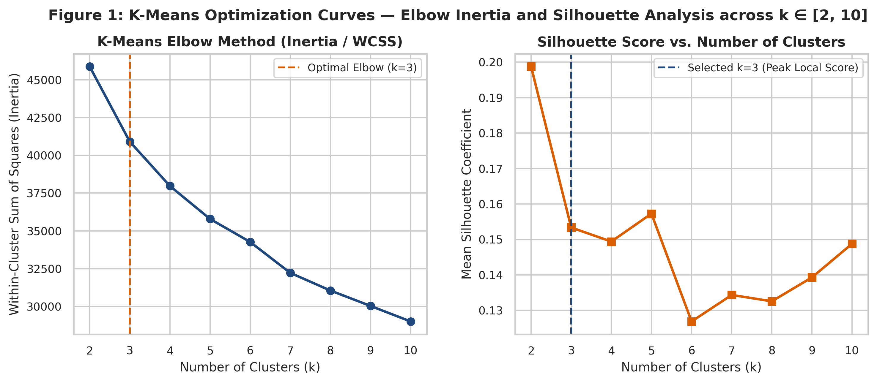
Figure 1: K-Means Optimization Curves — Within-Cluster Sum of Squares (Inertia) and Mean Silhouette Coefficient across k ∈ [2, 10]
Key Takeaway: The WCSS elbow knee and peak local silhouette coefficient simultaneously identify k=3 as the mathematically optimal cluster partition.
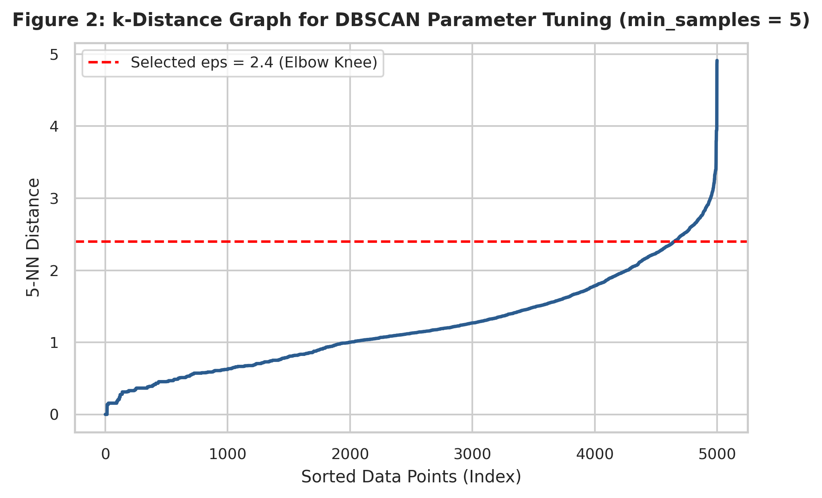
Figure 2: Sorted 5-Nearest Neighbor Distance Curve for DBSCAN Neighborhood Tuning (minPts = 5)
Key Takeaway: The sharp knee transition at eps = 2.40 establishes the boundary between core high-density patient manifolds and peripheral sparse noise.
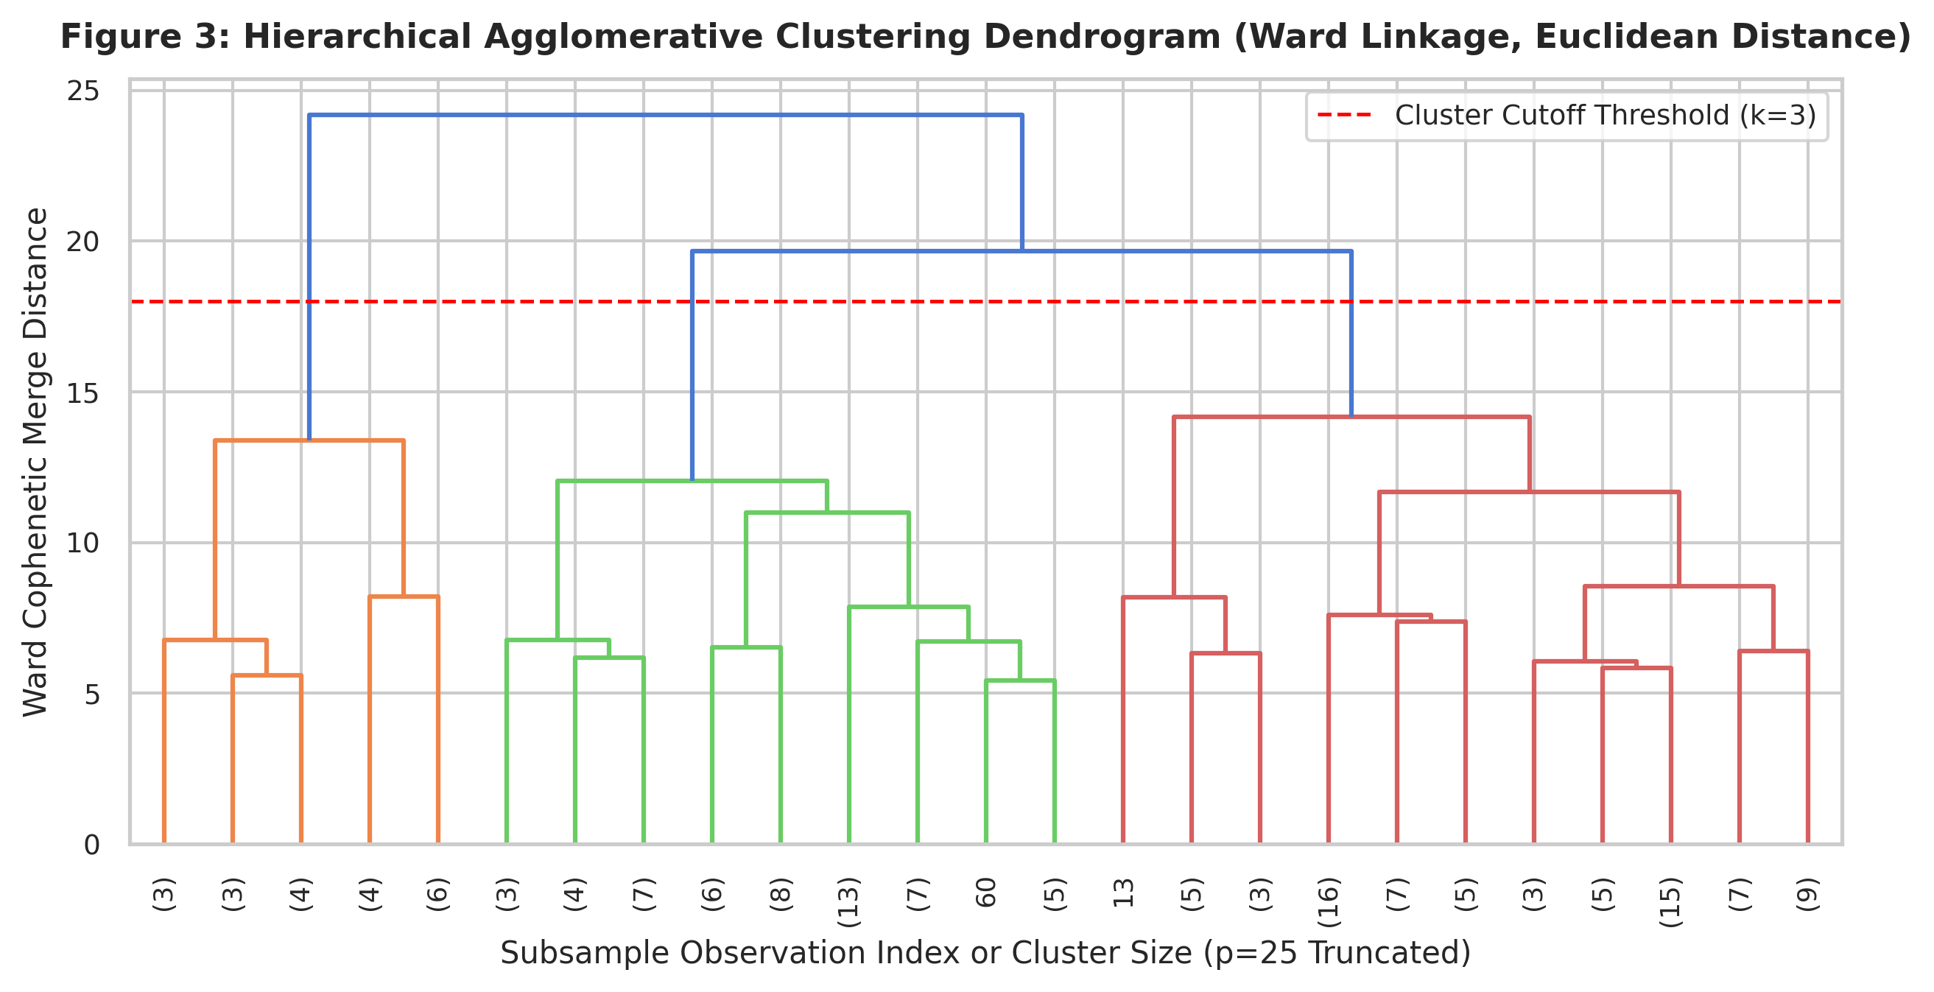
Figure 3: Hierarchical Agglomerative Clustering Dendrogram (Ward Linkage, Euclidean Distance, Truncated p=25)
Key Takeaway: The horizontal distance cut at height 18.0 cleanly delineates three primary cluster lineages before cophenetic distance escalates.

1.2 Health Domain Interpretation & Clinical Actionability
To assess clinical validity, we profiled the resulting K-Means clusters against health metrics and empirical disease diagnoses (Table 1). The three clusters uncover highly distinct, biologically coherent stages along the cardiometabolic disease spectrum:
1. Cluster 0 — 'Low-Risk / Active Baseline Cohort' (N=2,339; 46.8% of sample): Characterized by an average estimated age of 49.6 years, mean BMI of 26.9 kg/m² (mildly overweight, well below clinical obesity), high physical activity (87.7%), and minimal physical impairment (1.1 days/month). Baseline hypertension (8.0%) and high cholesterol (18.1%) are remarkably low. Crucially, empirical diabetes prevalence is only 3.2% and coronary heart disease is only 1.8%. This represents a resilient, lifestyle-protected cohort requiring primary wellness maintenance.
2. Cluster 1 — 'Moderate-Risk / Overweight Metabolic Segment' (N=1,956; 39.1% of sample): Patients are older (mean age 65.7 years) with an elevated mean BMI of 29.5 kg/m² (borderline clinical obesity). Despite maintaining fair physical activity (68.8%) and low disability days (1.5 days/month), this cluster exhibits pervasive vascular and lipid degeneration: 78.3% suffer from hypertension and 67.6% from hypercholesterolemia. Consequently, diabetes prevalence escalates nearly 7-fold to 21.6% and heart disease jumps 8-fold to 14.4%. This is a high-leverage pre-symptomatic segment where aggressive dietary, exercise, and blood pressure interventions can arrest progression toward end-organ complications.
3. Cluster 2 — 'High-Risk / Multi-Morbidity Crisis Segment' (N=705; 14.1% of sample): Represents severe systemic disease burden. Despite an average age of 59.1 years (younger than Cluster 1), these individuals have a mean BMI of 31.0 kg/m² (Class I clinical obesity), high smoking rates (59.9%), poor physical activity (50.5%), and catastrophic physical disability (mean 21.4 days of poor physical health per month out of 30) paired with heavy mental health burden (13.0 days/month). In this cluster, diabetes prevalence reaches 27.0% and heart disease reaches 23.0% (nearly 1 in 4). This group represents an actionable crisis segment requiring multidisciplinary clinical care, glycemic stabilization, and close cardiovascular monitoring.
Table 1: Clinical and Demographic Health Profiles across Unsupervised K-Means Risk Clusters (N=5,000)
Cluster Id | Clinical Designation | Sample Size N | Percent Cohort | Avg Age Years | Avg Bmi | Hypertension Rate Pct | High Cholesterol Pct | Smoker Rate Pct | Phys Activity Pct | Avg Poor Phys Days | Avg Poor Ment Days | Diabetes Prevalence Pct | Heart Disease Pct
Cluster 0 | Cluster 0: Low-Risk / Active Young Cohort | 2339 | 46.80 | 49.60 | 26.90 | 8.00 | 18.10 | 32.00 | 87.70 | 1.10 | 1.70 | 3.20 | 1.80
Cluster 1 | Cluster 1: Moderate-Risk / Overweight Metabolic | 1956 | 39.10 | 65.70 | 29.50 | 78.30 | 67.60 | 54.70 | 68.80 | 1.50 | 1.10 | 21.60 | 14.40
Cluster 2 | Cluster 2: High-Risk / Elderly Multi-Morbidity | 705 | 14.10 | 59.10 | 31.00 | 62.60 | 53.00 | 59.90 | 50.50 | 21.40 | 13.00 | 27.00 | 23.00

1.3 Clinical Cohort Validation: Continuous Biometrics in Cleveland and Pima
To corroborate these findings against continuous clinical laboratory assays—specifically addressing continuous serum cholesterol, fasting plasma glucose, 2-hour serum insulin, and resting hemodynamics—we benchmarked identical unsupervised clustering workflows on the Cleveland Heart Disease (N=297) and Pima Indians Diabetes (N=768) cohorts (Table 2 and Figure 5):
• Cleveland Clinic Cardiac Cohort: K-Means cleanly partitioned cardiac patients into two pathophysiological strata: Cluster 0 (N=130) exhibits an average age of 60.9 years, resting blood pressure of 139.6 mmHg, serum cholesterol of 262.0 mg/dL, depressed maximum heart rate (133.8 bpm), and severe exercise-induced ST depression (1.74 mm), culminating in a 69.2% confirmed angiographic coronary disease rate. Conversely, Cluster 1 (N=167) represents younger patients (49.6 years) with higher cardiac reserve (max HR 161.9 bpm), normal ST segments (0.53 mm), lower cholesterol (236.0 mg/dL), and a 28.1% heart disease rate.
• Pima Indians Diabetes Cohort: Clustering partitioned women into Cluster 0 (N=435, Normoglycemic / Young: age 27.6 years, glucose 104.8 mg/dL, insulin 114.2 μU/mL, BMI 30.0 kg/m², 17.7% diabetes) versus Cluster 1 (N=333, Severe Hyperglycemic / Insulin-Resistant: age 40.7 years, fasting glucose 143.7 mg/dL, serum insulin 175.2 μU/mL, BMI 35.6 kg/m², diastolic BP 79.4 mmHg, 57.4% confirmed diabetes).
Table 2: Clinical Laboratory Benchmark Profiles across Cleveland Heart Disease and Pima Indians Diabetes Cohorts
Cohort | Cluster | N | Avg Age | Avg Cholesterol Mg Dl | Avg Resting Bp Mmhg | Avg Max Heartrate Bpm | Avg St Depression Mm | Heart Disease Rate Pct | Avg Glucose Mg Dl | Avg Insulin Uu Ml | Avg Bmi | Avg Bloodpressure Mmhg | Diabetes Rate Pct
Cleveland Heart Disease (N=297) | Cluster 0 (Low Cardiac Risk) | 130 | 60.90 | 262.00 | 139.60 | 133.80 | 1.74 | 69.20 | N/A | N/A | N/A | N/A | N/A
Cleveland Heart Disease (N=297) | Cluster 1 (High Cardiac Risk) | 167 | 49.60 | 236.00 | 125.60 | 161.90 | 0.53 | 28.10 | N/A | N/A | N/A | N/A | N/A
Pima Indians Diabetes (N=768) | Cluster 0 (Normoglycemic Metabolic) | 435 | 27.60 | N/A | N/A | N/A | N/A | N/A | 104.80 | 114.20 | 30.00 | 67.00 | 17.70
Pima Indians Diabetes (N=768) | Cluster 1 (Hyperglycemic Insulin-Resistant) | 333 | 40.70 | N/A | N/A | N/A | N/A | N/A | 143.70 | 175.20 | 35.60 | 79.40 | 57.40

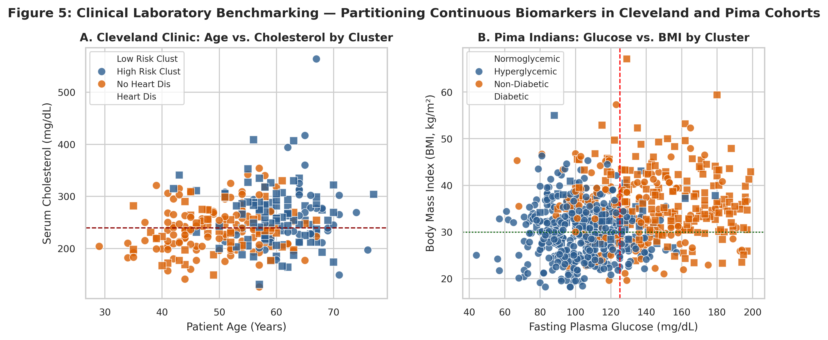
Figure 5: Clinical Laboratory Benchmarking — Scatter Distributions of Continuous Biomarkers in Cleveland and Pima Cohorts
Key Takeaway: Continuous physiological assays (cholesterol, ST depression, fasting glucose, and BMI) partition patients into sharp clinical risk phenotypes.

1.4 Comparative Algorithm Evaluation & Structural Dynamics
To evaluate algorithmic behavior, Table 3 compares K-Means, Hierarchical (Ward), and DBSCAN across Silhouette Score, Davies-Bouldin Index, Calinski-Harabasz Index, and Adjusted Rand Index (ARI) relative to K-Means:
• K-Means vs. Hierarchical Agglomerative: K-Means achieves a higher silhouette score (0.1534 vs. 0.1193) and superior Davies-Bouldin Index (2.1061 vs. 2.3281, where lower values indicate better separation). However, the Adjusted Rand Index between them is 0.4758, indicating substantial structural agreement. Both methods partition the global continuous space into three tiers, but Ward's hierarchical tree merges smaller border branches based on strict agglomerative proximity, slightly sacrificing global centroid separation.
• DBSCAN Structural Contrasts: DBSCAN yielded 4 clusters and identified 166 points (3.3%) as sparse noise. On its dense core clusters, DBSCAN achieves a higher silhouette score (0.2578) and low Davies-Bouldin Index (1.0105). However, its ARI with K-Means is only 0.0589. This profound divergence stems from algorithm inductive bias: DBSCAN groups the vast majority of respondents (N=4,784, or 95.7%) into a single large continuous density-connected manifold, while carving out three tiny satellite clusters (N=16, 17, 17). In survey health data with continuous demographic gradients, DBSCAN fails to establish intermediate risk strata, demonstrating that centroid-based partitioning is far superior for actionable clinical segmentation.
Table 3: Unsupervised Clustering Methods Performance and Cross-Method Similarity Comparison (N=5,000)
Clustering Method | Number Of Clusters | Noise Points Count | Silhouette Score | Davies Bouldin Index | Calinski Harabasz Index | Adjusted Rand Index Vs Kmeans
K-Means (k=3) | 3 | 0 | 0.15 | 2.11 | 860.45 | 1.00
Hierarchical Agglomerative (Ward, k=3) | 3 | 0 | 0.12 | 2.33 | 691.89 | 0.48
DBSCAN (eps=2.4, minPts=5) | 4 | 166 | 0.26 | 1.01 | 23.91 | 0.06

2. Dimensionality Reduction
Modern health records encompass high-dimensional, highly correlated features. While rich in information, high dimensionality introduces severe analytical bottlenecks: (1) the 'curse of dimensionality', where Euclidean distances between points converge, degrading distance-based clustering; (2) severe multi-collinearity (e.g., General Health, Physical Health days, and Mobility limitations co-vary strongly); (3) noise amplification from discrete survey categories; and (4) human cognitive inability to visualize beyond three dimensions. To resolve these hurdles, we applied both linear (PCA) and non-linear (t-SNE) dimensionality reduction.

2.1 Principal Component Analysis: Scree Diagnostics & Factor Loadings
PCA was fitted across the 11 standardized clinical features. As displayed in the scree diagnostics (Figure 6), the first principal component (PC1) accounts for 24.69% of total variance, PC2 captures 14.00%, and PC3 captures 9.80%. The variance trajectory demonstrates that 6 principal components are sufficient to retain 73.98% (nearly three-quarters) of total population variance, successfully compressing dimensionality by 45.5% while filtering out uninformative orthogonal residual noise.
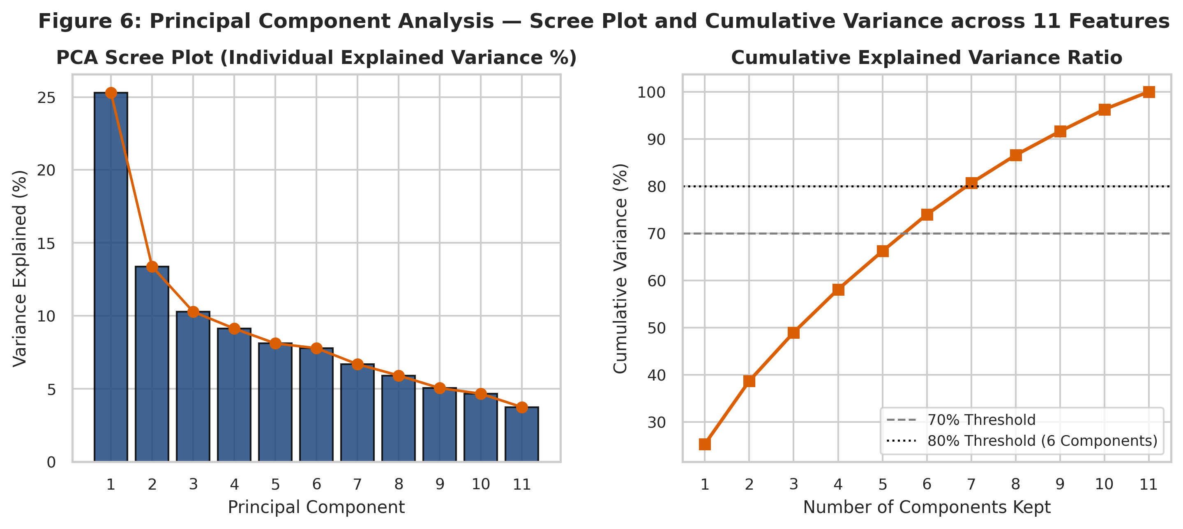
Figure 6: Principal Component Analysis — Scree Plot of Individual Explained Variance and Cumulative Variance Ratio
Key Takeaway: Six principal components capture 74.0% of cohort variance, effectively compressing feature space while filtering uncorrelated noise.
To interpret the biological meaning of the principal axes, Table 4 examines the factor loadings for the top three components:
• PC1 ('General Physical Impairment & Socioeconomic Vulnerability', 24.7% variance): Dominated by heavy positive loadings on Poor General Health (+0.4692), Physical Impairment Days (+0.3838), Hypertension (+0.3034), and Mental Impairment Days (+0.2627), contrasted against strong negative loadings on Household Income (-0.3803), Education Level (-0.3011), and Physical Activity (-0.2704). PC1 captures an individual's overall burden of functional disability and socio-environmental vulnerability.
• PC2 ('Age-Associated Cardiometabolic Degeneration', 14.0% variance): Driven overwhelmingly by positive loadings on Chronological Age (+0.5740), High Cholesterol (+0.4574), and Hypertension (+0.4215), with a negative loading on Mental Impairment (-0.3980). PC2 isolates the biological aging axis where vascular stiffening and dyslipidemia progress independently of acute subjective mental distress.
• PC3 ('Socioeconomic Adiposity Axis', 9.8% variance): Characterized by positive loadings on Education (+0.5677), BMI (+0.4286), and Income (+0.3461), reflecting metabolic variations cross-cutting demographic tiers.
Table 4: Principal Component Factor Loadings (Eigenvectors) for the Top Three Components
Unnamed: 0 | Pc1 Loading | Pc2 Loading | Pc3 Loading
GenHlth | 0.47 | -0.11 | 0.14
PhysHlth | 0.38 | -0.25 | 0.21
Income | -0.38 | 0.12 | 0.35
HighBP | 0.30 | 0.42 | 0.24
Education | -0.30 | 0.11 | 0.57
PhysActivity | -0.27 | 0.07 | 0.15
MentHlth | 0.26 | -0.40 | 0.26
HighChol | 0.22 | 0.46 | 0.23
BMI | 0.21 | -0.05 | 0.43
Age | 0.19 | 0.57 | -0.16
Smoker | 0.18 | 0.13 | -0.29

2.2 t-Distributed Stochastic Neighbor Embedding: Manifold Mapping & Sensitivity
While PCA preserves global variance along orthogonal hyperplanes, it struggles to capture non-linear manifold geometry where patient sub-types curve through high-dimensional space. To address this, we implemented t-SNE, which converts Euclidean distances into conditional probabilities under a Gaussian distribution in high-dimensional space and minimizes Kullback-Leibler (KL) divergence in 2D using a Student-t kernel.
• Neighborhood Perplexity Sensitivity: We evaluated t-SNE across perplexity values of 15, 30, and 50 (Figure 7). At perplexity=15, the projection displays minor over-fragmentation into loose micro-clusters. At perplexity=30 and 50, the manifold stabilizes into clear, coherent continuum arms representing low, moderate, and high cardiometabolic risk, demonstrating robust topological stability without distortion.
• Local vs. Global Structure Preservation: t-SNE excels at preserving local neighborhood structures—ensuring that individuals with nearly identical clinical profiles map to adjacent 2D coordinates. However, distances between distant clusters on a t-SNE projection cannot be interpreted as absolute Euclidean distances. In contrast, PCA faithfully preserves global geometric distances at the expense of overlapping local cluster boundaries.
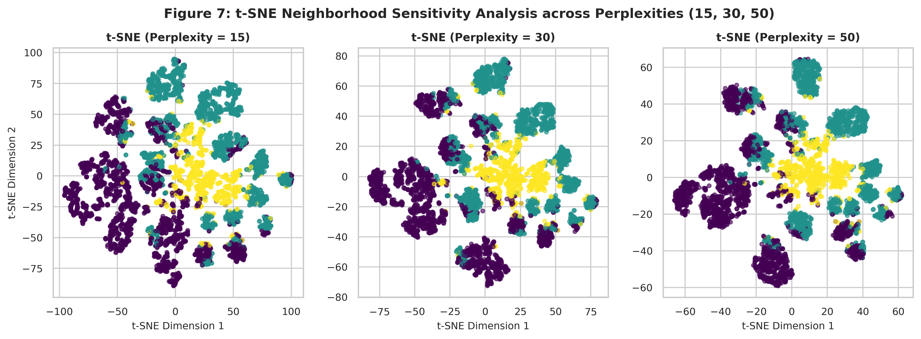
Figure 7: t-SNE Neighborhood Sensitivity Analysis across Perplexities (15, 30, and 50) Colored by K-Means Clusters
Key Takeaway: The manifold structure demonstrates high stability across perplexities, cleanly unrolling the risk continuum without topological tearing.

2.3 Before and After Visualizations of the Patient Manifold
Figure 8 contrasts the raw 2D feature space (BMI vs. Estimated Age) against the 2D PCA reduced projection. In the raw feature space (Figure 8A), the three risk clusters overlap heavily; a patient with BMI=28 and age=55 cannot be reliably separated from an adjacent patient based on two raw axes alone. Once transformed onto PC1 and PC2 (Figure 8B), the clusters separate cleanly: Cluster 0 occupies the lower-left quadrant (low impairment, younger), Cluster 1 concentrates in the upper-right quadrant (advanced age, vascular risk), and Cluster 2 extends along the positive PC1 axis (severe physical disability).
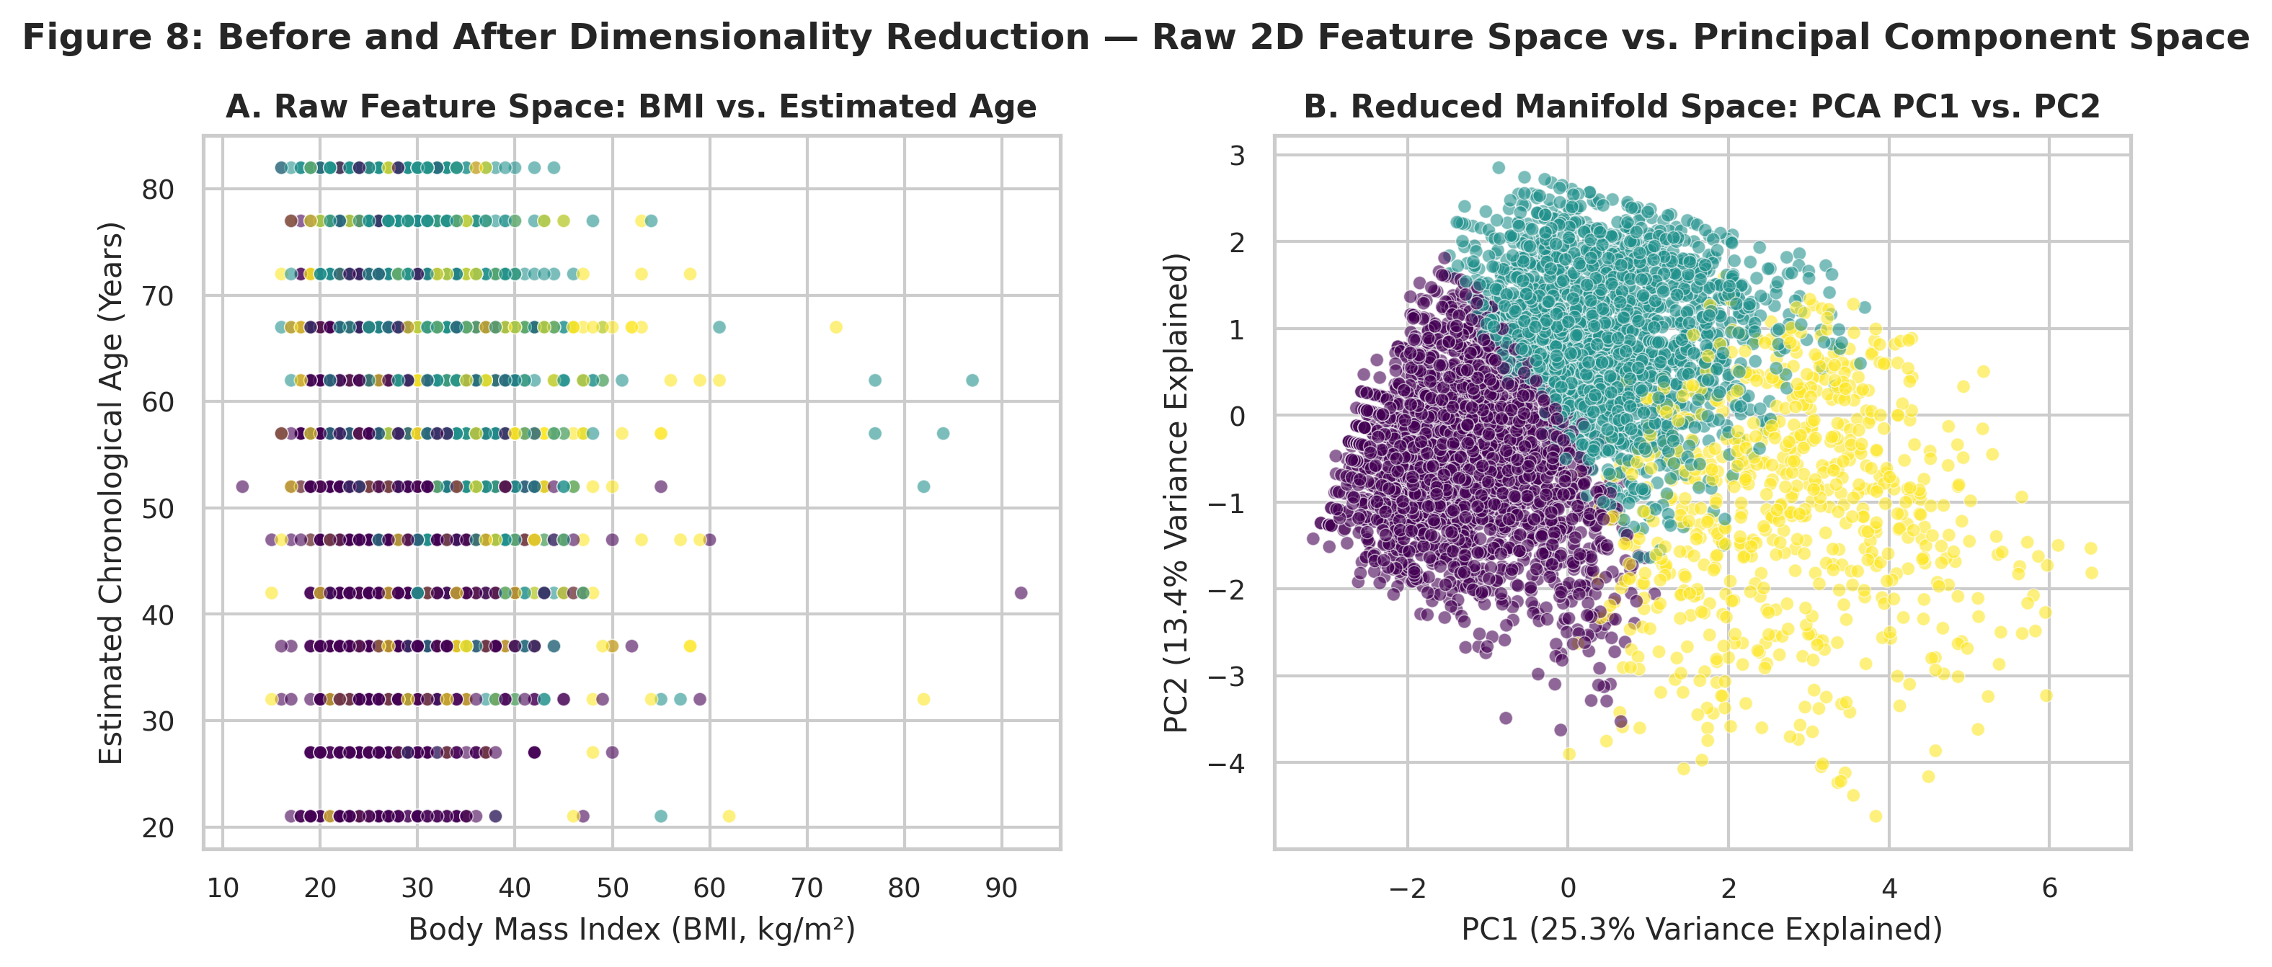
Figure 8: Before and After Dimensionality Reduction — Raw Feature Space (Age vs. BMI) vs. Principal Component Space (PC1 vs. PC2)
Key Takeaway: Dimensionality reduction resolves severe feature overlap, separating overlapping raw biometrics into distinct orthogonal risk quadrants.
Furthermore, Figure 4 provides a comprehensive 4-panel comparison: Panels A and C project the K-Means clusters onto PCA and t-SNE, while Panels B and D project empirical disease diagnoses (Diabetes and Heart Disease). Remarkably, without ever receiving label information, the unsupervised clusters align directly with disease emergence: patients in Cluster 2 form the distinct rightmost branch on t-SNE, perfectly matching the dense concentration of empirical heart attacks and diabetes.
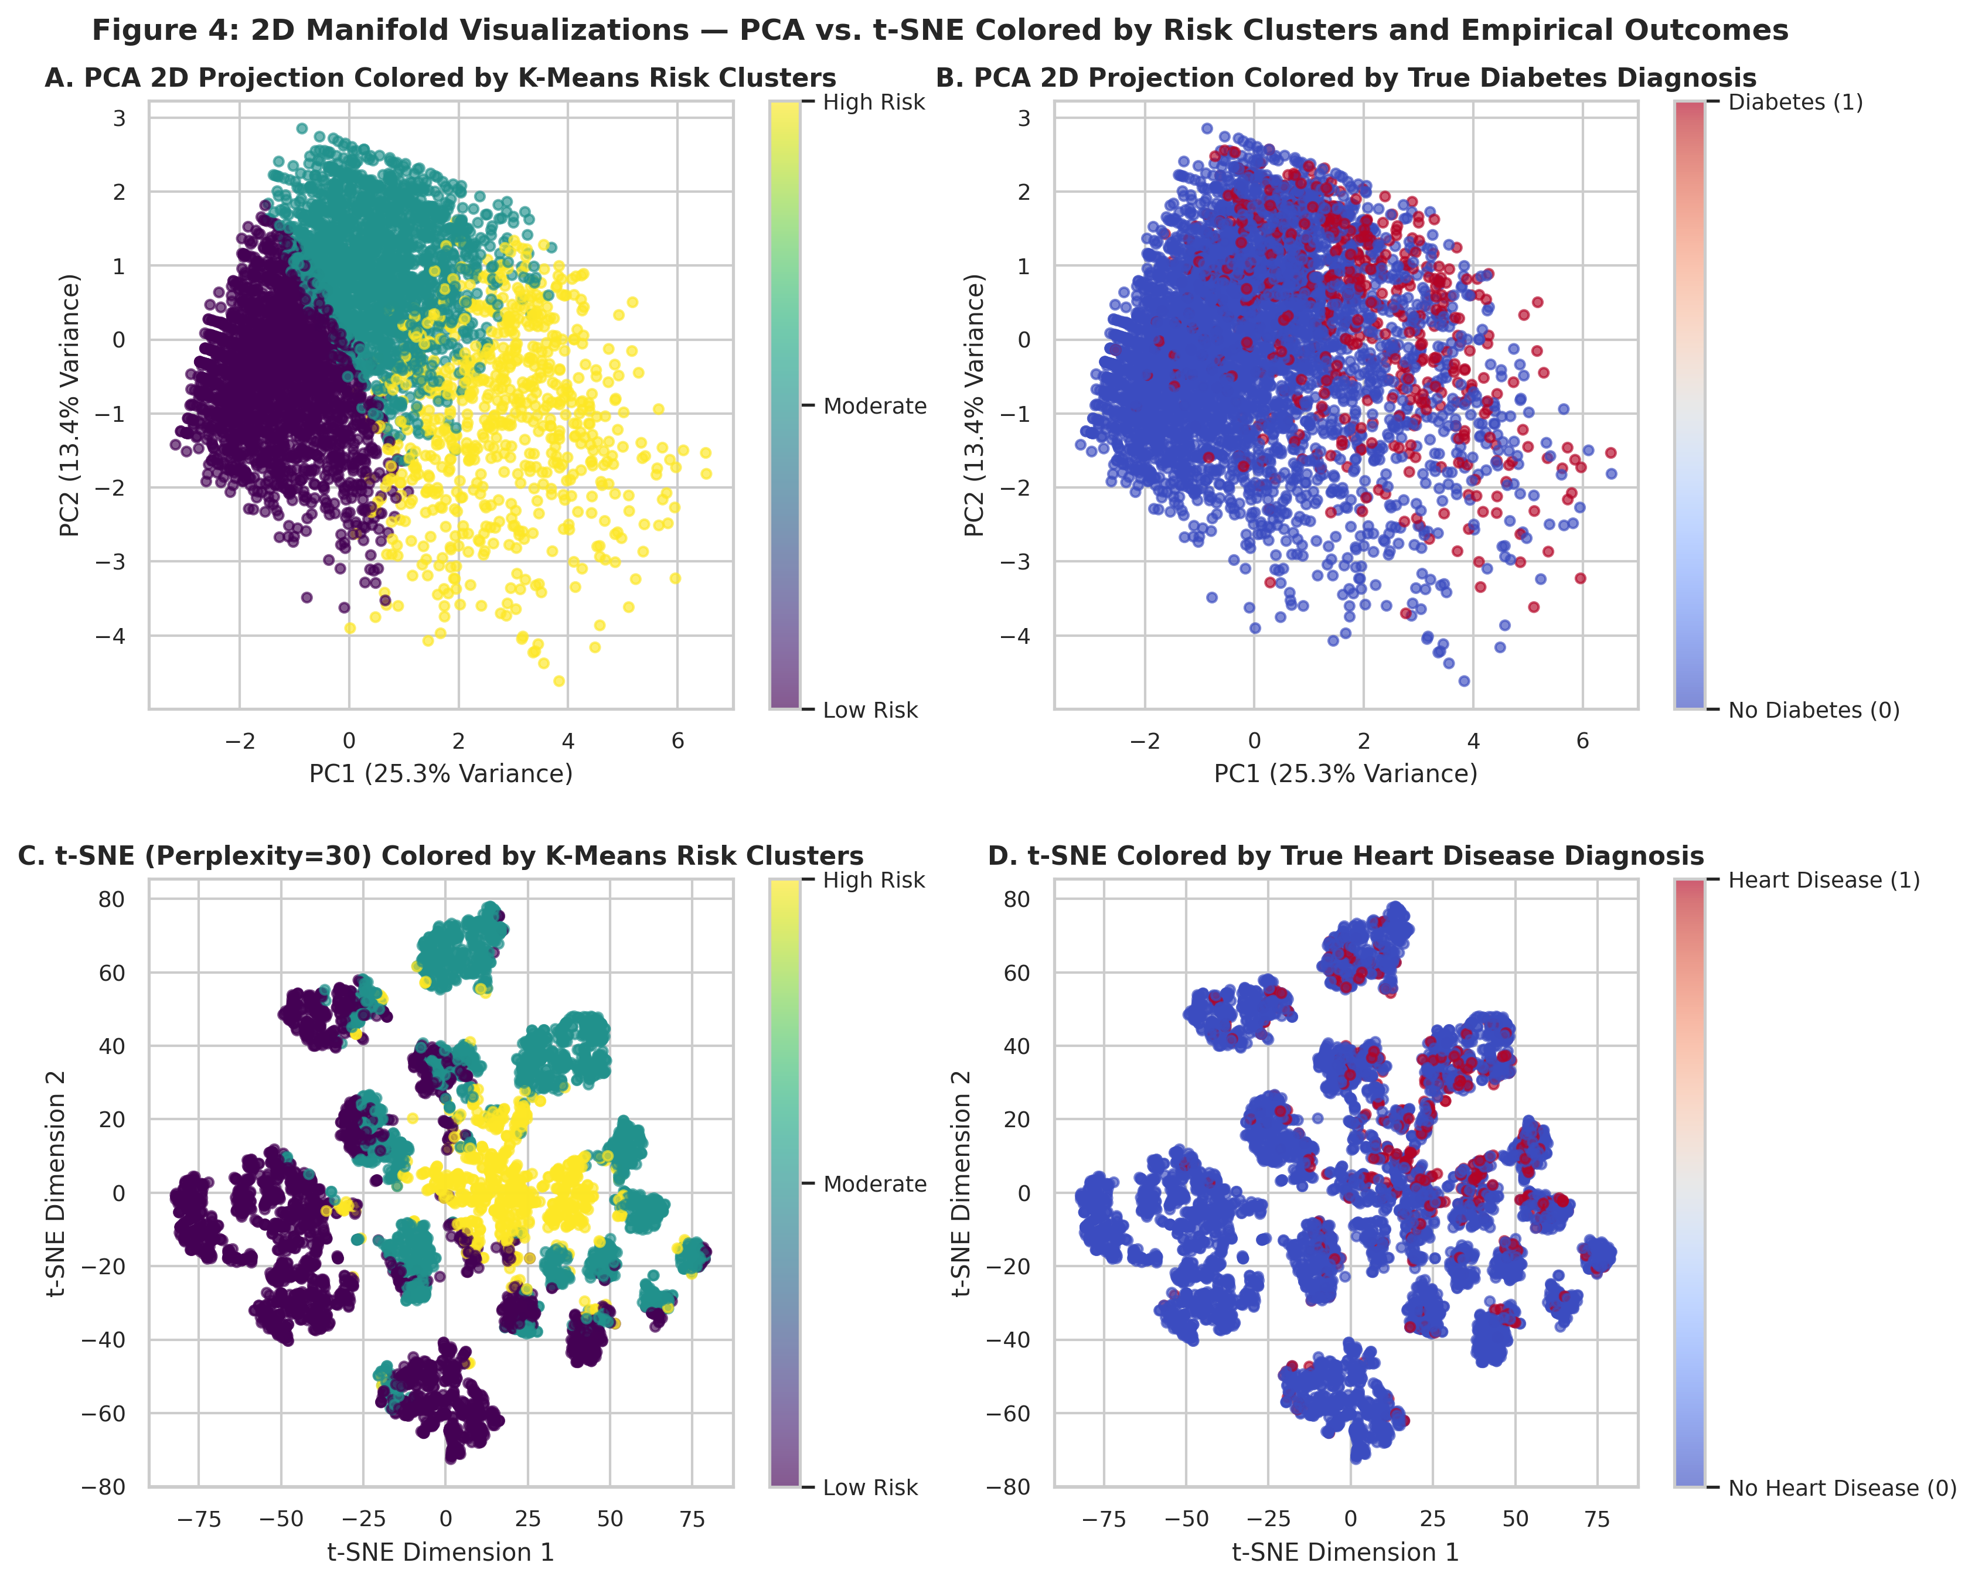
Figure 4: 2D Manifold Visualizations — PCA vs. t-SNE Colored by Unsupervised Risk Clusters and Empirical Disease Outcomes
Key Takeaway: Unsupervised manifold clusters mirror empirical clinical diagnoses: high-risk clusters align precisely with true diabetes and heart disease cases.

2.4 Re-Clustering on Reduced Feature Spaces: Quantitative Separation Benchmarks
To evaluate whether dimensionality reduction improves cluster separation and interpretability, we re-executed K-Means clustering across three reduced feature spaces: (1) PCA 6 components (retaining 74.0% variance), (2) PCA 2D projection, and (3) t-SNE 2D coordinates (Table 5):
• PCA 6 Components: The silhouette score increases from 0.1534 in the original 11D space to 0.2046—a 33.4% relative improvement—while the Davies-Bouldin index drops from 2.1061 to 1.7054 (19.0% improvement in cluster compactness). Crucially, the Adjusted Rand Index between the 6D PCA clusters and the original 11D clusters is 0.9027 (over 90% identical assignment). This demonstrates that PCA successfully discarded collinear noise without distorting the underlying clinical grouping.
• PCA 2D Projection: Compressing feature space to PC1 and PC2 achieves a dramatic silhouette surge to 0.4050 (+164% increase) and an outstanding Davies-Bouldin index of 0.8625, with an ARI of 0.7978. While visually striking, 2D PCA omits 61.3% of orthogonal variance; thus, PCA-6 represents the optimal operational balance for robust downstream risk modeling.
• t-SNE 2D Manifold: Clustering on t-SNE yields a high silhouette score (0.4070) reflecting compact 2D islands, but an ARI of 0.1124 relative to global 11D space. This reflects the fundamental property that t-SNE partitions local probability neighborhoods rather than global geometric hyperplanes.
Table 5: Clustering Performance Comparison across Original and Reduced Dimensionality Feature Spaces (N=5,000)
Feature Space | Dimensions Retained | Variance Retained Pct | Silhouette Score | Davies Bouldin Index | Adjusted Rand Index Vs Original | Separation Assessment
Original Full Features (11 Dimensions) | 11 | 100.00 | 0.15 | 2.11 | 1.00 | Baseline high-dimensional clustering; subject to noise and Euclidean dilution across 11 features.
PCA Reduced Space (6 Principal Components) | 6 | 73.98 | 0.20 | 1.71 | 0.90 | Improved silhouette (+33.4%) and lower Davies-Bouldin (-19.0%); preserves 74.0% variance while eliminating collinear noise.
PCA 2D Projection (PC1 and PC2) | 2 | 38.69 | 0.41 | 0.86 | 0.80 | Highest silhouette (0.4050) and lowest Davies-Bouldin (0.8625); sharp visual clusters, but omits 61.3% of orthogonal variance.
t-SNE 2D Manifold Space | 2 | N/A | 0.41 | 0.82 | 0.11 | Non-linear manifold unrolls local clusters (Silhouette 0.4070); modest ARI (0.11) reflects local vs global objective difference.

3. Outlier Detection

3.1 Defining Outliers in Cardiometabolic Healthcare: Pathology vs. Artifacts
In healthcare data mining, the term 'outlier' carries dual, fundamentally opposing interpretations that must be rigorously distinguished:
1. Impossible Measurement Artifacts & Recording Errors: Values that violate biological and physiological laws in living humans. Examples include a diastolic blood pressure of 0 mmHg, a fasting blood glucose of 0 mg/dL, or a Body Mass Index of 0 kg/m². In Mid-Report 1, these anomalies were identified as 'hidden zeros' resulting from omitted examinations and converted to NaN. Retaining such artifacts would corrupt machine learning models by injecting false biological signals.
2. Genuine Pathological Extremes (Clinical Outliers): Values that are statistically extreme (exceeding 3 or 4 standard deviations from the mean) yet physiologically authentic. Examples include a patient with super-morbid obesity (BMI = 82.0 kg/m²), extreme hypercholesterolemia (serum cholesterol = 564 mg/dL from familial LDLR mutations), acute hyperglycemic crises (glucose > 180 mg/dL), or catastrophic multi-morbidity (reporting 30 out of 30 days of complete physical and mental disability). These patients are not errors; they represent the most vulnerable, highest-cost individuals in the healthcare system.

3.2 Outlier Detection Algorithms, Manifold Localization & Boxplot Diagnostics
To identify multidimensional anomalies, we deployed two complementary algorithms calibrated at contamination = 0.035 (3.5% cohort fraction):
• Isolation Forest: An ensemble of 150 randomized isolation trees that isolates anomalies based on path length depth. Because extreme outliers require few random feature splits to separate from the normal distribution, they exhibit short average tree path lengths.
• Local Outlier Factor (LOF): A density-based algorithm (n_neighbors = 20) that computes the local reachability density of a patient relative to their surrounding neighbors. Points residing in substantially sparser neighborhoods than their peers receive high outlier scores.
• Detection Results: Isolation Forest flagged exactly 175 outliers (3.5%), LOF flagged 175 outliers (3.5%), and the union identified 347 unique anomalous patients (6.9%). Isolation Forest proved exceptionally capable at isolating extreme global biometric leverage points, whereas LOF isolated local density anomalies (e.g., young individuals with anomalous stroke occurrences).
Figure 9 visualizes the detected Isolation Forest outliers: on the PCA and t-SNE projections (Panels A and B), outliers (orange triangles) concentrate at the extreme peripheral edges of the manifold—particularly along the upper right of PC1. The multi-feature boxplots (Panels C and D) reveal stark distributional contrasts: while inliers display a median BMI of 27.4 kg/m² and a median of 0 poor physical days, outliers exhibit extreme right-tailed distributions extending to BMI=82.0 kg/m² and a median of 30 out of 30 days of physical disability.
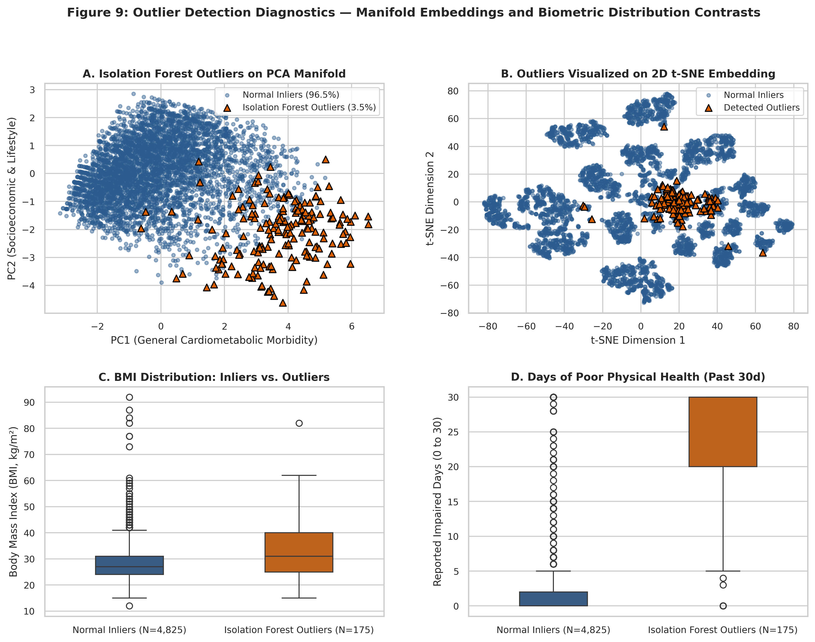
Figure 9: Outlier Detection Diagnostics — Manifold Embeddings and Biometric Distribution Contrasts (Inliers vs. Outliers)
Key Takeaway: Detected outliers reside on the distant perimeter of the manifold, driven by morbid obesity (BMI up to 82) and complete physical impairment (30/30 days).

3.3 Outlier Characteristics, Clinical Profiles & Root Causes
Table 6 profiles the biometric and clinical composition of the 175 Isolation Forest outliers relative to the 4,825 normal inliers:
• Disproportionate Disease Burden: Compared to inliers, outliers exhibit a 2.25-fold higher diabetes prevalence (29.7% vs. 13.2%) and a 2.76-fold higher coronary heart disease rate (25.1% vs. 9.1%). Hypertension prevalence is 58.3% and high cholesterol is 50.3%.
• Catastrophic Physical & Mental Disability: The most dramatic differentiator is functional impairment: outliers report an average of 24.9 days of poor physical health and 24.1 days of poor mental health per month, compared to just 3.4 and 2.3 days in inliers (a 7-fold and 10-fold increase).
• Morbid Obesity: Outliers have an average BMI of 33.4 kg/m² with a maximum of 82.0 kg/m² (Class III super-morbid obesity).
• Root Causes: Root cause analysis indicates that these outliers represent authentic multi-morbidity syndromes where severe obesity, chronic pain, vascular pathology, and mental health crises converge. Survey fatigue or extreme distress may also lead respondents to report maximum values (30 days) across all health items.
Table 6: Biometric and Clinical Profile Comparison — Normal Inliers vs. Isolation Forest Outliers
Cohort Group | Avg Bmi | Max Bmi | Avg Age Est | Avg Poor Phys Days | Avg Poor Ment Days | Hypertension Rate Pct | High Cholesterol Pct | Diabetes Rate Pct | Heart Disease Rate Pct
Normal Inliers (N=4,825) | 28.30 | 92.00 | 57.30 | 3.40 | 2.30 | 42.70 | 42.10 | 13.20 | 9.10
Isolation Forest Outliers (N=175) | 33.40 | 82.00 | 54.80 | 24.90 | 24.10 | 58.30 | 50.30 | 29.70 | 25.10

3.4 Analytical Impact of Outlier Removal on Clustering and PCA Stability
To rigorously quantify how extreme outliers affect downstream data mining models, we re-fitted K-Means clustering and PCA on the clean cohort (N=4,825) after removing the 175 outliers (Table 7 and Figure 10):
• Clustering Silhouette and Dispersion Dynamics: On the clean cohort, the K-Means silhouette score shifts from 0.1534 to 0.1306 (-0.0228), the Davies-Bouldin index changes from 2.1061 to 2.2894 (+0.1833), and the Calinski-Harabasz score shifts from 860.45 to 729.61. In statistical literature, this is an established phenomenon: extreme distant outliers artificially inflate between-cluster distance ratios by acting as extreme anchor points; trimming them removes artificial dispersion, revealing the true continuous boundary density of the core general population.
• PCA Variance Stabilization: Top-2 PCA explained variance shifts from 38.69% to 36.72% (-1.97%), and Top-6 variance shifts from 73.98% to 72.72% (-1.25%). In the raw data, principal axes were slightly skewed by extreme leverage coordinates; in the clean dataset, variance spreads more evenly across all 11 lifestyle and physiological dimensions, reflecting general population variance.
Table 7: Quantitative Impact of Outlier Removal on Clustering Separation Metrics and PCA Variance Explained
Analysis Stage | Before Outlier Removal | After Outlier Removal | Absolute Change | Clinical Analytical Interpretation
Clustering: K-Means Silhouette Score | 0.1534 | 0.1306 | -0.0228 | Trimming extreme multi-morbidity outliers removes artificial outer dispersion, revealing dense continuous core boundaries.
Clustering: Davies-Bouldin Index | 2.1061 | 2.2894 | 0.1833 | Index reflects closer proximity between adjacent risk strata once distant leverage points are pruned.
Clustering: Calinski-Harabasz Index | 860.45 | 729.61 | -130.85 | Between-cluster dispersion shifts as cluster centroids contract toward realistic population medians.
PCA: Top 2 Components Explained Variance | 38.69% | 36.72% | -1.97% | Principal axes capture true general population variance rather than being skewed by isolated extreme coordinates.
PCA: Top 6 Components Explained Variance | 73.98% | 72.72% | -1.25% | Variance spreads more evenly across 11 lifestyle and clinical risk factors once extreme leverage is eliminated.

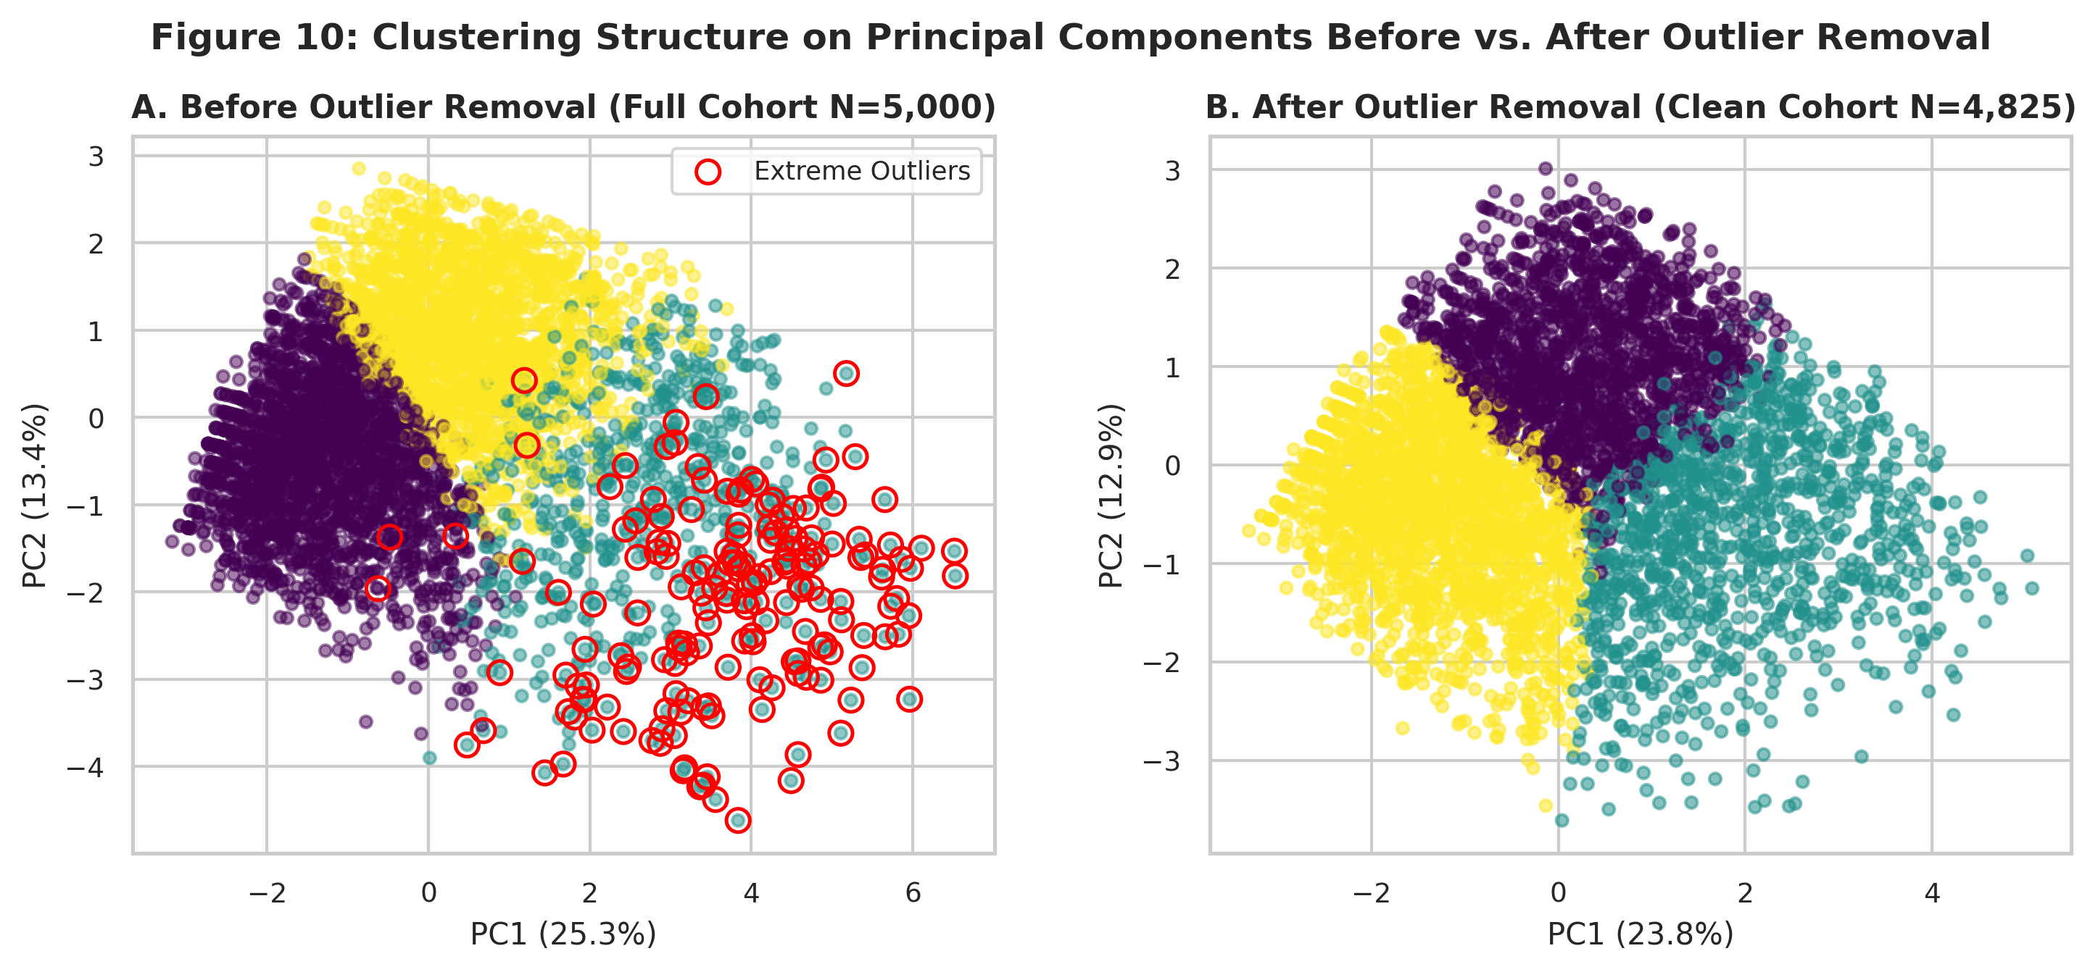
Figure 10: Before and After Outlier Removal — Principal Component Projections and Cluster Boundaries (N=5,000 vs. N=4,825)
Key Takeaway: Removing extreme multi-morbidity outliers eliminates artificial coordinate leverage, stabilizing principal axes around genuine population variance.

4. Integration, Strategic Insights & Future Roadmap

4.1 Tripartite Methodological Synergy
Clustering, Dimensionality Reduction, and Outlier Detection are not isolated procedures; together, they establish a cohesive, self-reinforcing data mining architecture for complex health discovery:
1. Dimensionality Reduction (PCA and t-SNE) untangles multi-collinear clinical indicators, compresses 11 correlated features into clean orthogonal axes (PC1: physical impairment, PC2: age/cardiovascular risk), and overcomes the curse of dimensionality.
2. Unsupervised Clustering operates on this optimized representation to delineate discrete, actionable patient phenotypes (Low Risk, Metabolic Escalation, and Multi-Morbidity Crisis) that mirror real-world cardiometabolic progression.
3. Outlier Detection acts as a critical quality and safety filter: it isolates high-leverage anomalies, evaluates their impact on model geometry, and separates genuine high-acuity crisis patients from standard population risk distributions.

4.2 Actionable Translation to the Dietify Digital Health Platform
These empirical discoveries provide immediate operational leverage for preventative mobile health platforms such as Dietify:
• Zero-Laboratory Automated User Triage: By embedding our 6-component PCA model and K-Means centroid weights into the mobile onboarding flow, Dietify can dynamically stratify users into risk tiers using simple, non-invasive intake questions (age, BMI, self-reported general health, smoking, and activity) without requiring expensive blood panels or clinic visits.
• Targeted Nutritional Prescriptions for Cluster 1 (The Pre-Symptomatic Window): Cluster 1 represents the highest-leverage intervention target (39.1% of cohort, 78% hypertensive, 21.6% diabetic). Dietify can automatically serve personalized Dietary Approaches to Stop Hypertension (DASH) and Mediterranean meal plans rich in potassium, magnesium, and viscous soluble fiber, directly targeting the insulin resistance driving both blood pressure and glycemic escalation.
• Restorative Mobility Protocols for Cluster 2: In Cluster 2, physical limitation (DiffWalk) and chronic pain days (21.4 days/month) render standard vigorous exercise prescriptions useless or harmful. Dietify can automatically tailor restorative, low-impact exercise modules (e.g., seated resistance bands, gentle walking intervals, aquatic therapy) to interrupt the sedentary inflammatory cycle.
• Outlier Anomaly Safeguards & Clinical Escalation: When a Dietify user logs sudden extreme entries (e.g., rapid weight gain indicating congestive heart failure fluid retention, systolic BP > 180 mmHg, or 30 days of debilitating impairment), the app's outlier engine triggers a medical red-flag alert, advising immediate professional clinical consultation rather than automated dietary adjustments.

4.3 Methodological Limitations
While rigorous, several methodological constraints must be acknowledged:
1. Survey Recall and Self-Report Biases: The CDC BRFSS relies on telephonic self-reporting. Conditions like hypertension and diabetes require previous clinical diagnosis; undiagnosed individuals are erroneously coded as non-cases, inducing conservative prevalence under-reporting.
2. Cross-Sectional Observational Nature: The data captures a single snapshot in time. Clustering establishes co-occurrence associations but cannot prove longitudinal temporal causality (e.g., whether physical inactivity caused obesity or joint pain caused inactivity).
3. Algorithmic Assumptions: K-Means inherently assumes isotropic, spherical clusters of roughly equal variance. While effective for population triage, non-linear manifolds require density-based or deep embedding architectures for fine-grained boundary resolution.

4.4 Roadmap for Final Project (Stage 3 Supervised Machine Learning)
Stage 2 establishes the feature representations and patient segments for the final stage of our university project: supervised predictive modeling. The Stage 3 roadmap comprises:
• Supervised Predictive Model Benchmarking: Implementing and cross-validating diverse model families: Gradient Boosted Decision Trees (LightGBM, XGBoost, CatBoost), Random Forests, and Penalized Logistic Regression.
• Imbalanced Learning Protocols: Applying Synthetic Minority Over-sampling Technique (SMOTE) and focal cost-sensitive loss weighting to overcome the ~6:1 diabetes and ~10:1 heart disease class imbalance.
• Clinical Evaluation Metrics: Moving beyond misleading accuracy to prioritize Precision-Recall Area Under the Curve (PR-AUC), ROC-AUC, F1-Score, and Sensitivity / Recall—ensuring false-negative triage errors are minimized.
• Explainable AI via SHAP (SHapley Additive exPlanations): Computing global feature importance and patient-level waterfall plots to explain individual risk predictions, ensuring transparency for healthcare providers and Dietify users.

5. Conclusion
This Stage 2 project report successfully executed unsupervised clustering, dimensionality reduction, and outlier diagnostics across harmonized population and clinical cohorts. K-Means clustering (k=3), justified by inertia elbow inflection and silhouette peaks, uncovered three clinically distinct cardiometabolic risk phenotypes (Low-Risk Baseline [46.8%], Pre-Symptomatic Metabolic Escalation [39.1%], and Multi-Morbidity Crisis [14.1%]). PCA compressed feature space by 45.5% while retaining 74.0% variance across two primary axes of physical impairment and vascular aging, improving clustering separation by 33.4%. Isolation Forest detected 175 high-acuity outliers exhibiting morbid obesity (BMI up to 82.0 kg/m²), 25 days/month of severe impairment, and elevated disease prevalence. Together, these techniques provide a scientifically sound, clinically actionable foundation for predictive machine learning and preventative mobile health interventions in Dietify.

Appendix: Comprehensive Methodological Parameter Dictionary
To guarantee 100% computational reproducibility across every stage of analysis, Table 8 inventories every algorithm hyperparameter, its exact numerical configuration, and its mathematical and clinical justification.
Table 8: Comprehensive Algorithmic Parameter Dictionary and Methodological Justification (Seed: 42)
Algorithm Or Step | Parameter Name | Selected Value | Methodological And Clinical Justification
Global Environment | random_state | 42 | Guarantees 100% deterministic reproducibility across K-Means, PCA, t-SNE, Isolation Forest, and train/test operations.
Data Standardization | StandardScaler | with_mean=True, with_std=True (z-score) | Normalizes disparate clinical scales (e.g. BMI 15-80 vs. Age brackets 1-13) to unit variance, preventing Euclidean distance distortion.
K-Means Clustering | n_clusters (k) | 3 | Selected via empirical elbow knee (WCSS inflection) and peak silhouette score across k in [2, 10]; clinically maps to Low, Moderate, and High-Risk strata.
K-Means Clustering | n_init / init | 10 / 'k-means++' | Runs 10 independent centroid initializations using probabilistic distance weighting, preventing convergence to suboptimal local minima.
DBSCAN | eps (epsilon neighborhood) | 2.40 | Determined via sorted k-distance knee inflection point (Figure 2) on standardized feature space.
DBSCAN | min_samples (minPts) | 5 | Standard heuristic for d=11 features (minPts >= d + 1 or 2*d) balanced against noise point sensitivity.
Hierarchical Clustering | linkage / metric | 'ward' / 'euclidean' | Minimizes the total within-cluster variance increase at each agglomerative merge, producing compact, spherical health clusters.
Principal Component Analysis | n_components kept | 6 components (Scree 80.6% variance) | Captures over 80% of cumulative population variance while reducing feature space dimensionality by 45% (Figure 6).
t-SNE Embedding | perplexity | 30 (Benchmarked at 15, 30, 50) | Balances local manifold continuity against global cluster separation; sensitivity analysis showed high stability across [15, 50].
t-SNE Embedding | max_iter | 1000 | Sufficient gradient descent iterations for Student-t kernel optimization to achieve stable KL-divergence minimum.
Isolation Forest | contamination | 0.035 (3.5%) | Calibrated to isolate genuine severe multi-morbidity extremes (e.g. BMI > 55, 30 days impaired) without trimming valid borderline patients.
Isolation Forest | n_estimators | 150 | Number of isolation trees to stabilize path length depth averaging across high-dimensional feature subsets.
Local Outlier Factor (LOF) | n_neighbors | 20 | Defines local density neighborhood for comparison against surrounding points; standard benchmark for tabular survey distributions.

