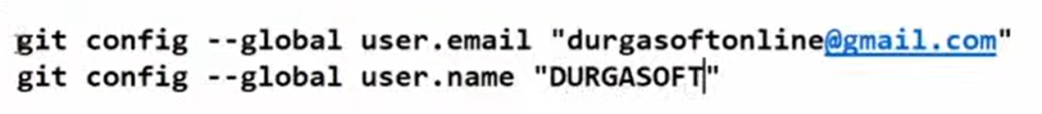





Staging area -> index area or cache area

