Home Security using ESP8266

Microcontroller

Devang Singhal

Student, IET Department

JK Lakshmipat University, Jaipur, Rajasthan

devangsinghal@jklu.edu.in

Divanshu Jain

Faculty, EEE Department

JK Lakshmipat University, Jaipur

divanshujain@jklu.edu.in

Aaditya Vyas

Student, IET Department

JK Lakshmipat University, Jaipur, Rajasthan

aadityavyas@jklu.edu.in

Mahesh Saini  
Faculty, EEE Department

JK Lakshmipat University, Jaipur  
mahesh.saini@jklu.edu.in

*Abstract –* Home security is a top priority for homeowners, and with the rise of the Internet of Things (IoT), it has become easier to monitor and secure homes using connected devices. The Home Security IoT project is designed to provide homeowners with an added layer of security by integrating various sensors and a NodeMCU board to detect potential threats such as fire, gas leakage, and intruders. The project uses a combination of sensors, a NodeMCU board, and the Blynk app to monitor the home and alert the homeowner in case of a potential threat. When a threat is detected, the NodeMCU board sends a notification to the Blynk app, which can be installed on the homeowner's smartphone, tablet, or computer. Additionally, the project can also send an email to the homeowner with the same information, providing an additional layer of security and peace of mind. With the integration of the NodeMCU board and Blynk app, the Home Security IoT project provides a modern and effective solution for homeowners looking to secure their homes.

*Keywords* - Fire Sensor, PIR sensor ,Smoke sensor, ESP8266 Microcontroller, Home Security, Blynk ,email.

1. **INTRODUCTION**

Basic necessities of any household or industry include fire and gas. LPG gas is provided with a distinct smell in case of leakage and creates a hazardous situation. Nevertheless, it takes some time to realize that smell. Therefore, extra precautions are recommended in order to stay safe from serious consequences. Installing sensors in-house for early detection of gas or fire breakout can be a good precautionary measure. Gas sensors can detect the gas as the leakage starts and alarm the user to allow them some time to take preventive measures. In case of fire, a fire extinguisher or a sprinkler can be triggered by the system to stop it from rising, warning the user in the process. In this paper, we have presented a home security system in form of a fire and gas detecting system that will detect gas leakage and fire. There can be three causes for the system, viz only gas leakage, only fire, and gas leakage with fire breakout. Actuators will be connected to the circuit to generate an alarm accordingly.

1. **MOTIVATION FOR THE RESEARCH**

There have been many instances where households and industries have faced hazards due to fire outbreaks, gas leakages, and intrusion. These scenarios not only pose a threat to human life but also result in heavy losses of property. The motivation for this research is to provide an effective and affordable solution to detect and alert homeowners of potential threats such as fire, gas leakages, and intrusion. The proposed device will help in avoiding such scenarios and provide homeowners with an added layer of security and peace of mind..

1. **BACKGROUND OF THE RESEARCH**

A literature survey was conducted on the existing devices that warn about any expected tragedies related to fire or gas. Many of the reviewed projects utilized online applications for informing the user of the accident. Solórzano et al. targeted the issue of the false alarm that is caused by fire detection sensors. Therefore, an experiment was conducted by the authors to reduce the chances of false alarms. The help of a group of different types of sensors, along with a pattern recognition system, assisted the authors in reducing the chances of false alarms but not completely. [1]

Anika et al. developed a system that will detect gas leakage & fire and will notify the user by an SMS as well sending notifications on Blynk App. It will also activate the automatic ventilation system and extinguish the fire. For this author used fire & gas sensors, Arduino microcontroller, buzzer, ventilation fan, solenoid valve for extinguishing the fire using water, and Blynk App. The author was able to make the system work but proposes to add a real-time camera to the infrastructure for future reference. [2]

Gaur et al., focus on the ways in which the fire can be detected in case of leakage. First, the areas with possible fire are discussed and categorized under domestic, industrial, forest, and others. Then different fire sensing technologies are discussed under the categorization of different techniques of fire sensing like heat, gas, smoke, flame, and others. Under these, there are different elements that can be used to sense fire and gas, and smoke. [3].

M. Fleischer provides information on the types of gas sensors that can be used to detect gas. Two types of gas sensors were mentioned, electric potential and metal oxide. They analyzed the change of potential in the electric-type sensor and the reaction of metal with gas in the metal oxide type sensor, which is used to detect the gas in these sensors. [4]

Chen and Hwang presented a fire safety management system for electrical fires precaution which will produce an early warning. Elements utilized include an electric energy meter with a smart breaker, fire alarm concentrator, dc powered smoke sensors. It acts on an early discovery scheme where the system constantly monitors the energy information and line losses for the identification of potential electric fires, shutting off any irrelevant electrical usage. It can also shorten the fire alarm delay contingent upon electrical fires. [5]

Ghosh and Dhar described such a system that can detect gas leakages, fires, and explosions. For controlling leaked gas or fire/explosions, the system is equipped with an exhaust fan or solenoid water inlet, respectively. Individual response is observed in case of fire breakout with no relation to gas leakage. The owner is sent information through SMS by GSM and is alerted through a buzzer while the display shows the message. [6]

Debnath et al. proposed a device for gas leakage and fire detection where the owner is alerted through a phone call via the GSM module. The owner is alerted through an alarm as well which in turn sends graphical alerts to the server via Node MCU. Additionally, a temperature sensor detects the temperature of the perilous situation, sending the data to a web server. [7]

Macker et al. proposes such a framework which robotizes the LPG cylinder booking system, making it free of any human interaction. It continuously weighs the cylinder and sends consequent messages to the authorized LPG agent for conveying the LPG chamber in time. In addition to this, the clients are alarmed of any leakage of LPG through the cylinder. [8]

In this paper, we have tried to alert using the traditional actuators (LEDs or buzzers) in case the network malfunctions. And the owners need to be notified immediately.

1. **PROPOSED SYSTEM**

This paper proposes a security system based on smoke, flame, and PIR motion sensing modules. It is not necessary for smoke to result in fire to turn hazardous, many instances have proven this like dangerous occurrence. Likewise, during a fire breakout, it is not always necessary for it to be caused due to gas, it could be an electrical fire too. During the development of this system, three cases were kept in mind.

* Firstly, when there is smoke detection. Be it a household or an industrial setting, smoke can prove to be harmful in more than one way. The smoke sensing module present in our system will be looking out for any such activity, and as soon as sensed, the microcontroller will activate the LED/buzzer as a warning signal and also send notification on the host device and enable us take safety measures..
* Secondly, when there is a fire breakout, not only due to smoke. Though automation has made numerous jobs easier, there is always an underlying risk of a fire breakout. Even a minor technical fault might pose a fire pitfall. In case of flame detection, the sensor will send a signal to the microcontroller which in turn will activate the connected actuator to warn about the threat.
* Lastly, when there is motion detected through PIR, indicating a possible intruder. In this situation, the microcontroller will activate the actuators to give a warning alarm, and the homeowner will receive a notification through the Blynk app installed on their device.

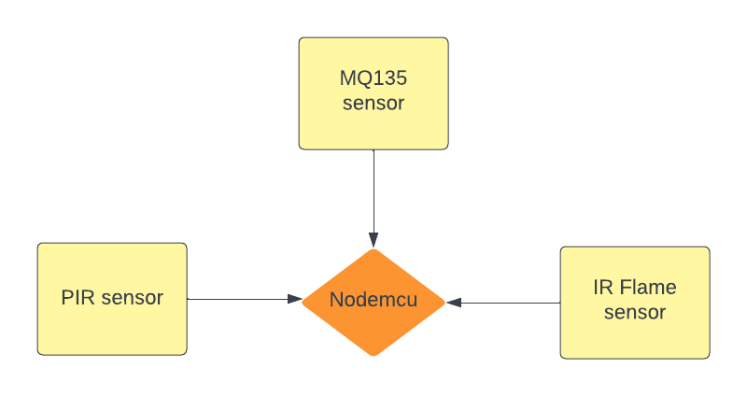

Figure1: Block diagram of the system

**Advantages of proposed system**

* Cost Efficient
* Enhanced Security
* Real-time Monitoring
* Customizable

1. **METHODLOGY & FLOW CHART**

The proposed Home Security IoT project focuses on integrating various sensors and a NodeMCU board to detect potential threats such as fire, smoke, and intruders. The system works as follows::

• Alarm for Fire Detection

• Alarm for Intruder Detection

`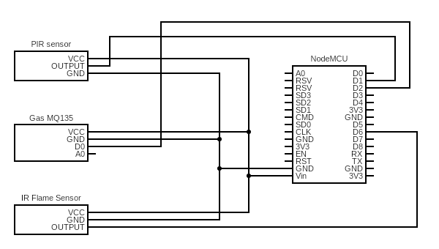

Figure 2 Circuit diagram of the project

As a warning, the actuators in the system will start producing an output i.e., either sending alert notification on Blynk app or on owner email.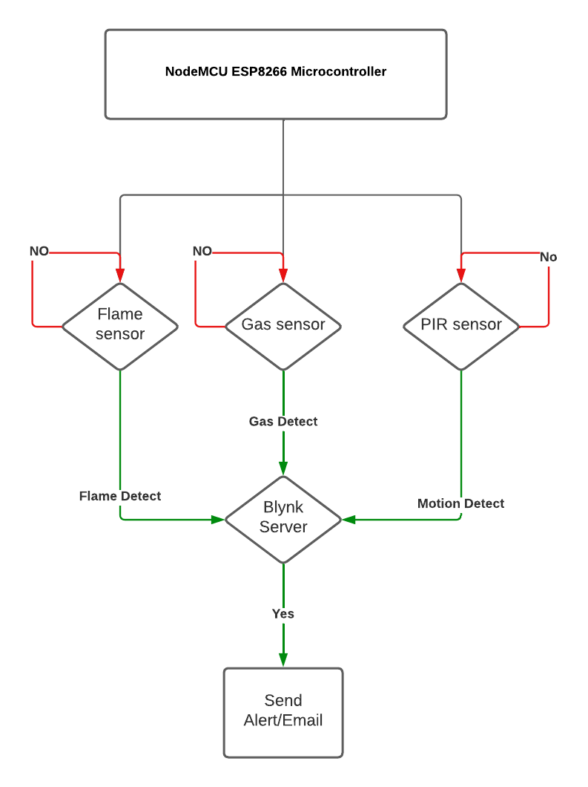

. Figure 3: Flowchart of the proposed project

1. **COMPONENTS USED**

* NodeMCU ESP8266 Microcontroller
* Fire Sensor Module (KY 026)
* Gas Sensor Module (MQ135)
* PIR(Motion) Sensor Module
* Connecting wires

1. **NodeMCU ESP8266 Microcontroller:** NodeMCU ESP8266. NodeMCU is an open-source Lua-based firmware and development board specially targeted for IoT-based Applications. It includes firmware that runs on the ESP8266 Wi-Fi SoC from Espress if Systems, and hardware which is based on the ESP-12 module.

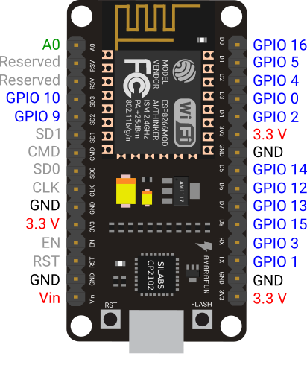

Figure 4: NodeMCU esp8266 Microcontroller

1. **Gas Sensor Module (MQ135):** The MQ 135 sensor can be implemented to detect smoke, benzene, vapors, and other hazardous gases. It can detect various harmful gases. It can be used for air quality monitoring, noxious gas detection, home air pollution detection, industrial pollution detection, portable air pollution detection, etc. A close-up of a hat

   Description automatically generated with low confidence

Figure 5: Gas Sensor Module

1. **IR Flame Sensor Module:** Flame sensors use UV (Ultraviolet) or IR (Infra-Red) or UV-IR technology to identify flames below a second. 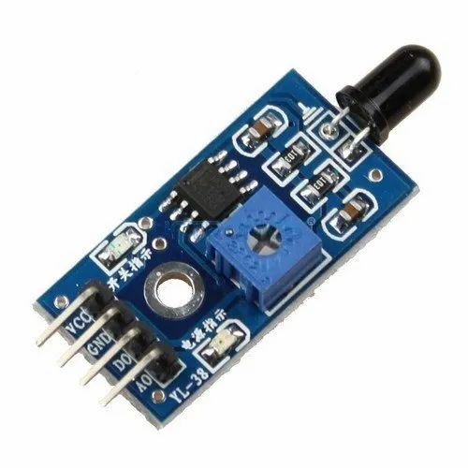

Figure 6: IR Flame Sensor Module

1. **PIR(Motion) Sensor Module:** A PIR sensor detects motion by sensing changes in infrared radiation emitted by warm objects in its surrounding area. PIR sensors are affordable, easy to use, and highly reliable.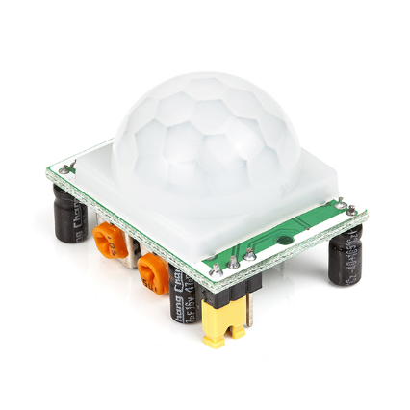

Figure 7: PIR Sensor Module

1. **WORKING OF THE PROPOSED SYSTEM**

To test the fabricated prototype, the system was connected to a Blink server and the data was sent to the owner's/host device through the internet. The system was tested for all three cases and was found to be working for all of them. In Case 1, when smoke was detected, the system sent a warning message "Smoke Detected" to the owner's device. In Case 2, when flames were detected, the system sent a warning message "Fire Detected" to the owner's device. In Case 3, when motion was detected, a warning message “Thief” was sent to the owner’s device. The owner can then take necessary actions to prevent any hazards.

Figure 8: Look of the prototype/model

**Case 1 and Case 2:** The system, when tested against smoke or flame, gave a warning, and sent a notification, message, and mail to the connected host device, in figure 9.

Figure 9: Output of Case 1 and Case 2

**Case 3:** The system, when tested against the motion, made the Blue inbuild LED glow and gave a warning, and sent a notification, message, and mail to the connected host device, shown in figure 10.

Figure 10: Output of Case 3

1. **RESULT AND DISCUSSION**

The developed system is found to be working for all of its cases. The messages were displayed on the LCD screen along with the actuators giving off warning signals accordingly.

1. **BUSINESS MODEL**

The Home Security IoT project can be monetized through a few different business models. One potential model is to sell the hardware components as a kit to customers who can then install and set up the system themselves. The kit could be priced according to the number and type of sensors included and can be sold directly to consumers through an online store or retail outlets. Another possible model is to offer the system as a subscription service, with customers paying a monthly fee for access to the software and services. The subscription model could include ongoing maintenance and upgrades to ensure the system is up to date and functioning optimally. Additionally, the project could be offered to home security companies as a white-label solution, where they can rebrand and offer it to their customers as a part of their own product line. By providing a comprehensive and efficient solution to home security, the Home Security IoT project has the potential to be a profitable business venture with multiple revenue streams.

1. **CONCLUSIONS**

In summary, the Home Security IoT project is designed to utilize its surrounding information to detect potential threats and alert the homeowner through their mobile devices. The proposed system eliminates the need to install separate systems for gas leakage and fire detection, as well as intruder alerts, providing an all-in-one solution. Moreover, the project is cost-effective, making it accessible to a wider audience. By providing a comprehensive and efficient solution to home security, the project can provide homeowners with peace of mind and a sense of security.

1. **FUTURE WORK**

The Home Security IoT project presents a robust and efficient solution for homeowners to secure their homes. However, there is always room for improvement and expansion. In the future, the project can be enhanced by adding more sensors to detect other potential threats such as water leakage or carbon monoxide. Additionally, the project can be integrated with smart locks to allow the homeowner to control the locks remotely and prevent unauthorized access. The system can also be made more intelligent by using machine learning algorithms to analyze sensor data and identify patterns that can be used to predict potential threats. With the advancement of technology, there are endless possibilities for the Home Security IoT project to evolve and become an even more comprehensive and effective solution for home security.

**REFERENCES**

1. A. Solórzano, J. Fonollosa, L. Fernández, J. Eichmann and S. Marco, "Fire detection using a gas sensor array with sensor fusion algorithms," 2017 ISOCS/IEEE International Symposium on Olfaction and Electronic Nose (ISOEN), 2017, pp. 1-3, doi: 10.1109/ISOEN.2017.7968889.
2. A. M. Anika, M. N. Akter, M. N. Hasan, J. F. Shoma and A. Sattar, "Gas Leakage with Auto Ventilation and Smart Management System Using IoT," 2021 International Conference on Artificial Intelligence and Smart Systems (ICAIS), 2021, pp. 1411-1415, doi: 10.1109/ICAIS50930.2021.9395774.
3. A. Gaur et al., "Fire Sensing Technologies: A Review," in IEEE Sensors Journal, vol. 19, no. 9, pp. 3191-3202, 1 May1, 2019, doi: 10.1109/JSEN.2019.2894665.
4. M. Fleischer, "Industrialisation of Gas Sensors for Comfort, Security and Wellness," TRANSDUCERS 2007 - 2007 International Solid-State Sensors, Actuators and Microsystems Conference, 2007, pp. 2389-2392, doi: 10.1109/SENSOR.2007.4300651.
5. Y. Chen and J. Hwang, "A Power-Line-Based Sensor Network for Proactive Electrical Fire Precaution and Early Discovery," in IEEE Transactions on Power Delivery, vol. 23, no. 2, pp. 633-639, April 2008, doi: 10.1109/TPWRD.2008.917945.
6. P. Ghosh and P. K. Dhar, "GSM Based Low-cost Gas Leakage, Explosion and Fire Alert System with Advanced Security," 2019 International Conference on Electrical, Computer and Communication Engineering (ECCE), 2019, pp. 1-5, doi: 10.1109/ECACE.2019.8679411.
7. S. Debnath, S. Ahmed, S. Das, A. -A. Nahid and A. K. Bairagi, "IoT based Low-Cost Gas Leakage, Fire, and Temperature Detection System with Call Facilities," 2020 2nd International Conference on Advanced Information and Communication Technology (ICAICT), 2020, pp. 11-16, doi: 10.1109/ICAICT51780.2020.9333530.
8. A. Macker, A. K. Shukla, S. Dey and J. Agarwal, "ARDUINO Based LPG Gas Monitoring … Automatic Cylinder Booking with Alert System," 2018 2nd International Conference on Trends in Electronics and Informatics (ICOEI), 2018, pp. 1209-1212, doi: 10.1109/ICOEI.2018.8553840.
9. Embedded systems. [Online]. Available: http://dvgadre.blogspot.com/2017/01/make-yourself-msp430-lunchbox-for-1.html. [Accessed: 05-Feb-2022].
10. “MSP430 Lunchbox's documentation!¶,” MSP430 LunchBox's documentation! - MSP430 LunchBox 1.0.0 documentation. [Online]. Available: https://lunchbox.sincgrid.com/docs/build/html/index.html. [Accessed: 05-Feb-2022].
11. N. *, “Mq2 Gas Sensor - Working Principle & Its Applications,” ElProCus, 12-Aug-2019. [Online]. Available: https://www.elprocus.com/an-introduction-to-mq2-gas-sensor/. [Accessed: 05-Feb-2022].
12. Rajguru Electronics- largest electronics components distributor in India. [Online]. Available: https://rajguruelectronics.com/ProductView?product=MQ2+GAS+SENSOR&tokDatRef=MTA5Mg&tokenId=Mzk#:~:text=are%20often%20estimated.-,Sensitive%20material%20of%20MQ%2D2%20gas%20sensor%20is%20SnO2%2C%20which,correspond%20output%20of%20gas%20concentration. [Accessed: 05-Feb-2022].
13. “KY-026 Flame Sensor Module,” ElectronicsComp.com. [Online]. Available: https://www.electronicscomp.com/ky-026-flame-sensor-module?gclid=Cj0KCQiA3fiPBhCCARIsAFQ8QzXw5p_PgTGziFjKhj1f6dYf281K5XaPvZTY4xnutaxgNZCO8kRfKpQaAsciEALw_wcB. [Accessed: 05-Feb-2022].
14. S. Gupta, D. Jain and M. T. Themalil, "Electronic Voting Mechanism using Microcontroller ATmega328P with Face Recognition," 2021 5th International Conference on Computing Methodologies and Communication (ICCMC), 2021, pp. 1471-1476, doi: 10.1109/ICCMC51019.2021.9418372.