AI-Based Biometric Evidence Authentication for Post-Quantum Digital Identity Systems
Aditya Gujar (23BIT0224) Aditya.070505@gmail.com | Devangi Joshi (23BIT0178) devangijoshi2004@gmail.com | Kevin Kurian Albert (23BIT0263) lionelkevin05@gmail.com

Abstract:
Remote identity verification (e-KYC, bank onboarding and government digital ID) depends on two assumptions: that the channel carrying a biometric capture is confidential and authentic, and that the capture itself is a genuine, live and fresh image of the claimed person. Today's systems protect the channel with RSA and elliptic-curve cryptography, which Shor's algorithm will break once a cryptographically relevant quantum computer exists. Adversaries can therefore record biometric sessions now and decrypt them later ("harvest now, decrypt later"). Channel security also says nothing about the content: a deepfake sent over a perfectly secure channel is still a deepfake. This project designs, implements and evaluates a prototype that closes both gaps in one pipeline. The channel is protected by the NIST-standardised lattice schemes ML-KEM-768 (FIPS 203) and ML-DSA-65 (FIPS 204) through liboqs. Every capture is cryptographically bound to a single verification session by an ML-DSA signature over the evidence hash, a 256-bit single-use nonce, a timestamp and a liveness-challenge response. Only evidence that passes this binding gate is analysed by five AI/signal-processing detectors (presentation attack, morphing, deepfake, replay and injection), whose scores are combined by a weighted fusion engine with per-module veto. To make the quantum threat model concrete rather than assumed, we implemented and simulated in Qiskit the three quantum circuits that define it. Shor's order-finding for N = 15 recovers the factors with probability 0.499 in the ideal case (theoretical 0.5). Grover's search over a 4-qubit key space succeeds with probability 0.960 (theoretical 0.961). An 8-qubit Hadamard quantum random number generator (QRNG) is proposed as a session-nonce source. Noise sweeps show that a two-qubit error rate of 1% drops Shor's success to 0.132 and Grover's to 0.430, which quantifies why fault tolerance, not qubit count alone, governs the attack timeline. On an Apple M3, ML-KEM-768 encapsulation plus decapsulation takes 0.045 ms, 47 times faster than RSA-3072. All post-quantum cryptography plus the binding checks cost 0.35 ms, about 2.2% of server-side compute. The median end-to-end verification time is 28.2 ms. In an eleven-scenario evaluation, all four binding-layer attacks were rejected in about 0.1 ms before any AI ran, and four of five content-layer attacks were rejected by the intended detector. The virtual-camera injection attack was accepted, and a flaw in the replay detector's scoring caused a 7.5% false-reject rate on genuine captures; both are reported with their root causes. The work shows that quantum-safe biometric evidence authentication is practical today at negligible latency cost. It also shows that the binding layer, not the cipher alone, is what turns post-quantum cryptography into protection for biometric evidence.
Keywords: Biometric presentation attack detection; Deepfake detection; ML-DSA; ML-KEM; Post-quantum cryptography; Shor's algorithm

Introduction:
Digital identity has moved from the branch counter to the smartphone camera. Banks, telecom operators and government ID schemes now onboard and re-authenticate users by asking them to show their face to a camera, then send the capture over the network to a verification server. The security of that interaction rests on public-key cryptography: TLS key exchange (ECDHE or RSA) keeps the capture confidential, and digital signatures (ECDSA or RSA) authenticate the parties. Both families rest on the hardness of integer factorisation and discrete logarithms, problems that Shor's algorithm solves in polynomial time on a fault-tolerant quantum computer [1]. Resource estimates for breaking RSA-2048 have fallen from about 20 million noisy qubits [6] to fewer than one million [7]. NIST has responded by standardising the lattice-based ML-KEM [3] and ML-DSA [4] and publishing a deprecation timeline for quantum-vulnerable algorithms [29].
Biometric data makes the quantum threat unusually serious. A password can be rotated after a breach; a face cannot. Encrypted biometric sessions recorded today can be decrypted once a cryptographically relevant quantum computer (CRQC) exists. This "harvest now, decrypt later" (HNDL) attack means data with a long confidentiality lifetime must be protected with quantum-resistant cryptography now [8], [9]. The quantum threat is not limited to public-key schemes either. Grover's algorithm [2] gives a quadratic speed-up for brute-force key search and hash pre-image search, halving the effective security of AES and SHA-2 [26].
A second, orthogonal problem is that cryptography secures the channel, not the content. A presentation attack (a printed photo or replayed screen) [13], a face morph that matches two identities [17], a GAN-generated deepfake [14], [16], a replay of a previously captured genuine sample, or a synthetic stream injected through a virtual camera all travel through a perfectly encrypted, perfectly authenticated channel. The cryptography then faithfully delivers forged evidence. Existing liveness and anti-spoofing products address content but rely on classical cryptography and rarely bind a capture to a specific session, a gap now recognised by the digital-identity industry itself [28]. Recent work combining spoofing detection with PQC [24] treats the two as adjacent layers rather than one protocol [25].
The problem assigned to our team is therefore: design a biometric verification pipeline in which (i) every cryptographic primitive is secure against a quantum adversary, (ii) each piece of biometric evidence is provably tied to one session, and (iii) the content of the evidence is checked for all five major attack classes, then quantify the cost and the residual risk. Quantum computing enters this problem in two ways. As a threat, Shor's and Grover's algorithms dictate which primitives must be replaced and how large the remaining symmetric keys and hashes must be. Simulating these circuits, including under realistic noise, turns that threat model from an assertion into a measured result. As a resource, measuring a qubit prepared in an equal superposition yields intrinsically unpredictable bits [19], which is a natural source for the session nonces that binding depends on.
Following from the above, the specific objectives of this course project are:
- O1: Replace every quantum-vulnerable primitive on the verification path with NIST-standardised post-quantum schemes (ML-KEM-768 for key establishment and ML-DSA-65 for signatures), keeping AES-256-GCM and SHA-256 sized for Grover.
- O2: Design a transaction-binding protocol that cryptographically ties each capture to a single-use nonce, a freshness window and a liveness challenge, and that rejects tampered, stale, reused or pre-recorded evidence before any AI runs.
- O3: Build a five-module AI/signal-processing detection pipeline (PAD, morph, deepfake, replay and injection) with a fusion and veto decision engine.
- O4: Implement and simulate the quantum circuits that define the threat model (Shor, Grover) and a quantum-entropy source (QRNG) in Qiskit, on ideal and noisy back-ends.
- O5: Quantify PQC versus classical overhead (latency and bytes on the wire), end-to-end latency, the defence layer that stops each attack class, and the effect of quantum noise on the attack circuits.
Novelty. The project's main contribution is to treat post-quantum cryptography and biometric attack detection as one protocol rather than two layers stacked side by side. The ML-DSA signature covers SHA-256(evidence) ‖ nonce ‖ timestamp ‖ challenge-response. The server rebuilds that payload from the nonce it stored itself and verifies it before any detector runs. As a result, replayed, substituted, stale or pre-recorded evidence is rejected cryptographically in about 0.1 ms, even when the biometric content is 100% genuine. A content classifier cannot achieve this, because a replayed genuine sample is genuine. Second, the quantum threat model is executed, not assumed. We map each quantum algorithm to the specific primitive it attacks and the countermeasure in our architecture (Fig. 1), and simulate the Shor, Grover and QRNG circuits, including noise sweeps. This shows that gate error, not qubit count, separates today's devices from an attack, and that a QRNG nonce source needs randomness extraction under asymmetric readout noise. Third, we report measured, reproducible costs on commodity hardware: PQC is 2.2% of server-side compute and ML-KEM is 47 times faster than the RSA-3072 it replaces. We also report negative findings from the same runs: an undetected injection attack and a replay-scoring flaw with its root cause. Neither appears in the project's own synthetic benchmark.
The remainder of this report is organised as follows. Section 2 reviews related work, introduces the quantum prerequisites and identifies the gap. Section 3 formulates the problem and presents the system architecture, the quantum circuits and the implementation. Section 4 describes the experimental setup, presents the screenshots and the results, and compares classical and quantum performance under noise. Section 5 discusses novelty, insights and limitations, and Section 6 concludes.

Background and research work

2.1 Literature Review
Quantum attacks on cryptography. Shor showed that period finding with the quantum Fourier transform (QFT) factors integers and computes discrete logarithms in polynomial time [1], breaking RSA, finite-field Diffie-Hellman and elliptic-curve cryptography. The smallest instance, N = 15, was first demonstrated on NMR hardware by Vandersypen et al. [20]. Gidney and Ekerå estimated that RSA-2048 could be factored in 8 hours with 20 million noisy qubits [6], and Gidney later reduced this to under one million qubits in under a week [7]. Grover's algorithm [2] finds a marked item among 2ⁿ in O(2^{n/2}) oracle calls. Grassl et al. produced concrete circuits for Grover attacks on AES [26], confirming that AES-128 falls to 64-bit quantum security while AES-256 keeps 128 bits.
Post-quantum cryptography. Bernstein and Lange surveyed the families of post-quantum cryptography (lattices, codes, hashes, multivariate and isogenies) [8]. Mosca's inequality, "shelf-life + migration time > time-to-CRQC ⇒ act now", formalises the urgency for long-lived secrets such as biometrics [9]. NIST selected CRYSTALS-Kyber [10] and CRYSTALS-Dilithium [11], standardised as ML-KEM [3] and ML-DSA [4]. Both reduce to Module Learning With Errors (MLWE), a structured variant of Regev's LWE problem [12]. The Open Quantum Safe project's liboqs [5] provides the reference implementations used here, and NIST IR 8547 [29] sets the timeline for deprecating RSA and ECC.
Biometric attack detection. ISO/IEC 30107-3 defines presentation attack detection (PAD) and its APCER/BPCER metrics [13]. CelebA-Spoof [18] and lightweight CNNs such as MiniFASNet [27] are standard for PAD. For deepfakes, FaceForensics++ [14] is the benchmark of record. MesoNet/Meso4 [15] is a compact CPU-friendly detector, and Frank et al. [16] showed that GAN up-sampling leaves characteristic high-frequency spectral artefacts. Scherhag et al. [17] survey morphing attacks and landmark- and texture-based morph detectors. Bathaei et al. [25] review deep-learning face and speaker recognition and note the continuing gap in replay and injection defences. The most closely related work, N S et al. [24], integrates spoofing detection with PQC but does not bind evidence to a session or address replay or injection.
Quantum randomness and key derivation. Measuring |+⟩ yields a fair, physically unpredictable bit. Herrero-Collantes and Garcia-Escartin review QRNG constructions and the randomness extraction they need when hardware is biased [19]. HKDF [23] is the standard extractor-then-expander, and the prototype already uses it for channel keys.

2.2 Theoretical Framework
State vectors and superposition. An n-qubit register is a unit vector |ψ⟩ = Σ_{x∈{0,1}ⁿ} α_x |x⟩ in ℂ^{2ⁿ}, with Σ|α_x|² = 1. Measuring in the computational basis yields x with probability |α_x|² (the Born rule) [21].
Unitary gates. Computation is a sequence of unitary operators U (U†U = I). The gates used in this work are:

Gate | Matrix / action | Role in this project
Hadamard H | (1/√2)[[1, 1], [1, −1]]; |0⟩ → |+⟩ | Creates uniform superposition (Shor counting register, Grover, QRNG)
Pauli-X | [[0, 1], [1, 0]] | Initialises |1⟩ work register (Shor); oracle/diffuser bit flips (Grover)
CNOT / multi-controlled X | flips target iff all controls are 1 | Grover oracle and diffuser; entanglement
SWAP, controlled-SWAP | exchanges two qubits | Builds the modular multiplier U|y⟩ = |7y mod 15⟩
Controlled phase R_k | diag(1, e^{2πi/2^k}) | Inside the inverse QFT
Measurement | projective, Z basis | Read-out of phase estimate / key / random bit
Table 1. Quantum gates used in the implemented circuits.

Quantum Fourier transform. QFT|x⟩ = (1/√2ⁿ) Σ_y e^{2πi xy/2ⁿ} |y⟩. Applied in reverse after phase kickback, it converts a periodic phase into a measurable integer close to 2ⁿ·s/r, which is the core of Shor's order finding [1].
Phase estimation and order finding. For U_a|y⟩ = |a·y mod N⟩, the eigenvalues of U_a are e^{2πi s/r}, where r is the order of a mod N. Controlled-U_a^{2^{j}} gates kick these phases into the counting register; QFT† and continued fractions then recover r. If r is even and a^{r/2} ≢ −1 (mod N), then gcd(a^{r/2} ± 1, N) yields non-trivial factors.
Amplitude amplification. Grover's oracle O|x⟩ = (−1)^{f(x)} |x⟩ marks the key and the diffuser D = 2|s⟩⟨s| − I reflects about the mean. After k iterations the success probability is sin²((2k+1)θ), with sin θ = 1/√2ⁿ. This is optimal at k ≈ (π/4)√2ⁿ, giving the quadratic speed-up that halves symmetric key strength [2].
Entanglement, interference and no-cloning. Shor's controlled-U gates entangle the counting and work registers. Interference in QFT† and the Grover diffuser concentrates probability on correct answers. No-cloning and measurement collapse are what make a QRNG output unpredictable even to an adversary holding the device description [19].
Noise. Real devices suffer decoherence (T₁ amplitude damping and T₂ dephasing), gate errors (modelled here as depolarising channels, ρ → (1 − p)ρ + p·I/d) and readout errors (bit-flip confusion matrices). Errors accumulate with circuit depth and the number of two-qubit gates, which is why deep circuits such as Shor's need fault-tolerant error correction [6], [7].
Lattice hardness (why the post-quantum schemes survive). ML-KEM and ML-DSA rely on MLWE: given (A, b = A·s + e) over the module R_q^k, with R_q = ℤ_q[X]/(X²⁵⁶ + 1) and small s and e, recovering s is hard [12]. No quantum algorithm is known to solve MLWE with more than a modest polynomial speed-up. MLWE has no hidden-subgroup (periodic) structure for the QFT to exploit, which is exactly the structure Shor's algorithm uses against RSA and ECC.

2.3 Gap Analysis

Capability | Classical e-KYC (TLS + liveness SDK) | PQC-only migration | Spoofing + PQC [24] | This work
Quantum-safe key establishment | ✗ (ECDHE/RSA) | ✓ | ✓ | ✓ ML-KEM-768
Quantum-safe signatures | ✗ | ✓ | partial | ✓ ML-DSA-65
Evidence bound to session (nonce + timestamp + challenge) | rarely | ✗ | ✗ | ✓ signed binding payload
Replay of genuine evidence blocked | ✗ | ✗ | ✗ | ✓ (nonce + pHash)
PAD / morph / deepfake / injection coverage | partial (PAD) | ✗ | PAD | ✓ all five, fused with veto
Quantum threat empirically modelled (circuits + noise) | ✗ | ✗ | ✗ | ✓ Shor, Grover, QRNG
Measured PQC cost inside a biometric pipeline | — | protocol-level only | not reported | ✓ 0.35 ms (2.2%)
Table 2. Gap analysis against related approaches.

This work builds on the PQC standards [3], [4] and on established detection ideas [15]–[17], but differs in three ways. First, cryptography and detection share one data structure, the signed binding payload, and binding gates detection. Second, the quantum threat is quantified by simulation rather than cited. Third, the evaluation reports which layer stops which attack rather than only aggregate accuracy.

Proposed Methodology & System Architecture

3.1 Problem Formulation
Let a verification session be issued as 𝒮 = (id, N, C, pk_KEM, pk_DSA, t₀), where N ←$ {0,1}²⁵⁶ is a single-use nonce, C is a liveness challenge drawn uniformly from a challenge set 𝒞, and pk_KEM is an ML-KEM-768 public key. The client captures frames F = (f₁, …, f_{m}) with timestamps τ₁ < … < τ_{m} and submits

E = ( h = SHA-256(F), ts, r, σ = Sign_{sk_DSA}( h ‖ N ‖ ts ‖ r ), F, τ ),

inside an AES-256-GCM channel keyed by k = HKDF-SHA256(K, salt = N), where (ct, K) ← ML-KEM.Encaps(pk_KEM).

Binding predicate. The server stores (N, C, used) and computes

B(E) = Verify_{pk_DSA}( h ‖ N_stored ‖ ts ‖ r, σ ) ∧ ¬used(N) ∧ |t_now − ts| ≤ Δ ∧ Challenge(C, r, F),

with Δ = 30 s. Because the server rebuilds the message from the nonce it issued, a signature over any other nonce fails structurally. The nonce is marked used whether B succeeds or fails.

Detection and fusion. Each detector i ∈ {PAD, Morph, Deepfake, Replay, Injection} returns sᵢ(F, τ) ∈ [0, 1] (0 = attack, 1 = genuine). The fused score and decision are

S = Σᵢ wᵢ sᵢ / Σᵢ wᵢ, w = (0.25, 0.20, 0.25, 0.15, 0.15), ACCEPT ⇔ B(E) ∧ S ≥ θ ∧ ∀i: sᵢ ≥ τᵢ, with θ = 0.6 and τᵢ = 0.5.

Security goals:
- (G1) Quantum confidentiality: an adversary with a CRQC who records ct and the ciphertext cannot recover F, since this reduces to MLWE (IND-CCA2 of ML-KEM).
- (G2) Evidence authenticity and freshness: no adversary can make the server accept evidence not signed for (N, ts, r) within Δ (EUF-CMA of ML-DSA plus nonce uniqueness).
- (G3) Content genuineness: attack evidence is rejected with low APCER at acceptable BPCER (ISO/IEC 30107-3 [13]).

Quantum adversary model:
The adversary 𝒜_Q has
- Shor's algorithm, which breaks any RSA, ECDH or ECDSA instance, so these are excluded from the design;
- Grover's algorithm, which reduces a k-bit symmetric key or n-bit hash pre-image to about 2^{k/2} or 2^{n/2} quantum operations, so AES-256 and SHA-256 keep 128-bit post-quantum security; and
- unlimited storage for HNDL. The quantum circuits in §3.2 instantiate (a) and (b) at toy scale.

Cost objective:
Minimise L_total = L_KEM + L_DSA + L_bind + L_detect + L_fuse subject to G1–G3, and quantify the PQC share ρ = (L_KEM + L_DSA + L_bind) / L_total.

3.2 Quantum Circuit and Diagrams
Overall architecture in Fig. 1 shows the full system with its quantum layer. The top band is the quantum adversary model (Shor, Grover and HNDL) together with the defensive quantum resource (QRNG). Dotted arrows connect each quantum capability to the classical-side countermeasure that neutralises or uses it. The client (steps 1–5) receives a session, captures frames under a challenge, hashes, signs and encapsulates. The server (steps 6–10) decapsulates, runs the four-way binding gate, rejects early on any failure, and otherwise runs the five detectors and the fusion and veto engine. Fig. 2 gives the same protocol as a message-sequence chart.

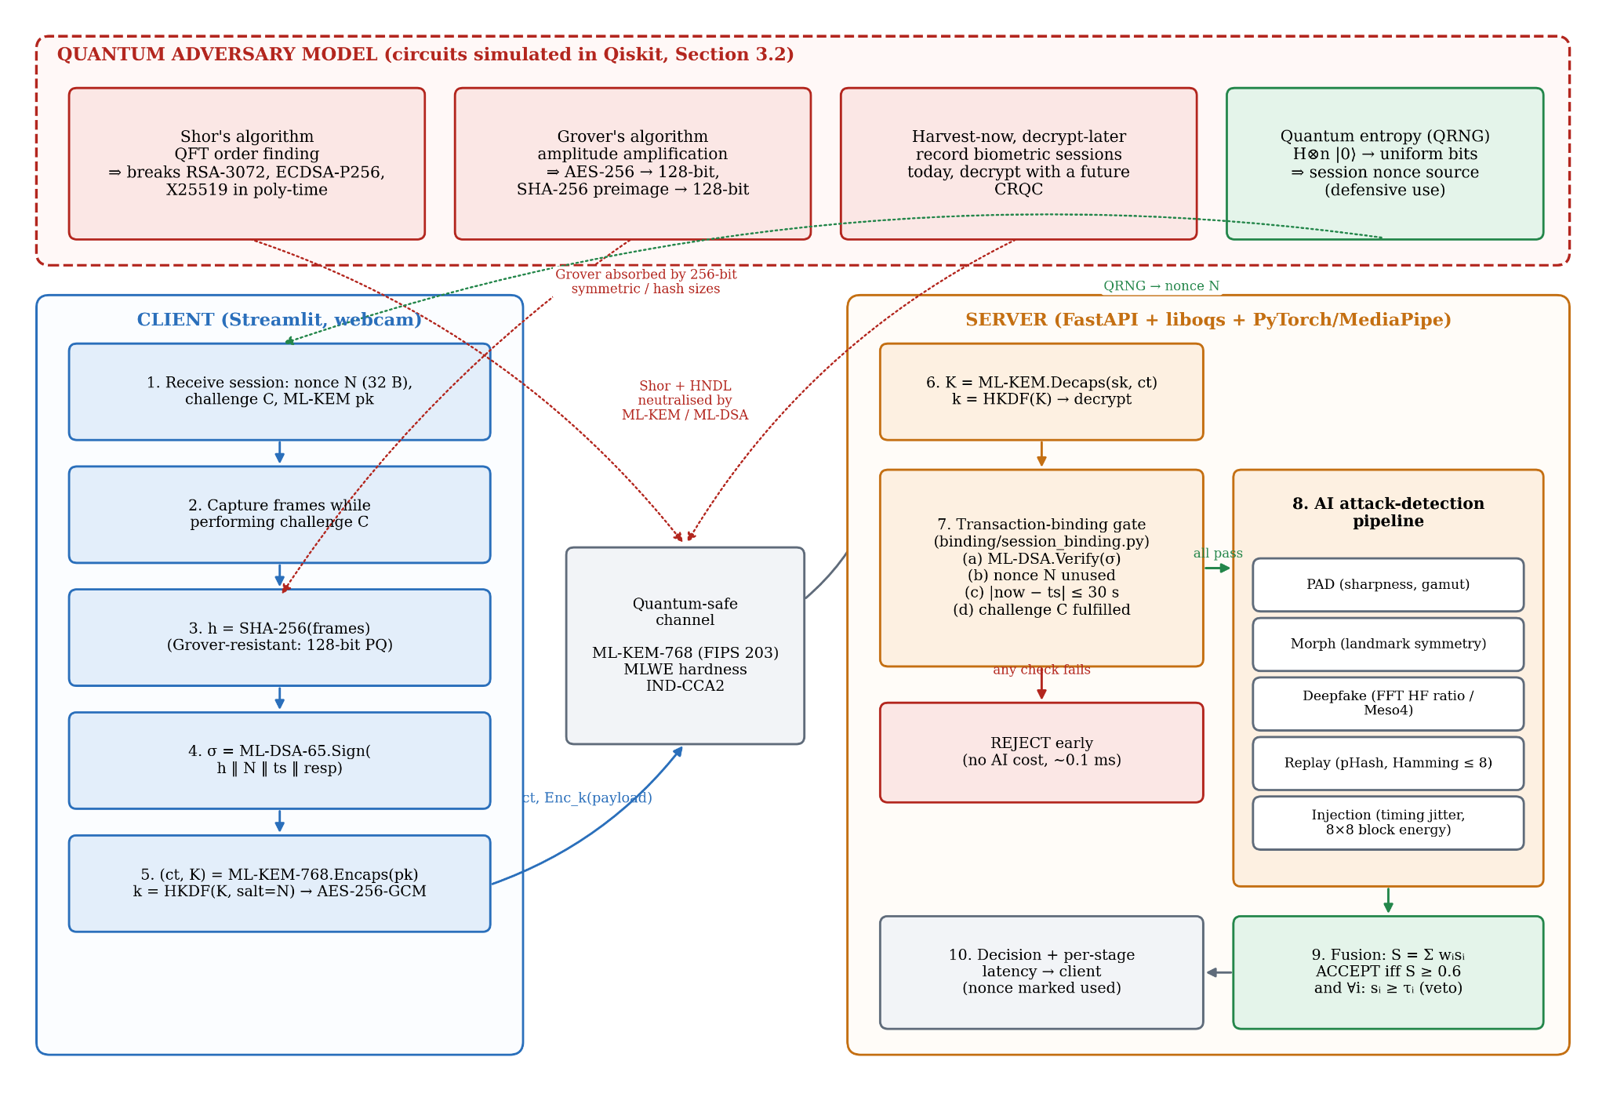
Figure 1. Quantum-aware system architecture. Red: quantum attack capabilities and the primitives they break. Green: the defensive quantum entropy source. Blue: client. Orange: server. Each threat arrow ends at the component that neutralises it (ML-KEM/ML-DSA for Shor and HNDL; 256-bit symmetric and hash sizes for Grover).

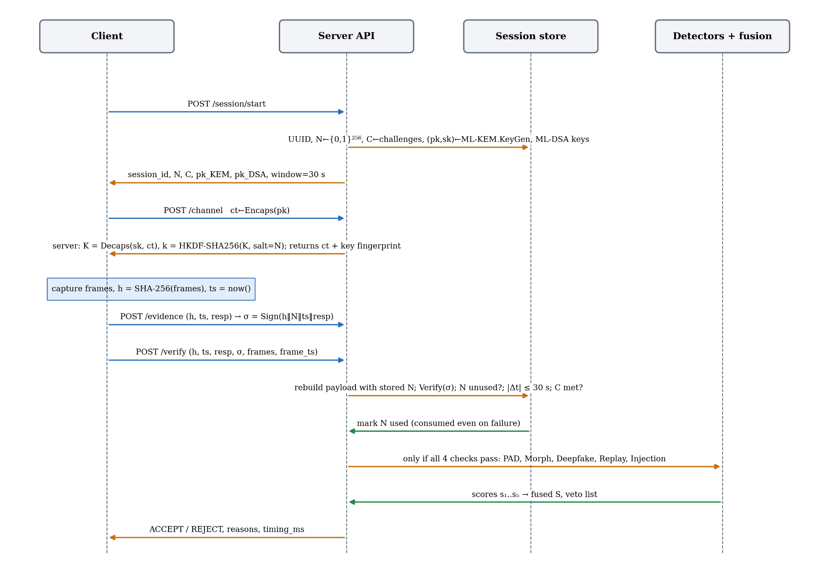
Figure 2. Transaction-binding message sequence, as implemented in server/main.py and binding/session_binding.py. Detection runs only after all four binding checks pass, and the nonce is consumed regardless of the outcome.

3.2.1 Circuit Q1 — Shor's order finding (threat to RSA / ECDSA / X25519)
Purpose: show at smallest scale the attack that forces the removal of every RSA and elliptic-curve primitive from the design.
- Registers. A 4-qubit counting register q₀–q₃ and a 4-qubit work register q₄–q₇ (8 qubits).
- Initialisation. Apply H^{⊗4} to the counting register to create (1/4) Σ_x |x⟩. Apply X to q₄ so that the work register is |0001⟩ = |1⟩.
- Modular exponentiation (phase kickback). For j = 0…3, apply controlled-U^{2^j}, with U|y⟩ = |7y mod 15⟩, controlled on qⱼ. U is built from SWAP cascades and X gates (a permutation of the 4-bit work states), giving gates labelled 7¹, 7², 7⁴ and 7⁸ mod 15.
- Inverse QFT on the counting register converts the phase s/r into an integer near 16·s/r.
- Measurement of the counting register; classical post-processing by continued fractions recovers r, then gcd(7^{r/2} ± 1, 15).
Since r = 4 for a = 7, the ideal output is uniform over {0, 4, 8, 12}. The outcomes 4 and 12 (s/r = 1/4, 3/4) yield r = 4 and gcd(48, 15) = 3, gcd(50, 15) = 5. The outcome 0 yields no information, and 8 gives r = 2, which fails because 7² ≢ 1 (mod 15). The theoretical success probability is therefore 0.5.

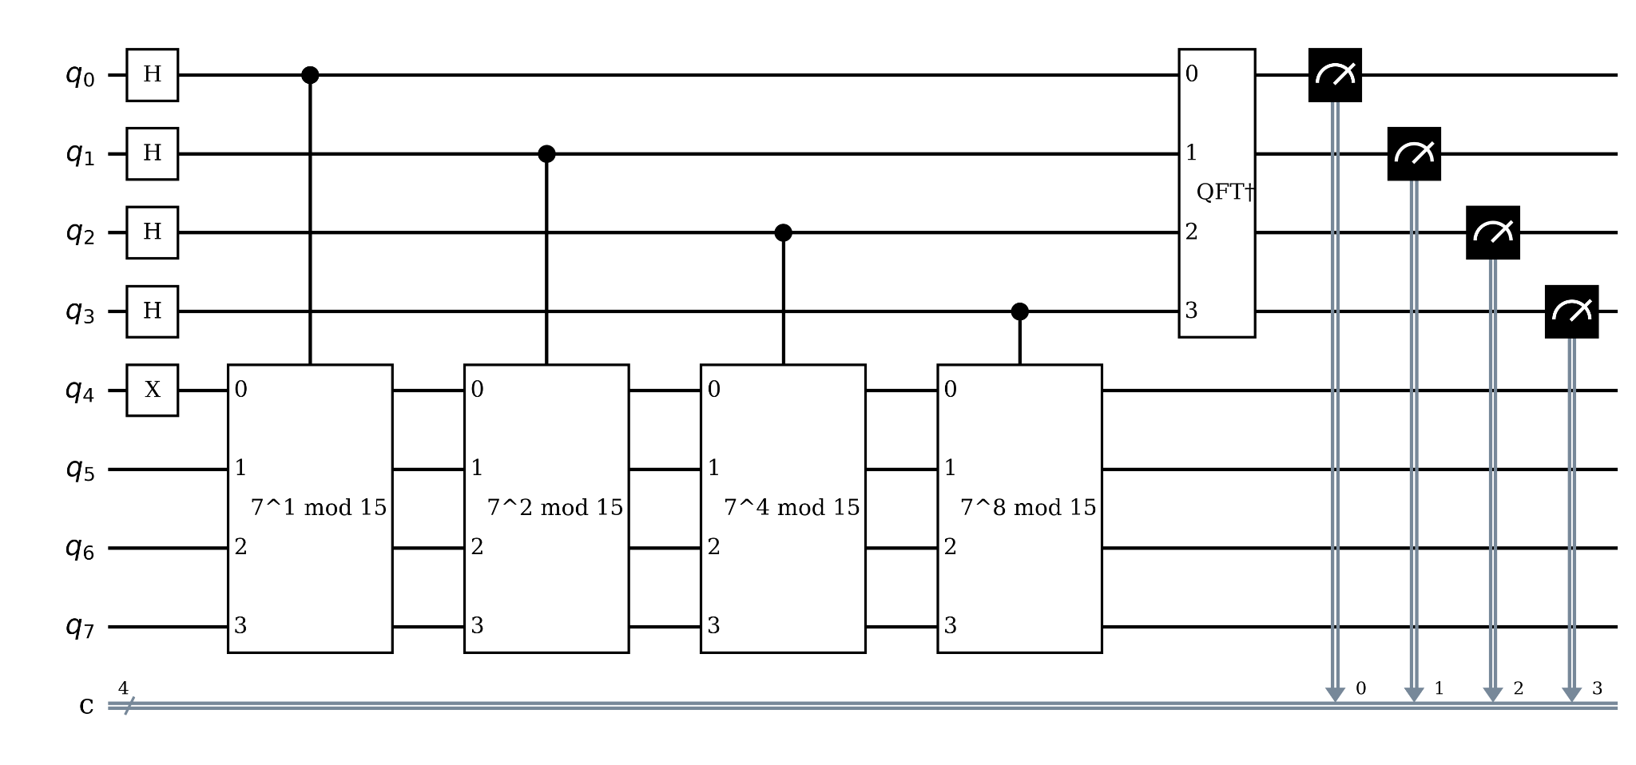
Figure 3. Implemented Shor order-finding circuit for N = 15, a = 7 (Qiskit 1.3.2). Hadamards on q₀–q₃, X on q₄, four controlled modular-multiplication gates, inverse QFT, measurement of the counting register.

3.2.2 Circuit Q2 — Grover key search (threat to AES-256 / SHA-256)
Purpose: show the quadratic speed-up that sets the symmetric key and hash sizes in the design.
- Initialisation. H^{⊗4} on q₀–q₃ gives the uniform superposition over all 16 candidate keys.
- Oracle O_k for key k = 1011. X on the qubits where k has a 0, then H–MCX–H on q₃ (a multi-controlled Z) and the X gates undone. This flips the phase of |1011⟩ only.
- Diffuser D. H^{⊗4}, X^{⊗4}, multi-controlled Z, X^{⊗4}, H^{⊗4}, which reflects amplitudes about their mean.
- Repeat O_{k}·D for k_opt = ⌊(π/4)√16⌋ = 3 iterations, then measure.
The theoretical success probability is sin²(7·arcsin(1/4)) = 0.961, compared with 1/16 = 0.0625 for one classical guess.

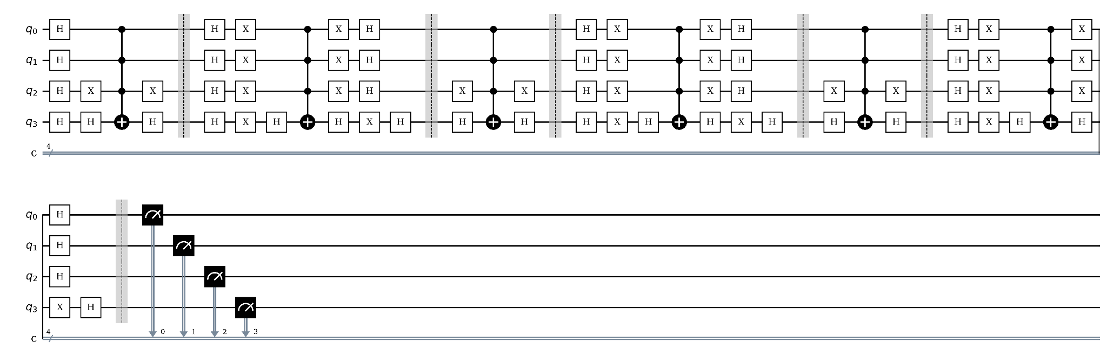
Figure 4. Implemented 4-qubit Grover circuit (3 oracle–diffuser iterations, barriers between stages) searching for key |1011⟩.

3.2.3 Circuit Q3 — Quantum random number generator for session nonces (defensive)
Purpose: provide a physically unpredictable source for the 256-bit session nonce N on which binding depends.
- H on each of 8 qubits gives |+⟩^{⊗8}.
- Measure: each shot yields one uniformly random byte.
- 32 shots form a 256-bit nonce. Under hardware bias, the output is conditioned with HKDF-SHA256 [19], [23].

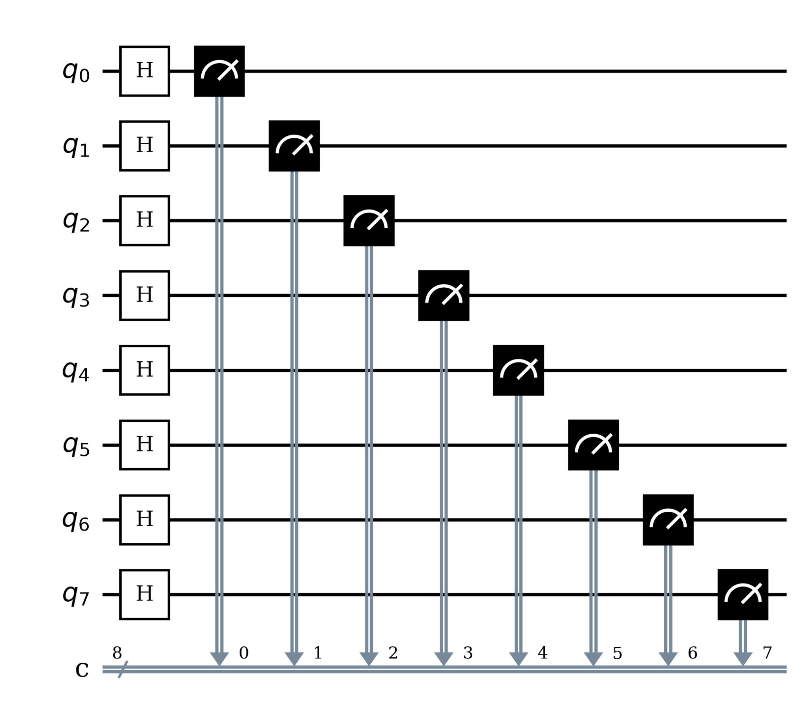
Figure 5. 8-qubit Hadamard QRNG circuit used to draw 256-bit session nonces (one byte per shot).

3.3 Implementation Details

Frameworks.
Layer | Technology (version) | Used for
Quantum circuits | Qiskit 1.3.2 [22], Qiskit Aer 0.15.1 | Shor, Grover, QRNG circuits; ideal and noisy simulation; transpilation and resource counts
Post-quantum crypto | liboqs 0.16.0 via liboqs-python | ML-KEM-512/768/1024, ML-DSA-44/65/87
Classical crypto | cryptography (pinned 44.0.0; 50.0.2 in the benchmark venv) | AES-256-GCM, HKDF-SHA256, RSA-3072-OAEP, ECDSA-P256, X25519 baseline
API server | FastAPI 0.115.6, Uvicorn | /session/start, /session/{id}/channel, /evidence, /verify, /health
Detection | NumPy 1.26.4, Pillow, imagehash 4.3.1, MediaPipe 0.10.18, PyTorch 2.5.1 (Meso4 architecture) | Five detectors and liveness-challenge checker
Client | Streamlit 1.41.1, streamlit-webrtc | Live-capture and simulate-attack demo
Evaluation | pytest 8.3.4 (78 tests), psutil, matplotlib | Unit tests, benchmarks, charts
Deployment | Docker / docker-compose (Linux), native macOS | Reproducible liboqs build
Table 3. Implementation stack.

Code organisation: The prototype comprises 3,611 lines of Python. crypto/kem.py and crypto/signature.py are liboqs wrappers; oqs is imported lazily so pure helpers stay testable. crypto/classical_baseline.py provides RSA and ECDSA. binding/session_binding.py holds the four checks, and detection/*.py the five detectors, fusion.py and liveness_challenge.py. server/main.py and server/session_store.py run the pipeline. client_demo/ is the Streamlit app, evaluation/ the benchmark harness and ISO 30107-3 metrics, and tests/ contains 10 test modules. The report's experiment scripts are in report/scripts/: quantum_experiments.py, system_experiments.py and diagrams.py.

Detector implementations (current "mock" mode): No pretrained checkpoints were available offline, so each detector runs a documented signal-processing heuristic and logs a fallback warning:

Detector | Signal | Score mapping | Pretrained path (ready, weights not bundled)
PAD | Laplacian variance (sharpness) + RGB channel std (gamut) | 0.6·min(var/500, 1) + 0.4·min(std/60, 1) | MiniFASNet [27]
Morph | MediaPipe landmark L/R symmetry; fallback: pixel-mirror residual | 1 − |asym − 18|/30 | (feature-based by design)
Deepfake | 2-D FFT high-frequency energy ratio (r > ¼ min(h, w)) [16]; min over frames | 1 − (HF − 0.35)/0.25 | Meso4 [15] on FF++ [14]
Replay | 64-bit pHash, Hamming distance to 24-h store | 0 if d ≤ 8, else (d − 8)/24 | (not a classifier)
Injection | Inter-frame jitter CV + 8×8 block-boundary energy | 0.65·timing + 0.35·compression | custom CNN (future)
Table 4. Detection modules and their current scoring rules.

Back-ends.
Back-end | Description | Used for
Aer ideal (statevector sampling) | Noise-free, 8,192 shots, seed 2026 | Reference distributions, theoretical validation
Aer noisy (custom model) | Depolarising p₁ = p₂/10 on {rz, sx, x}, p₂ on cx; symmetric readout error 2·p₂ | Noise impact; p₂ swept 0–5%
Aer asymmetric readout | P(0|1) = 4%, P(1|0) = 1% (T₁-like) | QRNG bias study
Table 5. Quantum execution back-ends.

All circuits were transpiled to the IBM-style basis {cx, rz, sx, x, id} at optimization_level=3 before simulation, so the gate counts and depths in Table 7 are hardware-realistic rather than logical.

4. Experimental Setup

4.1 Experimental Setup

Hardware and OS. Apple M3 (8-core CPU), 16 GB RAM, macOS 14.6, Python 3.11.15. All timings are single-threaded wall-clock (time.perf_counter), median of n runs after one warm-up.

Parameter | Value
KEM / signature (default) | ML-KEM-768 / ML-DSA-65 (NIST level 3); levels 1/2 and 5 also benchmarked
Classical baseline | RSA-3072-OAEP-SHA256, ECDSA-P256-SHA256, X25519
Symmetric / KDF / hash | AES-256-GCM, HKDF-SHA256 (salt = nonce), SHA-256
Nonce / freshness window | 32 bytes / 30 s
Fusion weights (PAD, Morph, DF, Replay, Inj.) | 0.25, 0.20, 0.25, 0.15, 0.15
Accept threshold θ / per-module veto τᵢ | 0.6 / 0.5
Replay pHash threshold / window | Hamming ≤ 8 bits / 86,400 s
Crypto micro-benchmark iterations | 500 per operation (RSA keygen: 30)
End-to-end runs | 40 full sessions (4 HTTP calls each, in-process TestClient)
Attack scenarios | 11 (1 genuine, 9 attacks, 1 control)
Frames per submission | 5 × 240×240 RGB JPEG (q = 95) at 30 fps ± 1.7 ms jitter
Quantum shots / seed | 8,192 / 2026 (simulator and transpiler)
Optimiser | None needed: Shor, Grover and QRNG are non-variational (fixed circuits), so there are no trainable parameters and no barren-plateau risk. Transpiler: Qiskit preset pass manager, level 3
Table 6. Experimental parameters.

Circuit | Qubits | Clbits | Logical depth | Transpiled depth | CX count | 1-qubit gates
Q1 Shor N = 15, a = 7 | 8 | 4 | 183 | 1,573 | 792 | 1,342
Q2 Grover n = 4, 3 iterations | 4 | 4 | 182 | 174 | 84 | 160
Q3 QRNG | 8 | 8 | 2 | 4 | 0 | 24
Table 7. Quantum circuit resources after transpilation to {cx, rz, sx, x}.

The textbook Shor circuit expands its controlled-SWAP multipliers into 792 CNOTs, a two-qubit depth that no NISQ device can execute faithfully. Grover needs about 10 times fewer CNOTs, and the QRNG needs none.
Test data (stated honestly). The repository bundles no face dataset. FaceForensics++, CelebA-Spoof and AMSL require access requests (datasets/download_samples.md). The pipeline experiments therefore use synthetic frames whose statistics match the signal each heuristic is designed to measure:
- Genuine: a 1/f^1.2 amplitude spectrum per channel (natural-image statistics) plus σ = 6 sensor noise, given face-like left/right symmetry.
- Recapture: the same frame Gaussian-blurred (σ = 4) with contrast reduced to 25%.
- GAN deepfake: the same frame plus σ = 30 broadband high-frequency residual [16].
- Morph: a 50/50 blend of two identities, then symmetrised.
- Injection: a JPEG re-encode at q = 35 with perfectly regular 1/30 s frame timestamps.
These are functional validations of each layer, not dataset accuracy figures.

4.2 Expected Outcomes & Performance Metrics

Metric | Definition | Target (from spec) | Achieved | Met?
Shor success probability (ideal) | P(classical post-processing yields {3, 5}) | 0.5 (theory) | 0.499 | ✓
Grover success probability (ideal) | P(measure |1011⟩) | 0.961 (theory) | 0.960 | ✓
QRNG uniformity | χ² over 256 byte values (255 dof, α = 0.05, critical 293.2) | pass | 272.3 (pass) | ✓
Quantum noise sensitivity | success vs p₂ | characterise | Table 14, Fig. 24 | ✓
PQC handshake latency | ML-KEM-768 encaps + decaps | < RSA-3072 | 0.045 ms vs 2.142 ms | ✓
Session initialisation | /session/start incl. ML-KEM + ML-DSA keygen | < 100 ms | 1.51 ms median | ✓
Individual detector | per module | < 100 ms | 0.26–1.86 ms | ✓
End-to-end latency | full session, 4 HTTP calls | < 1 s | 28.2 ms median, 29.3 ms p95 | ✓
Throughput | /session/start per second | > 10 req/s | 394 sessions/s at concurrency 4 | ✓
Binding-layer attacks rejected before AI | A1–A4 | 4/4 | 4/4 (≈ 0.1 ms each) | ✓
Content-layer attacks rejected | A5–A9 | 5/5 | 4/5 (A7 injection accepted) | ✗ partial
BPCER (genuine false-reject) | on 40 synthetic genuine sessions | low | 7.5% (3/40), root cause found (§4.4.3) | ✗ partial
PQC share of compute ρ | (KEM + DSA + binding) / server compute | "negligible" | 2.2% | ✓
Table 8. Target outcomes versus achieved results.

4.3 Screenshots

4.4 Results

4.4.1 Post-quantum versus classical primitives
Scheme | Family | NIST level | Quantum-safe | KeyGen (ms) | Op 1 (ms) | Op 2 (ms) | Public key (B) | Ciphertext / signature (B)
ML-KEM-512 | KEM, lattice | 1 | Yes | 0.015 | 0.017 (encaps) | 0.014 (decaps) | 800 | 768
ML-KEM-768 | KEM, lattice | 3 | Yes | 0.022 | 0.023 (encaps) | 0.021 (decaps) | 1,184 | 1,088
ML-KEM-1024 | KEM, lattice | 5 | Yes | 0.030 | 0.032 | 0.033 | 1,568 | 1,568
RSA-3072-OAEP | classical | ≈ 1 | No (Shor) | 155.1 | 0.047 (enc) | 2.095 (dec) | 422 | 384
X25519 | classical | ≈ 1 | No (Shor) | 0.040 | 0.040  (exchange) | — | 32 | 32
ML-DSA-44 | signature, lattice | 2 | Yes | 0.043 | 0.077 (sign) | 0.037 (verify) | 1,312 | 2,420
ML-DSA-65 | signature, lattice | 3 | Yes | 0.070 | 0.125 (sign) | 0.062 (verify) | 1,952 | 3,309
ML-DSA-87 | signature, lattice | 5 | Yes | 0.117 | 0.179 | 0.106 | 2,592 | 4,627
ECDSA-P256 | classical | ≈ 1 | No (Shor) | 0.021 | 0.028 (sign) | 0.071 (verify) | 91 | 71
Table 9. Primitive latency (median of 500 runs) and sizes (source: data/s1_primitives.csv).

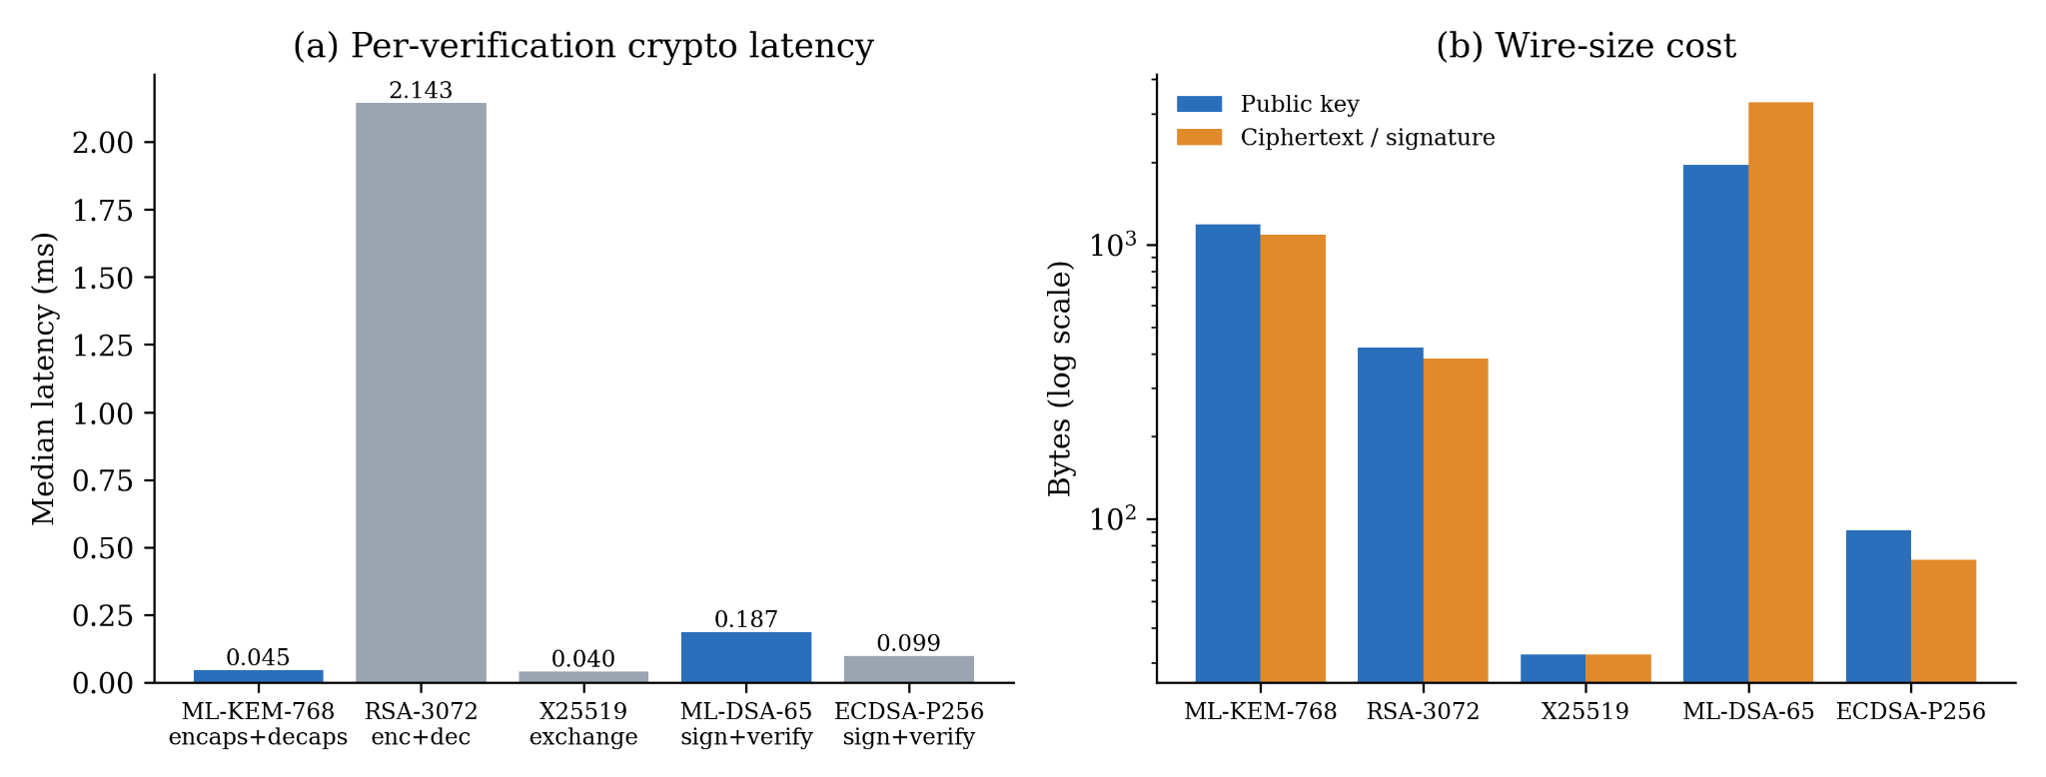
Figure 17. (a) Crypto latency on the verification critical path. (b) Bytes on the wire (log scale). PQC is blue, quantum-vulnerable classical is grey.

ML-KEM-768 completes a full encapsulation plus decapsulation in 0.045 ms, 47 times faster than RSA-3072 (2.142 ms, dominated by the private-key decryption) and about the same as X25519 (0.040 ms). ML-DSA-65 sign plus verify (0.186 ms) is 1.9 times ECDSA-P256 (0.099 ms), a difference of 87 µs. The real cost of PQC is size. One verification carries an ML-KEM public key, a ciphertext and an ML-DSA signature, 1,184 + 1,088 + 3,309 = 5,581 bytes, against 422 + 384 + 71 = 877 bytes for RSA-3072 plus ECDSA (6.4 times). This is negligible next to five JPEG frames (about 60–90 kB) but matters for constrained links such as NFC or QR-based IDs.

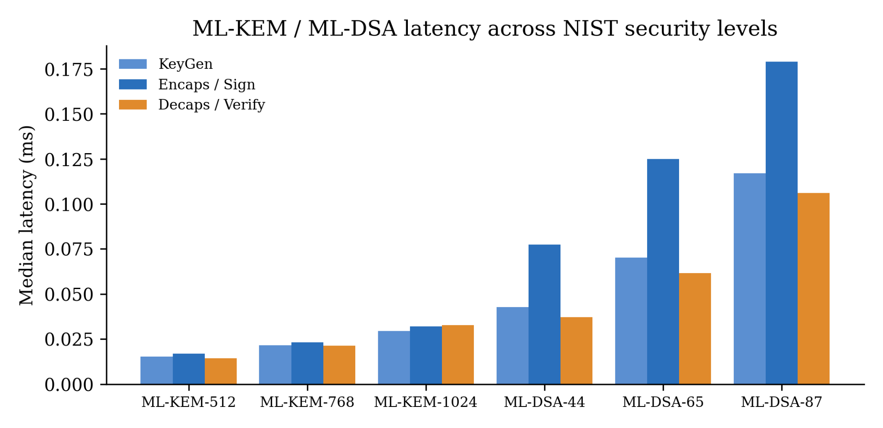
Figure 18. ML-KEM and ML-DSA latency across NIST security levels 1/2, 3 and 5.

Moving from level 3 to level 5 increases latency by about 40% for ML-KEM and 45% for ML-DSA signing, still well under 0.2 ms. The security margin can be raised (.env: KEM_ALG=ML-KEM-1024, SIG_ALG=ML-DSA-87) with no perceptible latency effect.

4.4.2 Which defence layer stops which attack

ID | Scenario | Attack class | Decision | Stopped by | Fused S | Server time (ms)
G1 | Genuine live capture | Bona fide | ACCEPT | — | 0.884 | 158.8*
A1 | Evidence substitution after signing (MITM) | Integrity / injection | REJECT | Binding: signature_valid | — | 0.13
A2 | Stale capture signed 120 s earlier | Replay (temporal) | REJECT | Binding: timestamp_fresh | — | 0.13
A3 | Second submission on the same nonce | Replay (session) | REJECT | Binding: nonce_unused | — | 0.18
A4 | Wrong liveness response (pre-recorded video) | Liveness | REJECT | Binding: challenge_fulfilled | — | 0.11
A5 | Previously accepted genuine capture, new session | Replay (content) | REJECT | AI: replay (s = 0.00) | 0.734 | 16.2
A6 | Photo / screen recapture | Presentation attack | REJECT | AI: PAD (s = 0.06) | 0.646 | 16.7
A8 | GAN deepfake (HF artefacts) | Deepfake | REJECT | AI: deepfake (s = 0.00) | 0.674 | 16.4
A9 | Two-identity morph | Morphing | REJECT | AI: morph (s = 0.40) | 0.665 | 16.0
A7 | Virtual-camera stream (regular timing, re-encoded) | Injection | ACCEPT ✗ | not stopped | 0.842 | 16.1
C1 | Control: white-noise frame (the repo benchmark's "genuine") | — | REJECT | AI: deepfake (s = 0.00) | 0.666 | 16.1
Table 10. Attack-scenario matrix through the real pipeline (source: data/s2_attack_scenarios.csv).

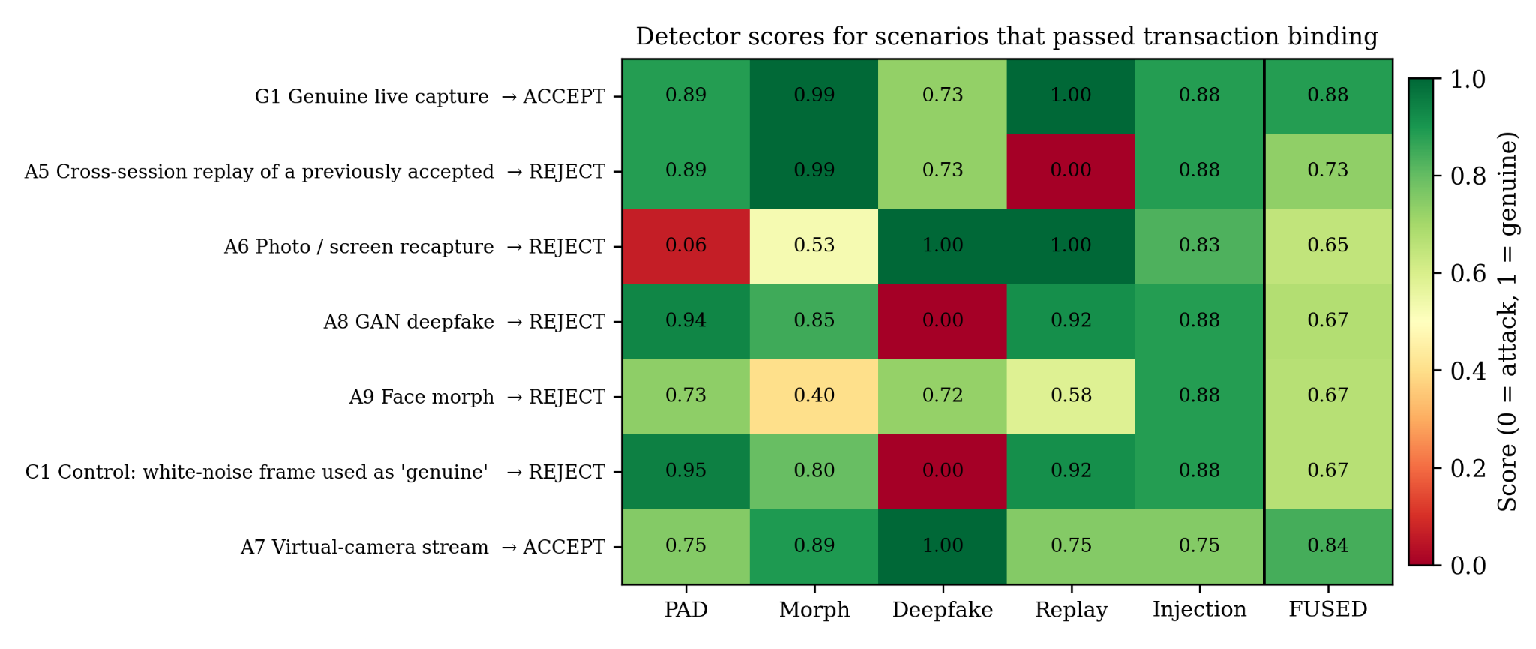
Figure 19. Per-detector scores for the scenarios that passed transaction binding (green = genuine, red = attack). The vertical line separates individual modules from the fused score.

All four binding-layer attacks (A1–A4) are rejected in 0.11–0.18 ms without running any detector. A5 shows why binding and content checks are complementary. The replayed capture is genuine in content (PAD 0.89, morph 0.99), and a fresh nonce lets it pass binding, but the pHash store matches it exactly (s = 0.00) and the per-module veto rejects it even though the fused score of 0.734 is above θ = 0.6. The same veto decides A6, A8 and A9: in each case a single module falls below 0.5 while the weighted average stays above 0.6. Without the veto, A5, A6, A8 and A9 would all have been accepted. A7, the injection attack, is accepted. The injection heuristic gives perfectly regular timing (jitter 0) a timing score of 0.75 because it penalises deviation from 5% jitter linearly with a 20% scale. The re-encode at q = 35 was not visible to the 8×8 block-energy proxy after a second JPEG pass. Row C1 shows that uniform white noise, which the repository's own evaluation/benchmark.py uses as its "genuine" sample, is flagged as a deepfake because its spectrum is flat. This explains the 0% deepfake "accuracy" in that harness (Table 14) and shows that synthetic test data must respect natural-image statistics.

4.4.3 End-to-end latency and cost of post-quantum security

Stage | Median (ms) | p95 (ms) | Share of server compute
ML-KEM-768 encapsulation | 0.060 | 0.116 | 0.37%
ML-KEM-768 decapsulation | 0.026 | 0.027 | 0.16%
ML-DSA-65 signing | 0.158 | 0.291 | 0.97%
Binding checks (incl. ML-DSA verify) | 0.110 | 0.139 | 0.68%
PQC + binding subtotal | 0.354 | — | 2.18%
AI detection (5 modules) | 15.876 | 16.517 | 97.75%
Fusion | 0.011 | 0.013 | 0.07%
/session/start HTTP (incl. ML-KEM + ML-DSA keygen) | 1.512 | 1.862 | —
/verify HTTP (decode 5 JPEGs + binding + detection) | 23.045 | 23.608 | —
Full session, 4 HTTP calls | 28.210 | 29.262 | —
Table 11. End-to-end latency breakdown over 40 genuine sessions (source: data/s3_end_to_end.csv, data/s3_summary.json).

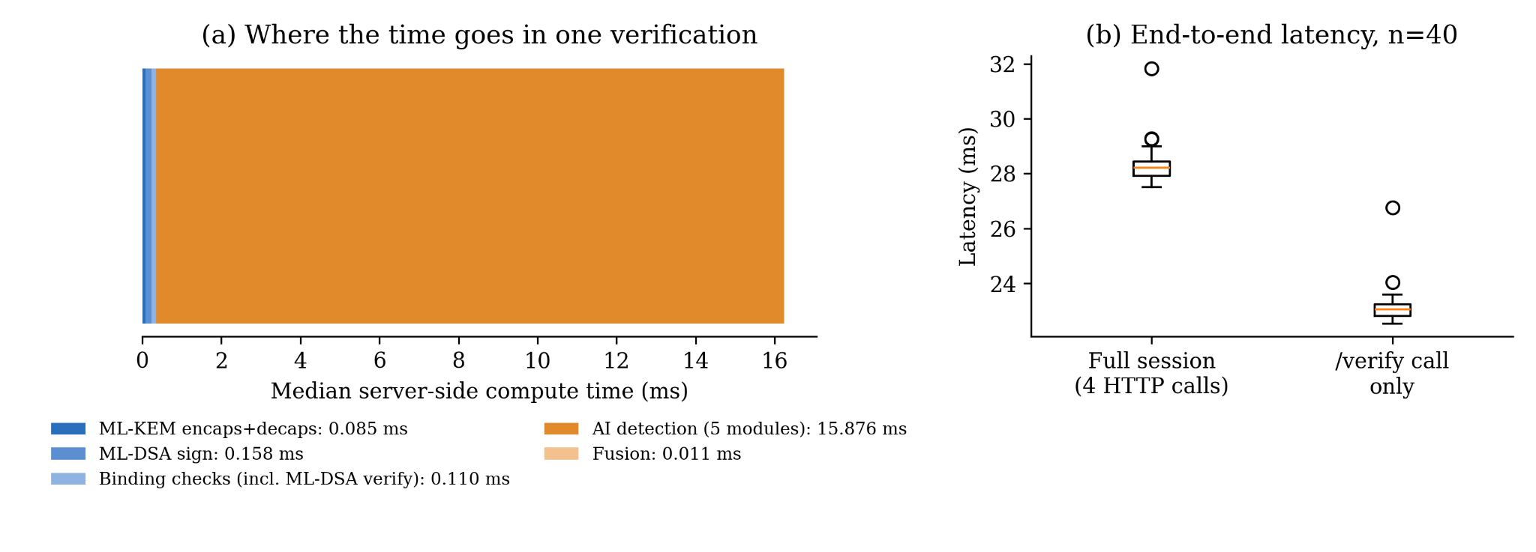
Figure 20. (a) Median server-side compute per verification stage (stacked). (b) Distribution of full-session and /verify latency (n = 40).

Post-quantum security is effectively free relative to the analysis that has to happen anyway. All PQC operations plus the four binding checks take 0.354 ms (2.2% of server compute, 1.3% of end-to-end time), while the five detectors take 15.9 ms. The 28 ms full-session median is about 35 times under the 1 s target. With pretrained CNNs the detection share will grow and the PQC share will fall further.

Genuine false rejections (BPCER). 37 of 40 genuine sessions were accepted (BPCER = 7.5%). All three rejections had fused scores of at least 0.79, so they were vetoes. Re-running the replay detector on those frames showed best-match Hamming distances of 18 bits to unrelated earlier captures, well outside the 8-bit replay threshold. ReplayDetector maps distances between 8 and 32 linearly onto [0, 1], giving s = (18 − 8)/24 = 0.417, below the generic per-module veto τ_replay = 0.5. The effective replay radius is therefore about 20 bits, not 8, and the false-reject rate will grow as the 24-hour hash store fills. The fix is a one-line configuration change (THRESHOLD_REPLAY ≤ 0.0 so that only exact matches within d ≤ 8 veto) or rescaling the interpolation. It is reported here rather than silently tuned away.

4.4.4 Repository Benchmark Harness

Concurrent clients | 1 (cold) | 2 | 4 | 8
/session/start per second (incl. ML-KEM + ML-DSA keygen) | 11.0 | 144.5 | 393.6 | 375.2
Table 13. Session-creation throughput against a live Uvicorn server (single worker).

4.4.5 Quantum Circuits : ideal vs noisy backends

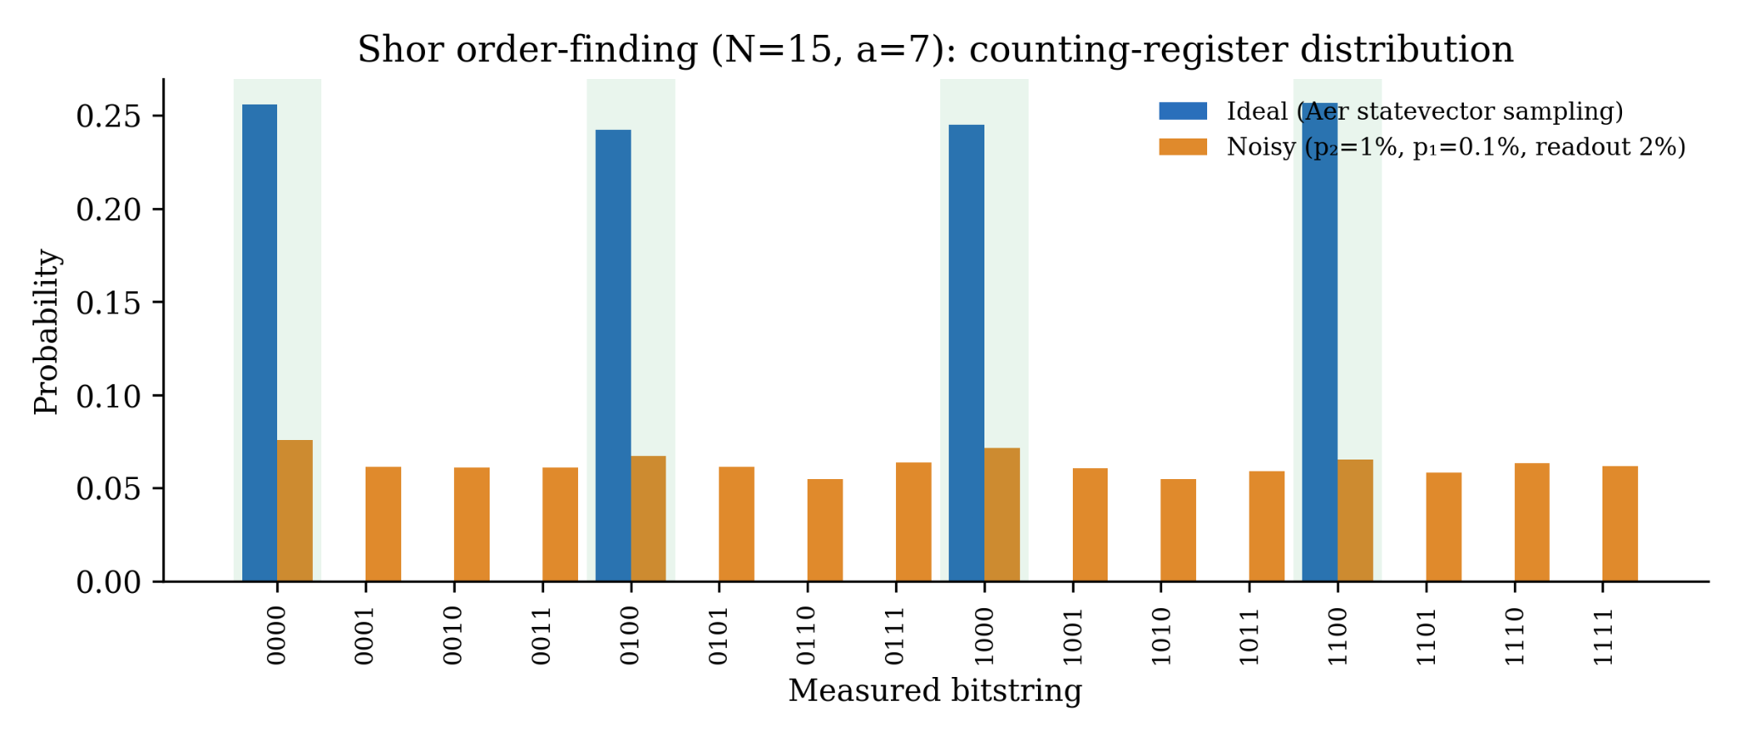
Figure 22. Shor (N = 15, a = 7) counting-register distribution, ideal (blue) versus noisy p₂ = 1% (orange). Shaded bars mark the four theoretical peaks 16·s/4.

The ideal simulator reproduces theory: four peaks of about 0.25 at 0000, 0100, 1000 and 1100. Post-processing succeeds on 0100 and 1100 (r = 4, factors 3 and 5), giving P_success = 0.499. At p₂ = 1% the 792-CNOT circuit is almost fully depolarised (every bitstring about 0.06), and success drops to 0.132, close to the 2/16 = 0.125 a random 4-bit outcome would give.

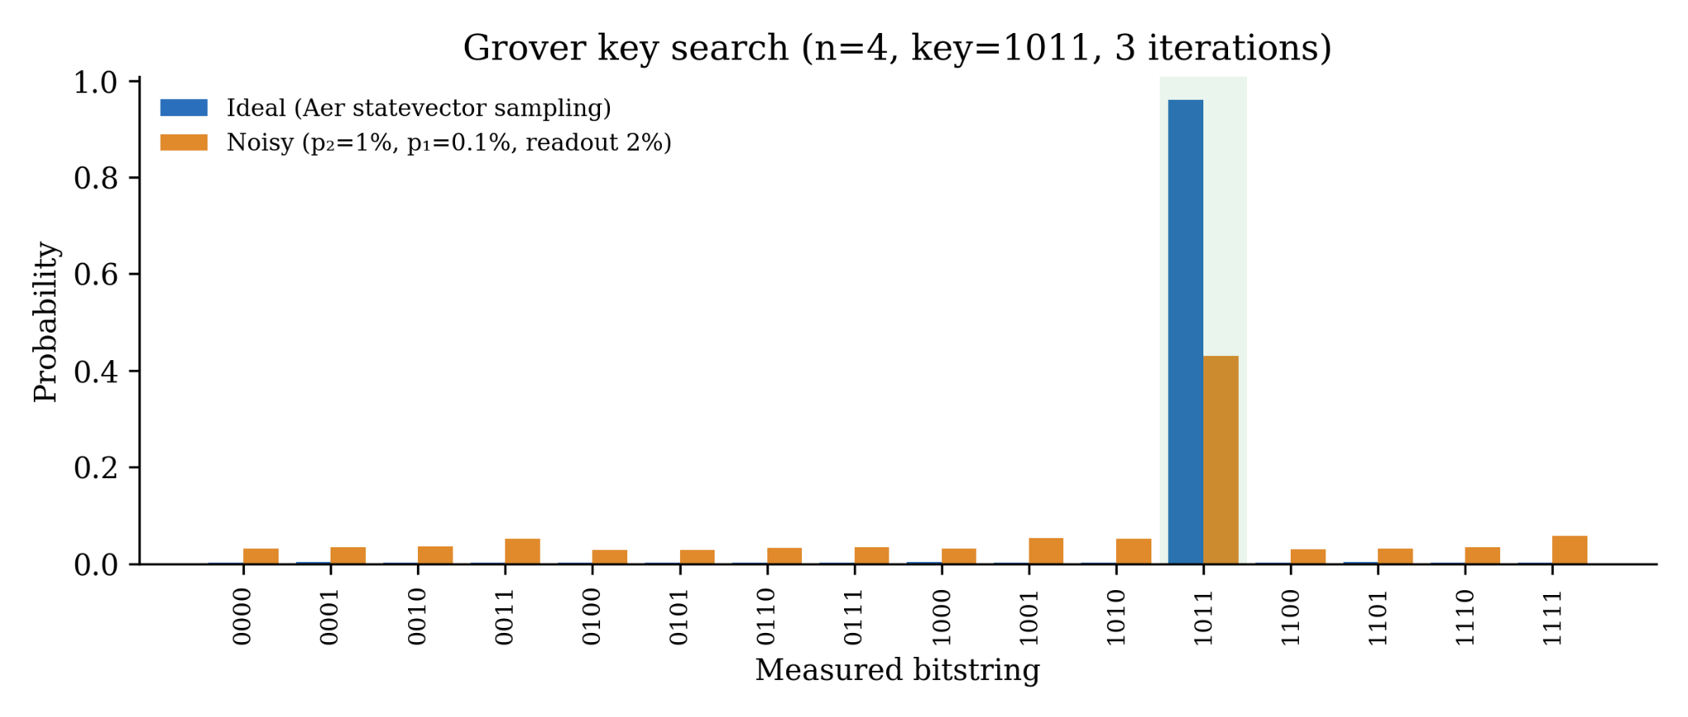
Figure 23. Grover (n = 4, key 1011, 3 iterations), ideal versus noisy p₂ = 1%.
Ideally the key is found with P = 0.960 (theory 0.961), 15.4 times the classical single-guess probability of 0.0625. At p₂ = 1% the 84-CNOT circuit still amplifies the key (P = 0.430, about 7 times random), because it is about 9 times shallower in two-qubit gates than the Shor circuit.

p₂ (two-qubit depolarising) | 0 | 0.1% | 0.25% | 0.5% | 1% | 2% | 3% | 5%
Shor P(correct factors) | 0.499 | 0.345 | 0.240 | 0.167 | 0.132 | 0.124 | 0.125 | 0.128
Grover P(key found) | 0.960 | 0.880 | 0.780 | 0.635 | 0.430 | 0.209 | 0.120 | 0.073
QRNG min-entropy / bit† | 0.912 | 0.920 | 0.916 | 0.916 | 0.912 | 0.927 | 0.923 | 0.935
QRNG P(bit = 1) | 0.498 | 0.499 | 0.499 | 0.500 | 0.500 | 0.501 | 0.500 | 0.501
†Plug-in estimate from 8,192 samples over 256 outcomes. The finite-sample maximum biases it below the true value of 1.0, so the trend matters, not the level.
Table 14. Noise sweep, p₁ = p₂/10 and readout error = 2·p₂ (source: data/quantum_noise_sweep.csv)

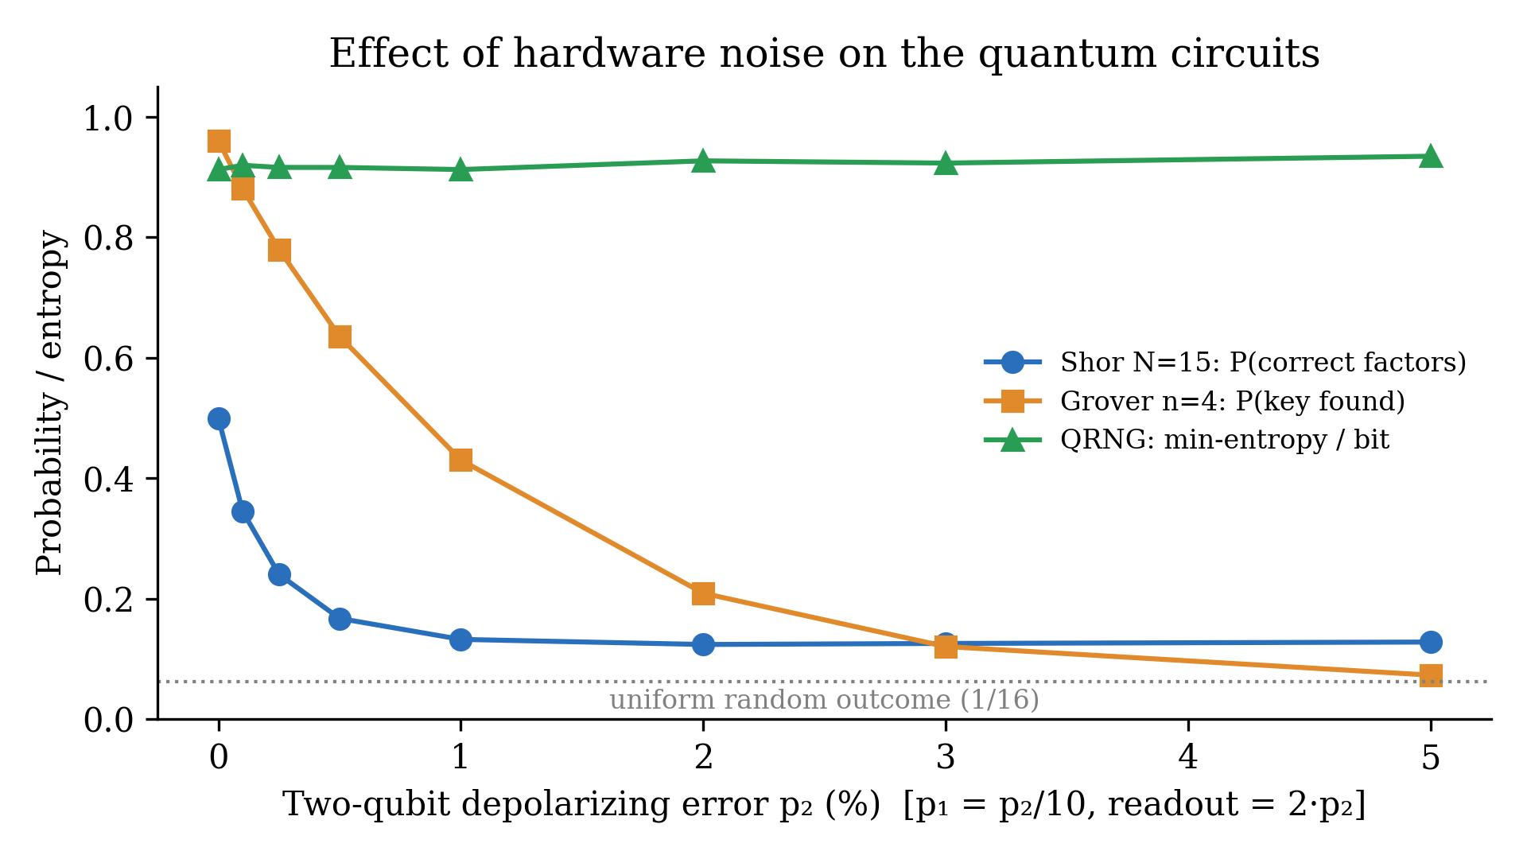
Figure 24. Success probability (Shor, Grover) and QRNG min-entropy as a function of two-qubit gate error.

Explanation and noise discussion:
- Gate errors. Shor loses 31% of its success at p₂ = 0.1%, which is roughly the error rate of today's best superconducting two-qubit gates, and reaches the random floor by 1%. Grover halves at about 0.7%. Even the smallest Shor instance is limited by gate fidelity rather than qubit count, so RSA-2048 needs the error-corrected logical qubits assumed in [6], [7]. Noise delays the quantum threat; it does not remove it, and HNDL makes the delay irrelevant for biometrics, which justifies migrating now.
- Decoherence. A transpiled depth of 1,573 layers is far beyond the T₁/T₂ coherence budget of current hardware (about 10³ two-qubit layers at best). Our depolarising model is an optimistic lower bound on degradation, since it ignores idle-qubit dephasing during those layers.
- Readout errors. These shift the floor but not the shape of the curves for Shor and Grover. For the QRNG they are the dominant error, discussed next.

4.5 Comparative Analysis & Discussion
Classical versus quantum (attacker's view). Table 16 compares the classical and quantum costs of attacking each primitive in the pipeline, which is what motivated each design choice.

Primitive in pipeline | Best classical attack | Best quantum attack | Post-quantum security | Status in design
RSA-3072 / ECDSA-P256 / X25519 | sub-exponential (GNFS) / 2¹²⁸ (Pollard ρ) | polynomial (Shor) — demonstrated at N = 15 (Fig. 22) | ≈ 0 bits | Removed; baseline only
ML-KEM-768 / ML-DSA-65 | lattice reduction ≈ 2¹⁸² | no known super-polynomial speed-up (no periodic structure) | ≈ 2¹⁶⁵ core-SVP (NIST level 3) [10] | Used
AES-256-GCM | 2²⁵⁶ | Grover 2¹²⁸ (Fig. 23 shows the √ speed-up at n = 4) | 128 bits | Used
SHA-256 (evidence hash, HKDF) | pre-image 2²⁵⁶ | Grover 2¹²⁸ | 128 bits | Used
256-bit nonce | guessing 2²⁵⁶ | Grover 2¹²⁸ | 128 bits | Used (QRNG optional)
Table 16. Classical versus quantum attack cost on each primitive.

Comparison across back-ends. Ideal simulation reproduced the analytical success probabilities within 0.1 percentage points (Table 8), validating the circuits. The noisy back-end shows the gap between algorithm and hardware: the 4-qubit Grover circuit degrades gracefully, while the textbook 8-qubit Shor circuit collapses at p₂ = 1% (Table 14). Compiled Shor variants used in hardware demonstrations [20] exploit the known answer to shorten the circuit and would perform better, but they are not general attacks, which is why we kept the full modular-exponentiation construction.
Classical versus post-quantum (defender's view). On the defender's side, Table 9 and Fig. 17 show that the PQC replacement costs no time (ML-KEM is faster than RSA, and ML-DSA costs 87 µs more than ECDSA) and about 4.7 kB more per verification. Table 11 shows that this is 2.2% of server compute. The overhead argument against PQC migration does not hold for this workload.
Layered defence. Table 10 shows the two defence layers to be complementary. Cryptographic binding alone stops A1–A4 in about 0.1 ms but cannot see A5–A9. Detection alone would see content but has no notion of session and would have accepted A1–A4 had the content been genuine. The veto rule determined the outcome in four of five content attacks.

5. Analysis and Discussion

5.1 Novelty & Insights
- Binding is what makes PQC protect evidence and not just bytes. ML-KEM and ML-DSA alone would leave A2 (stale), A3 (nonce reuse), A4 (pre-recorded) and A5 (genuine replay) open. The novel element is signing h ‖ N ‖ ts ‖ r and rebuilding it from the server's own stored nonce. This makes "same nonce" a structural property of signature verification rather than a comparison an attacker can influence, and it lets the server reject before any AI runs, at 0.1 ms instead of 16 ms. This also gives a denial-of-service advantage: forged traffic costs the server about 150 times less than real traffic.
- An executed quantum threat model. Simulating Shor, Grover and a QRNG grounds each design constant in a measured result. RSA and ECC were removed because the Shor circuit recovers the factors (P = 0.499). 256-bit symmetric keys and hashes are kept because Grover gives the predicted quadratic amplification (P = 0.960, 15 times a classical guess). The nonce source must be conditioned because of asymmetric readout (χ² fail). We found no biometric-authentication work that connects its cryptographic parameters to circuit-level quantum experiments.
- Trade-off: noise delays the threat but HNDL cancels the delay. At p₂ = 0.1% the smallest Shor instance already loses 31% of its success. The quantum attack is therefore years away for RSA-3072, yet the data being protected (faces) remains sensitive for decades. Mosca's inequality [9], evaluated with our measured p₂ sensitivity, still says migrate now, and our latency numbers show migration is free.
- The cost of PQC lies in bytes, not milliseconds. PQC is 47 times faster than RSA-3072 for key establishment, and the overhead is a 6.4-fold increase in key and signature bytes. For a camera-based flow this is irrelevant; for an NFC passport or QR-code credential it would decide the parameter set (ML-KEM-512, ML-DSA-44).
- Fusion needs a veto. A weighted average let four of five content attacks through (fused S = 0.646–0.734 > 0.6). Single-signal attacks hide inside an average, so a strong detector must be able to override it.
- Negative results with root causes. These are (i) the injection heuristic's timing curve rewards perfectly regular synthetic streams (score 0.75), (ii) the replay score's linear interpolation combined with a generic 0.5 veto widens the replay radius from 8 to about 20 bits and causes 7.5% BPCER, and (iii) white-noise test frames are classified as deepfakes, which invalidates the repository's synthetic accuracy table. Each finding has a concrete fix (§6).

5.2 Limitations
- Qubit and depth limits. The Shor demonstration factors 15 with 8 qubits and 792 CNOTs. Scaling to RSA-3072 needs millions of physical qubits under error correction [6], [7], so our experiments show the mechanism and the noise sensitivity, not the timeline.
- Simulated noise only. The noise model is a parametric depolarising and readout model, not a device-calibrated one. It omits crosstalk, leakage, non-Markovian drift and idle dephasing, so real hardware would degrade faster. [[PLACEHOLDER: if run on IBM Quantum hardware, report here how far the measured success fell below the simulated p₂ = 0.1–1% curve.]]
- Barren plateaus and optimisation. These do not apply: all three circuits are fixed, non-variational algorithms with no trained parameters. If future work adds a variational or quantum-kernel classifier to the detection pipeline, barren plateaus and shot-noise-limited gradients would become relevant.
- Detectors in mock mode. All five detectors run calibrated signal-processing heuristics, and no pretrained checkpoints (MiniFASNet, Meso4) are loaded. Results in Table 10 are functional per-layer validations on synthetic frames, not APCER/BPCER on FaceForensics++, CelebA-Spoof or AMSL.
- Injection detection is unsolved in this prototype (A7 accepted), consistent with the scarce public data on virtual-camera attacks.
- Single-process trust model. On Windows, liboqs is unavailable natively, so the "client" ML-DSA signer runs inside the server process (README.md, Assumption 2). The protocol is demonstrated, but not a hardened client holding its own key.
- Spoken-digit challenges are checked by string match on the client's claimed response, with no ASR.
- QRNG not wired in. The nonce is currently drawn from os.urandom.

6. Conclusions
This project addressed a two-sided weakness in remote biometric identity verification. Classical public-key cryptography will fall to Shor's algorithm, so recorded biometric sessions are already at risk ("harvest now, decrypt later"). Even perfect cryptography only protects the channel, not whether the face it carries is live, unmanipulated and fresh. We set out to build a single pipeline that is quantum-safe end to end, binds every capture to one session, and checks content for all five attack classes, and then to measure its cost. The resulting prototype combines ML-KEM-768 and ML-DSA-65 (liboqs), an ML-DSA-signed binding of evidence hash, nonce, timestamp and challenge response that gates a five-detector pipeline, and a fusion engine with per-module veto. To ground the quantum threat model, we implemented Shor's order finding, Grover's search and a QRNG in Qiskit. Ideal simulation reproduced theory (0.499 vs 0.5; 0.960 vs 0.961), and noise sweeps quantified how quickly gate errors erase the quantum advantage.
Objectives O1, O2, O4 and O5 were fully met. Every quantum-vulnerable primitive was replaced at a cost of 0.354 ms (2.2% of compute), with ML-KEM 47 times faster than RSA-3072. All binding-layer attacks were rejected in about 0.1 ms before any AI ran. Median end-to-end latency was 28 ms against a 1 s target, and session creation reached about 390 sessions/s. O3 was partially met: four of five content attacks were stopped by the intended detector, but the injection attack passed and a replay-scoring interaction produced a 7.5% genuine false-reject rate. We traced both to specific lines of code rather than tuning them away. The significance of the work is practical. It shows that quantum-safe biometric authentication can be deployed today with no latency penalty. It shows that the binding protocol, not the choice of cipher, turns post-quantum cryptography into protection for evidence. And it shows that a hardware quantum entropy source needs extraction before it can supply nonces.
Natural next steps are:
- Load pretrained MiniFASNet and Meso4 checkpoints and report APCER/BPCER on CelebA-Spoof, FaceForensics++ and AMSL.
- Fix the replay veto (THRESHOLD_REPLAY ≤ 0) and redesign the injection timing curve to penalise zero jitter, with a small CNN for virtual-camera artefacts.
- Wire the QRNG (via HKDF conditioning) into SessionStore.create(), using IBM Quantum hardware or a certified QRNG service.
- Run the Shor and Grover circuits on real IBM Quantum hardware to replace the parametric noise model with measured device noise.
- Adopt hybrid X25519 + ML-KEM-768 key exchange as recommended for the transition period [29].
- Move ML-DSA signing to a separate client device or TEE so that the private key never leaves the capture device.

Code: https://github.com/Devangi777/AI-Based-Biometric-Evidence-Authentication-for-Post-Quantum-Digital-Identity-Systems
The repository contains the full prototype (crypto/, binding/, detection/, server/, client_demo/, evaluation/, tests/), Docker files, and the report experiment scripts and raw data (report/scripts, report/data). Datasets are not redistributed. Download instructions for FaceForensics++, CelebA-Spoof and AMSL are in datasets/download_samples.md.
Originality Statement: We, the undersigned members of this project team, declare that this report and the accompanying implementation are our original work, carried out as part of course Quantum Computing (BITE407L). To the best of our knowledge the integration of post-quantum transaction binding with multi-vector biometric attack detection, and its evaluation against simulated quantum attack circuits, as presented here is novel. All external ideas, algorithms, datasets, software libraries and standards are acknowledged and cited in the References. No part of this work has been submitted elsewhere for academic credit.
Aditya Gujar
Devangi Joshi
Kevin Kurian Albert

AI Usage Statement: AI assistants were used in this project as follows. [[PLACEHOLDER — edit to reflect your actual usage. Suggested accurate wording:]] (i) An AI coding assistant (Claude Code) was used to scaffold parts of the prototype code and documentation from the team's written specification (PQ-Biometric-Auth-Spec.md). All generated code was reviewed and tested by the team (78 unit tests). (ii) An AI assistant was used to draft the experiment scripts in report/scripts/ (Qiskit circuits, benchmark and plotting) and a first draft of this report from the codebase and project notes. The team verified every number against the generated CSV and JSON outputs, re-ran all experiments, and edited the text. (iii) [[PLACEHOLDER: any image-generation tool used for polished diagrams]]. No AI tool was used to fabricate data or results. All reported measurements come from executing the code described.

7. References
[1] P. W. Shor, "Polynomial-time algorithms for prime factorization and discrete logarithms on a quantum computer," SIAM J. Comput., vol. 26, no. 5, pp. 1484–1509, 1997.
[2] L. K. Grover, "A fast quantum mechanical algorithm for database search," in Proc. 28th Annu. ACM Symp. Theory Comput. (STOC), 1996, pp. 212–219.
[3] National Institute of Standards and Technology, "Module-Lattice-Based Key-Encapsulation Mechanism Standard," FIPS 203, Aug. 2024.
[4] National Institute of Standards and Technology, "Module-Lattice-Based Digital Signature Standard," FIPS 204, Aug. 2024.
[5] D. Stebila and M. Mosca, "Post-quantum key exchange for the Internet and the Open Quantum Safe project," in Selected Areas in Cryptography (SAC 2016), LNCS vol. 10532, Springer, 2017, pp. 14–37.
[6] C. Gidney and M. Ekerå, "How to factor 2048 bit RSA integers in 8 hours using 20 million noisy qubits," Quantum, vol. 5, p. 433, 2021.
[7] C. Gidney, "How to factor 2048 bit RSA integers with less than a million noisy qubits," arXiv:2505.15917, 2025.
[8] D. J. Bernstein and T. Lange, "Post-quantum cryptography," Nature, vol. 549, no. 7671, pp. 188–194, 2017.
[9] M. Mosca, "Cybersecurity in an era with quantum computers: Will we be ready?" IEEE Security & Privacy, vol. 16, no. 5, pp. 38–41, 2018.
[10] J. Bos et al., "CRYSTALS-Kyber: A CCA-secure module-lattice-based KEM," in Proc. IEEE Eur. Symp. Security and Privacy (EuroS&P), 2018, pp. 353–367.
[11] L. Ducas et al., "CRYSTALS-Dilithium: A lattice-based digital signature scheme," IACR Trans. Cryptogr. Hardw. Embed. Syst., vol. 2018, no. 1, pp. 238–268, 2018.
[12] O. Regev, "On lattices, learning with errors, random linear codes, and cryptography," J. ACM, vol. 56, no. 6, Art. 34, 2009.
[13] Information technology — Biometric presentation attack detection — Part 3: Testing and reporting, ISO/IEC 30107-3:2017.
[14] A. Rössler, D. Cozzolino, L. Verdoliva, C. Riess, J. Thies, and M. Nießner, "FaceForensics++: Learning to detect manipulated facial images," in Proc. IEEE/CVF Int. Conf. Comput. Vis. (ICCV), 2019, pp. 1–11.
[15] D. Afchar, V. Nozick, J. Yamagishi, and I. Echizen, "MesoNet: A compact facial video forgery detection network," in Proc. IEEE Int. Workshop Inf. Forensics Security (WIFS), 2018, pp. 1–7.
[16] J. Frank, T. Eisenhofer, L. Schönherr, A. Fischer, D. Kolossa, and T. Holz, "Leveraging frequency analysis for deep fake image recognition," in Proc. 37th Int. Conf. Mach. Learn. (ICML), PMLR vol. 119, 2020, pp. 3247–3258.
[17] U. Scherhag, C. Rathgeb, J. Merkle, R. Breithaupt, and C. Busch, "Face recognition systems under morphing attacks: A survey," IEEE Access, vol. 7, pp. 23012–23026, 2019.
[18] Y. Zhang et al., "CelebA-Spoof: Large-scale face anti-spoofing dataset with rich annotations," in Proc. Eur. Conf. Comput. Vis. (ECCV), 2020, pp. 70–85.
[19] M. Herrero-Collantes and J. C. Garcia-Escartin, "Quantum random number generators," Rev. Mod. Phys., vol. 89, no. 1, Art. 015004, 2017.
[20] L. M. K. Vandersypen, M. Steffen, G. Breyta, C. S. Yannoni, M. H. Sherwood, and I. L. Chuang, "Experimental realization of Shor's quantum factoring algorithm using nuclear magnetic resonance," Nature, vol. 414, pp. 883–887, 2001.
[21] M. A. Nielsen and I. L. Chuang, Quantum Computation and Quantum Information, 10th anniv. ed. Cambridge, U.K.: Cambridge Univ. Press, 2010.
[22] A. Javadi-Abhari et al., "Quantum computing with Qiskit," arXiv:2405.08810, 2024.
[23] H. Krawczyk, "Cryptographic extraction and key derivation: The HKDF scheme," in Advances in Cryptology — CRYPTO 2010, LNCS vol. 6223, Springer, 2010, pp. 631–648.
[24] G. G. N S, J. Mol J, M. K. S, V. Reddy, and M. T, "Biometric spoofing detection with post-quantum cryptography integration," in Proc. Int. Conf. Comput. Intell. Data Sci. (ICCIDS), 2026, [[PLACEHOLDER: pages/DOI]].
[25] S. F. Bathaei, A. Torkamanpary, and P. Amini, "A comprehensive review of deep learning-based speaker and face recognition in biometric authentication," in Proc. Int. Conf. Signal Process. Intell. Syst. (ICSPIS), 2025, [[PLACEHOLDER: pages/DOI]].
[26] M. Grassl, B. Langenberg, M. Roetteler, and R. Steinwandt, "Applying Grover's algorithm to AES: Quantum resource estimates," in Post-Quantum Cryptography (PQCrypto 2016), LNCS vol. 9606, Springer, 2016, pp. 29–43.
[27] Minivision AI, "Silent-Face-Anti-Spoofing (MiniFASNet)," GitHub repository, 2020. [Online]. Available: https://github.com/minivision-ai/Silent-Face-Anti-Spoofing
[28] Biometric Update, "Post-quantum identity expands beyond cryptography," biometricupdate.com, Aug. 2026. [[PLACEHOLDER: exact URL and access date]]
[29] D. Moody, R. Perlner, A. Regenscheid, A. Robinson, and D. Cooper, "Transition to post-quantum cryptography standards," NIST IR 8547 (Initial Public Draft), Nov. 2024.

