CMS PROJECT

“NOW MOVIES”- wordpress application

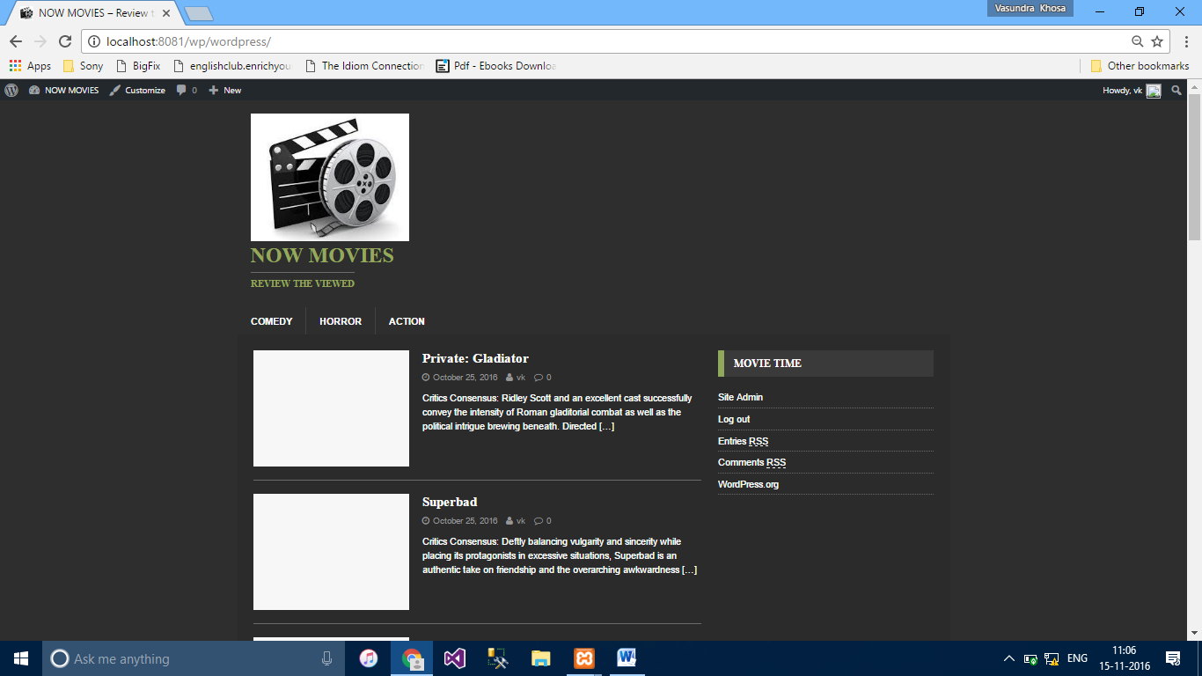

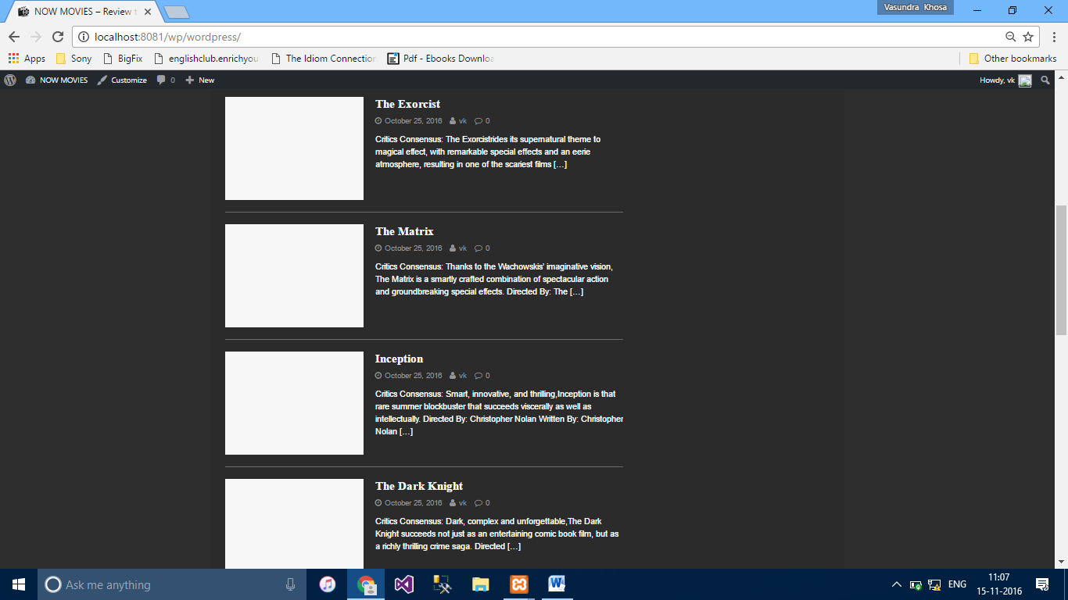

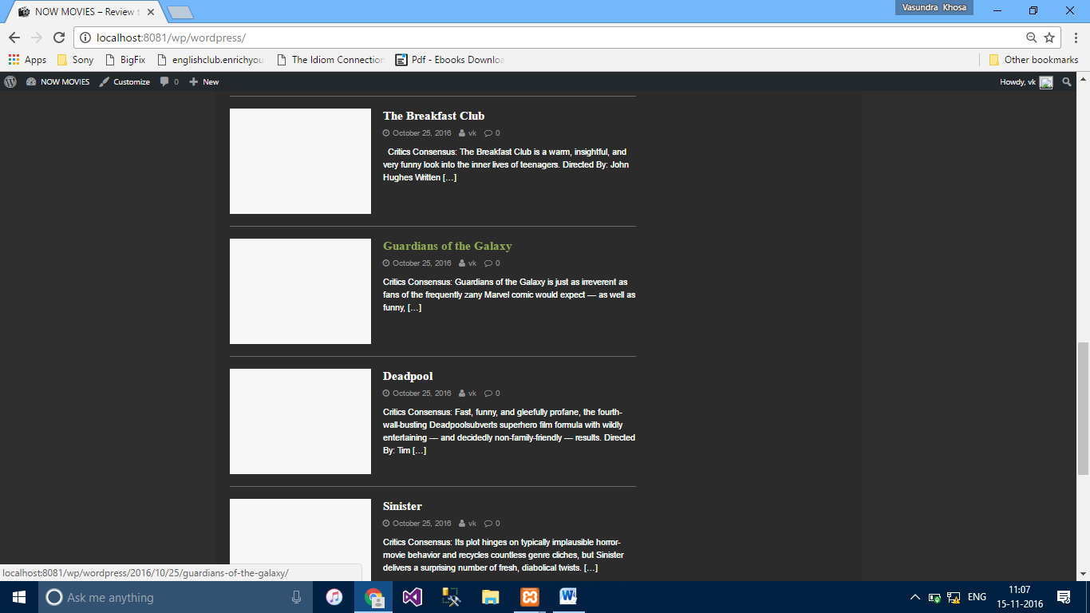

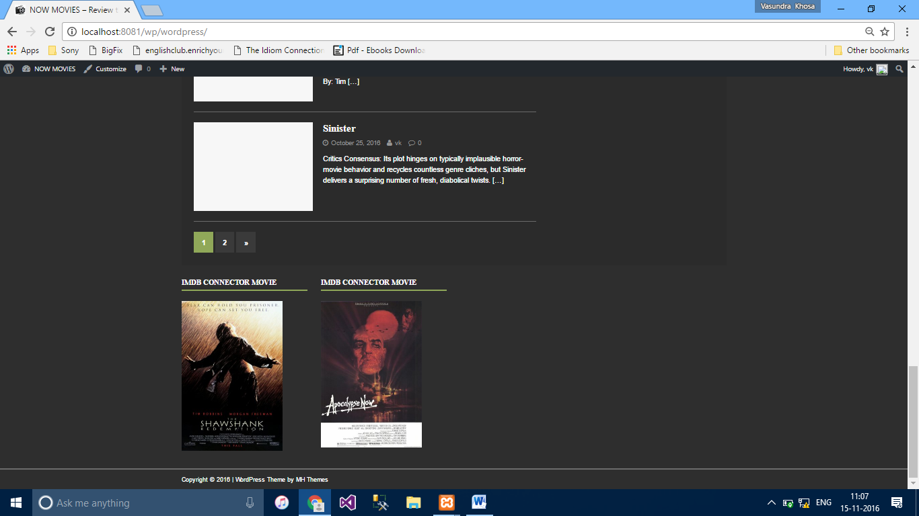

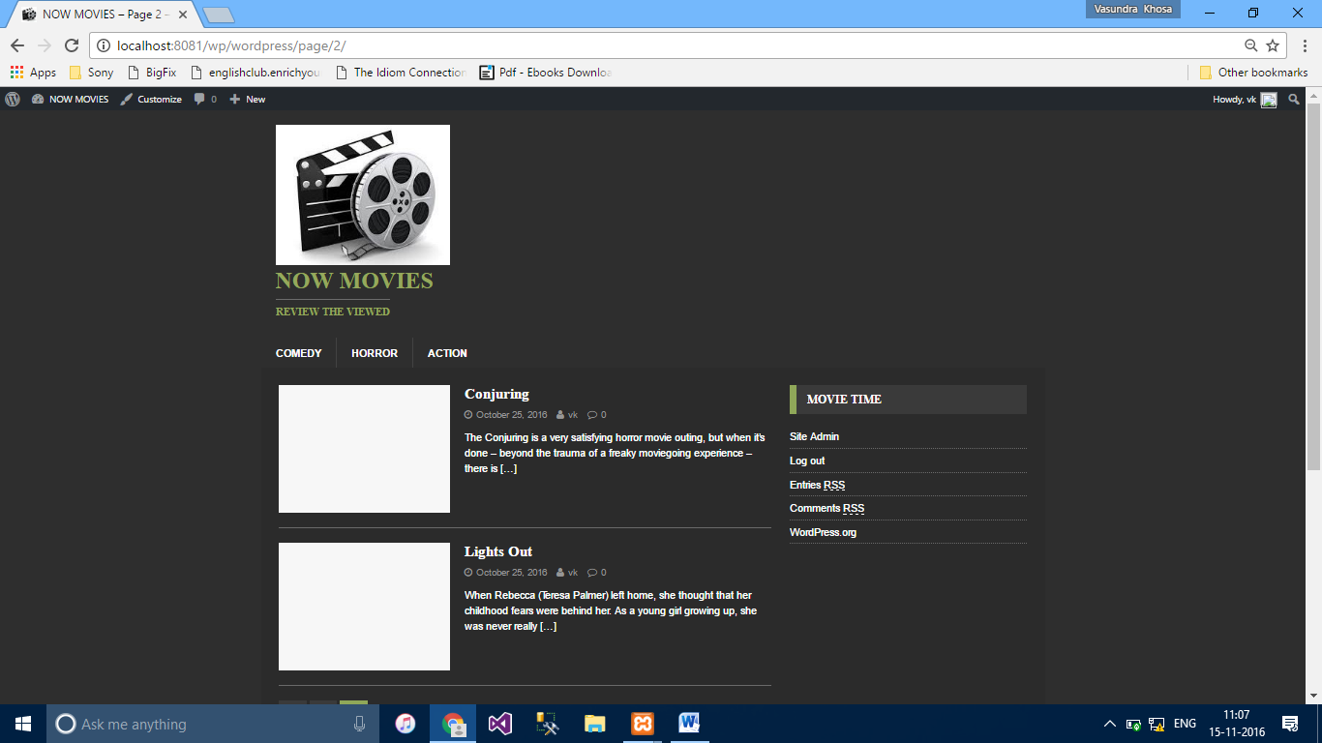

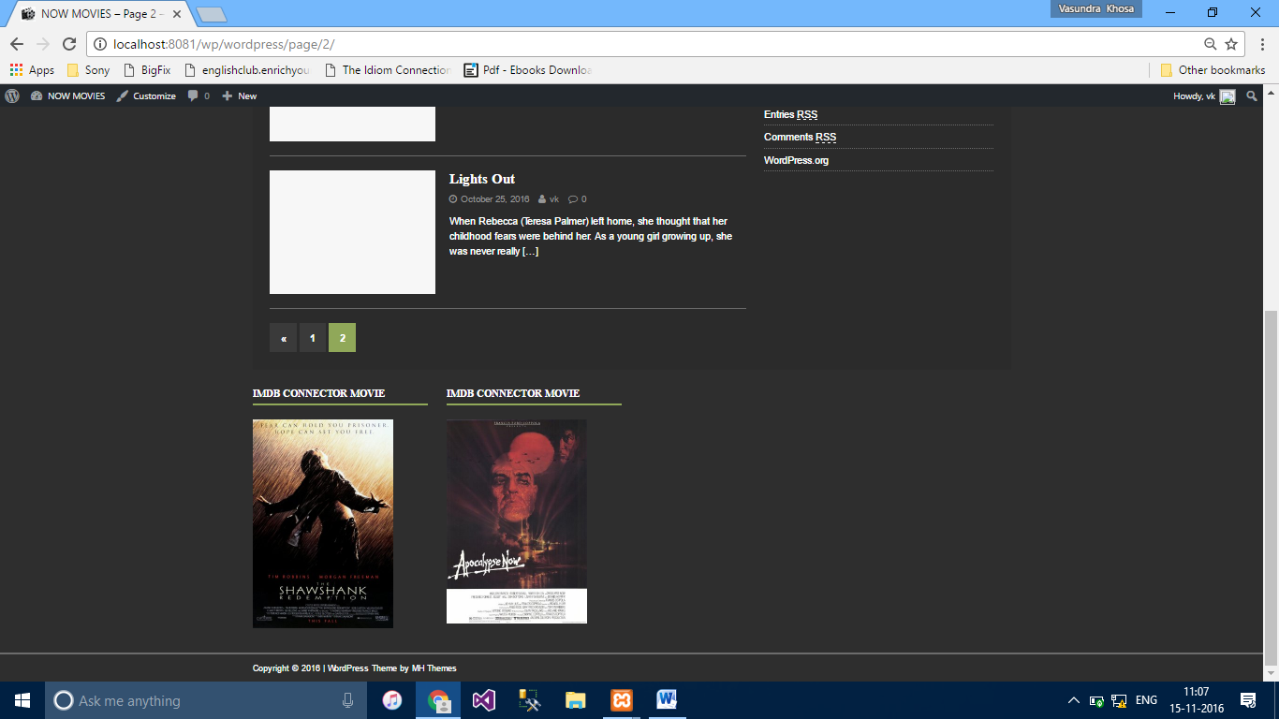

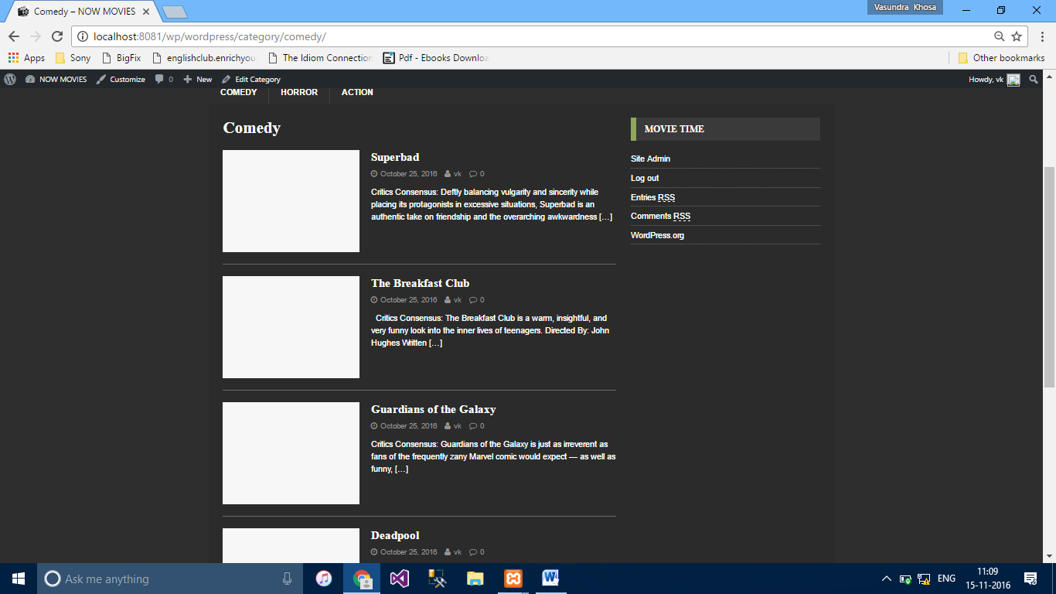

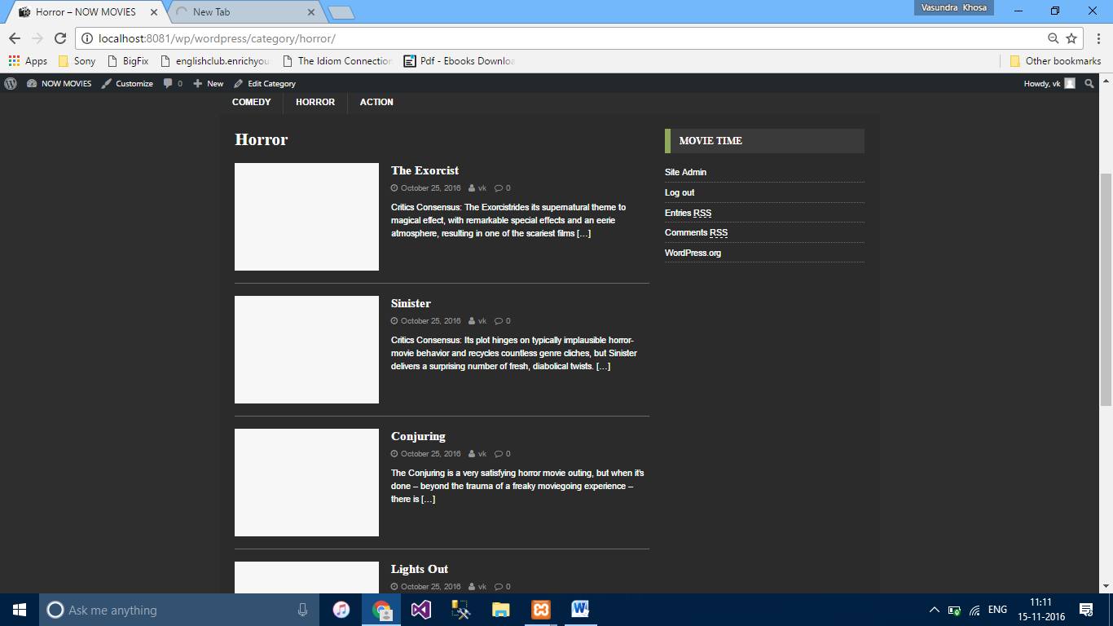

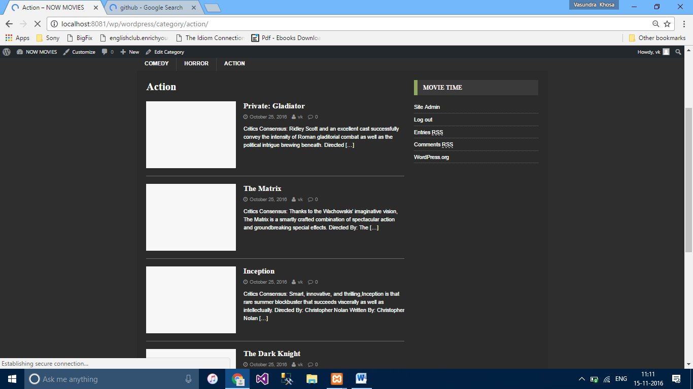

|  |  |
| --- | --- |
|  | <!DOCTYPE html> |
|  | <html class="no-js" lang="en-US"> |
|  | <head> |
|  | <meta charset="UTF-8"> |
|  | <meta name="viewport" content="width=device-width, initial-scale=1.0"> |
|  | <link rel="profile" href="<http://gmpg.org/xfn/11>" /> |
|  | <title>NOW MOVIES &#8211; Review the viewed</title> |
|  | <meta name='robots' content='noindex,follow' /> |
|  | <link rel='dns-prefetch' href='[//fonts.googleapis.com](http://fonts.googleapis.com/)' /> |
|  | <link rel='dns-prefetch' href='[//s.w.org](http://s.w.org/)' /> |
|  | <link rel="alternate" type="application/rss+xml" title="NOW MOVIES &raquo; Feed" href="<http://localhost:8081/wp/wordpress/feed/>" /> |
|  | <link rel="alternate" type="application/rss+xml" title="NOW MOVIES &raquo; Comments Feed" href="<http://localhost:8081/wp/wordpress/comments/feed/>" /> |
|  | <script type="text/javascript"> |
|  | window._wpemojiSettings = {"baseUrl":"https:\/\/s.w.org\/images\/core\/emoji\/2\/72x72\/","ext":".png","svgUrl":"https:\/\/s.w.org\/images\/core\/emoji\/2\/svg\/","svgExt":".svg","source":{"concatemoji":"http:\/\/localhost:8081\/wp\/wordpress\/wp-includes\/js\/wp-emoji-release.min.js?ver=4.6.1"}}; |
|  | !function(a,b,c){function d(a){var c,d,e,f,g,h=b.createElement("canvas"),i=h.getContext&&h.getContext("2d"),j=String.fromCharCode;if(!i||!i.fillText)return!1;switch(i.textBaseline="top",i.font="600 32px Arial",a){case"flag":return i.fillText(j(55356,56806,55356,56826),0,0),!(h.toDataURL().length<3e3)&&(i.clearRect(0,0,h.width,h.height),i.fillText(j(55356,57331,65039,8205,55356,57096),0,0),c=h.toDataURL(),i.clearRect(0,0,h.width,h.height),i.fillText(j(55356,57331,55356,57096),0,0),d=h.toDataURL(),c!==d);case"diversity":return i.fillText(j(55356,57221),0,0),e=i.getImageData(16,16,1,1).data,f=e[0]+","+e[1]+","+e[2]+","+e[3],i.fillText(j(55356,57221,55356,57343),0,0),e=i.getImageData(16,16,1,1).data,g=e[0]+","+e[1]+","+e[2]+","+e[3],f!==g;case"simple":return i.fillText(j(55357,56835),0,0),0!==i.getImageData(16,16,1,1).data[0];case"unicode8":return i.fillText(j(55356,57135),0,0),0!==i.getImageData(16,16,1,1).data[0];case"unicode9":return i.fillText(j(55358,56631),0,0),0!==i.getImageData(16,16,1,1).data[0]}return!1}function e(a){var c=b.createElement("script");c.src=a,c.type="text/javascript",b.getElementsByTagName("head")[0].appendChild(c)}var f,g,h,i;for(i=Array("simple","flag","unicode8","diversity","unicode9"),c.supports={everything:!0,everythingExceptFlag:!0},h=0;h<i.length;h++)c.supports[i[h]]=d(i[h]),c.supports.everything=c.supports.everything&&c.supports[i[h]],"flag"!==i[h]&&(c.supports.everythingExceptFlag=c.supports.everythingExceptFlag&&c.supports[i[h]]);c.supports.everythingExceptFlag=c.supports.everythingExceptFlag&&!c.supports.flag,c.DOMReady=!1,c.readyCallback=function(){c.DOMReady=!0},c.supports.everything||(g=function(){c.readyCallback()},b.addEventListener?(b.addEventListener("DOMContentLoaded",g,!1),a.addEventListener("load",g,!1)):(a.attachEvent("onload",g),b.attachEvent("onreadystatechange",function(){"complete"===b.readyState&&c.readyCallback()})),f=c.source||{},f.concatemoji?e(f.concatemoji):f.wpemoji&&f.twemoji&&(e(f.twemoji),e(f.wpemoji)))}(window,document,window._wpemojiSettings); |
|  | </script> |
|  | <style type="text/css"> |
|  | img.wp-smiley, |
|  | img.emoji { |
|  | display: inline !important; |
|  | border: none !important; |
|  | box-shadow: none !important; |
|  | height: 1em !important; |
|  | width: 1em !important; |
|  | margin: 0 .07em !important; |
|  | vertical-align: -0.1em !important; |
|  | background: none !important; |
|  | padding: 0 !important; |
|  | } |
|  | </style> |
|  | <link rel='stylesheet' id='dashicons-css' href='<http://localhost:8081/wp/wordpress/wp-includes/css/dashicons.min.css?ver=4.6.1>' type='text/css' media='all' /> |
|  | <link rel='stylesheet' id='admin-bar-css' href='<http://localhost:8081/wp/wordpress/wp-includes/css/admin-bar.min.css?ver=4.6.1>' type='text/css' media='all' /> |
|  | <link rel='stylesheet' id='imdb-connector-style-widget-css' href='<http://localhost:8081/wp/wordpress/wp-content/plugins/imdb-connector/styles/widgets.css?ver=1.5.0>' type='text/css' media='all' /> |
|  | <link rel='stylesheet' id='mh-magazine-lite-css' href='<http://localhost:8081/wp/wordpress/wp-content/themes/mh-magazine-lite/style.css?ver=2.5.4>' type='text/css' media='all' /> |
|  | <link rel='stylesheet' id='mh-urbanmag-css' href='<http://localhost:8081/wp/wordpress/wp-content/themes/mh-urbanmag/style.css?ver=1.1.1>' type='text/css' media='all' /> |
|  | <link rel='stylesheet' id='mh-font-awesome-css' href='<http://localhost:8081/wp/wordpress/wp-content/themes/mh-magazine-lite/includes/font-awesome.min.css>' type='text/css' media='all' /> |
|  | <link rel='stylesheet' id='mh-urbanmag-fonts-css' href='<https://fonts.googleapis.com/css?family=Muli:300,400,400italic%7cCaudex:400,400italic,700>' type='text/css' media='all' /> |
|  | <script type='text/javascript' src='<http://localhost:8081/wp/wordpress/wp-includes/js/jquery/jquery.js?ver=1.12.4>'></script> |
|  | <script type='text/javascript' src='<http://localhost:8081/wp/wordpress/wp-includes/js/jquery/jquery-migrate.min.js?ver=1.4.1>'></script> |
|  | <script type='text/javascript' src='<http://localhost:8081/wp/wordpress/wp-content/themes/mh-magazine-lite/js/scripts.js?ver=2.5.4>'></script> |
|  | <link rel='https://api.w.org/' href='<http://localhost:8081/wp/wordpress/wp-json/>' /> |
|  | <link rel="EditURI" type="application/rsd+xml" title="RSD" href="<http://localhost:8081/wp/wordpress/xmlrpc.php?rsd>" /> |
|  | <link rel="wlwmanifest" type="application/wlwmanifest+xml" href="<http://localhost:8081/wp/wordpress/wp-includes/wlwmanifest.xml>" /> |
|  | <meta name="generator" content="WordPress 4.6.1" /> |
|  | <!--[if lt IE 9]> |
|  | <script src="http://localhost:8081/wp/wordpress/wp-content/themes/mh-magazine-lite/js/css3-mediaqueries.js"></script> |
|  | <![endif]--> |
|  | <style type="text/css" media="print">#wpadminbar { display:none; }</style> |
|  | <style type="text/css" media="screen"> |
|  | html { margin-top: 32px !important; } |
|  | * html body { margin-top: 32px !important; } |
|  | @media screen and ( max-width: 782px ) { |
|  | html { margin-top: 46px !important; } |
|  | * html body { margin-top: 46px !important; } |
|  | } |
|  | </style> |
|  | <link rel="icon" href="<http://localhost:8081/wp/wordpress/wp-content/uploads/2016/10/cropped-images-1-1-32x32.jpg>" sizes="32x32" /> |
|  | <link rel="icon" href="<http://localhost:8081/wp/wordpress/wp-content/uploads/2016/10/cropped-images-1-1-192x192.jpg>" sizes="192x192" /> |
|  | <link rel="apple-touch-icon-precomposed" href="<http://localhost:8081/wp/wordpress/wp-content/uploads/2016/10/cropped-images-1-1-180x180.jpg>" /> |
|  | <meta name="msapplication-TileImage" content="http://localhost:8081/wp/wordpress/wp-content/uploads/2016/10/cropped-images-1-1-270x270.jpg" /> |
|  | </head> |
|  | <body id="mh-mobile" class="home blog logged-in admin-bar no-customize-support wp-custom-logo mh-right-sb" itemscope="itemscope" itemtype="http://schema.org/WebPage"> |
|  | <div class="mh-header-mobile-nav clearfix"></div> |
|  | <header class="mh-header" itemscope="itemscope" itemtype="http://schema.org/WPHeader"> |
|  | <div class="mh-container mh-container-inner mh-row clearfix"> |
|  | <div class="mh-custom-header clearfix"> |
|  | <div class="mh-site-identity"> |
|  | <div class="mh-site-logo" role="banner" itemscope="itemscope" itemtype="http://schema.org/Brand"> |
|  | <a href="<http://localhost:8081/wp/wordpress/>" class="custom-logo-link" rel="home" itemprop="url"><img width="240" height="193" src="<http://localhost:8081/wp/wordpress/wp-content/uploads/2016/10/cropped-images-1-e1477452980647.jpg>" class="custom-logo" alt="cropped-images-1-e1477452980647.jpg" itemprop="logo" /></a><style type="text/css" id="mh-header-css">.mh-header-title, .mh-header-tagline { color: #95a85c; }</style> |
|  | <div class="mh-header-text"> |
|  | <a class="mh-header-text-link" href="<http://localhost:8081/wp/wordpress/>" title="NOW MOVIES" rel="home"> |
|  | <h1 class="mh-header-title">NOW MOVIES</h1> |
|  | <h2 class="mh-header-tagline">Review the viewed</h2> |
|  | </a> |
|  | </div> |
|  | </div> |
|  | </div> |
|  | </div> |
|  | </div> |
|  | <div class="mh-main-nav-wrap"> |
|  | <nav class="mh-navigation mh-main-nav mh-container mh-container-inner clearfix" itemscope="itemscope" itemtype="http://schema.org/SiteNavigationElement"> |
|  | <div class="menu-genre-container"><ul id="menu-genre" class="menu"><li id="menu-item-115" class="menu-item menu-item-type-taxonomy menu-item-object-category menu-item-115"><a href="<http://localhost:8081/wp/wordpress/category/comedy/>">Comedy</a></li> |
|  | <li id="menu-item-116" class="menu-item menu-item-type-taxonomy menu-item-object-category menu-item-116"><a href="<http://localhost:8081/wp/wordpress/category/horror/>">Horror</a></li> |
|  | <li id="menu-item-117" class="menu-item menu-item-type-taxonomy menu-item-object-category menu-item-117"><a href="<http://localhost:8081/wp/wordpress/category/action/>">Action</a></li> |
|  | </ul></div> </nav> |
|  | </div> |
|  | </header><div class="mh-container mh-container-outer"> |
|  | <div class="mh-wrapper clearfix"> |
|  | <div id="main-content" class="mh-loop mh-content" role="main"><article class="mh-loop-item clearfix post-124 post type-post status-private format-standard hentry category-action"> |
|  | <figure class="mh-loop-thumb"> |
|  | <a href="<http://localhost:8081/wp/wordpress/2016/10/25/gladiator/>"><img class="mh-image-placeholder" src="<http://localhost:8081/wp/wordpress/wp-content/themes/mh-magazine-lite/images/placeholder-medium.png>" alt="No Picture" /> </a> |
|  | </figure> |
|  | <div class="mh-loop-content clearfix"> |
|  | <header class="mh-loop-header"> |
|  | <h3 class="entry-title mh-loop-title"> |
|  | <a href="<http://localhost:8081/wp/wordpress/2016/10/25/gladiator/>" rel="bookmark"> |
|  | Private: Gladiator </a> |
|  | </h3> |
|  | <div class="mh-meta mh-loop-meta"> |
|  | <span class="mh-meta-date updated"><i class="fa fa-clock-o"></i>October 25, 2016</span> |
|  | <span class="mh-meta-author author vcard"><i class="fa fa-user"></i><a class="fn" href="<http://localhost:8081/wp/wordpress/author/vk/>">vk</a></span> |
|  | <span class="mh-meta-comments"><i class="fa fa-comment-o"></i><a class="mh-comment-count-link" href="<http://localhost:8081/wp/wordpress/2016/10/25/gladiator/#mh-comments>">0</a></span> |
|  | </div> |
|  | </header> |
|  | <div class="mh-loop-excerpt"> |
|  | <div class="mh-excerpt"><p>Critics Consensus: Ridley Scott and an excellent cast successfully convey the intensity of Roman gladitorial combat as well as the political intrigue brewing beneath. Directed <a class="mh-excerpt-more" href="<http://localhost:8081/wp/wordpress/2016/10/25/gladiator/>" title="Private: Gladiator">[&#8230;]</a></p> |
|  | </div> </div> |
|  | </div> |
|  | </article><article class="mh-loop-item clearfix post-121 post type-post status-publish format-standard hentry category-comedy"> |
|  | <figure class="mh-loop-thumb"> |
|  | <a href="<http://localhost:8081/wp/wordpress/2016/10/25/superbad/>"><img class="mh-image-placeholder" src="<http://localhost:8081/wp/wordpress/wp-content/themes/mh-magazine-lite/images/placeholder-medium.png>" alt="No Picture" /> </a> |
|  | </figure> |
|  | <div class="mh-loop-content clearfix"> |
|  | <header class="mh-loop-header"> |
|  | <h3 class="entry-title mh-loop-title"> |
|  | <a href="<http://localhost:8081/wp/wordpress/2016/10/25/superbad/>" rel="bookmark"> |
|  | Superbad </a> |
|  | </h3> |
|  | <div class="mh-meta mh-loop-meta"> |
|  | <span class="mh-meta-date updated"><i class="fa fa-clock-o"></i>October 25, 2016</span> |
|  | <span class="mh-meta-author author vcard"><i class="fa fa-user"></i><a class="fn" href="<http://localhost:8081/wp/wordpress/author/vk/>">vk</a></span> |
|  | <span class="mh-meta-comments"><i class="fa fa-comment-o"></i><a class="mh-comment-count-link" href="<http://localhost:8081/wp/wordpress/2016/10/25/superbad/#mh-comments>">0</a></span> |
|  | </div> |
|  | </header> |
|  | <div class="mh-loop-excerpt"> |
|  | <div class="mh-excerpt"><p>Critics Consensus: Deftly balancing vulgarity and sincerity while placing its protagonists in excessive situations, Superbad is an authentic take on friendship and the overarching awkwardness <a class="mh-excerpt-more" href="<http://localhost:8081/wp/wordpress/2016/10/25/superbad/>" title="Superbad">[&#8230;]</a></p> |
|  | </div> </div> |
|  | </div> |
|  | </article><article class="mh-loop-item clearfix post-118 post type-post status-publish format-standard hentry category-horror"> |
|  | <figure class="mh-loop-thumb"> |
|  | <a href="<http://localhost:8081/wp/wordpress/2016/10/25/the-exorcist/>"><img class="mh-image-placeholder" src="<http://localhost:8081/wp/wordpress/wp-content/themes/mh-magazine-lite/images/placeholder-medium.png>" alt="No Picture" /> </a> |
|  | </figure> |
|  | <div class="mh-loop-content clearfix"> |
|  | <header class="mh-loop-header"> |
|  | <h3 class="entry-title mh-loop-title"> |
|  | <a href="<http://localhost:8081/wp/wordpress/2016/10/25/the-exorcist/>" rel="bookmark"> |
|  | The Exorcist </a> |
|  | </h3> |
|  | <div class="mh-meta mh-loop-meta"> |
|  | <span class="mh-meta-date updated"><i class="fa fa-clock-o"></i>October 25, 2016</span> |
|  | <span class="mh-meta-author author vcard"><i class="fa fa-user"></i><a class="fn" href="<http://localhost:8081/wp/wordpress/author/vk/>">vk</a></span> |
|  | <span class="mh-meta-comments"><i class="fa fa-comment-o"></i><a class="mh-comment-count-link" href="<http://localhost:8081/wp/wordpress/2016/10/25/the-exorcist/#mh-comments>">0</a></span> |
|  | </div> |
|  | </header> |
|  | <div class="mh-loop-excerpt"> |
|  | <div class="mh-excerpt"><p>Critics Consensus: The Exorcistrides its supernatural theme to magical effect, with remarkable special effects and an eerie atmosphere, resulting in one of the scariest films <a class="mh-excerpt-more" href="<http://localhost:8081/wp/wordpress/2016/10/25/the-exorcist/>" title="The Exorcist">[&#8230;]</a></p> |
|  | </div> </div> |
|  | </div> |
|  | </article><article class="mh-loop-item clearfix post-112 post type-post status-publish format-standard hentry category-action"> |
|  | <figure class="mh-loop-thumb"> |
|  | <a href="<http://localhost:8081/wp/wordpress/2016/10/25/the-matrix/>"><img class="mh-image-placeholder" src="<http://localhost:8081/wp/wordpress/wp-content/themes/mh-magazine-lite/images/placeholder-medium.png>" alt="No Picture" /> </a> |
|  | </figure> |
|  | <div class="mh-loop-content clearfix"> |
|  | <header class="mh-loop-header"> |
|  | <h3 class="entry-title mh-loop-title"> |
|  | <a href="<http://localhost:8081/wp/wordpress/2016/10/25/the-matrix/>" rel="bookmark"> |
|  | The Matrix </a> |
|  | </h3> |
|  | <div class="mh-meta mh-loop-meta"> |
|  | <span class="mh-meta-date updated"><i class="fa fa-clock-o"></i>October 25, 2016</span> |
|  | <span class="mh-meta-author author vcard"><i class="fa fa-user"></i><a class="fn" href="<http://localhost:8081/wp/wordpress/author/vk/>">vk</a></span> |
|  | <span class="mh-meta-comments"><i class="fa fa-comment-o"></i><a class="mh-comment-count-link" href="<http://localhost:8081/wp/wordpress/2016/10/25/the-matrix/#mh-comments>">0</a></span> |
|  | </div> |
|  | </header> |
|  | <div class="mh-loop-excerpt"> |
|  | <div class="mh-excerpt"><p>Critics Consensus: Thanks to the Wachowskis&#8217; imaginative vision, The Matrix is a smartly crafted combination of spectacular action and groundbreaking special effects. Directed By: The <a class="mh-excerpt-more" href="<http://localhost:8081/wp/wordpress/2016/10/25/the-matrix/>" title="The Matrix">[&#8230;]</a></p> |
|  | </div> </div> |
|  | </div> |
|  | </article><article class="mh-loop-item clearfix post-109 post type-post status-publish format-standard hentry category-action"> |
|  | <figure class="mh-loop-thumb"> |
|  | <a href="<http://localhost:8081/wp/wordpress/2016/10/25/inception/>"><img class="mh-image-placeholder" src="<http://localhost:8081/wp/wordpress/wp-content/themes/mh-magazine-lite/images/placeholder-medium.png>" alt="No Picture" /> </a> |
|  | </figure> |
|  | <div class="mh-loop-content clearfix"> |
|  | <header class="mh-loop-header"> |
|  | <h3 class="entry-title mh-loop-title"> |
|  | <a href="<http://localhost:8081/wp/wordpress/2016/10/25/inception/>" rel="bookmark"> |
|  | Inception </a> |
|  | </h3> |
|  | <div class="mh-meta mh-loop-meta"> |
|  | <span class="mh-meta-date updated"><i class="fa fa-clock-o"></i>October 25, 2016</span> |
|  | <span class="mh-meta-author author vcard"><i class="fa fa-user"></i><a class="fn" href="<http://localhost:8081/wp/wordpress/author/vk/>">vk</a></span> |
|  | <span class="mh-meta-comments"><i class="fa fa-comment-o"></i><a class="mh-comment-count-link" href="<http://localhost:8081/wp/wordpress/2016/10/25/inception/#mh-comments>">0</a></span> |
|  | </div> |
|  | </header> |
|  | <div class="mh-loop-excerpt"> |
|  | <div class="mh-excerpt"><p>Critics Consensus: Smart, innovative, and thrilling,Inception is that rare summer blockbuster that succeeds viscerally as well as intellectually. Directed By: Christopher Nolan Written By: Christopher Nolan <a class="mh-excerpt-more" href="<http://localhost:8081/wp/wordpress/2016/10/25/inception/>" title="Inception">[&#8230;]</a></p> |
|  | </div> </div> |
|  | </div> |
|  | </article><article class="mh-loop-item clearfix post-94 post type-post status-publish format-standard hentry category-action"> |
|  | <figure class="mh-loop-thumb"> |
|  | <a href="<http://localhost:8081/wp/wordpress/2016/10/25/the-dark-knight/>"><img class="mh-image-placeholder" src="<http://localhost:8081/wp/wordpress/wp-content/themes/mh-magazine-lite/images/placeholder-medium.png>" alt="No Picture" /> </a> |
|  | </figure> |
|  | <div class="mh-loop-content clearfix"> |
|  | <header class="mh-loop-header"> |
|  | <h3 class="entry-title mh-loop-title"> |
|  | <a href="<http://localhost:8081/wp/wordpress/2016/10/25/the-dark-knight/>" rel="bookmark"> |
|  | The Dark Knight </a> |
|  | </h3> |
|  | <div class="mh-meta mh-loop-meta"> |
|  | <span class="mh-meta-date updated"><i class="fa fa-clock-o"></i>October 25, 2016</span> |
|  | <span class="mh-meta-author author vcard"><i class="fa fa-user"></i><a class="fn" href="<http://localhost:8081/wp/wordpress/author/vk/>">vk</a></span> |
|  | <span class="mh-meta-comments"><i class="fa fa-comment-o"></i><a class="mh-comment-count-link" href="<http://localhost:8081/wp/wordpress/2016/10/25/the-dark-knight/#mh-comments>">0</a></span> |
|  | </div> |
|  | </header> |
|  | <div class="mh-loop-excerpt"> |
|  | <div class="mh-excerpt"><p>Critics Consensus: Dark, complex and unforgettable,The Dark Knight succeeds not just as an entertaining comic book film, but as a richly thrilling crime saga. Directed <a class="mh-excerpt-more" href="<http://localhost:8081/wp/wordpress/2016/10/25/the-dark-knight/>" title="The Dark Knight">[&#8230;]</a></p> |
|  | </div> </div> |
|  | </div> |
|  | </article><article class="mh-loop-item clearfix post-90 post type-post status-publish format-standard hentry category-comedy"> |
|  | <figure class="mh-loop-thumb"> |
|  | <a href="<http://localhost:8081/wp/wordpress/2016/10/25/the-breakfast-club/>"><img class="mh-image-placeholder" src="<http://localhost:8081/wp/wordpress/wp-content/themes/mh-magazine-lite/images/placeholder-medium.png>" alt="No Picture" /> </a> |
|  | </figure> |
|  | <div class="mh-loop-content clearfix"> |
|  | <header class="mh-loop-header"> |
|  | <h3 class="entry-title mh-loop-title"> |
|  | <a href="<http://localhost:8081/wp/wordpress/2016/10/25/the-breakfast-club/>" rel="bookmark"> |
|  | The Breakfast Club </a> |
|  | </h3> |
|  | <div class="mh-meta mh-loop-meta"> |
|  | <span class="mh-meta-date updated"><i class="fa fa-clock-o"></i>October 25, 2016</span> |
|  | <span class="mh-meta-author author vcard"><i class="fa fa-user"></i><a class="fn" href="<http://localhost:8081/wp/wordpress/author/vk/>">vk</a></span> |
|  | <span class="mh-meta-comments"><i class="fa fa-comment-o"></i><a class="mh-comment-count-link" href="<http://localhost:8081/wp/wordpress/2016/10/25/the-breakfast-club/#mh-comments>">0</a></span> |
|  | </div> |
|  | </header> |
|  | <div class="mh-loop-excerpt"> |
|  | <div class="mh-excerpt"><p>&nbsp; Critics Consensus: The Breakfast Club is a warm, insightful, and very funny look into the inner lives of teenagers. Directed By: John Hughes Written <a class="mh-excerpt-more" href="<http://localhost:8081/wp/wordpress/2016/10/25/the-breakfast-club/>" title="The Breakfast Club">[&#8230;]</a></p> |
|  | </div> </div> |
|  | </div> |
|  | </article><article class="mh-loop-item clearfix post-83 post type-post status-publish format-standard hentry category-comedy"> |
|  | <figure class="mh-loop-thumb"> |
|  | <a href="<http://localhost:8081/wp/wordpress/2016/10/25/guardians-of-the-galaxy/>"><img class="mh-image-placeholder" src="<http://localhost:8081/wp/wordpress/wp-content/themes/mh-magazine-lite/images/placeholder-medium.png>" alt="No Picture" /> </a> |
|  | </figure> |
|  | <div class="mh-loop-content clearfix"> |
|  | <header class="mh-loop-header"> |
|  | <h3 class="entry-title mh-loop-title"> |
|  | <a href="<http://localhost:8081/wp/wordpress/2016/10/25/guardians-of-the-galaxy/>" rel="bookmark"> |
|  | Guardians of the Galaxy </a> |
|  | </h3> |
|  | <div class="mh-meta mh-loop-meta"> |
|  | <span class="mh-meta-date updated"><i class="fa fa-clock-o"></i>October 25, 2016</span> |
|  | <span class="mh-meta-author author vcard"><i class="fa fa-user"></i><a class="fn" href="<http://localhost:8081/wp/wordpress/author/vk/>">vk</a></span> |
|  | <span class="mh-meta-comments"><i class="fa fa-comment-o"></i><a class="mh-comment-count-link" href="<http://localhost:8081/wp/wordpress/2016/10/25/guardians-of-the-galaxy/#mh-comments>">0</a></span> |
|  | </div> |
|  | </header> |
|  | <div class="mh-loop-excerpt"> |
|  | <div class="mh-excerpt"><p>Critics Consensus: Guardians of the Galaxy is just as irreverent as fans of the frequently zany Marvel comic would expect &#8212; as well as funny, <a class="mh-excerpt-more" href="<http://localhost:8081/wp/wordpress/2016/10/25/guardians-of-the-galaxy/>" title="Guardians of the Galaxy">[&#8230;]</a></p> |
|  | </div> </div> |
|  | </div> |
|  | </article><article class="mh-loop-item clearfix post-78 post type-post status-publish format-standard hentry category-comedy"> |
|  | <figure class="mh-loop-thumb"> |
|  | <a href="<http://localhost:8081/wp/wordpress/2016/10/25/deadpool/>"><img class="mh-image-placeholder" src="<http://localhost:8081/wp/wordpress/wp-content/themes/mh-magazine-lite/images/placeholder-medium.png>" alt="No Picture" /> </a> |
|  | </figure> |
|  | <div class="mh-loop-content clearfix"> |
|  | <header class="mh-loop-header"> |
|  | <h3 class="entry-title mh-loop-title"> |
|  | <a href="<http://localhost:8081/wp/wordpress/2016/10/25/deadpool/>" rel="bookmark"> |
|  | Deadpool </a> |
|  | </h3> |
|  | <div class="mh-meta mh-loop-meta"> |
|  | <span class="mh-meta-date updated"><i class="fa fa-clock-o"></i>October 25, 2016</span> |
|  | <span class="mh-meta-author author vcard"><i class="fa fa-user"></i><a class="fn" href="<http://localhost:8081/wp/wordpress/author/vk/>">vk</a></span> |
|  | <span class="mh-meta-comments"><i class="fa fa-comment-o"></i><a class="mh-comment-count-link" href="<http://localhost:8081/wp/wordpress/2016/10/25/deadpool/#mh-comments>">0</a></span> |
|  | </div> |
|  | </header> |
|  | <div class="mh-loop-excerpt"> |
|  | <div class="mh-excerpt"><p>Critics Consensus: Fast, funny, and gleefully profane, the fourth-wall-busting Deadpoolsubverts superhero film formula with wildly entertaining &#8212; and decidedly non-family-friendly &#8212; results. Directed By: Tim <a class="mh-excerpt-more" href="<http://localhost:8081/wp/wordpress/2016/10/25/deadpool/>" title="Deadpool">[&#8230;]</a></p> |
|  | </div> </div> |
|  | </div> |
|  | </article><article class="mh-loop-item clearfix post-69 post type-post status-publish format-standard hentry category-horror"> |
|  | <figure class="mh-loop-thumb"> |
|  | <a href="<http://localhost:8081/wp/wordpress/2016/10/25/sinister/>"><img class="mh-image-placeholder" src="<http://localhost:8081/wp/wordpress/wp-content/themes/mh-magazine-lite/images/placeholder-medium.png>" alt="No Picture" /> </a> |
|  | </figure> |
|  | <div class="mh-loop-content clearfix"> |
|  | <header class="mh-loop-header"> |
|  | <h3 class="entry-title mh-loop-title"> |
|  | <a href="<http://localhost:8081/wp/wordpress/2016/10/25/sinister/>" rel="bookmark"> |
|  | Sinister </a> |
|  | </h3> |
|  | <div class="mh-meta mh-loop-meta"> |
|  | <span class="mh-meta-date updated"><i class="fa fa-clock-o"></i>October 25, 2016</span> |
|  | <span class="mh-meta-author author vcard"><i class="fa fa-user"></i><a class="fn" href="<http://localhost:8081/wp/wordpress/author/vk/>">vk</a></span> |
|  | <span class="mh-meta-comments"><i class="fa fa-comment-o"></i><a class="mh-comment-count-link" href="<http://localhost:8081/wp/wordpress/2016/10/25/sinister/#mh-comments>">0</a></span> |
|  | </div> |
|  | </header> |
|  | <div class="mh-loop-excerpt"> |
|  | <div class="mh-excerpt"><p>Critics Consensus: Its plot hinges on typically implausible horror-movie behavior and recycles countless genre cliches, but Sinister delivers a surprising number of fresh, diabolical twists. <a class="mh-excerpt-more" href="<http://localhost:8081/wp/wordpress/2016/10/25/sinister/>" title="Sinister">[&#8230;]</a></p> |
|  | </div> </div> |
|  | </div> |
|  | </article><div class="mh-loop-pagination clearfix"><span class='page-numbers current'>1</span> |
|  | <a class='page-numbers' href='<http://localhost:8081/wp/wordpress/page/2/>'>2</a> |
|  | <a class="next page-numbers" href="<http://localhost:8081/wp/wordpress/page/2/>">&raquo;</a></div> </div> |
|  | <aside class="mh-widget-col-1 mh-sidebar" itemscope="itemscope" itemtype="http://schema.org/WPSideBar"><div id="meta-4" class="mh-widget widget_meta"><h4 class="mh-widget-title"><span class="mh-widget-title-inner">Movie Time</span></h4> <ul> |
|  | <li><a href="<http://localhost:8081/wp/wordpress/wp-admin/>">Site Admin</a></li> <li><a href="[http://localhost:8081/wp/wordpress/wp-login.php?action=logout&#038;_wpnonce=89420956d6](http://localhost:8081/wp/wordpress/wp-login.php?action=logout&_wpnonce=89420956d6)">Log out</a></li> |
|  | <li><a href="<http://localhost:8081/wp/wordpress/feed/>">Entries <abbr title="Really Simple Syndication">RSS</abbr></a></li> |
|  | <li><a href="<http://localhost:8081/wp/wordpress/comments/feed/>">Comments <abbr title="Really Simple Syndication">RSS</abbr></a></li> |
|  | <li><a href="<https://wordpress.org/>" title="Powered by WordPress, state-of-the-art semantic personal publishing platform.">WordPress.org</a></li> </ul> |
|  | </div></aside></div> |
|  | </div><!-- .mh-container-outer --> |
|  | <footer class="mh-footer" itemscope="itemscope" itemtype="http://schema.org/WPFooter"> |
|  | <div class="mh-container mh-container-inner mh-footer-widgets mh-row clearfix"> |
|  | <div class="mh-col-1-4 mh-widget-col-1 mh-footer-area mh-footer-1"> |
|  | <div id="imdb_connector_movie-3" class="mh-footer-widget widget_imdb_connector_movie"><h6 class="mh-widget-title mh-footer-widget-title"><span class="mh-widget-title-inner mh-footer-widget-title-inner">IMDb Connector movie</span></h6> <div class="movie-poster-container"> |
|  | <a href="<http://www.imdb.com/title/tt0111161/>" class="poster-link" target="_blank"> <img src="<http://localhost:8081/wp/wordpress/wp-content/plugins/imdb-connector/cache/c121b9f5.jpg>" alt="The Shawshank Redemption" class="movie-poster" width="200" height="230"/> |
|  | </a> </div> |
|  | </div> </div> |
|  | <div class="mh-col-1-4 mh-widget-col-1 mh-footer-area mh-footer-4"> |
|  | <div id="imdb_connector_movie-8" class="mh-footer-widget widget_imdb_connector_movie"><h6 class="mh-widget-title mh-footer-widget-title"><span class="mh-widget-title-inner mh-footer-widget-title-inner">IMDb Connector movie</span></h6> <div class="movie-poster-container"> |
|  | <img src="<http://localhost:8081/wp/wordpress/wp-content/plugins/imdb-connector/cache/2cfdae84.jpg>" alt="Apocalypse Now" class="movie-poster" width="200" height="230"/> |
|  | </div> |
|  | </div> </div> |
|  | </div> |
|  | </footer> |
|  | <div class="mh-copyright-wrap"> |
|  | <div class="mh-container mh-container-inner clearfix"> |
|  | <p class="mh-copyright">Copyright &copy; 2016 | WordPress Theme by <a href="<http://www.mhthemes.com/>" rel="nofollow">MH Themes</a></p> |
|  | </div> |
|  | </div> |
|  | <script type='text/javascript' src='<http://localhost:8081/wp/wordpress/wp-includes/js/admin-bar.min.js?ver=4.6.1>'></script> |
|  | <script type='text/javascript' src='<http://localhost:8081/wp/wordpress/wp-includes/js/wp-embed.min.js?ver=4.6.1>'></script> |
|  | <script type="text/javascript"> |
|  | (function() { |
|  | var request, b = document.body, c = 'className', cs = 'customize-support', rcs = new RegExp('(^|\\s+)(no-)?'+cs+'(\\s+|$)'); |
|  |  |
|  | request = true; |
|  |  |
|  | b[c] = b[c].replace( rcs, ' ' ); |
|  | b[c] += ( window.postMessage && request ? ' ' : ' no-' ) + cs; |
|  | }()); |
|  | </script> |
|  | <div id="wpadminbar" class="nojq nojs"> |
|  | <a class="screen-reader-shortcut" href="[#wp-toolbar](http://localhost:8081/wp/wordpress/#wp-toolbar)" tabindex="1">Skip to toolbar</a> |
|  | <div class="quicklinks" id="wp-toolbar" role="navigation" aria-label="Toolbar" tabindex="0"> |
|  | <ul id="wp-admin-bar-root-default" class="ab-top-menu"> |
|  | <li id="wp-admin-bar-wp-logo" class="menupop"><a class="ab-item" aria-haspopup="true" href="<http://localhost:8081/wp/wordpress/wp-admin/about.php>"><span class="ab-icon"></span><span class="screen-reader-text">About WordPress</span></a><div class="ab-sub-wrapper"><ul id="wp-admin-bar-wp-logo-default" class="ab-submenu"> |
|  | <li id="wp-admin-bar-about"><a class="ab-item" href="<http://localhost:8081/wp/wordpress/wp-admin/about.php>">About WordPress</a> </li></ul><ul id="wp-admin-bar-wp-logo-external" class="ab-sub-secondary ab-submenu"> |
|  | <li id="wp-admin-bar-wporg"><a class="ab-item" href="<https://wordpress.org/>">WordPress.org</a> </li> |
|  | <li id="wp-admin-bar-documentation"><a class="ab-item" href="<https://codex.wordpress.org/>">Documentation</a> </li> |
|  | <li id="wp-admin-bar-support-forums"><a class="ab-item" href="<https://wordpress.org/support/>">Support Forums</a> </li> |
|  | <li id="wp-admin-bar-feedback"><a class="ab-item" href="<https://wordpress.org/support/forum/requests-and-feedback>">Feedback</a> </li></ul></div> </li> |
|  | <li id="wp-admin-bar-site-name" class="menupop"><a class="ab-item" aria-haspopup="true" href="<http://localhost:8081/wp/wordpress/wp-admin/>">NOW MOVIES</a><div class="ab-sub-wrapper"><ul id="wp-admin-bar-site-name-default" class="ab-submenu"> |
|  | <li id="wp-admin-bar-dashboard"><a class="ab-item" href="<http://localhost:8081/wp/wordpress/wp-admin/>">Dashboard</a> </li></ul><ul id="wp-admin-bar-appearance" class="ab-submenu"> |
|  | <li id="wp-admin-bar-themes"><a class="ab-item" href="<http://localhost:8081/wp/wordpress/wp-admin/themes.php>">Themes</a> </li> |
|  | <li id="wp-admin-bar-widgets"><a class="ab-item" href="<http://localhost:8081/wp/wordpress/wp-admin/widgets.php>">Widgets</a> </li> |
|  | <li id="wp-admin-bar-menus"><a class="ab-item" href="<http://localhost:8081/wp/wordpress/wp-admin/nav-menus.php>">Menus</a> </li> |
|  | <li id="wp-admin-bar-header" class="hide-if-customize"><a class="ab-item" href="<http://localhost:8081/wp/wordpress/wp-admin/themes.php?page=custom-header>">Header</a> </li></ul></div> </li> |
|  | <li id="wp-admin-bar-customize" class="hide-if-no-customize"><a class="ab-item" href="<http://localhost:8081/wp/wordpress/wp-admin/customize.php?url=http%3A%2F%2Flocalhost%3A8081%2Fwp%2Fwordpress%2F>">Customize</a> </li> |
|  | <li id="wp-admin-bar-comments"><a class="ab-item" href="<http://localhost:8081/wp/wordpress/wp-admin/edit-comments.php>"><span class="ab-icon"></span><span id="ab-awaiting-mod" class="ab-label awaiting-mod pending-count count-0" aria-hidden="true">0</span><span class="screen-reader-text">0 comments awaiting moderation</span></a> </li> |
|  | <li id="wp-admin-bar-new-content" class="menupop"><a class="ab-item" aria-haspopup="true" href="<http://localhost:8081/wp/wordpress/wp-admin/post-new.php>"><span class="ab-icon"></span><span class="ab-label">New</span></a><div class="ab-sub-wrapper"><ul id="wp-admin-bar-new-content-default" class="ab-submenu"> |
|  | <li id="wp-admin-bar-new-post"><a class="ab-item" href="<http://localhost:8081/wp/wordpress/wp-admin/post-new.php>">Post</a> </li> |
|  | <li id="wp-admin-bar-new-media"><a class="ab-item" href="<http://localhost:8081/wp/wordpress/wp-admin/media-new.php>">Media</a> </li> |
|  | <li id="wp-admin-bar-new-page"><a class="ab-item" href="<http://localhost:8081/wp/wordpress/wp-admin/post-new.php?post_type=page>">Page</a> </li> |
|  | <li id="wp-admin-bar-new-user"><a class="ab-item" href="<http://localhost:8081/wp/wordpress/wp-admin/user-new.php>">User</a> </li></ul></div> </li></ul><ul id="wp-admin-bar-top-secondary" class="ab-top-secondary ab-top-menu"> |
|  | <li id="wp-admin-bar-search" class="admin-bar-search"><div class="ab-item ab-empty-item" tabindex="-1"><form action="http://localhost:8081/wp/wordpress/" method="get" id="adminbarsearch"><input class="adminbar-input" name="s" id="adminbar-search" type="text" value="" maxlength="150" /><label for="adminbar-search" class="screen-reader-text">Search</label><input type="submit" class="adminbar-button" value="Search"/></form></div> </li> |
|  | <li id="wp-admin-bar-my-account" class="menupop with-avatar"><a class="ab-item" aria-haspopup="true" href="<http://localhost:8081/wp/wordpress/wp-admin/profile.php>">Howdy, vk<img alt='' src='[http://1.gravatar.com/avatar/a53697175b9e46b0ddb08988712e69d4?s=26&#038;d=mm&#038;r=g](http://1.gravatar.com/avatar/a53697175b9e46b0ddb08988712e69d4?s=26&d=mm&r=g)' srcset='http://1.gravatar.com/avatar/a53697175b9e46b0ddb08988712e69d4?s=52&amp;d=mm&amp;r=g 2x' class='avatar avatar-26 photo' height='26' width='26' /></a><div class="ab-sub-wrapper"><ul id="wp-admin-bar-user-actions" class="ab-submenu"> |
|  | <li id="wp-admin-bar-user-info"><a class="ab-item" tabindex="-1" href="<http://localhost:8081/wp/wordpress/wp-admin/profile.php>"><img alt='' src='[http://1.gravatar.com/avatar/a53697175b9e46b0ddb08988712e69d4?s=64&#038;d=mm&#038;r=g](http://1.gravatar.com/avatar/a53697175b9e46b0ddb08988712e69d4?s=64&d=mm&r=g)' srcset='http://1.gravatar.com/avatar/a53697175b9e46b0ddb08988712e69d4?s=128&amp;d=mm&aamp;r=g 2x' class='avatar avatar-64 photo' height='64' width='64' /><span class='display-name'>vk</span></a> </li> |
|  | <li id="wp-admin-bar-edit-profile"><a class="ab-item" href="<http://localhost:8081/wp/wordpress/wp-admin/profile.php>">Edit My Profile</a> </li> |
|  | <li id="wp-admin-bar-logout"><a class="ab-item" href="[http://localhost:8081/wp/wordpress/wp-login.php?action=logout&#038;_wpnonce=89420956d6](http://localhost:8081/wp/wordpress/wp-login.php?action=logout&_wpnonce=89420956d6)">Log Out</a> </li></ul></div> </li></ul> </div> |
|  | <a class="screen-reader-shortcut" href="[http://localhost:8081/wp/wordpress/wp-login.php?action=logout&#038;_wpnonce=89420956d6](http://localhost:8081/wp/wordpress/wp-login.php?action=logout&_wpnonce=89420956d6)">Log Out</a> |
|  | </div> |
|  |  |
|  | </body> |
|  | </html> |