<http://assignment2final.wide-plating-97021.appspot.com/>

Time taken to upload:0:00:00.232000

Time taken to insert into DB:0:00:20.570000

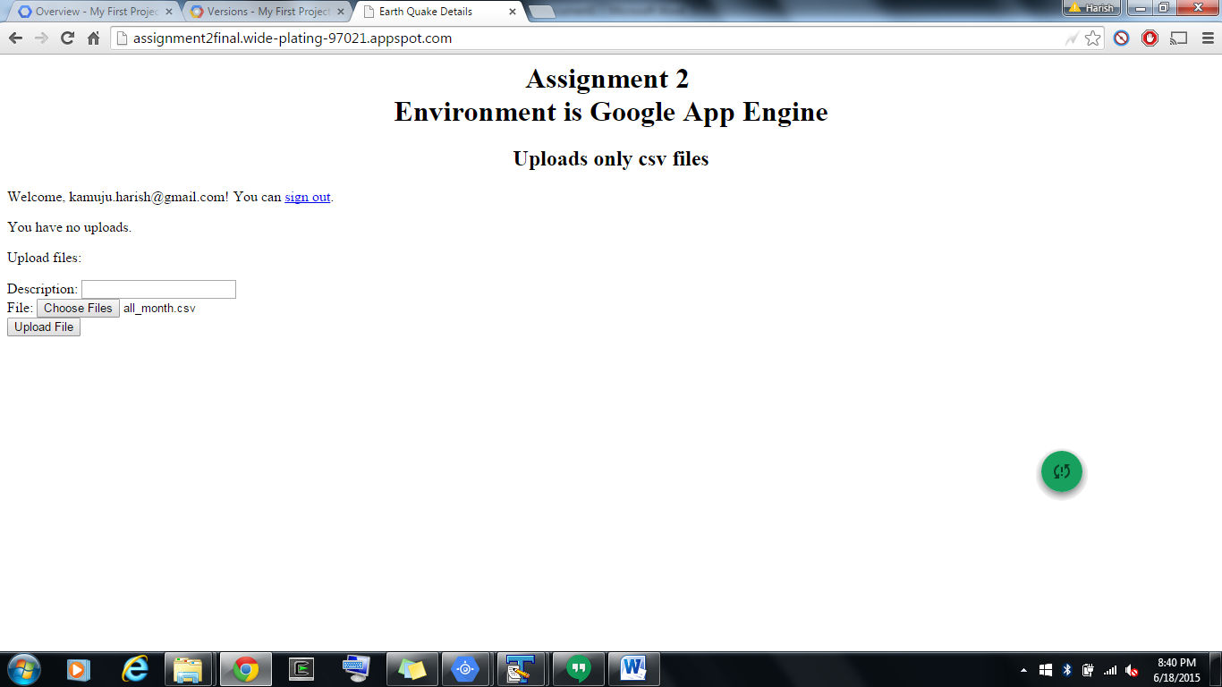

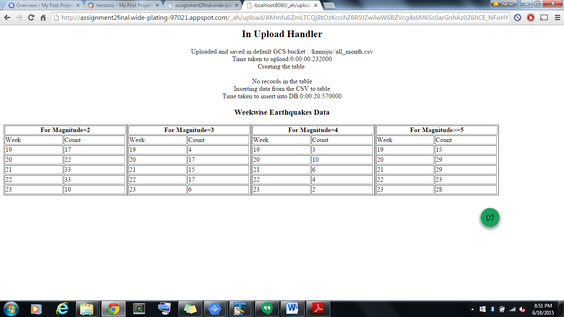

1. Page has been handled to maintain multiple users data and their file uploads.
2. Lists and deletes files uploaded by the user.
3. Displays the time taken to upload the files
4. If table doesn’t exists creates a new table and inserts the records. And time taken for this process is displayed.
5. If table exists performs the queries which are inbuilt in the code.

References:

<https://cloud.google.com/appengine/docs/python/blobstore/>

<https://cloud.google.com/appengine/docs/python/cloud-sql/>

<https://github.com/dansanderson/pgae-examples> “examples from the book _Programming Google

App Engine_, 2nd edition, by Dan Sanderson, originally published in

October 2012.

“