# Assignment 3

<http://assignment3final.wide-plating-97021.appspot.com/>

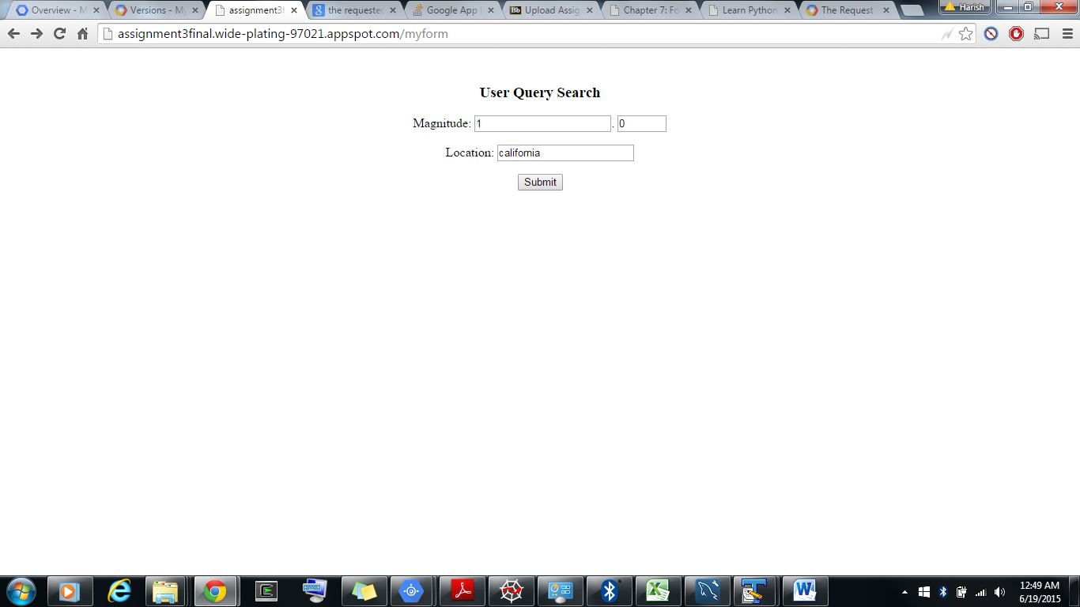

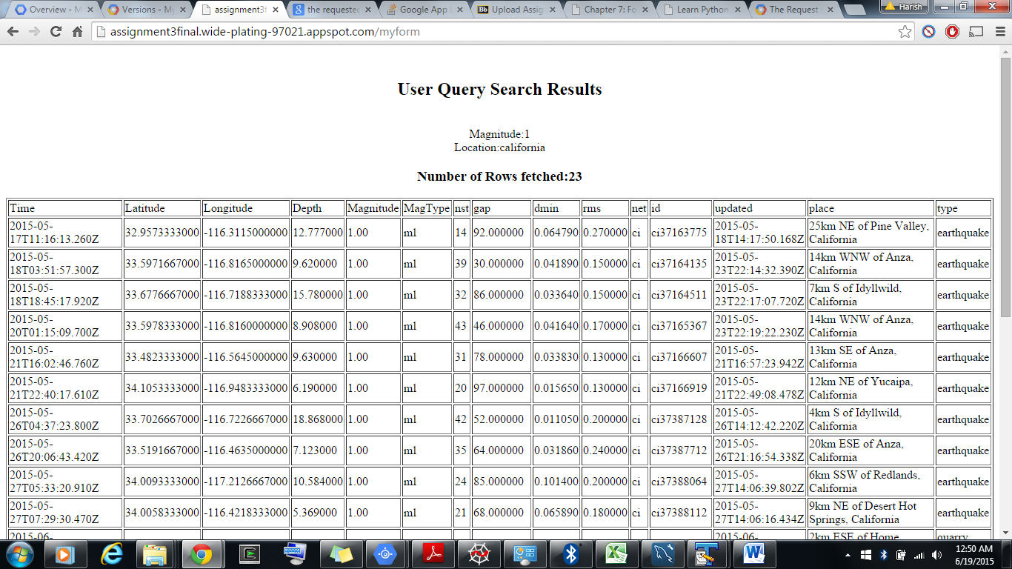

1. Page has been handled to maintain multiple users data and their file uploads.
2. Lists and deletes files uploaded by the user.
3. Has Magnitude and Location as search attributes.
4. Displays data in a tabular format of all records which satisfy the search criteria.
5. Lists the number of records.

References:

<https://cloud.google.com/appengine/docs/python/blobstore/>

<https://cloud.google.com/appengine/docs/python/cloud-sql/>

<https://github.com/dansanderson/pgae-examples> “examples from the book _Programming Google

App Engine_, 2nd edition, by Dan Sanderson, originally published in

October 2012.

“