# Assignment 5

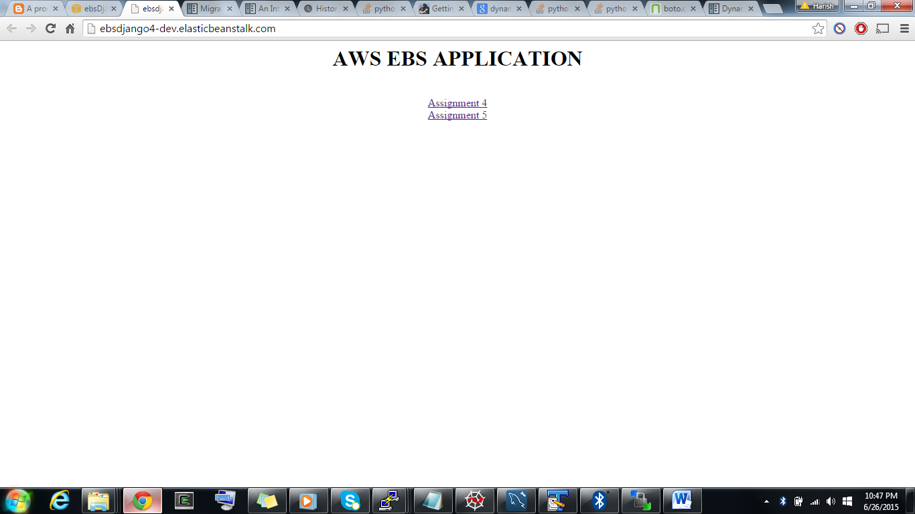

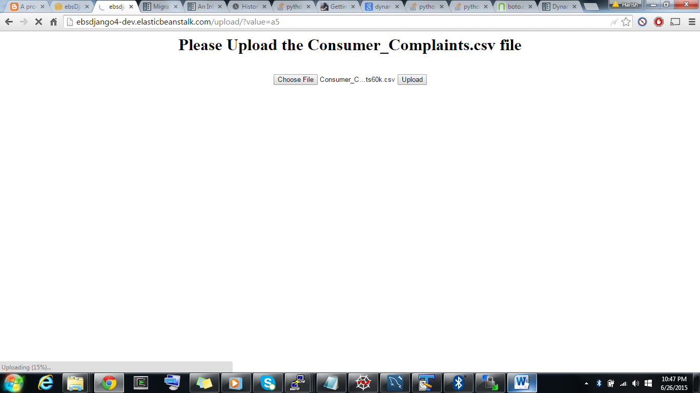

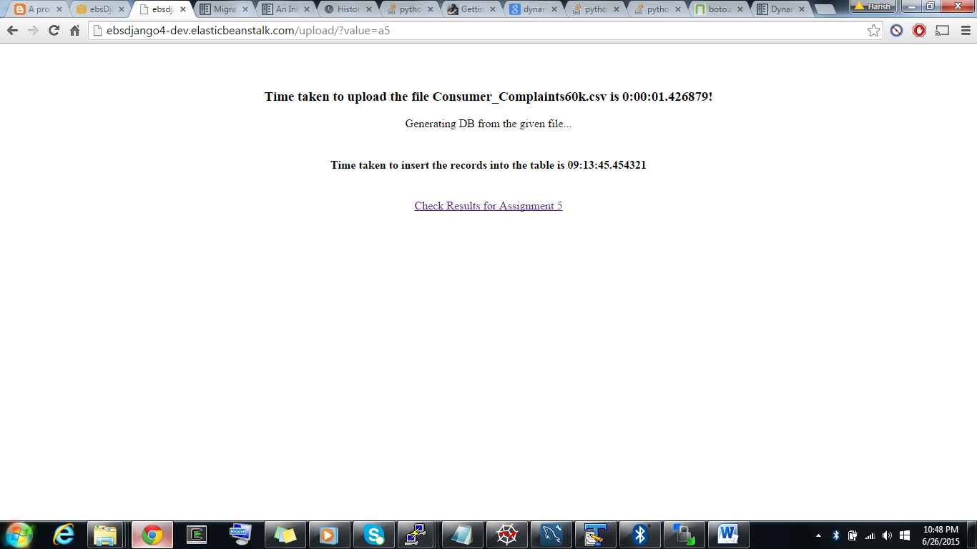

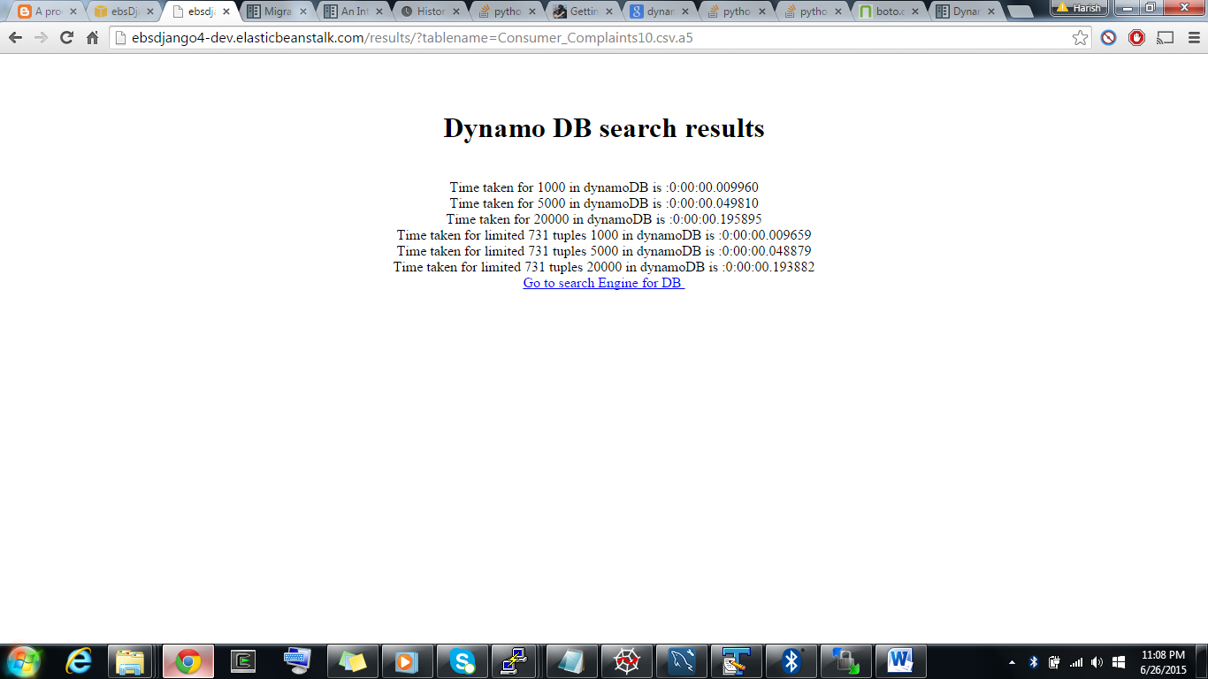

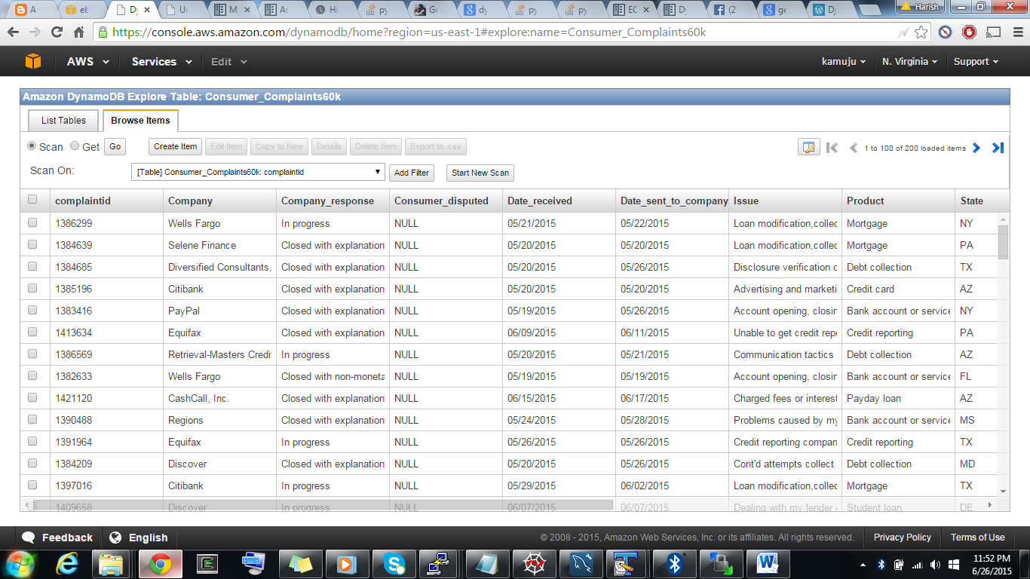

1. Handled to maintain users data and their file uploads by unique key which it takes as the filename.
2. Uploaded the file to AWS S3 data storage through web interface using django.
3. Uploaded the data to dynamodb from S3 by using mysql db python package.
4. Created random queries of 1000,5000,20000 and limited queries of tuples between 200 to 800 and their times.
5. Results with and without memcache have been updated.

CACHES = {

'default': {

'BACKEND':'django_elasticache.memcached.ElastiCache',

'LOCATION':'a4cache.5odawy.cfg.usw2.cache.amazonaws.com:11211',

}

}

References:

<http://boto.readthedocs.org/en/latest/ref/s3.html>

<http://aws.amazon.com/documentation/s3/>

<http://aws.amazon.com/documentation/rds/>

<http://aws.amazon.com/documentation/elasticache/>

<http://aws.amazon.com/documentation/iam/>