# Assignment 7

http://assignment7.kamujupython.appspot.com/

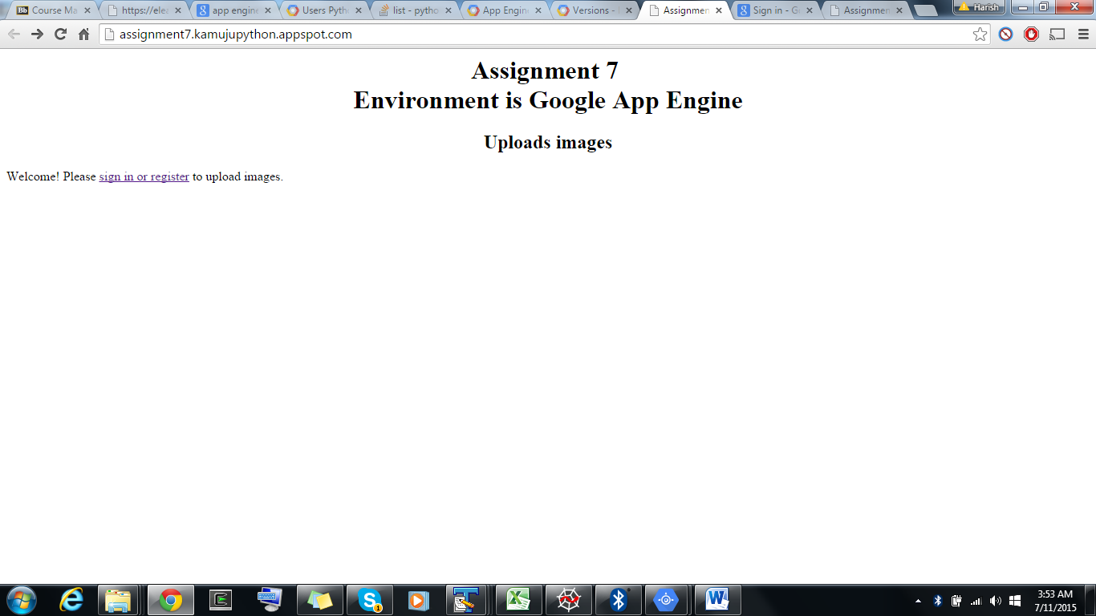

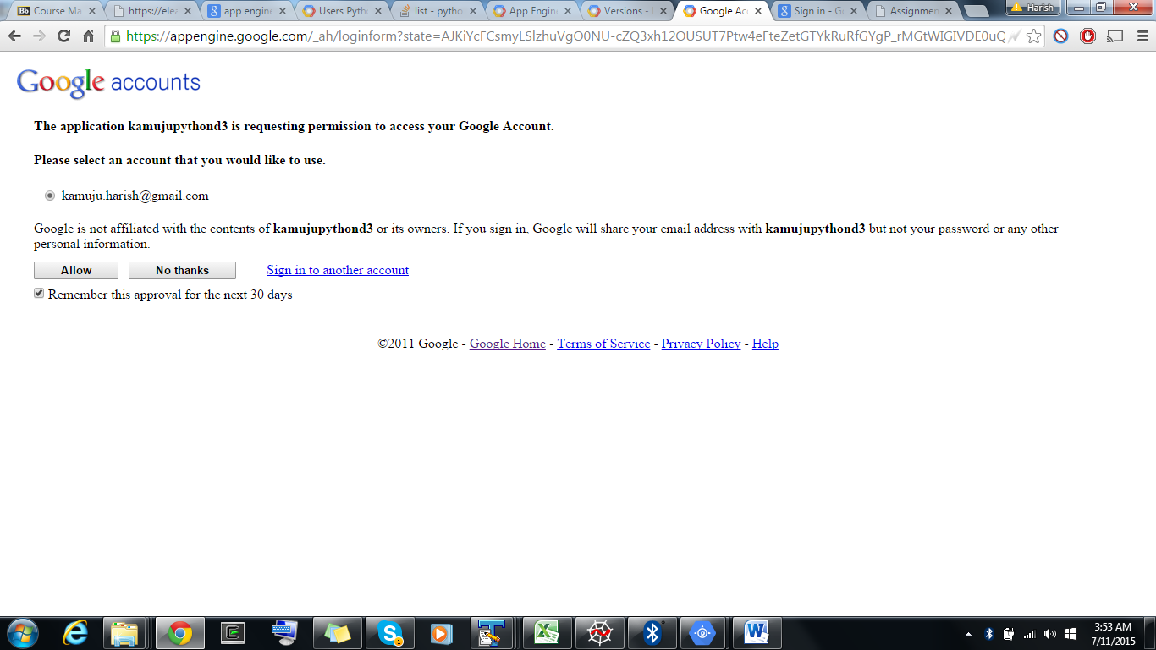

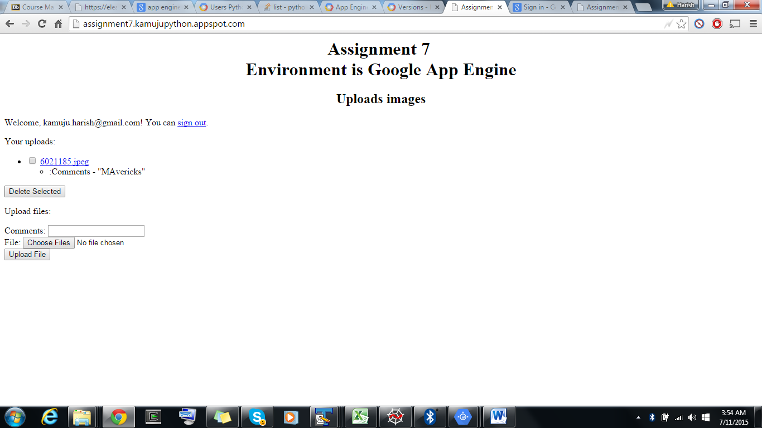

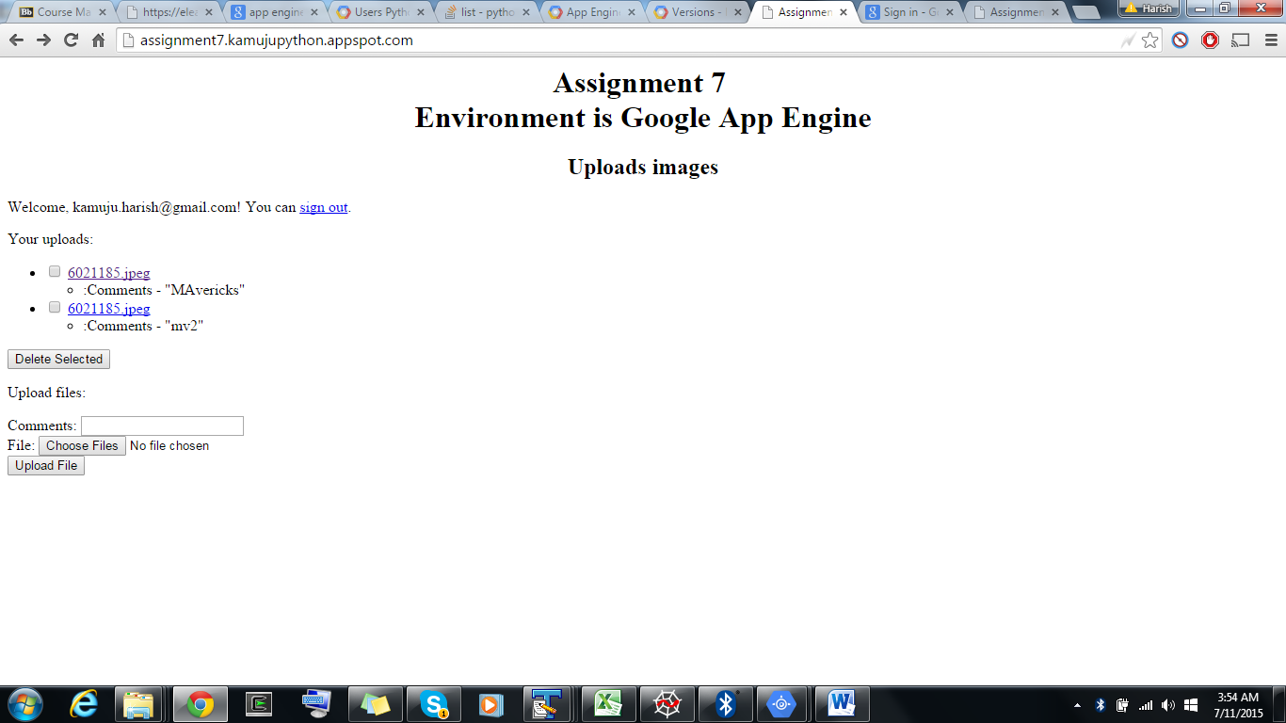

1. Page has been handled to maintain multiple users data and their image uploads.
2. Lists and deletes images uploaded by the user.
3. Additionally user can provide the comments on the image.
4. Implemented Basic scaling methods.
5. Used apaches jmeter for stress testing.
6. instance_class: B1  
   basic_scaling:  
     max_instances: 11  
     idle_timeout: 10m

References:

<https://cloud.google.com/appengine/docs/python/blobstore/>

<https://cloud.google.com/appengine/docs/python/cloud-sql/>

<https://github.com/dansanderson/pgae-examples> “examples from the book _Programming Google

App Engine_, 2nd edition, by Dan Sanderson, originally published in

October 2012.

<https://cloud.google.com/appengine/docs/python/modules/#Python_Instance_scaling_and_class>

<https://cloud.google.com/appengine/docs/python/config/appconfig#Python_app_yaml_Requiring_login_or_administrator_status>