**CSE 6331 Assignment 2, Part-3**

**Executing 2000 random queries and in 2000 limited scope**

* DBRandomQuery.py contains the implementation of 2000 Random Queries.
* The time taken for executing the 2000 Queries is secs.
* I am attaching the screenshot for reference.

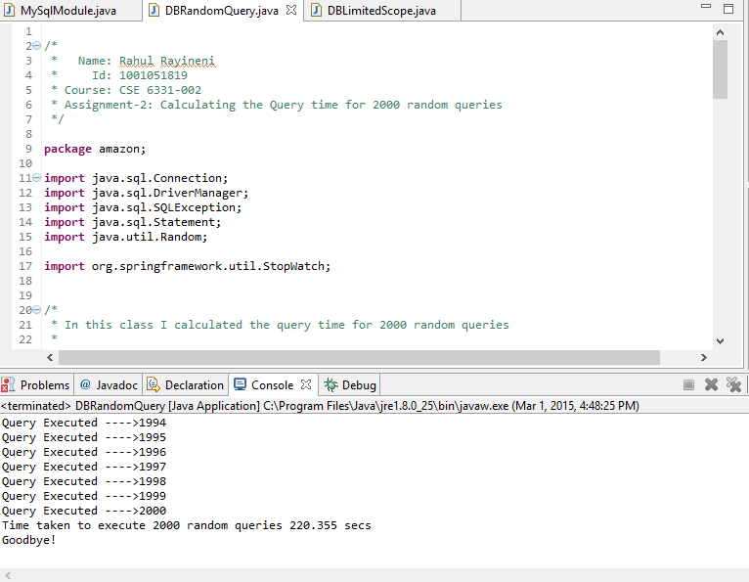

* DBLimitedScope.java contains the implementation of 2000 random queries on 2000 limited scope
* The time taken to execute the 2000 random queries on 2000 limited scope is 204.023 seconds

