# Assignment 10

Name:Harish Kamuju

UTA ID: 1001120930

1. Implemented using google app engine and python,twython for twitter streaming map.
2. Loads twitter data and based on the search keyword displays the location of the tweets on a map.
3. Used location api and tweeter streaming api
4. Store more than 100MB data in Google App Engine: DataStore
5. Accelerates the data computation via Google App Engine: Memcached
6. Retreives more than 100MB Tweet via Twitter API
7. Uses Google Heat Map API to display 100MB tweet by awesome Heat Map
8. Modified the original version of the app to handle additional data and search keywords.

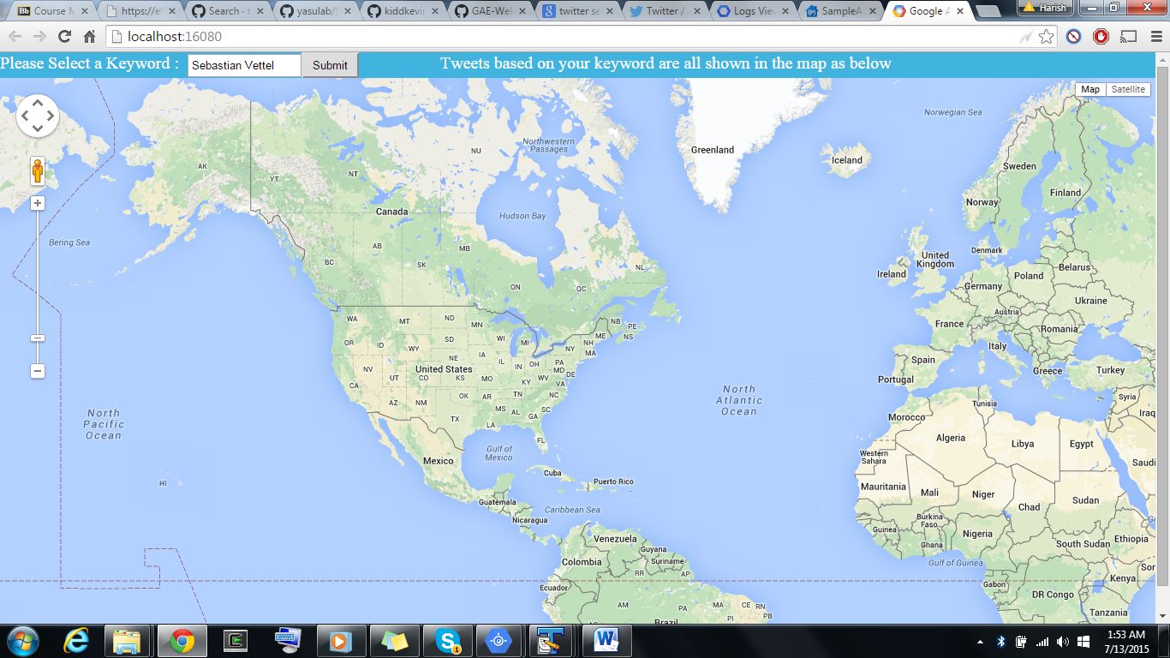

References:

<https://maps.googleapis.com/maps/api>

<https://code.google.com/p/python-twitter/>

<https://github.com/kiddkevin00>

<https://github.com/kiddkevin00/GAE-Web-Application___Tweet-Map>