# Project 3 TCP Weather Alert System Part 1

## Devan Rivera and Ashley Villegas

## 4/13/2025

## Project Description

This project implements an interactive TCP Weather Alert System Server and Client. The multi-threaded server will run indefinitely, can handle multiple clients, retain information if running, and maintains connections to clients if the port and sockets are known. Once a connection has been made, the client can login to the server, register an account, and is then given a sub menu of options to choose from. Once logged in, the client can subscribe/unsubscribe to a location, list all current subscriptions, change password, and logoff.

## System Protocols

Protocol’s Utilized:

* TCP (Transmission Control Protocol)
  + Transport Layer
* IP (Internet Protocol)
  + Transport Layer
* Custom Sever/Client Communication
  + Application Layer
* File I/O (Operating System File System Protocols)
  + Local File Access

By utilizing these protocols, we can reliably communicate and exchange requests between our Client and Server. Through these protocols we can also ensure that all requests from the Client are handled efficiently by the Server, and that the correct responses are delivered to the Client.

## Testing of HTTP Server (WSLa – UBUNTU)

Figure 1. The server accepts the client connection and allows the user to login

Figure 2. Multiple clients can be connected to the server at once

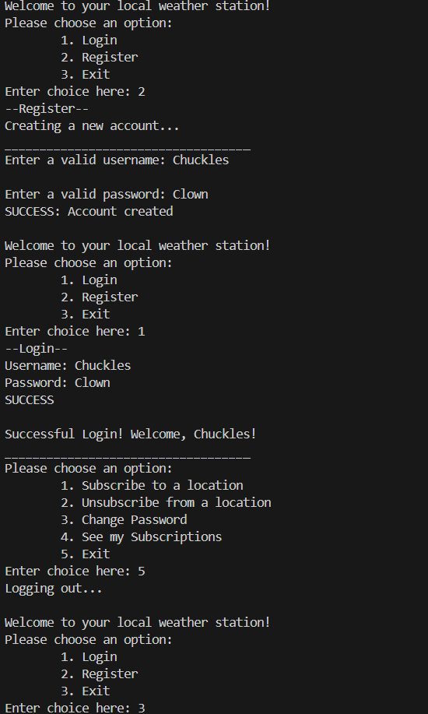

Figure 3. A client registering for an account in the program

Figure 4. The client can subscribe to multiple locations

Figure 5. The client can unsubscribe from locations as well as list current subscriptions

Figure 6. The client can change their password and re-login

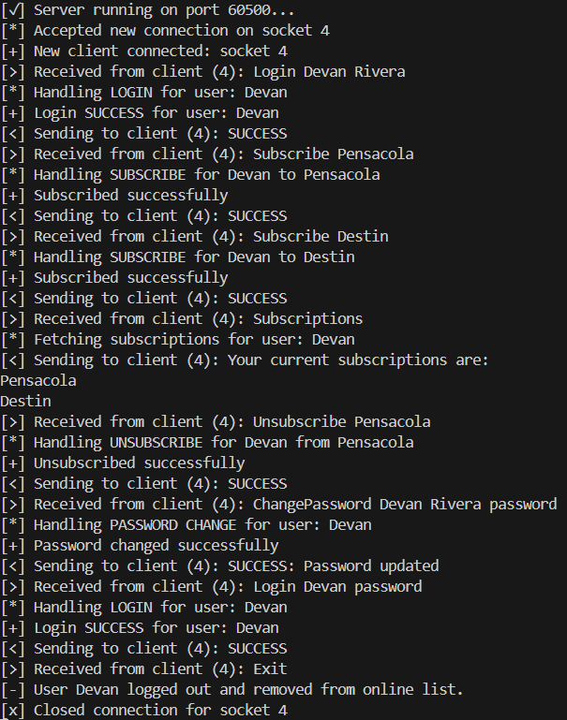

Figure 7. The server responds to all client actions appropriately

## Testing of HTTP Server (Putty)

Figure 8. The client can register an account, login, and subscribe to a location

Figure 9. The client can subscribe to multiple locations

Figure 10. The client can unsubscribe from locations

Figure 11. The client can change their password and re-login with the new password.