SMART INDIA HACKATHON 2026 | PROBLEM STATEMENT PS26073
Ministry of Earth Sciences | India Meteorological Department | Software | Disaster Management
SkyGuard
AI-based intelligent anomaly detection for Automatic Weather Stations
Project overview

1. About the project
- SkyGuard is a real-time system that checks readings coming from Automatic Weather Stations and finds the stations that are reporting wrong values.
- It uses only the three parameters the problem statement allows: temperature (°C), atmospheric pressure (hPa) and relative humidity (%).
- It separates a genuine weather event from a sensor or equipment fault, and tells the operator which one it is.
- It runs across a full network of 344 stations covering 33 states and union territories.
- It is deployed online and can be opened in any browser.

2. What the problem statement asks for
Objectives
- Detect anomalies in real-time AWS data streams.
- Identify sensor faults, spikes, frozen values and communication errors.
- Learn normal temporal and seasonal patterns.
- Perform multivariate consistency analysis among the parameters.
- Provide confidence scores and explainable AI-based reasoning.
- Predict sensor degradation and maintenance requirements.
- Optionally suggest corrected values.
Expected outputs
- Real-time anomaly alerts, severity and confidence scores, root-cause classification, visualisation dashboard, sensor health status, corrected data estimation.
Suggested technologies
- Explainable AI (SHAP / LIME), and Edge AI for low-power deployment on ESP32.

3. What we are making
- Detection engine — checks every reading from every station as it arrives and grades it.
- Three-agent decision panel — three independent checkers and one adjudicator that decide the final action.
- Explainability layer — shows how much each checker contributed to the decision, and the full list of rules that were checked.
- Live dashboard — network map, station history charts, alert list and a maintenance board.
- Edge program for ESP32 — runs the first level of checking on the station itself and sends readings to the same server.
- Weather-station data generator — builds a full network with known faults injected, so accuracy can be measured exactly.
- Documentation — a design blueprint and an as-built report covering the full method.

4. What we are doing — the approach
- Compare each station with its neighbours. Weather is shared across a region, so it cancels out in the comparison. A fault belongs to one instrument and does not cancel.
- Learn each station's own normal pattern first. Every station is compared against its own hour-by-hour history, so altitude and local climate do not create false alarms.
- Use each station's own limits. A quiet inland site and a stormy coastal site get different thresholds, calculated from their own recent behaviour.
- Confirm before alerting. An alert opens only after three bad readings in a row, and closes only after six clean readings.
- Name the fault. The alert says which type of failure it is — drift, offset, frozen value, spike or dropout.
- Recommend an action. Every alert ends in one of four outcomes: monitor, weather event, recalibrate, or inspect today.

5. The decision panel
Agent | Evidence it uses | Question it answers
Data Quality | How far the station has moved from its neighbours | Offset, drift or noise?
Hardware Health | Power, logger, link, repeated values, gaps | Is the equipment unwell?
Weather or Fault | What the neighbouring stations did at that moment | Did the region move too?

- The adjudicator checks a fixed order of rules and stops at the first one that applies.
- Hardware problems are checked first, then whether the weather explains the reading, then the size of the local deviation.
- If there is not enough evidence, the result is reported as "unknown" instead of a guess.

6. Explainability
- Each of the three agents gets a contribution value showing how much it pushed the decision, positive or negative.
- The values are calculated by testing every combination of the three agents, so they add up exactly to the final decision.
- Each agent also shows a what-if: the action the panel would have reached without that agent.
- The full rule trail is shown — every question the adjudicator asked and the answer it received.
- A second layer using a learned reference model with TreeSHAP is designed and shown as dashed boxes in the flowcharts.

7. Technology used
Layer | Technology
Backend | Python, FastAPI, single process serving API, live WebSocket and dashboard
Storage | SQLite in WAL mode
Frontend | React 19, Vite, TypeScript, Leaflet maps
Edge | ESP32 firmware in C++, TLS upload to the same server endpoint
Analysis | NumPy and Pandas for the detection pipeline
Hosting | Hugging Face Spaces (public), source on GitHub

8. Outputs delivered
Output | Where it appears
Real-time alerts | Live network map, updating as readings arrive
Severity and confidence | Watch, warning or critical, with a confidence value
Root-cause classification | Named fault type on every alert
Visualisation dashboard | Map, station charts, alert ledger, maintenance board
Sensor health status | A running health state per station and per parameter
Recommended action | Monitor, weather event, recalibrate, or inspect today

9. Current status
Component | Status
Detection engine and alert episodes | Working
Three agents, adjudicator and explanations | Working
Dashboard, map and maintenance board | Working
Data generator with injected faults | Working
ESP32 edge program | Working in hardware simulator
Learned reference model with TreeSHAP | Designed, to be built

10. Links
- Live system: huggingface.co/spaces/Dev-66/skyguard-api
- Source code: github.com/Devansh-66/skyguard

Flowcharts
The same three diagrams used in the presentation.
1. The system, end to end
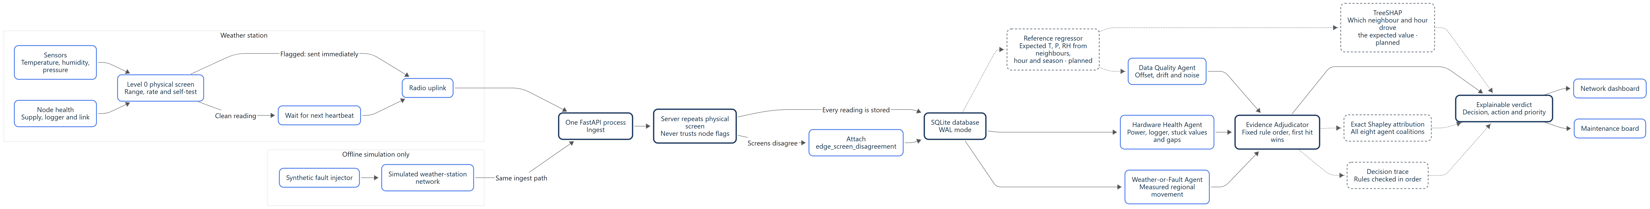
Sensor to work order: the station screen, the uplink, ingest, storage, the three agents, the adjudicator and the operator screens. Dashed boxes are planned.
2. The reasoning layer
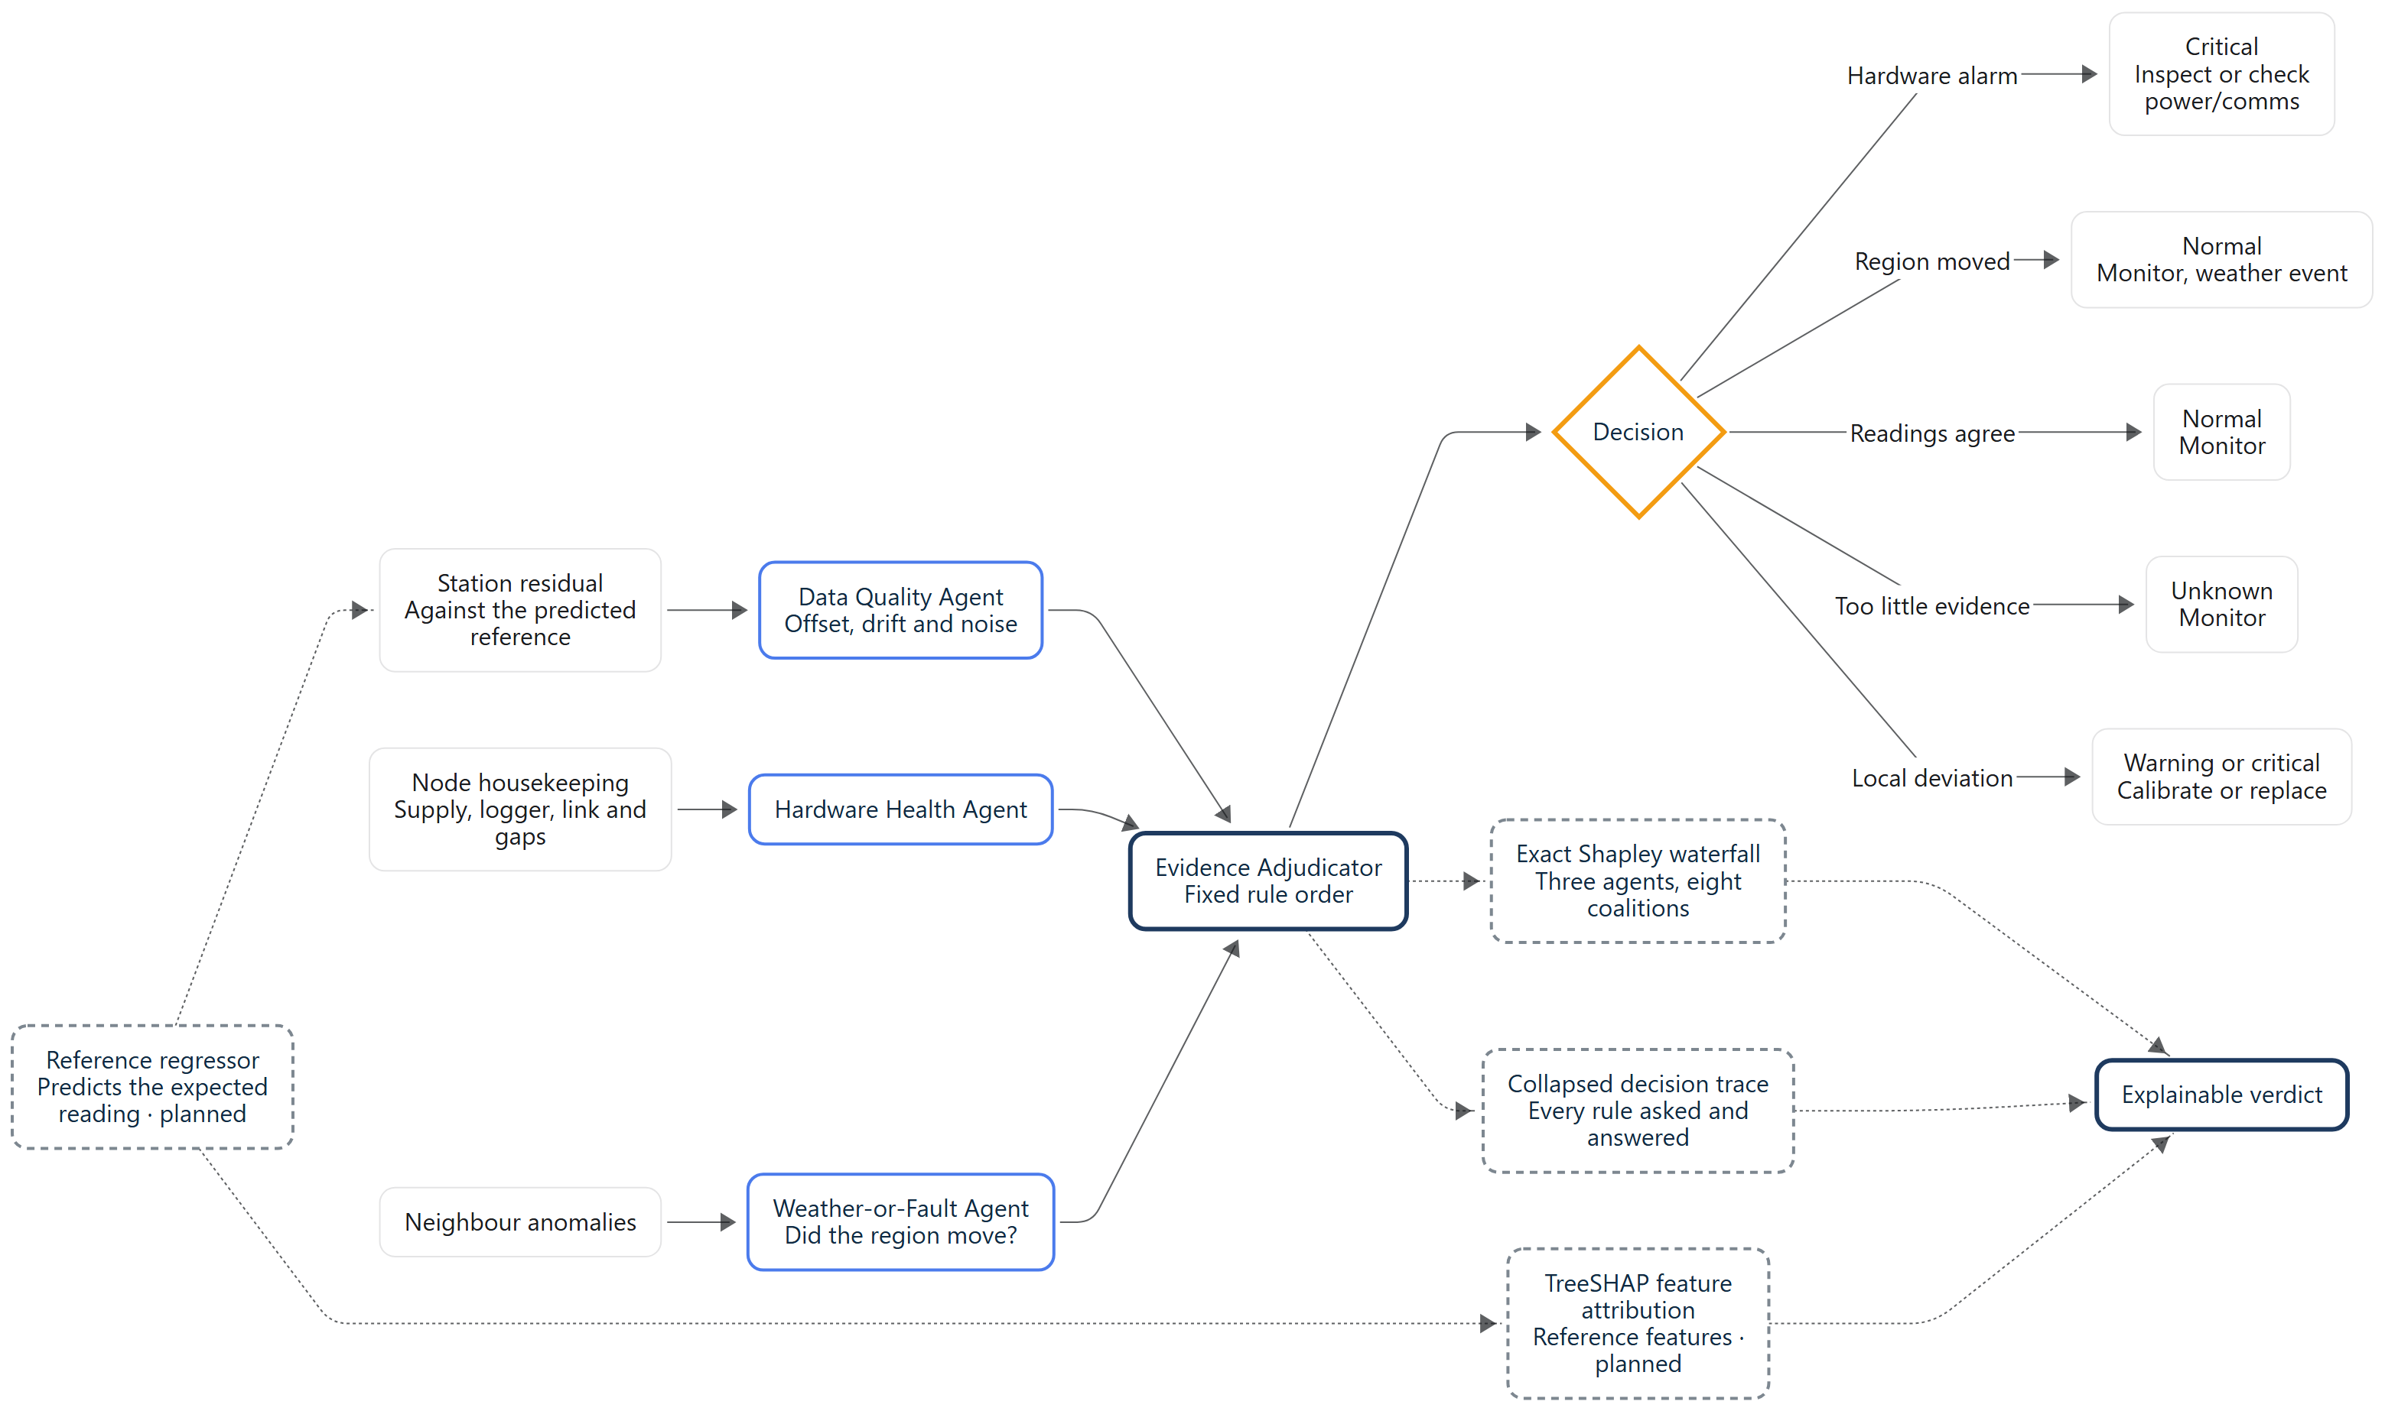
Three agents over separate evidence feed one adjudicator, which follows a fixed rule order and produces the action plus the explanation.
3. What the operator does
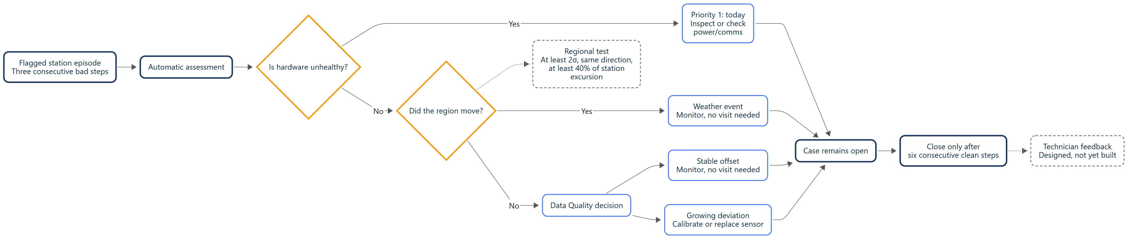
From a flagged station episode to a maintenance decision, and the condition for closing the case.

