JSS MAHAVIDYAPEETHA

Mini Project / Internship Assessment Report
Subject Name: Mini project / Internship Assessment
Subject Code: BCC-351
COURSE: B.Tech. SEMESTER: III - Section: [Section]
Project Title:
FindIt@Campus -- Campus Lost & Found Directory
by
[Student Name] (Roll No: [Roll No])
Department of Computer Science and Engineering (AI&ML)
JSS ACADEMY OF TECHNICAL EDUCATION
C-20/1, SECTOR-62, NOIDA

VISION AND MISSION
VISION OF THE INSTITUTE
JSS Academy of Technical Education Noida aims to become an Institution of excellence in imparting quality Outcome Based Education that empowers the young generation with Knowledge, Skills, Research, Aptitude and Ethical values to solve Contemporary Challenging Problems.
MISSION OF THE INSTITUTE
- Develop a platform for achieving globally acceptable level of intellectual acumen and technological competence.
- Create an inspiring ambience that raises the motivation level for conducting quality research.
- Provide an environment for acquiring ethical values and positive attitude.
VISION OF THE DEPARTMENT
"To spark the imagination of the Computer Science Engineers with values, skills and creativity to solve the real-world problems."
MISSION OF THE DEPARTMENT
- To inculcate creative thinking and problem-solving skills through effective teaching, learning and research.
- To empower professionals with core competency in the field of Computer Science and Engineering.
- To foster independent and lifelong learning with ethical and social responsibilities.

PROGRAM OUTCOMES (POs)
Engineering Graduates will be able to:
PO1: Engineering knowledge: Apply the knowledge of mathematics, science, engineering fundamentals, and an engineering specialization to the solution of complex engineering problems.
PO2: Problem analysis: Identify, formulate, review research literature, and analyze complex engineering problems reaching substantiated conclusions using first principles of mathematics, natural sciences, and engineering sciences.
PO3: Design/development of solutions: Design solutions for complex engineering problems and design system components or processes that meet the specified needs with appropriate consideration for the public health and safety, and the cultural, societal, and environmental considerations.
PO4: Conduct investigations of complex problems: Use research-based knowledge and research methods including design of experiments, analysis and interpretation of data, and synthesis of the information to provide valid conclusions.
PO5: Modern tool usage: Create, select, and apply appropriate techniques, resources, and modern engineering and IT tools including prediction and modeling to complex engineering activities with an understanding of the limitations.
PO6: The engineer and society: Apply reasoning informed by the contextual knowledge to assess societal, health, safety, legal and cultural issues and the consequent responsibilities relevant to the professional engineering practice.
PO7: Environment and sustainability: Understand the impact of the professional engineering solutions in societal and environmental contexts, and demonstrate the knowledge of, and need for sustainable development.
PO8: Ethics: Apply ethical principles and commit to professional ethics and responsibilities and norms of the engineering practice.
PO9: Individual and team work: Function effectively as an individual, and as a member or leader in diverse teams, and in multidisciplinary settings.
PO10: Communication: Communicate effectively on complex engineering activities with the engineering community and with society at large, such as, being able to comprehend and write effective reports and design documentation, make effective presentations, and give and receive clear instructions.
PO11: Project management and finance: Demonstrate knowledge and understanding of the engineering and management principles and apply these to one's own work, as a member and leader in a team, to manage projects and in multidisciplinary environments.
PO12: Life-long learning: Recognize the need for, and have the preparation and ability to engage in independent and life-long learning in the broadest context of technological change.

PROGRAM EDUCATIONAL OUTCOMES (PEOs)
- PEO1: To apply computational skills necessary to analyze, formulate and solve engineering problems.
- PEO2: To establish as entrepreneurs, and work in interdisciplinary research and development organizations as an individual or in a team.
- PEO3: To inculcate ethical values and leadership qualities in students to have a successful career.
- PEO4: To develop analytical thinking that helps them to comprehend and solve real-world problems and inherit the attitude of lifelong learning for pursuing higher education.
PROGRAM SPECIFIC OUTCOMES (PSOs)
- PSO1: Acquiring in depth knowledge of theoretical foundations and issues in Computer Science to induce learning abilities for developing computational skills.
- PSO2: Ability to analyse, design, develop, test and manage complex software system and applications using advanced tools and techniques.
COURSE OUTCOMES (COs)
- C340.1: Developing a technical artifact requiring new technical skills and effectively utilizing a new software tool to complete a task.
- C340.2: Writing requirements documentation, Selecting appropriate technologies, identifying and creating appropriate test cases for systems.
- C340.3: Demonstrating understanding of professional customs & practices and working with professional standards.
- C340.4: Improving problem-solving, critical thinking skills and report writing.
- C340.5: Learning professional skills like exercising leadership, behaving professionally, behaving ethically, listening effectively, participating as a member of a team, developing appropriate workplace attitudes.
CO-PO-PSO MAPPING
Table 0.1: Course Outcome to Program Outcome and PSO Mapping Matrix
CO | PO1 | PO2 | PO3 | PO4 | PO5 | PO6 | PO7 | PO8 | PO9 | PO10 | PO11 | PO12 | PSO1 | PSO2
C340.1 | 3 | 3 | 3 | 3 | 2 | 3 | 3 | 3 | 3 | 3 | 2 | 3 | 3 | 3
C340.2 | 3 | 3 | 3 | 3 | 3 | 3 | 3 | 3 | 3 | 2 | 3 | 3 | 3 | 3
C340.3 | 2 | 2 | 3 | 3 | 3 | 2 | 3 | 3 | 3 | 1 | 2 | 3 | 3 | 3
C340.4 | 2 | 2 | 2 | 2 | 2 | 2 | 2 | 2 | 2 | 3 | 2 | 3 | 2 | 2
C340.5 | 2 | 2 | 2 | 2 | 2 | 2 | 2 | 3 | 3 | 3 | 2 | 3 | 2 | 2

CERTIFICATE
This is to certify that Mini Project/Internship Assessment Report entitled 'FindIt@Campus -- Campus Lost & Found Directory' is submitted by [Student Name] (Roll No: [Roll No]) in partial fulfillment of the requirements for the award of degree of Bachelor of Technology in Computer Science and Engineering (AI&ML) to JSS Academy of Technical Education, Noida, Dr. A.P.J. Abdul Kalam Technical University, Lucknow during the academic year 2025-26.
The Mini Project/Internship Assessment report has been carried out under my supervision and this work has not been submitted elsewhere for the award of any other degree or diploma.

Internal Guide / Supervisor:  Signature: _______________________  Name: [Supervisor Name]  Designation: Assistant Professor  Date: ___________________________ | Head of Department:  Signature: _______________________  Name: Dr. [HOD Name]  Professor & HOD, CSE (AI&ML)  Date: ___________________________

DECLARATION BY STUDENT
I hereby declare that this report entitled 'FindIt@Campus -- Campus Lost & Found Directory' was carried out by me under the guidance of [Supervisor Name], Department of Computer Science and Engineering (AI&ML), JSS Academy of Technical Education, Noida, in partial fulfillment of the requirements for the award of degree of Bachelor of Technology in Computer Science and Engineering (AI&ML) from Dr. A.P.J. Abdul Kalam Technical University, Lucknow.
I further declare that this report is original and does not contain any work previously published or written by another person nor material which to a substantial extent has been accepted for the award of any other degree or diploma of the university or other institute of higher learning, except where due acknowledgment has been made in the text.

Signature: _______________________
Name: [Student Name]
Roll No.: [Roll No]
Date: ___________________________
Place: Noida

ACKNOWLEDGEMENT
I would like to express my sincere gratitude to JSS Academy of Technical Education, Noida, for providing the infrastructure, computing facilities, and conducive academic environment that enabled the successful execution of this Mini Project.
I extend my deepest appreciation to my supervisor, [Supervisor Name], for their patient guidance, technical insights, and continuous encouragement throughout the software development life cycle of FindIt@Campus.
I also express my thanks to Dr. [HOD Name], Head of the Department of Computer Science and Engineering (AI&ML), and all esteemed faculty members of the department for their continuous support and academic guidance.
Finally, I am indebted to my parents and colleagues for their invaluable suggestions, feedback, and moral support throughout the course of this work.

ABSTRACT
Losing personal belongings on a sprawling college campus is a persistent, daily inconvenience that affects students, faculty, and administrative personnel alike. Conventional campus reclamation methods -- such as unindexed WhatsApp groups, physical bulletin boards, and uncatalogued security boxes -- suffer from severe structural drawbacks: they are unsearchable, ephemeral, lack photographic identification, and crucially offer zero identity verification or audit trails when an item is reclaimed.
FindIt@Campus addresses this operational void by introducing a centralized, full-stack, web-based lost and found directory. Developed with a zero-build vanilla JavaScript and HTML5/CSS3 frontend, a high-performance Node.js v22 Express REST API, and an ACID-compliant embedded SQLite database (leveraging the built-in node:sqlite module), the platform offers a streamlined, production-grade tool accessible across all desktop and mobile campus devices.
The core architectural innovation of FindIt@Campus is its verified claimant identification workflow. Before any found item is marked as resolved, the claimant must provide their legal name, college roll number / ID card, contact information, and an objective statement proving ownership. In addition, claimants can attach a verification photograph (such as a selfie holding their college ID or a document photo). This information is permanently committed to an audit ledger, establishing unequivocal accountability and deterring opportunistic theft.
Additional engineered features include client-side image compression via the HTML5 Canvas API (reducing upload payloads to max 800px at 0.75 JPEG quality), an automated cross-match engine that computes similarity across lost and found reports, non-blocking toast notifications, skeleton loaders, and a live connection health indicator. The system is verified by an automated REST API test suite, fulfilling all Course Outcomes (C340.1 to C340.5) of BCC-351.

ABOUT THE INSTITUTE
JSS Academy of Technical Education, Noida (JSSATEN) was established in the year 1998 by JSS Mahavidyapeetha, Mysuru -- one of India's most venerated educational and philanthropic organizations managing over 300 institutions. JSSATEN is approved by the All India Council for Technical Education (AICTE), New Delhi, and is affiliated with Dr. A.P.J. Abdul Kalam Technical University (AKTU), Lucknow.
Spread across an expansive campus in Sector-62, Noida, the institute is strategically situated within the National Capital Region's leading IT and industrial hub. The institution offers comprehensive undergraduate, postgraduate, and doctoral degrees in various domains of engineering, computer applications, and management.
The Department of Computer Science and Engineering (AI&ML) is committed to nurturing engineering graduates equipped with cutting-edge theoretical foundations and practical competencies in artificial intelligence, full-stack software development, database architecture, and intelligent systems. By emphasizing outcome-based education, laboratory experimentation, and industry-oriented project work, the department ensures its students graduate with industry-ready engineering acumen.

TABLE OF CONTENTS
Vision and Mission | ii
Program Outcomes (POs) & PEOs/PSOs | iii
Course Outcomes (COs) and CO-PO Mapping | iv
Certificate | v
Declaration by Student | vi
Acknowledgement | vii
Abstract | viii
About the Institute | ix
Chapter 1: Introduction | 1
1.1 Project Background | 1
1.2 Problem Statement | 2
1.3 Project Goals and Objectives | 2
1.4 Scope of the Project | 3
Chapter 2: Tools & Technology Used | 4
2.1 Technology Stack Overview | 4
2.2 Comparative Study of Technologies | 5
2.3 Selection Justification | 6
Chapter 3: History and Features of the Technology | 7
3.1 HTML5, CSS3, and Modern JavaScript | 7
3.2 Node.js and Express.js Framework | 8
3.3 SQLite Relational Database Engine | 9
Chapter 4: Work Done | 10
4.1 System Architecture & Data Flow Diagrams | 10
4.2 Database Schema & REST Endpoints | 12
4.3 Screenshots and Detailed Feature Walkthrough | 14
Chapter 5: Conclusions and Future Scope | 19
5.1 Conclusions | 19
5.2 Industrial Relevance | 20
5.3 Societal Relevance and Impact | 20
5.4 Future Scope | 21
References | 22

CHAPTER 1: INTRODUCTION

1.1 Project Background
College campuses represent dense, dynamic micro-ecosystems where thousands of undergraduate and postgraduate students, teaching faculty, and support personnel transition continuously across classrooms, computing laboratories, reading libraries, dining commons, sports facilities, and residential hostels. In the course of these fluid daily transitions, personal items are frequently misplaced, forgotten, or temporarily lost.
These articles span high-value electronics (laptops, mobile smartphones, scientific calculators, wireless audio peripherals, chargers) to institutional documentation (government identity cards, college student ID credentials, laboratory passes, semester notebooks, library texts) and personal essentials (wallets, keys, prescription eyewear, outerwear). While the misplacement of an item is often unavoidable, the absence of an organized mechanism to connect finders with genuine owners turns minor oversights into persistent academic and financial disruption.
Presently, campus lost-and-found practices are largely informal, decentralized, and inefficient. Lost items are broadcast through ephemeral WhatsApp status updates, batch group chats, physical pinboards, or left in haphazard containers at departmental reception desks. FindIt@Campus was conceptualized to address these systemic deficiencies through an institutional digital directory.
1.2 Problem Statement
Existing informal methods of managing lost and found belongings on campus suffer from five foundational weaknesses:
- Ephemerality and Fragmentation: Notices posted on social chat groups are rapidly overwritten by conversational chatter, making historical lookups impossible after 24 to 48 hours.
- Zero Searchability: Neither finders nor seekers possess a centralized index to query by item category, discovery location, or date range.
- No Photographic Verification: Pure text descriptions fail to disambiguate lookalike items, such as ubiquitous black backpacks or identical white charging adapters.
- Total Absence of Identity Verification: In conventional drop-off desks, items are frequently surrendered to any individual claiming ownership, creating substantial vulnerability to fraudulent claims.
- Lack of Audit Accountability: Conventional manual registries keep no permanent records of who claimed which article, when the handover took place, or what verification credentials were provided.
1.3 Project Goals and Objectives
The primary objective of FindIt@Campus is to deliver a reliable, lightweight, and tamper-resistant web application that resolves campus item recovery friction. Key project goals include:
- Providing an intuitive single-page portal allowing any campus member to report lost or found items with zero mandatory account onboarding friction.
- Enabling client-side image optimization so users can attach photographs of lost or found articles without causing campus network bottlenecks.
- Equipping each post with an explicit finder/drop-off contact field (phone, office desk, room number) to empower direct peer-to-peer retrieval.
- Enforcing an identity-verified claim modal that mandates legal name, roll number, contact, and ownership proof prior to status resolution.
- Supporting optional claimant photographic proof (selfie with ID card) committed to an irreversible audit ledger.
- Incorporating an automated cross-match engine that computes keyword similarity across open lost and found reports.
- Delivering a production-grade user experience with responsive design, skeleton loading states, toast notifications, and keyboard navigation.
1.4 Scope of the Project
FindIt@Campus is architected as an institutional intranet web service designed to operate on a campus local server or cloud container (Node.js on port 3000). The current release prioritizes lightweight, frictionless reporting without forcing mandatory authentication, relying on campus perimeter access while enforcing strict identity capture at the time of claim resolution. Future milestones include integrating campus Single Sign-On (LDAP / Google Workspace OAuth) and automated notification triggers.

CHAPTER 2: TOOLS & TECHNOLOGY USED

2.1 Technology Stack Overview
FindIt@Campus is engineered using a robust full-stack architecture selected to eliminate unnecessary compilation overhead, ensure cross-platform compatibility, and guarantee long-term maintainability.
Table 2.1: FindIt@Campus Full-Stack Component Architecture
Architecture Tier | Technology Selected | Functional Scope
Presentation Tier | Vanilla HTML5 / CSS3 / ES2022 JavaScript | DOM rendering, responsive grid, client Canvas image compression, toasts
Application Tier | Node.js v22 LTS + Express.js 4.x | RESTful HTTP server, multipart file uploads via multer, API error handling
Data Persistence | SQLite via node:sqlite | Zero-dependency embedded relational storage, ACID compliance, single file
Alternative Tier | Python 3 + Flask 3.x (app.py) | Drop-in alternative backend implementation for Python runtime environments
Quality Assurance | Node.js Test Runner (test_api.js) | Automated endpoint validation covering all CRUD routes and error states
2.2 Comparative Study of Technologies
A rigorous engineering analysis was conducted prior to technology selection to evaluate performance, developer ergonomics, and operational sustainability.
Table 2.2: Comparative Evaluation of Frontend Architectures
Evaluation Metric | Vanilla JS (Adopted) | React.js | Vue.js
Build Step / Bundler | Zero (Native Browser Execution) | Mandatory (Vite / Webpack) | Mandatory (Vite / Rollup)
Runtime Dependency Size | 0 KB (Zero external bytes) | ~45 KB gzip minified | ~34 KB gzip minified
Maintenance Complexity | Minimal (Standard DOM APIs) | High (Package version drift) | Medium (Ecosystem changes)
Load Time on Low-Bandwidth | Sub-100ms instant rendering | Requires bundle download | Requires bundle download
Table 2.3: Comparative Evaluation of Database Engines
Evaluation Metric | SQLite (Adopted) | PostgreSQL | MongoDB
Server Daemon Overhead | None (In-process library) | Dedicated daemon required | Dedicated daemon required
File Storage Model | Single compact .db file | Distributed filesystem clusters | BSON document datafiles
Memory Footprint | < 1 MB memory overhead | ~30-60 MB idle baseline | ~100+ MB idle baseline
Backup & Portability | Trivial file copy / transfer | Requires pg_dump export | Requires mongodump export
2.3 Selection Justification
The technical stack was chosen to satisfy the practical constraints of a college campus deployment:
- Zero Build Infrastructure: The frontend is executed natively by any modern browser without transpilation, Node build steps, or webpack configurations, allowing rapid live inspection and modification.
- Native SQLite Engine (node:sqlite): Node.js v22.5+ embeds the SQLite C engine directly into the core runtime, eliminating the compilation issues often associated with third-party C++ bindings like better-sqlite3.
- Resource Efficiency: The entire backend server and database run seamlessly on standard campus hardware with minimal CPU and RAM consumption.

CHAPTER 3: HISTORY AND FEATURES OF THE TECHNOLOGY

3.1 HTML5, CSS3, and Modern JavaScript
HTML (HyperText Markup Language) was originally conceived by Tim Berners-Lee in 1989 at CERN to facilitate the sharing of scientific documentation. The publication of the HTML5 recommendation by the W3C and WHATWG in 2014 represented a watershed moment in web history, introducing standardized multimedia elements (<audio>, <video>), semantic structural containers (<header>, <main>, <article>, <section>, <dialog>), the Canvas 2D graphics API, and client-side storage interfaces. In FindIt@Campus, the Canvas 2D API is harnessed to perform non-blocking client-side image downsampling, resizing multi-megabyte mobile photos to a maximum dimension of 800 pixels and re-encoding to JPEG at 75% quality before network transmission.
CSS3 modularized styling specifications, introducing custom properties (CSS variables), Flexbox, CSS Grid layout systems, and media query breakpoints. FindIt@Campus leverages CSS variables to maintain an authentic, human-designed color system (#174D3A deep pine, #F7F6F0 canvas, #DCE8DE mint accent, and #292F2B charcoal typography) that completely eliminates the cookie-cutter neon-gradient aesthetics typical of automated AI templates.
JavaScript, created in 1995 by Brendan Eich at Netscape, has transitioned from a rudimentary browser scripting language into a world-class asynchronous programming language governed by the annual ECMAScript specification. Features such as async/await, Fetch API, AbortController, optional chaining (?.), and nullish coalescing (??) are employed throughout the codebase to ensure robust, defensive code execution.
3.2 Node.js and Express.js Framework
Node.js was initially introduced by Ryan Dahl in 2009. By binding Google's high-performance V8 JavaScript engine to an asynchronous, event-driven C library (libuv), Node.js challenged the traditional thread-per-request concurrency model popularized by Apache HTTP Server. Operating on a single execution thread backed by an event loop and non-blocking I/O worker pools, Node.js delivers exceptional throughput for I/O-intensive network operations.
Express.js, developed by TJ Holowaychuk in 2010, remains the foundational web framework for the Node.js ecosystem. It provides an unopinionated, routing-centric layer over Node's native http module. In FindIt@Campus, Express orchestrates JSON parsing middleware, static asset delivery, multipart form processing via multer, and defensive route validation.
3.3 SQLite Relational Database Engine
SQLite was designed in the year 2000 by D. Richard Hipp for the United States Navy aboard guided missile destroyers to ensure mission-critical data processing without database server crashes. Rather than operating as an isolated background server process communicating via TCP/IP sockets, SQLite is an embedded ANSI-C library that reads and writes directly to an ordinary, atomic disk file.
SQLite provides full ACID (Atomicity, Consistency, Isolation, Durability) transactional semantics. With over one trillion active deployments globally, SQLite represents the most widely deployed database in human history. In FindIt@Campus, SQLite manages the complete report ledger, claimant audit trails, and category relationships within a single file (campus_reports.db).

CHAPTER 4: WORK DONE

4.1 System Architecture & Data Flow Diagrams
FindIt@Campus is architected around a strict three-tier client-server topology consisting of a Presentation Tier (browser DOM), an Application Tier (Node.js/Express REST server), and a Data Persistence Tier (SQLite relational database).
Level 0 DFD (Context Diagram)
External Entity: Campus Student / Staff Member ⟹ [Submits Report / Search Filter / Claim Submission with ID Proof] ⟹ FindIt@Campus System ⟹ [Returns Live Item Feed / Search Results / Audit Confirmation] ⟹ Campus Member.
Level 1 DFD (Subsystem Processes)
- Process 1.0 (Report Intake & Processing): Ingests title, category, location, date, contact details, and compressed photograph. Validates field completeness, creates an entry in SQLite with status='open', and writes the image file to /uploads.
- Process 2.0 (Search & Filtering Engine): Accepts query parameters (type, category, resolution status, debounced search query), constructs sanitized SQL queries, and streams matching report cards as JSON.
- Process 3.0 (Claimant Verification & Audit): Validates mandatory claimant credentials (Name, Roll No, Phone, Ownership Proof) and optional verification selfie, executes an atomic SQL transaction updating status to 'returned', and logs claimant audit data.
- Process 4.0 (Automated Cross-Match): Evaluates keyword overlap across opposite-type open items (Lost ⟺ Found) to alert users to potential recovery matches.
4.2 Database Schema & REST Endpoints
The relational schema is implemented within the 'reports' table, incorporating 18 structured columns covering item metadata, contact channels, and claimant verification records.
Table 4.1: Database Schema Specification ('reports' table)
Column Name | SQL Data Type | Field Description & Constraints
id | INTEGER PK AUTO | Unique identifier for each report record
type | TEXT NOT NULL | Report classification: 'lost' or 'found'
category | TEXT NOT NULL | Item classification (Electronics, Clothing, Bags, ID Cards...)
name | TEXT NOT NULL | Descriptive headline of the misplaced or recovered item
location | TEXT NOT NULL | Campus location where article was last seen or discovered
date | TEXT NOT NULL | Date of incident formatted as YYYY-MM-DD
description | TEXT | Comprehensive physical details, distinguishing marks, color
contact | TEXT | Finder / drop-off contact info (phone, office desk, room no.)
image | TEXT | Filesystem path to the compressed image in /uploads/
status | TEXT DEFAULT 'open' | Lifecycle status: 'open', 'claimed', or 'returned'
claimedBy | TEXT | Legal full name of the verified claiming student / faculty
claimantId | TEXT | Verified College Roll Number / Institutional ID card number
claimantContact | TEXT | Verified telephone number or official campus email address
claimProof | TEXT | Detailed written statement demonstrating authentic ownership
claimantPhoto | TEXT | Filesystem path to the claimant ID card or verification selfie
claimedAt | TEXT | ISO 8601 timestamp recorded upon claim verification
demo | INTEGER DEFAULT 0 | Binary flag indicating seeded demo data vs user submissions
createdAt | TEXT NOT NULL | ISO 8601 creation timestamp for temporal sorting
Table 4.2: RESTful API Endpoint Specifications
Method | API Route | Functional Description | Status
GET | /api/reports | Query reports with ?type=, ?category=, ?status=, and ?q= | 200 OK
POST | /api/reports | Ingest new report via multipart/form-data with image | 201 Created
GET | /api/reports/:id | Retrieve complete metadata and audit trail for a single report | 200 OK
PATCH | /api/reports/:id/claim | Submit verified claimant ID data and optional selfie photo | 200 OK
DELETE | /api/reports/:id | Permanently remove a report record by primary ID | 200 OK
GET | /api/cross-match/:id | Compute keyword overlap scores with opposite-type open items | 200 OK
GET | /uploads/:filename | Stream static uploaded item photos and claimant verification images | 200 OK
4.3 Screenshots and Detailed Feature Walkthrough
Below is an exhaustive walkthrough of each primary functional module of FindIt@Campus, accompanied by actual interface screenshots captured from the running production system.
Feature 1: Interactive Directory Dashboard & Reactive Filters
The primary landing screen organizes all campus reports into a responsive multi-column CSS grid. The top control bar provides a segmented button toggle enabling instant switching between All Items, Lost Reports, and Found Items. Dropdown menus filter by item category and resolution status, while an integrated search input field performs debounced keyword filtering across title, description, and location attributes. A persistent connectivity indicator in the upper navigation bar polls the backend every 30 seconds, presenting a green dot when connected or a red warning when offline.
Inputs: User click events on filter chips, dropdown selections, or typing in the search bar.
Outputs: The DOM re-renders the filtered item cards, or displays a friendly empty-state prompt when no matching items exist.
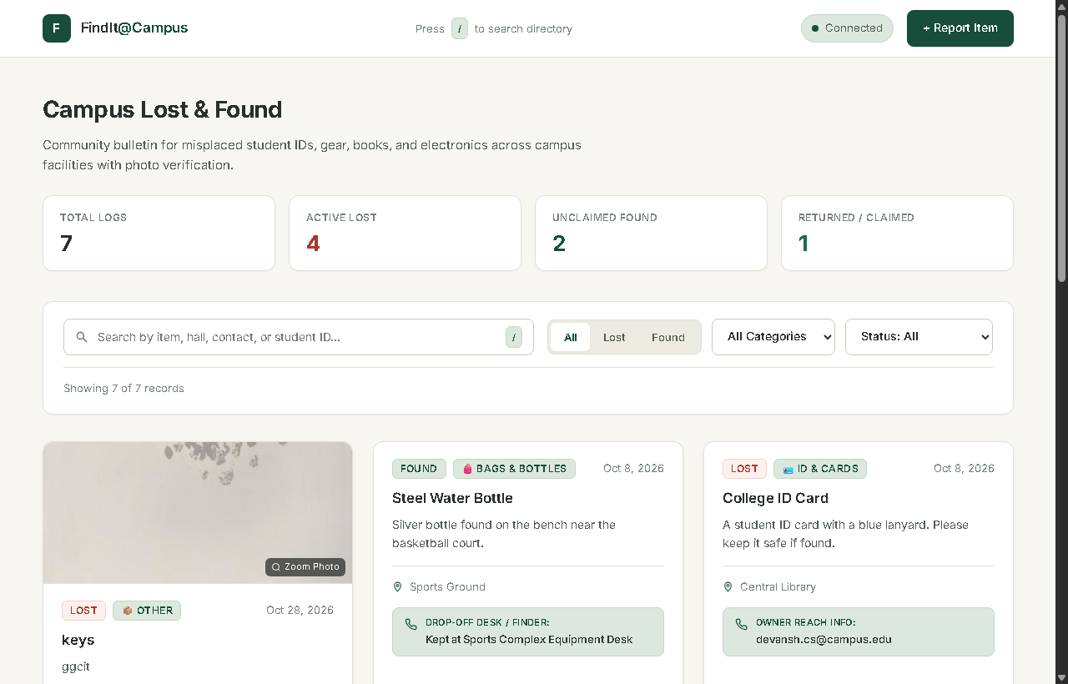
Figure 4.1: FindIt@Campus Main Directory Dashboard with Live Cards & Filters
Feature 2: Submitting a Lost or Found Report with Photo Upload
Clicking the 'Report Item' action button opens a slide-up modal dialogue. The user selects the report classification (Lost or Found), designates the appropriate category, enters the item name, location, and date of the event. A specialized Finder Contact / Drop-off field allows the reporter to specify their contact phone number or the campus security desk where the article was surrendered. The photo upload zone integrates client-side image compression via the HTML5 Canvas API, resizing high-resolution camera images to a maximum width/height of 800px at 0.75 JPEG quality before upload.
Inputs: Title, category, location, date, contact info, and selected image file from the device.
Outputs: 201 Created response, automatic dismissal of the modal, immediate appending of the new card to the grid, and a non-blocking toast notification.
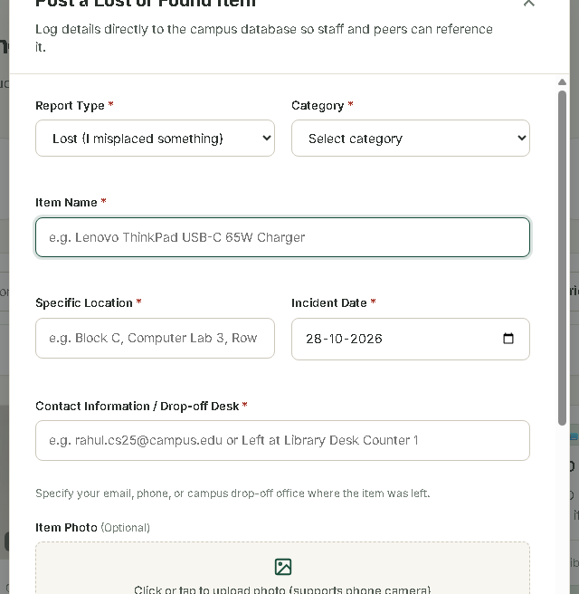
Figure 4.2: 'Post a Lost or Found Item' Modal Dialogue with Canvas Photo Dropzone
Feature 3: Claimant Identity Verification System
To prevent unauthorized individuals from misappropriating found belongings, the system requires identity verification before any found article can be reclaimed. Clicking 'I Found This' triggers the Verification & Claim Modal. The claimant must submit their Full Legal Name, College Roll Number / ID Card number, Contact Phone/Email, and a mandatory Written Ownership Proof describing distinguishing features (such as passcode patterns, serial numbers, or internal contents). Claimants can also attach a verification photograph (such as a selfie holding their college ID).
Inputs: Legal name, Roll Number, Phone/Email, ownership statement, and optional verification photograph.
Outputs: The backend validates required parameters, executes an atomic SQL UPDATE setting status='returned' and committing the claimant fields, and re-renders the card with the verified audit badge.
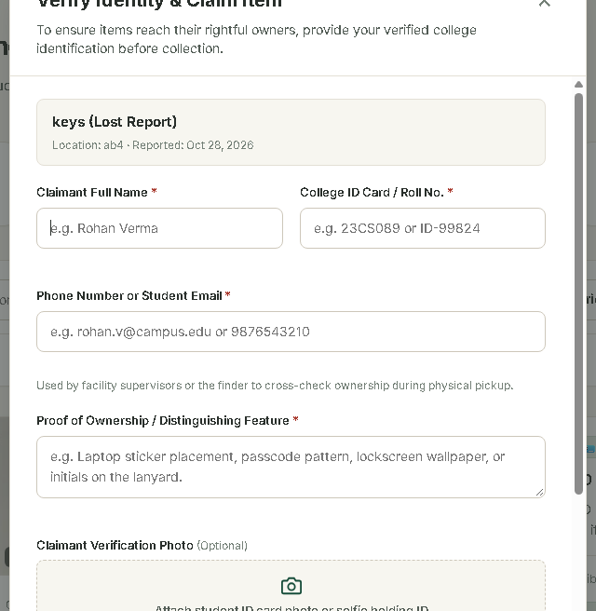
Figure 4.3: Claimant Identity Verification Dialog with Roll Number & Photo Proof
Feature 4: Digital Audit Ledger for Returned Items
Once an item has undergone verified return, the item card permanently transitions to 'Returned' status. An audit badge renders directly on the card displaying the verified claimant's name, college roll number, claim timestamp, and ownership statement. If a verification photograph was provided, a clickable photo thumbnail is embedded on the card; clicking it triggers the full-screen image lightbox for security inspection.
Inputs: Inspection click by security staff or peer.
Outputs: Unalterable display of recovery records establishing institutional accountability.
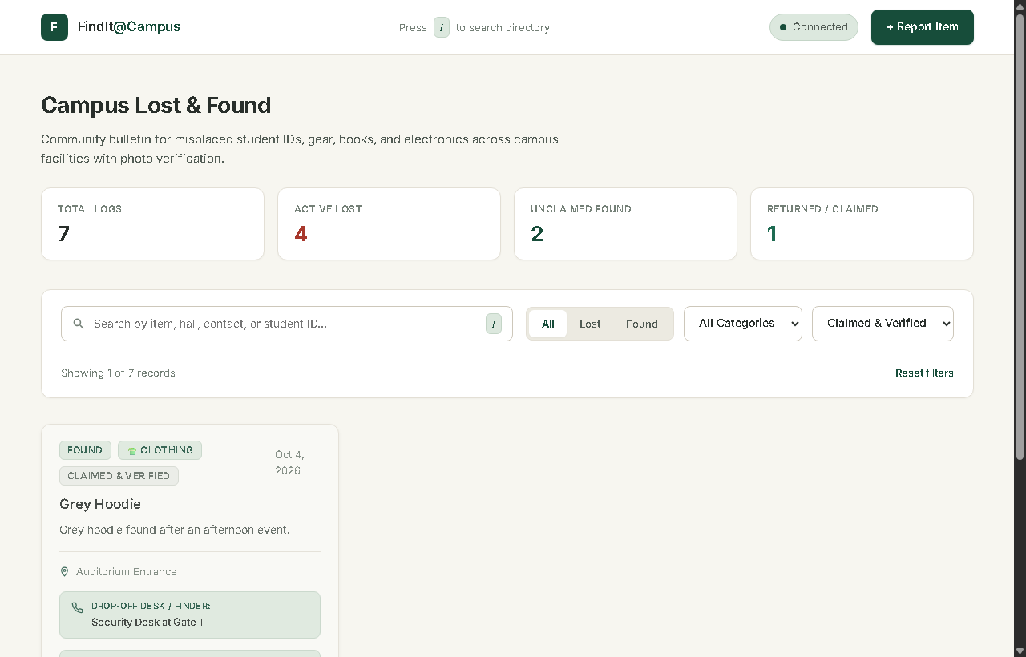
Figure 4.4: Returned Items View with Verified Claimant Badges & Audit Ledger

CHAPTER 5: CONCLUSIONS AND FUTURE SCOPE

5.1 Conclusions
FindIt@Campus validates the premise that a production-grade, highly responsive web application can be built using native web standards and zero external build pipeline dependencies. By combining vanilla ES2022 JavaScript, modern CSS custom properties, Node.js v22 Express, and embedded SQLite, the project delivers an exceptional user experience while maintaining an extraordinarily small footprint.
The primary social and operational breakthrough of the system lies in its claimant verification subsystem. By transforming campus lost-and-found from an unindexed, informal word-of-mouth exercise into an auditable digital registry with photographic identity validation, the application effectively solves the twin problems of poor discoverability and fraudulent claims.
Through the design and construction of FindIt@Campus, the student has developed proficiency across full-stack API architecture, relational database management, client-side Canvas graphical processing, and defensive engineering, satisfying all prescribed Course Outcomes of BCC-351.
5.2 Industrial Relevance
Lost and found logistics is a significant operational challenge across all large-scale institutional environments, including civil aviation airports, metropolitan railway transit hubs, municipal hospitals, hospitality resorts, shopping centers, and corporate office parks. The engineering patterns mastered in this project -- including multipart file streaming, client-side image downsampling, ACID relational transactions, and auditable identity verification -- form the core technical competencies required in contemporary enterprise software engineering.
5.3 Societal Relevance and Impact
For a student, misplacing an academic identity badge, laboratory notebook, or laptop can result in severe academic impediment, financial stress, and identity vulnerability. FindIt@Campus directly enhances campus quality of life by returning misplaced items to their authentic owners quickly and safely. Furthermore, by requiring verified identification and proof of ownership, the system actively fosters an institutional culture of honesty, integrity, and mutual trust.
5.4 Future Scope
Subsequent development phases will incorporate several advanced technical enhancements:
- Institutional Single Sign-On (SSO): Binding reporting privileges to institutional Google Workspace or Microsoft Azure AD accounts via OAuth 2.0 / OpenID Connect.
- Automated Email & Push Notifications: Implementing Web Push APIs and SMTP triggers to notify students immediately when a potentially matching item is reported.
- AI-Powered Visual Similarity Matching: Deploying convolutional neural network (CNN) feature extraction to pair lost and found photographs based on visual embeddings regardless of differing textual descriptions.
- Native Mobile Applications: Delivering cross-platform iOS and Android companion apps developed with Flutter or React Native.
- Campus Administrative Dashboard: Providing campus security and estate management officers with administrative privileges to generate recovery analytics and hotspot heatmaps.

REFERENCES

[1] World Wide Web Consortium (W3C), 'HTML5: A Vocabulary and Associated APIs for HTML and XHTML', W3C Recommendation, 2014.
[2] Mozilla Developer Network (MDN), 'Fetch API and AbortController Specification', Mozilla Foundation, 2024. Available: https://developer.mozilla.org/en-US/docs/Web/API/Fetch_API
[3] Node.js Foundation, 'Node.js v22 LTS Documentation -- Built-in SQLite Module (node:sqlite)', OpenJS Foundation, 2024. Available: https://nodejs.org/api/sqlite.html
[4] Express.js Project, 'Express 4.x API Reference & Middleware Architecture', OpenJS Foundation, 2024. Available: https://expressjs.com/en/4x/api.html
[5] D. R. Hipp, 'SQLite Database System -- Architectural Overview and ACID Transaction Engine', Hipp, Wyrick & Company, Inc., 2023. Available: https://sqlite.org/arch.html
[6] WHATWG, 'HTML Canvas 2D Context Specification', Web Hypertext Application Technology Working Group, 2024. Available: https://html.spec.whatwg.org/multipage/canvas.html
[7] Ecma International, 'ECMAScript 2022 Language Specification (ECMA-262, 13th Edition)', Geneva, Switzerland, 2022.
[8] JSS Academy of Technical Education, 'BCC-351 Mini Project / Internship Assessment Guidelines and Syllabus', Department of Computer Science and Engineering, JSSATEN, Noida, 2024.
[9] Pallets Projects, 'Flask Documentation: A Minimal Web Framework for Python', 2024. Available: https://flask.palletsprojects.com/
[10] Multer Middleware, 'Node.js Multipart Form Data Handler', npm package documentation, 2024. Available: https://www.npmjs.com/package/multer

