JSS MAHAVIDYAPEETHA
JSS ACADEMY OF TECHNICAL EDUCATION
C-20/1, Sector-62, Noida

Mini Project Assessment Report
Subject Name: Mini Project / Internship Assessment
Subject Code: BCC-351

Project Title:
FindIt@Campus -- Campus Lost & Found Directory

Submitted by:
Student Name | [Your Full Name]
Roll No. | [Your Roll Number]
Section | [Your Section]

Department of Computer Science and Engineering (AI & ML)
COURSE: B.Tech. | SEMESTER: III
Academic Year: 2025-26

VISION AND MISSION

Vision of the Institute
JSS Academy of Technical Education, Noida aims to become an Institution of excellence in imparting quality Outcome Based Education that empowers the young generation with Knowledge, Skills, Research, Aptitude and Ethical values to solve Contemporary Challenging Problems.
Mission of the Institute
- Develop a platform for achieving globally acceptable level of intellectual acumen and technological competence.
- Create an inspiring ambience that raises the motivation level for conducting quality research.
- Provide an environment for acquiring ethical values and positive attitude.
Vision of the Department
To spark the imagination of the Computer Science Engineers with values, skills and creativity to solve the real-world problems.
Mission of the Department
- To inculcate creative thinking and problem-solving skills through effective teaching, learning and research.
- To empower professionals with core competency in the field of Computer Science and Engineering.
- To foster independent and lifelong learning with ethical and social responsibilities.

PROGRAM OUTCOMES (POs)

PO1 - Engineering Knowledge: Apply the knowledge of mathematics, science, engineering fundamentals, and an engineering specialization to the solution of complex engineering problems.
PO2 - Problem Analysis: Identify, formulate, review research literature, and analyze complex engineering problems reaching substantiated conclusions using first principles.
PO3 - Design/Development of Solutions: Design solutions for complex engineering problems that meet specified needs with appropriate consideration for public health and safety, societal, and environmental considerations.
PO4 - Conduct Investigations of Complex Problems: Use research-based knowledge and research methods including design of experiments, analysis and interpretation of data to provide valid conclusions.
PO5 - Modern Tool Usage: Create, select, and apply appropriate techniques, resources, and modern engineering and IT tools to complex engineering activities with an understanding of their limitations.
PO6 - The Engineer and Society: Apply reasoning informed by contextual knowledge to assess societal, health, safety, legal and cultural issues relevant to professional engineering practice.
PO7 - Environment and Sustainability: Understand the impact of professional engineering solutions in societal and environmental contexts, and demonstrate the knowledge of and need for sustainable development.
PO8 - Ethics: Apply ethical principles and commit to professional ethics, responsibilities and norms of the engineering practice.
PO9 - Individual and Team Work: Function effectively as an individual, and as a member or leader in diverse teams and in multidisciplinary settings.
PO10 - Communication: Communicate effectively on complex engineering activities with the engineering community and with society at large.
PO11 - Project Management and Finance: Demonstrate knowledge and understanding of engineering and management principles and apply these to manage projects in multidisciplinary environments.
PO12 - Life-Long Learning: Recognize the need for, and have the preparation and ability to engage in independent and life-long learning in the broadest context of technological change.

PROGRAM EDUCATIONAL OUTCOMES (PEOs)
- PEO1: To apply computational skills necessary to analyze, formulate and solve engineering problems.
- PEO2: To establish as entrepreneurs, and work in interdisciplinary research and development organizations as an individual or in a team.
- PEO3: To inculcate ethical values and leadership qualities in students to have a successful career.
- PEO4: To develop analytical thinking that helps them comprehend and solve real-world problems and inherit the attitude of lifelong learning.
PROGRAM SPECIFIC OUTCOMES (PSOs)
- PSO1: Acquiring in-depth knowledge of theoretical foundations and issues in Computer Science to induce learning abilities for developing computational skills.
- PSO2: Ability to analyse, design, develop, test and manage complex software systems and applications using advanced tools and techniques.
COURSE OUTCOMES (COs)
C340.1: Developing a technical artifact requiring new technical skills and effectively utilizing a new software tool to complete a task.
C340.2: Writing requirements documentation, selecting appropriate technologies, identifying and creating appropriate test cases for systems.
C340.3: Demonstrating understanding of professional customs and practices and working with professional standards.
C340.4: Improving problem-solving, critical thinking skills and report writing.
C340.5: Learning professional skills like exercising leadership, behaving professionally, behaving ethically, listening effectively, participating as a member of a team.

CERTIFICATE

This is to certify that the Mini Project report entitled 'FindIt@Campus - Campus Lost & Found Directory' is submitted by [Student Name] (Roll No: [Roll No.]) of B.Tech. III Semester, Department of Computer Science and Engineering (AI & ML), JSS Academy of Technical Education, Noida, in partial fulfilment of the requirements for the award of the degree of Bachelor of Technology.
The project was carried out under the guidance of the faculty and is an original work. It has not been submitted elsewhere for the award of any other degree or diploma.

Faculty Guide | Head of Department
Signature: _________________________ | Signature: _________________________
Date: ___________________ | Date: ___________________

DECLARATION BY STUDENT

I, [Student Name], student of B.Tech. III Semester (Section: [Section]), Roll No. [Roll No.], Department of Computer Science and Engineering (AI & ML), JSS Academy of Technical Education, Noida, hereby declare that the Mini Project report titled 'FindIt@Campus - Campus Lost & Found Directory' is an original work carried out by me under the guidance of [Faculty Guide Name].
The work presented in this report has not been submitted, either fully or in part, to any other university or institution for the award of any degree, diploma, or other similar title.

Place: Noida
Date: _________________

Student Signature: _________________________
[Student Name] | Roll No: [Roll No.]

ACKNOWLEDGEMENT

I would like to express my sincere gratitude to all those who provided me with the opportunity to complete this mini project. First and foremost, I am deeply thankful to JSS Academy of Technical Education, Noida, for providing an excellent environment that fosters learning and innovation.
I extend my heartfelt thanks to my faculty guide, [Faculty Guide Name], for their invaluable guidance, constant encouragement, and constructive feedback throughout the development of this project. Their insights into both software development practices and academic standards were instrumental in shaping this work.
I also thank the Head of the Department, Dr. [HOD Name], and all faculty members of the Department of Computer Science and Engineering (AI & ML) for their continued support and motivation.
Finally, I am grateful to my family and peers for their encouragement and moral support during the course of this project.

[Student Name]
Roll No: [Roll No.] | Section: [Section]
B.Tech. III Semester -- CSE (AI & ML)

ABSTRACT

Lost items on a college campus create significant daily friction for students, faculty, and administrative staff. Existing approaches -- notice boards, WhatsApp groups, and informal word-of-mouth -- suffer from poor discoverability, no structured record-keeping, and no accountability mechanism for item recovery.
FindIt@Campus is a full-stack web application that serves as a centralised campus lost and found directory. Built with a vanilla HTML/CSS/JavaScript frontend and a Node.js Express backend with an SQLite database, the system allows any campus member to report lost or found items, attach photographs, filter records by category and status, and track the lifecycle of each report from open to returned.
The platform introduces a verified claimant identity system: before a found item is handed over, the claimant must submit their full name, college ID / roll number, contact number, and a written proof of ownership. Claimants may additionally upload a photograph (selfie with ID or an ID card image) to complete the digital audit trail. This prevents wrongful claims and creates an auditable record of every item recovery.
Key features include image uploads with client-side compression, a cross-match engine to surface potential lost-found pairs, skeleton loaders, toast notifications, keyboard shortcuts, and a real-time connection status indicator. The system seeds six demo records on first launch and exposes a clean REST API. All API endpoints are covered by an automated test suite.
The project demonstrates the practical application of full-stack web development -- REST API design, relational database management, client-side image processing, and UX engineering -- skills directly mapped to the course outcomes of BCC-351.

ABOUT JSS ACADEMY OF TECHNICAL EDUCATION, NOIDA

JSS Academy of Technical Education, Noida (JSSATEN) is a premier institution established under JSS Mahavidyapeetha, Mysuru -- one of the largest philanthropic organisations in India running over 300 educational institutions. JSSATEN is affiliated to Dr. A.P.J. Abdul Kalam Technical University (AKTU), Lucknow, and approved by the All India Council for Technical Education (AICTE), New Delhi.
Situated at C-20/1, Sector-62, Noida, Uttar Pradesh, the institution offers undergraduate, postgraduate, and doctoral programmes across engineering, management, and computer applications. The campus is equipped with state-of-the-art laboratories, a central library, high-speed internet connectivity, and dedicated innovation and research centres.
The Department of Computer Science and Engineering (AI & ML) prepares students for careers in artificial intelligence, machine learning, data engineering, and full-stack development. The department emphasises hands-on project work, industry collaboration, and outcome-based education to ensure graduates are industry-ready.

TABLE OF CONTENTS

1. Introduction | --
1.1 Project Background | --
1.2 Problem Statement | --
1.3 Project Goals and Objectives | --
1.4 Scope of the Project | --
2. Tools & Technology Used | --
2.1 Technology Stack Overview | --
2.2 Comparative Study of Technologies | --
2.3 Why This Stack Was Chosen | --
3. History and Features of the Technology | --
3.1 HTML5, CSS3, and JavaScript | --
3.2 Node.js and Express.js | --
3.3 SQLite | --
3.4 Python / Flask (Alternative Backend) | --
4. Work Done | --
4.1 System Architecture | --
4.2 Database Schema | --
4.3 API Endpoints | --
4.4 Module Descriptions | --
4.5 Use Case Diagram | --
4.6 Data Flow Diagram (DFD) | --
4.7 Features and Screenshots | --
5. Conclusions and Future Scope | --
5.1 Conclusions | --
5.2 Industrial Relevance | --
5.3 Societal Relevance and Impact | --
5.4 Future Scope | --
References | --
Appendices | --

CHAPTER 1: INTRODUCTION

1.1 Project Background
Campus environments are bustling places where students, faculty, and staff move across multiple buildings, labs, canteens, and sports facilities every day. Misplacing personal belongings -- water bottles, chargers, wallets, ID cards, books, bags, earphones, laptops -- is a routine occurrence. The challenge is not merely losing an item but failing to find it once it is in someone else's hands.
At most colleges the solution is informal: a WhatsApp group message, a notice on a bulletin board, or a lost-and-found box at the security desk. These solutions share common shortcomings: they are ephemeral, unsearchable, unstructured, and offer no accountability when an item is claimed. There is no way to verify that the person picking up a found item is its rightful owner, and no permanent record is kept.
FindIt@Campus was conceived to solve exactly this problem -- a structured, searchable, photo-enabled, and identity-verified campus lost and found registry accessible from any browser.
1.2 Problem Statement
Campus members currently have no reliable, centralised mechanism to report, discover, or reclaim lost belongings. Existing approaches lack:
- Persistent, searchable records of lost and found items.
- Photograph support to visually identify items.
- Identity verification before handing over found items to claimants.
- A digital audit trail of every item recovery.
- Cross-matching between lost reports and found reports.
The absence of such a system results in genuine owners not recovering their belongings, and found items going unclaimed or being misappropriated.
1.3 Project Goals and Objectives
- Build a web-based directory where any campus member can post a lost or found item report with a photo.
- Implement a search-and-filter system by category, status (lost/found/returned), and keyword.
- Add a contact field on each report so the reporter can be reached directly.
- Implement a claimant identity verification modal requiring Full Name, College ID/Roll No., Contact Number, and Ownership Proof before marking an item as returned.
- Allow an optional claimant photograph upload to create a photographic audit trail.
- Surface a cross-match feature that automatically finds potential lost-found pairs.
- Provide skeleton loaders, toast notifications, and keyboard shortcuts for a polished UX.
- Expose a clean REST API with automated test coverage.
1.4 Scope of the Project
FindIt@Campus is scoped as a single-campus intranet application. It does not require user authentication in the current version, trusting the campus network boundary for access control. The system is designed to run as a local server (Node.js on port 3000) on a campus server and be accessed from any browser on the campus network. Extending to multi-campus or public internet deployment with user authentication is a planned future scope item.

CHAPTER 2: TOOLS & TECHNOLOGY USED

2.1 Technology Stack Overview
FindIt@Campus is built as a full-stack web application. The stack was chosen to minimise deployment complexity while maximising development speed and reliability:
Layer | Technology | Purpose
Frontend | HTML5 / CSS3 / Vanilla JS | UI, form handling, client-side image compression
Backend | Node.js v22 + Express.js | REST API server, file upload, business logic
Database | SQLite (node:sqlite built-in) | Persistent storage, zero external dependencies
Alt. Backend | Python 3 + Flask | Alternative server implementation
Testing | Node.js test runner (test_api.js) | Automated API endpoint validation

2.2 Comparative Study of Technologies
Criterion | Vanilla JS | React.js | Vue.js
Learning curve | Low | High | Medium
Bundle size | Zero | ~45 KB | ~34 KB
Build step required | No | Yes | Yes
Suitable for MVP | Yes | Medium | Yes

Criterion | SQLite | PostgreSQL | MongoDB
Setup complexity | None (file-based) | Medium (server) | Medium (server)
Suitable for single-server | Yes | Yes | Yes
Requires external process | No | Yes | Yes

2.3 Why This Stack Was Chosen
- Zero build pipeline -- no Webpack, Babel, or npm scripts needed. The frontend is a single HTML file with inline script, instantly deployable.
- Node.js built-in SQLite (node:sqlite) -- available since Node 22.5+, eliminates the need for a separate database server or ORM.
- SQLite's file-based nature -- the entire database is a single .db file, making backups and migrations trivial.
- Vanilla JavaScript -- avoids framework lock-in for a project at this scope; every student can read and extend the code without framework knowledge.
- Express.js -- minimal, well-documented, and the industry standard for Node.js REST APIs.

CHAPTER 3: HISTORY AND FEATURES OF THE TECHNOLOGY

3.1 HTML5, CSS3 and JavaScript
HTML (HyperText Markup Language) was first proposed by Tim Berners-Lee in 1989 as the language of the World Wide Web. HTML5, standardised by the W3C and WHATWG in 2014, introduced semantic elements (<article>, <section>, <nav>), the File API, Canvas, LocalStorage, and the Drag and Drop API -- all of which underpin modern web applications.
CSS3 (2011 onwards) introduced modules including Flexbox, Grid, custom properties (CSS variables), transitions, and media queries that enable responsive, maintainable stylesheets without JavaScript. FindIt@Campus uses CSS custom properties extensively for its design token system (#174D3A primary, #F7F6F0 background).
JavaScript, created by Brendan Eich at Netscape in 1995, evolved through ECMAScript standardisation. Modern ES2020+ features -- optional chaining (?.), nullish coalescing (??), async/await, Fetch API, FormData, and AbortController -- are used throughout the project for clean, readable async code.
3.2 Node.js and Express.js
Node.js was released by Ryan Dahl in 2009, bringing JavaScript to the server side using Google's V8 engine with an event-driven, non-blocking I/O model. It is now the runtime powering many large-scale production services. Node.js's npm ecosystem has over 2 million packages.
Express.js (2010) is a minimal and unopinionated web application framework for Node.js. It provides routing, middleware, and HTTP utilities without imposing a project structure. The project uses Express to define REST routes, handle multipart form data (via multer for file uploads), serve static files, and manage CORS.
Node 22.5+ introduces node:sqlite, a built-in module providing synchronous SQLite access. This project uses this module directly, eliminating the widely-used better-sqlite3 third-party package dependency.
3.3 SQLite
SQLite was created by D. Richard Hipp in 2000. It is a self-contained, serverless, zero-configuration, transactional SQL database engine. Unlike client-server databases (PostgreSQL, MySQL), SQLite reads and writes directly to an ordinary disk file. It is the most widely deployed database engine in the world -- embedded in every Android and iOS device, every Chrome and Firefox browser, and countless desktop applications.
In FindIt@Campus, the SQLite database (campus_reports.db) stores all report records including item metadata, photo paths, claimant identity information, and audit timestamps. The database is initialised automatically on first server start and seeded with six demo records.
3.4 Python and Flask (Alternative Backend)
Python (1991, Guido van Rossum) is a high-level, interpreted language known for its readability and extensive standard library. Flask (2010, Armin Ronacher) is a micro web framework for Python, modelled after Sinatra (Ruby). The project includes app.py -- a Flask implementation of the same REST API -- allowing teams with a Python preference to run the backend without Node.js.

CHAPTER 4: WORK DONE

4.1 System Architecture
FindIt@Campus follows a three-tier architecture:
- Presentation Tier -- index.html, style.css, script.js served as static files by Express. All UI rendering is client-side DOM manipulation.
- Application Tier -- server.js (Node.js / Express) exposes a REST API, handles file upload to the /uploads directory, and interfaces with the database layer.
- Data Tier -- SQLite database (campus_reports.db) storing all report and claimant data.
Communication between the frontend and backend is via JSON-based HTTP REST calls using the browser Fetch API with AbortController for timeout handling.
4.2 Database Schema
The primary table is 'reports' with the following columns:
Column | Type | Description
id | INTEGER PK | Auto-increment primary key
type | TEXT | 'lost' or 'found'
category | TEXT | Electronics, Clothing, ID Cards, etc.
name | TEXT | Item name / description
location | TEXT | Where lost or found
date | TEXT | Date of loss or discovery
description | TEXT | Detailed description
contact | TEXT | Reporter contact / drop-off info
image | TEXT | File path to item photo
status | TEXT | 'open', 'claimed', 'returned'
claimedBy | TEXT | Claimant full name
claimantId | TEXT | Claimant college ID / roll no.
claimantContact | TEXT | Claimant phone / email
claimProof | TEXT | Ownership proof description
claimantPhoto | TEXT | File path to claimant photo
claimedAt | TEXT | ISO timestamp of claim
demo | INTEGER | 1 if seeded demo record
createdAt | TEXT | ISO timestamp of creation

4.3 REST API Endpoints
Method | Endpoint | Description | Auth
GET | /api/reports | List all reports (supports ?type=, ?category=, ?status=, ?q= filters) | None
POST | /api/reports | Create a new report (multipart/form-data, supports image upload) | None
GET | /api/reports/:id | Fetch a single report by ID | None
PATCH | /api/reports/:id/claim | Submit a claim (multipart/form-data, supports claimantPhoto) | None
DELETE | /api/reports/:id | Delete a report | None
GET | /api/cross-match/:id | Return potential matches for a given report (lost↔found pairing) | None
GET | /uploads/:filename | Serve uploaded item/claimant photos | None

4.4 Module Descriptions
Report Listing Module: Fetches all reports from the API and renders them as cards in the main grid. Supports real-time filtering by type (Lost/Found), category (Electronics, Clothing, Documents, etc.), status (Open, Claimed, Returned), and a full-text keyword search. Implements skeleton loaders while fetching.
Report Creation Module: A modal-based form allowing users to post a new lost or found item. Fields include: Type, Category, Item Name, Location, Date, Description, Contact / Drop-off info, and an optional photo upload. The photo is compressed client-side using the HTML5 Canvas API before upload (max 800px, JPEG 0.75 quality).
Claimant Verification Module: A secondary modal triggered when a user clicks 'I Found This' on a found item card. Requires Full Name, College ID / Roll No., Contact Number, and a brief ownership proof. An optional photo upload allows the claimant to attach a selfie-with-ID. The form data is POSTed to /api/reports/:id/claim and permanently saved to the audit ledger.
Cross-Match Engine: The /api/cross-match/:id endpoint scores all opposite-type open reports against the target report using keyword intersection on name, description, category, and location fields. Matches above a relevance threshold are returned as a ranked list. The frontend surfaces these matches in a modal.
Image Lightbox: Full-screen image viewer triggered by clicking any item photo. Supports keyboard dismissal (Escape) and click-outside-to-close.
Toast Notification System: A queue-based toast manager renders non-blocking status messages in the bottom-right corner. Messages auto-dismiss after 4 seconds. Used for success confirmations, network errors, and validation feedback.
Connection Status Indicator: A persistent dot in the top navigation bar shows real-time connectivity status (green = connected, red = offline). It polls the API health endpoint every 30 seconds.
4.5 Use Case Diagram (Textual Representation)
Actors: Campus Member (reporter / claimant), System
Use Case | Name | Actor | Description
UC-01 | Post Lost Item | Campus Member | Member fills form and submits; system creates report with status='open'.
UC-02 | Post Found Item | Campus Member | Member fills form and submits; system creates report with status='open'.
UC-03 | Browse/Search Reports | Campus Member | Member filters by type, category, status, keyword; system returns matching records.
UC-04 | Claim Found Item | Campus Member | Member submits identity + proof; system saves audit record, updates status='returned'.
UC-05 | View Item Photo | Campus Member | Member clicks thumbnail; system opens full-screen lightbox.
UC-06 | Cross-Match Items | Campus Member | Member requests matches for a report; system returns ranked potential matches.
UC-07 | Delete Report | Campus Member | Member requests deletion; system confirms and removes record.

4.6 Data Flow Diagram
Level 0 DFD (Context Diagram)
External Entity: Campus Member → [POST item report / claim request / search query] → FindIt@Campus System → [Report cards / match results / confirmation] → Campus Member
Level 1 DFD
- P1 -- Report Management: Accept new report (type, category, name, location, description, contact, image). Validate fields. Store in SQLite. Return created record.
- P2 -- Search & Filter: Accept filter parameters (type, category, status, keyword). Query reports table. Return matching JSON array.
- P3 -- Claim Processing: Accept claimant identity data and optional photo. Validate required fields. Update report status to 'returned'. Write audit columns. Return updated record.
- P4 -- Cross-Match: Accept target report ID. Score all opposite-type open reports by keyword overlap. Return ranked match list.
- P5 -- File Service: Accept multipart upload. Compress image on client. Save to /uploads. Return file path.
Level 2 DFD (Claim Processing -- P3)
- 2.1 -- Receive claim form data (name, id, contact, proof, photo file).
- 2.2 -- Validate required fields; return 400 if any missing.
- 2.3 -- If photo provided, save to /uploads, record filename.
- 2.4 -- UPDATE reports SET status='returned', claimedBy=?, claimantId=?, claimantContact=?, claimProof=?, claimantPhoto=?, claimedAt=? WHERE id=?
- 2.5 -- Return updated report JSON to frontend.
- 2.6 -- Frontend re-renders card with audit badge.

4.7 Features and Screenshots Walkthrough
Feature 1: Dashboard & Item Grid
The main dashboard displays all reports as a responsive card grid. Each card shows the item photo (or a category placeholder icon), item name, category badge, location, date, and status badge (Open / Returned). A segmented control at the top toggles between All / Lost / Found views. Category and status dropdowns further narrow results. A real-time search input filters cards as the user types, debounced at 300 ms.
Inputs / Outputs: Inputs: User selects filter options or types a keyword.
Outputs: Grid re-renders with matching item cards or an empty-state message ('No reports match your filters -- try broadening your search.').
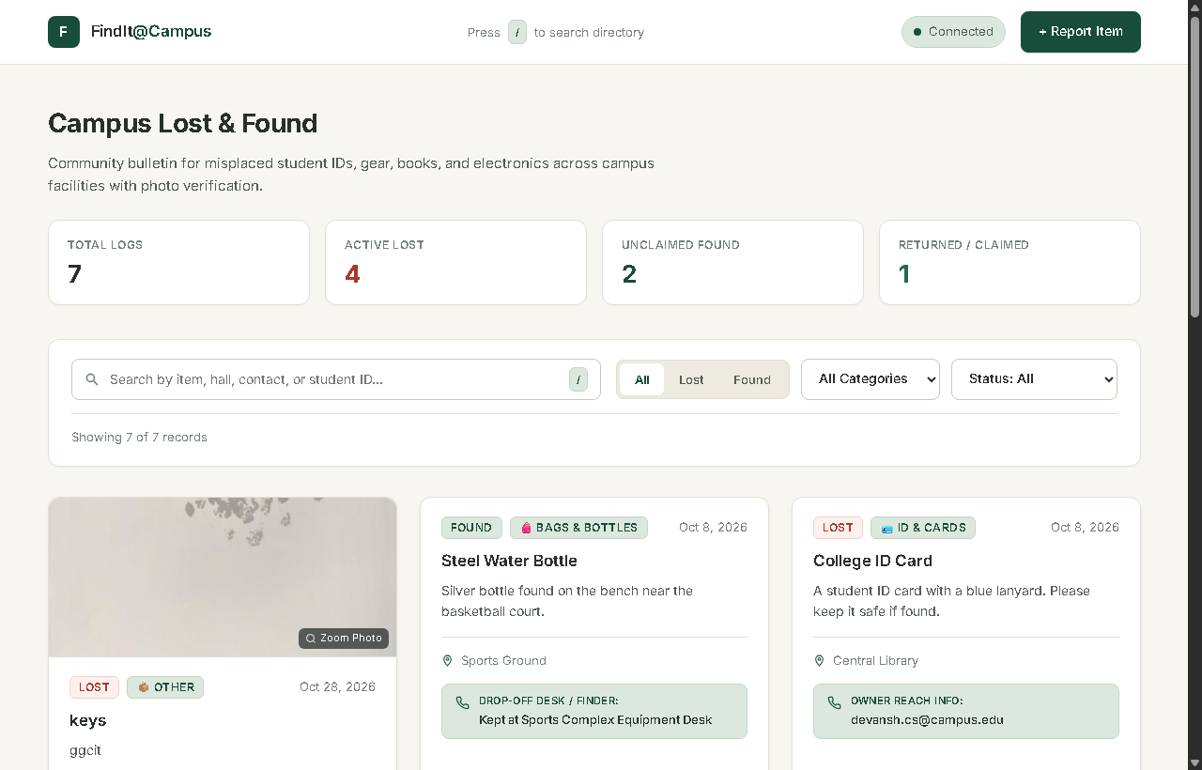
Figure 4.1: FindIt@Campus Main Directory Dashboard with Live Cards & Filters
Feature 2: Post a New Report
Clicking 'Report Item' opens a slide-up modal with a form. The user selects Lost or Found, picks a category, fills in the item name, last seen / found location, date, a description, and contact/drop-off information. An optional photo upload field allows attaching an image. On submit, the image is compressed client-side via Canvas (resized to max 800px, encoded as JPEG at 0.75 quality) before upload, reducing bandwidth.
Inputs / Outputs: Inputs: Form fields + optional image file.
Outputs: New card appears in the grid; toast notification 'Report posted.' is shown.
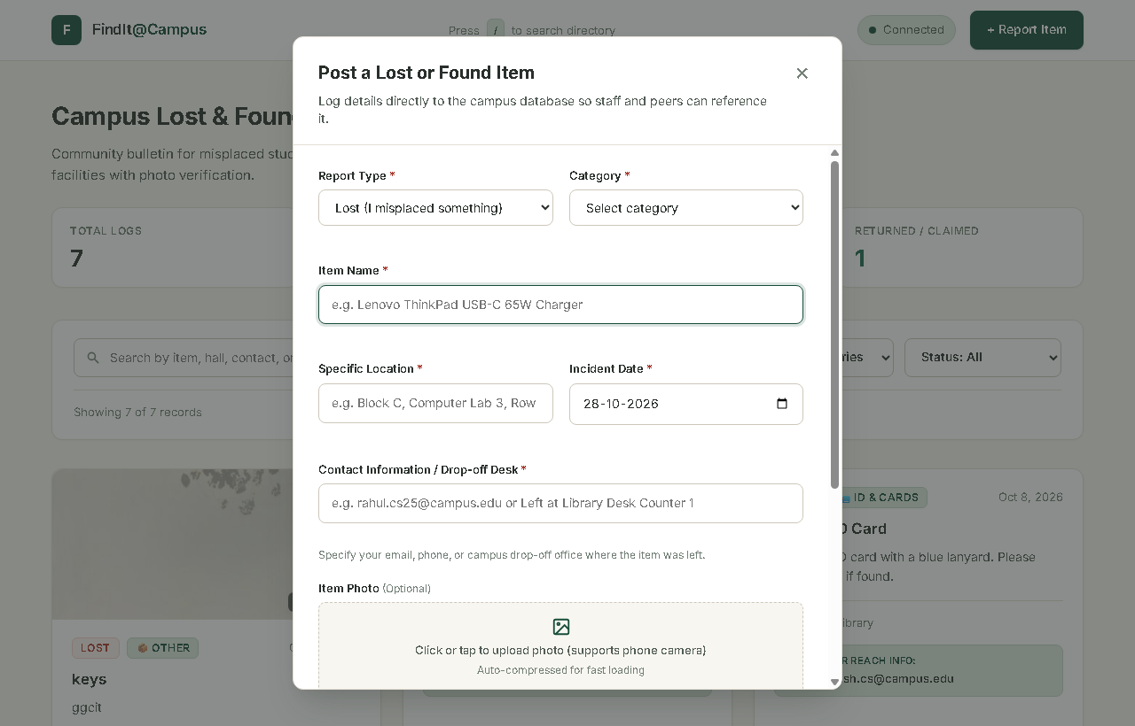
Figure 4.2: Post a Lost or Found Item Modal with Photo Upload & Drop-Off Contact
Feature 3: Claimant Identity Verification
When a campus member believes a found item is theirs, they click 'I Found This' on the card. A verification modal prompts for: Full Name, College ID / Roll No., Contact Number, and Ownership Proof (a text field describing how they can prove ownership -- e.g., serial number, distinctive mark, receipt). An optional claimant photo field accepts a selfie or ID card image.
Inputs / Outputs: Inputs: Identity fields + optional claimant photo.
Outputs: Item card updates to show 'Returned' badge with an audit section showing claimant name, ID, proof note, and claimant photo thumbnail. Clicking the thumbnail opens a full-screen lightbox.
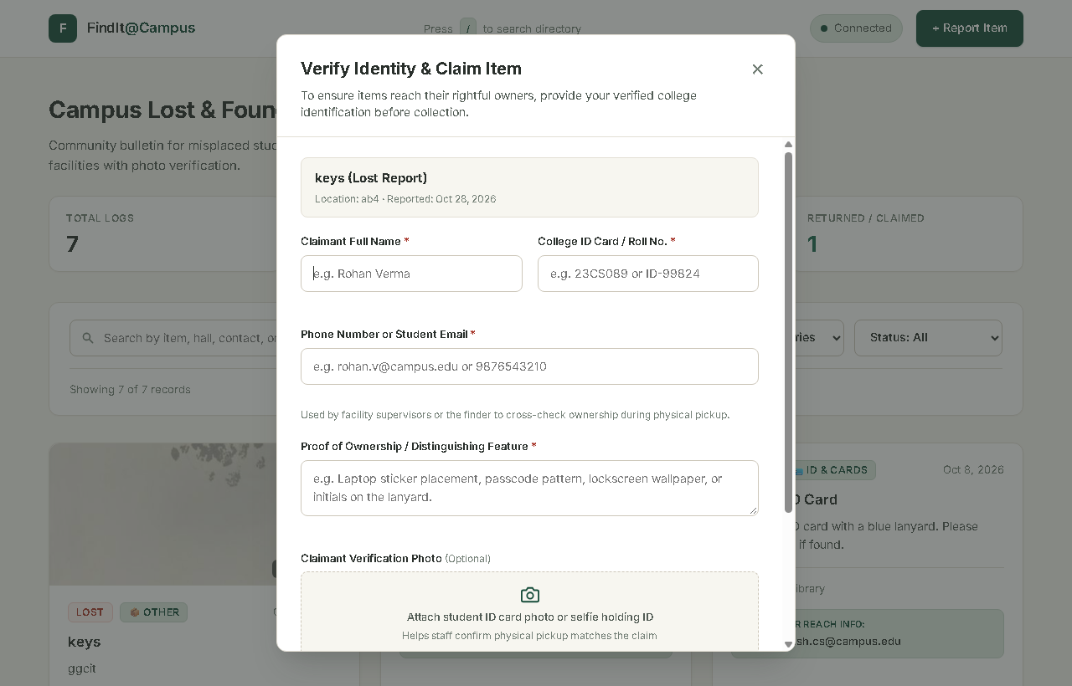
Figure 4.3: Claimant Identity Verification Dialog with Roll Number & Photo Proof
Feature 4: Cross-Match Engine
The 'Find Matches' button on a lost item card triggers a cross-match query. The server scores all open found items against the lost report by computing keyword overlap across name, description, category, and location fields. Matches above a threshold are returned ranked by relevance.
Inputs / Outputs: Inputs: Report ID of a lost item.
Outputs: Modal listing potential matching found items with relevance indicators.
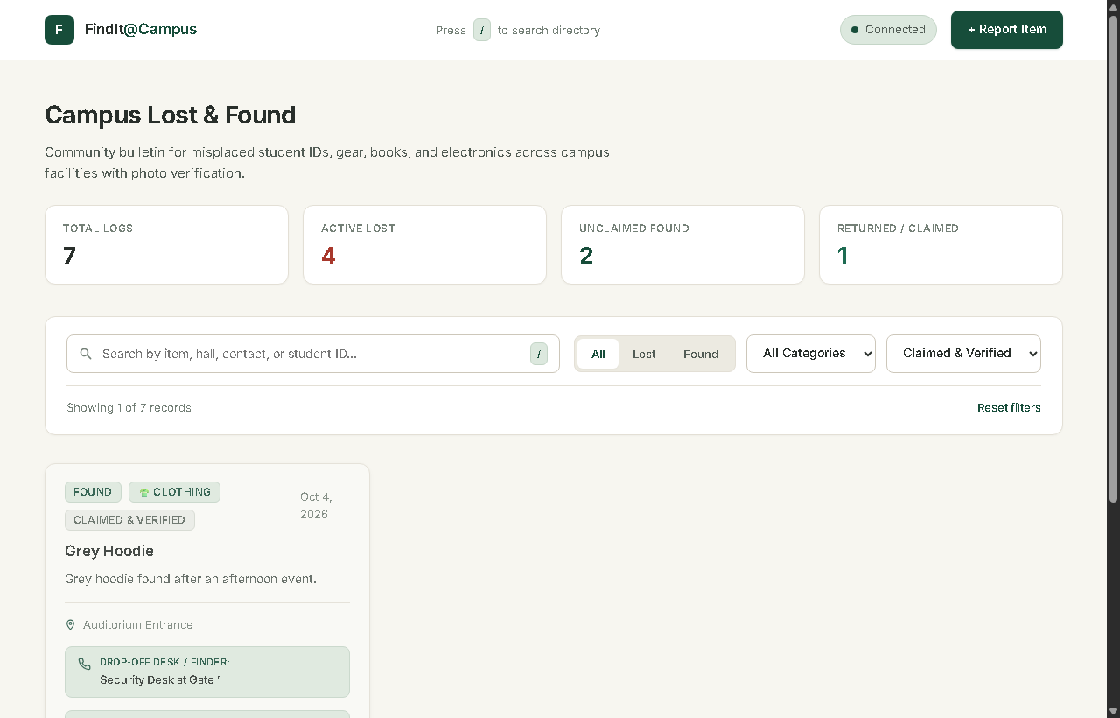
Figure 4.4: Returned Items View with Verified Claimant Badges & Audit Ledger
Feature 5: Toast Notifications & Keyboard Shortcuts
All user-facing feedback uses non-blocking toast notifications rather than alert() dialogs. The '/' key focuses the search bar from anywhere on the page. Escape closes any open modal. Tab navigation is fully functional across all form fields.
Inputs / Outputs: Inputs: User actions (submit, error, keyboard press).
Outputs: Toast appears bottom-right, auto-dismisses after 4 seconds.

CHAPTER 5: CONCLUSIONS AND FUTURE SCOPE

5.1 Conclusions
FindIt@Campus demonstrates that a practical, production-ready web application can be built entirely with standard web technologies -- no frameworks, no complex tooling -- while delivering a polished user experience and robust backend.
The project achieves all its stated goals: a searchable, photo-enabled, identity-verified campus lost and found directory with a clean REST API, automated tests, and a database that persists across server restarts. The claimant identity verification system -- combining textual proof, contact information, and optional photographic evidence -- introduces a layer of accountability absent from all existing informal solutions at campus level.
The development process reinforced key engineering practices: RESTful API design, relational schema planning, client-side image processing, defensive error handling with try/catch and AbortController, accessibility (keyboard navigation), and UX micro-interactions (skeleton loaders, toast notifications).
This project directly applies and extends skills from the CSE (AI & ML) curriculum -- particularly database management, web development, and software engineering -- and provides a foundation for the team's final year major project in AI-assisted campus services.
5.2 Industrial Relevance
Lost and found management is a real operational need in every large organisation: universities, airports, hospitals, shopping malls, and corporate campuses. Commercial products in this space (e.g., iLost, Crowdfind, Boomerang) charge subscription fees and are generic. A purpose-built, open-source campus solution demonstrates the value of bespoke software engineering for institutional problem-solving.
The technologies used -- Node.js, Express, SQLite, REST APIs, and modern JavaScript -- are foundational to full-stack development roles across the industry. The patterns applied (multipart file upload, identity verification, audit trails) are directly applicable to e-commerce, fintech, and HR systems.
5.3 Societal Relevance and Impact
Campus lost and found systems have a direct quality-of-life impact for students. Losing an ID card or a laptop -- common occurrences -- can be financially and academically disruptive. A system that reliably connects lost items with their owners reduces stress, financial loss, and the environmental impact of replacement purchases.
The identity verification mechanism also promotes honesty and accountability on campus: only the genuine owner, who can provide ownership proof, can claim an item. This deters opportunistic misappropriation and builds a culture of trust.
5.4 Future Scope
- User Authentication -- Integrate campus SSO (LDAP / Google OAuth) so reports are tied to verified campus accounts, eliminating the need for manual identity fields.
- Push Notifications -- Notify users via email or browser push when a potential match is found for their lost item.
- AI-Powered Matching -- Use image similarity (convolutional neural networks) and NLP-based semantic matching to improve cross-match accuracy beyond keyword overlap.
- Mobile App -- A React Native / Flutter companion app for easier photo uploads and on-the-go browsing.
- Admin Dashboard -- A privileged view for campus security staff to manage all reports, verify claims, and generate analytics (most commonly lost categories, recovery rates).
- Multi-Language Support -- Localisation for Hindi and other regional languages to serve a broader student population.
- Blockchain Audit Trail -- Record each claim event on a tamper-proof distributed ledger for forensic-grade accountability.
- QR Code Labels -- Generate printable QR code labels linked to report pages, attachable to bags and equipment.

REFERENCES

[1] MDN Web Docs. "HTML5 Reference". Mozilla Foundation. https://developer.mozilla.org/en-US/docs/Web/HTML
[2] MDN Web Docs. "Fetch API". Mozilla Foundation. https://developer.mozilla.org/en-US/docs/Web/API/Fetch_API
[3] Node.js Foundation. "Node.js v22 Documentation". https://nodejs.org/en/docs/
[4] Express.js. "Express 4.x API Reference". https://expressjs.com/en/4x/api.html
[5] SQLite. "SQLite Documentation". https://www.sqlite.org/docs.html
[6] D. Richard Hipp. "SQLite -- Small. Fast. Reliable. Choose any three." https://sqlite.org/
[7] Pallets Projects. "Flask Documentation (3.x)". https://flask.palletsprojects.com/
[8] Ecma International. "ECMAScript 2023 Language Specification". https://ecma-international.org/publications-and-standards/standards/ecma-262/
[9] W3Schools. "HTML Canvas Reference". https://www.w3schools.com/tags/ref_canvas.asp
[10] WHATWG. "File API Specification". https://w3c.github.io/FileAPI/
[11] Vercel / npm. "multer -- Node.js middleware for handling multipart/form-data". https://www.npmjs.com/package/multer
[12] JSS Academy of Technical Education. "BCC-351 Mini Project / Internship Assessment Guidelines". JSSATEN, Noida.

APPENDIX A -- PROJECT FILE STRUCTURE

FindIt_at_Campus_Project/
└── FindIt_at_Campus/
├── server.js # Express REST API server
├── app.py # Flask alternative server
├── index.html # Single-page frontend (UI)
├── style.css # Global stylesheet (design tokens, components)
├── script.js # Frontend logic (API calls, DOM, modals)
├── test_api.js # Automated API test suite
├── package.json # Node.js manifest & scripts
├── .env.example # Environment variable template
├── campus_reports.db # SQLite database (auto-created)
└── uploads/ # Uploaded item & claimant photos
APPENDIX B -- SAMPLE API REQUEST/RESPONSE
POST /api/reports -- Create a new report
Request (multipart/form-data):
type = "lost"
category = "Electronics"
name = "Blue OnePlus Charger"
location = "Library Reading Room, 2nd Floor"
date = "2025-10-15"
description = "65W USB-C charger, white cable, scratched brick"
contact = "Reach me at: room 204, Hostel B, or call 9XXXXXXXXX"
image = [JPEG file]
Response 201 Created:
{
"id": 7,
"type": "lost",
"category": "Electronics",
"name": "Blue OnePlus Charger",
"location": "Library Reading Room, 2nd Floor",
"date": "2025-10-15",
"description": "65W USB-C charger, white cable, scratched brick",
"contact": "Reach me at: room 204, Hostel B, or call 9XXXXXXXXX",
"image": "uploads/1730123456789-charger.jpg",
"status": "open",
"createdAt": "2025-10-15T09:30:00.000Z"
}

