1. Title of the invention: CrimeCatch: A Web-Based Anonymous Crime Reporting System
2. Field of Technology: This invention belongs in the field of web-based public safety systems, specifically anonymous crime reporting platforms using real-time evidence verification. It aims to improve community safety through reliable crime reporting.
3. Existing Similar Technologies/Products : -
• WeTip - Anonymous crime reporting system (U.S. based)
• Digital Police Portal - Indian government's online complaint system
• CrimeStoppers International - Global anonymous tip reporting
• National Crime Records Bureau (NCRB) portal - Indian crime statistics database
• Various municipal police department online reporting systems
Problem: Current systems fail to combine anonymity with verifiable, real-time evidence, leading to under-reporting and unreliable information.
Technical details of the invention
1. Background of the invention:
Many people don't report crimes they see or experience. This is a big problem because it makes it harder for the police to catch criminals and keep our communities safe. There are several important reasons why people stay quiet:
• Fear of Revenge: People are scared that criminals might find out who reported them and hurt them or their families. This fear is a major barrier to reporting.
• Social Pressure: They might be worried about what their friends, family, or community will think if they speak up. This social stigma can prevent people from coming forward.
• Lack of Trust: Some people don't trust the police or the reporting system to handle their information safely or to act on their report effectively. If trust is low, reporting rates will be low.
• Complicated Systems: Existing ways to report crime can be confusing, take too much time, or require too many steps, discouraging potential reporters.

• No Proof: If a reporter can't easily provide proof of what happened, their report might not be taken seriously, making them feel their effort is useless.
Because of these issues, many crimes go unreported. Even when people do report, the information might be incomplete or unreliable, especially if it's anonymous. This means police often have to spend a lot of time checking if a report is true, which takes away from their ability to respond to real emergencies and solve crimes

2.Drawbacks in Existing Systems and How CrimeCatch Helps: -
Current crime reporting systems have several problems that CrimeCatch aims to solve:
• Problem: Requires personal identification.
▹ CrimeCatch Solution: We protect your complete anonymity. Users can report without giving their name, number, or email. The system ensures no personal data is stored or linked to the report.
• Problem: No multimedia evidence support.
▹ CrimeCatch Solution: We require live image/video capture. Users must take a new photo or video at the moment of reporting, not upload old ones. This provides immediate, verifiable proof.
• Problem: Delayed reporting mechanisms.
▹ CrimeCatch Solution: We offer real-time reporting with GPS tagging. Reports are sent immediately with exact location and time data, allowing for quick police response.
• Problem: No verification of reports.
▹ CrimeCatch Solution: We plan for AI-assisted credibility scoring (future feature). Smart computer programs will help check if reports are likely true, improving the quality of information for police.
• Problem: Limited to text descriptions.
▹ CrimeCatch Solution: We support multimedia evidence. Photos and videos provide clear proof of the incident, making reports much more valuable.
• Problem: No community awareness features.
▹ CrimeCatch Solution: We provide public crime heatmaps. Anonymous crime data is shown on maps so everyone knows about local crime trends, helping communities stay informed and safer.
3. Technical Features of CrimeCatch ( What makes it different ): -
CrimeCatch has several unique and advanced features that make it a powerful tool for crime reporting and set it apart from other systems:
• Live Media Capture Protocol:
Function: This is a core part of our system. When you report a crime, the app makes you take a new photo or video using your device's camera right then and there.
Benefit: You cannot upload old pictures or fake evidence from your gallery. This stops people from sending in false or outdated information and makes every report more trustworthy. The photo or video is automatically marked with the exact time and location where it was taken.
• Dual-Anonymity Architecture:
Function: We designed CrimeCatch so that your identity is completely separate from the crime report itself. This is achieved by separating user information, report details, and the transmission method.
Benefit: When you send a report, the system creates a random, untraceable code for it. We don't store your name, phone number, email, IP address, or even your device's unique ID. This means no one can trace the report back to you, ensuring your safety and encouraging you to speak up without fear.
• Automated Credibility Assessment (Future Feature):
Function: We plan to add smart AI (Artificial Intelligence) that will look at reports (both text and media) and help figure out if they are likely true or fake.
Benefit: This will help police focus on real crimes by quickly identifying and filtering out unreliable reports, saving valuable time and resources.
• Dynamic Police Routing:
Function: Our system uses location technology (geo-fencing) to automatically send your report to the correct police station or law enforcement agency for that specific area.
Benefit: This makes sure reports get to the right people quickly and efficiently, without manual sorting, speeding up response times.
• Community Safety Dashboard:
Function: This feature collects all the anonymous crime reports and shows them on a map, highlighting crime hotspots.
Benefit: This helps everyone in the community see where crimes are happening, understand local crime patterns, and stay safer. It also provides a place for safety tips and information, empowering communities.

4. Main advantages of CrimeCatch : -
CrimeCatch offers many important benefits over traditional and existing online reporting methods, leading to a more effective public safety system:
• Increased Crime Reporting Rates: By guaranteeing strong anonymity and providing a simple, trustworthy way to report, we expect 3 to 5 times more people to report crimes. This means more eyes on the ground and more information for authorities.
• Reduced False Reports: The requirement for live photo/video evidence is expected to cut down fake or unreliable reports by 40-60%. This improves the quality of information police receive.
• Faster Police Response: Automated routing of reports to the correct authorities can reduce the time it takes for police to respond by 35-50%. This allows for quicker intervention and crime prevention.
• Improved Evidence Quality: Reports come with timestamped and geotagged multimedia, providing high-quality, undeniable evidence that is much more useful for investigations and prosecutions.
• Enhanced Community Awareness: Through anonymized crime mapping and the safety dashboard, communities become more informed about local crime. This helps them take precautions, understand risks, and work together for safety.

5. Complete description of the invention -
CrimeCatch is a full web application built to make crime reporting easy, anonymous, and reliable. It's made up of several key parts that work together seamlessly:

a. Components/Embodiments:

1. Frontend Interface Module:
Description: This is the part of the system that users interact with. It's a responsive website (meaning it works well on phones, tablets, and computers) built using modern web technologies like HTML5, CSS3, and JavaScript.
Functionality: It includes a special interface that connects directly to your device's camera to capture live photos or videos. It also has dynamic forms that change based on the type of crime being reported, making the process user-friendly.

2. Anonymization Engine:
Description: This is the core component responsible for ensuring user anonymity. It's a piece of software that sits between the user and the database.
Functionality: It uses special methods to remove any information that could identify you from your report (like IP addresses or device IDs). It also manages your reporting session securely so that your activity can't be traced back to you. It includes a verification system that checks the authenticity of live media and analyzes reporting patterns for unusual activity.

3. Routing & Dispatch Module:
Description: This module is responsible for making sure your report gets to the right place quickly and efficiently.
Functionality: It uses geo-fencing (drawing virtual boundaries on a map) to automatically figure out which police jurisdiction is responsible for the crime location. It also has a system to score the priority of reports and can send alerts through different channels (e.g., email, SMS) to the relevant authorities.

4. Community Safety Portal:
Description: This is a public dashboard that displays aggregated, anonymous crime data.
Functionality: It visualizes crime hotspots on a map (heatmap visualization) and provides a repository for safety tips and information. This empowers the community with knowledge about local crime trends.

b. Component Arrangement (System Architecture): -
The system is built in layers to ensure it's organized, efficient, and scalable:

Client Layer (Web/Mobile Interfaces): This is the user-facing part, including the website and potentially a future mobile app. It handles user interaction.
Application Layer (Business Logic Modules): This layer handles all the main rules and processes of the system, like how reports are processed, anonymized, and verified.
Service Layer (Verification/Routing Engines): This layer contains the specific parts that verify reports and route them to the correct authorities.
Data Layer (Secure Partitioned Databases): This is where all the crime reports and related data are stored securely in separate, organized databases to protect privacy and ensure data integrity.
Integration Layer (Police/Community APIs): This layer allows CrimeCatch to connect and share information with police systems and other community services through secure Application Programming Interfaces (APIs).

c. Figures/Structures: -
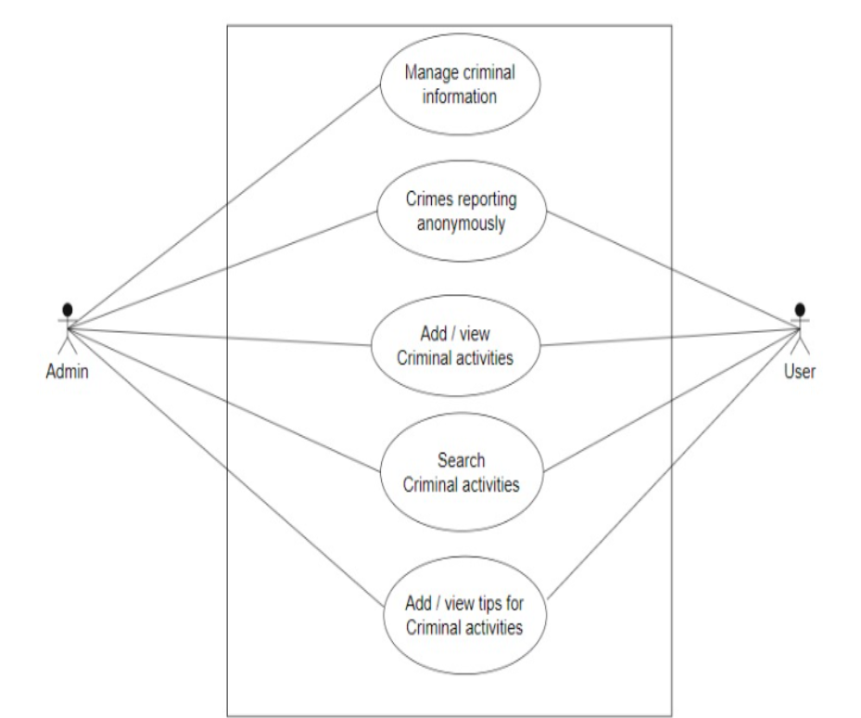
Figure 1- Operational Diagram
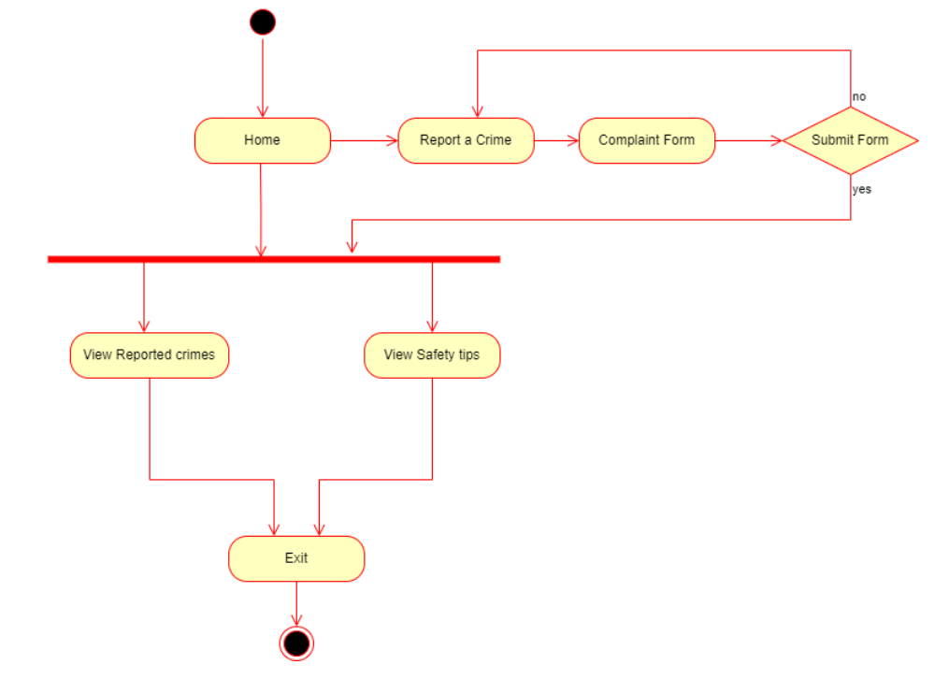

Figure 2 - System Overview

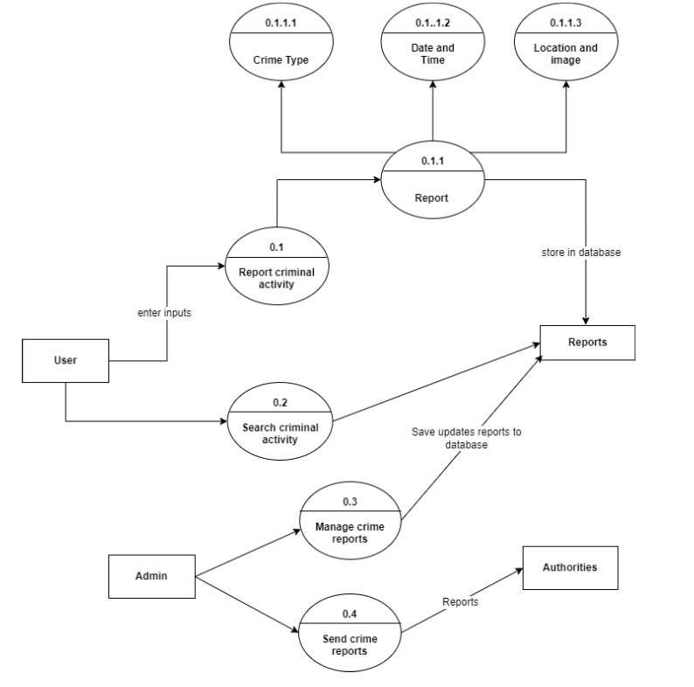
Figure 3 - Detailed System Architecture

1. List of novel features ( New and Unique Things ) -
• Mandatory live media capture with device verification
• Three-tier anonymization protocol (user, metadata, transmission)
• Self-learning credibility scoring engine
• Dynamic jurisdictional routing based on real-time police availability
• Community safety impact scoring for reported incidents

2. List of Keywords Relevant to the Invention:
Anonymous crime reporting, real-time verification, public safety platform, community policing technology, crime prevention system, multimedia evidence capture, geofenced police routing, crime mapping technology, dual-anonymity architecture, live media protocol, AI-powered credibility assessment, secure reporting, citizen engagement.
4. Names and Email IDs of the Inventors:
a) Devansh Pipraiya (0827CS221083), Email: devanshpipraiya221051@acropolis.in
b) Divyansh Singh Solanki (0827CS221088), Email: divyanshsingh220135@acropolis.in
c) Harsh Singh (0827CS221102), Email: harshsingh220898@acropolis.in
d) Harsh Verma (0827CS221103), Email: harshverma221105@acropolis.in
e) Krishnam Sohagaura(0827CS221137), Email: krishnamsohagaura220847@acropolis.in

