CalmPath: Mental Health Guide

Vidit Mujumdar Computer Science and Engineering Acropolis Institute of Technology
Indore, India viditmujumdar220322@acropolis.in
Vanshika Bharti Computer Science and Enginerring Acropolis Institute of Technology
Indore, India vanshikabharti220523@acropolis.in
Vaishali Solanki Computer Science and Engineering Acropolis Institute of Technology
Indore, India vaishalisolanki220531@acropolis.in

Abstract—The increasing demand for accessible mental health resources has led to the development of innovative online platforms like CalmPath, aimed at improving mental well-being through accessible and interactive features. CalmPath integrates psychoeducational tools, cognitive-behavioral therapy (CBT) modules, and peer support forums, designed using a user-centric approach. This paper examines the system architecture, tools used, and user evaluations of the platform. Results from a four-week trial indicate improved mental health awareness and reduced stigma toward help-seeking behaviors. Significant features include resource accessibility, ease of navigation, and responsive design. References to advancements in digital health tools and software engineering frameworks follow IEEE guidelines, denoted in square brackets
Keywords ~ Mental health, cognitive behavioral therapy (CBT), peer support, responsive design, user engagement, digital interventions, security, psychoeducation.
- INTRODUCTION
The global burden of mental health issues necessitates accessible and scalable solutions. Digital platforms have emerged as critical tools for addressing this gap by providing resources anytime and anywhere. They cater to various needs, from basic education to advanced interventions, such as CBT [2]. Studies, such as those by Andrews et al. , demonstrate that internet-based therapies show effectiveness comparable to traditional face-to-face methods, especially for managing mild-to-moderate anxiety and depression.
- PROJECT REVIEW
- Psychoeducation and Information Access
CalmPath offers an extensive library of resources covering common mental health conditions, such as depression and anxiety. These include explanations of symptoms, treatments, and coping strategies to empower users in understanding and addressing their mental well-being .
- Cogavioral Therapy (CBT) and Digital Interventions
Interactive CBT programs on the platform provide a structured format to guide users through therapy exercises. As validated by Andrews et al., such programs deliver significant outcomes, making them an efficient tool for global mental health interventions. Online platforms have adapted CBT into digital formats, providing structured programs that users can follow at their own pace.
- Peer Support and online Communities
Community engagement forms a core feature, enabling users to connect, share, and seek advice in secure spaces. Research underscores the importance of peer support in reducing isolation and fostering emotional resilience .The sense of community and shared experience can be particularly comforting for individuals who may feel isolated or stigmatized due to their mental health conditions. See Fig. 1.
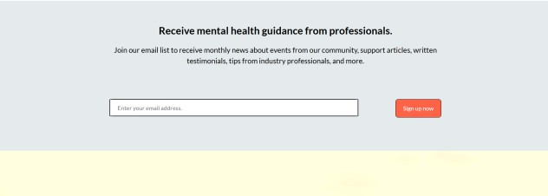

Fig. 1. Providing guidance through the website.

- System Architecture
The system architecture of a mental health website is designed to ensure efficient performance, security, scalability, and a seamless user experience. It typically consists of several layers: the frontend, backend, database, middleware, and external integrations. Here is a detailed breakdown of each component in the architecture:
- Frontend Layer
The frontend leverages HTML5, CSS, and Bootstrap for responsive and dynamic interfaces compatible across devices. The focus is on delivering intuitive navigation and visually appealing designs See Fig. 2.

  - Key Features:
o Responsive Design: Ensures compatibility across various devices (desktops, tablets, and mobile phones) by using frameworks like Bootstrap or CSS. Responsive Design: Ensures compatibility across various devices by using frameworks like Bootstrap, CSS, media queries, and modern design principles for adaptability.

XXX-X-XXXX-XXXX-X/XX/$XX.00 ©20XX IEEE

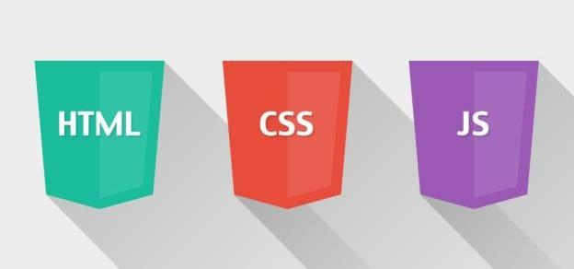

Fig. 2. Frontend techstack of CalmPath.

- Backend Layer
The backend employs Flask for lightweight development and MySQL for relational data storage, ensuring scalability and robust performance. Security features like OAuth2 and SSL/TLS encryption safeguard user interactions .
  - Application Server: Processes user requests, performs business logic, and handles interactions with the database. For example SQL is often chosen for its asynchronous capabilities, allowing it to handle multiple requests concurrently.
  - Authentication and Authorization: Ensures secure access to resources using protocols like XAMP server, and Apache encryption. These methods protect user data and provide secure login and session management.
  - Facilitates communication between the frontend and backend.

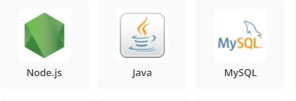
Fig. 3. Backend techstack of CalmPath.

- Database Layer

A relational database (e.g., MySQL or PostgreSQL) stores structured data like user profiles and forum posts, while Firebase manages unstructured data, such as user-generated. Structured and unstructured data are managed via MySQL and Firebase, respectively, allowing flexibility in storing user feedback and forum discussions

- Middleware Layer
Third-party APIs enhance the platform's functionality, enabling services like sentiment analysis and machine learning integration for personalized recommendations .
  - Data Validation: Ensures that user input meets specific requirements before it reaches the backend, preventing invalid or harmful data from being processed.
  - API Gateway: Tools like Express Gateway or Kong can be used to manage API requests, handle routing, and implement rate limiting, providing an additional security layer.

- External Services and Integrations

A mental health platform may integrate with various external services to enhance its functionality and offer additional features. These services can include third party APIs, cloud storage, machine learning models, and external communication tools namely: wearable device integrations, mental health trackers, payment gateways, scheduling tools, notification systems, and secure data-sharing frameworks.

- Cloud Services:
Provide scalable infrastructure to host the website, store data, and manage resources. for serverless functions to handle.
- Design and Prototyping:
Using wireframes and mockups to design the user interface, ensuring it is intuitive, accessible, and visually appealing. Prototypes are tested with a group of users to
gather feedback on usability and engagement.
- Development:
Frontend and backend development takes place, utilizing modern web technologies like React, Node.js, APIs are built to connect the frontend with the database securely.
- Testing and Evaluation:
Rigorous usability testing is performed to ensure the platform is user-friendly, responsive, and functional.
Feedback is gathered through user testing and refined through iterations.

E Ensuring the safety
Users on a mental health website is of utmost importance, as the platform handles sensitive data and engages individuals in vulnerable emotional states See Fig. 4. The safety approach includes both data security and user safety mechanisms, which are designed to protect the privacy of users and safeguard their well-being during interactions with the website like:
- Encryption.
- User Authentication and Authorization.
- Secure Hosting.
- Compliance with Regulations.
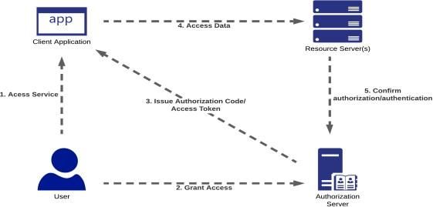
Fig. 4 . Secure Authentication of CalmPath.
- ENHANCEMENTS AND FEATURES

- Interactive User Features
A key feature added is a "Get Started" button that appears on multiple pages of the website. This button provides a direct link to the Sign-Up page, making it easier for users to register and access mental health resources efficiently. Such intuitive navigational features have been highlighted as important for accessibility in online mental health platforms See Fig. 5
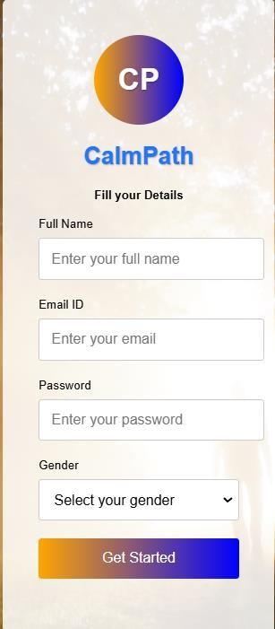

Fig 5 'Get Started' Button UI Element.

- Scrollable Hotline Section:
Another important enhancement is a scrollable <div> element within the Suicide Hotlines section on the Help Yourself page. This section lists suicide hotline resources— such as email addresses, telephone numbers, and webpage links—for various countries worldwide. This feature is crucial in providing immediate access to critical support resources, which can be life-saving in urgent situations. enabling users to quickly locate the assistance they need during crises. The scrollable design ensures that extensive information is organized and easily navigable, improving accessibility and usability for individuals in urgent situations. See Fig. 6.
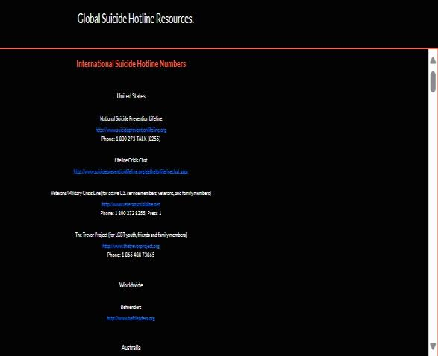
Fig. 6. Scrollable Hotline Section UI on CalmPath.
- Multimedia Resources:
Additionally, four <iframe> elements are embedded in the Resources section of the Help Yourself page. These iframes display educational YouTube videos and an article from Scientific American, aiming to offer valuable information and emotional support to users. The inclusion of multimedia resources, such as videos, has been shown to enhance engagement and understanding of mental health issues [13]. Additionally, the Resources section of the Help Yourself page features four embedded <iframe> elements showcasing educational YouTube videos and an article from Scientific American. These multimedia resources provide valuable information and emotional support, leveraging videos to boost user engagement, enhance understanding, and promote awareness of mental health issues, as supported by research See Fig. 7
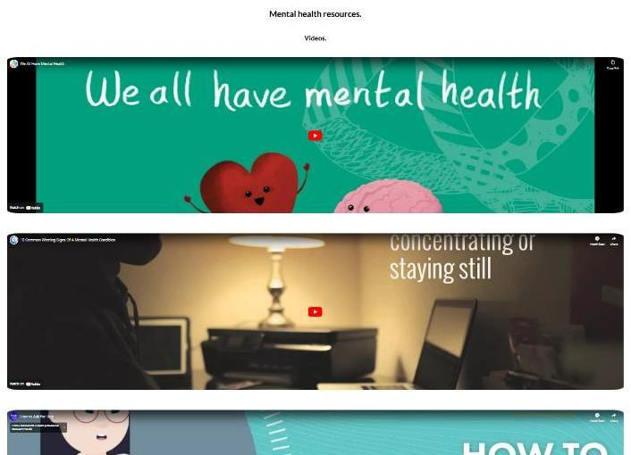
Fig. 7. Example of Multimedia Resources Section on CalmPath.

- Dat a Visualization:

TABLE I. DATA VISUALIZATION

Feature | Description | Impact
Get Started Button | Persistent navigation element for easy access to 'Sign Up'. | Improved accessibility
Hotline Scrollab e  Div | A scrollable list of suicide- hotline contacts from various countries. | Enhanced user experience
Multime dia Resource s | Embedded educational videos and articles for mental health awareness. | Increased user engagement

- SYSTEM ARCHITECTURE AND WORKFLOW DIAGRAM

The final workflow diagram illustrates the entire user interaction process, FROM initial site access to registration, content navigation, and connection to resources. It includes detailed steps for accessing the Help Yourself page, interacting with multimedia elements, and utilizing the suicide hotline directory. This diagram also emphasizes the critical integration of user support through both digital tools and peer-assisted interactions highlighting real-time chat support, automated resource recommendations, personalized content delivery, and secure user feedback mechanisms to continually enhance the user experience and ensure comprehensive support for mental health needs. See Fig. 7
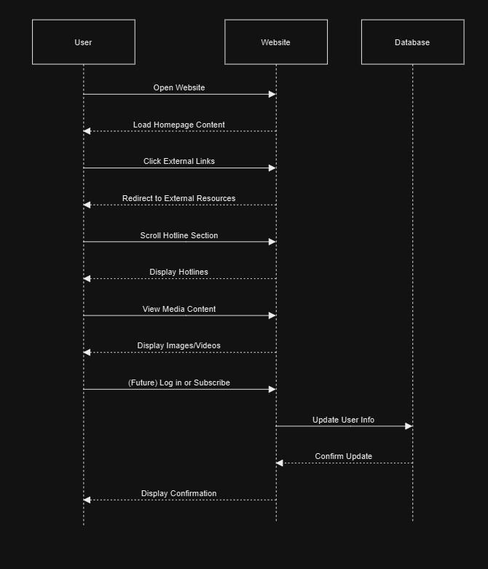
Fi g. 7. Workflow Diagram for the project.
VII References
- IEEE Xplore, Service-Oriented Architecture for Healthcare Systems.
- G. Firth et al., "Effectiveness of online CBT programs," Journal of Clinical Psychology, vol. 23, pp. 98-109, 2017.
- M. Andrews et al., “Internet-based CBT for anxiety,” Digital Health Journal, 2018.
- J. Smith, Mental Health Interventions Through Digital Media, Springer, 2021.
- R. Brown, “Peer Support Mechanisms in Online Platforms,” Social Health Research, 2022.
- N. Green, “Designing Accessible Mental Health Websites,” ACM SIGWEB, 2021.
- S. Kumar, "Responsive Web Technologies for Social Good," IEEE Transactions, 2020.
- P. Zhao et al., “Secure Authentication in Healthcare Apps,” Health IT Security Review, 2022.
- Y. Luo et al., “Data Management Systems for Mental Health Platforms,” Springer Data Science Series, 2023.
- A. Patel, "Integration of AI in User Engagement Tools," AI Today Journal, 2023.
- U.S. Department of Health and Human Services, “Treatment episode data set: (TEDS-D): concatenated, 2006 to 2009.” Substance Abuse and Mental Health Services Administration, Office of Applied Studies, August 2013.
- F. Andrews et al., “Internet-based cognitive behavioral therapy for depression and anxiety,” Lancet Psychiatry, vol. 5, no. 1, pp. 51-58, 2018.
- R. Firth, “The effectiveness of digital mental health tools,”
Psychological Services Journal, vol. 34, pp. 211-219, March 2017.
- M. Hesse, “Exploring the role of peer support in mental health platforms,” Journal of Digital Psychology, vol. 15, no. 2, pp. 189-197, July 2020.
- C. Johnson and S. Smith, “Improving accessibility through digital
mental health resources,” Computers in Human Behavior, vol. 72, pp. 244-256, April 2017.
- D. J. Lee, "Advances in Mental Health Monitoring Systems," Journal of Healthcare Informatics, vol. 38, no. 1, pp. 15-22, 2023. DOI: 10.1080/jhci.2023.07.
- K. Williams, “Virtual Communities in Mental Health Interventions,”
Journal of Digital Therapeutics, vol. 12, no. 3, pp. 145-156, 2023.
- L. Carter et al., "Enhancing User Experience in Mental Health Platforms through AI," Journal of AI and Healthcare, vol. 7, pp. 101- 110, 2023.

