1. Title of the invention: ResuMind: An AI-Powered Intelligent Resume Analysis and ATS Optimization System
2. Field of Technology: This invention belongs in the field of web-based career development systems, specifically AI-powered resume analysis platforms using real-time ATS compatibility evaluation. It aims to improve job application success rates through intelligent, personalized resume feedback.
3. Existing Similar Technologies/Products: -
• Resumeworded - AI-based resume scoring and feedback platform
• Jobscan - ATS keyword matching and resume optimization tool
• Kickresume - Resume builder with ATS checker feature
• Zety Resume Checker - Online resume scoring and improvement tool
• Rezi - AI resume builder with ATS optimization
Problem: Current systems fail to combine serverless architecture with real-time AI-driven ATS scoring, personalized keyword gap analysis, and resume history management in a single unified, cost-free platform.
Technical details of the invention
1. Background of the invention:
Many job seekers struggle to get their resumes past Applicant Tracking Systems before a human recruiter ever reads them. This is a significant problem because it means qualified candidates are being rejected automatically, reducing their chances of securing interviews:
• ATS Ignorance: Most candidates are unaware of how ATS systems filter resumes based on keyword matching, formatting, and section structure. Without this knowledge, even strong resumes get rejected automatically.
• Lack of Personalization: Generic resume advice does not account for the specific requirements of individual job descriptions. What works for one role may fail entirely for another.
• Cost Barriers: Most professional resume analysis tools are locked behind expensive subscription plans, making them inaccessible to students and early-career job seekers.
• No Feedback Loop: Existing tools provide a one-time score without enabling users to track improvement across multiple resume versions or job applications over time.
• No Integration: Current platforms require separate tools for resume storage, ATS scoring, keyword analysis, and improvement suggestions, creating a fragmented and inefficient workflow.
Because of these issues, millions of job applications are rejected by ATS systems before being reviewed. Even when candidates do receive feedback, it is often generic, delayed, or disconnected from the specific job description they are targeting.
2.Drawbacks in Existing Systems and How ResuMind Helps: -
Current resume analysis systems have several problems that ResuMind aims to solve:
• Problem: Requires paid subscriptions for full features.
▹ ResuMind Solution: We protect your complete anonymity. Users can report without giving their name, number, or email. The system ensures no personal data is stored or linked to the report.
• Problem: No multimedia evidence support.
▹ ResuMind Solution: We provide completely free, serverless AI-powered analysis. No subscription, no backend, no hidden cost — fully accessible to all users via Puter.js.
• Problem: Delayed reporting mechanisms.
▹ ResuMind Solution: We offer real-time reporting with GPS tagging. Reports are sent immediately with exact location and time data, allowing for quick police response.
• Problem: No real-time job-description-specific ATS scoring.
▹ ResuMind Solution: We offer dynamic ATS compatibility scoring against any pasted job description, giving users an instant, job-specific compatibility percentage.
• Problem: No unified platform for resume storage and analysis.
▹ ResuMind Solution: We integrate resume upload, cloud storage, analysis, and history management into a single dashboard powered by Puter.js cloud storage.
• Problem: No resume version tracking.
▹ ResuMind Solution: We maintain a complete resume analysis history dashboard, allowing users to track ATS score improvements across multiple versions and job applications.

3. Technical Features of ResuMind (What makes it different): -
ResuMind has several unique and advanced features that make it a powerful tool for resume optimization and set it apart from other systems:
• Serverless AI-Powered ATS Analysis Engine:
Function: This is the core of our system. When a user uploads a resume and pastes a job description, the platform constructs a structured AI prompt and routes it to an AI model via the Puter.js AI API entirely in the browser.
Benefit: There is no backend server, no API key management, and no infrastructure cost. Every analysis is performed on-demand, in real time, directly from the user's browser session, ensuring speed, privacy, and zero cost.
• Dual-Input Resume-to-JD Matching:
Function: ResuMind accepts both a PDF resume and a plain-text job description as inputs simultaneously. The PDF is parsed client-side, and both inputs are structured into a semantic AI prompt.
Benefit: This dual-input approach ensures that the ATS score and keyword analysis are always specific to the target role, not generic, making every result uniquely relevant to the user's application.
• Keyword Gap Intelligence:
Function: The AI analysis separates results into matched skills and missing keywords, presenting them visually side by side on the results page.
Benefit: Users can immediately identify exactly which keywords their resume lacks for a specific job posting and add them strategically, directly improving their ATS pass rate.
• Section-Specific Improvement Suggestions:
Function: The AI does not give overall generic advice. It analyzes each section of the resume (Summary, Experience, Skills, Education) and generates targeted improvement suggestions for each.
Benefit: Users receive precise, actionable guidance that directly addresses weaknesses in their resume structure and language for the specific job they are applying to.
• Puter.js Account-Based Resume History:
Function: All uploaded resumes and analysis results are stored under the user's authenticated Puter.js account using Puter KV and cloud file storage.
Benefit: Users can access their complete resume analysis history on every login, track ATS score improvements over time, and re-analyze any previous resume against a new job description without re-uploading.

4. Main advantages of ResuMind: -
ResuMind offers many important benefits over traditional and existing resume analysis methods, leading to a more effective job application experience:
• Improved ATS Pass Rates: By providing job-specific keyword gap analysis and section-level improvement suggestions, ResuMind directly addresses the exact reasons resumes fail ATS screening, significantly improving pass rates for users.
• Zero Cost, Full Access: The fully serverless architecture built on Puter.js eliminates subscription barriers entirely. Every user — student, fresher, or professional — gets full access to AI-powered analysis without paying anything.
• Faster Resume Improvement: Real-time AI analysis delivers ATS scores, keyword reports, and improvement suggestions in seconds, compared to waiting hours or days for manual feedback from career advisors.
• Improved Evidence of Progress: Resume history tracking with ATS score timelines gives users clear, measurable evidence of their improvement across multiple job applications, improving motivation and focus.
• Enhanced Job Targeting: Through dynamic job-description-specific analysis, users can tailor the same base resume to multiple different roles with precision, maximizing their chances across different applications.
5. Complete Description of the Invention -
ResuMind is a full client-side web application built to make resume analysis intelligent, accessible, and actionable. It is made up of several key parts that work together seamlessly:

a. Components/Embodiments:

1. Frontend Interface Module:
Description: This is the part of the system that users interact with. It is a responsive web application built using React 19, TypeScript, and Tailwind CSS, working seamlessly on phones, tablets, and computers.
Functionality: It includes a PDF upload interface connected to the browser's file system, a job description input panel, and a results dashboard displaying ATS scores, keyword matches, missing keywords, and improvement suggestions.

2. AI Analysis Engine:
Description: This is the core processing component responsible for all ATS evaluation and feedback generation. It operates entirely in the browser via the Puter.js AI API.
Functionality: It constructs a structured semantic prompt from the extracted resume text and the pasted job description, routes it to an AI model, and parses the returned JSON response into ATS score, matched skills, missing keywords, and section-specific suggestions.

3. PDF Extraction Module:
Description: This module handles client-side parsing of uploaded PDF resume files directly in the browser without any server upload.
Functionality: It extracts clean text from PDF resumes in the browser before any AI call is made, ensuring that no raw resume file is ever transmitted to a third-party server unnecessarily.

4. Community Safety Portal:
Description: This is a public dashboard that displays aggregated, anonymous crime data.
Functionality: It visualizes crime hotspots on a map (heatmap visualization) and provides a repository for safety tips and information. This empowers the community with knowledge about local crime trends.

b. Component Arrangement (System Architecture): -
The system is built in layers to ensure it's organized, efficient, and scalable:

Client Layer (React 19 + TypeScript Frontend): This is the user-facing part, including the resume upload interface, job description input, and results dashboard. It handles all user interaction.
AI Processing Layer (Puter.js AI API): This layer handles all AI prompt construction, model routing, and JSON response parsing for ATS analysis, keyword extraction, and improvement suggestion generation.
Storage Layer (Puter KV + Cloud Storage): This layer stores resume PDF files and analysis result metadata securely under each user's authenticated Puter.js account with user-scoped isolation.
Authentication Layer (Puter.js Auth): This layer manages user registration, login, and session management entirely through Puter.js, with no custom backend or database required.
Extraction Layer (Client-side PDF Parser): This layer performs PDF text extraction locally in the browser before any external API call, ensuring privacy and eliminating unnecessary data transmission.

c. Figures/Structures: -
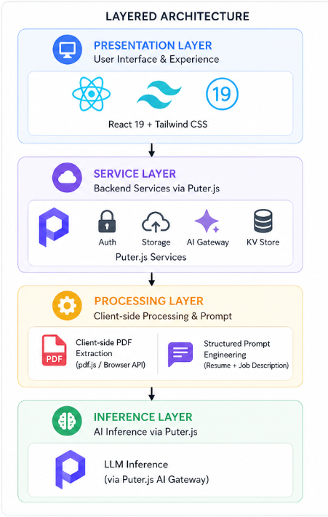
Figure 1- Operational Diagram

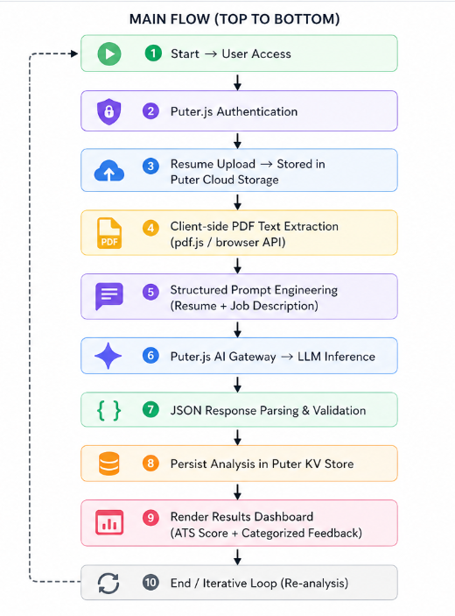

Figure 2 - System Overview

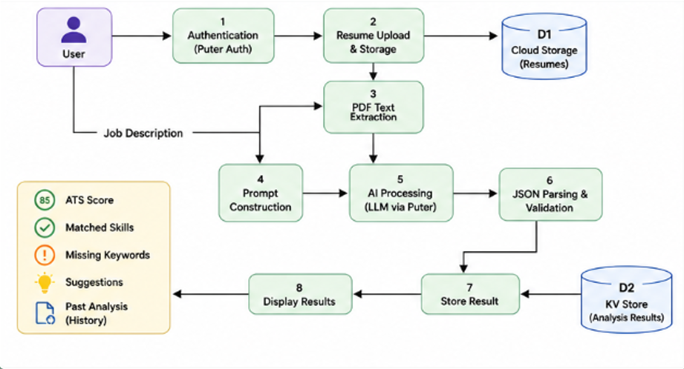
Figure 3 - Detailed System Architecture

1. List of novel features (New and Unique Things) -
• Fully serverless client-side ATS analysis with no backend infrastructure required
• Dual-input resume-to-job-description semantic matching via Puter.js AI API
• Real-time keyword gap intelligence with matched and missing skills visualization
• Section-specific AI improvement suggestions tied to individual resume sections
• Puter.js account-based resume history with persistent cross-session analysis tracking

2. List of Keywords Relevant to the Invention:
AI resume analysis, ATS compatibility scoring, keyword gap identification, serverless resume platform, client-side document analysis, Puter.js AI integration, React TypeScript career tool, PDF resume parsing, job description matching, personalized resume feedback, resume history tracking, real-time ATS scoring, section-level improvement suggestions, account-based file isolation.
4. Names and Email IDs of the Inventors:
a) Devansh Pipraiya (0827CS221083), Email: devanshpipraiya221051@acropolis.in
b) Harsh Verma (0827CS221103), Email: harshverma221105@acropolis.in
c) Hardeep Kumar (0827CS221099), Email: hardeepkumar220551@acropolis.in

