PETZ
Animal Welfare Platform
Functional Requirements Document
(with Wireframes)
Prepared for the Testing Team
Version 1.0 · 28 April 2026

1. Document Control
Field | Value
Project | PETZ — Animal Welfare Platform
Document | Functional Requirements Document (FRD)
Version | 1.0
Date | 28 April 2026
Audience | QA / Testing Team
Backend | Spring Boot, MySQL, port 8081
Frontend | Angular 21 (zone.js), port 4200
Status | Ready for system / acceptance testing

2. Introduction

2.1 Purpose
This document captures the functional requirements of the PETZ Animal Welfare Platform with annotated screenshots of the implemented user interface. It is intended for the testing team to design test cases, execute system tests, and verify that the build matches the agreed behaviour.

2.2 Scope
PETZ is a multi-actor platform that connects citizen reporters of injured/stray animals with NGO rescue partners and verified veterinary hospitals, and supports an adoption network. The system covers four user roles:
- Reporter (anonymous / temporary) — submits SOS reports for animals in distress.
- Adopter — registered citizen who can browse and apply to adopt rescued pets, and book vet appointments.
- NGO Representative — manages adoptable pet listings, accepts rescue missions, reviews adoption applications.
- Administrator — verifies hospitals, monitors KPIs, oversees rescue operations.

2.3 Document Conventions
- Functional requirements are tagged FR-MM-NN where MM is the module code (e.g. AUTH, SOS, BOOK).
- Screenshots reflect the implemented build at v1.0 and serve as wireframes for visual validation.
- Test scenarios indicate the minimum coverage expected for each module.

2.4 References
- Backend API base URL: http://localhost:8081/api/v1
- Frontend base URL: http://localhost:4200
- Test credentials: admin@petz.dev / Petz@1234, ngo@petz.dev / Petz@1234

3. System Overview

3.1 High-level architecture
The platform is a single-page Angular application backed by a Spring Boot REST API. Authentication is JWT-based with three onboarding paths: phone OTP (full account), email/phone + password (full account), and emergency quick session (temporary reporter, no OTP).

3.2 Key non-functional notes for testing
- Emergency SOS flow must complete in under 30 seconds (no OTP, no SMS round-trip).
- Slot booking holds a 2-minute lock to prevent double-booking; the lock is released on confirm or expiry.
- All authenticated API calls must include the Authorization: Bearer <jwt> header (handled by the auth interceptor).
- CORS preflight (OPTIONS) is permitted for all endpoints.

4. Functional Requirements by Module

4.1 Public Landing & Navigation
The home page is the public entry point. It surfaces the EMERGENCY one-tap button, top-level navigation, and live activity feed.
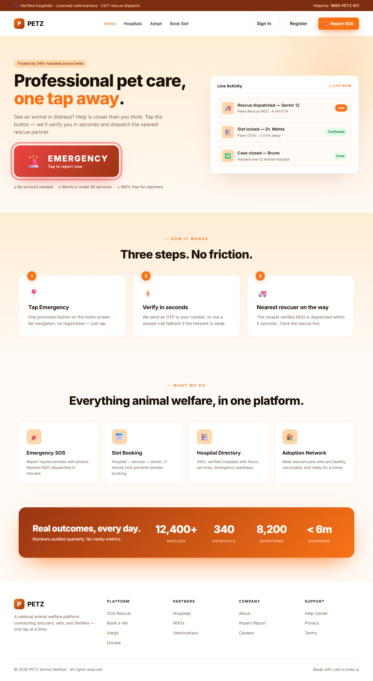
Figure 1 — Public landing page

Functional requirements
Req ID | Description | Role | Priority
FR-HOME-01 | Display EMERGENCY button prominently above the fold; one tap routes to /sos/auth. | All | High
FR-HOME-02 | Display top-nav links: Home, Hospitals, Adopt, Book Slot. Hide drawer on desktop, show hamburger on mobile. | All | High
FR-HOME-03 | Authenticated users see role-specific links: My Appointments, My Reports, NGO Portal (NGO_REP), Admin (ADMIN). | Auth | High
FR-HOME-04 | Show "Sign In" and "Register" CTAs when no session is present; show "Sign Out" otherwise. | All | Medium

Test scenarios
Test ID | Test Case | Steps | Expected Result
TC-HOME-01 | Emergency button routes correctly | 1. Open /  2. Click "EMERGENCY" button. | Browser navigates to /sos/auth.
TC-HOME-02 | Hamburger menu toggles | 1. Resize to mobile width.  2. Click hamburger.  3. Click again. | Drawer opens, then closes; does not submit any form.
TC-HOME-03 | Role-specific nav appears | 1. Sign in as admin.  2. Open / . | "Admin" link is shown in top-nav.

4.2 Authentication
PETZ supports three authentication paths: phone OTP, email/phone + password, and the emergency quick session (covered in §4.3).
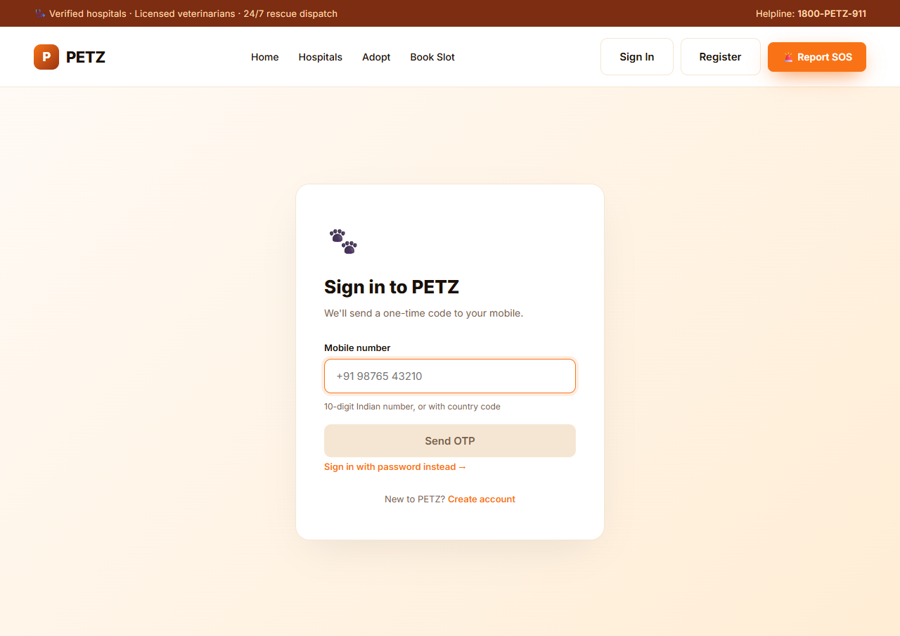
Figure 2 — Login (phone OTP mode)
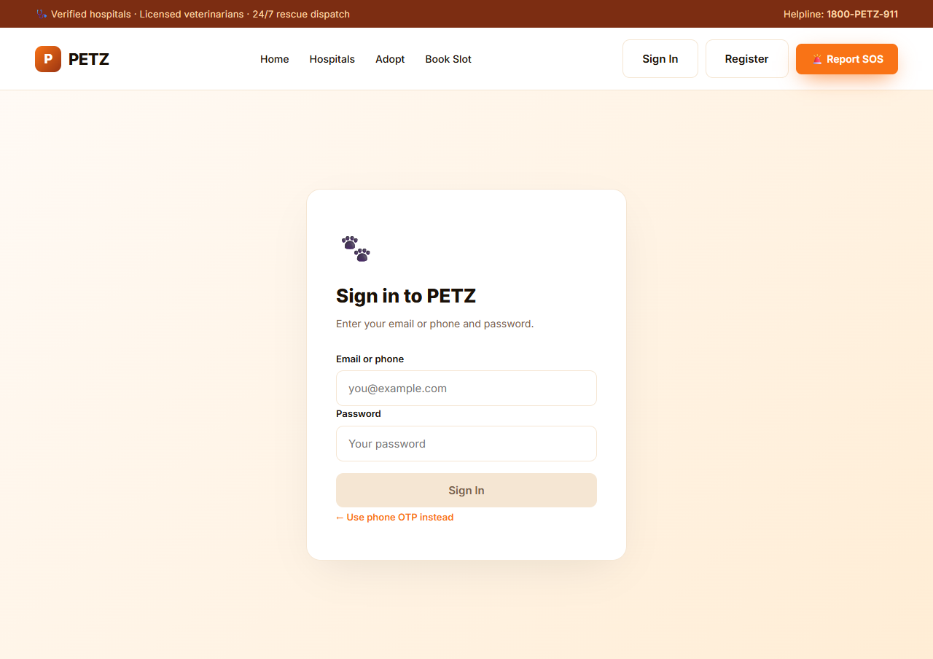
Figure 3 — Login (email/phone + password mode)
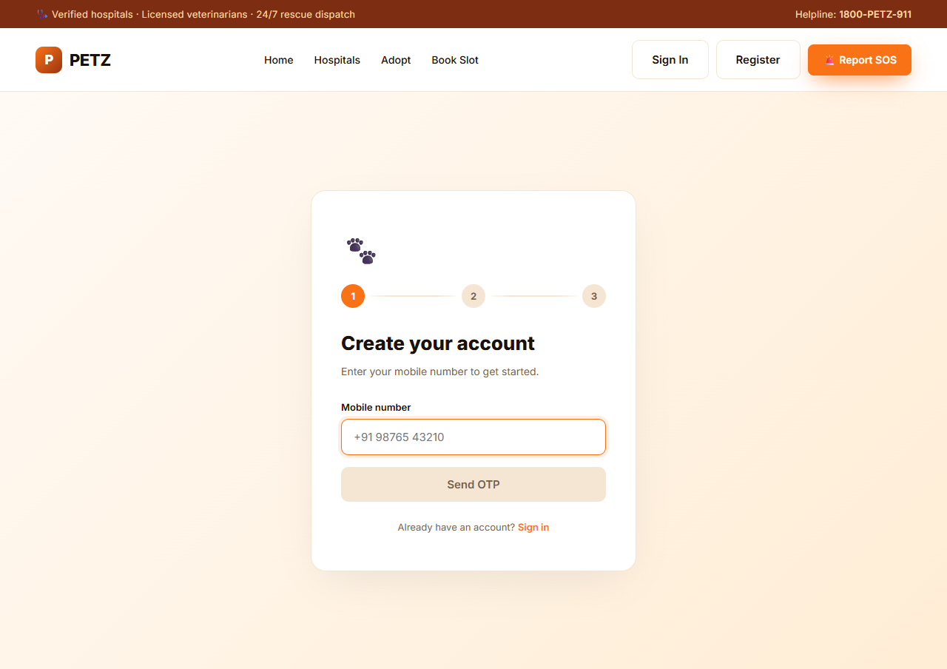
Figure 4 — Register account (3-step wizard)

Functional requirements
Req ID | Description | Role | Priority
FR-AUTH-01 | Phone-OTP login: collect phone, request OTP via Firebase, verify, redirect by role (ADMIN→/admin, NGO_REP→/ngo/dashboard, else /). | All | High
FR-AUTH-02 | Password login: identifier may be email or phone; account lockout after 5 failed attempts for 15 minutes. | Adopter, NGO, Admin | High
FR-AUTH-03 | Registration form captures full name, phone, email, password, role (ADOPTER, NGO_REP, VET); ADMIN role rejected. | Public | High
FR-AUTH-04 | Successful registration kicks off a phone OTP for verification. | Public | Medium
FR-AUTH-05 | JWT session is persisted in localStorage under key "petz.session"; auth-interceptor attaches Bearer token. | All | High
FR-AUTH-06 | authGuard redirects unauthenticated users from protected routes to /login. | All | High

Test scenarios
Test ID | Test Case | Steps | Expected Result
TC-AUTH-01 | Password login succeeds | 1. Open /login.  2. Click "Sign in with password instead".  3. Enter admin@petz.dev / Petz@1234.  4. Click Sign In. | Redirected to /admin; localStorage has petz.session with role ADMIN.
TC-AUTH-02 | Wrong password is rejected | Login with admin@petz.dev / wrongpass. | Error "Invalid credentials"; failedLoginAttempts increments.
TC-AUTH-03 | Account lockout | Submit 5 wrong passwords for one user. | 6th attempt returns 423 Locked (or "Account locked" message).
TC-AUTH-04 | Auth guard redirects | Without session, navigate to /book. | Redirects to /login with notice "Please sign in to continue."
TC-AUTH-05 | ADMIN registration blocked | POST /auth/register with role=ADMIN. | 400 Bad Request with "ADMIN accounts cannot be created via self-registration."

4.3 Emergency SOS Reporting
The SOS flow is the platform’s critical path. To minimise time-to-rescue, the OTP step is intentionally bypassed: the user enters a phone number, the backend creates or finds a temporary REPORTER session immediately, and the user is taken directly to the report form.
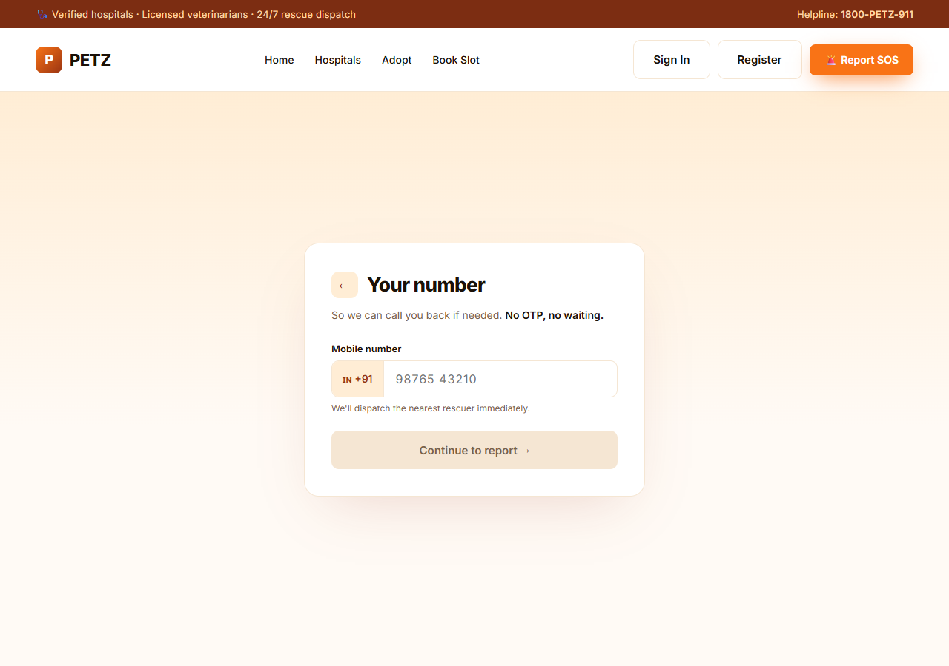
Figure 5 — SOS quick session (phone only, no OTP)
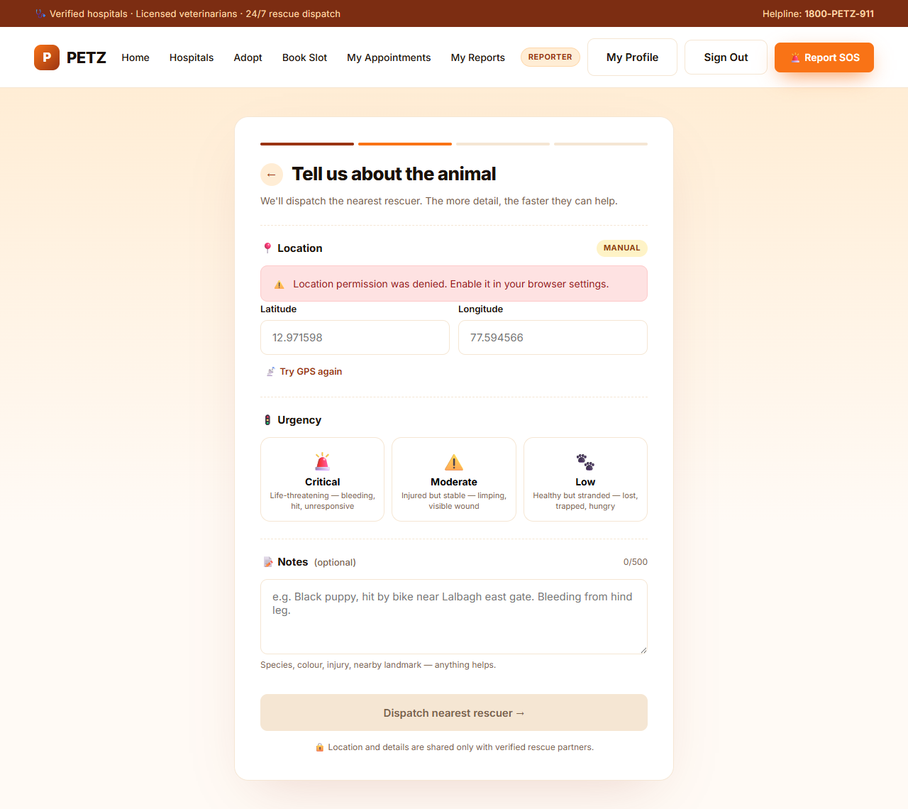
Figure 6 — SOS report form (location, urgency, description, media)

Functional requirements
Req ID | Description | Role | Priority
FR-SOS-01 | POST /api/v1/auth/sos-quick-session accepts a phone number, creates/finds a temporary REPORTER user, and returns a JWT (no OTP, no SMS). | Reporter | Critical
FR-SOS-02 | After quick-session, the EMERGENCY flow navigates directly to /sos/report (no OTP/missed-call screens). | Reporter | Critical
FR-SOS-03 | Report form auto-captures GPS via browser geolocation; falls back to manual lat/lon entry if denied. | Reporter | High
FR-SOS-04 | Urgency is mandatory (CRITICAL / MODERATE / LOW); description is optional, max 500 chars. | Reporter | High
FR-SOS-05 | On submit, backend creates a SosReport row, auto-creates a paired RescueMission, and writes a status log. | System | High
FR-SOS-06 | After submit, user is taken to media upload (/sos/report/:id/media) with an option to skip. | Reporter | Medium
FR-SOS-07 | Media upload supports up to 3 photos OR 1 video (mutually exclusive); photos ≤10MB, video ≤50MB. | Reporter | Medium
FR-SOS-08 | After media (or skip), confirmation page shows urgency, location, status REPORTED, and "What happens next" text. | Reporter | High
FR-SOS-09 | Rate limiting at the filter level prevents abuse of the quick-session endpoint. | System | High

Test scenarios
Test ID | Test Case | Steps | Expected Result
TC-SOS-01 | End-to-end happy path | 1. Open /.  2. Click EMERGENCY.  3. Enter "9876543210".  4. Click "Continue to report".  5. Fill lat/lon, pick CRITICAL, submit.  6. Skip media. | Confirmation page shows REPORTED, urgency CRITICAL, ref code visible.
TC-SOS-02 | Phone validation | Try "abc" or "123" as phone. | "Continue to report" button is disabled.
TC-SOS-03 | Missing urgency | Submit without picking urgency. | "Dispatch nearest rescuer" button is disabled.
TC-SOS-04 | Manual location entry | Deny geolocation permission. | Form falls back to manual lat/lon; submission succeeds with valid coords.
TC-SOS-05 | Mission auto-creation | After successful submit, query /api/v1/rescue-missions/by-report/{sosId}. | Returns a mission with rescueStatus=REPORTED.

4.4 Hospital Directory
Public directory of verified hospitals with filtering and a profile page.
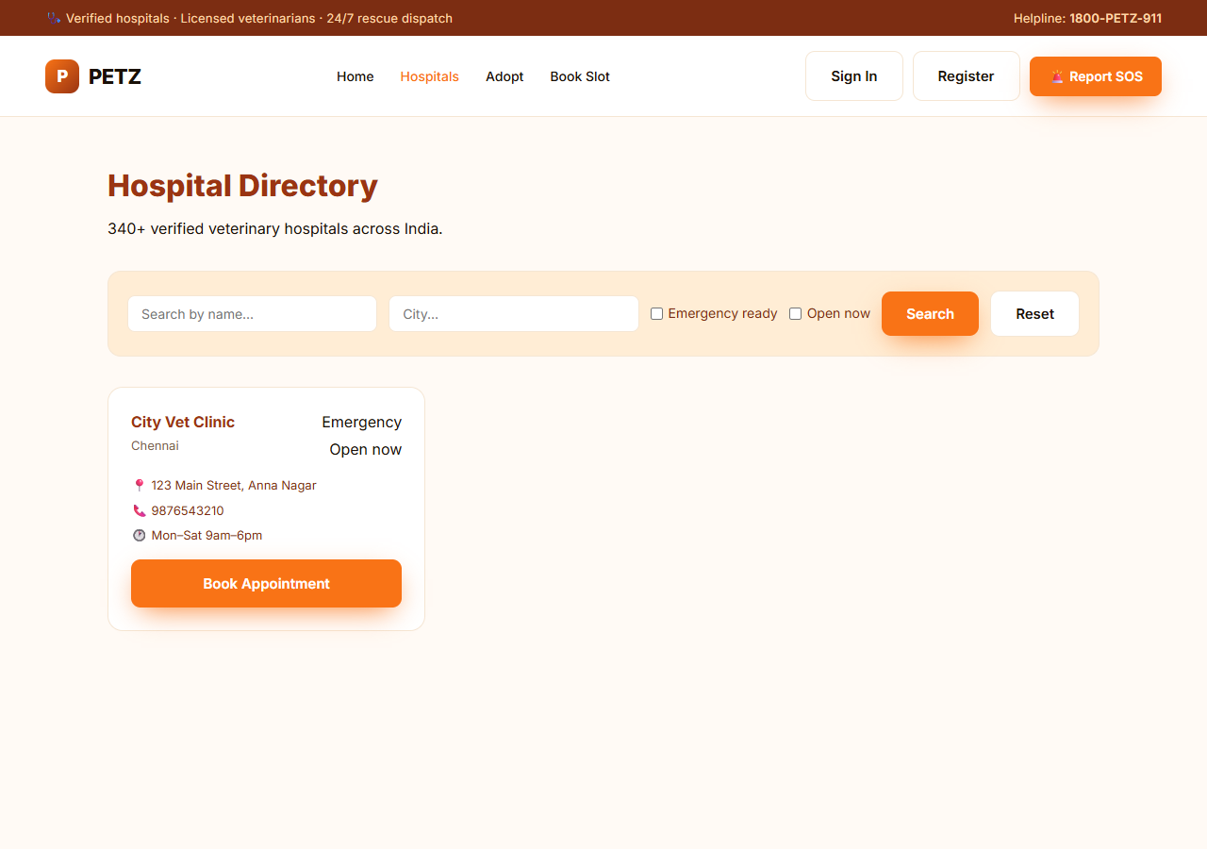
Figure 7 — Hospital directory list with filters

Functional requirements
Req ID | Description | Role | Priority
FR-HOSP-01 | GET /hospitals returns hospitals with isVerified=true; default sort by GPS distance. | All | High
FR-HOSP-02 | Filter by name, city, emergencyReady, openNow via /hospitals/search query params. | All | High
FR-HOSP-03 | Hospital card shows name, city, address, contact phone, operating hours, Emergency badge, Open-now / Closed badge. | All | Medium
FR-HOSP-04 | Each hospital card has a "Book Appointment" CTA that navigates to /book with that hospital pre-selected. | Auth | High
FR-HOSP-05 | Hospital profile (/hospitals/{id}) lists services, doctors, and distance from user. | All | Medium

Test scenarios
Test ID | Test Case | Steps | Expected Result
TC-HOSP-01 | List loads | Open /hospitals. | List of verified hospitals renders within 5s; spinner disappears.
TC-HOSP-02 | City filter | Type "Mumbai" in city, click Search. | List re-fetches; shows only Mumbai hospitals or empty state.
TC-HOSP-03 | Emergency filter | Tick "Emergency ready" and Search. | Only hospitals with emergencyReady=true are returned.
TC-HOSP-04 | Reset filters | Click Reset. | All filter inputs cleared; full list reloads.

4.5 Appointment Booking Wizard (5 steps)
Authenticated five-step wizard. State persists in sessionStorage under key "petz.booking" so the user can navigate back/forward without losing progress.
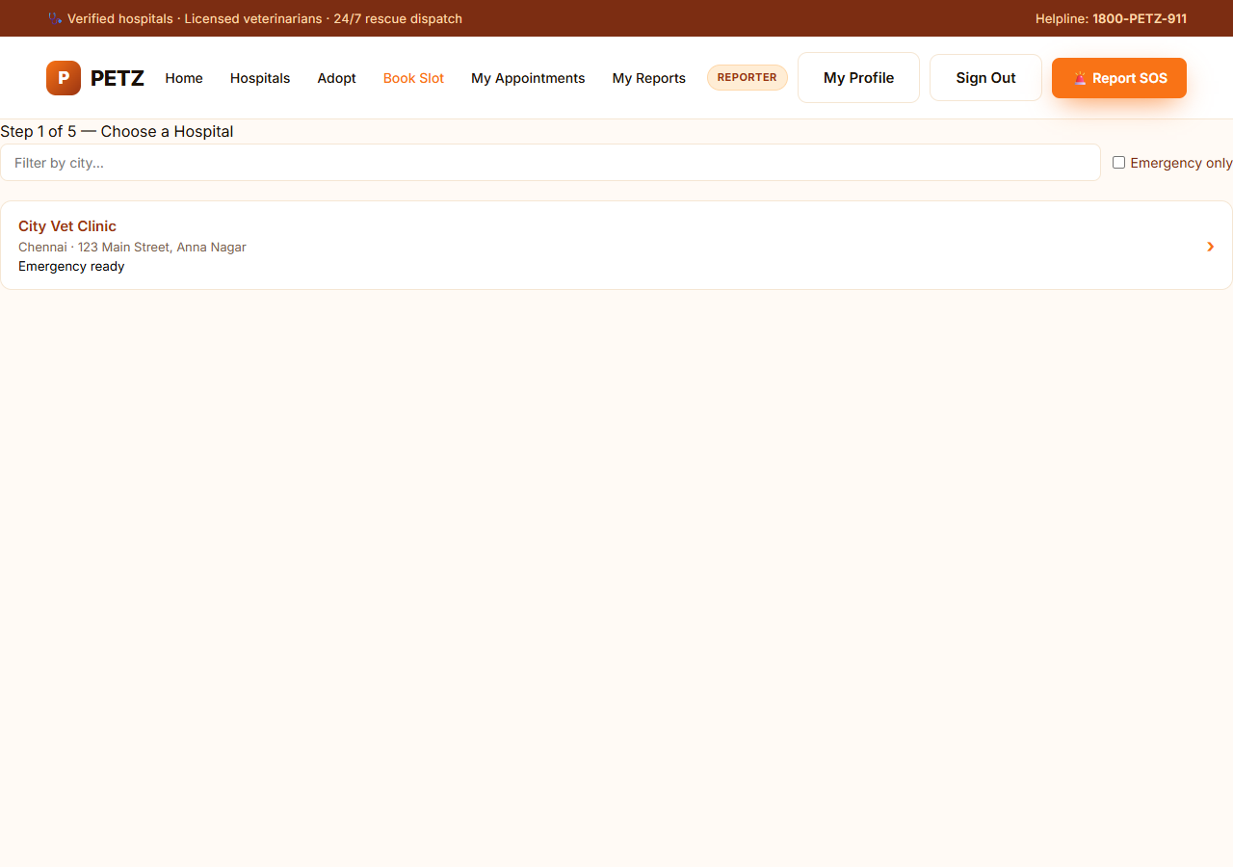
Figure 8 — Booking step 1: choose hospital

Functional requirements
Req ID | Description | Role | Priority
FR-BOOK-01 | Step 1 — Hospital: list hospitals; selecting one stores hospitalId and advances to /book/service. | Auth | High
FR-BOOK-02 | Step 2 — Service: list services for the chosen hospital. | Auth | High
FR-BOOK-03 | Step 3 — Doctor: list doctors at the hospital; show name, specialisation, availability. | Auth | High
FR-BOOK-04 | Step 4 — Slot: GET /hospitals/{hospitalId}/slots?date=… and filter client-side by doctor and (optionally) service. | Auth | High
FR-BOOK-05 | Step 5 — Pet: list user’s pets via /users/{userId}/pets; "Add a new pet" form posts to the same path. | Auth | High
FR-BOOK-06 | Review & Confirm: POST /appointments/lock with {slotId,userId} → returns 2-minute hold; countdown is displayed. | Auth | Critical
FR-BOOK-07 | Confirm: POST /appointments/confirm with {slotId,userId,petId,bookingType=ROUTINE} → returns appointmentId and confirmation details. | Auth | Critical
FR-BOOK-08 | Lock expiry shows error and offers "Choose another slot". | Auth | High

Test scenarios
Test ID | Test Case | Steps | Expected Result
TC-BOOK-01 | Happy path booking | Complete all 5 steps with a valid pet. | "Appointment Confirmed!" page; appointment appears in /appointments.
TC-BOOK-02 | Empty slots | Pick a date with no slots. | "No available slots on this date." message; date picker remains usable.
TC-BOOK-03 | Lock countdown | Reach Review & Confirm; wait 2 min without confirming. | Countdown reaches 00:00; error "Your slot lock expired" is shown.
TC-BOOK-04 | New pet creation | In step 5 click "+ Add a new pet", fill form, save. | Pet saved; appears in list and is auto-selected.
TC-BOOK-05 | Auth guard | Without session, open /book. | Redirects to /login.

4.6 User History (My Reports & My Appointments)
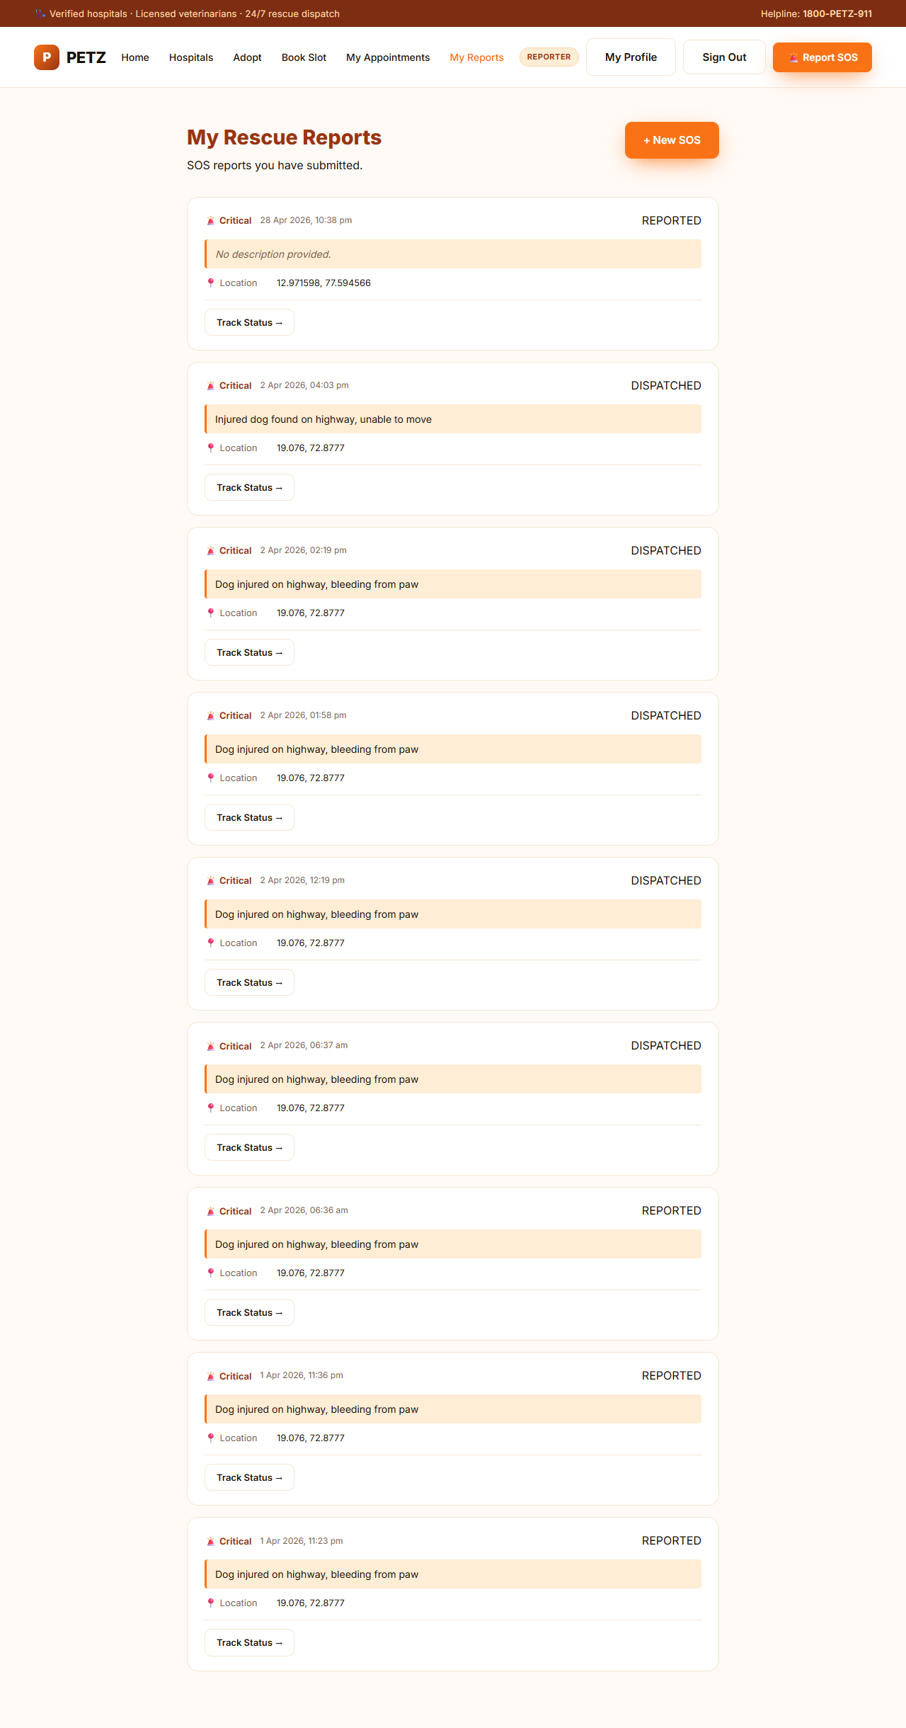
Figure 9 — My Rescue Reports
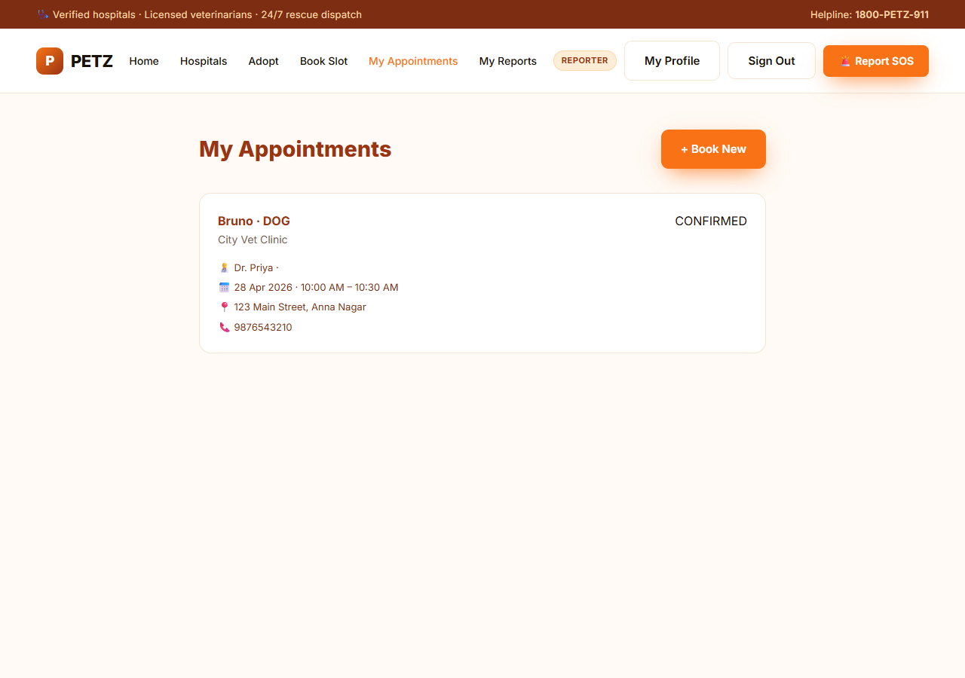
Figure 10 — My Appointments

Functional requirements
Req ID | Description | Role | Priority
FR-HIST-01 | /my-reports calls GET /users/{userId}/rescue-history; renders a card per report with urgency, status, location, description. | Auth | High
FR-HIST-02 | Each report card has "Track Status" link to /sos/report/{id}/status. | Auth | Medium
FR-HIST-03 | /appointments calls GET /users/{userId}/appointments; renders a card per appointment with hospital, doctor, date, time. | Auth | High
FR-HIST-04 | Empty state shown when there are no reports / no appointments, with a CTA to create one. | Auth | Medium

Test scenarios
Test ID | Test Case | Steps | Expected Result
TC-HIST-01 | Reports list | Sign in as a reporter who has submitted SOS. | All reports listed in reverse chronological order.
TC-HIST-02 | No reports empty state | Sign in as fresh user. | "No reports yet" message + CTA to /sos/report.
TC-HIST-03 | Appointment status | After confirming a booking, open /appointments. | New appointment appears with status CONFIRMED.

4.7 Adoption Network
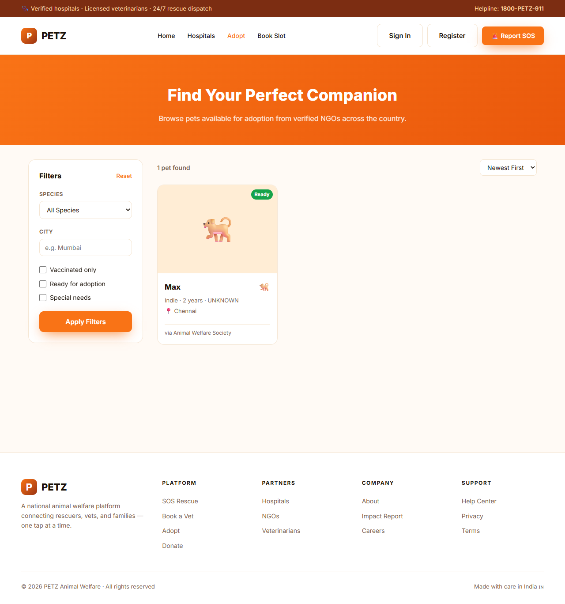
Figure 11 — Adopt browse with filters
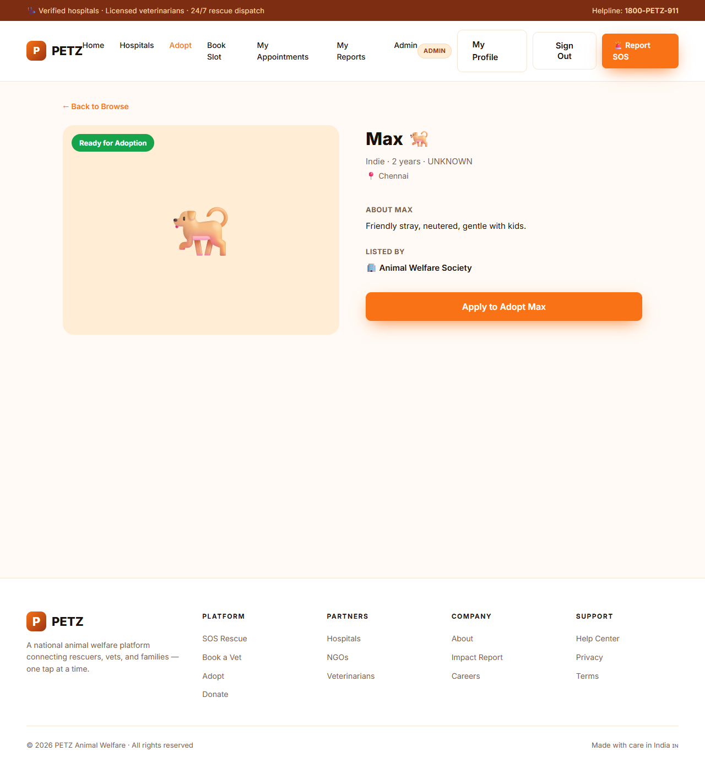
Figure 12 — Adoption detail page

Functional requirements
Req ID | Description | Role | Priority
FR-ADOPT-01 | GET /adoptable-pets returns paginated LISTED pets with media; default sort newest first. | All | High
FR-ADOPT-02 | Filters: species, city, vaccinatedOnly, readyForAdoption, specialNeeds. | All | High
FR-ADOPT-03 | Pet card shows photo (or species icon), name, breed, age, gender, city, NGO name, "Ready" / "Pending" badge. | All | Medium
FR-ADOPT-04 | Detail page (/adopt/:id) loads via GET /adoptable-pets/{id}; shows description, temperament, medical summary, vaccination status, NGO, contact. | All | High
FR-ADOPT-05 | "Apply to Adopt" CTA is auth-gated; unauthenticated users are bounced to /login with redirect query param. | All | High
FR-ADOPT-06 | /adopt/:id/apply submits an AdoptionApplication; appears in NGO review queue. | Adopter | High

Test scenarios
Test ID | Test Case | Steps | Expected Result
TC-ADOPT-01 | Browse loads | Open /adopt. | Pets render; "0 pets found" never appears unless backend genuinely empty.
TC-ADOPT-02 | Filter by species | Pick "Cat" in species filter. | List re-fetches; only cats shown.
TC-ADOPT-03 | Detail page | Click a pet card. | Navigates to /adopt/{id}; full profile renders.
TC-ADOPT-04 | Apply requires auth | On detail page, click "Apply to Adopt" while logged out. | Redirects to /login with redirect=/adopt/{id}/apply.

4.8 NGO Portal
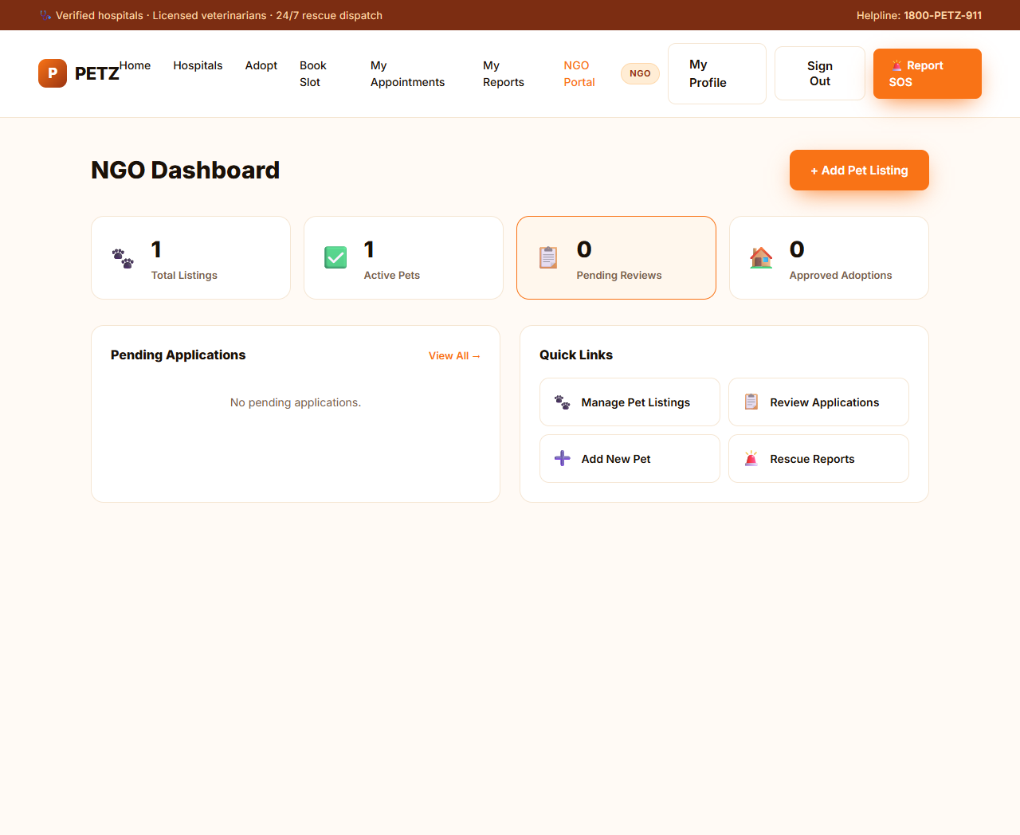
Figure 13 — NGO dashboard
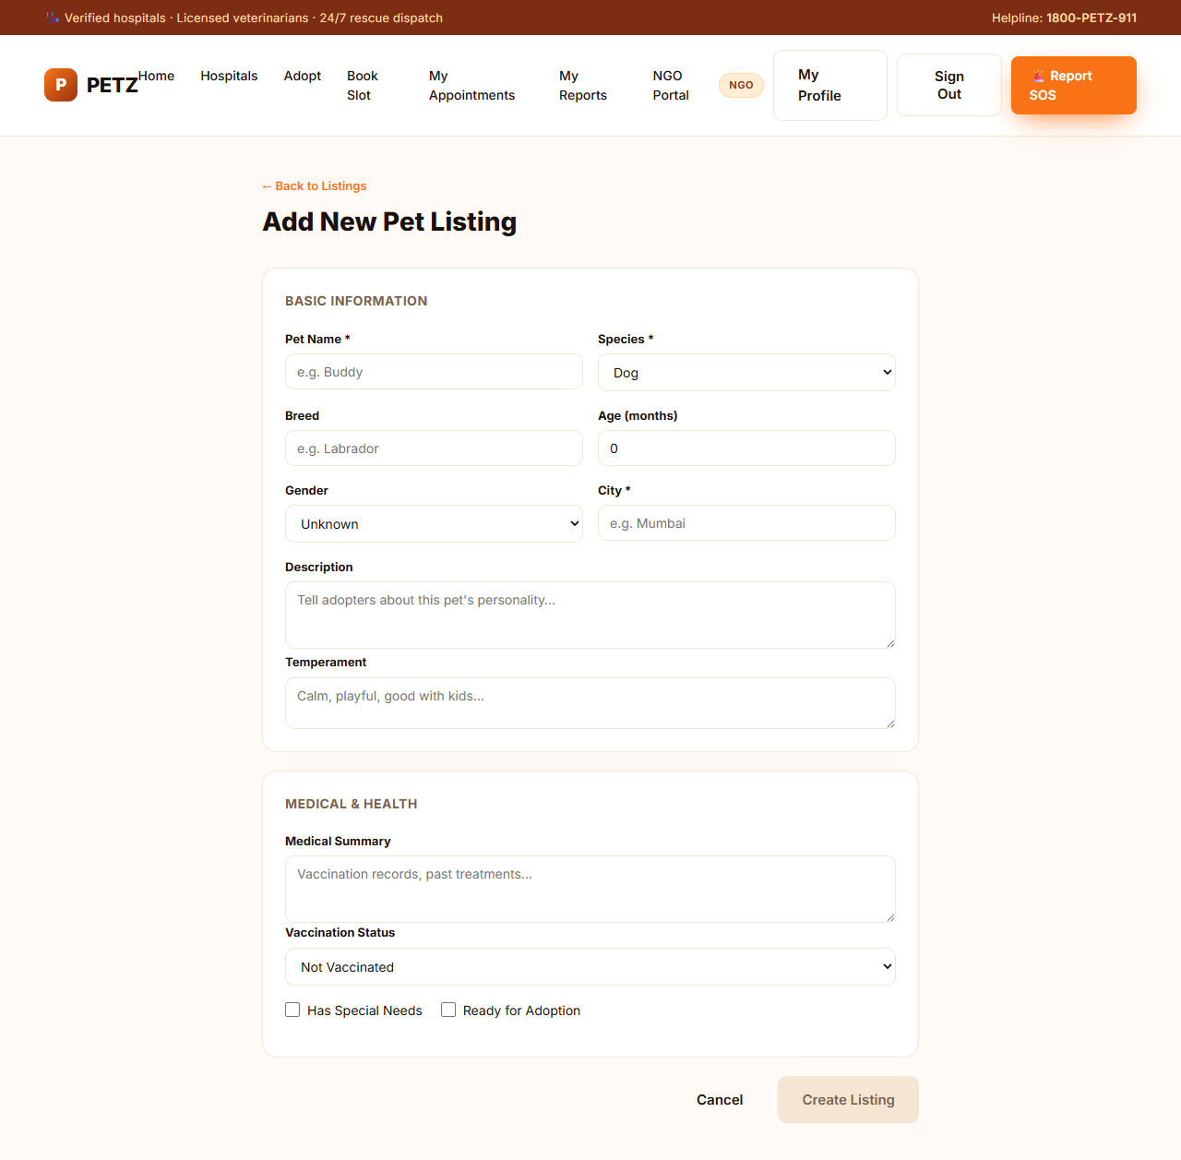
Figure 14 — Add new pet listing
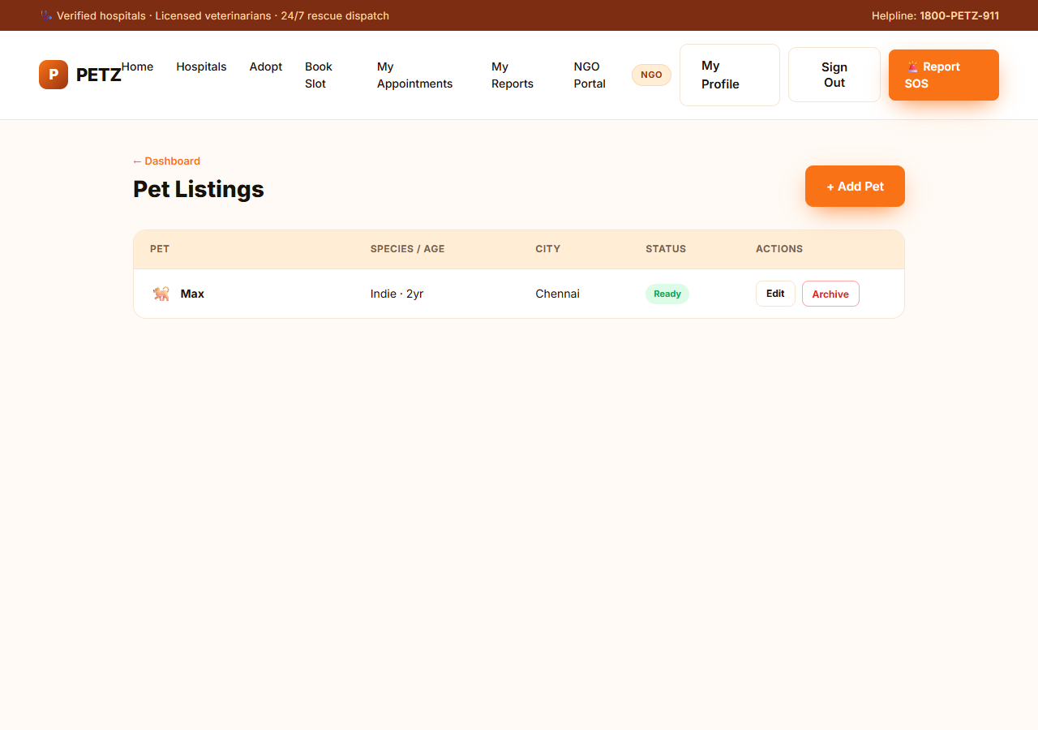
Figure 15 — NGO pet listings

Functional requirements
Req ID | Description | Role | Priority
FR-NGO-01 | /ngo/dashboard shows total listings, active pets, pending reviews, approved adoptions, and a Pending Applications widget. | NGO_REP | High
FR-NGO-02 | POST /api/v1/ngo/adoptable-pets creates a listing with pet name, species, breed, age, gender, city, description, temperament, medical summary, vaccination status, special-needs flag, adoption-ready flag. | NGO_REP | High
FR-NGO-03 | /ngo/pets lists this NGO's pets with status; Edit and Archive actions per row. | NGO_REP | High
FR-NGO-04 | /ngo/queue lists incoming rescue missions for this NGO; Accept and Decline actions. | NGO_REP | High
FR-NGO-05 | /ngo/missions/:id shows mission detail and on-site update controls. | NGO_REP | High
FR-NGO-06 | /ngo/adoptions lists adoption applications; /ngo/adoptions/:id/review shows review controls. | NGO_REP | High

Test scenarios
Test ID | Test Case | Steps | Expected Result
TC-NGO-01 | Create pet listing | Login as ngo@petz.dev → /ngo/pets/new → fill form → Create Listing. | Pet appears on /ngo/pets and is visible to public on /adopt.
TC-NGO-02 | Public view picks up listing | After NGO creates pet, open /adopt as a guest. | Pet card is visible with NGO name "via Animal Welfare Society".
TC-NGO-03 | Accept rescue mission | Submit an SOS report; login as NGO; /ngo/queue → Accept. | Mission moves to ACCEPTED and appears in NGO's active missions.

4.9 Admin Portal
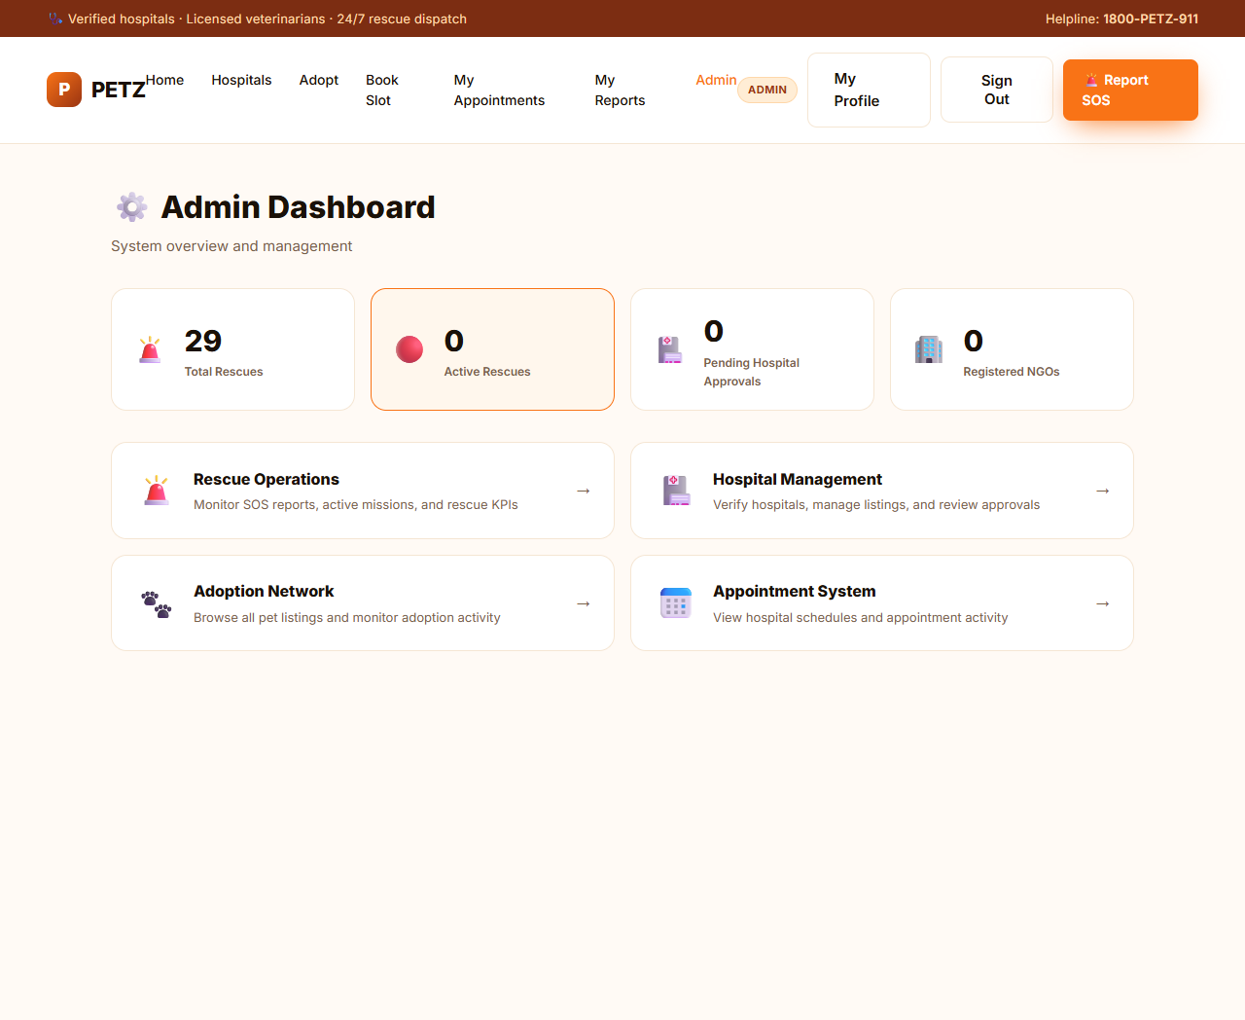
Figure 16 — Admin dashboard
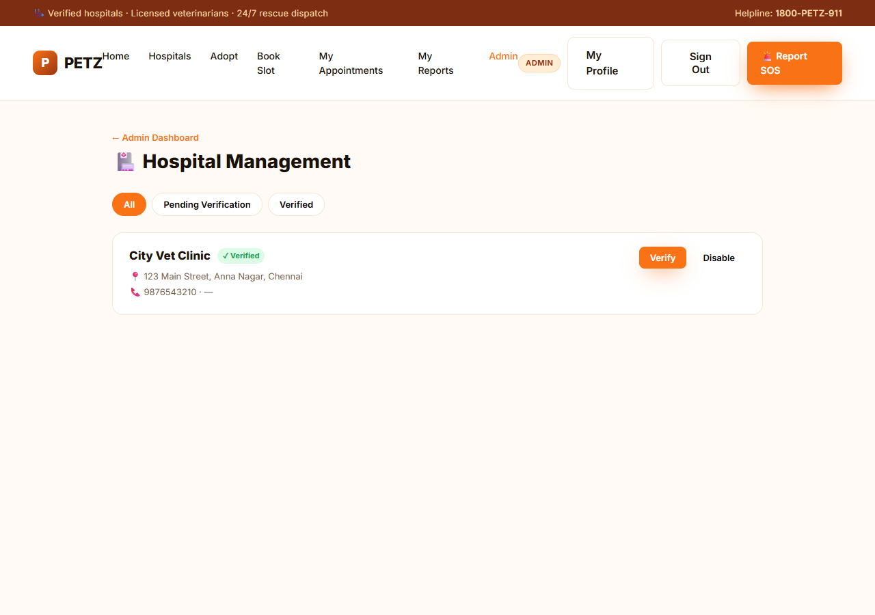
Figure 17 — Admin hospital management
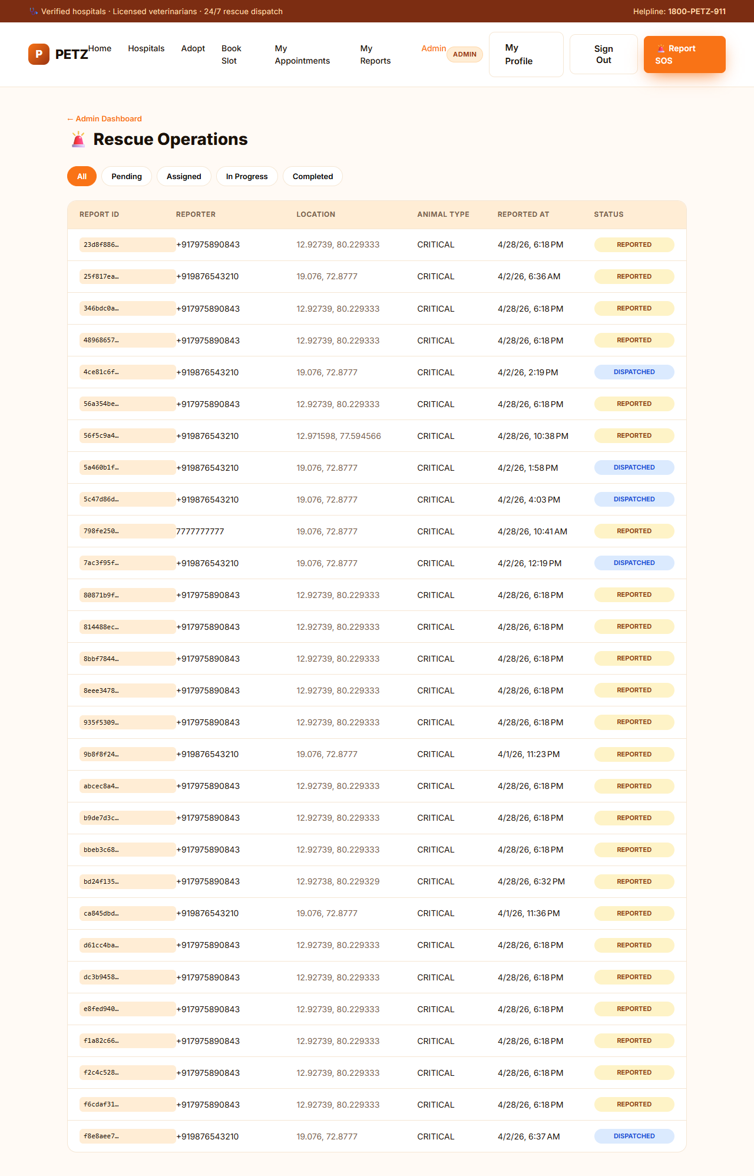
Figure 18 — Admin rescue operations

Functional requirements
Req ID | Description | Role | Priority
FR-ADMIN-01 | /admin loads KPIs (Total Rescues, Active Rescues, Pending Hospital Approvals, Registered NGOs) via GET /admin/kpis. | ADMIN | High
FR-ADMIN-02 | /admin/hospitals lists hospitals; tabs filter All / Pending Verification / Verified. | ADMIN | High
FR-ADMIN-03 | /admin/rescues lists active rescue missions via GET /admin/rescues/live; filter by status. | ADMIN | High
FR-ADMIN-04 | Reassign rescue mission via PATCH /admin/rescues/{sosReportId}/reassign. | ADMIN | Medium

Test scenarios
Test ID | Test Case | Steps | Expected Result
TC-ADMIN-01 | Dashboard KPIs | Login as admin → /admin. | Total Rescues equals total SOS count from /admin/kpis.
TC-ADMIN-02 | Filter rescues | On /admin/rescues click "Pending". | Only REPORTED rescues are listed.
TC-ADMIN-03 | Hospital tabs | Click "Verified" on /admin/hospitals. | Only verified hospitals visible.

4.10 Cross-cutting Concerns
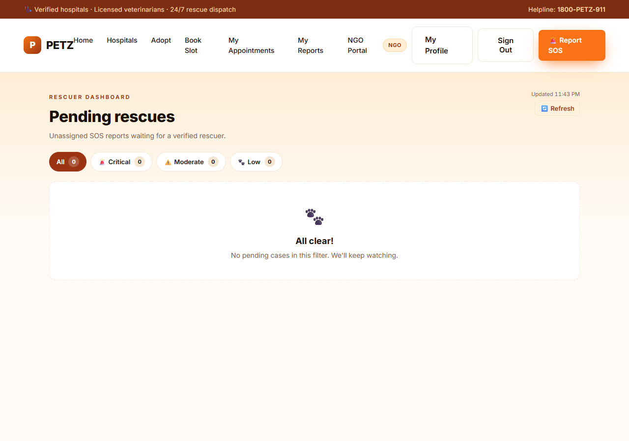
Figure 19 — NGO mission queue
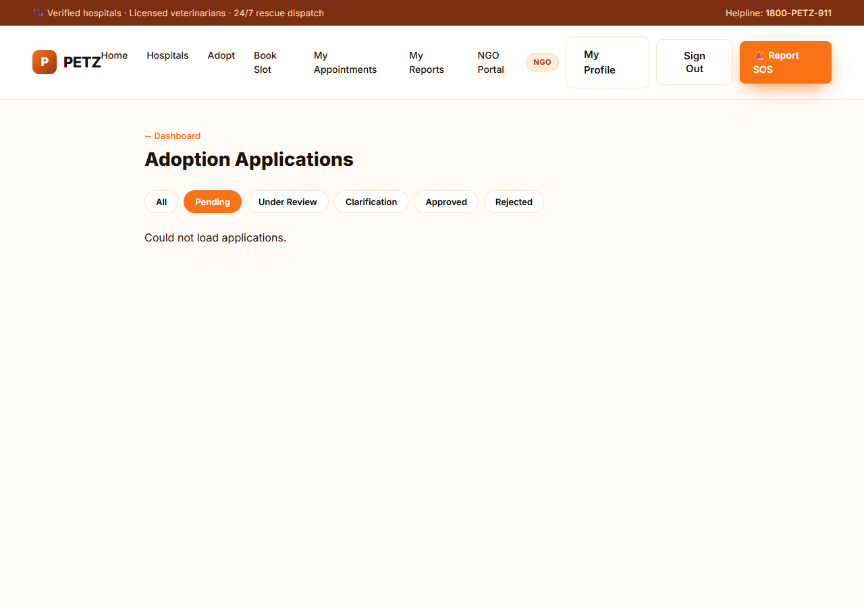
Figure 20 — NGO adoption review

Cross-cutting requirements
Req ID | Description | Role | Priority
FR-X-01 | Every async page must show a loading state and an error state distinct from the empty state. | All | High
FR-X-02 | JWT bearer token is auto-injected by HTTP interceptor on all outgoing API calls. | All | High
FR-X-03 | CORS preflight (OPTIONS) is permitted for all paths so authenticated requests succeed cross-origin. | System | High
FR-X-04 | Buttons that are not form submitters use type="button" to avoid accidental submissions. | All | Medium
FR-X-05 | All text inputs round-trip without losing apostrophes / unicode characters. | All | Medium

5. Acceptance Criteria & Exit Criteria for QA

5.1 Acceptance Criteria
- All test scenarios in §4 pass on a fresh build with seeded data.
- Emergency SOS flow completes in under 30 seconds end-to-end.
- No console errors on home, hospitals, adopt, /admin, /ngo/dashboard.
- All 401/403/404 responses surface a user-friendly message; never raw stack traces.

5.2 Known Limitations / Out-of-scope for v1.0
- Admin "Verify hospital" and "Disable hospital" actions are not yet wired to backend endpoints; UI buttons render but POSTs return 404.
- Hospital service price field is null in seed data; pricing UI is suppressed.
- Booking wizard does not auto-release the slot lock if the user navigates back; it expires after 2 minutes regardless.
- Phone-OTP login still uses Firebase; for QA convenience, use the email/phone + password mode instead.
- Adoptable pet listing does not yet support image upload; pets show species icon as placeholder.

6. Test Environment & Credentials

6.1 URLs
- Frontend: http://localhost:4200
- Backend: http://localhost:8081/api/v1
- Database: MySQL on localhost:3306, schema petz_db

6.2 Test Accounts
Role | Identifier | Password
ADMIN | admin@petz.dev | Petz@1234
NGO_REP | ngo@petz.dev | Petz@1234
REPORTER (temp) | +919876543210 | — (no password, use SOS quick-session)

6.3 Browser support
- Chrome ≥ 120 (primary).
- Edge ≥ 120 and Firefox ≥ 120 expected to work; not separately verified.
- iOS Safari and Android Chrome must render mobile drawer and EMERGENCY button without horizontal scroll.

6.4 Reporting Defects
Defects should include: page URL, role used, steps to reproduce, expected vs actual behaviour, screenshot of console, and HAR file if a network request is involved.

7. Sign-off
Role | Name | Signature | Date
Product Owner
Tech Lead
QA Lead

