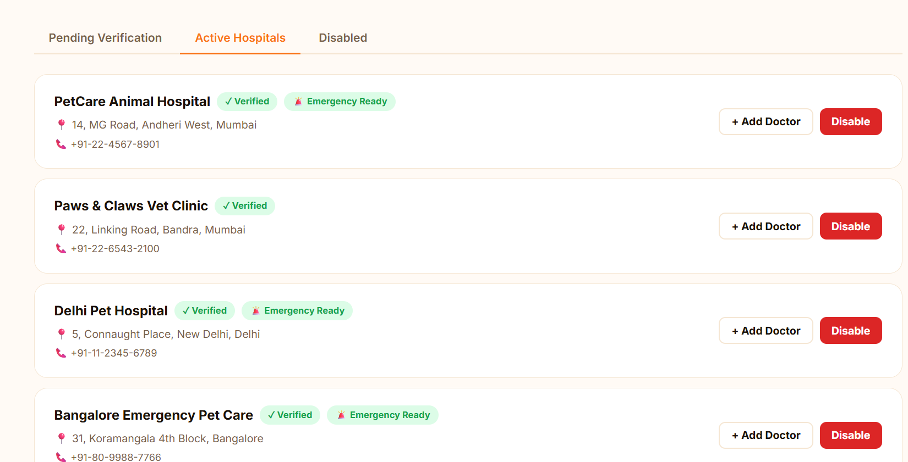
When I am disabling it , it is not getting disabled and moved to disabled section it is not getting populated as it must be
fix this, st

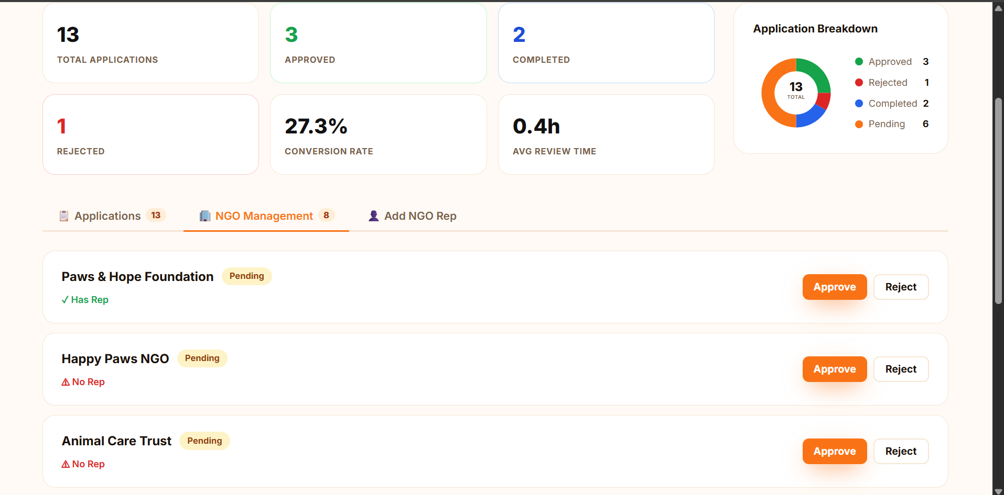
Remove this ngo management thing and keep add ngo rep and in this itself add add ngo and in that form a representative , there is no need to have ngos with no represenatatives
Only keep ngo wise animal listings , so that admin can see that how many animals a particular ngo has listed and what is the status of each animal for this you might have to create cards popup on selecting view status button build upon that idea apply your inense creativity and build it
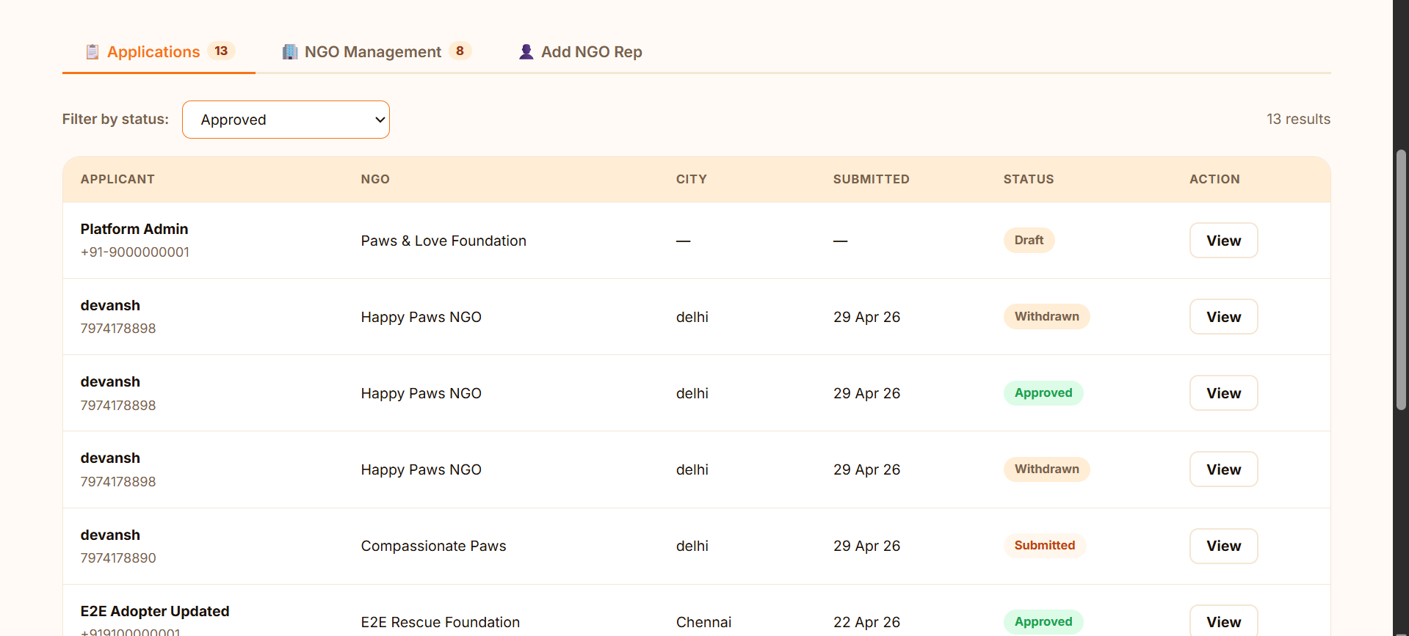that filter is not working as intended, fix this ,
Actually change it as follow remove this approval thing from admin , because approval will done by ngo for a particular pet but keep the listing and add a status view when the view button is clicked so admin can have a view on whats happening in adoption of animals which ngo is assigning what to what !!
Ask again and again to me to fix this

