*ADDITION OF TWO UNSIGNED NUMBER USING MANTISSA AND EXPONENT*

MVI D,04 //move 04 to registor D that represent exponent

MVI E,03 //move 03 to registor D that represent exponent

MVI B,20 //move 20 to registor b that represent mantissa

MVI C,C0 //move 03 to registor D that represent mantissa

MOV A,D //copy content of D in accumulator

SUB E // subtract E from accumulator

JZ ADD // jump to ADD if result is zero otherwise

MOV H,A // move content of Ai in H

MOV A,C // move content of c in accumulator

LOOP1: STC //set carry flag 1

CMC //complement carry flag

RAR // rotate content of accumulator right

STC //set carry flag 1

CMC //complement carry flag

DCR H //decrement carry flag

JNZ LOOP1 // jump to loop 1 if h is non zero

MOV C,A // move C in accumulator

ADD: MOV A,C // move C in accumulator

ADD B // add B with accumulator

STA 0060 // store the result of addition from accumulator to memory locaton 0060H

MOV A,D //move content of D in accumulator

STA 0061 // store the content of accumulator in memory location 0061

HLT // end execution of program

AFTER ASSEMBLING PROGRAM

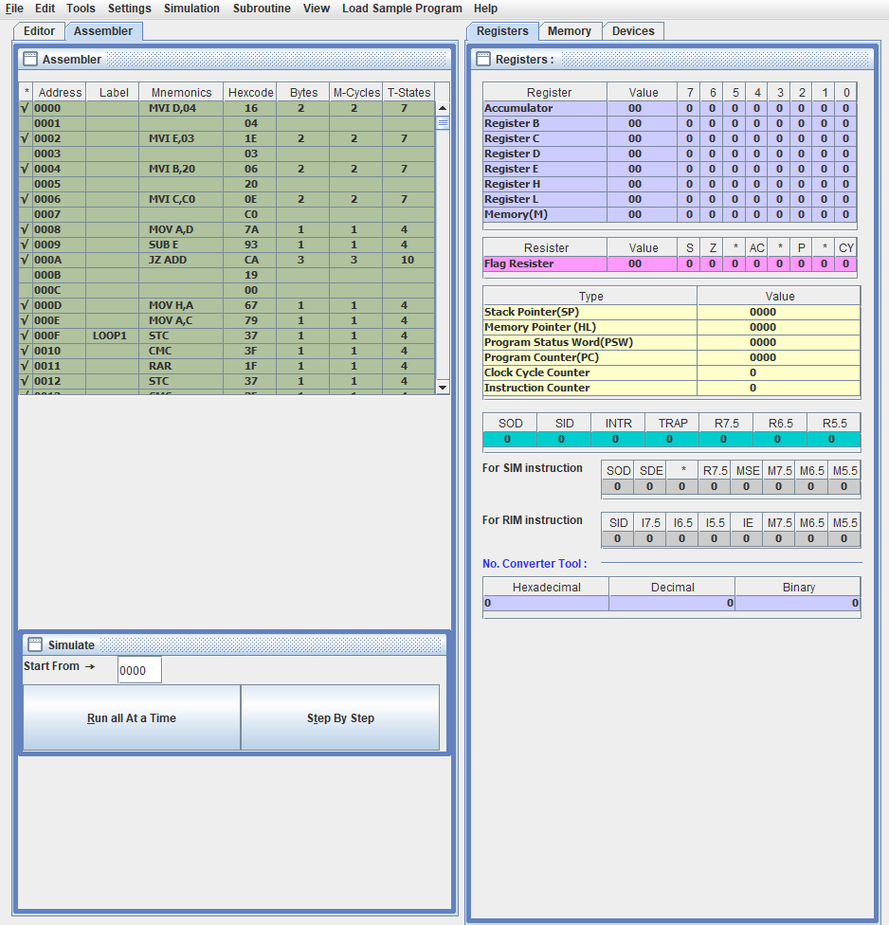

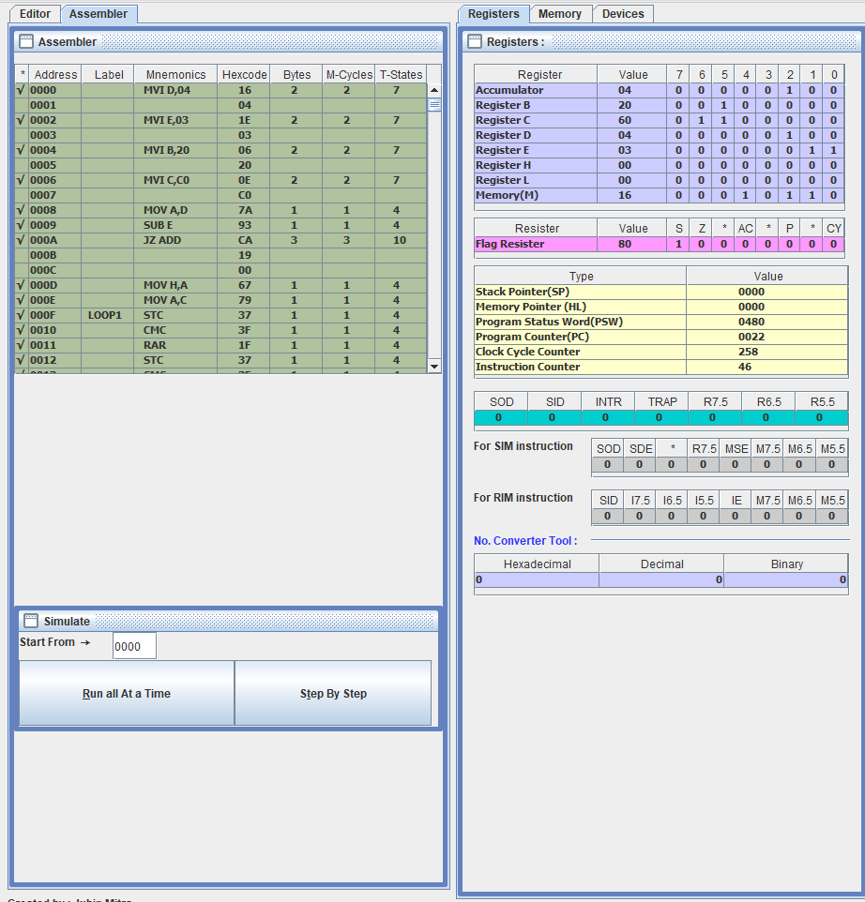

AFTER RUNNING THE PROGRAM

