Project Overview

Backend: server.js
The backend entry point configures Express, CORS, JSON parsing, static file serving, API routes, and a Cerebras connectivity check.

server.js
import express from "express";
import cors from "cors";
import dotenv from "dotenv";
import path from "path";
import fs from "fs/promises";
import { fileURLToPath } from "url";
import { initDatabase } from "./db.js";
import { listAvailableModels } from "./services/celebrasClient.js";
import documentRoutes from "./routes/documentRoutes.js";

dotenv.config();

const __filename = fileURLToPath(import.meta.url);
const __dirname = path.dirname(__filename);
const app = express();
const uploadsPath = path.join(__dirname, "../uploads");

await fs.mkdir(uploadsPath, { recursive: true });

app.use(cors());
app.use(express.json());
app.use(express.urlencoded({ extended: true }));

app.use((req, res, next) => {
console.log(`[HTTP] ${req.method} ${req.url}`);
next();
});

app.use("/uploads", express.static(uploadsPath));
app.use("/api", documentRoutes);

app.get("/", (req, res) => {
console.log("Received health check request");
res.send("Doc Intelligence Backend is running.");
});

const PORT = process.env.PORT || 5000;

const testCerebrasConnection = async () => {
try {
const models = await listAvailableModels();
if (models.length > 0) {
console.log(`✓ Cerebras API connected. Available models: ${models.map(m => m.id).join(", ")}`);
return true;
}
} catch (error) {
console.warn("⚠ Could not verify Cerebras API. Make sure your CEREBRAS_API_KEY is valid.");
}
return false;
};

initDatabase()
.then(async () => {
await testCerebrasConnection();
app.listen(PORT, () => {
console.log(`Server is running on http://localhost:${PORT}`);
});
})
.catch((error) => {
console.error("Failed to initialize database:", error);
process.exit(1);
});

Backend: documentController.js
Handles uploads, file parsing, AI extraction, database insertion, document retrieval, and search features.

documentController.js
import fs from "fs/promises";
import path from "path";
import pdfParse from "pdf-parse";
import { query } from "../db.js";
import { extractDocumentData } from "../services/celebrasClient.js";

const uploadsDir = path.resolve(process.cwd(), "uploads");

const ensureUploadsDirectory = async () => {
await fs.mkdir(uploadsDir, { recursive: true });
};

const parsePdfText = async (filePath) => {
const fileBuffer = await fs.readFile(filePath);
const data = await pdfParse(fileBuffer);
return data.text || "";
};

const parseTextFile = async (filePath) => {
return fs.readFile(filePath, "utf-8");
};

const extractTextFromFile = async (filePath, mimeType) => {
try {
if (mimeType === "application/pdf") {
return await parsePdfText(filePath);
}
return await parseTextFile(filePath);
} catch (error) {
console.warn(`Unable to parse file type ${mimeType}:`, error.message);
return "";
}
};

export const uploadDocument = async (req, res) => {
try {
console.log("Upload request received", {
fileName: req.file?.originalname,
mimeType: req.file?.mimetype,
});

await ensureUploadsDirectory();

if (!req.file) {
console.warn("Upload failed: no file provided");
return res.status(400).json({ error: "No file uploaded." });
}

const sourcePath = req.file.path;
const targetPath = path.join(uploadsDir, `${Date.now()}-${req.file.originalname}`);
await fs.rename(sourcePath, targetPath);
const fileUrl = `/uploads/${path.basename(targetPath)}`;

const text = await extractTextFromFile(targetPath, req.file.mimetype);
console.log("File text extracted", { length: text.length, mimeType: req.file.mimetype });
const extractedData = await extractDocumentData(text);
console.log("Document extraction result", { extractedData });

const result = await query(
`INSERT INTO documents (file_name, file_path, full_text, vendor, invoice_number, invoice_date, amount, processed)
VALUES (?, ?, ?, ?, ?, ?, ?, ?)`,
[
req.file.originalname,
targetPath,
text,
extractedData.vendor || null,
extractedData.invoice_number || null,
extractedData.invoice_date || null,
extractedData.amount || null,
1,
]
);

const documentId = result.insertId;

await query(
`INSERT INTO document_extracts (document_id, data)
VALUES (?, ?)`,
[documentId, JSON.stringify(extractedData)]
);

const document = {
id: documentId,
file_name: req.file.originalname,
file_path: targetPath,
file_url: fileUrl,
vendor: extractedData.vendor || null,
invoice_number: extractedData.invoice_number || null,
invoice_date: extractedData.invoice_date || null,
amount: extractedData.amount || null,
processed: true,
extracted_data: extractedData,
};

return res.status(201).json(document);
} catch (error) {
console.error("Upload error:", error);
return res.status(500).json({ error: error.message || "Upload failed." });
}
};

Backend: celebrasClient.js
Configures Cerebras AI client, lists models, and sends invoice extraction prompts. It parses AI responses into structured JSON.

celebrasClient.js
import Cerebras from "@cerebras/cerebras_cloud_sdk";
import dotenv from "dotenv";

dotenv.config();

const apiKey = process.env.CEREBRAS_API_KEY;
const model = process.env.CEREBRAS_MODEL || "llama-3.1-70b-instruct";

if (!apiKey || apiKey.startsWith("your-")) {
throw new Error(
"Missing or placeholder CEREBRAS_API_KEY in environment configuration. Please set your Cerebras API key from https://console.cerebras.ai"
);
}

const client = new Cerebras({
apiKey,
});

export const listAvailableModels = async () => {
try {
console.log("Listing Cerebras models...");
const models = await client.models.list();
console.log(`Retrieved ${models.data?.length || 0} models from Cerebras`);
return models.data || [];
} catch (error) {
console.warn("Could not list models:", error.message);
return [];
}
};

const extractionPrompt = (text) => `Extract the key fields from the following invoice document text in valid JSON format with these exact keys: vendor, invoice_number, invoice_date, amount, summary, line_items.

Document text:
"""
${text}
"""

Return only valid JSON with these keys. Use null for missing values. For amount, extract the total amount as a number (without currency symbol). For line_items, provide an array of item descriptions if available.`;

export const extractDocumentData = async (text) => {
try {
console.log("Sending text extraction request to Cerebras", { model, textLength: text.length });
const response = await client.chat.completions.create({
messages: [
{
role: "system",
content:
"You are a document intelligence assistant that extracts invoice and purchase-order fields from raw text. Always respond with valid JSON only.",
},
{
role: "user",
content: extractionPrompt(text),
},
],
model,
temperature: 0.0,
max_tokens: 500,
});

const content = response?.choices?.[0]?.message?.content || "";
console.log("Received Cerebras response", { contentLength: content.length });

try {
return JSON.parse(content);
} catch (parseError) {
const jsonMatch = content.match(/\{[\s\S]*\}/);
if (jsonMatch) {
try {
return JSON.parse(jsonMatch[0]);
} catch (secondParseError) {
console.warn("Failed to parse extracted JSON:", secondParseError.message);
}
}
console.warn("AI response was not valid JSON, using fallback:", content);
return {
vendor: null,
invoice_number: null,
invoice_date: null,
amount: null,
summary: content.substring(0, 200),
line_items: [],
};
}
} catch (error) {
console.error("Cerebras API Error:", error);
console.error("Current model:", model);
console.error("Available models can be found at: https://console.cerebras.ai/");
throw new Error(`Failed to extract document data: ${error.message}`);
}
};

Frontend: api.js
Defines Axios API functions for document upload, list fetch, detail fetch, and search.

api.js
import axios from "axios";

const API = axios.create({
baseURL: "http://localhost:5000/api",
});

API.interceptors.request.use((request) => {
console.log(`[API] Request: ${request.method.toUpperCase()} ${request.url}`
{
data: request.data,
params: request.params,
});
return request;
});

API.interceptors.response.use(
(response) => {
console.log(`[API] Response: ${response.config.method.toUpperCase()} ${response.config.url}`
{
status: response.status,
});
return response;
},
(error) => {
console.error("[API] Request error:", error);
return Promise.reject(error);
}
);

export const uploadDocument = (formData) =>
API.post("/upload", formData, {
headers: { "Content-Type": "multipart/form-data" },
});

export const getDocuments = () => API.get("/documents");

export const getDocumentById = (id) => API.get(`/document/${id}`);

export const searchDocuments = (query) => API.get(`/search?q=${encodeURIComponent(query)}`);

Frontend: Dashboard.jsx
Displays summary cards, filters documents, and shows recent activity and top vendors.

Dashboard.jsx
import React, { useEffect, useState } from "react";
import { getDocuments } from "../services/api";
import { useNavigate } from "react-router-dom";

function Dashboard() {
const [documents, setDocuments] = useState([]);
const [search, setSearch] = useState("");
const navigate = useNavigate();

useEffect(() => {
console.log("Dashboard mounted, fetching documents");
fetchDocs();
}, []);

const fetchDocs = async () => {
console.log("Fetching documents from API...");
try {
const res = await getDocuments();
console.log(`Loaded ${res.data.length} documents`);
setDocuments(res.data);
} catch (error) {
console.error("Failed to load documents:", error);
setDocuments([]);
}
};

const filteredDocs = documents.filter((doc) =>
doc.file_name.toLowerCase().includes(search.toLowerCase()) ||
(doc.vendor || "").toLowerCase().includes(search.toLowerCase())
);

const totalDocs = documents.length;
const totalAmount = documents.reduce((sum, doc) => {
const amount = typeof doc.amount === "number"
? doc.amount
: parseFloat(String(doc.amount || "").replace(/[^0-9.-]+/g, ""));
return sum + (Number.isFinite(amount) ? amount : 0);
}, 0);

const formatAmount = (value) =>
value.toLocaleString("en-IN", { minimumFractionDigits: 2, maximumFractionDigits: 2 });

const formatDate = (value) => {
const date = new Date(value);
if (Number.isNaN(date.getTime())) return "Unknown time";
return date.toLocaleString("en-IN", {
year: "numeric",
month: "short",
day: "numeric",
hour: "2-digit",
minute: "2-digit",
});
};

const recentActivity = [...documents]
.sort((a, b) => new Date(b.uploaded_at) - new Date(a.uploaded_at))
.slice(0, 3)
.map((doc) => ({
label: `✔ ${doc.file_name} processed`,
time: formatDate(doc.uploaded_at),
}));

const vendorStats = documents.reduce((acc, doc) => {
const vendor = doc.vendor || "Unknown Vendor";
const amount = typeof doc.amount === "number"
? doc.amount
: parseFloat(String(doc.amount || "").replace(/[^0-9.-]+/g, ""));
if (!acc[vendor]) acc[vendor] = { count: 0, total: 0 };
acc[vendor].count += 1;
acc[vendor].total += Number.isFinite(amount) ? amount : 0;
return acc;
}, {});

const topVendors = Object.entries(vendorStats)
.sort(([, a], [, b]) => b.total - a.total)
.slice(0, 3)
.map(([vendor, stats]) => ({
label: vendor,
count: stats.count,
total: stats.total,
}));

return (
<div>
<h2 style={{ marginBottom: "20px", color: "white" }}>📊 Dashboard</h2>
...
</div>
);
}

Updated report for the Doc Intelligence project with additional frontend components.

Frontend: Upload.jsx
Handles file selection and upload to the backend API, with loading states and error handling.

Upload.jsx
import React, { useState, useRef } from "react";
import { uploadDocument } from "../services/api";

function Upload({ onUploadSuccess }) {
const [file, setFile] = useState(null);
const [loading, setLoading] = useState(false);
const fileInputRef = useRef(null);

const handleUpload = async () => {
if (!file) {
console.warn("Upload attempted without selecting a file");
return alert("Select a file");
}

console.log("Starting upload for file:", file.name);
const formData = new FormData();
formData.append("file", file);

try {
setLoading(true);
const res = await uploadDocument(formData);
console.log("Upload succeeded", res.data);
alert("Document uploaded and processed successfully!");
onUploadSuccess(res.data);
setFile(null);
if (fileInputRef.current) {
fileInputRef.current.value = "";
}
} catch (err) {
console.error("Upload failed:", err);
alert("Upload failed: " + (err.response?.data?.error || err.message));
} finally {
setLoading(false);
}
};

return (
<div>
<input type="file" ref={fileInputRef} onChange={(e) => setFile(e.target.files[0])} />
<button onClick={handleUpload}>
{loading ? "Uploading..." : "Upload"}
</button>
</div>
);
}

export default Upload;

Frontend: DocumentDetail.jsx
Fetches and displays individual document details, including the file preview and extracted data.

DocumentDetail.jsx
import React, { useEffect, useState } from "react";
import { useParams } from "react-router-dom";
import { getDocumentById } from "../services/api";
import DocumentViewer from "../components/DocumentViewer";
import ExtractedData from "../components/ExtractedData";

function DocumentDetail() {
const { id } = useParams();
const [doc, setDoc] = useState(null);

useEffect(() => {
console.log(`DocumentDetail mounted for id=${id}`);
fetchDoc();
}, []);

const fetchDoc = async () => {
console.log("Fetching document detail", { id });
try {
const res = await getDocumentById(id);
console.log("Document detail loaded", res.data);
setDoc(res.data);
} catch (error) {
console.error("Failed to load document:", error);
setDoc(null);
}
};

if (!doc) return <p style={{ color: "white" }}>Loading...</p>;

return (
<div>
<h2 style={{ color: "white" }}>📄 Document Details</h2>
<p style={{ color: "#94a3b8", marginBottom: "20px" }}>{doc.file_name}</p>

<DocumentViewer fileUrl={doc.file_url || doc.file_path} />
<ExtractedData data={doc.extracted_data || doc} />
</div>
);
}

export default DocumentDetail;

The Doc Intelligence project is a full-stack web application designed for automated document processing and intelligence extraction. It allows users to upload invoice documents (PDF or text files), automatically extract key information using AI, and store the processed data for analysis and retrieval.

Key Features:
- Document Upload: Support for PDF and text file uploads
- AI-Powered Extraction: Uses Cerebras AI to extract vendor, invoice number, date, amount, and other fields
- Data Storage: MySQL database for structured data storage
- File Management: Local file storage with web-accessible URLs
- Dashboard Analytics: Real-time statistics, recent activity, and vendor summaries
- Search Functionality: Full-text search across documents and metadata
- Document Preview: In-browser viewing of uploaded files

Technology Stack:
- Backend: Node.js with Express.js framework for REST API development
- Database: MySQL for relational data storage with connection pooling
- AI Integration: Cerebras Cloud SDK for document intelligence
- Frontend: React with Vite for fast development and modern UI
- File Processing: pdf-parse for PDF text extraction, native file system for text files
- Styling: Inline CSS with dark theme for professional appearance

Architecture Overview:
The application follows a client-server architecture with clear separation of concerns. The frontend provides an intuitive user interface for document management, while the backend handles business logic, AI processing, and data persistence. MySQL serves as the primary data store, and Cerebras AI provides the intelligence layer for document understanding.

Data Flow:
1. User uploads a document via the frontend
2. File is sent to backend and stored locally
3. Text is extracted from the file (PDF parsing or direct read)
4. Extracted text is sent to Cerebras AI for structured data extraction
5. AI response is parsed and stored in MySQL along with file metadata
6. Frontend displays processed document with extracted information
7. Dashboard aggregates data for analytics and summaries
System Architecture Diagram:
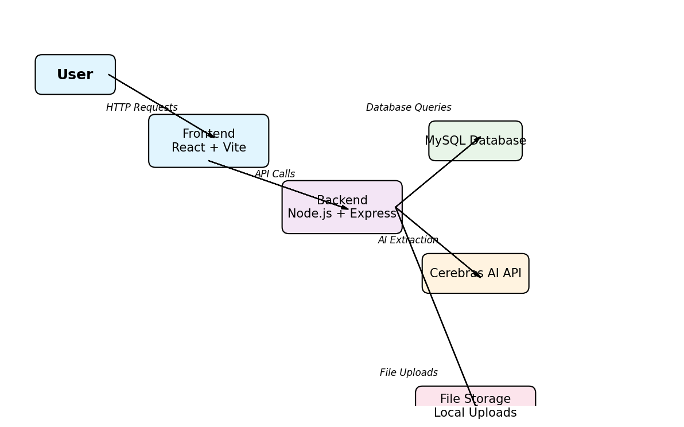
Figure 1: Doc Intelligence System Architecture

3.1: Software Requirement Specifications
The Software Requirement Specifications (SRS) document outlines the functional and non-functional requirements for the Doc Intelligence system. This section provides a comprehensive overview of what the system should do and how it should perform.

3.1.1: Functional Requirements of the Project
Functional requirements define the specific behaviors and functionalities that the system must implement.

FR1: Document Upload
The system shall allow users to upload documents (PDF and text files) through a user-friendly web interface. The maximum file size shall be configurable (default 50MB).

FR2: File Format Support
The system shall support PDF and plain text file formats. The system shall extract readable text from PDF files using the pdf-parse library.

FR3: AI-Powered Data Extraction
The system shall integrate with Cerebras AI API to extract structured information from uploaded documents. Extracted fields shall include: vendor, invoice_number, invoice_date, amount, summary, and line_items.

FR4: Data Persistence
The system shall store uploaded files locally in a secure directory and maintain metadata in MySQL database. Each document shall have a unique identifier and timestamp.

FR5: Dashboard Display
The system shall display a dashboard showing: total documents count, total amount aggregated, list of processed documents, recent activity (last 3 uploads), and top vendors by total amount.

FR6: Document Search
The system shall provide full-text search functionality allowing users to search documents by file name or vendor name.

FR7: Document Preview
The system shall allow users to view uploaded documents in a browser-based preview (iframe for text/PDF display).

FR8: Extracted Data Display
The system shall display extracted data in a formatted view with vendor, invoice number, date, amount, and other extracted fields clearly visible.

FR9: Error Handling
The system shall provide meaningful error messages for upload failures, parsing errors, and API failures.

FR10: Logging
The system shall maintain comprehensive logs of all operations (uploads, extractions, API calls) for debugging and auditing purposes.

3.1.2: Non-functional Requirements of the Project
Non-functional requirements define quality attributes and performance criteria for the system.

NFR1: Performance
The system shall process and extract data from a 10MB PDF file within 30 seconds.
The dashboard shall load within 3 seconds even with 1000+ documents.

NFR2: Scalability
The system architecture shall support horizontal scaling of backend services.
The database shall handle at least 10,000 documents without performance degradation.

NFR3: Security
The API key for Cerebras AI shall be stored securely in environment variables, never in source code.
Uploaded files shall be stored in a secure directory outside the web root.
All API endpoints shall validate input to prevent injection attacks.

NFR4: Availability
The system shall maintain 99% uptime during operational hours.
The system shall gracefully handle Cerebras API outages with fallback responses.

NFR5: Maintainability
The code shall follow modular architecture with clear separation of concerns.
All functions and modules shall have appropriate documentation.
The system shall use consistent naming conventions and coding standards.

NFR6: Usability
The user interface shall be intuitive and require minimal training.
The system shall provide clear feedback for all user actions.
Error messages shall be user-friendly and actionable.

NFR7: Compatibility
The system shall work on major browsers (Chrome, Firefox, Safari, Edge).
The backend shall run on Windows, macOS, and Linux platforms.

NFR8: Reliability
The system shall not lose data even in case of unexpected crashes.
All database operations shall use transactions to ensure data consistency.

NFR9: Integration
The system shall seamlessly integrate with Cerebras Cloud API.
The frontend and backend shall communicate via standard REST API.

3.2: Feasibility Study of the Project
The feasibility study assesses the viability of the Doc Intelligence project across technical, economic, and operational dimensions.

Technical Feasibility:
The project is technically feasible. All required technologies (Node.js, React, MySQL, Cerebras SDK) are mature, well-documented, and actively maintained. The architecture design is sound with clear separation between frontend, backend, and data layers. No novel or untested technologies are required.

Economic Feasibility:
The project has good economic feasibility:
- Most technologies used are open-source and free (Express, React, MySQL community edition)
- Cerebras API has a free tier for development and testing
- Infrastructure costs are minimal for initial deployment
- Long-term ROI is positive due to automation of document processing

Operational Feasibility:
The project is operationally feasible:
- The development team has expertise in Node.js, React, and MySQL
- Development timeline is reasonable (4-6 weeks for MVP)
- Deployment process is straightforward using Docker or traditional server deployment
- Maintenance requirements are minimal with automated logging in place

Schedule Feasibility:
The project can be completed within a reasonable timeframe:
- Backend API development: 1-2 weeks
- Database design and implementation: 1 week
- Frontend development: 2-3 weeks
- AI integration and testing: 1 week
- Bug fixes and optimization: 1 week
- Total estimated time: 6-8 weeks

3.3: Tools / Technologies / Platform used
Backend Technologies:
- Runtime: Node.js (v18+) - JavaScript runtime for server-side development
- Framework: Express.js - Lightweight web framework for building REST APIs
- Database: MySQL 8.0+ - Relational database for structured data storage
- ORM/Query: Native mysql2/promise - Database query library for Node.js
- AI Integration: Cerebras Cloud SDK - AI model access for document intelligence
- File Processing: pdf-parse - PDF text extraction library
- Environment Management: dotenv - Environment variable management
- Middleware: CORS, Body Parser - Request handling middleware

Frontend Technologies:
- Framework: React 18+ - Component-based UI library
- Build Tool: Vite - Fast module bundler and development server
- HTTP Client: Axios - Promise-based HTTP client
- Routing: React Router - Client-side routing library
- Styling: CSS-in-JS (inline styles) - Lightweight styling approach

Development Tools:
- Version Control: Git - Source code management
- Code Editor: VS Code - Lightweight, feature-rich editor
- Package Manager: npm - Node package manager
- Testing: Jest, React Testing Library (recommended for future)
- Deployment: Docker (optional) - Container orchestration

Platform/Infrastructure:
- Development: Windows/macOS/Linux with Node.js
- Server Deployment: Linux-based server or cloud platform (AWS, Azure, GCP)
- Database Hosting: MySQL server (self-hosted or managed service)
- External APIs: Cerebras Cloud API for AI intelligence

3.4: Use Case Diagrams / Data Flow Diagrams
Use Case Diagram:
The system has the following primary actors and use cases:

Actors:
- End User: Interacts with the system to upload and manage documents
- System Administrator: Maintains system health and configurations

Use Cases:
UC1: Upload Document - User uploads a PDF or text file
UC2: View Dashboard - User views aggregated statistics and recent activity
UC3: Search Documents - User searches documents by name or vendor
UC4: View Document Details - User views a specific document and extracted data
UC5: Extract Data - System processes document and extracts structured information
UC6: Store Data - System stores document and extracted data in database

Data Flow:
1. User Action: Upload file through web interface
2. Frontend Processing: Validate file type and size
3. API Call: POST /api/upload with multipart form data
4. Backend Receive: Express route receives file in /api/upload
5. File Storage: Save file to /uploads directory with timestamp
6. Text Extraction: Extract text using pdf-parse (PDF) or file system read (TXT)
7. AI Processing: Send extracted text to Cerebras AI API
8. Response Parsing: Parse AI response and structure data (vendor, amount, etc.)
9. Database Store: Insert document metadata and extracted data into MySQL
10. Response to Frontend: Return document object with file_url and extracted_data
11. UI Update: Dashboard and document list are refreshed
12. User View: User sees processed document in list and can access details

Use Case Diagram:
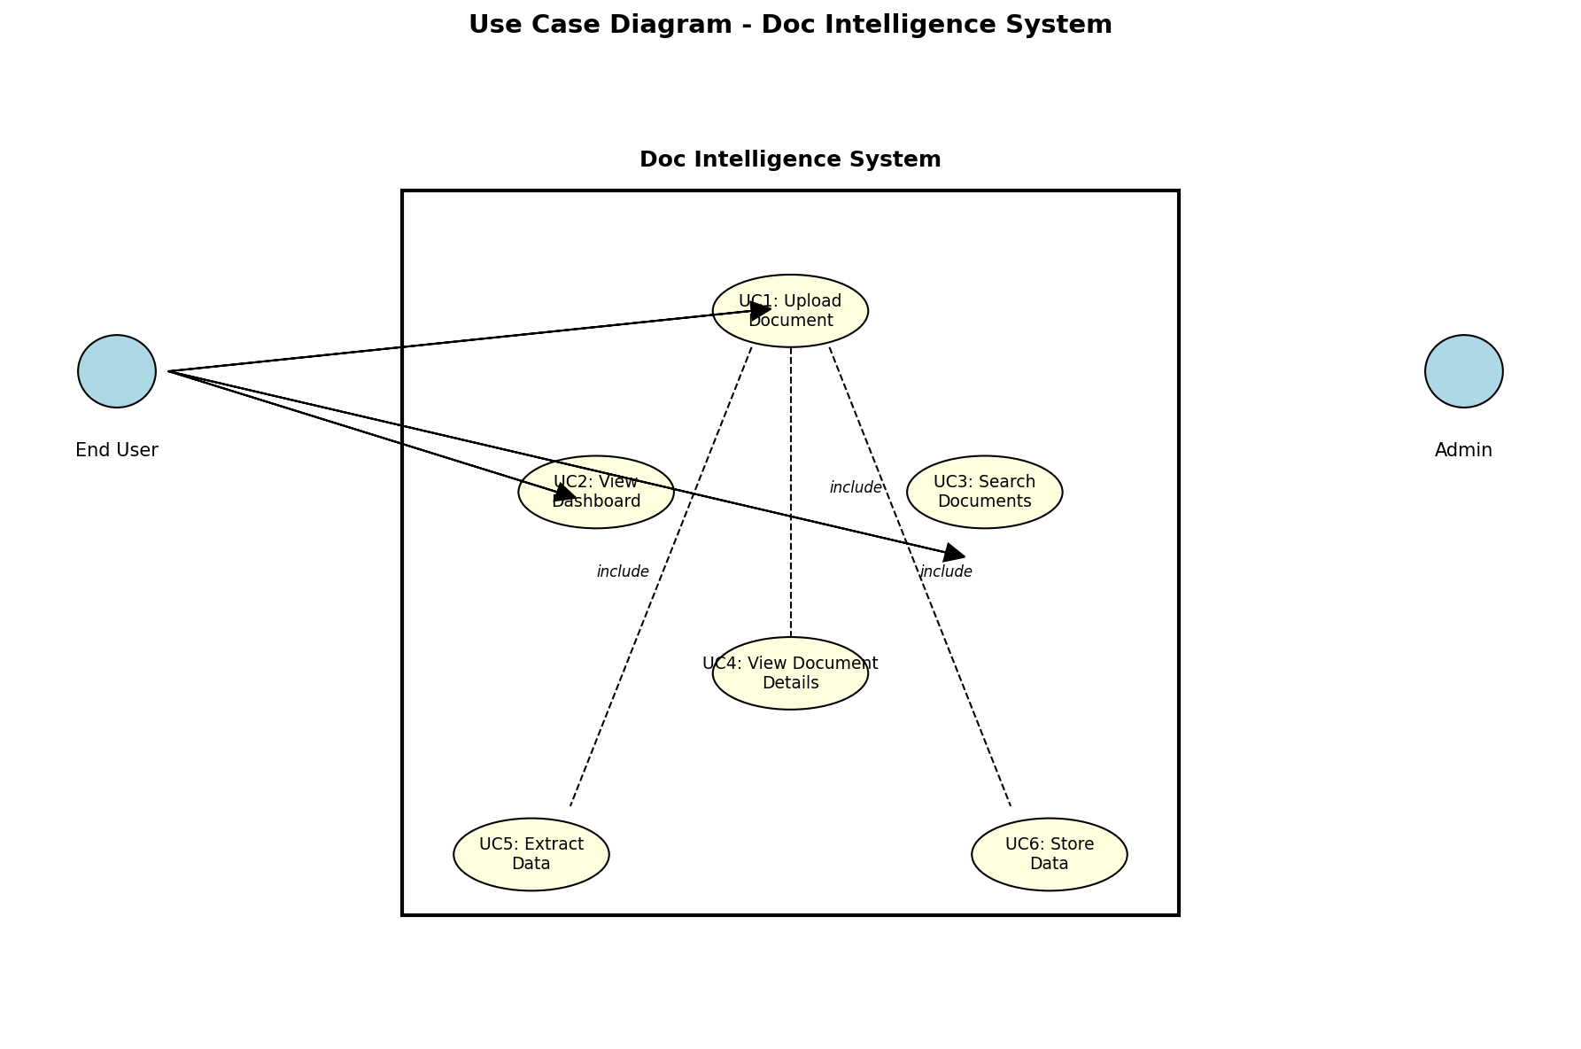
Figure 2: Use Case Diagram - Shows actors (End User, Admin) and their interactions with the system through various use cases (Upload, Dashboard, Search, View Details, Extract, Store).

Data Flow Diagram:
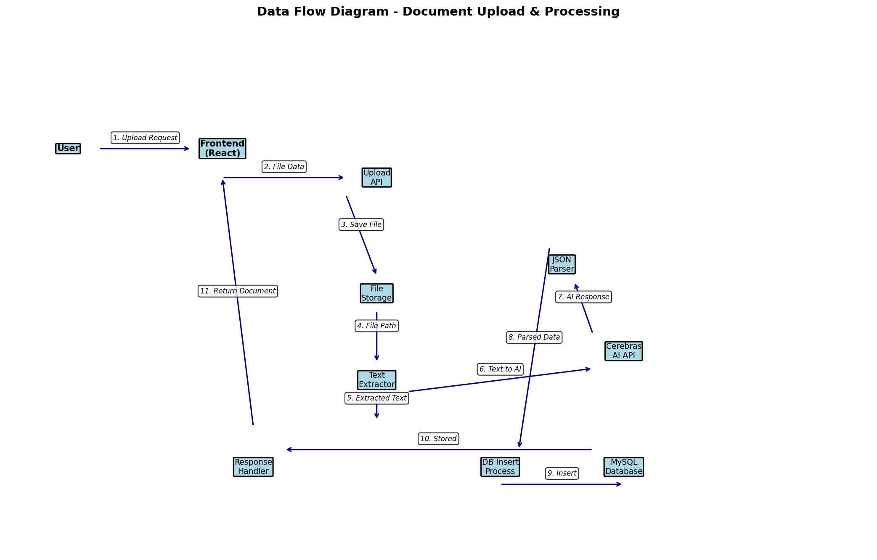
Figure 3: Data Flow Diagram - Shows the complete flow from user upload through file storage, text extraction, AI processing, JSON parsing, and finally database insertion.

Diagrams
Work Breakdown Structure (WBS) Diagram:
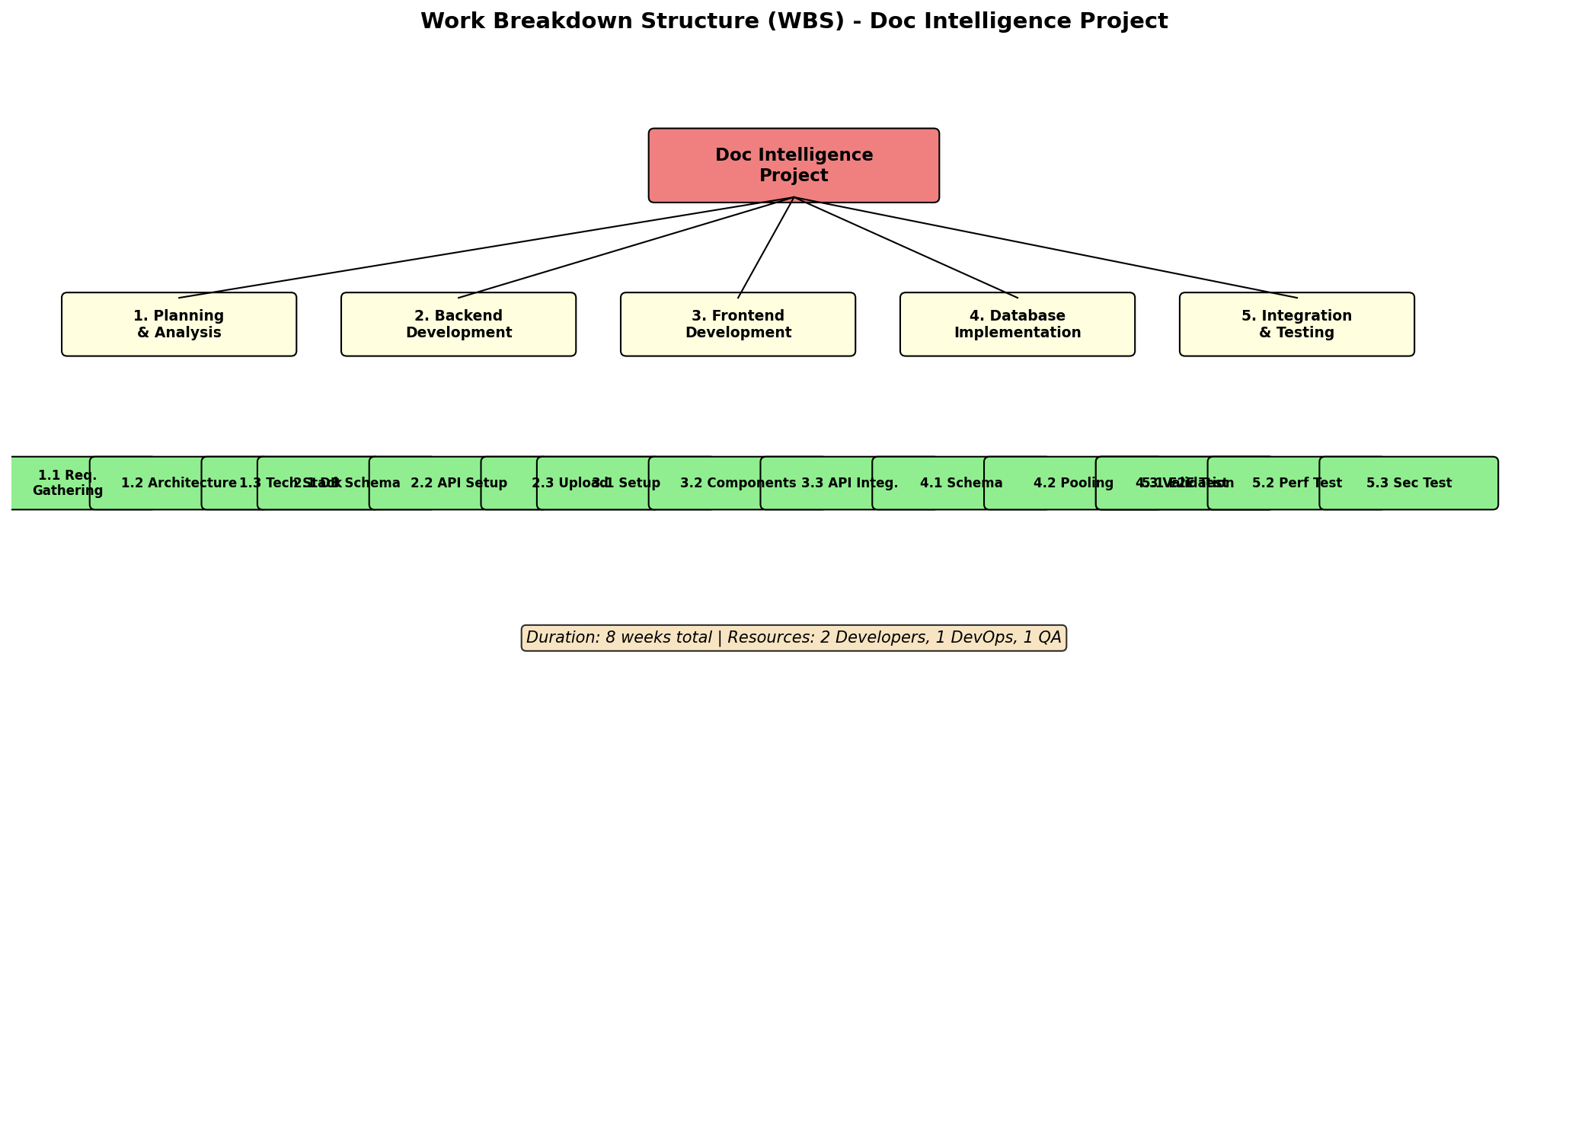
Figure 4: WBS showing project decomposition into 6 main phases with detailed subtasks, timeline, and resources.

Activity Diagram - Document Upload Flow:
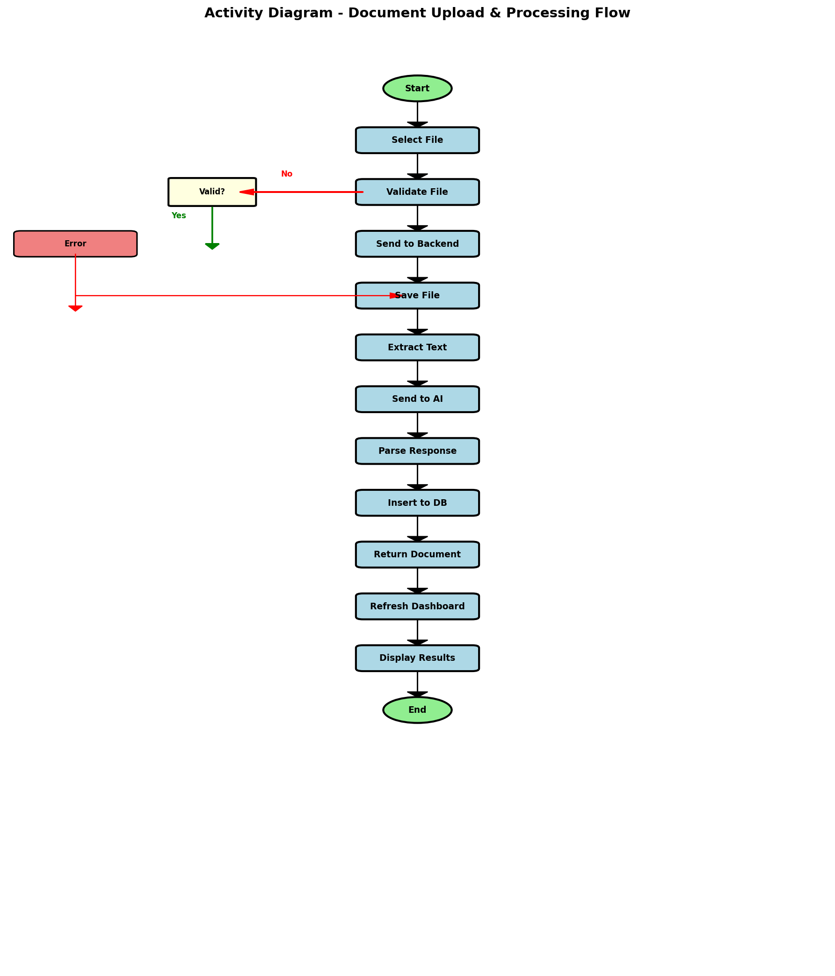
Figure 5: Activity diagram showing the sequential flow of document upload, validation, processing, AI extraction, and database storage.

Entity-Relationship (ER) Diagram:
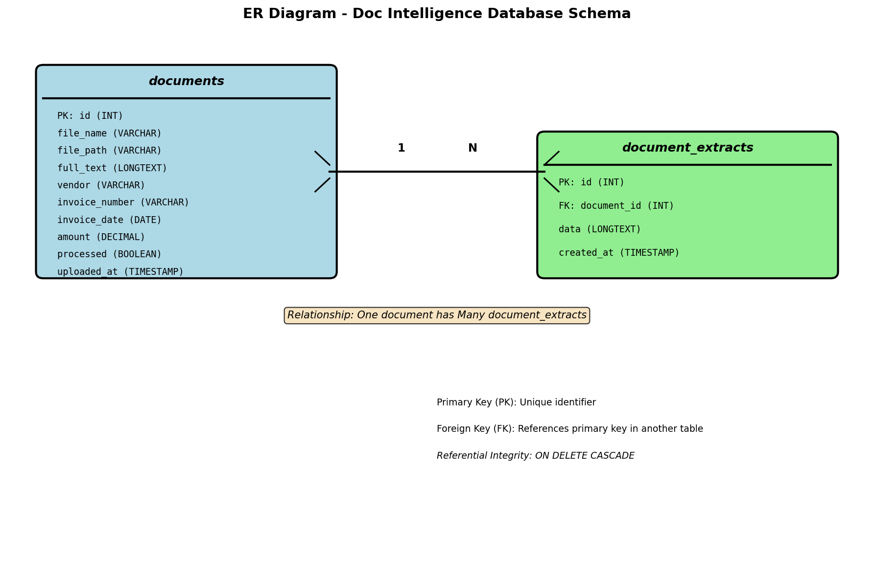
Figure 6: ER diagram showing the database schema with documents and document_extracts tables, relationships, and attributes.

