# **Catastrophe Risk Analysis in Europe (1990–2024)**

**1. INTORDUCTION**

Catastrophe (CAT) modelling forms an essential part of actuarial science and risk analysis. It helps quantify the financial and human impact of natural disasters and supports better preparedness, pricing, and capital-allocation decisions.  
This project examines the **economic damages caused by natural disasters across Europe and the United Kingdom** from 1990 to 2024. The purpose is to replicate a simplified version of what a risk or CAT analyst might perform while exploring historical loss patterns.

**2. OBJECTIVE**

The main objectives of this project are to:

* Measure the **total adjusted economic losses** due to natural disasters.
* Compare the **relative impact of different disaster types** (storms, floods, earthquakes, extreme temperatures).
* Identify **geographical hotspots** within Europe with high financial exposure.
* Observe **temporal trends** to determine whether the frequency or severity of losses has changed over time.
* Present results visually to highlight key insights for actuarial and risk-modelling purposes.

**3. DATA SOURCE**

The dataset used was obtained from the **EM-DAT International Disaster Database**, maintained by the Centre for Research on the Epidemiology of Disasters (CRED).  
Key variables include:

* Disaster Type
* Country
* Start Year
* Total Deaths
* Total Affected
* Total Damage, Adjusted (’000 US$) — inflation-adjusted damages expressed in thousands of US dollars.

Only European and UK records between 1990 and 2024 were retained for analysis. Rows with missing or zero values for total damage were reviewed and, where necessary, excluded from financial summaries.

**4. METHODOLOGY**

1. **Data Cleaning**
   * Removed duplicate entries and irrelevant columns (e.g., end year).
   * Left missing cells for Total Damage as blanks rather than substituting artificial values.
   * Ensured numeric fields were properly formatted for analysis.
2. **PivotTable Analysis**
   * **Pivot 1:** Sum of Total Damage, Adjusted by Disaster Type. (Appendix Table1)
   * **Pivot 2:** Sum of Total Damage, Adjusted by Start Year (to show trends). (Appendix Table 2)
   * **Pivot 3:** Sum of Total Damage, Adjusted by Country. (Appendix Table3)
3. **Visualisation**

Each chart was formatted using clear axis titles, readable labels, and consistent colour palettes.

**5. FINDINGS**

The analysis revealed several noteworthy insights:

* **Disaster Type Impact:**  
  Storms and floods account for the majority of recorded financial losses across Europe. Storm events alone contribute a significant proportion of total damages, followed by floods and extreme temperatures.
* **Temporal Trend:**  
  From 1990 to 2024, a general upward trend in reported damages is visible, with notable spikes in certain years corresponding to major European flood and storm events.  
  (Figure 2)  
  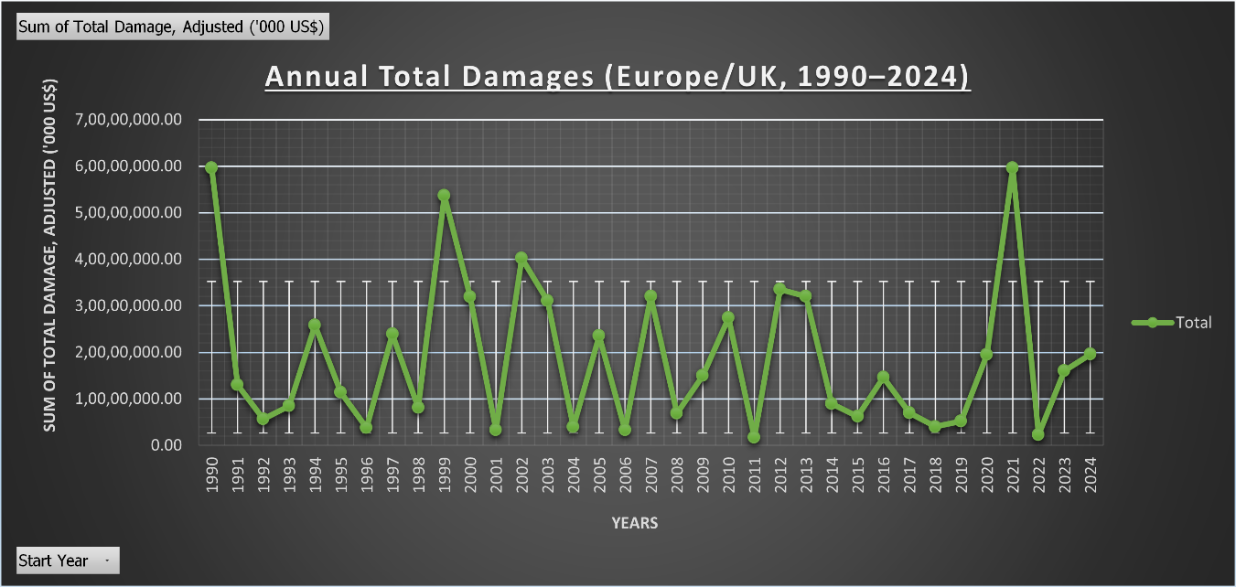
* **Geographical Distribution:**  
  Countries such as **Germany, Italy, France, Belgium, and the United Kingdom** display the highest overall losses. The logarithmic scale ensures smaller nations remain visible despite the wide value range.  
  (Figure 3.1)  
  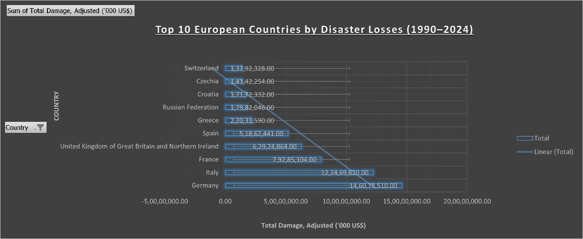  
    
  (Figure 3.2)  
  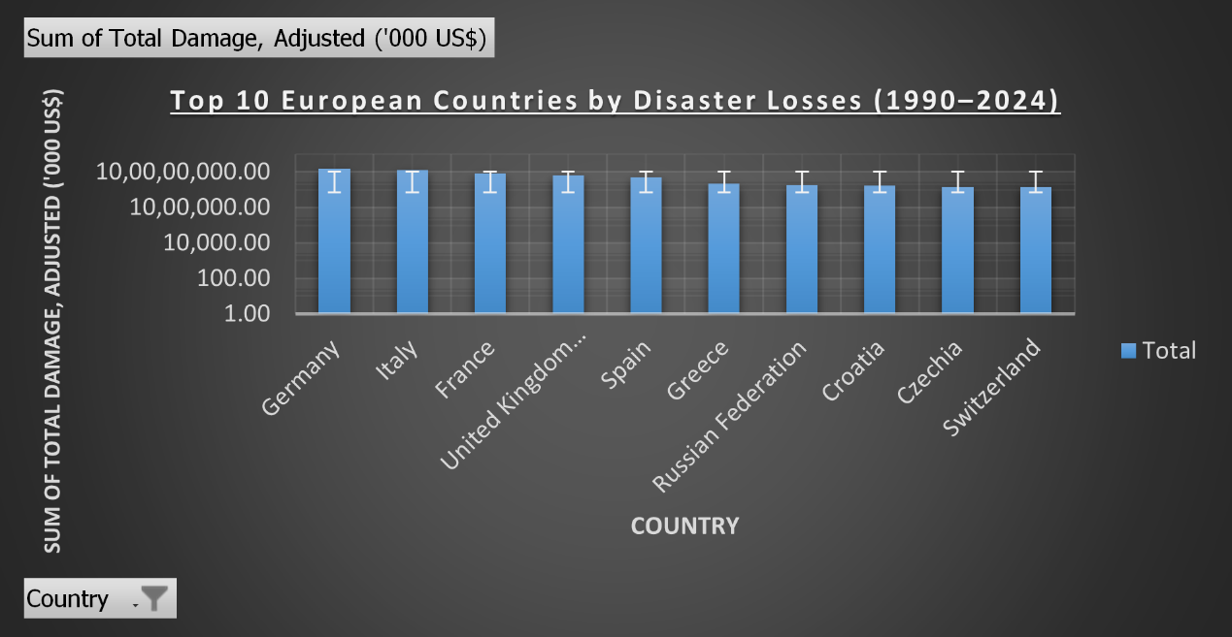
* **Event Concentration:**  
  The majority of damages arise from a limited number of high-impact events rather than many small ones, reflecting the heavy-tailed nature typical of catastrophe losses.

(Figure 1)  
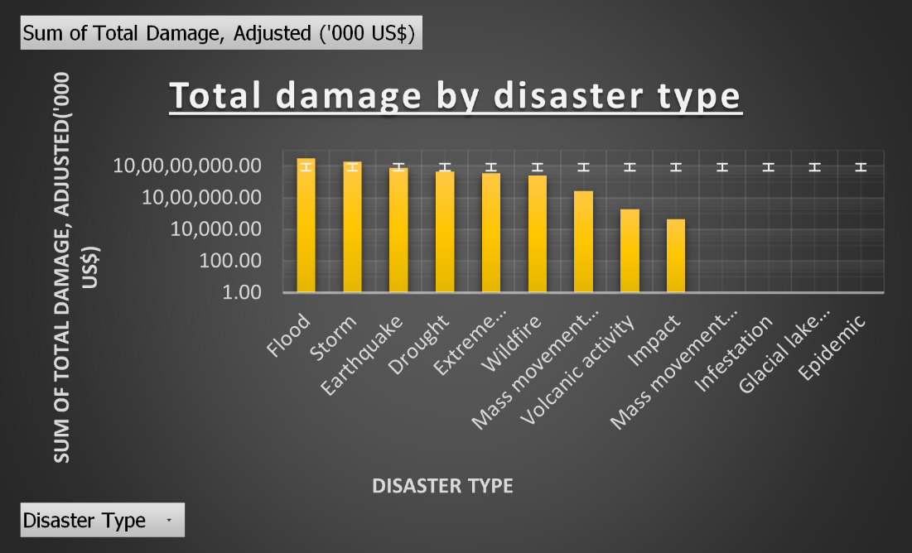

**6. CONCLUSION**

This analysis illustrates how actuarial principles of **risk quantification and exposure measurement** can be applied using accessible tools like Excel.  
Key takeaways include:

* Natural-disaster losses are highly concentrated geographically and by peril type.
* Inflation-adjusted damages show a gradual increase over time, highlighting the growing financial exposure in Europe.
* Visual analytics such as PivotTables and charts provide clear communication of complex data — a skill valued by employers in risk and actuarial domains.

**7. REFERENCING**

Cred (no date) *Dat - The International Disaster Database*, *EM*. Available at: <https://www.emdat.be/> (Accessed: 16 October 2025).

**8. APPENDIX**

TABLE 1

|  |  |
| --- | --- |
| **Row Labels** | **Sum of Total Damage, Adjusted ('000 US$)** |
| Flood | 29,50,49,375.00 |
| Storm | 18,16,02,672.00 |
| Earthquake | 7,94,30,405.00 |
| Drought | 4,41,70,054.00 |
| Extreme temperature | 3,42,33,228.00 |
| Wildfire | 2,47,44,064.00 |
| Mass movement (wet) | 26,28,112.00 |
| Volcanic activity | 1,82,152.00 |
| Impact | 44,436.00 |
| Mass movement (dry) | 0.00 |
| Infestation | 0.00 |
| Glacial lake outburst flood | 0.00 |
| Epidemic | 0.00 |
| **Grand Total** | **66,20,84,498.00** |

TABLE 2

|  |  |
| --- | --- |
| **Row Labels** | **Sum of Total Damage, Adjusted ('000 US$)** |
| 1990 | 5,95,86,293.00 |
| 1991 | 1,29,97,464.00 |
| 1992 | 56,39,917.00 |
| 1993 | 85,02,140.00 |
| 1994 | 2,57,60,056.00 |
| 1995 | 1,13,99,205.00 |
| 1996 | 37,48,689.00 |
| 1997 | 2,39,22,304.00 |
| 1998 | 81,22,044.00 |
| 1999 | 5,36,41,001.00 |
| 2000 | 3,19,05,145.00 |
| 2001 | 32,80,535.00 |
| 2002 | 4,01,90,101.00 |
| 2003 | 3,10,72,472.00 |
| 2004 | 39,74,607.00 |
| 2005 | 2,35,62,885.00 |
| 2006 | 32,85,620.00 |
| 2007 | 3,20,19,383.00 |
| 2008 | 68,59,404.00 |
| 2009 | 1,49,71,125.00 |
| 2010 | 2,73,68,555.00 |
| 2011 | 16,63,719.00 |
| 2012 | 3,35,63,828.00 |
| 2013 | 3,20,32,532.00 |
| 2014 | 89,42,600.00 |
| 2015 | 62,18,560.00 |
| 2016 | 1,46,10,932.00 |
| 2017 | 69,34,386.00 |
| 2018 | 40,13,745.00 |
| 2019 | 52,17,159.00 |
| 2020 | 1,95,25,029.00 |
| 2021 | 5,96,12,196.00 |
| 2022 | 23,10,871.00 |
| 2023 | 1,60,39,534.00 |
| 2024 | 1,95,90,462.00 |
| **Grand Total** | **66,20,84,498.00** |

TABLE 3

|  |  |
| --- | --- |
| **Row Labels** | **Sum of Total Damage, Adjusted ('000 US$)** |
| Germany | 14,60,78,510.00 |
| Italy | 12,24,69,820.00 |
| France | 7,92,85,104.00 |
| United Kingdom of Great Britain and Northern Ireland | 6,29,24,864.00 |
| Spain | 5,18,62,441.00 |
| Greece | 2,20,31,590.00 |
| Russian Federation | 1,79,82,046.00 |
| Croatia | 1,71,72,332.00 |
| Czechia | 1,41,42,254.00 |
| Switzerland | 1,37,92,328.00 |
| **Grand Total** | **54,77,41,289.00** |