TITLE OF THE PROJECT

**NASAKE**

**“Journey to Inner Peace Starts at Nasake”**

Enrollment Numbers - 21103001, 21103053, 21103060

Name of Students - Anujesh Bansal, Devansh Singh, Sidhant Gautam Parimoo

Name of Supervisor - Mrs. Purtee J Kohli



**December - 2023**

**Submitted in partial fulfillment of the Degree of**

**Bachelor of Technology**

**in**

**Computer Science Engineering**

**DEPARTMENT OF COMPUTER SCIENCE ENGINEERING & INFORMATION TECHNOLOGY**

**JAYPEE INSTITUTE OF INFORMATION TECHNOLOGY, NOIDA**

**TABLE OF CONTENTS**

**Chapter No. Topics Page No.**

Declaration 3

Certificate 4

Acknowledgement 5

Summary 6

**Chapter-1 Introduction 7 - 15**

1.1 General Introduction 7

1.2 Problem Statement 9

1.3 Significance/Novelty of the problem 10

1.4 Empirical Study 12

1.5 Brief Description of the Solution Approach 13

1.6 Comparison of existing approaches to the problem framed 14

**Chapter-2 Literature Survey 16 - 19**

2.1 Summary of Papers Studied 16

2.2 Integrated Summary of Literature studied 17

**Chapter-3 Requirement Analysis and Solution Approach 20 - 24**

3.1 Overall Description of the Project 20

3.2 Requirement Analysis 21

3.3 Solution Approach 23

**Chapter-4 Modeling and Implementation Details 25 - 37**

4.1 Design Diagrams 25

4.1.1 Use Case Diagrams 29

4.1.2 Class Diagrams/Control Flow Diagrams 30

4.1.3 Sequence Diagrams/Activity Diagrams 31

4.1.4 Journal Sequence 32

4.1.5 Test Sequence 33

4.2 Implementation Details and Issues 34

4.3 Risk Analysis and Mitigation 36

**Chapter-5 Testing 38 - 42**

5.1 Testing Plan 38

5.1.1 Testing using PyTest Library 38

5.1.2 Testing using Selenium Library 40

**Chapter-6 Findings, Conclusion, and Future Work 43 - 46.**

6.1 Findings 43

6.2 Conclusion 44

6.3 Future Work 45

**References 47 - 48**

**DECLARATION**

We hereby declare that this submission is my/our own work and that, to the best of my knowledge and belief, it contains no material previously published or written by another person or material which has been accepted for the award of any other degree or diploma of the university or other institute of higher learning, except where due acknowledgment has been made in the text.

Date: 2/12/2023

Signature of the Student ……………………..

Name of Student - ANUJESH BANSAL

Enrolment Number - 21103001

Signature of the Student ……………………..

Name of Student - DEVANSH SINGH

Enrolment Number - 21103053

Signature of the Student ……………………..

Name of Student - SIDHANT GAUTAM PARIMOO

Enrolment Number - 21103060

**CERTIFICATE**

This is to certify that the work titled “Nasake - Journey to Inner Peace Starts at Nasake” is a Web development Project submitted by Anujesh Bansal, Devansh Singh and Sidhant Gautam Parimoo in partial fulfillment for the award of degree of “Bachelor of Technology in Computer Science Technology” of Jaypee Institute of Information Technology, Noida has been carried out under my supervision. This work has not been submitted partially or wholly to any other University or Institute for the award of this or any other degree or diploma.

Signature of Supervisor:

Name of Supervisor:

Designation:

Date:

**ACKNOWLEDGEMENT**

We would like to express our deepest gratitude to Mrs. Purtee Kohli, whose guidance and expertise have been invaluable throughout the development of our minor project, "Nasake". Her insightful feedback, unwavering support, and profound knowledge in web development have been instrumental in shaping this project. This project, aimed at fostering the mental health wellbeing of individuals, particularly adolescents, could not have reached its fruition without the foundational skills and understanding imparted by Mrs. Kohli. Her ability to simplify complex concepts in Python, PostgreSQL, HTML, JavaScript, and CSS has been crucial in the development of a website that is both functional and impactful. Mrs. Kohli's dedication to teaching and commitment to student success have not only guided this project but have also inspired a deeper appreciation for the field of web development. Her enthusiasm and passion for technology have been contagious, motivating us to explore innovative solutions and strive for excellence in this project. We would also like to thank our peers for their collaborative spirit and constructive feedback, which have been essential in refining the Nasake website. Their perspectives and insights have contributed significantly to enhancing the user experience of the platform. Lastly, we extend our thanks to our families for their constant encouragement and support, providing us with the strength and confidence to undertake and complete this project.

Date: 2/12/2023

Signature of the Student ……………………..

Name of Student - ANUJESH BANSAL

Enrolment Number - 21103001

Signature of the Student ……………………..

Name of Student - DEVANSH SINGH

Enrolment Number - 21103053

Signature of the Student ……………………..

Name of Student - SIDHANT GAUTAM PARIMOO

Enrolment Number - 21103060

**SUMMARY**

"Nasake," a web development project undertaken by students at the Jaypee Institute of Information Technology, represents a significant stride in addressing mental health and well-being, especially among adolescents and young adults. With the guidance of Ms. Purtee J Kohli, the project aims to create a compassionate online space that empowers users by providing them with a wide range of valuable resources and services. This platform is particularly tailored to enhance the mental health journey of its users.

The project was motivated by alarming statistics indicating that around 20% of the world's children and adolescents have a mental health condition, with suicide ranking as the fourth leading cause of death among 15-29-year-olds. The team recognized the urgency to increase awareness about mental health risks and the need for appropriate support, particularly for young adults.

"Nasake" is a development project that involves the use of various profound services such as an Emotional Analysis model to define and evaluate emotions conveyed in textual data, An AI chatbot to cater to the emotional needs of a user and a Mental Health Test Interface for self assessment of the user. The team utilized PostgreSQL for database management, Python for backend development, and a combination of HTML, CSS, and JavaScript for frontend development.

Our Project, Nasake, motivated by the urgent need for increased awareness and support for mental health, particularly among adolescents and young adults, transcends its technical achievements to address a crucial societal challenge. This initiative is not just about building a web platform; it's about fostering a supportive environment where young individuals can navigate their mental health journey with greater understanding and less stigma. The project has taken significant strides in making mental health resources more accessible and approachable for its target audience.

By integrating features such as therapist databases, mental health tests, sentiment analysis, and personalized support through an AI chatbot, "Nasake" provides a comprehensive approach to mental well-being. The platform is a reflection of the team's dedication to enhancing mental health awareness and offering pragmatic solutions tailored to the unique challenges of the digital age.

**Chapter - 1**

**INTRODUCTION**

**1.1 General Introduction**

Mental health, once a topic relegated to the periphery of public discourse, has evolved into a critical global concern. The 21st century witnesses a seismic shift in societal attitudes towards mental well-being, recognizing its profound impact on individuals, communities, and broader global dynamics. This paradigm shift is especially pronounced among adolescents and young adults, where the vulnerability to mental health challenges is heightened due to various reasons such as bullying in schools, cyber bullying, examination and study pressure etc.

**Global Significance of Mental Health**

In recent years, mental health has transcended geographical and cultural boundaries, becoming a universal concern that demands urgent attention. The escalating prevalence of mental health conditions among adolescents and young adults has prompted a reevaluation of societal priorities. According to a report by the World Health Organization (WHO), approximately 20% of the world's children and adolescents grapple with various mental health conditions. Alarmingly, suicide has emerged as the fourth leading cause of death among 15-29 year-olds, underscoring the severity and immediacy of the issue.

**The Birth of NASAKE: A Comforting Response to the Impending Crisis**

In response to this burgeoning crisis, the NASAKE project comes to the forefront as a proactive and innovative solution.In Japanese, "Nasake" (なさけ) translates to compassion or empathy. We chose this name for our project as it encapsulates the essence of our mission – to provide a comforting solution to the serious problems posed by mental health issues. Mental illnesses should be handled with care and compassion, and the name "NASAKE" symbolizes our commitment to embodying these values in our approach. It goes beyond being just a project; NASAKE is a pledge to create a nurturing online space where individuals can find solace and support on their mental health journey. Through this name, we express our dedication to fostering empathy and understanding, essential elements in addressing the complexities of mental health challenges.

**Nurturing Mental Health in the Digital Age**

NASAKE represents a pioneering venture into the realms of digital mental health support. In an era dominated by technology and connectivity, the project leverages the power of the internet to provide a lifeline for those grappling with mental health challenges. The online platform aspires to be more than just a repository of information; it aims to be a dynamic and interactive ecosystem where individuals can find solace, support, and resources tailored to cater to their emotional needs.

**Compassion in Cyberspace: A Holistic Approach**

What sets NASAKE apart is its commitment to a holistic approach in addressing mental health. It recognizes that mental well-being is a multifaceted aspect of human existence, influenced by biological, psychological, social, and environmental factors. The project, therefore, doesn't merely offer a singular solution but envisions a comprehensive ecosystem comprising various features and resources. Rather than focusing on the technical aspects by providing the users with resources, NASAKE also tries to create a comfortable environment for its user along with the resource provision.

**Empowering Through Awareness**

At the core of NASAKE's mission is the desire to empower individuals by increasing awareness about mental health risks and issues. Stigma remains a significant barrier to seeking help, with only half of those affected by mental health conditions pursuing treatment. NASAKE endeavors to dismantle this stigma, fostering an environment where individuals feel not only accepted but encouraged to prioritize their mental well-being.

**Adolescents and Young Adults: A Vulnerable Population**

The emphasis on adolescents and young adults in the NASAKE project is a strategic response to the unique challenges faced by this demographic. Adolescence, marked by transitions and identity formation, is a crucial period for mental health development. However, it is also a phase where mental health conditions often surface, contributing to long-term consequences if left unaddressed. It is a stage where their minds and personalities are still developing and through our project we envision to provide a support system at the vulnerable stage of their lives to negate the problems faced by them at this age.

**Unveiling the Statistics: A Stark Reality**

Depression, anxiety, and behavioral disorders are not merely abstract concepts; they manifest tangibly in the statistics that paint a stark reality. These conditions rank among the leading causes of illness and disability among adolescents. The consequences of untreated mental illness extend beyond individual suffering, encompassing higher medical costs, diminished academic and job performance, limited employment prospects, and an increased risk of suicide.

**Bridging the Treatment Gap**

NASAKE acknowledges the existing treatment gap, where a significant portion of those in need refrains from seeking help. The project acts as a bridge, connecting individuals with the support and resources essential for their mental well-being. By doing so, NASAKE aims not only to alleviate the immediate challenges posed by mental health conditions but also to prevent the long-term consequences that can ripple through an individual's life trajectory.

The general introduction to our project titled “NASAKE”, encapsulates the urgency and significance of addressing mental health challenges on a global scale. The initiative goes beyond acknowledging the problem; it actively seeks to redefine the narrative surrounding mental health, positioning it at the forefront of societal priorities. In the face of a burgeoning global mental health crisis, NASAKE stands as a testament to the transformative power of compassion, awareness, and proactive intervention.

**1.2 Problem Statement : The Escalating Crisis: Rising Mental Health Challenges Among Adolescents and Young Adults**

The burgeoning crisis of mental health challenges among adolescents and young adults has emerged as a defining issue of our time. As we delve into the problem statement, it becomes evident that the statistics and concern surrounding this alarming trend necessitate urgent attention and innovative solutions to this impending problem. NASAKE is not merely a response to a theoretical problem; it is a proactive intervention aimed at mitigating the profound impact of mental health issues on the younger demographic.

**Motive Behind NASAKE: A Call to Address the Urgency**

The NASAKE project is not born out of abstract concerns; it is a direct response to the urgent need to address the escalating prevalence of mental health challenges among adolescents and young adults. It recognizes that the statistical realities and the associated concerns demand more than passive acknowledgment – they demand proactive intervention and innovative solutions.

In a nutshell, The problem statement captures the gravity of the escalating mental health challenges among adolescents and young adults. The statistics revealing the high prevalence of mental health conditions and the stark reality of suicide rates emphasize the urgency of the matter. Coupled with the pervasive stigma that acts as a formidable barrier to seeking treatment, the problem statement underscores the need for innovative and comprehensive solutions.

**1.3 Significance/Novelty of the Problem**

Exploring the importance of Mental Health Challenges in Young Adults, NASAKE confronts various concerns surrounding mental health of teenagers and young adults which are further explained below:

**Statistical Realities**

The statistical landscape paints a grim picture of the mental health landscape among adolescents and young adults. According to the World Health Organization (WHO), approximately 20% of the world's children and adolescents are grappling with mental health conditions. This statistic alone underscores the pervasive nature of the problem, highlighting that mental health challenges are not isolated incidents but rather a widespread and pressing concern affecting a significant portion of the youth population.

Perhaps one of the most alarming statistics is the revelation that suicide stands as the fourth leading cause of death among 15-29 year-olds globally. The fact that young individuals are resorting to such drastic measures to cope with their mental health challenges demands a nuanced understanding of the underlying issues. It serves as a poignant reminder that the consequences of untreated mental health conditions extend beyond psychological suffering to life-threatening outcomes.

**Stigma: A Formidable Barrier to Treatment**

The gravity of the problem is further compounded by the stigma associated with seeking treatment for mental health issues. Despite the high prevalence of mental health conditions among adolescents and young adults, only half of those affected actively seek treatment. Stigma creates a formidable barrier, deterring individuals from acknowledging their struggles and reaching out for the support they desperately need which in turn prioritizes the process of dismantling it.

**Untreated Mental Illness: A Cascade of Consequences**

The reluctance to seek treatment results in a cascade of consequences that reverberate through various aspects of an individual's life. Untreated mental illness is not a mere abstract concept; it manifests in higher medical costs, diminished academic and job performance, limited employment prospects, and an increased risk of suicide. The impact extends beyond the individual, affecting families, communities, and societies at large.

**Transitioning to Adulthood: A Vulnerable Phase**

Young adulthood is a phase marked by profound transitions, where individuals navigate the intricate path from adolescence to full-fledged adulthood. This period, though rife with opportunities and potential, is equally characterized by unique challenges. The pressure to establish one's identity, make significant life choices, and navigate complex relationships can contribute to heightened stress and mental health concerns. Other factors such as loneliness and anxiety are also very prevalent during this phase.

**The Unmet Need: Lack of Adequate Platforms**

In the digital age, one might assume that access to mental health support and awareness would be readily available. However, the reality is starkly different. A significant gap exists in the availability of platforms dedicated to addressing the mental health needs of young adults comprehensively. Traditional healthcare systems often fall short in catering to the specific challenges faced by this demographic, leaving a void that NASAKE aims to fill.

**Beyond Traditional Healthcare: Redefining Mental Health Support**

The novelty of NASAKE lies in its departure from traditional healthcare models. It goes beyond the clinical setting, acknowledging that mental well-being is not just confined to medical diagnosis and treatment plans. Instead, NASAKE adopts a holistic approach, integrating various elements that cater to the multifaceted nature of mental health, such as journal entries and sentiment analysis.

The significance of addressing mental health among young adults extends beyond individual well-being. The repercussions of untreated mental health conditions can permeate communities and societies, affecting productivity, social dynamics, and overall societal health. By addressing the unique needs of young adults, NASAKE contributes to the broader goal of creating mentally healthy and resilient communities. The significance of NASAKE transcends its role as a digital platform; it represents a paradigm shift in how we perceive and address mental health in the context of young adulthood.

**1.4 Empirical Study**

In drawing the curtains on the empirical study conducted by the World Health Organization (WHO) and other research papers, it becomes evident that these scholarly articles constitute a crucial foundation for comprehending the pressing need for mental health support among adolescents. The synthesis of insights from these studies forms the bedrock upon which initiatives, like our project, NASAKE, are built, echoing a collective call to action for the betterment of the mental well-being of the younger generation.

The World Health Organization, as a global authority on public health, holds a distinctive position in shaping policies and interventions that address global health challenges. The WHO's comprehensive report on "Adolescent Mental Health" not only provides a panoramic view of the prevalence of mental health conditions among adolescents but also emphasizes the critical juncture of adolescence as both vulnerable and opportune. This emphasis aligns seamlessly with the mission of NASAKE, which recognizes the unique challenges and opportunities presented during this formative phase of life.

Adolescence, as highlighted by the WHO, is a period characterized by significant physical, cognitive, and emotional development. It is during these years that individuals are not only susceptible to mental health issues but also possess the potential for transformative growth. The vulnerability stems from the heightened emotional and psychological changes. Simultaneously, the opportunity lies in the malleability of young minds, presenting a window where proactive and holistic support can produce lasting positive impacts. NASAKE positions itself as a beacon of support during this crucial phase, aiming not only to alleviate current challenges but also to nurture the mental health of adolescents for the future.

The bridge between research insights and practical interventions is a critical juncture where the efficiency of mental health initiatives is determined. NASAKE, motivated by the findings of empirical studies, aims to cover this gap by translating theoretical knowledge into accessible support systems. It is not merely an acknowledgment of the challenges posed by adolescent mental health but a proactive response to address them with compassion.

The importance of NASAKE extends beyond the confines of the project itself. It serves as a rallying call for societal responsibility in prioritizing and supporting the mental health of the younger generation. The empirical study not only underscores the importance of NASAKE's mission but also reinforces the collective duty of society to contribute to the well-being of adolescents. It highlights that mental health is not an isolated concern but a shared responsibility that necessitates collaborative efforts from individuals, communities, healthcare systems, and policymakers.

In essence, the empirical study acts as a catalyst, propelling other projects and initiatives like NASAKE towards a meaningful impact on a global scale. In this confluence, there lies the potential for transformative change in the landscape of adolescent mental health support, ushering in a time where the well-being of the younger generation is prioritized, protected, and nurtured for holistic betterment of the society in future.

**1.5 Brief Description of the Solution Approach**

**NASAKE's Holistic Approach to Mental Health Support**

As the prevalence of mental health challenges among adolescents and young adults continues to escalate, the need for innovative and comprehensive solutions becomes increasingly evident. NASAKE, in response to this urgent call, introduces a holistic approach to mental health support. Through a multifaceted strategy encompassing therapist databases, mental health tests, and community support, NASAKE aims to redefine the landscape of mental health interventions for young individuals.

1. **The Therapist Database: Curating a Comprehensive Network**

At the heart of NASAKE's solution approach lies the Therapist Database. Recognizing the pivotal role mental health professionals play in guiding individuals through their mental health journeys, NASAKE commits to curating a comprehensive network of verified therapists. This database becomes a crucial pillar of support, allowing users to connect with therapists who align with their preferences, locations, and specific needs.

1. **Mental Health Tests: Enhancing Self-Awareness**

NASAKE recognizes the importance of proactive mental health management. To empower users with greater self-awareness and insights into their mental well-being, the platform incorporates Mental Health Tests. These tests, designed by verified mental health professionals, utilize user responses to some simple questions related to their day to day activities providing some valuable insights. By engaging users in a reflective process, NASAKE fosters a proactive approach to mental health, allowing individuals to identify potential challenges early on.

The Mental Health Tests cover a spectrum of psychological aspects, ranging from mood and stress levels to more nuanced emotional states. Users receive a detailed analysis of their responses, offering a comprehensive understanding of their mental well-being. This not only facilitates early intervention but also equips individuals with the knowledge needed to communicate effectively with mental health professionals.

1. **Sentiment Analysis: Nurturing Emotional Well-being**

To provide ongoing and personalized support, NASAKE integrates Sentiment Analysis features. Users can track their emotional well-being over time, allowing the platform to identify patterns and fluctuations. This information enables the user to analyze their mood through their prompts and writings. This feature reinforces the platform's commitment to not only addressing existing challenges but also preventing the escalation of mental health issues.

1. **AI Chatbot for Emotional Support: Creating a Safe Space for Venting**

In addition to the comprehensive mental health support approach, NASAKE recognizes the paramount importance of emotional well-being and introduces an AI chatbot as part of its solution strategy. This innovative feature provides users with a dedicated space to vent out their thoughts and feelings. Programmed to offer empathetic responses and understanding, the AI chatbot acts as a virtual support system, fostering a sense of comfort and allowing users to express themselves freely.

**1.6 Comparison of Existing Approaches to the Problem Framed**

In the rapidly evolving landscape of mental health platforms, NASAKE distinguishes itself through a unique and comprehensive approach to supporting the mental well-being of adolescents and young adults. To appreciate the distinctive features and benefits of NASAKE, it is crucial to conduct a comparative analysis with existing mental health platforms.

**NASAKE's Therapist Database vs. Conventional Directories**

Many existing mental health platforms that provide therapist information often ask for the user to sign up first or often hide contact details of the therapists until the user books an appointment through their website. Understanding the user’s dilemma it's important to not let users feel restricted using these monetary functionalities. While these directories provide a basic framework for finding therapists, they are not accessible to everyone.

NASAKE does not give into such monetary functionalities and gives access to any guest user in need to access the Therapist Database. The platform considers users' mental state as their top priority and allows them to use the information provided by us according to their need. This personalized approach enhances the therapeutic relationship, ensuring a more tailored and effective support system.

**The Integration of Mental Health Tests**

Several platforms that claim to cater to mental illnesses of user often lack a functionality to let users know their current mental state. The platforms that have such quizzes and tests often lack genuinity of these tests and mostly use it for personal gain of user information. NASAKE's Mental Health Tests draws inspiration from community based non profit organization called MHA Screening who claim to be dedicated to addressing the needs of those living with mental illness and to promoting the overall mental health.

**NASAKE's Proactive Intervention using Sentiment Analysis vs. Reactive Approaches**

A few platforms primarily focus on reactive approaches to mental health, offering support when users actively seek it. While somewhat valuable, this reactive model might miss opportunities for early intervention. Such approaches might also make the user uncomfortable and anxious.

NASAKE integrates Sentiment Analysis features through their Journal Entry feature, allowing users to track their emotional well-being over time, while at the same time facilitating a compassionate feature of journal entry that has also proved to be an effective strategy to cater to the mental health of an individual.

**Chapter** - **2**

**LITERATURE** **SURVEY**

**2.1** **Summary** **of** **Papers Studied**

For the project, a comprehensive approach to adolescent mental health is undertaken. NASAKE draws from several significant research papers that provide a deep understanding of adolescent mental health issues and integrates this understanding with a range of technological tools used in its development. Some of the research papers and their summaries are as follows:

1. **World Health Organization - "Adolescent Mental Health":**

This paper from WHO provides a comprehensive overview of mental health issues in adolescents. It highlights the prevalence of mental disorders in this age group and underscores the challenges in accessing adequate mental health care. The report emphasizes the importance of early identification and intervention, and the need for integrating mental health services into primary health care and educational settings.

1. **BMC Psychiatry - "Risk and protective factors associated with the mental health of young adults":**

This study examines the mental health status of young adults in Kabul, Afghanistan. It identifies both risk and protective factors affecting their mental health. The study found that poor mental health was common among participants, with higher education emerging as a risk factor, whereas good physical health and higher perceived hope-optimism served as protective factors. The research underlines the influence of current economic conditions in Kabul on mental health and the importance of developing culturally competent policies and interventions.

1. **Journal of Adolescent Health - "Stigma starts early: Gender differences in teen willingness to use mental health services":**

This paper investigates gender differences in teenagers' willingness to use mental health services. The study reveals that gender-based disparities in attitudes toward mental health and service utilization start early in adolescence. It finds that girls are generally more willing than boys to use mental health services and highlights the need for mental health education and services in middle schools, involving parents and addressing knowledge gaps.

1. **Current Opinion in Psychology - "Contextualizing adolescent structural brain development: Environmental determinants and mental health outcomes":**

This article explores how environmental factors influence the structural development of the adolescent brain and its impact on mental health outcomes. It emphasizes the importance of understanding these developmental changes in the context of the environment to develop effective interventions for mental health issues during adolescence.

1. **Lancet Psychiatry - "Mental Health Interventions in Schools in High-Income Countries":**

The paper discusses the role and effectiveness of mental health interventions in schools in high-income countries. It reviews various programs and strategies implemented in schools to address mental health issues, evaluating their success and impact on students' well-being.

1. **The Journal of Child Psychology and Psychiatry - "Adolescent mental health in the digital age: facts, fears, and future directions":**

This research paper delves into the mental health challenges and opportunities presented by the digital age for adolescents. It examines the impact of digital technologies on youth mental health and discusses potential strategies for leveraging these technologies to support adolescent mental health.

1. **Cyberpsychology - "Impact of Social Media on Adolescent Mental Health":**

This study focuses on the effects of social media usage on the mental health of adolescents. It investigates both the positive and negative impacts of social media and provides insights into how these platforms can influence the psychological well-being of young users.

**2.2 Integrated Summary of Literature Studied**

Our Project, NASAKE, is based on solid research, using information from different studies and reports, as summarized earlier. It highlights the importance of providing mental health support for teenagers. These studies give a thorough understanding of the difficulties faced by young people and emphasize the need to prioritize their mental well-being. Below, we show how these research papers connect with our project.

1. **World Health Organization - "Adolescent Mental Health":**

The WHO's emphasis on the prevalence of mental disorders among adolescents and the importance of early intervention aligns with Nasake's objective to provide accessible mental health resources and support to young individuals. The platform aims to bridge the gap in mental health services availability, particularly for those in their formative years.

1. **BMC Psychiatry - "Risk and protective factors associated with the mental health of young adults":**

This study's findings on the impact of economic conditions, education, and the protective role of hope and optimism in mental health resonate with Nasake's approach. The platform's resources and emotional support features are designed to foster a sense of optimism and resilience among users, while also being mindful of the diverse socio-economic backgrounds of its audience.

1. **Journal of Adolescent Health - "Stigma starts early: Gender differences in teen willingness to use mental health services":**

The gender disparities highlighted in this study inform Nasake’s approach to creating a gender-inclusive platform. By understanding these differences in attitudes towards mental health, Nasake can tailor its resources and outreach strategies to ensure that both male and female adolescents feel equally welcomed and supported.

1. **Current Opinion in Psychology - "Contextualizing adolescent structural brain development: Environmental determinants and mental health outcomes":**

The insights from this paper on environmental impacts on adolescent brain development can guide the creation of Nasake’s content and tools. Understanding these factors allows Nasake to offer resources that are not only informative but also empathetic to the environmental influences that adolescents experience.

1. **Lancet Psychiatry - "Mental Health Interventions in Schools in High-Income Countries":**

This research underscores the importance of school-based mental health interventions, which Nasake can complement through its online resources. The platform can serve as an additional support system for students, providing resources that schools might not be able to offer.

1. **The Journal of Child Psychology and Psychiatry - "Adolescent mental health in the digital age: facts, fears, and future directions":**

The digital age's impact on mental health, as discussed in this paper, is central to Nasake’s operation. The project seeks to harness the positive aspects of digital technology to support mental health, while also addressing the challenges and fears associated with digital media consumption among adolescents.

1. **Cyberpsychology - "Impact of Social Media on Adolescent Mental Health":**

The dual nature of social media’s impact on mental health is particularly relevant for Nasake. Understanding these dynamics allows the platform to offer guidance on healthy social media use and provide resources for those who might be negatively affected by their online experiences.

Each of these research papers provides valuable insights that are directly applicable to the development and refinement of our project. By considering these varied perspectives and findings, the project can ensure that its resources, tools, and strategies are grounded in current research and tailored to effectively address the multifaceted nature of adolescent mental health challenges.

**Chapter - 3**

**REQUIREMENT ANALYSIS & SOLUTION APPROACH**

**3.1 Overall Description of the Project**

Our Project, NASAKE stands as a pioneering initiative in the digital healthcare domain, particularly focusing on the mental health of adolescents and young adults. The project aims to transcend traditional mental health services by offering a dynamic, interactive, and holistic platform. It leverages the power of technology to create an accessible, informative, and supportive environment, tailored specifically for the unique needs of its young audience.

* **Objectives**

1. **Accessible to Therapists Database:** To ensure that adolescents have easy access to a wide range of mental health resources and access to Therapist Database.
2. **Stigma-Free Environment:** To cultivate an environment where mental health issues can be openly discussed without fear of judgment, thereby reducing stigma and encouraging more young people to seek help.
3. **Self-Assessment Tools:** To provide interactive and engaging self-assessment tools that offer insights into one's mental health, facilitating early detection and intervention.
4. **Professional Guidance:** To connect users with mental health professionals for personalized care and support.
5. **Resource-Need Bridging:** To identify gaps in existing mental health resources and fill them effectively through the platform, ensuring comprehensive support is available.

* **Target Audience:**

Nasake's primary audience includes adolescents and young adults grappling with mental health challenges or seeking knowledge about mental wellness. This group includes:

1. Individuals experiencing symptoms of mental health conditions seeking understanding and support.
2. Young adults looking for resources to support their peers or family members with mental health issues.
3. Students and educators seeking to incorporate mental health education into their curriculum or personal knowledge.

* **Main Features:**

1. **Interactive Tools for User Engagement:** The platform includes a variety of interactive tools like mental health quizzes, Journal Entries, AI Chatbot, Sentiment Analysis. These tools are designed to engage users actively, helping them gain insights into their mental health status and encouraging them to explore different aspects of their mental well-being.
2. **Professional Directory:** A comprehensive database of licensed mental health professionals, including therapists, counselors, and psychiatrists, is available. This feature allows users to find and connect with professionals for consultations, therapy sessions, and ongoing treatment plans.
3. **Mental Health Tests:** Nasake incorporates a range of mental health tests designed to help users assess their mental well-being. These tests cover various aspects of mental health, including stress, anxiety, depression, and mood disorders. Our self-assessment tools empower users to conduct initial evaluations of their mental health through scientifically validated questionnaires, ensuring reliability. These interactive and user-friendly tests provide instant feedback, designed to be engaging and non-intimidating, promoting open and honest participation. Prioritizing user confidentiality, the results are kept private and secure, creating a safe space for self-exploration.
4. **Sentiment Analyzing Journal Entry:** The Sentiment Analyzing Journal Entry is a unique feature of Nasake that leverages AI technology to provide users with insights into their emotional well-being. This enhances self-awareness, acting as a digital mirror that encourages users to express themselves freely while prioritizing privacy and security through encrypted and secure storage of journal entries
5. **Personalized AI Chatbot:** Nasake's innovative AI-powered chatbot is designed to offer personalized support and interaction. It offers 24/7 instant support, making it valuable for users seeking immediate guidance or someone to talk to during challenging moments.

**3.2 Requirement Analysis**

* **Technical Requirements**

1. **Database Management: PostgreSQL**

Nasake leverages PostgreSQL, a robust open-source relational database management system (RDBMS), ensuring secure and efficient data storage. This choice is critical for managing extensive data, including a therapist database, user information, and mental health resources. PostgreSQL's scalability and reliability make it an ideal choice for handling dynamic content and high user traffic, ensuring smooth and consistent platform performance.

1. **Programming Languages: Python, HTML, CSS, JavaScript**

Python's versatility makes it the backbone of Nasake's backend development. Its extensive libraries and frameworks are ideal for web development, particularly in handling complex data structures and ensuring smooth server-side operations. For the frontend, HTML, CSS, and JavaScript are employed to create a user-friendly interface. HTML structures the platform’s content, CSS adds style and layout, and JavaScript introduces interactive elements, providing a seamless user experience.

1. **API Integration**

Incorporating APIs is crucial for extending Nasake’s functionalities. These include APIs for AI-driven features like sentiment analysis. The utilization of APIs enhances user interaction and engagement, offering a dynamic and responsive platform.

* **User Requirements**

1. **Accessibility**

Ensuring accessibility is a top priority for Nasake. The platform is designed to be inclusive, catering to users belonging to any financial background.

1. **User Interface (UI)**

The UI is designed to be intuitive and appealing, particularly to the younger demographic. The layout is clean. Interactive elements and a visually engaging design are employed to enhance user engagement and ensure a pleasant user experience.

1. **Ease of Navigation:** The Web Interface is thoughtfully crafted with a user-friendly navigation structure, ensuring a seamless and intuitive experience for individuals accessing the platform.
2. **Privacy and Security**

Nasake places a high emphasis on the privacy and security of user data. Implementing robust security measures secure login processes to protect user information and maintain platform integrity.

1. **Challenges and Solutions**

Nasake’s future development journey involves overcoming challenges like ensuring cross-platform compatibility, managing large volumes of data, and maintaining user engagement. Solutions include using responsive web design techniques, employing efficient data management practices, and regularly updating content and features based on user feedback.

The requirement analysis for Nasake encompasses a holistic approach, addressing both technical and user-centric aspects. The technical architecture of the platform is designed to ensure functionality, security, and scalability, while the user-focused features emphasize accessibility, engagement, and content diversity. By balancing these elements, Nasake aims to provide a comprehensive and user-friendly platform that effectively supports adolescent mental health and well-being.

**3.3 Solution Approach**

**Methodology and Implementation of Nasake**

NASAKE represents a comprehensive endeavor to create a compassionate and resource-rich online space dedicated to nurturing mental health and well-being. The development process, informed by thorough research and planning, integrates advanced technological solutions with a deep understanding of the target audience's needs.

**Research and Planning**

Initial research involved a meticulous analysis of mental health challenges faced by adolescents, examining global statistics and trends. This phase, guided by resources like the World Health Organization's report on adolescent mental health, identified key areas of focus, such as stigma reduction, resource accessibility and emotional support.

**Development Process**

1. **Backend Development:**
2. Python and Django: Leveraging Python and its high-level web framework Django for backend development. Django's robust tools facilitate rapid web application development, including user authentication and session management.
3. PostgreSQL Database: Employing PostgreSQL for its reliability and scalability, crucial for storing data of verified mental health professionals, user information, and resources.
4. SQLAlchemy: Integrating SQLAlchemy for streamlined database interactions, enabling efficient data management.
5. **Frontend Development:**
6. HTML, CSS, JavaScript: Developing a user-friendly interface with HTML, CSS, and JavaScript, ensuring the platform is intuitive and accessible to the target demographic.
7. **API Integration and OpenAI Technologies:**
8. Implementing OpenAI technologies for AI-driven features like AI Chatbots, enhancing the platform's interactivity and user engagement.

**Deployment and Maintenance**

The platform was aimed to be deployed on a secure server, with a focus on scalability and reliability.

NASAKE’'s solution approach is a blend of empirical research, cutting-edge technology, and user-centric design. Its methodology encompasses every aspect of modern web development, from backend management with Python and Django to frontend interaction with HTML, Javascript and CSS. By addressing the acute need for accessible mental health resources and support, Nasake stands as a testament to the power of technology in transforming healthcare services, particularly in the realm of mental wellness.

## 

## 

## 

## 

**CHAPTER 4**

## **MODELING AND IMPLEMENTATION DETAILS**

**4.1 Design Diagram:**

**Project Structure:**

**nasake**

**├── Makefile**

**├── config.py**

**├── gunicorn.conf.py**

**├── internal**

**│ ├── analysis.py**

**│ ├── error.py**

**│ ├── models**

**│ │ └── emotion**

**│ │ ├── config.json**

**│ │ ├── merges.txt**

**│ │ ├── model.safetensors**

**│ │ ├── special_tokens_map.json**

**│ │ ├── tokenizer.json**

**│ │ ├── tokenizer_config.json**

**│ │ └── vocab.json**

**│ ├── session.py**

**│ └── tests**

**│ ├── adhd.py**

**│ ├── anxiety.py**

**│ ├── bipolar.py**

**│ ├── depression.py**

**│ ├── psychosis.py**

**│ ├── ptsd.py**

**│ └── youth.py**

**├── main.py**

**├── models**

**│ ├── database.py**

**│ ├── journal.py**

**│ ├── schemas.py**

**│ ├── test.py**

**│ ├── therapist.py**

**│ └── user.py**

**├── poetry.lock**

**├── pyproject.toml**

**├── requirements.txt**

**├── routers**

**│ ├── auth.py**

**│ ├── chat.py**

**│ ├── home.py**

**│ ├── journal.py**

**│ ├── profile.py**

**│ ├── search.py**

**│ └── tests.py**

**├── server**

**│ └── app.py**

**├── static**

**│ ├── chat.js**

**│ ├── images**

**│ │ ├── icon-account-1.svg**

**│ │ ├── icon-account-2.svg**

**│ │ ├── icon-account-3.svg**

**│ │ └── icon-account-4.svg**

**│ └── styles.css**

**└── templates**

**├── analysis.html**

**├── base.html**

**├── chat.html**

**├── error.html**

**├── helplines.html**

**├── home.html**

**├── index.html**

**├── journal.html**

**├── login.html**

**├── profile.html**

**├── result.html**

**├── search.html**

**├── signup.html**

**├── test.html**

**└── tests.html**

**(Data Base 1)**

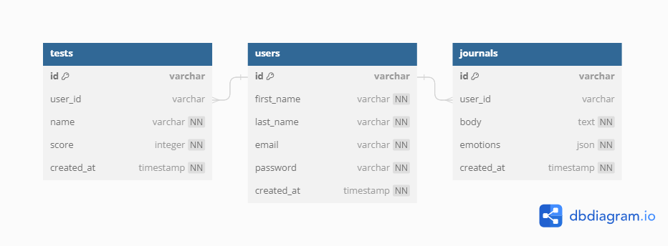

**(Data Base 2)**

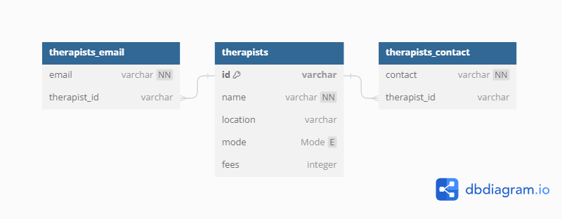

**4.1.1 UML Diagram:**

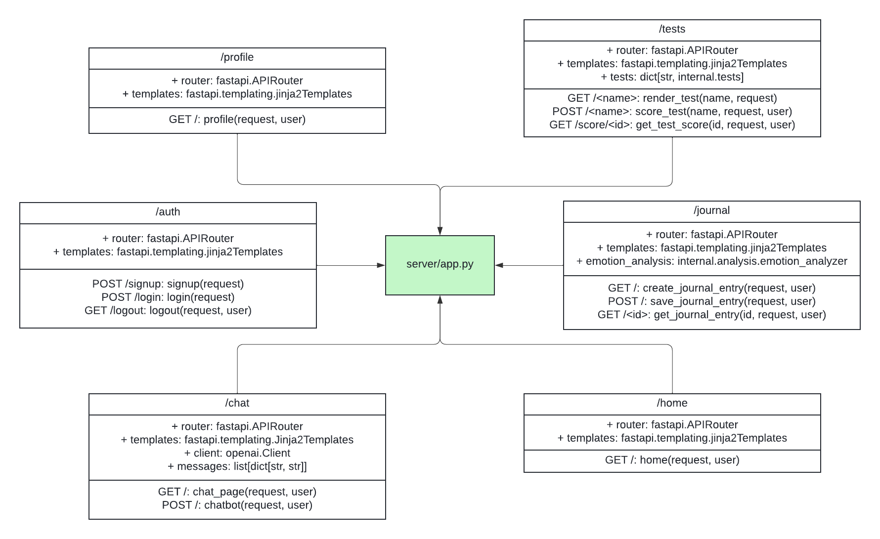

**4.1.2 Authentication Sequence:**

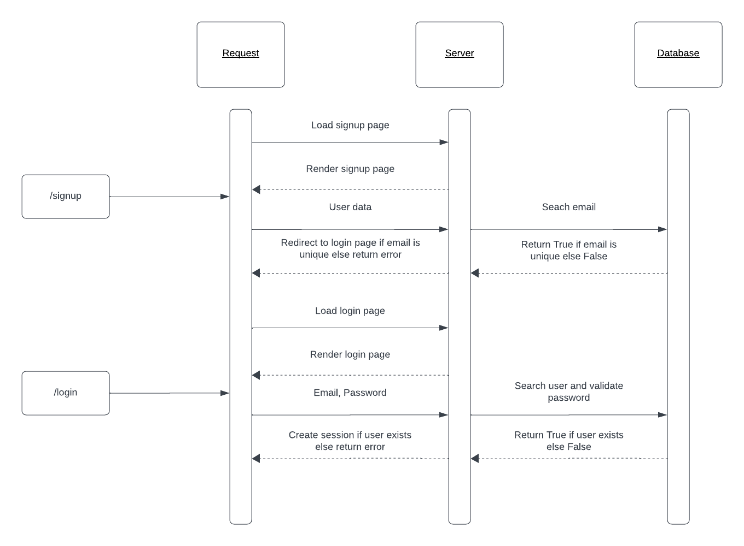

**4.1.3 Chat Sequence:**

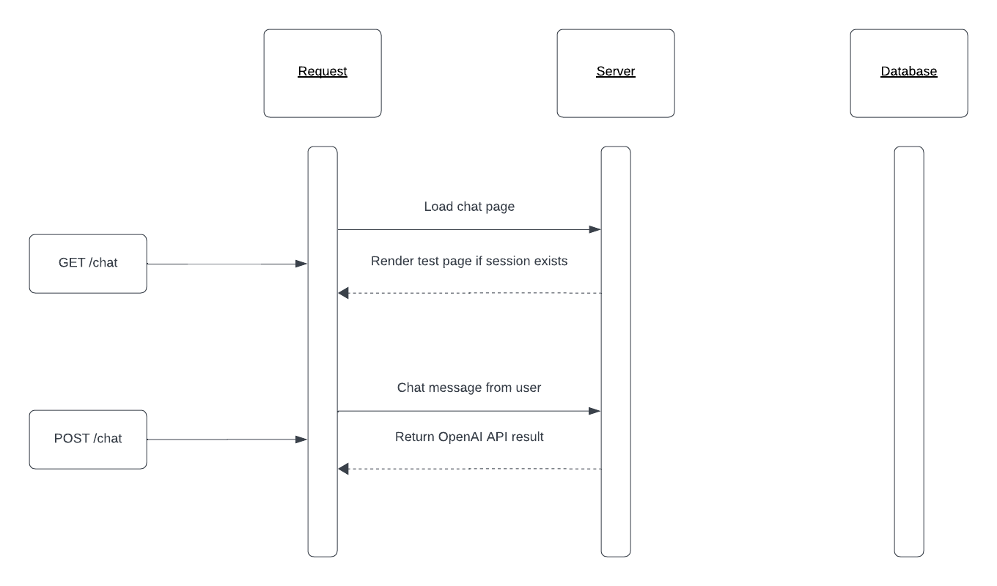

**4.1.4 Journal Sequence:**

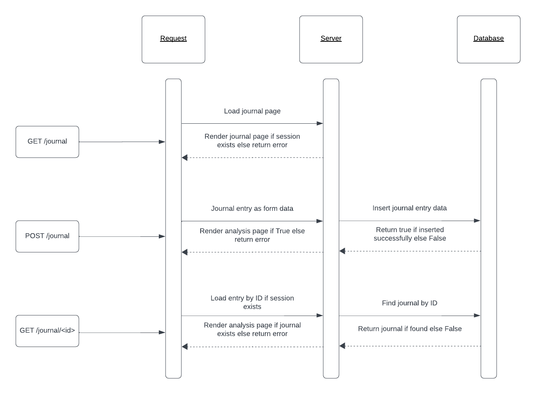

**4.1.5 Test Sequence:**

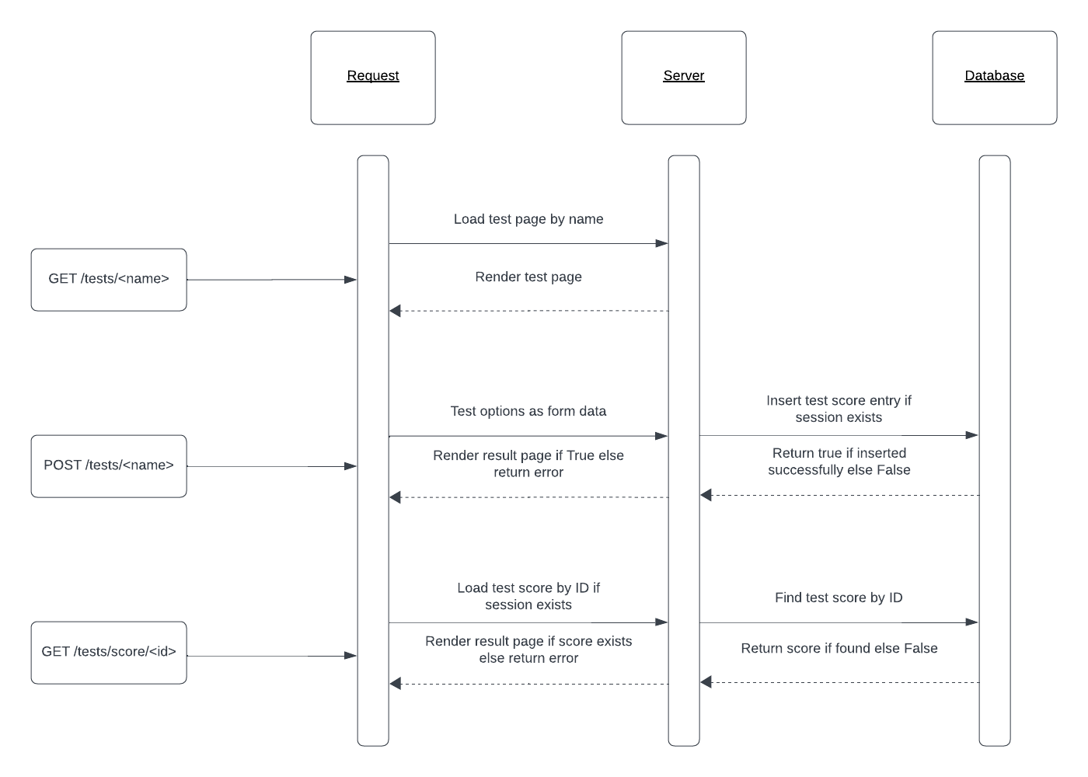

**4.2 Implementation Details:**

The Nasake project is an online application designed to help young adults with their mental health. The implementation makes use of a number of frameworks and technologies to produce a stable and intuitive platform. Here are specific details about how the aforementioned technologies were implemented:

**QuickAPI:**

Nasake's main backend framework, FastAPI, offers excellent performance and simplicity of development. It makes use of automatic OpenAPI (Swagger) documentation creation and Python type hints to make API understanding and interaction easier. The asynchronous features of FastAPI improve the application's responsiveness.

**Jinja 2:**

Nasake utilizes Jinja2 as its templating engine. It easily combines with FastAPI, enabling HTML pages to be generated dynamically. Jinja2's template inheritance makes code organization easier and makes it possible to create layouts that are modular and consistent.

**Transformers & OpenAI:**

Nasake's natural language processing (NLP) capabilities are powered by the Transformers library and OpenAI. Sentiment analysis and journal mode understanding are two applications that make use of OpenAI's GPT (Generative Pre-trained Transformer) models. This makes it possible for Nasake to decipher user emotions and provide customized solutions.

**SQLAlchemy:**

Is used as the Object-Relational Mapping (ORM) tool for Nasake's database interactions,. It makes smooth connection with the database below possible, which makes it possible to store and retrieve user information, journal entries, and business contacts quickly and easily. Database schema definition is streamlined by SQLAlchemy's declarative syntax.

**Uvicorn and Gunicorn:**

In Nasake, Uvicorn acts as the ASGI server to handle asynchronous requests. A WSGI server called Gunicorn serves as a ready-to-use HTTP server. This combination guarantees that web requests are handled efficiently. making Nasake capable of handling concurrent connections and scaling to meet user demands.

**Pydantic:**

Pydantic is utilized by Nasake for serialization and data validation. It offers a simple method for defining data schemas, which makes the process of creating data models easier. Before processing, pydantic models are used to validate user input and guarantee data integrity.

**Pytest**:

Because of its simplicity and versatility, Pytest has been selected as the testing framework for Nasake. It makes it easier to test different components, such as the correctness of the AI bot's responses, database interactions, and creation of visual aids, unit, integration, and end-to-end testing.

**HTTPX**:

Within Nasake, HTTPX is used to make HTTP requests. In line with FastAPI's asynchronous capabilities, it handles both synchronous and asynchronous requests. When integrating external APIs, such retrieving instructional materials from outside sources or utilizing the OpenAI API, HTTPX is used.

**Bcrypt:**

For managing user credentials securely, Bcrypt hashing library was selected. Because it uses a one-way hash function, user credentials are kept private. By eliminating the risks connected with quick hashing methods, Bcrypt's adaptive hashing algorithm improves security.

**Selenium:**

Nasake has integrated Selenium, a potent browser automation tool, for end-to-end user interface testing. It enables extensive testing of the functionality of the web application, including journal entry creation and AI bot interactions, by simulating user interactions.

**4.2.1 Workflow for Implementation:**

**User Interaction:**

Through the online interface, users may access different functions, engage with the AI bot, and provide diary entries to Nasake.

**FastAPI Routing:**

Incoming requests are handled by FastAPI routes, which forward them to the relevant handlers for processing.

**Jinja2 Templating:**

Jinja2 templates ensure a responsive and interesting user experience by dynamically generating HTML pages that present information to users.

**Integrating OpenAI with Transformers:**

The AI bot can better comprehend user emotions by utilizing sentiment analysis on user-generated text thanks to the integration of the Transformers library with OpenAI.

**SQLAlchemy ORM:**

Through database interactions with SQLAlchemy ORM, Nasake is able to store and retrieve user information, journal entries, and business contacts in a durable manner.

**Validation of Pydantic Data:**

In order to guarantee data integrity and conformance to specified schemas, pydantic models check user input.

**Asynchronic Tasks:**

Because Uvicorn handles asynchronous processes, Nasake is more responsive and scalable overall.

**Using Pytest for testing:**

Pytest is used for automated testing, including end-to-end, unit, and integration tests, which verify the accuracy and functioning of Nasake's features.

**Safe Management of Passwords:**

The security of user accounts is increased by Bcrypt, which safely hashes and validates user passwords.

**Interactions with External APIs:**

With HTTPX, interacting with external APIs is much easier, making it possible for Nasake to retrieve instructional materials or make use of extra resources.

**Automating Browsers Using Selenium:**

For end-to-end testing, Selenium automates browser interactions to verify the accuracy and usability of the online application.

In conclusion, the Nasake project's implementation makes use of a potent technology stack to produce a thorough platform for mental health support. Together, Jinja2, Transformers, SQLAlchemy, FastAPI, and other tools give users a safe, effective, and intuitive experience. In order to serve young adults with mental health difficulties, Nasake integrates AI capabilities, secure data handling, and thorough testing techniques.

**CHAPTER 5**

**TESTING**

**5.1 Testing Plan**

**5.1.1 Testing using Pytest Library:**

Pytest is a powerful and flexible testing framework used in the Nasake project to conduct module unit testing. Unit testing is a crucial aspect of software development, aiming to validate the correctness of individual components (modules) of the application. Pytest simplifies the testing process, providing a clean and intuitive syntax while offering extensive features for efficient test creation and execution.

**Examine Discovery:**

Pytest uses naming conventions to automatically find test functions and modules. "Test_" prefixed files and functions are regarded as test candidates.

Fixture Configuration:

Preconditions for tests are established using Pytest fixtures. Functions designated with the @pytest.fixture decorator are known as fixtures. They can be used to numerous tests, encouraging the reuse of code and cutting down on redundancy.

**Test Features:**

The prefix def test_ is used to specify test functions. By passing the fixture's name as an input, they make use of preset resources or data.

**Assertions:**

Pytest utilizes Python's standard assert statement for making assertions. If an assertion fails, Pytest reports the failure along with detailed information, aiding in quick issue identification.

**Testing with parameters:**

Using the @pytest.mark.parametrize decorator, Pytest allows parameterized testing. It improves test coverage by enabling the testing of a function with several input parameter sets.

**Exam Fixtures:**

Fixtures can be used to supply data required for testing or to set up a test environment. Fixtures for Pytest are modular and can be shared by several tests.

**Mocking:**

Pytest supports the use of the pytest-mock plugin for mocking objects and functions. This is valuable for isolating the unit under test and controlling external dependencies.

**Test Extent:**

Pytest easily interfaces with pytest-cov and other coverage measuring tools. As a result, all code paths that are performed may be tested, and code coverage can be tracked throughout testing.

Various command-line options enable customizing the testing process, such as running specific tests or generating detailed reports.

Pytest is a reliable and effective testing framework that provides a simple method for unit testing in the Nasake project. The Nasake development team can write extensive and maintainable tests by utilizing Pytest's fixtures, parameterized testing, assertions, and mocking features. The general dependability and quality of Nasake's codebase are enhanced by the framework's smooth integration with other tools, such as coverage measuring tools. By using Pytest, Nasake makes sure that every module works well when used alone, which helps the project achieve its goal of giving young adults appropriate mental health support.

**5.1.2 Testing using Selenium Library:**

To make sure the separate parts (modules) of the Nasake project work as planned, module unit testing is essential. This degree of testing enables the independent validation of functions, classes, and methods to make sure they yield the desired outcomes.

Framework: Nasake uses Pytest, a reliable and user-friendly testing framework, for module unit testing. Pytest makes creating test cases easier, offers strong assertions, and makes fixture management easier.

**Testing Approach-**

**Module for Journal Mode:**

Goal: Confirm the features associated with the generation and examination of journal entries.

Test scenarios:

Examine how journal entries are created and stored in the database.

Check how well the keyword analysis function captures the feelings of the user.

**AI Bot Module:**

Goal: Evaluate the AI bot's accuracy and responsiveness in producing pertinent answers.

Test scenarios:

Examine how the AI bot reacts to different types of user inquiries and facial expressions.

Verify the correctness of the mental aptitude test's administration and interpretation.

**Module for Professional Contacts:**

Goal: Ensure that business contacts are accurately stored and retrieved.

Test Cases: Evaluate adding, deleting, and altering professional contacts.

Test the contacts' retrieval using various category criteria.

**Methodology for Testing:**

**User Sign-up and Access:**

Goal: Verify the functionality of user registration and login.

Test Procedures:Use real data to simulate user registration.Test the login procedure with the credentials you registered.Check that you were able to log in and go successfully to the user dashboard.

**Making a Journal Entry:**

Making ensuring users can write and submit diary entries is the goal.

Test Procedures:Select the journal mode.Enter text in the journal and hit enter.

Check to make sure the journal entry was successfully stored.

**AI Bot Communication:**

Verify the correctness and responsiveness of the AI bot is the goal.

Test Procedures:Start a dialogue with the AI bot.Check if the AI bot can comprehend the feelings and questions of the user.Verify that the mental aptitude test was administered and interpreted correctly.

**Expert Relationship Management:**

Goal: Make sure users are able to maintain their business relationships.

Steps in the Test:Include a fresh business contact.Change the current contact information.Check if a professional contact has been removed.

**Access to Educational Content:**

Goal: Verify the educational content retrieval.

Steps in the Test:Go to the section with instructional content.Choose a certain aspect of mental health.

Check to make sure the data displayed is accurate and relevant.

**Display of Visual Aids:**

Goal: Verify that visual aids are created and shown correctly.

Steps for Testing: Enter data to create pie charts.

Examine the diagrams that are used to illustrate mental health subjects.

**Execution:**

**Command**:

A Python script that communicates with the web application using the Selenium WebDriver can be used to perform the Selenium test suite.

Advantages:

verifies the web application's complete operation.

finds problems with the way several modules are integrated.

guarantees a smooth user experience for all features.

Crucial elements of Nasake's testing approach are integration testing of the entire web application and unit testing of its separate modules. While Selenium integration testing ensures that several modules cooperate and function as intended when integrated into the entire system, module unit testing makes sure that each component functions as intended when used independently. When combined, these testing strategies improve Nasake's overall quality and dependability and offer a safe and efficient mental health support platform.

**CHAPTER 6**

**FINDINGS, CONCLUSIONS AND FUTURE WORK**

**6.1 Findings-**

While online mental health tests have limitations, they play a crucial role in fostering mental health awareness, particularly among young adults. In the post-2020 era, these tests have gained significance due to the pandemic's impact on mental well-being. Studies indicate a surge in stress, anxiety, and depression among young adults, making online assessments valuable in identifying potential issues.

Data from ‘NASAKE’ shows a rise in symptoms of anxiety and depressive disorders, emphasizing the need for accessible mental health tools. Online tests often address common mental health concerns such as generalized anxiety disorder and major depressive disorder.

The Pew Research Center reports an increased willingness among young adults to discuss mental health, indicating a positive shift in destigmatizing the topic. Online tests contribute to this openness, providing a low-barrier entry point for individuals to reflect on their mental well-being.

Online platforms like ‘NASAKE’ are designed to encourage early intervention and connect users with appropriate resources. The anonymity of online assessments can reduce the fear of judgment, making it more likely for young adults to seek help.

Moreover, a study published in the Journal of Medical Internet Research indicates that online mental health screenings are effective in identifying individuals at risk for mental health disorders. The convenience and accessibility of these tests facilitate timely interventions, potentially preventing the escalation of mental health challenges.

Online assessments empower young adults to be proactive about their mental health. The World Health Organization (WHO) recognizes the role of digital tools in expanding mental health services, especially during times of crisis. Apps and online platforms complement traditional mental health services, offering a scalable solution to address the growing demand.

In conclusion, while online mental health tests are not diagnostic tools, they serve a crucial role in promoting mental health awareness and encouraging early intervention. With increasing acceptance of mental health discussions, these tools contribute to a broader public health approach, fostering resilience and well-being among young adults. However, it is essential to emphasize that online assessments should be part of a comprehensive mental health strategy that includes professional evaluation and support.

**6.2 Conclusion**-

In conclusion, the NASAKE project has embarked on a commendable journey to establish a compassionate online space devoted to fostering mental health and overall well-being. The genesis of this initiative is rooted in a profound recognition of the pressing need for heightened awareness and robust support systems for mental health, particularly among young adults grappling with the unique challenges of the 21st century. The initiative signifies a proactive response to the escalating mental health concerns exacerbated by the complexities of modern life.

As the NASAKE project approaches its completion phase, the focus is on meticulous refinement to ensure the platform's efficacy and quality. This involves a thorough touch-up and a series of test runs to validate its functionality and user experience. The commitment to creating a nurturing digital environment underscores the project's dedication to providing a meaningful and impactful resource for individuals seeking mental health support.

NASAKE's vision aligns with the evolving landscape of mental health awareness, acknowledging the significance of accessible and empathetic platforms in addressing mental health concerns. By offering a dedicated online space, NASAKE aspires to contribute meaningfully to the well-being of its users, fostering a sense of community and support. The project stands poised to make a positive impact, fostering resilience and mental health literacy among users navigating the intricate dynamics of mental well-being in the contemporary era.

**6.3 Future Works-**

Instant Crisis Assistance:

Concept: Include real-time crisis assistance tools, including chatbots for crises or quick access to emergency numbers or helplines. Use sentiment analysis to spot troubled users and provide support in a timely manner.

Participation in the Community:

Concept: Establish a community section on Nasake where users may interact with one another, support one another, and exchange stories. Incorporate moderation mechanisms to guarantee a secure and encouraging atmosphere.

Counselor/Therapist Portal:

Idea: Create a different portal where users looking for professional help can connect with mental health providers. Implement a system that allows professionals to access pertinent user data and secure video conferencing for online therapy sessions.

Support in Multiple Languages:

Idea: Add multilingual support to increase the platform's accessibility. This makes sure that Nasake's mental health materials are accessible to people with a variety of linguistic backgrounds.

Music/Movie for Mood

Enhancing the User Experience with the Integration of Mood-Based Spotify Playlist

Providing Movie Recommendations tailored to the user's personality to enhance their well-being.

Application

Creating an Android Application to improve accessibility to the website.Enhancing user-friendliness to accommodate a wider age demographic, particularly older individuals.

**REFERENCES**

[1] World Health Organization, "Adolescent Mental Health," [Online]. Available: <https://www.who.int/news-room/fact-sheets/detail/adolescent-mental-health>.

[2] BMC Psychiatry, "Risk and protective factors associated with the mental health of young adults," [Online]. Available:<https://bmcpsychiatry.biomedcentral.com/articles/10.1186/s12888-018-1648-4>.

[3] Journal of Adolescent Health, "Stigma starts early: Gender differences in teen willingness to use mental health services," [Online]. Available: <https://www.sciencedirect.com/science/article/abs/pii/S1054139X05003952>

[4] Current Opinion in Psychology, "Contextualizing adolescent structural brain development: Environmental determinants and mental health outcomes," [Online]. Available: <https://www.sciencedirect.com/science/article/pii/S2352250X21001834> .

[5] Lancet Psychiatry, "Mental Health Interventions in Schools in High-Income Countries," [Online]. Available: <https://www.thelancet.com/journals/lanpsy/article/PIIS2215-0366(14)70312-8/fulltext> .

[6] The Journal of Child Psychology and Psychiatry, "Adolescent mental health in the digital age: facts, fears, and future directions," [Online]. Available: <https://acamh.onlinelibrary.wiley.com/doi/abs/10.1111/jcpp.13190> .

[7] Cyberpsychology, "Impact of Social Media on Adolescent Mental Health," [Online]. Available: <https://www.researchgate.net/publication/343205479_Impact_of_Social_Media_on_Adolescent's_Mental_Health> .

[8] PostgreSQL Documentation, [Online]. Available: <https://www.postgresql.org/docs/>

[9] Python Documentation, [Online]. Available: <https://docs.python.org/3/> .

[10] HTML5 Specification, W3C, [Online]. Available: <https://www.w3.org/TR/html5/> .

[11] CSS: Cascading Style Sheets, W3C, [Online]. Available: <https://www.w3.org/Style/CSS/Overview.en.html>

[12] JavaScript | MDN, Mozilla, [Online]. Available: <https://developer.mozilla.org/en-US/docs/Web/JavaScript>

[13] Django Project, [Online]. Available: <https://www.djangoproject.com/>