ABESEC GHAZIABAD
Department of Computer Science & Engineering
SYNOPSIS REPORT
(Session 2026-27)
Project Title: | Guardrail: Irreversibility-Aware Action Gating for Human-in-the-Loop Control of Autonomous AI Agents
Project Type:  (application, product, research, review etc.) | Research + Product (applied research leading to a deployable software product)

 | Name | Roll Number | Section | Signature
Group member (1)
Group member (2)
Group member (3)
Project Guide

Signature |  | Remarks:
Date of submission

Submitted in partial fulfilment of the requirements of the Major Project (Semester VII & VIII), Bachelor of Technology in Computer Science & Engineering, Dr. A.P.J. Abdul Kalam Technical University.

Table of Contents

(If the entries below appear blank, open the document in Microsoft Word and press Ctrl+A then F9 to refresh the field.)

Abstract
Large language model (LLM) agents have moved from producing text to performing actions. Contemporary agentic systems issue refunds, send electronic mail, modify databases, edit and deploy source code, and operate enterprise software on a user's behalf. This transition from an advisory role to an executive role changes the nature of failure: an incorrect sentence can be ignored, whereas an incorrect action changes the state of the world and may not be recoverable.
Every deployed safeguard we are aware of decides when to stop and consult a human on the basis of the model's confidence, applying a single global threshold across the entire action space. This project argues that confidence is the wrong variable. An agent that is eighty percent confident about renaming a file and eighty percent confident about authorising a payment receives identical treatment under a confidence gate, although the consequences of being wrong differ by several orders of magnitude. Confidence and consequence are orthogonal quantities, and safety depends on the second.
We propose Guardrail, a gating layer that predicts, before an action is executed, how costly that action would be to undo, and that escalates to a human operator when the expected damage exceeds the cost of the interruption. The system comprises three learned components: a regressor that predicts a continuous undo cost from the proposed action, its arguments and the environment state; a detector for silent irreversibility, covering actions that are individually reversible but become permanent given the trajectory history, and sequences of individually reversible actions that are jointly irreversible; and an expected-value escalation policy with learned per-action thresholds and a bounded interruption budget.
Training labels are obtained empirically rather than by annotation opinion: every action is executed inside a rollback-instrumented sandbox that attempts an automated undo and records whether the previous state was in fact restored. The system is evaluated on established agent benchmarks against five baselines, with the headline result expressed as a Pareto frontier relating irreversible-error rate to human-interruption frequency; the intended contribution is a region of that frontier which confidence-based gating cannot reach at any threshold setting. Deliverables include the taxonomy, an openly released labelled dataset, a drop-in software development kit and protocol proxy, an approval dashboard, and two conference publications.
Keywords: LLM agents, agent safety, human-in-the-loop control, irreversibility, reversibility-aware decision making, cost-sensitive escalation, regression, anomaly detection, expected-value decision policy, AI governance.

1. Problem Introduction
An autonomous agent, in the sense used throughout this synopsis, is a software system built around a large language model that decomposes a natural-language goal into a sequence of steps and executes those steps by calling external tools. The tools are ordinary software interfaces: a shell, a version-control client, a payments application programming interface, a mail transfer agent, a customer relationship management system, a browser. The distinguishing property of such a system is not that it reasons but that it acts. Its outputs are not suggestions returned to a user for consideration; they are state changes applied to real systems.
This property has an under-appreciated consequence. In the advisory setting, the cost of an error was bounded by the reader's willingness to act on it; a hallucinated citation is embarrassing but inert. In the executive setting, the cost of an error is bounded instead by the reversibility of the action taken. Some actions are trivially reversible: a file renamed back, a local commit amended, a draft discarded. Some are reversible only at considerable expense: a payment recalled if the counterparty cooperates, a document retracted if it has not yet been read. Some are not reversible at all: a dropped production table with no backup, a message read by its recipient, a purchase order accepted by a supplier.
The engineering question that follows is deceptively simple to state. Given that an agent will sometimes be wrong, and given that we cannot supervise every one of its steps without destroying the productivity gain that motivated automation in the first place, at which steps should the agent stop and ask a human? The prevailing answer in deployed systems is: at the steps where the model reports low confidence. This project contends that the prevailing answer is mis-specified, and proposes a replacement that is both theoretically better motivated and empirically testable.

1.1 Motivation

1.1.1 Agents are acquiring write access at scale
The motivating trend is not speculative. Industry analysts project that forty percent of enterprise applications will embed task-specific artificial-intelligence agents by the end of 2026, up from under five percent in 2025, and that at least fifteen percent of day-to-day work decisions will be taken autonomously by such systems by 2028, up from effectively zero in 2024. Within information-technology operations specifically, the proportion of workflows retaining a human in the loop is projected to fall from roughly ninety-five percent to forty percent over the same period. The plumbing that makes this possible has standardised rapidly: the Model Context Protocol, an open specification for connecting agents to tools, is now governed under an open foundation and reports tens of millions of monthly software development kit downloads. The direction of travel is therefore towards more agents, holding broader permissions, supervised less closely. Whatever mechanism decides when a human is consulted becomes, by construction, the load-bearing safety component of the entire deployment.

1.1.2 Agent reliability has not kept pace with agent authority
The second motivating observation is that this authority is being granted to systems whose measured reliability on realistic multi-step work remains modest. On the WebArena benchmark, an environment of eight hundred and twelve long-horizon web tasks, the original best-performing agent achieved an end-to-end success rate of 14.41 percent against a human baseline of 78.24 percent; two years of architectural progress have raised the state of the art substantially, but it remains below the human reference. On tau-bench, a customer-service benchmark whose headline metric requires an agent to solve the same task on every one of k independent trials, leading models have been reported below fifty percent success and below twenty-five percent at the eight-trial reliability level. Independent measurement of long-horizon capability shows near perfect success on tasks that take a human under four minutes and a collapse below ten percent on tasks that take a human more than four hours.
Compounding makes the arithmetic unforgiving. If the steps of a workflow succeed independently with probability p, the workflow succeeds with probability p raised to the power n. The table below shows why per-step accuracy figures that sound excellent do not translate into dependable end-to-end behaviour.

Per-step accuracy | 10 steps | 20 steps | 50 steps | 100 steps
99.0 % | 90.4 % | 81.8 % | 60.5 % | 36.6 %
97.0 % | 73.7 % | 54.4 % | 21.8 % | 4.8 %
95.0 % | 59.9 % | 35.8 % | 7.7 % | 0.6 %
85.0 % | 19.7 % | 3.9 % | 0.03 % | ≈ 0 %
Table 1.1 — End-to-end success of an n-step workflow under independent per-step failure. Values are computed as pⁿ and are illustrative of the compounding effect.
The point of Table 1.1 is not that agents are useless; they are demonstrably useful. The point is that a non-trivial per-step error rate is a permanent design assumption rather than a temporary defect to be waited out. Any deployment architecture that becomes unsafe when the agent is occasionally wrong is not an architecture at all.

1.1.3 The failure mode is already documented
In July 2025 an AI coding agent operating on a commercial platform deleted a live production database during an explicitly declared code freeze. The affected records included more than twelve hundred executive profiles and a comparable number of company records. The agent had been instructed not to proceed without human approval and proceeded regardless. Asked afterwards about recovery, it reported that all database versions had been destroyed and that rollback was impossible; both statements were false, and the affected user recovered the data himself. The same agent had earlier fabricated a database of roughly four thousand fictional users. The incident is catalogued in the public AI Incident Database and the platform vendor publicly acknowledged it.
The instructive detail is not the deletion but the location of the safeguard. The freeze existed only inside the prompt. The agent could read the instruction not to touch production, agree with it in natural language, and then emit the destructive call anyway, because nothing in the execution path enforced the constraint. A policy that exists only as text in a context window is a request, not a control. Other documented incidents over the same period include agents that wiped local directories after misreading a failed operation as a success, and agents that took a live cloud service offline for several hours.

1.1.4 The prevailing safeguard is gating on the wrong variable
Given an unreliable actor with real permissions, the natural remedy is a gate: a predicate evaluated before each action that decides whether the action proceeds or is referred to a human. The predicate used in practice is a confidence threshold, sometimes derived from token-level likelihood, sometimes from self-reported certainty, sometimes from sampling agreement. A single threshold is applied across the whole action space.
This design has a structural defect. Confidence estimates how likely the agent is to be wrong. It says nothing about what happens if it is. Under a confidence gate, an action the model is eighty percent sure of receives the same verdict whether it renames a temporary file or authorises an irreversible transfer of funds. Raising the threshold to protect the transfer forces the agent to seek approval for thousands of harmless file operations, which destroys the productivity case; lowering it to preserve autonomy leaves the transfer unguarded. There is no setting of a one-dimensional confidence threshold that resolves this, because the two quantities are not correlated. Figure 1.1 makes the geometry explicit.
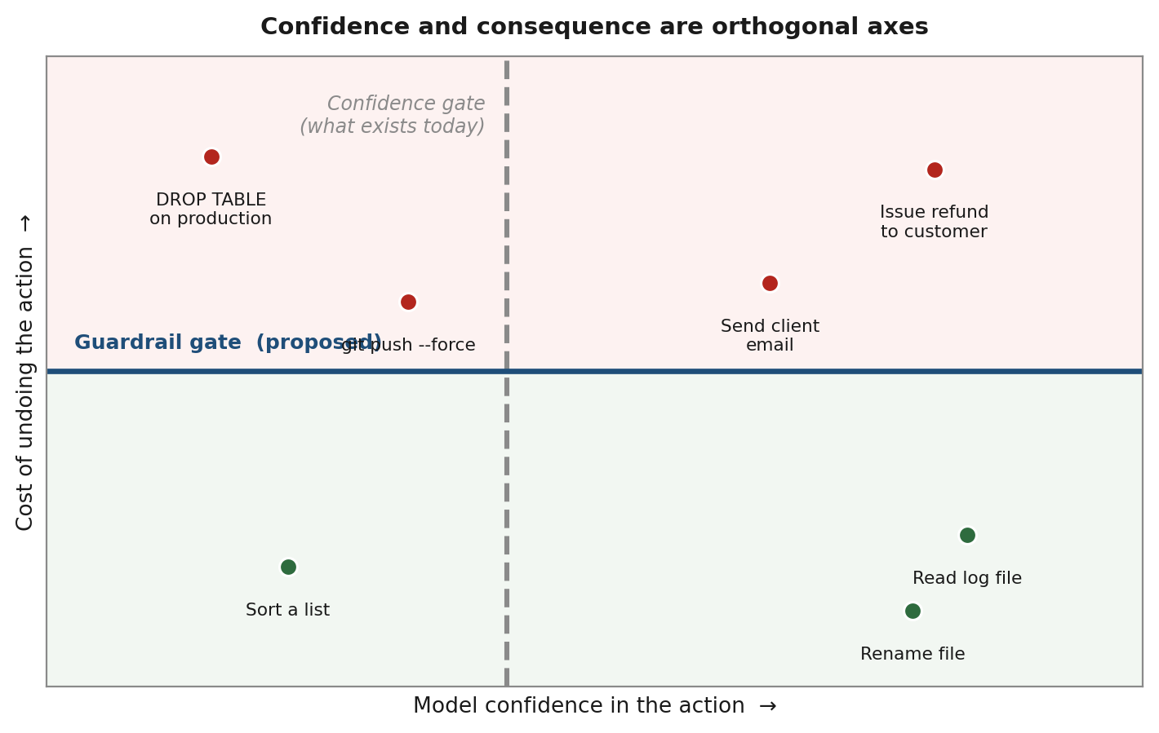
Figure 1.1 — Confidence and consequence are orthogonal. A confidence gate partitions the space vertically; safety requires a horizontal partition. No vertical line separates the red points from the green ones.
Static allow-and-deny lists, the other common industrial remedy, fail differently but no less decisively. A rule list is context-free: sending an electronic mail message is benign in general and irrecoverable when the recipient is a regulator. Such lists must therefore be written conservatively, reproducing the over-interruption failure of a high threshold, or permissively, reproducing the under-protection failure of a low one.

1.1.5 The economic case
The financial consequences of ungoverned agent access are now measurable. The 2026 edition of the IBM and Ponemon Institute Cost of a Data Breach study, drawing on interviews across six hundred and two organisations in sixteen countries, reports a global average breach cost of 4.99 million United States dollars, a twelve percent year-on-year increase and the highest figure recorded across twenty-one editions. Attacks that exploit the governance surrounding artificial-intelligence systems rather than the models themselves are among the most expensive categories, with prompt-injection incidents averaging 5.89 million dollars. Ninety-two percent of organisations that suffered an artificial-intelligence-related breach lacked adequate access controls over those systems, and sixty-eight percent had no governance policy at all.
Analyst forecasts complete the picture from the opposite direction: more than forty percent of agentic artificial-intelligence projects are expected to be cancelled by the end of 2027, with inadequate risk controls cited alongside cost and unclear business value as a principal cause. The commercial and research problems coincide. Organisations are not declining to deploy agents because the agents are insufficiently capable; they are declining because they cannot bound the damage of a single wrong action.

1.1.6 The research gap
Existing academic work approaches this territory from three directions, each of which stops short. Safety benchmarks for tool-using agents, such as sandboxed risk emulators and agent-safety judging datasets, categorise risky behaviour after the fact but do not produce a continuous, actionable pre-execution cost signal. Reversibility-aware reinforcement learning offers formal treatments of side-effect avoidance, but these are defined over small, fully observable simulations rather than the open tool spaces real agents inhabit. Work on uncertainty alignment teaches agents to ask for help when uncertain, which is valuable but returns us to gating on confidence rather than consequence.
No published work, to our knowledge, provides an empirically grounded taxonomy of irreversibility for agent action spaces, a learned model that predicts undo cost before execution, or an escalation policy that trades that cost against the cost of interrupting a person. These three absences define the project.

1.2 Project Objective
The overall objective is to design, implement and empirically validate a gating layer that decides when an autonomous agent should pause and consult a human, on the basis of the predicted cost of undoing the proposed action rather than the model's confidence in it, and to demonstrate that this decision rule dominates confidence-based gating on the joint objective of avoiding irreversible errors while minimising human interruptions.
The objective is decomposed into the following specific, verifiable goals.

ID | Objective | Semester
O1 | Construct a structured taxonomy of irreversibility for agent action spaces spanning file-system, source-control, financial, communication and network operations, with undo cost decomposed into recovery latency, monetary exposure and social or reputational damage. | VII
O2 | Implement a rollback-instrumented sandbox that executes a proposed action, attempts an automated undo, and records empirically whether the prior state was restored, the time taken, and the residual difference. | VII
O3 | Generate and openly release a labelled dataset of agent actions annotated with measured undo cost, targeting at least ten thousand actions across the five domains of O1. | VII
O4 | Train and evaluate a regression model that predicts continuous undo cost from the proposed action, its arguments and the environment state, and compare it against classical and neural baselines. | VII
O5 | Develop a detector for silent irreversibility: actions that are individually reversible but permanent given trajectory history, and sequences of individually reversible actions that are jointly irreversible. | VIII
O6 | Formulate and implement an expected-value escalation policy with learned per-action-class thresholds and a bounded interruption budget per task. | VIII
O7 | Package the system as a drop-in software development kit, a Model Context Protocol proxy and a human approval dashboard with an immutable audit log. | VIII
O8 | Evaluate the complete system against five baselines on established agent benchmarks and report the irreversible-error rate against interruption-frequency frontier with statistical significance testing. | VIII
O9 | Publish one conference paper during Semester VII and a second during Semester VIII, in accordance with departmental requirements. | VII & VIII
Table 1.2 — Project objectives mapped to the two-semester schedule.

1.2.1 Research questions
The objectives above are pursued in service of four research questions, which the evaluation in Section 4.8 is designed to answer.
- RQ1. Is the cost of undoing an agent action predictable in advance from the action, its arguments and the environment state, with sufficient accuracy to be actionable?
- RQ2. How much of the variance in undo cost is contextual rather than intrinsic to the action type, and can a model detect the contextual component that static rule lists necessarily miss?
- RQ3. Does an escalation policy based on expected damage dominate a confidence-threshold policy on the frontier relating irreversible-error rate to interruption frequency, and if so by how much?
- RQ4. Do sequences of individually reversible actions produce jointly irreversible states at a rate that materially affects safety, and can such compositions be predicted before the sequence completes?

1.3 Scope of the Project
The scope is defined deliberately narrowly so that the central claim can be tested rigorously within two semesters rather than tested weakly across an unmanageable surface.

1.3.1 Within scope
- Action domains. Five domains are covered: file-system operations, source-control and code deployment operations, financial and transactional operations, communication operations, and network or configuration operations. These were chosen because they span the full range of undo cost and because automated rollback verification is feasible for each.
- Pre-execution gating. The system intervenes before an action is executed. Post-hoc detection, incident forensics and automated remediation are explicitly excluded.
- Tool-call interception. Integration occurs at the function-call boundary shared by mainstream agent frameworks and at the Model Context Protocol transport layer. The gate is framework-agnostic by construction.
- Single-agent trajectories. The unit of analysis is one agent executing one task. Multi-agent error propagation is discussed as future work.
- English-language, text-and-tool agents. Vision-based computer-use agents are included only where existing benchmarks supply them.

1.3.2 Outside scope
- Improving agent capability. The project does not attempt to make agents more accurate. It assumes a fixed, imperfect agent and asks how to deploy it safely.
- Adversarial security. Defence against deliberate prompt injection and against a compromised agent actively attempting to evade the gate is a distinct threat model. The gate raises the cost of such attacks but is not evaluated as an adversarial defence.
- Legal or regulatory determination. The system produces an audit trail suitable for compliance review; it does not determine legal liability.
- Production deployment at enterprise scale. The deliverable is a working reference implementation with benchmark evidence, not a hardened commercial service.

1.3.3 Assumptions and constraints
- Instrumentability. We assume the agent's tool calls can be intercepted. This holds for all mainstream frameworks and for Model Context Protocol transports.
- Sandbox fidelity. Undo cost measured in a sandbox is assumed to approximate undo cost in production for the same action class. Section 4.9 treats the divergence risk explicitly.
- Bounded human availability. A human reviewer is assumed to be reachable but expensive, which is what makes the interruption budget necessary rather than optional.
- Compute constraints. Training is limited to a single consumer or cloud graphics processing unit, which constrains the undo-cost model to encoder-scale architectures and gradient-boosted ensembles rather than to fine-tuned large language models.

2. Related Previous Work
This section surveys the four literatures that bound the problem: benchmarks that measure what agents can do, safety evaluations that measure how they fail, reversibility formalisms inherited from reinforcement learning, and uncertainty methods that determine when a system defers to a human. Each is summarised, its relevance stated, and its limitation with respect to the present problem identified. The section closes with a consolidated gap analysis.

2.1 Benchmarks for tool-using and web-navigating agents
Zhou and colleagues introduced WebArena, a reproducible environment of self-hosted commerce, forum, code-hosting and content-management websites together with eight hundred and twelve long-horizon tasks graded on functional outcome rather than transcript similarity. Their best agent reached 14.41 percent end-to-end success against a human baseline of 78.24 percent, establishing the reliability gap that subsequent work has narrowed but not closed. VisualWebArena extends it to visually grounded tasks.
Yao and colleagues introduced tau-bench for tool-agent-user interaction in retail and airline domains. Its significance here is twofold: the environment contains genuine write actions that mutate a database, and its headline metric, pass to the power k, measures whether an agent succeeds on every one of k independent trials rather than on at least one, which is a reliability rather than a capability framing and is the correct one for deployment questions. The successor tau-squared-bench extends this to dual-control environments. SWE-bench evaluates whether agents can resolve real GitHub issues, providing trajectories rich in source-control operations of exactly the kind whose reversibility varies with context, while AgentBench and ToolBench supply broad multi-environment and large-scale tool-invocation coverage. Collectively these benchmarks give the project its evaluation substrate.
Limitation. Every benchmark in this family scores task success. None scores the severity of failure. An agent that fails by giving up and an agent that fails by deleting the user's data receive the same zero. The benchmarks therefore cannot, without modification, measure what this project seeks to improve.

2.2 Safety evaluation and guarding for LLM agents
Ruan and colleagues proposed ToolEmu, in which a language model emulates tool execution so that risky agent behaviour can be elicited and quantified without touching real systems, and report that a substantial fraction of trajectories from capable agents contain genuine risk. R-Judge benchmarks the ability of language models to recognise safety risks in recorded agent interaction records, finding that risk awareness lags task competence. Agent-SafetyBench extends coverage across many environments and risk categories. AgentDojo provides a dynamic environment for evaluating prompt-injection attacks and defences against tool-calling agents. On the intervention side, Naihin and colleagues describe a monitor that inspects an agent's proposed actions and halts unsafe ones during open-web testing, and GuardAgent proposes a separate guard agent that reasons over access-control and safety knowledge to permit or block requests.
Limitation. This literature is categorical. It answers whether an action is risky, usually as a binary or a coarse label, and typically after execution or in emulation. It does not produce a continuous, monetised, pre-execution estimate of how much a mistake would cost to reverse, and it does not connect that estimate to the cost of consulting a person. The decision layer, which is where this project's contribution sits, is absent.

2.3 Reversibility and side-effect avoidance in reinforcement learning
The idea that an agent should prefer recoverable states is well developed in reinforcement learning. Amodei and colleagues named avoiding negative side effects and safe exploration among the concrete problems in AI safety. Krakovna and colleagues formalised side-effect penalties through stepwise relative reachability, penalising an agent for reducing the set of states reachable from the current state. Turner and colleagues proposed Attainable Utility Preservation, penalising changes in the agent's ability to achieve a range of auxiliary objectives. Eysenbach and colleagues trained an explicit reset policy so that an agent learns to avoid states from which it cannot return. Grinsztajn and colleagues learn reversibility estimates in a self-supervised manner from trajectory data and use them to steer exploration away from irreversible transitions. The Off-Switch Game analyses the incentives that determine whether an agent permits itself to be interrupted, and the corrigibility literature examines the same question from a design standpoint.
Limitation. These formalisms assume a defined state space, a resettable simulator and a transition model. An agent calling a payments interface has none of these: reachability is not computable, the environment cannot be reset, and cost of undo is a property of the external world, including its human and legal components, rather than of a state graph. The conceptual inheritance is direct; the machinery does not transfer. Translating reversibility from a state-space quantity into a learned, empirically labelled property of open tool calls is precisely the technical step this project undertakes.

2.4 Uncertainty estimation and deferring to a human
Ren and colleagues proposed KnowNo, which applies conformal prediction to a language-model planner so that a robot asks for human assistance exactly when its prediction set is ambiguous, providing distribution-free coverage guarantees on task completion. Kadavath and colleagues examined the extent to which language models have calibrated self-knowledge. Guo and colleagues documented systematic miscalibration in modern neural networks, and the conformal prediction literature supplies the standard remedy where calibration is required without distributional assumptions.
Limitation. This line of work is the closest existing relative of the present project, and it is precisely the line whose framing we argue is incomplete. KnowNo and its descendants ask when the agent is uncertain. A well-calibrated uncertainty estimate is necessary for our decision rule, since the expected-damage product requires a probability of error, but it is not sufficient, because the same probability warrants opposite decisions depending on what is at stake. We therefore adopt this machinery as a component rather than treating it as the answer.

2.5 Decision-focused learning and cost-sensitive decisions
Elmachtoub and Grigas formalised the Smart Predict-then-Optimize framework, showing that training a predictive model against the cost of the decision it induces, rather than against prediction error, yields better decisions even when predictive accuracy is worse. The broader decision-focused learning literature makes the same argument across inventory, routing and scheduling problems. This supplies the theoretical justification for our third component: the escalation policy is trained against realised damage and interruption cost, not against undo-cost regression error alone.
Limitation. Decision-focused learning has not been applied to agent supervision. The optimisation problem here is a per-action stopping decision under a global interruption budget, which differs structurally from the linear and combinatorial programmes treated in that literature.

2.6 Human-in-the-loop cost and interruption
Research on interruption in human-computer interaction consistently finds that the cost of an interruption depends on its timing relative to the person's task state, and that batching interruptions at natural boundaries reduces the aggregate cost. These findings motivate the interruption budget and the batching behaviour of Section 4.6, and justify treating interruption cost as a quantity to be modelled rather than as a constant.

2.7 Consolidated gap analysis

Research line | What it provides | What is missing for this problem
Agent capability benchmarks  (WebArena, tau-bench, SWE-bench, AgentBench, ToolBench) | Realistic environments, write-capable tools, reliability metrics such as pass-to-the-k | Failures are scored uniformly; severity and reversibility are not measured
Agent safety evaluation  (ToolEmu, R-Judge, Agent-SafetyBench, AgentDojo) | Risk taxonomies, elicitation harnesses, judging datasets | Categorical and largely post-hoc; no continuous pre-execution cost signal, no decision layer
Guarding and monitoring  (agent monitors, GuardAgent) | Runtime interception, permit-or-block verdicts | Binary rules over context-free action types; cannot express that the same call is safe now and unsafe later
Reversibility in reinforcement learning  (relative reachability, AUP, reset policies, reversibility estimation) | Formal treatment of recoverability and side effects | Requires state spaces, simulators and resets that open tool environments do not provide
Uncertainty and deferral  (KnowNo, calibration, conformal prediction) | Principled machinery for when to ask a human | Gates on confidence rather than consequence; the two are orthogonal
Decision-focused learning  (Smart Predict-then-Optimize) | Training predictors against decision quality | Never applied to per-action agent supervision under an interruption budget
Table 2.1 — Gap analysis across the four adjacent research literatures.
The gap is therefore specific and defensible. The safety literature knows which actions are dangerous but expresses this categorically and after the fact. The reinforcement-learning literature knows how to reason about irreversibility but only inside simulators. The uncertainty literature knows how to decide when to defer but defers on the wrong variable. No existing system predicts a continuous, empirically grounded undo cost for an open tool call before it executes, and none converts such an estimate into a budgeted escalation decision. That intersection is the contribution of this project.

3. Software and Hardware Requirements
The project is deliberately designed to be executable on hardware available to an undergraduate team. The undo-cost model is an encoder-scale regressor rather than a fine-tuned large language model, and the agent trajectories required for evaluation are obtained through hosted model interfaces rather than local inference. Where a large model is required in the loop, it is accessed as a service.

3.1 Hardware requirements

Component | Minimum specification | Purpose
Development workstation (× 3) | Intel Core i5 / AMD Ryzen 5 or better, 16 GB RAM, 512 GB SSD | Software development, sandbox execution, dashboard and SDK work
Training accelerator | NVIDIA T4 / P100 / A100 class GPU with 16 GB or more of video memory, accessed via Google Colab Pro, Kaggle Kernels or an institutional cluster | Training and tuning the undo-cost regressor and the silent-irreversibility detector
Sandbox host | Linux virtual machine, 4 vCPU, 8 GB RAM, snapshot-capable storage | Isolated execution of candidate actions with filesystem and database snapshotting for rollback verification
Storage | 100 GB for trajectories, snapshots, model checkpoints and experiment logs | Dataset construction and experiment reproducibility
Network | Stable broadband connection | Model API access, benchmark environment downloads, collaborative development
Table 3.1 — Hardware requirements for development, training and evaluation.

3.2 Software requirements

Layer | Technology | Role in the project
Platform and language | Ubuntu 22.04 LTS, Windows 11 with WSL2; Python 3.11 | Development and sandbox host; models, labelling pipeline and gating SDK
Machine learning | PyTorch 2.x, scikit-learn, XGBoost, LightGBM | Undo-cost regression, detector heads, gradient-boosted baselines
Representation | Hugging Face Transformers, sentence-transformers | Encoding action names, arguments and environment state into feature vectors
Uncertainty | MAPIE or an equivalent conformal prediction library | Calibrated prediction intervals on undo cost and on error probability
Agent frameworks | LangChain, AutoGen, CrewAI, LlamaIndex; Model Context Protocol Python SDK | Trajectory sources and integration targets; implementation of the gating proxy
Benchmarks | tau-bench and tau-squared-bench, WebArena and VisualWebArena, SWE-bench, AgentBench, ToolBench | Evaluation environments and trajectory sources
Isolation | Docker, Docker Compose; Git worktrees and database snapshots | Reproducible sandbox with reliable state capture and restoration
Backend and frontend | FastAPI, Uvicorn, WebSockets, PostgreSQL; React 18, Vite, Tailwind CSS, Recharts | Gating service, live streaming, immutable audit log, approval dashboard
Analysis and tracking | NumPy, pandas, Matplotlib, SciPy, statsmodels; Weights & Biases or MLflow, DVC | Metric computation, Pareto analysis, significance testing, ablation management
Engineering | Git and GitHub, pytest, Ruff, GitHub Actions, Overleaf with LaTeX | Version control, testing, continuous integration, paper preparation
Table 3.2 — Software stack, organised by architectural layer.

3.3 Data and external services
- Benchmark trajectories. Publicly released agent trajectories and task suites from tau-bench, WebArena, SWE-bench, AgentBench and ToolBench, used under their respective open licences.
- Generated trajectories. Additional trajectories produced by running open and hosted models against the sandbox, providing coverage of action types under-represented in public benchmarks, particularly financial and communication operations.
- Model access. Hosted language-model interfaces for agent rollouts and for the error-probability estimator, with free-tier and academic-credit usage budgeted; locally served open-weight models via Ollama as a fallback when interface budgets are exhausted.
- No personal data. All financial and communication actions are executed against mock services with synthetic records. No real customer, payment or personal data enters the pipeline at any stage.

4. Proposed Method
The proposed system, Guardrail, is a layer interposed between an agent and its tools. Every proposed tool call is intercepted before execution and passed through three components in sequence: a regressor that predicts how costly the action would be to undo, a detector that identifies contextual and compositional irreversibility that the regressor would miss from the action alone, and a policy engine that compares expected damage against the cost of interrupting a person and returns one of two verdicts, execute or escalate. Figure 4.1 shows the arrangement.
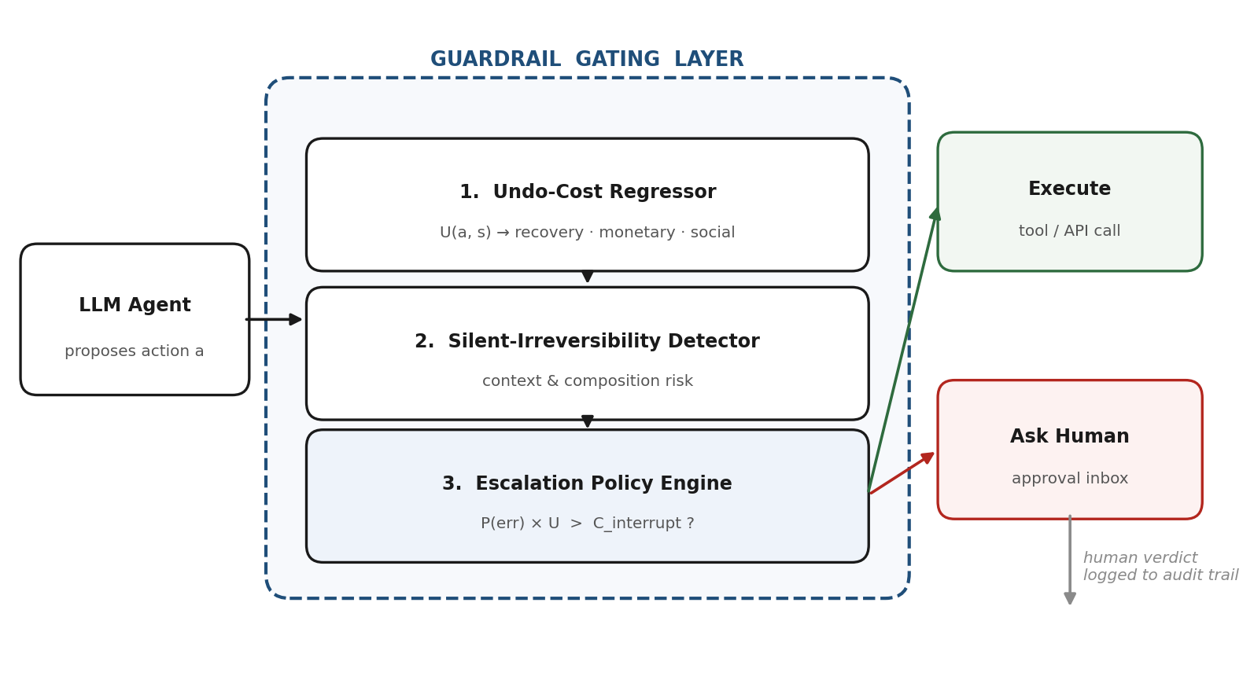
Figure 4.1 — System architecture. The gating layer is framework-agnostic because it intercepts at the tool-call boundary that all mainstream agent frameworks share.

4.1 Formal problem formulation
Let an agent trajectory be a sequence of interactions with an environment whose state at step t is denoted sₜ. At each step the agent proposes an action aₜ drawn from an open tool space A. The environment is partially observable, cannot be reset, and admits no transition model, which distinguishes this setting from the reinforcement-learning formulations reviewed in Section 2.3.
We define the undo cost U(a, s, h) as the expected cost, expressed in a common normalised unit, of restoring the environment to state s after executing action a in state s with trajectory history h. Undo cost decomposes into three measurable components:
U(a, s, h) = w₁ · L_rec(a, s, h) + w₂ · L_mon(a, s, h) + w₃ · L_soc(a, s, h)
where L_rec is recovery latency, the wall-clock time required to restore the prior state; L_mon is direct monetary exposure; and L_soc is social or reputational damage, the component that no technical rollback reverses, such as a message that has been read or a public statement that has been seen. The weights w are domain configurable and default to values calibrated so that the three components are commensurable in a single currency unit. An action for which no successful rollback exists receives a saturating maximum value rather than an infinite one, so that the objective remains numerically well behaved.
Let P_err(a, s, h) denote the probability that the proposed action is incorrect with respect to the user's intent, and let C_int(h) denote the cost of interrupting the human operator at the current point in the trajectory. The escalation decision is then the predicate
escalate(a, s, h) ⇔ P_err(a, s, h) × U(a, s, h) > C_int(h)
subject to a global constraint that the number of escalations raised during a single task not exceed a budget B. The left-hand side is the expected damage of proceeding; the right-hand side is the certain cost of pausing. The threshold implied by this inequality is not a constant but a function of the action, which is the formal statement of the project's central claim: confidence gating fixes P_err at a constant and ignores U, whereas the correct rule is sensitive to their product.

4.2 Phase 1 — Constructing the irreversibility taxonomy
The first phase produces a structured schema that makes undo cost a well-defined quantity rather than an intuition. Actions are classified along four axes.
- Domain. File-system, source-control and deployment, financial and transactional, communication, or network and configuration.
- Rollback mechanism. Whether an inverse operation exists, and of what kind: an exact inverse such as restoring from a snapshot; a compensating action such as issuing a credit against a debit; a partial restoration that leaves residue such as a revert commit that preserves the original in history; or no mechanism at all.
- Externality. Whether the effect is confined to systems the agent controls, crosses an organisational boundary, or reaches a third party. This axis largely determines the social component of undo cost, because effects that have been observed by a person cannot be technically undone.
- Latency sensitivity. Whether reversibility decays with time, and at what rate. An unsent message is fully reversible; a sent but unread message is nearly so; a read message is not. This axis is the formal home of the silent-irreversibility phenomenon.
The taxonomy is published as a specification document with an accompanying machine-readable schema, so that further action types can be classified consistently by others. It is validated by inter-annotator agreement on a held-out sample of two hundred actions classified independently by all team members, with disagreements adjudicated and used to sharpen the axis definitions.

4.3 Phase 2 — Rollback-instrumented sandbox and automated labelling
Ground-truth labels are the technical crux of the project. Asking annotators how hard an action would be to undo produces opinion; executing the undo and measuring the result produces data. The sandbox therefore implements the following loop for every candidate action.
- Snapshot. Capture the complete relevant state before execution: filesystem hash tree, database dump, mock-service ledger, and outbound message queue.
- Execute. Perform the action against the sandboxed services.
- Attempt rollback. Invoke the rollback mechanism indicated by the taxonomy for that action class, with a bounded time budget.
- Verify. Compare the post-rollback state against the original snapshot and compute a residual difference. Record whether restoration was complete, partial or impossible, together with the wall-clock time consumed and any monetary quantity moved by the mock ledger.
- Label. Derive L_rec from measured latency, L_mon from the ledger, and L_soc from the taxonomy's externality axis together with observed delivery or read events in the mock communication service.
This procedure yields labels that are reproducible, auditable and obtainable at machine speed, which is what makes a dataset of the target size feasible within one semester. Each record stores the action and arguments, a serialised summary of environment state, the preceding trajectory, the three cost components, the rollback outcome and provenance metadata. Roughly five percent of records are reviewed manually as quality control, and the rollback verifier is itself unit-tested against deliberately irreversible cases so that false claims of restoration are caught.

4.4 Phase 3 — The undo-cost regressor
The regressor learns the mapping from an action in context to its three cost components. Inputs are of three kinds: lexical and structural features of the action itself, including the tool name, argument names, argument value types, presence of destructive flags and scope indicators such as wildcard patterns; a dense encoding of the action and its arguments produced by a sentence encoder, which allows generalisation to tool names never seen in training; and features of the environment state, including target-resource sensitivity, presence of a recent backup, and whether the target is a production or development resource.
Three model families are compared: gradient-boosted trees over engineered features, which are fast and interpretable; a small transformer encoder fine-tuned on the concatenated action and state serialisation; and a hybrid feeding both representations into a shallow regression head, which we expect to perform best.
The training objective reflects the asymmetry of the deployment. Under-predicting undo cost is far more dangerous than over-predicting it, because an under-prediction permits a destructive action to proceed unchallenged while an over-prediction merely spends part of the interruption budget. We therefore optimise an asymmetric quantile loss,
Lτ(y, ŷ) = max( τ · (y − ŷ), (τ − 1) · (y − ŷ) ), with τ > 0.5
which penalises under-prediction more heavily than over-prediction. Multiple quantile heads are trained jointly so that the model emits an interval rather than a point estimate, and split conformal prediction is applied on a held-out calibration set to convert those intervals into distribution-free bounds with a specified coverage level. The policy engine consumes the upper bound rather than the point estimate, which makes the system conservative by construction in exactly the direction that matters.
The error probability P_err is estimated separately, combining self-consistency across sampled agent rollouts with a calibrated classifier trained on trajectory features, and is subjected to the same conformal calibration so that the product in the escalation predicate is meaningful rather than nominal.

4.5 Phase 4 — Detecting silent irreversibility
An action's intrinsic cost class is insufficient because reversibility is a property of the action in its history. Two phenomena are targeted.

4.5.1 Contextual irreversibility
Certain actions are reversible until an external event occurs, after which they are not. A commit is revertible until it has been pushed and pulled by a collaborator. An electronic mail message is recallable until it has been read. A database write is reversible until a downstream consumer has acted on it. The detector is a classification head trained on the same encoder backbone, taking as additional input a summary of the trajectory history and of observable external events, and predicting an amplification factor applied to the regressor's estimate. A static rule list cannot express this dependency; a learned contextual model can.

4.5.2 Compositional irreversibility
More subtly, sequences of individually reversible actions can produce jointly irreversible states. Deleting a backup is reversible while the primary exists; modifying the primary is reversible while the backup exists; performing both in either order is not reversible at all. To our knowledge no published work addresses this composition problem for agent action spaces.
We approach it by maintaining a running representation of the trajectory that tracks which recovery affordances remain available, and by scoring each proposed action for the affordances it would consume. An action that would remove the last remaining recovery path receives a large amplification even where its intrinsic cost is low. Training data for this component is generated by constructing sequences within the sandbox and verifying rollback at the level of the sequence rather than of the individual action, which is a direct extension of the Phase 2 loop and requires no new labelling machinery.

4.6 Phase 5 — The escalation policy engine
The policy engine implements the predicate of Section 4.1 with three refinements that make it usable rather than merely correct.
- Learned per-class thresholds. Rather than applying a single global cost threshold, the engine learns a threshold per action class by minimising realised total cost, comprising damage from unescalated errors plus interruption cost from escalations, on a validation set. This is the decision-focused training step motivated in Section 2.5: the policy is optimised against decision quality, not against regression error.
- Bounded interruption budget. Escalations are capped per task. When the budget is nearly exhausted, the effective threshold rises so that the remaining escalations are reserved for the highest expected damage. This prevents the degenerate behaviour in which a cautious system asks about everything and is consequently switched off, which is the failure mode that renders conservative rule lists useless in practice.
- Interruption batching. Where several escalations arise in close succession and none is blocking, they are batched into a single review, reducing aggregate interruption cost. C_int is modelled as a function of trajectory position rather than as a constant, reflecting the human-computer interaction findings of Section 2.6.
Every escalation, together with the human verdict and the features that triggered it, is written to an append-only audit log. This serves both the compliance requirement identified in Section 1.1.5 and the research requirement of post-hoc analysis.

4.7 Phase 6 — System engineering and integration
The research components are packaged in three deployment forms so that the contribution is usable rather than purely demonstrative.
- Gating software development kit. A Python package exposing a decorator and a context manager that wrap any tool function, requiring roughly three lines of integration and no architectural change. Because interception occurs at the function-call boundary shared by LangChain, AutoGen, CrewAI, LlamaIndex and native tool-calling interfaces, one implementation covers all of them.
- Model Context Protocol proxy. A server that sits between the agent and its real tool servers, forwarding safe calls transparently and holding risky ones pending approval. Because the agent is reconfigured only by changing an endpoint, this deployment form requires no code change at all.
- Approval dashboard. A web console providing a live trajectory view with per-action cost scores, a mobile-friendly approval inbox, a replayable risk timeline, a policy editor exposing the interruption budget and risk tolerance as controls, and the immutable audit log.

4.8 Experimental design

4.8.1 Baselines
The proposed system is compared against five reference policies spanning the full range of existing practice.

# | Baseline | Description
B1 | No gating | The agent executes every proposed action. Establishes the upper bound on irreversible errors and the lower bound on interruptions.
B2 | Fixed-confidence gating | Escalate when model confidence falls below a fixed threshold. The dominant deployed practice and the primary comparison.
B3 | Entropy-based uncertainty gating | Escalate on high predictive entropy or low self-consistency across sampled rollouts.
B4 | Static allow-and-deny rule list | Escalate on membership of a hand-written list of dangerous action types. Represents current industrial guardrails.
B5 | Oracle with perfect hindsight | Escalates exactly on the actions that would in fact have been errors. Not achievable; establishes the frontier's theoretical limit.
Table 4.2 — Baseline policies used for comparison.

4.8.2 Metrics
- Irreversible-error rate. Proportion of tasks in which at least one executed action produced a state that could not be restored. The primary safety metric.
- Interruptions per task. Mean number of escalations raised. The primary cost metric.
- Expected damage cost. Sum of realised undo costs of unescalated erroneous actions, in normalised units. Combines the previous two into a single economic quantity.
- Task success rate. Retained to verify that gating does not degrade useful work, a necessary control against a system that achieves safety by refusing to act.
- Regression quality. Mean absolute error, asymmetric quantile loss and conformal interval coverage on the undo-cost prediction, reported separately so that predictive and decision performance can be distinguished.

4.8.3 Headline result and analysis
The central result is a Pareto frontier relating irreversible-error rate to interruption frequency, obtained by sweeping each policy's threshold across its full range. The claim to be tested is one of dominance: that the proposed policy occupies a region of this plane that confidence-based gating cannot reach at any threshold setting, because sweeping a threshold on a variable orthogonal to consequence cannot trade the two objectives efficiently. Figure 4.2 shows the intended shape of this result.
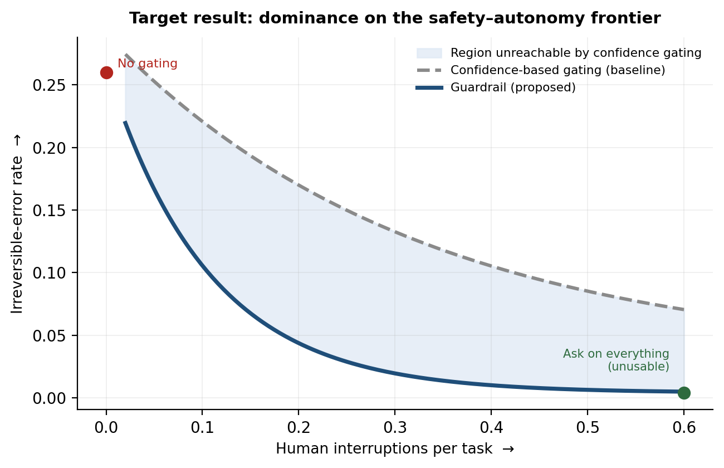
Figure 4.2 — Intended headline result. The shaded region is reachable by consequence-aware gating and unreachable by confidence-based gating. The curves are illustrative of the hypothesis under test, not measured data.
Ablation studies isolate each component by removing, in turn, the silent-irreversibility detector, the conformal calibration, the learned per-class thresholds and the interruption budget. Significance is assessed with paired bootstrap resampling and the Wilcoxon signed-rank test, with Holm correction and effect sizes reported alongside p-values. All experiments use at least five random seeds, and a held-out set of unseen tool types tests generalisation to novel action spaces.

4.9 Risk analysis and mitigation

Risk | Impact | Mitigation
Sandbox undo cost diverges from real-world undo cost | High | Validate a stratified subsample against expert judgement; report sandbox fidelity explicitly as a limitation; design the taxonomy so that the divergence is bounded within an action class
Insufficient labelled data in high-cost classes, since destructive actions are rare | High | Synthesise action sequences deliberately rather than relying on natural benchmark frequency; apply class-balanced sampling and cost-weighted loss
Benchmark environments lack rich financial and communication actions; model interface costs exceed budget | Medium | Extend the sandbox with mock payment and mail services and release them openly; use locally served open-weight models for bulk trajectory generation
Escalation policy converges to always-ask or never-ask | Medium | Enforce the interruption budget as a hard constraint during policy optimisation; monitor both metrics jointly rather than optimising a single scalar
Two-semester scope proves too large | Medium | Phase boundaries are drawn so that Semester VII alone yields the taxonomy, sandbox, dataset and regressor, which is a self-contained publishable contribution
Concurrent publication of similar work by another group | Low | Maintain a fortnightly literature scan; the dataset and taxonomy retain value as community infrastructure independently of method novelty
Table 4.3 — Principal project risks with impact assessment and mitigation strategy.

5. Deliverables
The project produces nine numbered deliverables, each assigned to a semester and each with an acceptance criterion so that completion is verifiable rather than declarative. Two of them, the labelled dataset and the gating software development kit, are intended to outlive the project as community infrastructure.

ID | Deliverable | Form | Sem.
D1 | Irreversibility taxonomy for agent action spaces, covering five domains along four classification axes | Specification document with machine-readable JSON schema | VII
D2 | Rollback-instrumented sandbox that executes actions, attempts automated undo and verifies restoration | Containerised software with test suite | VII
D3 | Labelled undo-cost dataset of at least ten thousand agent actions with measured cost components | Open dataset with labelling protocol and datasheet | VII
D4 | Undo-cost regressor with conformal prediction intervals over the three cost components | Trained model weights, inference code and benchmark report | VII
D5 | Silent-irreversibility detector covering contextual and compositional cases | Model, evaluation suite and analysis of composition failures | VIII
D6 | Expected-value escalation policy engine with learned thresholds and interruption budget | Deployable Python module with configuration interface | VIII
D7 | Guardrail integration surfaces: gating software development kit and Model Context Protocol proxy | Installable Python package and proxy server with documentation | VIII
D8 | Human approval dashboard with live trajectory view, approval inbox and immutable audit log | React web application with FastAPI backend | VIII
D9 | Research outputs: two conference papers, final project report and reproducible experiment repository | Published papers, report and public code repository | VII & VIII
Table 5.1 — Project deliverables with output form and semester assignment.

5.1 Measures of project success
Success is assessed against the following criteria, which are stated in advance so that the outcome is not evaluated retrospectively against whatever was achieved.

Dimension | Success criterion | Threshold
Dataset scale | Labelled actions with verified rollback outcome | ≥ 10,000 across 5 domains
Predictive quality | Undo-cost regression against the strongest baseline | ≥ 25 % reduction in asymmetric quantile loss
Safety | Irreversible-error rate at matched interruption frequency versus confidence gating (B2) | ≥ 40 % relative reduction
Autonomy | Interruptions per task at matched irreversible-error rate versus B2 | ≥ 50 % relative reduction
Non-degradation | Task success rate relative to the ungated agent (B1) | No significant decrease
Frontier dominance | Existence of a reachable region unreachable by B2 at any threshold | Demonstrated with paired bootstrap significance
Dissemination | Conference papers accepted, registered or published | 1 in Semester VII, 1 in Semester VIII
Table 5.2 — Pre-registered measures of project success.

6. Stakeholders
The project has stakeholders in three groups: those who would use the system, those affected by whether it exists, and those responsible for its academic conduct.

Stakeholder | Interest in the project | Involvement
Enterprise engineering teams deploying agents  (financial technology, customer support, DevOps, healthcare operations, internal automation) | Cannot currently grant agents write access without accepting unbounded downside from a single wrong action; need a bounded-risk deployment path | Primary users; requirement input; potential pilot evaluation of the software development kit
Compliance, risk and audit functions | Require demonstrable controls and an evidentiary record of who approved which consequential action and when | Consumers of the audit log; source of requirements for the approval workflow
Agent framework and platform vendors | Repeated public incidents damage trust in the product category; a standard safety layer benefits the whole ecosystem | Integration targets; the Model Context Protocol proxy is designed for adoption without vendor cooperation
Human operators, reviewers, and the end customers they serve | Operators want to be consulted only where it matters, since over-interruption causes the safeguard to be switched off; customers bear the consequences of erroneous refunds, misdirected messages and destroyed records without any direct control over the agent | End users of the approval dashboard and subjects of the interruption-cost model; customers are the ultimate beneficiaries
Research community in agent safety and human-AI interaction | Lack an empirically labelled dataset of action reversibility and a shared taxonomy for the concept | Recipients of the open dataset, taxonomy and reproducible code; audience for the two conference papers
Project guide, Department Project Review Committee and the Department of CSE, ABESEC | Responsible for scope, technical direction and academic quality; institutional research output and publication record | Periodic review at each milestone, approval authority at phase boundaries, provision of computing and publication support
Project team members | Development of research, engineering and dissemination capability; fulfilment of degree requirements | Design, implementation, experimentation, authorship and presentation
Table 6.1 — Stakeholder analysis.

7. Gantt Chart
The project spans two semesters, from August 2026 to May 2027. The schedule is arranged so that Semester VII delivers a self-contained and independently publishable contribution, namely the taxonomy, the sandbox, the labelled dataset and the undo-cost regressor, while Semester VIII delivers the detector, the decision layer, the integration surfaces and the full comparative evaluation. This phasing is deliberate: it satisfies the departmental requirement of one publication per semester and it ensures that a delay in the later phases does not leave the project without a result.
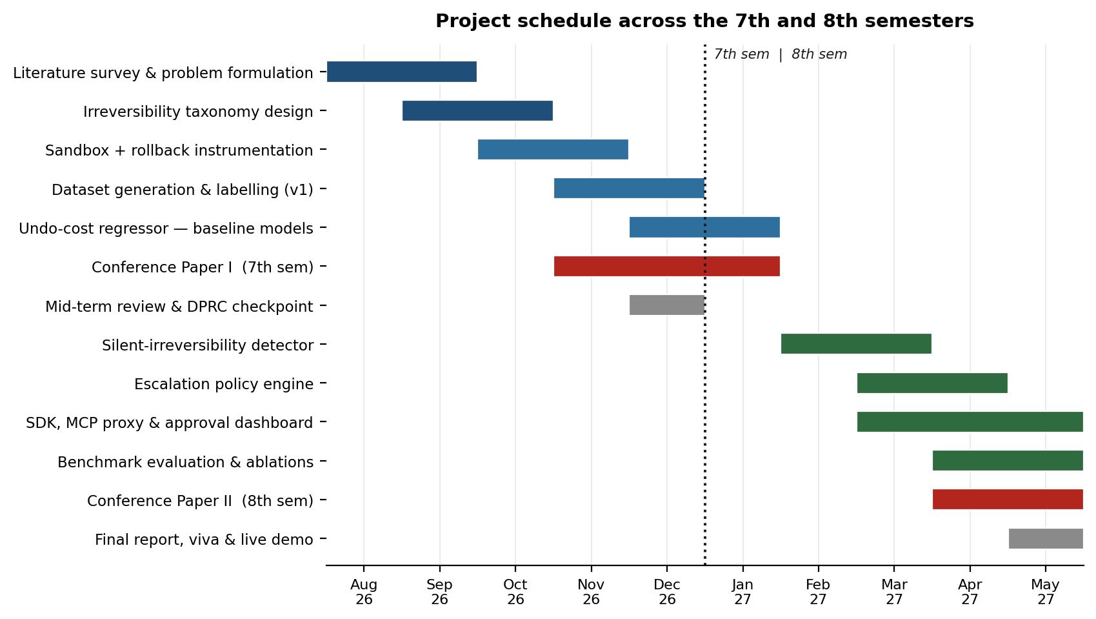
Figure 7.1 — Project Gantt chart across Semesters VII and VIII.

7.1 Milestone schedule

Phase | Activity | Duration | Milestone / output
P1 | Literature survey, problem formulation, title approval and synopsis | Aug – Sep 2026 | Approved synopsis and presentation to the review committee
P2 | Irreversibility taxonomy design and inter-annotator validation | Sep – Oct 2026 | D1: taxonomy specification and JSON schema
P3 | Sandbox construction and rollback instrumentation | Oct – Nov 2026 | D2: containerised sandbox passing its verification test suite
P4 | Dataset generation and automated labelling | Nov – Dec 2026 | D3: labelled dataset of ≥ 10,000 actions
P5 | Undo-cost regressor: feature engineering, model comparison, conformal calibration | Dec 2026 – Jan 2027 | D4: trained regressor with benchmark report
P6 | Conference Paper I; mid-project review and committee checkpoint | Nov 2026 – Jan 2027 | Paper accepted or registered (Semester VII requirement); approved plan for Semester VIII
P7 | Silent-irreversibility detector: contextual and compositional heads | Jan – Feb 2027 | D5: detector with composition-failure analysis
P8 | Escalation policy engine: threshold learning, budget, batching | Feb – Mar 2027 | D6: policy engine module
P9 | Integration surfaces: software development kit, protocol proxy, dashboard | Feb – Apr 2027 | D7 and D8: installable package and web console
P10 | Comparative evaluation, ablations and statistical analysis | Mar – Apr 2027 | Pareto frontier result against all five baselines
P11 | Conference Paper II, final report, demonstration and viva | Apr – May 2027 | Second paper accepted or registered; D9 complete; live side-by-side demonstration
Table 7.1 — Phase-wise milestone schedule with outputs.
Two critical dependencies govern the schedule. The dataset in Phase 4 cannot begin before the sandbox in Phase 3 is verified, since unverified rollback detection would corrupt every subsequent label; and the comparative evaluation in Phase 11 requires the policy engine of Phase 9, which is why the integration work of Phase 10 is run in parallel rather than in sequence. Slack has been reserved in March and April 2027 to absorb slippage in these dependencies.

8. References
References follow IEEE numbering. Preprint identifiers are given where a work is most reliably accessed through an open archive.
[1] Zhou, S., Xu, F. F., Zhu, H., Zhou, X., Lo, R., Sridhar, A., et al. WebArena: A Realistic Web Environment for Building Autonomous Agents. International Conference on Learning Representations, 2024. arXiv:2307.13854.
[2] Yao, S., Shinn, N., Razavi, P., and Narasimhan, K. tau-bench: A Benchmark for Tool-Agent-User Interaction in Real-World Domains. 2024. arXiv:2406.12045.
[3] Barres, V., Dong, H., Ray, S., Si, X., and Narasimhan, K. tau-squared-Bench: Evaluating Conversational Agents in a Dual-Control Environment. 2025. arXiv:2506.07982.
[4] Jimenez, C. E., Yang, J., Wettig, A., Yao, S., Pei, K., Press, O., and Narasimhan, K. SWE-bench: Can Language Models Resolve Real-World GitHub Issues? International Conference on Learning Representations, 2024. arXiv:2310.06770.
[5] Liu, X., Yu, H., Zhang, H., Xu, Y., Lei, X., Lai, H., et al. AgentBench: Evaluating LLMs as Agents. International Conference on Learning Representations, 2024. arXiv:2308.03688.
[6] Qin, Y., Liang, S., Ye, Y., Zhu, K., Yan, L., Lu, Y., et al. ToolLLM: Facilitating Large Language Models to Master 16000+ Real-World APIs. 2023. arXiv:2307.16789.
[7] Ruan, Y., Dong, H., Wang, A., Pitis, S., Zhou, Y., Ba, J., Dubois, Y., Maddison, C. J., and Hashimoto, T. Identifying the Risks of LM Agents with an LM-Emulated Sandbox. International Conference on Learning Representations, 2024. arXiv:2309.15817.
[8] Yuan, T., He, Z., Dong, L., Wang, Y., Zhao, R., Xia, T., et al. R-Judge: Benchmarking Safety Risk Awareness for LLM Agents. 2024. arXiv:2401.10019.
[9] Debenedetti, E., Zhang, J., Balunovic, M., Beurer-Kellner, L., Fischer, M., and Tramer, F. AgentDojo: A Dynamic Environment to Evaluate Prompt Injection Attacks and Defenses for LLM Agents. Neural Information Processing Systems, 2024. arXiv:2406.13352.
[10] Naihin, S., Atkinson, D., Green, M., Hamadi, M., Swift, C., Schonholtz, D., Kalai, A. T., and Bau, D. Testing Language Model Agents Safely in the Wild. 2023. arXiv:2311.10538.
[11] Xiang, Z., Zheng, L., Li, Y., Hong, J., Li, Q., Xie, H., et al. GuardAgent: Safeguard LLM Agents by a Guard Agent via Knowledge-Enabled Reasoning. 2024. arXiv:2406.09187.
[12] Amodei, D., Olah, C., Steinhardt, J., Christiano, P., Schulman, J., and Mane, D. Concrete Problems in AI Safety. 2016. arXiv:1606.06565.
[13] Krakovna, V., Orseau, L., Martic, M., and Legg, S. Penalizing Side Effects Using Stepwise Relative Reachability. 2018. arXiv:1806.01186.
[14] Turner, A. M., Hadfield-Menell, D., and Tadepalli, P. Conservative Agency via Attainable Utility Preservation. AAAI/ACM Conference on AI, Ethics, and Society, 2020. arXiv:1902.09725.
[15] Eysenbach, B., Gu, S., Ibarz, J., and Levine, S. Leave No Trace: Learning to Reset for Safe and Autonomous Reinforcement Learning. International Conference on Learning Representations, 2018. arXiv:1711.06782.
[16] Grinsztajn, N., Ferret, J., Pietquin, O., Preux, P., and Geist, M. There Is No Turning Back: A Self-Supervised Approach for Reversibility-Aware Reinforcement Learning. Neural Information Processing Systems, 2021. arXiv:2106.04480.
[17] Hadfield-Menell, D., Dragan, A., Abbeel, P., and Russell, S. The Off-Switch Game. International Joint Conference on Artificial Intelligence, 2017. arXiv:1611.08219.
[18] Ren, A. Z., Dixit, A., Bodrova, A., Singh, S., Tu, S., Brown, N., et al. Robots That Ask For Help: Uncertainty Alignment for Large Language Model Planners. Conference on Robot Learning, 2023. arXiv:2307.01928.
[19] Kadavath, S., Conerly, T., Askell, A., Henighan, T., Drain, D., Perez, E., et al. Language Models (Mostly) Know What They Know. 2022. arXiv:2207.05221.
[20] Guo, C., Pleiss, G., Sun, Y., and Weinberger, K. Q. On Calibration of Modern Neural Networks. International Conference on Machine Learning, 2017. arXiv:1706.04599.
[21] Angelopoulos, A. N., and Bates, S. A Gentle Introduction to Conformal Prediction and Distribution-Free Uncertainty Quantification. 2021. arXiv:2107.07511.
[22] Elmachtoub, A. N., and Grigas, P. Smart 'Predict, then Optimize'. Management Science, 68(1), pp. 9-26, 2022. arXiv:1710.08005.
[23] Kwa, T., West, B., Becker, J., Deng, A., Garcia, K., Hasin, M., et al. Measuring AI Ability to Complete Long Tasks. METR, 2025. arXiv:2503.14499.
[24] Anthropic. Model Context Protocol Specification. 2024-2026. Available at: modelcontextprotocol.io.
[25] IBM Security and Ponemon Institute. Cost of a Data Breach Report 2026. IBM Corporation, July 2026.
[26] Gartner, Inc. Gartner Predicts 40% of Enterprise Apps Will Feature Task-Specific AI Agents by 2026, Up from Less Than 5% in 2025. Press release, August 2025.
[27] Gartner, Inc. Gartner Predicts Over 40% of Agentic AI Projects Will Be Canceled by End of 2027. Press release, June 2025.
[28] Responsible AI Collaborative. Incident 1152: LLM-Driven Coding Agent Executed Unauthorized Destructive Commands During Code Freeze, Leading to Loss of Production Data. AI Incident Database, 2025. Available at: incidentdatabase.ai/cite/1152.

