Project Final Report
APPLICATIONS OF VOLATILITY ESTIMATION

- Introduction
Ocean wave parameter estimation from HF radar data has traditionally been performed by first forming the Doppler spectrum from the received data, and then performing further processing on this spectrum to extract desired ocean wave parameters such as significant wave height (Hs) and principal wave direction. In our paper from an earlier instance of this conference [1], we introduced a paradigm shift where instead of following the traditional methodology of first forming the Doppler spectrum, we dealt directly with the received time-domain data from the HF radar. This work was further developed by the authors in [2].
From an equation modelling the first-order return from a pulsed HF radar, we found that the significant wave height is linearly proportional to the standard deviation of either the real part, the imaginary part of the magnitude of the received voltages from the HF radar. Furthermore, the proportionality constant was found to theoretically not depend on the ocean patch under consideration, meaning that once it was found in one patch, the same constant could be used in another.
In the field of financial mathematics, volatility analysis is a common tool to, for example, estimate the volatility of time series from stock markets, which might itself be time-dependent. Such tools are based on well-founded and developed statistical estimation theory. One component of such volatility estimation is the determination of the variance of the time series data at any given time. By virtue of the previously-derived linear proportionality relationship between the standard deviation (square root of the variance) of the received HF radar time series and the significant wave height of the interrogated ocean wave field, this suggests the application of such volatility analysis to the received HF radar time series as a way of estimating time-dependent significant wave height values.
In this paper, we apply a typical model for volatility analysis on field data acquired from our group’s Wera HF radar installation at Argentia, Newfoundland, Canada and find that we obtain slightly better results in terms of root-mean squared error (RMSE) for the significant wave height than those found in [1]. Perhaps more importantly, we have now initiated the use of the vast framework of volatility estimation to the problem of significant wave height estimation, which could enable further positive developments in the latter.

- Existing Work
This proposal for the project ‘Applications of Volatility Estimation’ outlines a systematic plan to enhance the existing algorithm for significant wave height estimation by incorporating advanced volatility modelling techniques. The proposed research is poised to contribute valuable insights and advancements to the field, with potential applications in diverse oceanic conditions.
Ocean wave parameter estimation, particularly significant wave height (Hs), has traditionally relied on Doppler Spectra Analysis derived from High Frequency (HF) radar data. In a prior publication, a groundbreaking approach by directly processing received time-domain data from HF radar was introduced, establishing a linear relationship between Hs and the standard deviation of the real or imaginary parts of the received voltages.

Building on the foundation, the proposal aims to extend and refine the algorithm by exploring advanced volatility modeling techniques from financial mathematics. While volatility models from financial mathematics have been applied in the Python code for the MIDAS Hyperbolic ARCH model already, now additional methodologies, parameters, and refinements will be investigated to further enhance the accuracy and flexibility of the volatility estimation algorithm.
Volatility models have been a tool for estimation of, for ex ample, financial markets. Two commonly-used volatility models are autoregressive conditional heteroskedasticity (ARCH) and generalized autoregressive conditional heteroskedasticity (GARCH) models. GARCH models assume an autoregressive moving average (ARMA) model for the error variance. In this paper, the main work in volatility estimation is performed according to the MIDAS Hyperbolic ARCH model. We do not include the mathematical details of the model here. The reader may refer to [3] for such details.
Initially, a zig-zag estimation strategy was used, where first a fixed variance was estimated using a Heterogeneous Autoregression with exogenous regressors (HARX) model, and then the estimates from this model fed into a MIDAS Hyperbolic ARCH model. This was done for 10 iterations for each data segment.

- Current Modifications & Implementation
We initially started with validating the existing algorithm that was built using MIDAS Hyperbolic ARCH Model and fixed the errors that were present in the model.
For Midas Hypebolic GARCH, we utilised the python libraries available for model building under arch.univariate.base.
The Methodology used has been described as the MIDAS Hyperbolic ARCH Zigzag model,
where first a fixed variance was estimated using a Heterogeneous Autoregression with exogenous regressors (HARX) model, and then the esimates from this model fed into a MIDAS HyperbolicARCH model. This was done for 10 iterations for each data
segment.
The MIDAS Hyperbolic ARCH model was used to estimate variances with a maximum lag of 512 This was quite a large lag but led to improved results over smaller maximum lag values
Then the MIDAS Hyperbolic ARCH model was applied to extract variances from both the real and imaginary parts. Finally, the result was once again smoothed, this time with a median filter of length 6, and the estimated variances from each of the real and imaginary parts averaged with each other to form the final estimate of the variance at each sample time. Finally, the estimated variances were averaged over the entire hour to obtain the estimated variance for the hour, after which the square root was taken to find the estimated standard deviation. Then using the fact that the standard deviation of each time series is roughly linearly proportional to the significant wave height, linear least squares was used to estimate the proportionality constant with respect to the recorded wave buoy data. Finally, this estimated proportionality constant was used to obtain the corresponding Hs values for each hour of the radar data.

However, the model was not as robust and had limitations within the data validation layers where the overlapping numpy arrays and pandas dataframes cause inconsistencies in shape of the test data and thus affecting the Forecast/Predicted values.
Also, the model was extremely slow with even a smaller data set and thereby, the option to explore other suitable Univariate models was considered.

Following are the Models that were considered for comparison and forecasting of test data:-
- ARIMA based ARCH
- GARCH
- GJR- GARCH
- EGARCH
- FIGARCH
- SARIMA
- HYGARCH
- LSTM
After careful exploration and analysis, we have implemented the EGARCH and GARCH for Volatility analysis, and further Training the model, validating it and Testing for the test data.
The Final Model implemented is a comparison between the EGARCH and GJR_GARCH (Replacing GARCH- As GARCH can only be used for Symmetric Shock) as GJR_GARCH can be used for combination of Symmetric and Asymmetric shock.
Additional inputs can be used to construct other models. This example sets o to 1, which includes one lag of an asymmetric shock which transforms a GARCH model into a GJR-GARCH model with variance dynamics given by
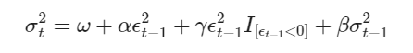

where I is an indicator function that takes the value 1 when its argument is true.
The log likelihood improves substantially with the introduction of an asymmetric term, and the parameter estimate is highly significant.

- Comparison of Models
MIDAS Hyperbolic ARCH/GARCH –
We start with MIDAS regressions involving daily regressors for predictions at horizon h :
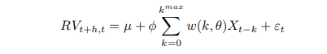
The volatility specification has a number of important features.
MIDAS regressions typically do not exploit an autoregressive scheme, so that
Xt−k is not necessarily related to lags of the left hand side variable. Instead, MIDAS
regressions are first and foremost regressions and therefore the selection of Xt−k
amounts to choosing the best predictor of future quadratic variation from the set of several possible measures of past fluctuations in returns. Examples of Xt−k are past daily squared returns (that correspond to the ARCH-type of models with some parameter restrictions.
It is a good fit for the model, as prescribed in the initial algorithm, but the performance of this model using the univariate.ARCH is very slow, we’ve tried training the model but it takes a lot of time, however, the accuracy of the results is at par with the GARCH Model.

GARCH – Generalized AutoRegressive Conditional Heteroskedasticity
Garch Model in the simplest form as GARCH (1,1) is denoted by the following:
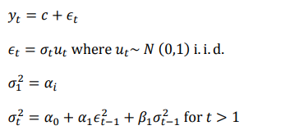
For the first period, the variance is estimated by the + initial condition parameter. It is assumed that all parameters in Equations are positive numbers. The error term is assumed to be N(0,1) independent and identically distributed. In more general specifications of the GARCH model, the error term sometimes is assumed to have t distribution.
- The GARCH Model is a preferred choice for the Volatility Forecasting as it has a greater tendency to evaluate/ analyse conditional variance for our use case.
- The Grach model is comparatively simpler to build and provides good accuracy.
- In theory, The basic GARCH model has the good overall performance without adding much complexity to the functionalities.

GJR_GARCH - Glosten-Jagannathan-Runkle Generalized AutoRegressive Conditional Heteroskedasticity
- The GJR GARCH Model is a modified version of the GARCH model that mitigates the model’s inability to take Asymmetric Shocks into considerations.
- It is denoted as GARCH(p,o,q)
where p denotes Symmetric Shock, o denotes Asymmetric Shock, q denotes Lag value.
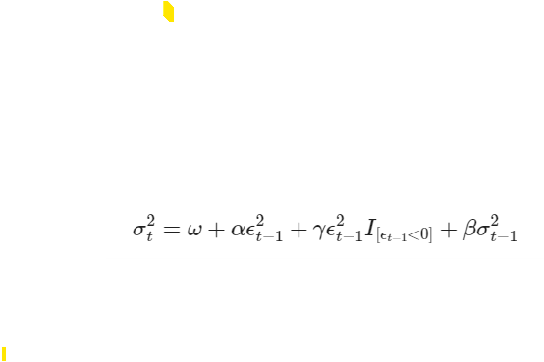
- The fundamental expression derived from the GARCH Model used to signify GJR GARCH is as follows :
Where I is an indicator function that takes the value 1 when its argument is true.

EGARCH – Exponential Generalized AutoRegressive Conditional Heteroskedasticity

- The EGARCH model allows for Asymmetric Volatility in conditional variance, which is not available in GARCH. This means that the height of wave Hs recorded at the Radar Frequency Hf can have different effects on future volatility of the Wave height.
- The EGARCH model is more robust as compared to GARCH as it can be estimated for a greater number of indices without numerical problems.
- However, overall performance of GARCH is still considered better than EGARCH as E-Garch is much complicated and impacts overall performance.
- Also, GARCH has a better tendency to evaluate the RMSE metric thus having a better forecast performance in theory.
- However, we will consider the EGARCH model for our use case and try to evaluate conditional volatility using this model and compare it against the observations from MIDAS Hyperbolic and the GARCH Model.

FIGARCH - Fractionally Integrated Generalized AutoRegressive Conditional Heteroscedasticity

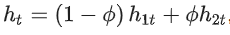
where, 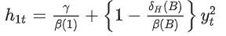 and 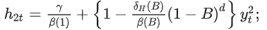
- It can be compared with the ARFIMA model as opposed to the ARIMA Model.
- It has components with long memory effect and a time varying intercept which allow for breaks, cycles and changes in drift.
- However, the model is complex to implement with certain limitations around the stationarity and ergodicity of the general FIGARCH(p,d,q) model.
- It is more relevant to the very slowly changing values such as a few instruments within financial markets, but volatility is mostly estimated in these cases as a smooth non linear transition which makes it suitable for Slowly Varying Functions.
- Hence, we will disregard the FIGARCH model as it doesn’t fit our use case

SARIMA Based model – Seasonal AutoRegressive Integrated Moving Average Model.
- It is similar to ARIMA but takes into consideration of the Seasonal dependency within the Time Series data being evaluated.
- However, in our case, there are no Seasonal patterns associated with the Hs and Hf data being used for modelling.
- It is a univariate model and is used to model the Autocorrelation in time series while we are trying to model the volatility clustering
- Hence, we will disregard this model for our use case.

LSTM Model – Long Short-Term Memory Model
- It is suitable for handling sequential data with
- It is bidirectional, can be used to train data in both directions forward and backwards
- Since it is computationally more complex, it is very time consuming to build the model and further train it.
- Requires
- It is less robust and has lower overall performance as compared to GARCH
- It is more suitable for Language Modelling and Speech Modelling
- Hence, we disregard this model for our use case.
- Garch & Egarch
- Testing
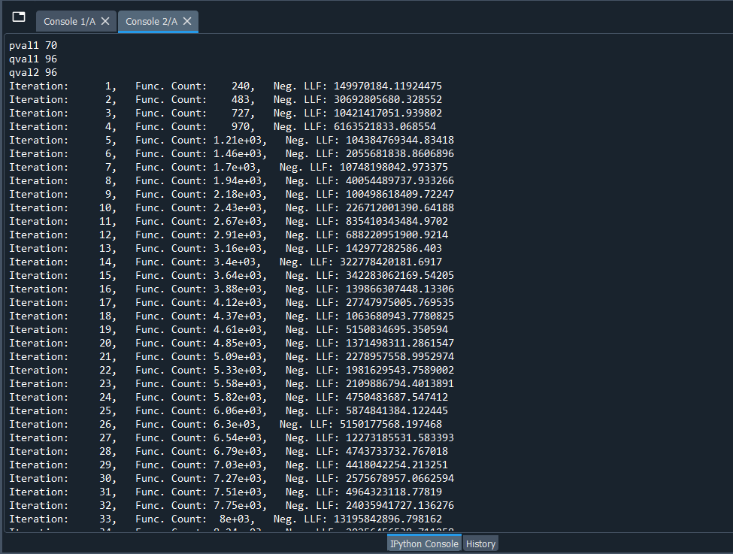
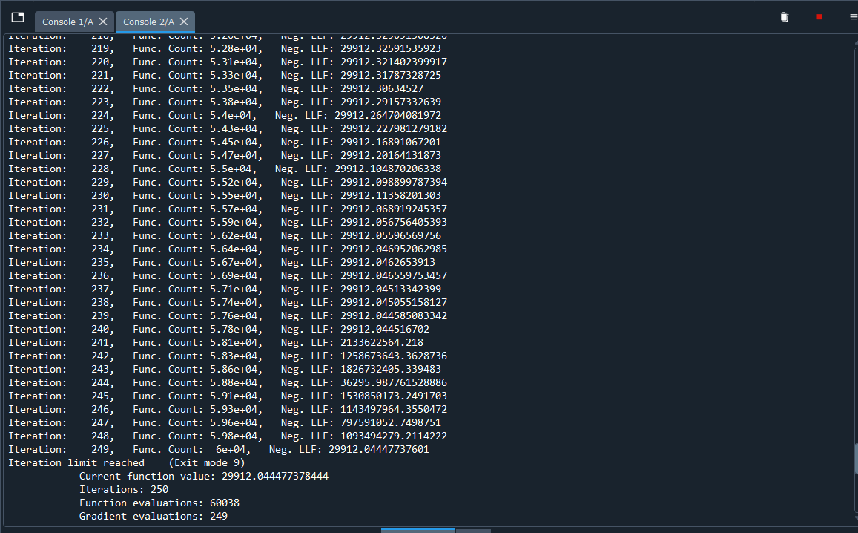
Using HARX EGARCH model
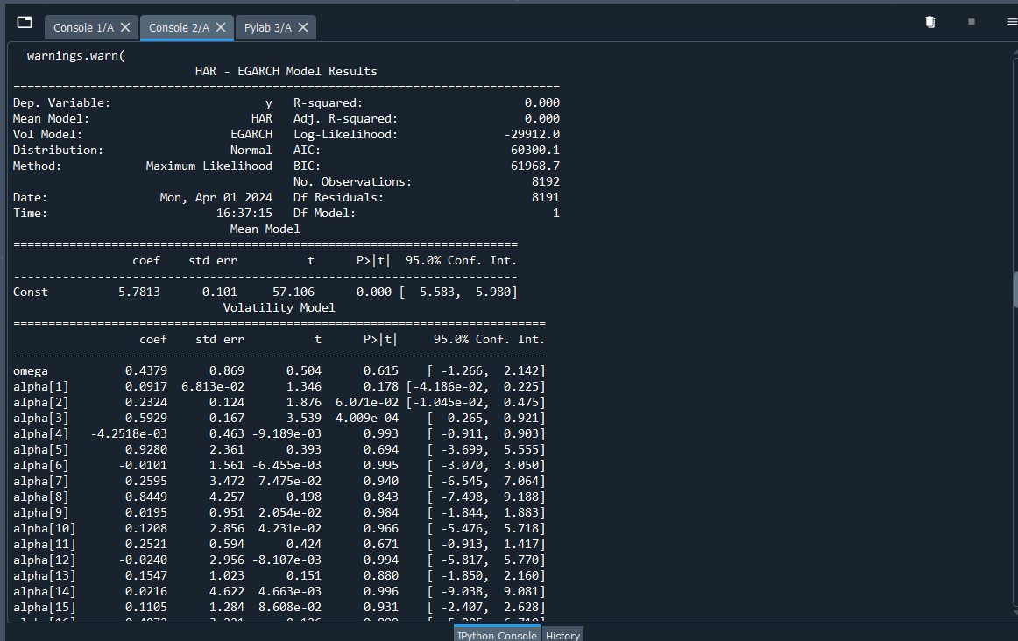

Graphical Representation of the Variance as forecasted by the EGARCH Model
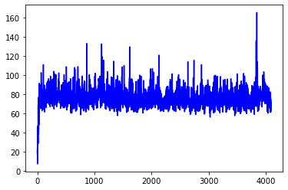

Using GJR-GARCH Model
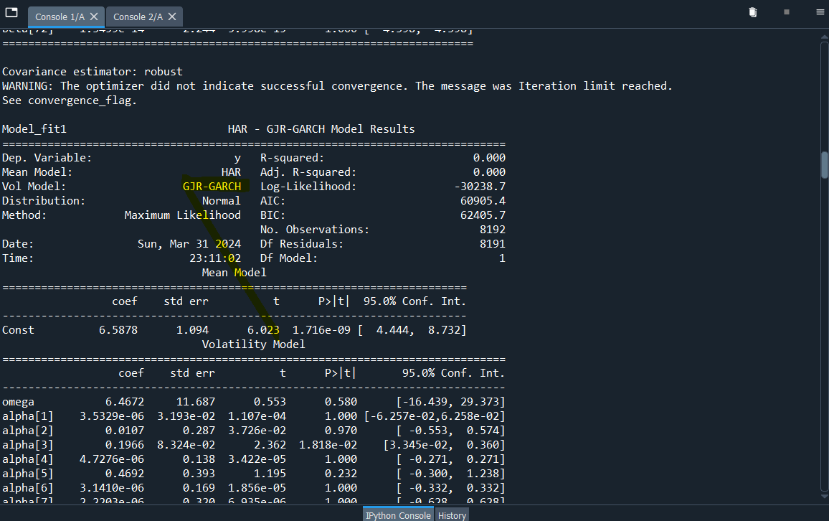
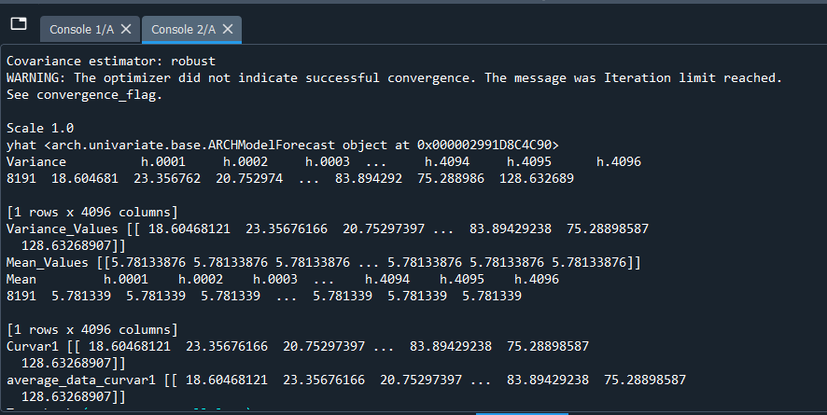
Graphical Representation of the Variance as forecasted by the GJR-GARCH Model

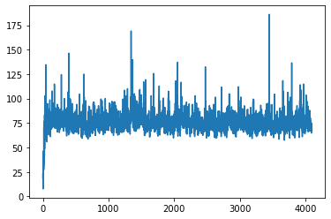
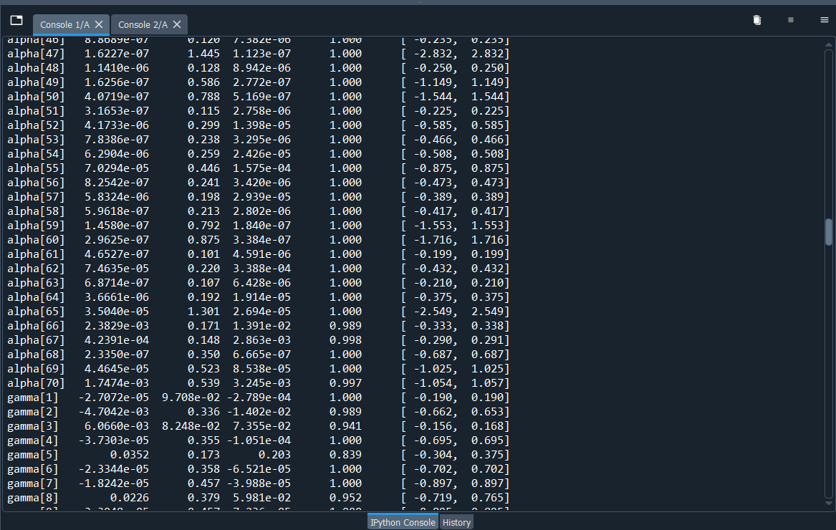
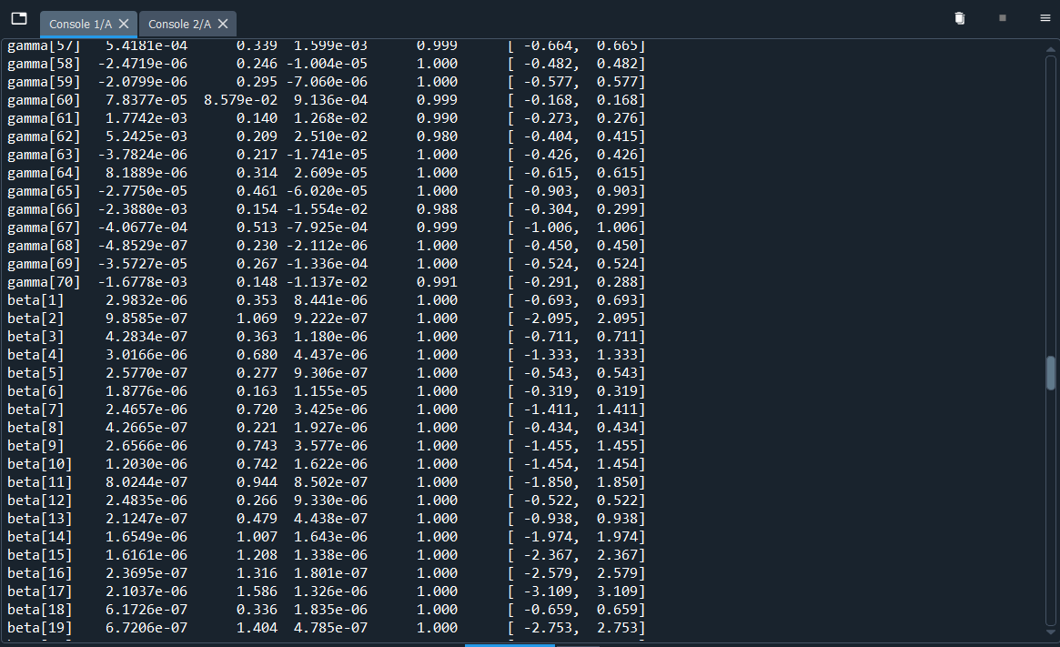
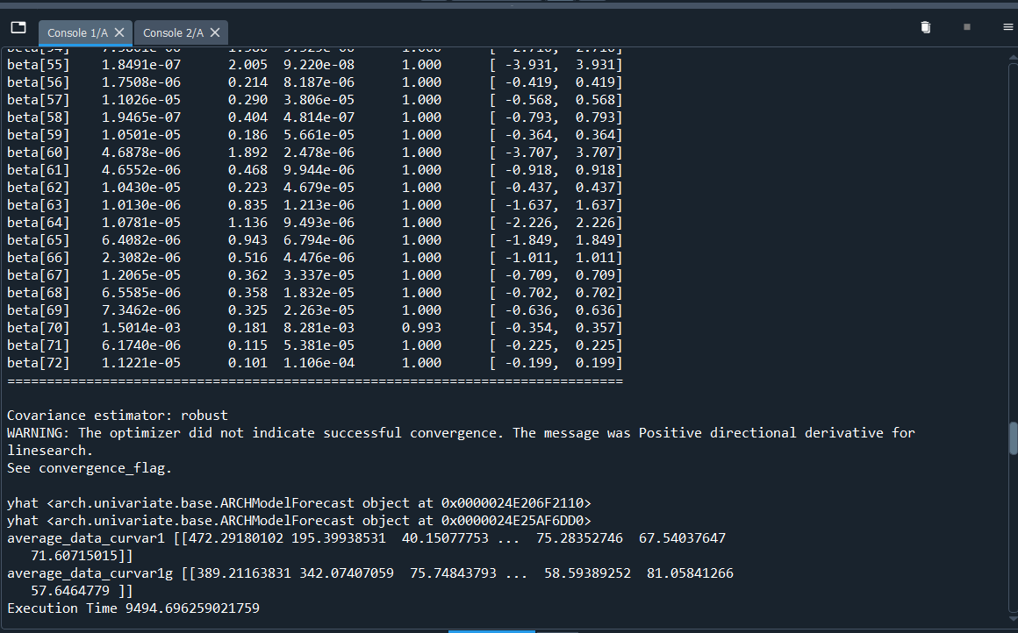
Graphical Representation of the Variance Comparison as forecasted by the EGARCH Model and the GJR-GARCH Model

- Major Experience & Acheivements
Performance Improvement – The overall performance can be observed with a variety of arrays, majorly revolving around the Accuracy of the Model, the Time complexity of the model, The Overall Execution Time of the model for successful run, and the clarity in terms of the objective of the model.
In this case we have worked on all aspects of the model and improved the overall performance in terms of the following :
- Accuracy
- Value/ Model Objective
- Overall Execution Time
Accuracy – The Accuracy of the models is defined by the Forecasting of the Test Data where we see that both the EGARCH and the GJR-GARCH Model have been overlapping at various convergence and divergence points for the actual variance thus validating the fact that the values forecasted by both EGARCH and GJR-GARCH are much closer to the actual value and hence the Accuracy is considered better than the one observed in MIDAS Hyperbolic ARCH model.
Model Objective (Model Comparison) – The comparison of the EGARCH and the GJR GARCH makes it much more interesting as we see a variable convergence and divergence at various data points where the variance forecasted by GJR-GARCH and EGARCH overlap with each other, thus providing even more mode confidence in the accuracy of the model.
Execution Time – Overall Execution time has been significantly reduced and the Model has been built in a robust manner to provide flexibility and agility along with lower Time Complexity.
- Stage 1 -The Overall Time taken by the MIDAS Hyperbolic was close to 42hrs for 50 numhours of Data. This includes Training, Validating and Testing the model and forecasting/predicting future values.
- Stage 2 – Midas Hyperbolic ARCH was replaced with GARCH and EGARCH, which made the execution faster and overall time for the Training, Validation and Testing of 50Numhours of Data was close to 10Hrs, thus reducing the time by more than 75%.
- Stage 3 – The GJR-GARCH and EGARCH comparison model with simultaneous comparison between the variance calculated by both models is much faster.
The Overall Time for Training, validation and testing the model for 50 Numhours of Data is close to 2.5hrs, thus reducing the overall time by 75% w.r.t the time taken in Stage 2.
Also, reducing the overall Time by almost 95% w.r.t the time taken in Stage 1

- FAQs
- Future Aspects for Modification
- Conclusion
- References
  - R. Shahidi and E. W. Gill, ”Significant Wave Height Estimation without Doppler Spectra,” 2018 18th International Symposium on Antenna Technology and Applied Electromagnetics (ANTEM), 2018, pp. 1-2, doi: 10.1109/ANTEM.2018.8572884.
  - R. Shahidi and E. W. Gill, ”Two New Methods for the Extraction of Significant Wave Heights From Received HF-Radar Time Series,” in IEEE Geoscience and Remote Sensing Letters, vol. 17, no. 12, pp. 2070 2074, Dec. 2020, doi: 10.1109/LGRS.2019.2961917.
  - C. Foroni and M. G. Marcellino, ”A survey of econometric methods for mixed-frequency data,” available at SSRN 2268912, 2013.
  - https://arch.readthedocs.io/en/latest/univariate/univariate_volatility_modeling.html

