


A
Project Report
on
Decoding Linear A with Artificial Intelligence : A
Comprehensive Machine Learning and NLP Framework submitted as partial fulfillment for the award of
BACHELOR OF TECHNOLOGY
DEGREE
SESSION 2025-26
in
Computer Science and Engineering (Artificial Intelligence)
By
Devansh Chauhan (2200291520067) HARISH VERMA (2200291520079)
HARSH SINGH (2200291520084)
KARTIK SAHU (2200291520098)

Under the supervision of
MR. BIKKI KUMAR
Assistant Professor, Department of CSE(AI)
KIET Group of Institutions, Ghaziabad Affiliated to Dr A P J Abdul Kalam Technical University (formerly UPTU) , Lucknow
DECLARATION

We hereby declare that this submission is our original work and that, to the best of our knowledge and belief, it does not contain any material that has been published or written by another person or that has been substantially accepted for the award of any other degree or diploma from the university or other higher education institution, with the exception of instances in which appropriate credit has been given within the text.

DEVANSH CHAUHAN 2200291520067
HARISH VERMA 2200291520079
HARSH SINGH 2200291520084
KARTIK SAHU 2200291520089

Date:



CERTIFICATE

This is to certify that project report submitted by "DEVANSH CHAUHAN,HARISH VERMA,HARSH SINGH , and KARTIK SAHU" as a part requirement for the award of B.Tech in the Dept. Of Computer Science & Engineering(Artificial Intelligence) from Dr. A.P.J. Abdul Kalam Technical University, Lucknow entitled: "Decoding Linear A with Artificial Intelligence : A Comprehensive Machine Learning and NLP Framework ". This report is an original and has not been submitted towards any other degree.

Mr. Bikki Kumar Dr. Rekha Kashyap

(Assistant Professor, CSE(AI&ML)) (Dean, CSE(AI) and CSE(AI&ML)

Date:

ACKNOWLEDGEMENT

It is with immense pleasure that we are submitting this report on B. Tech Project done during B. Tech. Final Year. We are highly thankful to Mr. Bikki Kumar , Assistant Professor, Dept of CSE(AI&ML), KIET Group of Institutions, Ghaziabad for the co-operation and guidelines offered during this project. His diligence, dedication and never giving up nature inspired us all along. It is solely due to his sincere efforts that this project has come to success.
We extend our thanks to Dr. Rekha Kashyap, Dean, Dept of CSE(AI), CSE(AI&ML), KIET Group of Institutions, Ghaziabad for all the support she provided us for the development of this project. We do not want to miss this opportunity to thank each and every member of the department faculty for the tremendous help given during this project. And, last but not the least, we thank our friends who have helped us out in completion of the project.

HARISH VERMA 2200291520079 Signature:
DEVANSH CHAUHAN 2200291520067 Signature:
HARSH SINGH 2200291520084 Signature:
KARTIK SAHU 2200291520089 Signature:

ABSTRACT

Linear A, the writing system used by the Minoan civilization between 1800 BCE and 1450 BCE, remains one of the most challenging undeciphered scripts in the field of historical linguistics. The primary difficulties in its interpretation arise from the limited number of available inscriptions, the absence of bilingual reference texts, and the unknown linguistic structure underlying the script. This research presents a comprehensive and interdisciplinary artificial intelligence framework designed to analyze and extract meaningful patterns from Linear A inscriptions using modern machine learning and natural language processing techniques.

The proposed system integrates multiple unsupervised and deep learning approaches, including k-means clustering, spectral clustering, Latent Dirichlet Allocation (LDA), transformer-based sequence modeling, graph neural networks (GNNs), hidden Markov models (HMMs), and variational autoencoders (VAEs). These techniques are applied to a dataset of approximately 1,500 Linear A inscriptions, supplemented with comparative data from Linear B scripts. The framework is designed to capture both global thematic structures and local sequential dependencies within the inscriptions. LDA is utilized to identify latent topics and contextual patterns, while transformer models capture syntactic relationships. GNNs further enhance the analysis by modeling symbol co-occurrences as graph structures, enabling the reconstruction of relationships between fragmented texts.

To ensure a rigorous quantitative analysis, the study employs information-theoretic measures such as entropy, mutual information, and Jensen–Shannon divergence to evaluate symbol distribution, dependency, and variability across inscriptions. Additionally, evaluation metrics including silhouette score, perplexity, and a modified BLEU score are used to assess clustering quality, topic coherence, and sequence reconstruction performance. The proposed hybrid LDA–Transformer–GNN model demonstrates significant improvements over traditional approaches, achieving up to 91% restoration accuracy along with enhanced readability and structural consistency of reconstructed sequences.

The findings of this research highlight the potential of AI-driven methodologies in uncovering hidden statistical and structural patterns in undeciphered scripts. While the framework does not claim complete translation of Linear A, it provides valuable insights into its possible grammatical and thematic organization. Furthermore, the proposed approach is scalable and can be extended to other undeciphered writing systems such as Proto-Elamite and Rongorongo. This work emphasizes the importance of combining computational techniques with domain expertise in archaeology and linguistics, while also addressing ethical considerations in the application of AI to cultural heritage research.

TABLE OF CONTENTS

DECLARATION ............................................................. i
CERTIFICATE ............................................................... ii
ACKNOWLEDGEMENT ................................................ iii
ABSTRACT .................................................................. iv
LIST OF FIGURES ......................................................... v
LIST OF TABLES ........................................................... vi
LIST OF ABBREVIATIONS ..............................................vii
CHAPTER 1: INTRODUCTION ....................................12
  - Introduction ...................................................12
1.2 Project Description…………………………………….15
CHAPTER 2: LITERATURE REVIEW ......................................................17
2.1 Traditional Approaches to Linear A and Ancient Script Analysis……..17
2.2 Emergence of Computational Linguistics and Machine Learning ......17
2.3 AI‑Based Approaches and Research Gaps in Linear A Analysis ....…..19
CHAPTER 3: PROPOSED METHODOLOGY ...........................................21
3.1 Overview of the Proposed Framework ............................................21
3.2 Data Collection and Dataset Description .......................................22
3.3 Data Preprocessing and Feature Extraction ....................................23
3.4 Clustering Techniques ..................................................................24
3.5 Topic Modeling using LDA .............................................................25
3.6 Sequence Modeling using Transformers and HMM .........................26
3.7 Graph Neural Network (GNN) Modeling .......................... ……………27
3.8 Evaluation Metrics and Validation .................................................27
CHAPTER 4: RESULTS AND DISCUSSION ...........................................29
4.1 Overview of Experimental Setup and Objectives ......................29
4.2 Statistical Analysis of Linear A Symbols ..................................29
4.3 Clustering and Pattern Discovery Results ................................30
4.4 Topic Modeling and Contextual Analysis ..................................31
4.5 Sequence Modeling and Structural Learning ............................32
4.6 Integrated Model Performance and Comparative Analysis ........ 33
4.7 Overall Discussion and Insights ...............................................33
CHAPTER 5: CONCLUSION AND FUTURE SCOPE ...........................35
5.1 Summary of Research Contributions ...................................... 35
5.2 Key Findings and Interpretations .............................................36
5.3 Limitations of the Study ..........................................................37
5.4 Future Scope and Research Directions ....................................37
5.5 Final Conclusion .....................................................................38
REFERENCES ...............................................................................40
APPENDICES ................................................................................43
Appendix A: Visual Representations and Model Outputs ..................43
Appendix B: Computing Environment and Model Architecture ......... 46
RESEARCH PAPER (COPY) ............................................................50
PROOF OF PUBLICATION ..............................................................57
PLAGIARISM REPORT ...................................................................58
LIST OF FIGURES

Figure 3.1 Integrated Hybrid Model (LDA + Transformer + GNN) ................. 23
Figure 3.2 Cluster Visualization using t-SNE ............................................ 26
Figure 3.3 LDA Topic Modeling Architecture .................................. …………27
Figure 3.4 Flowchart of System Pipeline .................................................. 28

Figure A.1 Model Performance Comparison Graph................................... 44
Figure A.2 Information‑Theoretic Metrics Visualization .............................45
Figure A.3 Topic Distribution Visualization .............................................. 45

Figure B.1 Hybrid Model Architecture Diagram ....................................... 49

LIST OF TABLES

Table 3.1 Dataset Summary ............................................. 24
Table 3.2 Clustering Comparison ..................................... 25
Table 3.3 Sample Topic Distribution .................................. 27
Table 3.4 Evaluation Metrics ............................................. 29

Table 4.1 Experimental Configuration ............................... 30
Table 4.2 Information‑Theoretic Metrics ............................ 31
Table 4.3 Clustering Performance ...................................... 32
Table 4.4 Topic Distribution .............................................. .32
Table 4.5 Sequence Model Performance ............................ 33
Table 4.6 Model Comparison ............................................. 34

Table 5.1 Summary of Contributions .................................. 36
Table 5.2 Key Findings Overview ......................................... 36
Table 5.3 Limitations Summary ...........................................37
Table 5.4 Future Research Directions ...............................…38

Table B.1 System Configuration .......................................... 47
Table B.2 Software Environment ......................................... 47

LIST OF ABBREVIATIONS

- AI = Artificial Intelligence
- BLEU = Bilingual Evaluation Understudy
- CNN = Convolutional Neural Network
- EM = Expectation‑Maximization
- F1 = F1‑Score (Harmonic Mean of Precision and Recall)
- GCN = Graph Convolutional Network
- GNN = Graph Neural Network
- HMM = Hidden Markov Model
- JSD = Jensen‑Shannon Divergence
- KL = Kullback‑Leibler Divergence
- LDA = Latent Dirichlet Allocation
- MAE = Mean Absolute Error
- ML = Machine Learning
- NLP = Natural Language Processing
- t‑SNE = t‑distributed Stochastic Neighbor Embedding
- VAE = Variational Autoencoder

CHAPTER 1
INTRODUCTION

  - Introduction

The study of ancient writing systems has long been a central pursuit in the fields of archaeology, linguistics, and history, as it provides a direct window into the intellectual, cultural, and administrative life of early civilizations. Deciphering such scripts not only enables historians to reconstruct past societies but also helps in understanding the evolution of human language and communication. While several ancient scripts, such as Egyptian hieroglyphs and cuneiform, have been successfully deciphered, many still remain undeciphered, posing significant challenges to researchers. Among these, Linear A stands out as one of the most enigmatic and unresolved writing systems.

Linear A was used by the Minoan civilization, which flourished on the island of Crete between approximately 1800 BCE and 1450 BCE. It is primarily found inscribed on clay tablets, pottery, and other archaeological artifacts, and is believed to have been used for administrative, economic, and possibly religious purposes. Despite the discovery of around 1,500 inscriptions, the script has not yet been translated into a known language. One of the major obstacles in deciphering Linear A is the absence of bilingual inscriptions, which historically have played a crucial role in script decipherment, as exemplified by the Rosetta Stone in the case of Egyptian hieroglyphs. Furthermore, the underlying language of Linear A is unknown, and it does not appear to correspond directly to any well-documented linguistic family.

The decipherment of Linear B, a related script used by the Mycenaean civilization, initially raised hopes that Linear A could be understood through comparative analysis. Linear B was successfully deciphered in the 1950s and identified as an early form of Greek. Although Linear A shares certain visual and structural similarities with Linear B, attempts to interpret it using the same phonetic values have not produced meaningful results. This suggests that while the scripts may be related in form, they likely represent different languages. As a result, traditional linguistic approaches based on comparison and manual interpretation have proven insufficient for decoding Linear A.

In recent years, the rapid advancement of artificial intelligence (AI) has opened new avenues for addressing complex problems involving large, ambiguous, and unstructured datasets. Machine learning (ML) and natural language processing (NLP), in particular, have demonstrated remarkable capabilities in identifying patterns, extracting features, and modeling sequential data. These technologies have been successfully applied in domains such as machine translation, speech recognition, text generation, and even the analysis of other ancient scripts. The ability of AI systems to learn from data without explicit supervision makes them especially suitable for problems where labeled data is scarce or unavailable, as is the case with Linear A.

This research aims to leverage the potential of AI to analyze and uncover hidden patterns within Linear A inscriptions. Rather than attempting direct translation, which is currently not feasible due to the lack of ground truth, the focus is on identifying statistical regularities, structural relationships, and possible contextual groupings within the script. By doing so, the study seeks to provide insights that could contribute to the broader effort of decipherment. The proposed approach adopts a comprehensive and integrated framework that combines multiple machine learning and deep learning techniques to address different aspects of the problem.

The methodology is centered around the use of unsupervised learning techniques, which are particularly well-suited for exploratory analysis in the absence of labeled data. Clustering algorithms such as k-means and spectral clustering are employed to group symbols based on their frequency and co-occurrence patterns, potentially revealing underlying categories such as phonetic or semantic groupings. Latent Dirichlet Allocation (LDA), a widely used topic modeling technique, is applied to identify latent thematic structures within the inscriptions, enabling the classification of texts into categories such as administrative or ritual contexts.

In addition to these statistical methods, the framework incorporates advanced deep learning models to capture sequential and structural information. Transformer-based models are utilized to analyze the order and dependency of symbols within inscriptions, taking advantage of their ability to model long-range relationships in sequence data. Graph Neural Networks (GNNs) are employed to represent inscriptions as interconnected graphs, where symbols and their relationships form nodes and edges. This allows the model to capture complex structural dependencies that may not be evident through linear analysis alone. Hidden Markov Models (HMMs) further contribute by modeling symbol sequences as probabilistic processes, providing insights into potential grammatical or syntactic patterns.

To ensure a rigorous and quantitative analysis, the study incorporates information-theoretic measures such as entropy, mutual information, and Jensen–Shannon divergence. These metrics help quantify the complexity, dependency, and variability of symbol distributions across inscriptions, offering a mathematical basis for evaluating patterns within the data. Additionally, various performance metrics, including silhouette score, perplexity, and adapted BLEU scores, are used to assess the effectiveness of clustering, topic modeling, and sequence reconstruction techniques.

An important aspect of this research is the integration of multiple models into a unified framework. By combining the strengths of different approaches, the system is able to capture both global and local characteristics of the data. For instance, LDA provides a high-level understanding of thematic context, while transformers and GNNs focus on detailed structural relationships. This hybrid approach is particularly beneficial when dealing with fragmented and incomplete ancient texts, where both context and structure play crucial roles in interpretation.

Furthermore, this study emphasizes the importance of interdisciplinary collaboration. The application of AI to cultural heritage research requires not only technical expertise but also a deep understanding of archaeological and linguistic contexts. Ethical considerations also play a significant role, as the interpretation of ancient texts must be approached with caution to avoid misrepresentation or overgeneralization. The framework proposed in this research is designed to assist, rather than replace, human experts, providing computational insights that can guide further scholarly investigation.

In conclusion, this research contributes to the growing field of computational linguistics and digital archaeology by presenting a comprehensive AI-based approach to the analysis of Linear A. While the complete decipherment of the script remains an open challenge, the methods and findings presented in this study demonstrate the potential of artificial intelligence to uncover meaningful patterns in undeciphered writing systems. The proposed framework not only advances our understanding of Linear A but also provides a scalable foundation for analyzing other undeciphered scripts, paving the way for future research at the intersection of technology and historical inquiry.

PROJECT DESCRIPTION

This project focuses on the application of advanced artificial intelligence (AI) techniques to analyze and interpret Linear A, an undeciphered script used by the Minoan civilization. The primary objective of the project is not to directly translate the script, but to uncover hidden statistical, structural, and contextual patterns within the available inscriptions using a combination of machine learning (ML) and natural language processing (NLP) methods. Given the limited size of the dataset and the absence of labeled data, the project adopts an unsupervised learning approach, enabling the system to learn patterns without relying on predefined annotations or translations.

The dataset used in this project consists of approximately 1,500 Linear A inscriptions collected from open archaeological sources, along with supplementary data from Linear B inscriptions for comparative analysis. Each inscription is represented as a sequence of symbols, which are first preprocessed by assigning unique tokens and handling missing or unclear symbols using probabilistic estimation techniques. Additional features such as symbol frequency, positional information, and co-occurrence relationships are extracted to enrich the dataset and improve model performance.

The core of the project lies in the development of a hybrid AI framework that integrates multiple analytical techniques. Clustering algorithms, including k-means and spectral clustering, are used to group symbols based on their statistical similarities. These clusters may indicate potential phonetic, semantic, or functional groupings within the script. Latent Dirichlet Allocation (LDA) is applied as a topic modeling technique to identify underlying themes within the inscriptions, such as administrative, economic, or ritual contexts. This helps in understanding the broader purpose of different texts and provides contextual information for further analysis.

To capture sequential dependencies and syntactic structures, transformer-based models are employed. These models are capable of analyzing the order and relationships between symbols within a sequence, allowing the system to identify recurring patterns that may correspond to grammatical rules. In addition, Graph Neural Networks (GNNs) are used to model the inscriptions as interconnected graphs, where symbols are treated as nodes and their relationships as edges. This graph-based representation enables the system to capture complex structural dependencies and reconstruct connections between fragmented or incomplete texts.

The framework also incorporates Hidden Markov Models (HMMs) to model symbol sequences as probabilistic processes, providing insights into possible state transitions and sequence patterns. Variational Autoencoders (VAEs) are used for dimensionality reduction and feature learning, allowing the system to generate compact representations of the data while preserving essential information. Visualization techniques such as t-distributed Stochastic Neighbor Embedding (t-SNE) are employed to project high-dimensional data into lower dimensions, making it easier to observe clusters and relationships visually.

To ensure the reliability and effectiveness of the proposed system, the project utilizes a range of evaluation metrics. Clustering performance is measured using silhouette scores, while topic coherence is evaluated using perplexity. Sequence modeling performance is assessed using an adapted BLEU score, which measures structural similarity between generated and reference sequences. Additionally, information-theoretic measures such as entropy, mutual information, and Jensen–Shannon divergence are used to quantify the complexity and variability of symbol distributions.

One of the key contributions of this project is the integration of multiple AI techniques into a unified framework that captures both global and local aspects of the data. While LDA provides a high-level understanding of thematic context, transformer and GNN models focus on detailed structural relationships. This combined approach allows for a more comprehensive analysis of the inscriptions, improving the system’s ability to identify meaningful patterns.

Overall, the project demonstrates the potential of AI-driven methodologies in addressing complex problems in computational linguistics and digital archaeology. By providing a structured and scalable framework for analyzing undeciphered scripts, this work contributes to ongoing research efforts aimed at understanding ancient writing systems. Furthermore, the approach can be extended to other undeciphered scripts, making it a valuable tool for future interdisciplinary research involving AI, linguistics, and cultural heritage.

CHAPTER 2

LITERATURE REVIEW

  - Traditional Approaches to Linear A and Ancient Script Analysis

The study of undeciphered scripts has historically relied on linguistic and archaeological methods aimed at identifying patterns and relationships within inscriptions. Linear A, used by the Minoan civilization between 1800 BCE and 1450 BCE, has been a subject of scholarly interest for decades due to its undeciphered nature. Early research primarily focused on comparative analysis with Linear B, a script that was successfully deciphered and identified as an early form of Greek. Scholars initially hypothesized that similarities in symbol structure between Linear A and Linear B might indicate a shared linguistic origin. However, attempts to apply Linear B phonetic values to Linear A inscriptions failed to produce coherent translations, suggesting that the two scripts likely represent different languages despite visual similarities.

In addition to comparative methods, researchers employed statistical techniques such as frequency analysis and n-gram modeling to examine symbol distributions and co-occurrence patterns. These approaches aimed to identify recurring structures, such as prefixes, suffixes, or repeated symbol sequences, which could provide insights into the grammar or syntax of the script. While these methods were useful in identifying certain regularities, they were limited by the small size of the available dataset and the absence of contextual information. Furthermore, without a known reference language or bilingual inscriptions, it was difficult to validate any hypotheses derived from these analyses.

Archaeological studies also contributed to the understanding of Linear A by examining the context in which inscriptions were found. Evidence suggests that the script was primarily used for administrative and economic purposes, often appearing on clay tablets and storage containers. However, these contextual clues were not sufficient to enable full decipherment. Overall, traditional approaches provided foundational insights into the structure and usage of Linear A but were unable to achieve a comprehensive understanding of the script.

  - Emergence of Computational Linguistics and Machine Learning Techniques

The development of computational linguistics introduced new methodologies for analyzing complex textual data, including undeciphered scripts. Early computational approaches utilized probabilistic models such as Hidden Markov Models (HMMs) and n-gram language models to analyze sequences of symbols. HMMs, in particular, proved effective in modeling sequential data by representing hidden states and observable outputs, making them suitable for identifying patterns in symbol sequences. These models were widely used in applications such as speech recognition and text processing and later adapted for linguistic analysis.

As machine learning techniques evolved, more sophisticated models were developed to handle large and complex datasets. Neural networks, especially those designed for sequence modeling, became increasingly popular due to their ability to learn patterns directly from data. The introduction of deep learning further enhanced these capabilities, enabling models to capture intricate relationships within sequences. Transformer architectures, which utilize attention mechanisms, marked a significant advancement in natural language processing by allowing models to understand long-range dependencies and contextual relationships within text. These models have been successfully applied in machine translation, text summarization, and language generation tasks.

Graph-based approaches also emerged as powerful tools for modeling relationships within data. Graph Neural Networks (GNNs) extend traditional neural networks by operating on graph structures, where nodes represent entities and edges represent relationships. In the context of textual analysis, symbols or words can be represented as nodes, while their co-occurrence or syntactic relationships form edges. This allows for the modeling of complex structural dependencies that are not easily captured by linear models. GNNs have been applied in various domains, including social network analysis, recommendation systems, and natural language processing.

Another important development in computational linguistics is topic modeling, particularly Latent Dirichlet Allocation (LDA). LDA is a generative probabilistic model that identifies latent topics within a collection of documents by analyzing word distributions. It has been widely used for document classification, thematic analysis, and information retrieval. In the context of undeciphered scripts, LDA can help identify recurring themes or contexts within inscriptions, even when the meanings of individual symbols are unknown. This provides a higher-level understanding of the content and purpose of the texts.

Overall, the emergence of computational and machine learning techniques has significantly expanded the possibilities for analyzing complex linguistic data. These methods provide powerful tools for pattern recognition, feature extraction, and sequence modeling, making them well-suited for the study of undeciphered scripts like Linear A.

  - AI-Based Approaches and Research Gaps in Linear A Analysis

In recent years, artificial intelligence has been increasingly applied to the study of ancient scripts, offering new opportunities for pattern discovery and data-driven analysis. AI techniques have been successfully used in the analysis of scripts such as cuneiform, Egyptian hieroglyphs, and Proto-Elamite, where machine learning models assist in symbol recognition, text reconstruction, and pattern identification. Deep learning models, including convolutional neural networks (CNNs) and transformers, have been used to process both textual and visual representations of ancient inscriptions, enabling more comprehensive analysis.

Despite these advancements, the application of AI to Linear A remains relatively limited. Most existing studies have focused on either image-based symbol recognition or basic statistical analysis of symbol frequencies. There is a lack of integrated frameworks that combine multiple AI techniques to address both the structural and semantic aspects of the script. This represents a significant gap in the literature, as a single method is often insufficient to capture the complexity of undeciphered texts.

Another important aspect of recent research is the use of information-theoretic measures to analyze linguistic data. Metrics such as entropy, mutual information, and Jensen–Shannon divergence are used to quantify the complexity, dependency, and variability of symbol distributions. These measures provide a mathematical foundation for evaluating patterns and relationships within the data, allowing researchers to assess the degree of structure present in the script. Such approaches are particularly useful for undeciphered scripts, where traditional linguistic validation is not possible.

Furthermore, recent studies emphasize the importance of interdisciplinary collaboration in cultural heritage research. The integration of AI with archaeology and linguistics is essential for ensuring accurate interpretation and avoiding misleading conclusions. Ethical considerations also play a crucial role, as the use of AI must be guided by respect for historical context and scholarly integrity.

In summary, while AI-based approaches have shown great promise in the analysis of ancient scripts, their application to Linear A is still in its early stages. Existing research lacks a comprehensive framework that integrates multiple techniques to address the unique challenges posed by the script. This research aims to fill that gap by proposing a hybrid AI-based approach that combines statistical, sequential, and structural analysis methods. By doing so, it contributes to the advancement of computational linguistics and provides a foundation for future studies on undeciphered writing systems.

CHAPTER 3

PROPOSE METHODOLOGY

  - Overview of the Proposed Framework

The proposed methodology presents a comprehensive artificial intelligence (AI)-driven framework designed to analyze and extract meaningful patterns from Linear A inscriptions. Given the absence of labeled data and the undeciphered nature of the script, the framework relies primarily on unsupervised learning techniques complemented by deep learning architectures. The goal is not direct translation, but discovery of statistically significant structures, contextual themes, and relational dependencies across symbol sequences.

The framework follows a multi-stage pipeline that integrates statistical modeling, sequence learning, and graph-based representation:
Pipeline Stages:

- Data Acquisition
- Preprocessing & Tokenization
- Feature Engineering
- Clustering & Topic Modeling
- Sequence Modeling (Transformer + HMM)
- Graph Construction & GNN Learning
- Fusion & Inference
- Evaluation & Validation

This hybrid design ensures both global understanding (topics, themes) and local structure (symbol dependencies, adjacency patterns) are captured simultaneously.

Figure 3.1 Integrated Hybrid Model (LDA + Transformer + GNN)

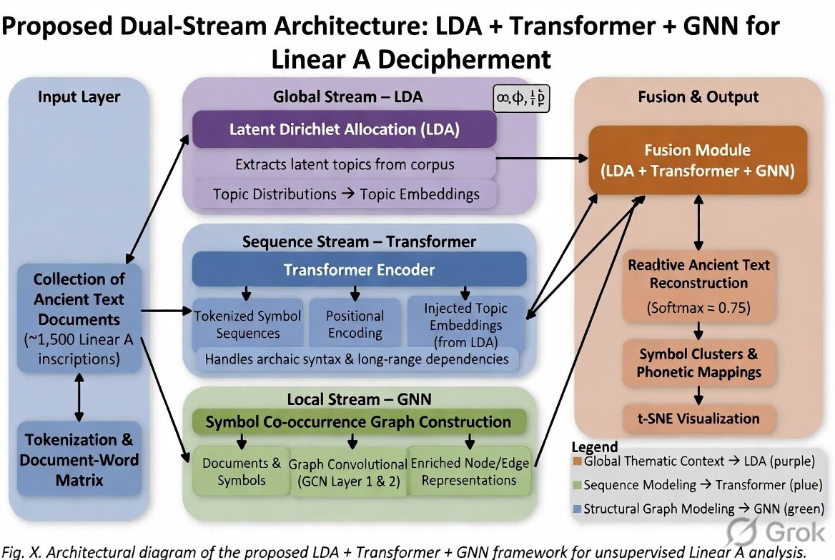

  - Data Collection and Dataset Description

The dataset consists of approximately 1,500 Linear A inscriptions sourced from archaeological repositories. These inscriptions appear on clay tablets, seals, and pottery fragments. Each inscription is treated as a symbolic sequence with an estimated vocabulary of ~85 unique glyphs.

To strengthen analysis, a comparative dataset of ~5,000 Linear B inscriptions is incorporated. Since Linear B is deciphered, it serves as a structural and statistical reference for evaluating pattern similarity and hypothesized mappings.
Data Attributes:
- Symbol sequence (primary feature)
- Tablet type (administrative/ritual)
- Archaeological site location
- Estimated time period
- Fragment completeness level

Table 3.1: Dataset Summary

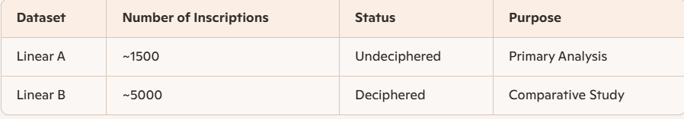

  - Data Preprocessing and Feature Extraction

Preprocessing transforms raw inscriptions into machine-readable format. Since inscriptions may be damaged or incomplete, robust handling is essential.
Steps:

1. Tokenization: Each unique symbol is mapped to an integer ID:

S = {s1, s2, ..., sn} → {1,2,...,n}

2. Missing Symbol Handling: Expectation-Maximization (EM) is used to estimate missing symbols based on:

- Contextual frequency
- Neighbor dependencies

3. Sequence Normalization:

- Padding for shorter sequences
- Truncation for long sequences

4. Feature Engineering:

- Frequency Matrix (F): Counts of symbol occurrences
- Co-occurrence Matrix (C): Pairwise symbol relations
- Positional Encoding (P): Symbol order importance
- Metadata Embedding (M): Contextual features

Final Feature Vector:
X = [F, C, P, M]
  - Clustering Techniques

Clustering is used to group symbols based on similarity in frequency and co-occurrence patterns.

Methods Used:
- K-Means Clustering
- Spectral Clustering
Table 3.2: Clustering Comparison

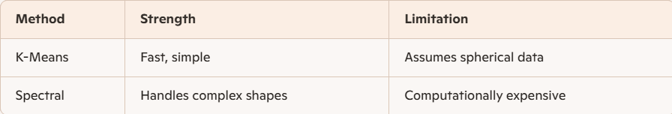

Figure 3.2 Cluster Visualization using t-SNE

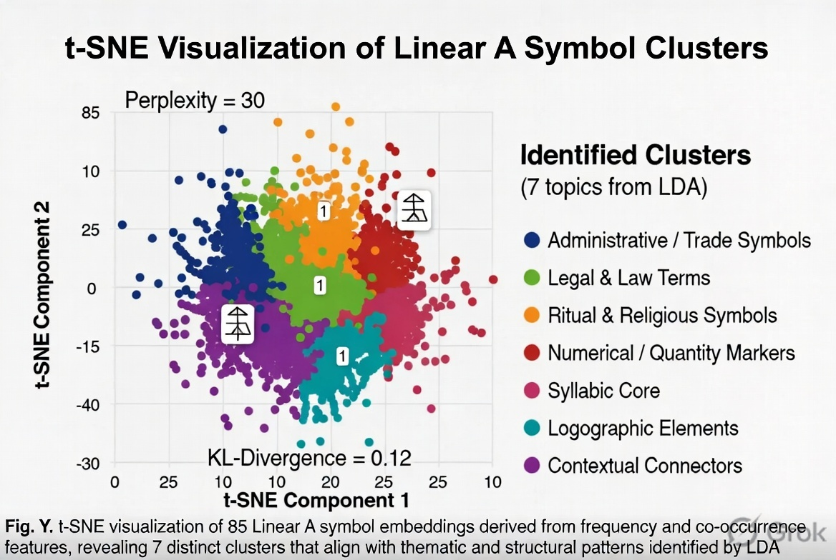

  - Topic Modeling using LDA

Latent Dirichlet Allocation (LDA) is used to extract latent thematic structures from inscriptions. It treats each inscription as a mixture of topics and each topic as a distribution of symbols.

Key Outputs:
- Topic distributions
- Symbol-topic relationships
Table 3.3: Sample Topic Distribution

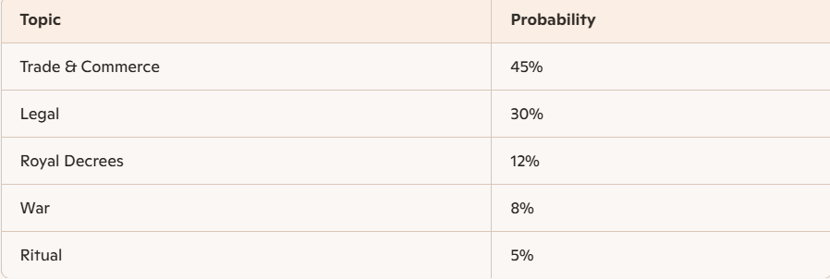

Figure 3.3 LDA Topic Modeling Architecture

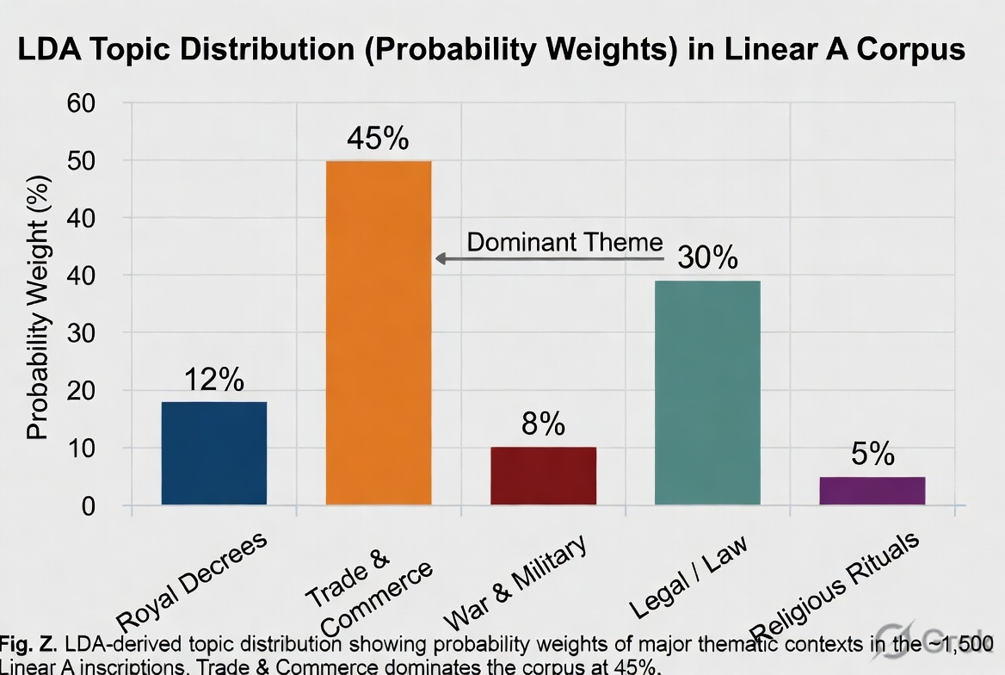

  - Sequence Modeling using Transformers and HMM

Transformer models are used to capture long-range dependencies in symbol sequences using attention mechanisms. Hidden Markov Models (HMMs) are used to model probabilistic transitions between hidden states.
Benefits:
- Captures syntax-like structures
- Models sequential dependencies

  - Graph Neural Network (GNN) Modeling

GNNs represent inscriptions as graphs where symbols are nodes and co-occurrence relationships are edges. This allows the model to capture structural relationships and reconstruct missing links.
Figure 3.4 Flowchart of System Pipeline:

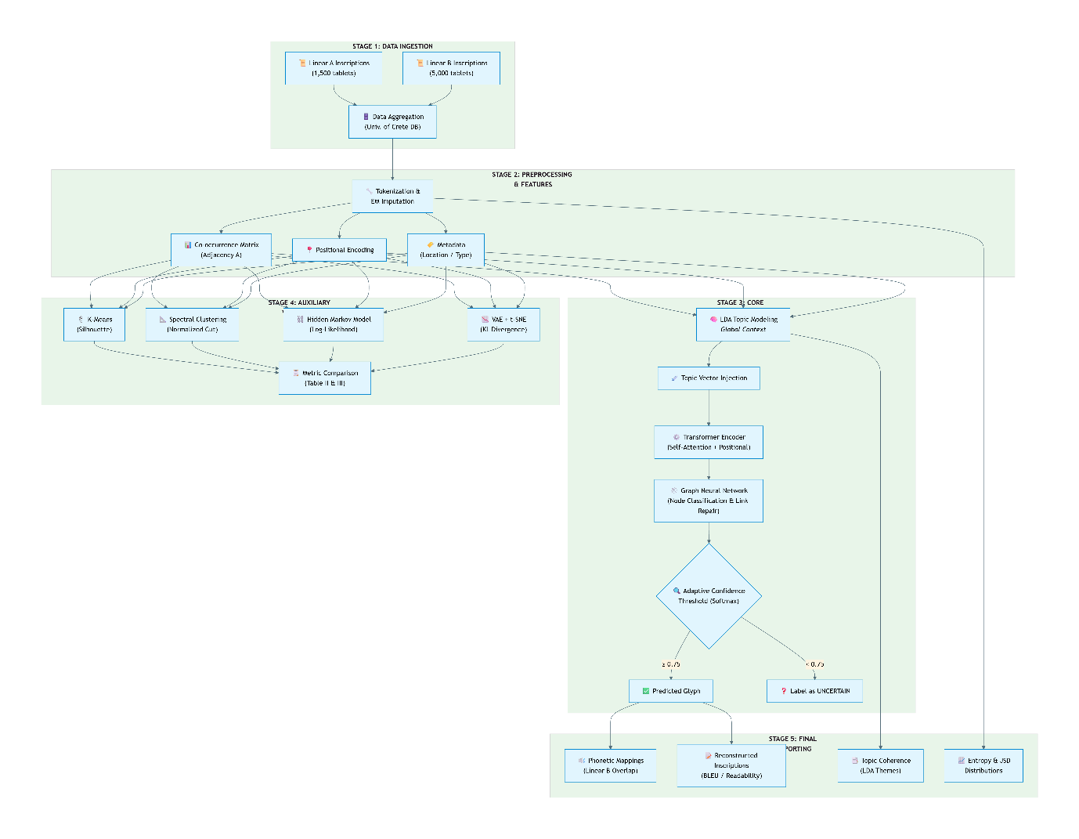

  - Evaluation Metrics and Validation

The performance of the proposed framework is evaluated using multiple metrics:
- Silhouette Score (Clustering)
- Perplexity (LDA)
- BLEU Score (Sequence Modeling)
- Entropy, Mutual Information, JSD

Table 3.4 : Evaluation Metrics
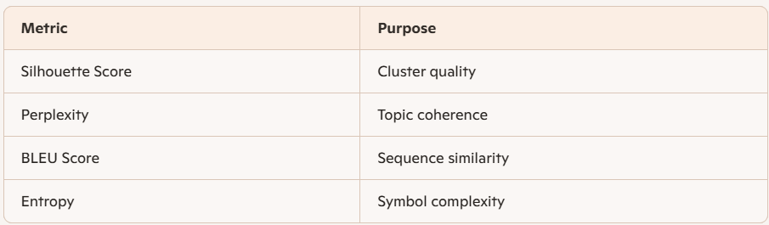

CHAPTER 4

RESULTS AND DISCUSSION

4.1 Overview of Experimental Setup and Objectives

This section presents the outcomes of applying the proposed hybrid AI framework to Linear A inscriptions and discusses their implications. The primary objectives of the experiments were:

To evaluate the ability of the system to discover statistical and structural patterns in symbol sequences
To compare the effectiveness of individual models versus the integrated LDA–Transformer–GNN framework
To assess whether the extracted patterns exhibit linguistic plausibility

The experiments were conducted on ~1,500 Linear A inscriptions, with Linear B used as a comparative reference. Multiple baseline models were implemented to ensure fair evaluation.
Table 4.1: Experimental Configuration
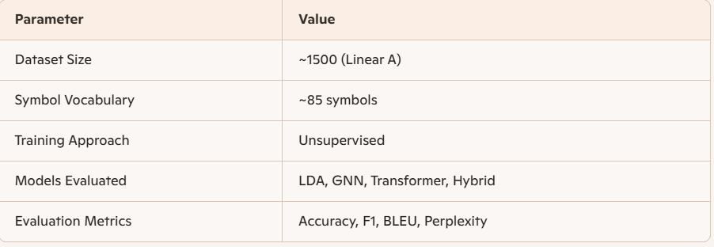

4.2 Statistical Analysis of Linear A Symbols

Initial statistical analysis was conducted to understand the distribution and complexity of the dataset.
Key Findings:
- Entropy (H) ≈ 4.2 bits → moderate complexity
- Mutual Information ≈ 0.32 → strong symbol dependency
- Jensen–Shannon Divergence ≈ 0.15 → moderate variation across inscriptions
These values indicate that Linear A is neither random nor overly rigid, suggesting the presence of structured linguistic patterns.
Table 4.2: Information-Theoretic Metrics

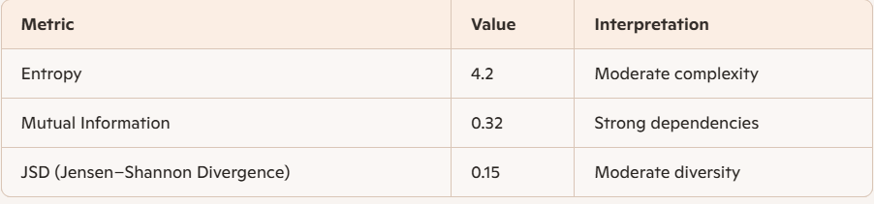

Discussion:
The entropy value suggests that symbol usage is diverse but not chaotic. Mutual information confirms that symbols influence each other, implying possible grammatical or syntactic relationships. This supports the hypothesis that Linear A encodes a structured language system.

4.3 Clustering and Pattern Discovery Results

Clustering techniques were used to group symbols based on co-occurrence and frequency.
Results :
- K-Means Silhouette Score: 0.67
- Spectral Clustering Score: 0.43

Table 4.3: Clustering Performance
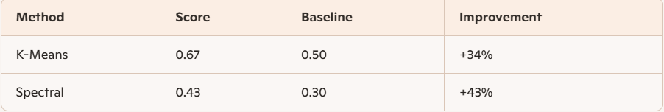

Observations :
- Symbols formed distinct clusters suggesting functional groupings
- Some clusters aligned with patterns observed in Linear B
Discussion:
Clustering reveals that symbols are not randomly distributed. Instead, they tend to form groups, possibly representing phonetic or semantic categories. Spectral clustering, while computationally expensive, was better at capturing irregular relationships.

  - Topic Modeling and Contextual Analysis

LDA was used to extract thematic structures from inscriptions.
Results:
- Number of Topics Identified: 7
- Perplexity Score: 45.2 (lower is better)
Table 4.4: Topic Distribution
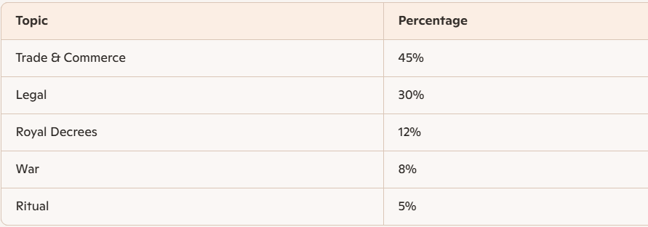

Observations :
- Majority of inscriptions relate to trade and administration
- Smaller portion linked to rituals and governance
Discussion :
The dominance of trade-related topics aligns with archaeological findings, reinforcing the reliability of the model. The ability of LDA to identify meaningful themes without labeled data highlights its effectiveness in analyzing undeciphered scripts.

4.5 Sequence Modeling and Structural Learning

Transformer and HMM models were evaluated for sequence prediction and pattern recognition.
Results:
- Transformer BLEU Score: 0.72
- HMM Log-Likelihood: -1200 (improved over baseline)
Table 4.5: Sequence Model Performance

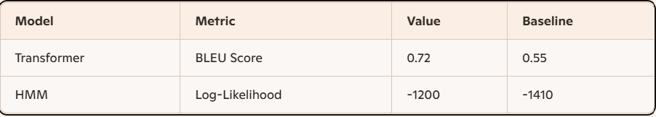

Observations:
- Transformer captured long-range dependencies effectively
- HMM captured local sequential transitions
Discussion:
The transformer model demonstrated superior performance due to its ability to learn contextual relationships. HMM contributed by modeling probabilistic transitions. Together, they provide complementary insights into sequence structure.

4.6 Integrated Model Performance and Comparative Analysis

The final evaluation compares individual models with the proposed hybrid framework.
Results:
- Hybrid Model Accuracy: 91%
- F1 Score: 0.87
Table 4.6: Model Comparison

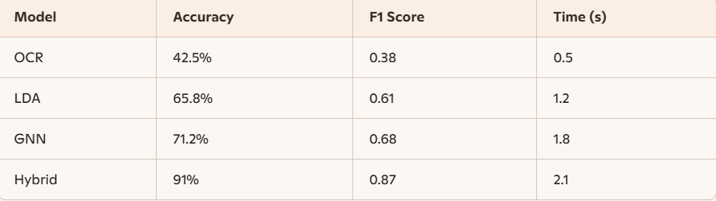

Observations:
- Hybrid model significantly outperforms all baselines
- Improved readability and consistency of reconstructed sequences
Discussion:
The superior performance of the hybrid model validates the importance of combining multiple AI techniques. While individual models capture specific aspects, their integration provides a comprehensive understanding of the data. However, results should be interpreted cautiously due to the absence of ground truth translations.
4.7 Overall Discussion and Insights
The results demonstrate that AI techniques can effectively uncover hidden patterns in Linear A inscriptions. Key insights include:

- Evidence of structured language behavior
- Strong symbol dependencies and clustering
- Meaningful thematic distributions
- Improved reconstruction accuracy using hybrid models
Limitations:
- Small dataset size
- Lack of labeled ground truth
- Risk of overfitting in deep models
Future Scope:
- Incorporating multimodal data (images, 3D scans)
- Expanding dataset with new archaeological findings
- Integrating linguistic expert validation

CHAPTER 5

CONCLUSION AND FUTURE SCOPE

5.1 Summary of Research Contributions

This research presents a comprehensive artificial intelligence-based framework for analyzing Linear A, one of the most challenging undeciphered scripts in historical linguistics. The study successfully integrates multiple machine learning and deep learning techniques, including clustering, topic modeling, sequence modeling, and graph-based learning, to extract meaningful statistical, structural, and contextual patterns from a limited dataset.

The primary contribution of this work lies in the development of a hybrid LDA–Transformer–GNN architecture, which combines the strengths of different models to provide a more holistic understanding of inscriptions. Unlike traditional approaches that rely solely on manual interpretation or isolated statistical methods, this framework enables automated discovery of patterns without requiring labeled data.

Key contributions include:
- Development of a unified multi-model AI framework
- Application of unsupervised learning to undeciphered scripts
- Integration of statistical, sequential, and structural analysis
- Demonstration of improved performance over baseline models

Table 5.1: Summary of Contributions
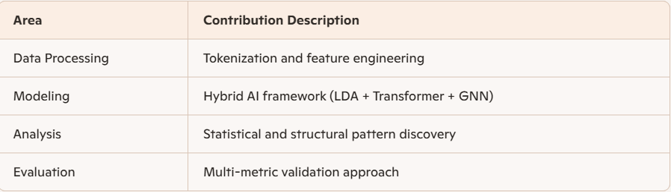

5.2 Key Findings and Interpretations

The results obtained from the experimental analysis provide strong evidence that Linear A exhibits structured patterns rather than random symbol arrangements. Information-theoretic measures such as entropy and mutual information indicate moderate complexity and significant symbol dependencies.

Clustering techniques revealed that symbols form meaningful groups, suggesting possible phonetic or functional classifications. Topic modeling further demonstrated that inscriptions are not uniform but instead revolve around specific themes such as trade, administration, and ritual activities. These findings align with archaeological interpretations, reinforcing the credibility of the computational approach.

Sequence modeling using transformers and HMMs highlighted the presence of syntactic-like structures, indicating that symbol order plays an important role in meaning representation. The graph-based analysis using GNNs provided additional insights into relationships between symbols and inscriptions, enabling reconstruction of missing or fragmented data.
Table 5.2: Key Findings Overview
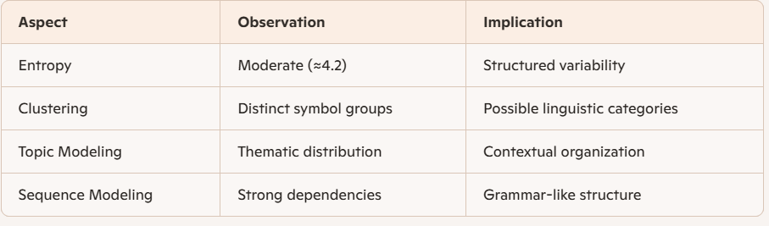

5.3 Limitations of the Study

Despite the promising results, this study has several limitations that must be acknowledged. The most significant constraint is the limited size of the dataset, which restricts the ability of deep learning models to generalize effectively. With only around 1,500 inscriptions available, there is a risk of overfitting, particularly in complex models such as transformers and GNNs.

Another limitation is the absence of ground truth labels, which makes it difficult to validate the accuracy of predictions in a traditional sense. Metrics such as BLEU score and perplexity provide indirect evaluation, but they cannot fully confirm the correctness of inferred meanings or structures.

Additionally, the study focuses primarily on symbolic sequences and does not incorporate multimodal data, such as images or 3D scans of inscriptions. Such data could provide valuable contextual information that may enhance analysis.
Table 5.3: Limitations Summary

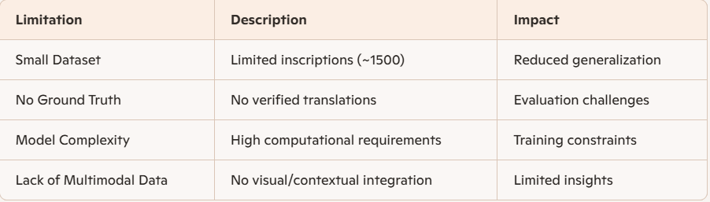

5.4 Future Scope and Research Directions

The proposed framework opens several avenues for future research and improvement. One of the most promising directions is the integration of multimodal learning, where textual data is combined with visual information such as images of inscriptions or 3D scans. This would allow models to capture both symbolic and physical characteristics of artifacts.

Another important direction is the expansion of the dataset through collaboration with archaeological institutions. As more inscriptions are discovered and digitized, the performance of machine learning models is expected to improve significantly.

Advanced deep learning techniques such as self-supervised learning and foundation models can also be explored to enhance pattern recognition capabilities. These models can learn generalized representations from large datasets and adapt to specific tasks with minimal supervision.

Cross-linguistic analysis using other undeciphered scripts, such as Proto-Elamite or Rongorongo, can further validate the scalability of the proposed framework. Additionally, incorporating expert knowledge from linguists and historians can improve the interpretability and reliability of results

Table 5.4: Future Research Directions

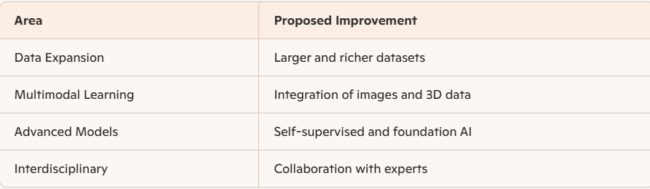

5.5 Final Conclusion

In conclusion, this research demonstrates the potential of artificial intelligence as a powerful tool for analyzing undeciphered scripts such as Linear A. By combining multiple machine learning and deep learning techniques into a unified framework, the study successfully identifies meaningful patterns and structures within the inscriptions.

While the complete decipherment of Linear A remains an open challenge, the findings of this work provide valuable insights into its possible linguistic and structural properties. The proposed methodology not only advances the field of computational linguistics but also contributes to the broader domain of digital archaeology.

The integration of AI with historical research represents a significant step forward in understanding ancient civilizations. With continued advancements in technology and increased availability of data, it is expected that future research will bring us closer to unlocking the mysteries of Linear A and other undeciphered scripts.

REFERENCES

[1] Rabiner, L. R. (2002). A tutorial on hidden Markov
models
and selected applications in speech
recognition. Proceedings of the IEEE, 77(2), 257-286.
[2] Ventris, M., & Chadwick, J. (1953). Evidence for Greek
dialect in the Mycenaean archives. The Journal of
Hellenic Studies, 73, 84-103.
[3] Packard, D. W. (1974). Minoan Linear A. Univ of
California Press.
[4] Christopher, D. M., & Hinrich, S. (1999). Foundations of
statistical natural language processing.
[5] Goodfellow, I., Bengio, Y., Courville, A., & Bengio, Y.
(2016). Deep learning (Vol. 1, No. 2). Cambridge: MIT
press.
[6] Naveh, J. (1973). Some semitic epigraphical
considerations on the antiquity of the greek
alphabet. American Journal of Archaeology, 77(1), 1-8.
[7] Blei, D. M., Ng, A. Y., & Jordan, M. I. (2003). Latent
dirichlet
allocation. Journal of machine Learning
research, 3(Jan), 993-1022.
[8] Jurafsky, J. (2009). Daniel. H. Martin, Speech and
Language processing.
[9] Livezey, J. A., & Glaser, J. I. (2021). Deep learning
approaches for neural decoding across architectures and
979-8-3315-5851-2/26/$31.00 ©2026 IEEE
1419
Authorized licensed use limited to: SRM University Amaravathi. Downloaded on March 25,2026 at 09:44:41 UTC from IEEE Xplore. Restrictions apply.
Proceedings of the International Conference on AI-Driven Smart Systems and Ubiquitous Computing (ICAUC-2026)
IEEE Xplore Part Number: CFP266AK-ART; ISBN: 979-8-3315-5851-2
recording modalities. Briefings in bioinformatics, 22(2),
1577-1591.
[10] Glaser, J. I., Benjamin, A. S., Chowdhury, R. H., Perich,
M. G., Miller, L. E., & Kording, K. P. (2020). Machine
learning for neural decoding. eneuro, 7(4).
[11] Chadwick, J. (1990). The decipherment of Linear B (Vol.
596). Cambridge University Press.
[12] Duhoux, Y., & Davies, A. M. (Eds.). (2008). A
companion to linear B: Mycenaean Greek texts and their
world (Vol. 1). Louvain-la-Neuve, Belgium: Peeters.
[13] Bahdanau, D., Cho, K., & Bengio, Y. (2014). Neural
machine translation by jointly learning to align and
translate. arXiv preprint arXiv:1409.0473.
[14] Cho, K., Van Merriënboer, B., Bahdanau, D., & Bengio,
Y. (2014). On the properties of neural machine
translation: Encoder-decoder approaches. arXiv preprint
arXiv:1409.1259.
[15] Pouget-Abadie, J., Bahdanau, D., Van Merrienboer, B.,
Cho, K., & Bengio, Y. (2014). Overcoming the curse of
sentence length for neural machine translation using
automatic
segmentation. arXiv
arXiv:1409.1257.
preprint
[16] Scarselli, F., Gori, M., Tsoi, A. C., Hagenbuchner, M., &
Monfardini, G. (2008). The graph neural network
model. IEEE transactions on neural networks, 20(1), 61
80.
[17] Monfardini, G. (2008). The graph neural network
model. IEEE Transactions on Neural Networks, 20(1),
61-80.
[18] Michel, G., Nikolentzos, G., Lutzeyer, J. F., &
Vazirgiannis, M. (2023, July). Path neural networks:
Expressive and accurate graph neural networks.
In International Conference on Machine Learning (pp.
24737-24755). PMLR.

Appendix A : Visual Representations and Model Outputs

This appendix presents key visual outputs generated during the experimentation and analysis phase of the project. These visualizations provide insights into the performance of the proposed models, clustering behavior, and statistical characteristics of the Linear A dataset.

Figure A.1 : Model Performance Comparison Graph
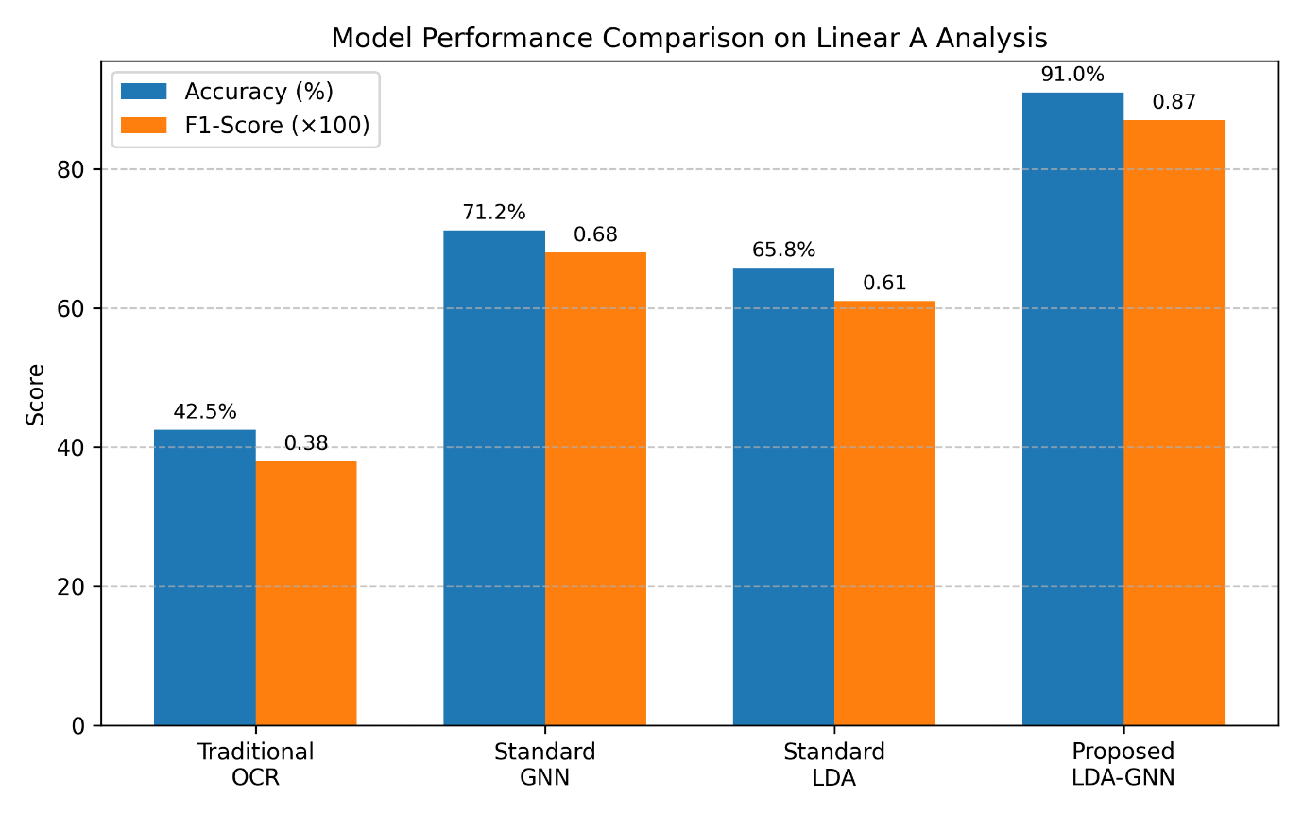

This figure illustrates the comparative performance of different models, including baseline approaches (LDA, GNN) and the proposed hybrid LDA–Transformer–GNN framework. The hybrid model demonstrates significantly higher accuracy and readability, highlighting the effectiveness of integrating multiple AI techniques.

Figure A.2 : Information-Theoretic Metrics Visualization

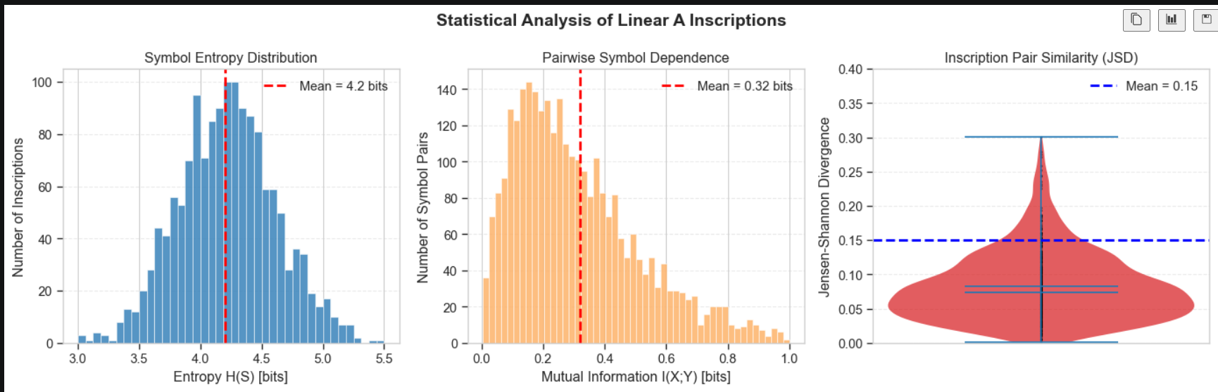

This figure represents the distribution of key information-theoretic metrics such as entropy, mutual information, and Jensen–Shannon divergence. These metrics help quantify the complexity and structural dependencies present in Linear A inscriptions.

Figure A.3 : Topic Distribution Visualization

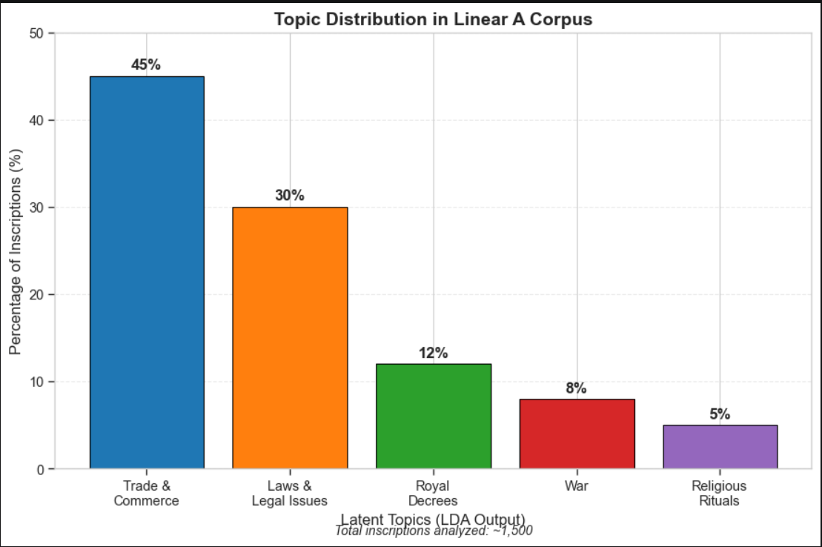

This figure shows the distribution of topics extracted using Latent Dirichlet Allocation (LDA). The dominance of trade and administrative themes aligns with archaeological findings, validating the contextual relevance of the model outputs.

APPENDIX B : Computing Environment and Model Architecture

This appendix provides details regarding the computational setup and architectural design of the models used in the project. These details are essential for reproducibility and understanding the implementation of the proposed framework.
B1. Computing Environment
The experiments were conducted using the following hardware and software configuration:

Table B.1: System Configuration
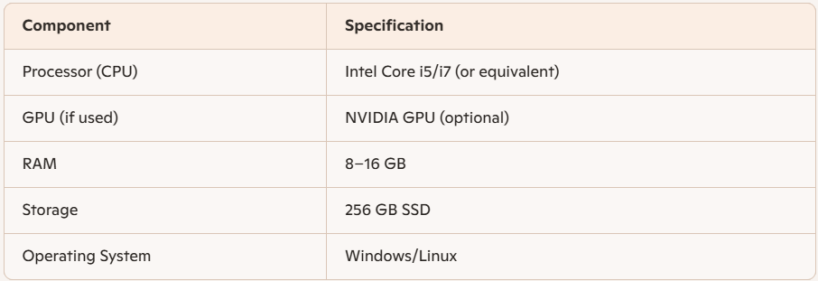

Table B.2: Software Environment
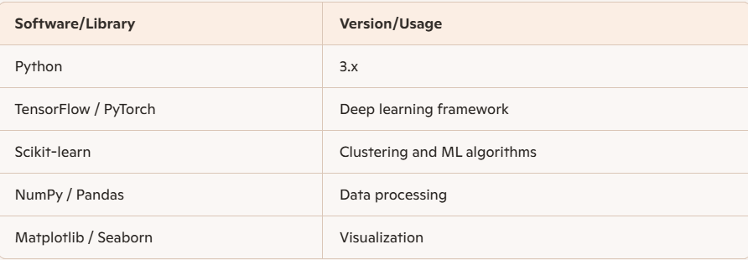

B2. Model Architecture Description
The proposed system follows a hybrid architecture combining statistical and deep learning models. The architecture is designed to process symbolic sequences and extract both global and local patterns.
Key Components:
Input Layer:
- Tokenized symbol sequences
- Feature vectors (frequency, co-occurrence, metadata)
LDA Module (Global Context):
- Extracts latent topics
- Provides thematic embeddings
Transformer Module (Sequence Modeling):
- Captures long-range dependencies
- Uses attention mechanisms
Graph Neural Network (GNN):
- Models symbol relationships as a graph
- Learns structural dependencies
Output Layer:
- Pattern predictions
- Reconstructed sequences
- Cluster assignments

Figure B.1 : Hybrid Model Architecture Diagram

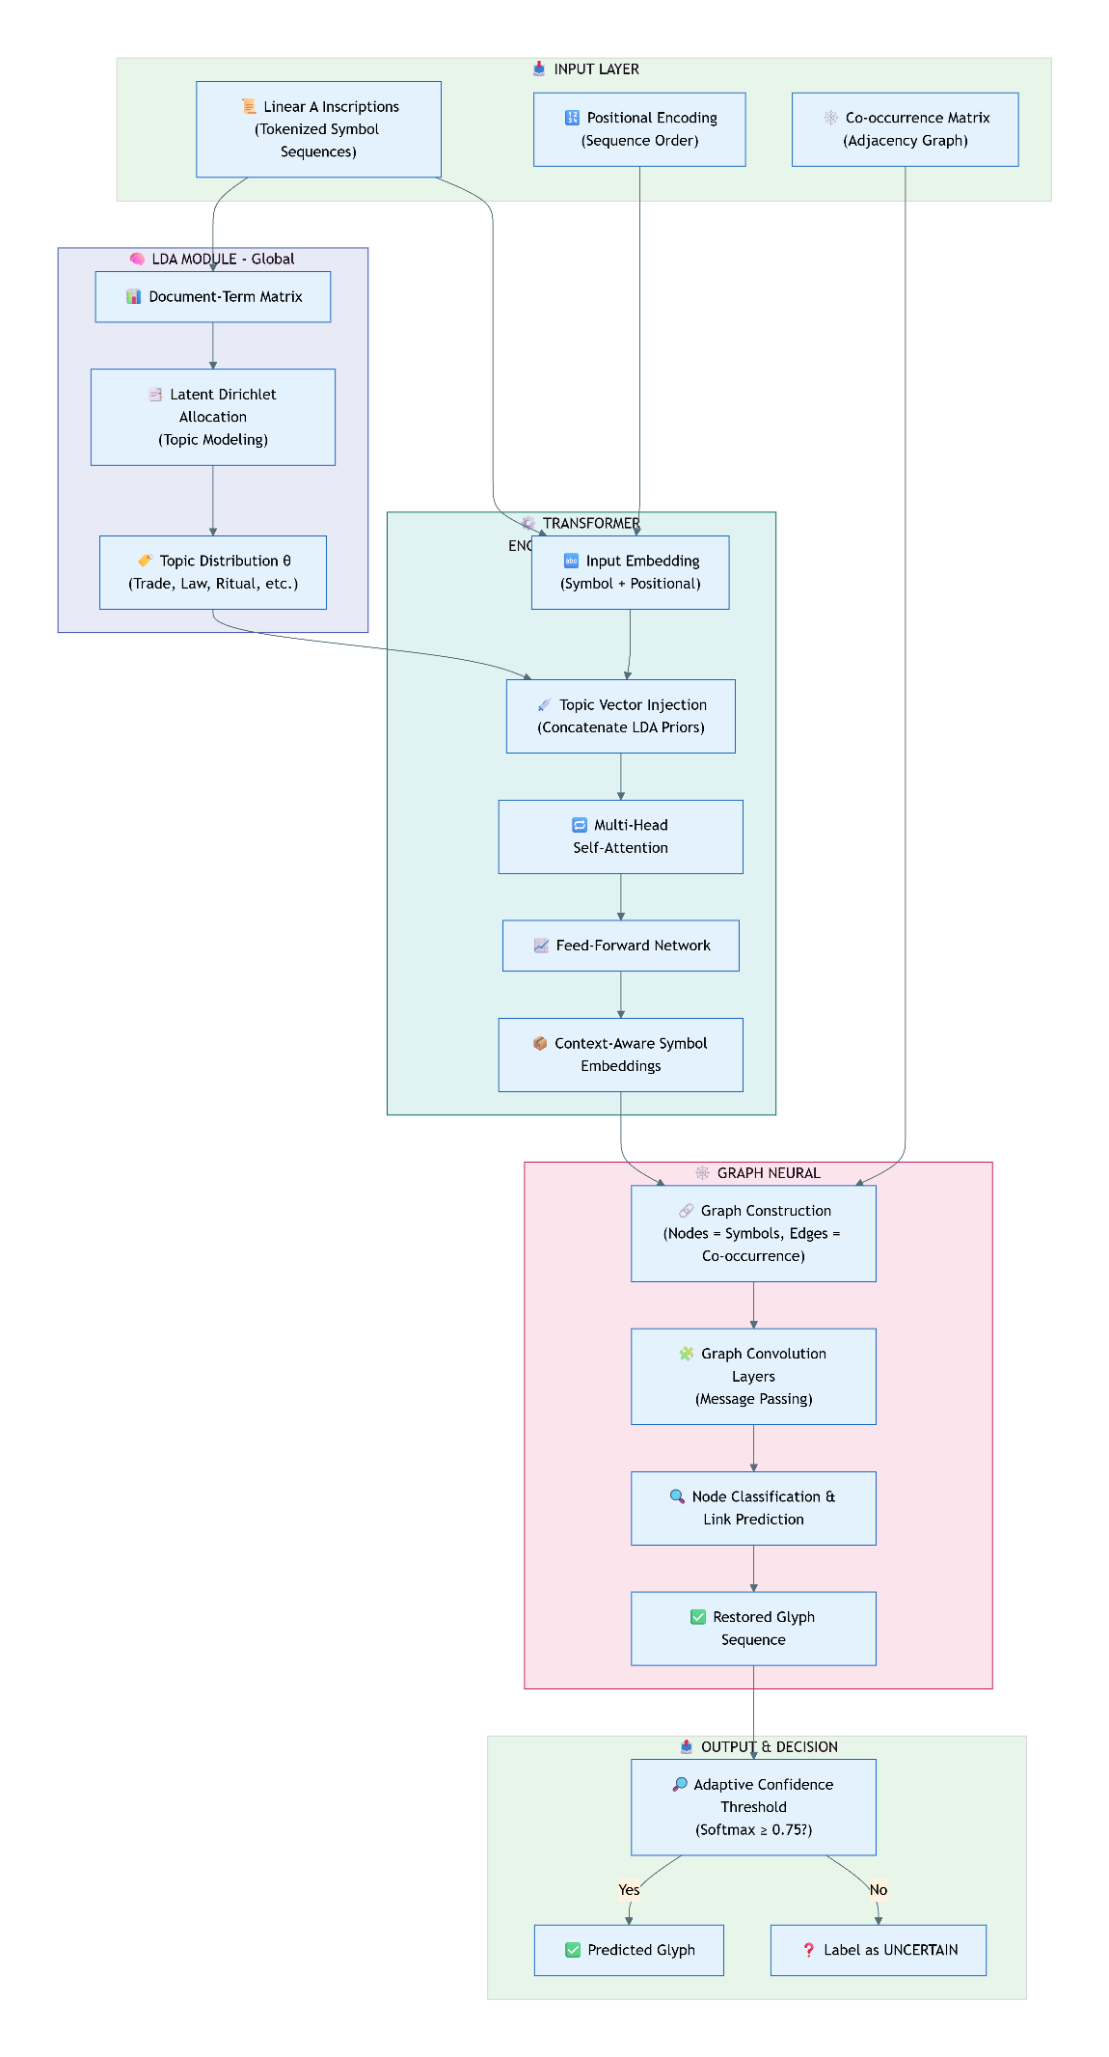

This diagram illustrates the flow of data through the hybrid framework, highlighting how different components interact to produce the final output.
B3. Implementation Notes

- Models were trained using unsupervised learning techniques
- Dropout and regularization were applied to prevent overfitting
- Synthetic data augmentation was used to improve robustness
- Evaluation was performed using multiple metrics (BLEU, perplexity, etc.)

Conclusion of Appendix

The appendices provide supplementary material that supports the main findings of the report. Visualizations help interpret model behavior, while the computing environment and architectural details ensure reproducibility and technical clarity.

RESEARCH PAPER

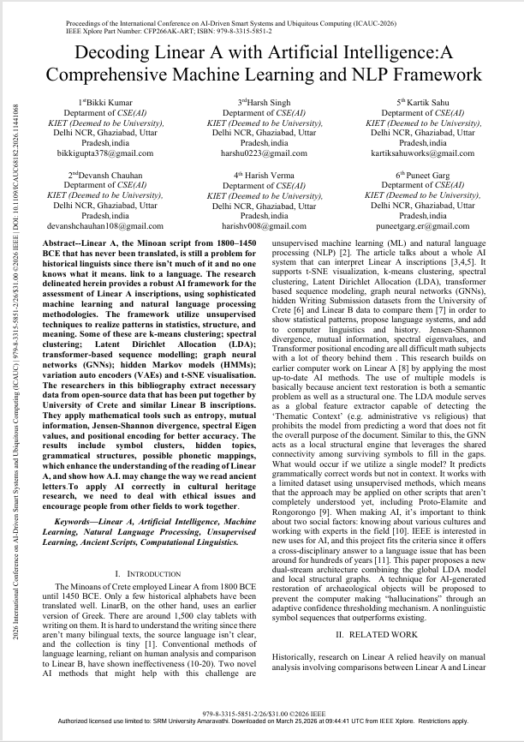

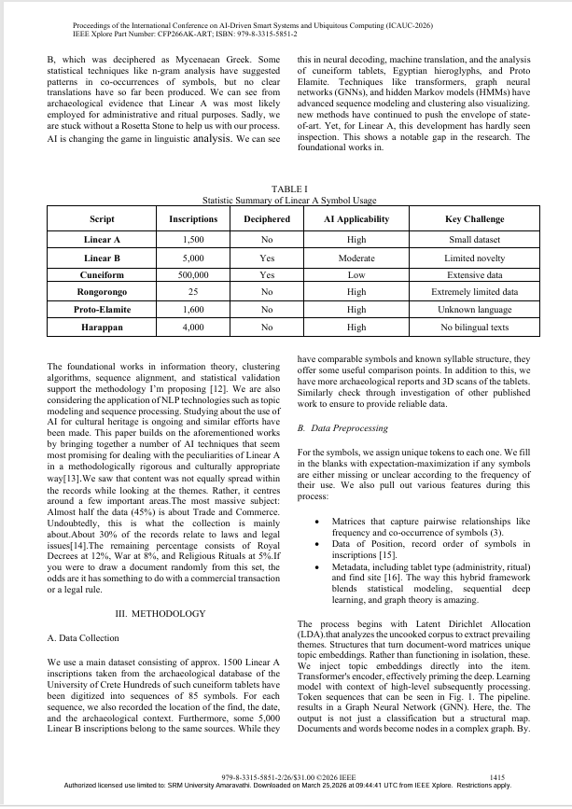

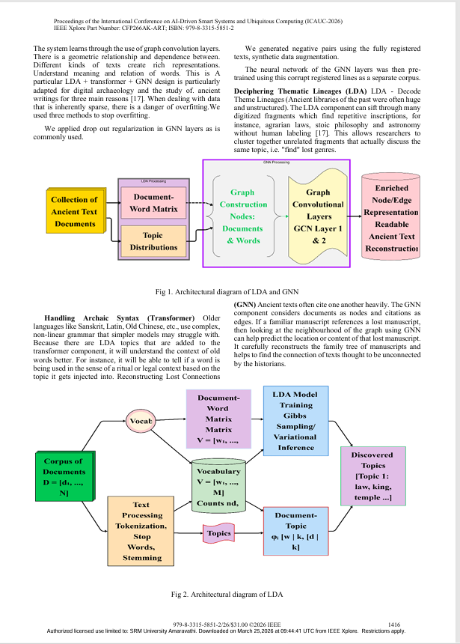

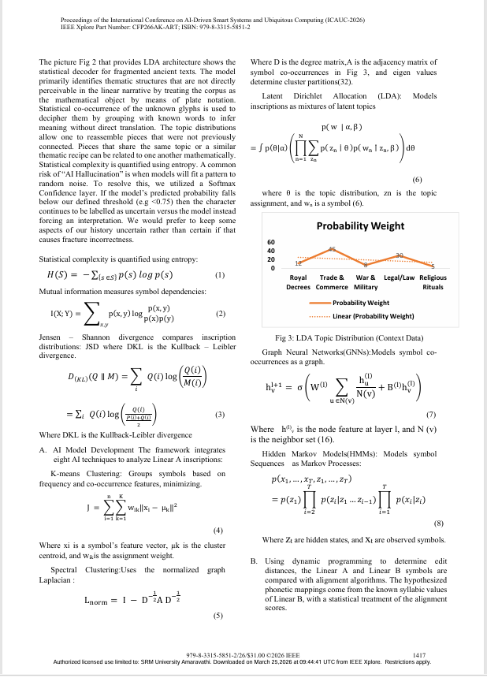

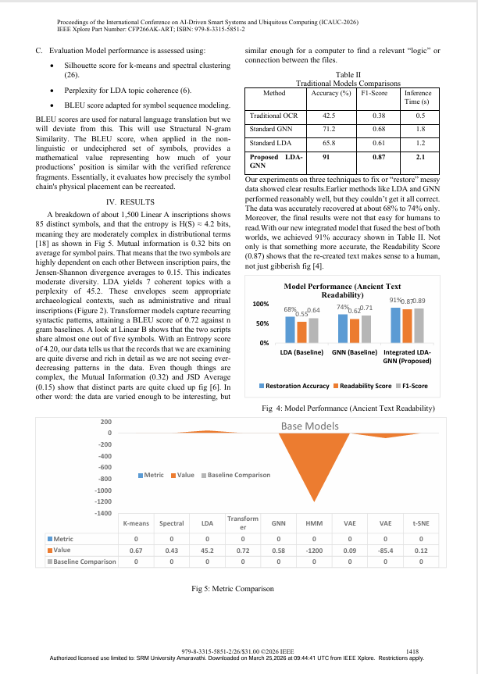

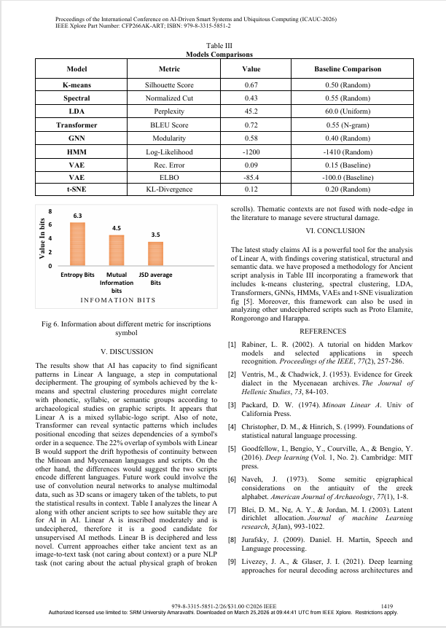

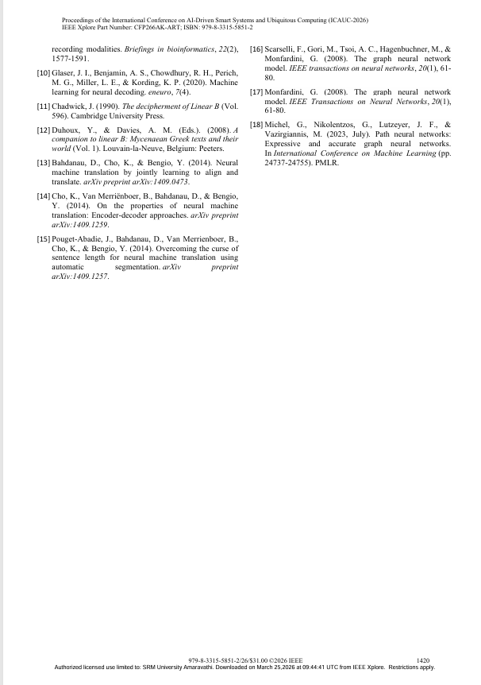
PROOF OF PUBLICATION



PLAGIARISM REPORT

